**Project: the-monkees-band**

This project allows users to gain access to the Monkees band details.

The website includes a potted history of the Monkees band as well as links to more in depth information via Wikipedia / youtube links. Users can listen to records, watch videos and see pictures of the band / members. So far there are 4 records, 1 video and several photos available – each of these is likely to increase in the future.

Each page should include links to the other pages of data eg. there are 4 pages, 1 for the potted history, 1 for playing records, 1 for playing videos and 1 for viewing photos.

**UX**

This website has been designed for fans of the Monkees.

Initially the user will be located at the index.html (ABOUT US) page. This page includes the potted history and links to various external sites. In addition there are buttons to allow the user to relocate to a different page. These are described above.

The website has been created to highlight the band’s achievements and allow access to the band’s memorabilia.

Wireframes for each page are shown below as Excel snips.

1. Page 1 – View Potted History

|  |  |
| --- | --- |
|  | TITLE |
| Social media links |  |
| LOGO graphic | Potted History |
| Page links/butons |  |

1. Play Music

|  |  |
| --- | --- |
|  | TITLE |
| Social media links |  |
| LOGO graphic | Play Music - list of tracks |
| Page links/butons |  |

1. Play Videos

|  |  |
| --- | --- |
|  | TITLE |
| Social media links |  |
| LOGO graphic | Play Videos - list of films |
| Page links/butons |  |
|  |  |

1. View Photos

|  |  |
| --- | --- |
|  | TITLE |
| Social media links |  |
| LOGO graphic | List of Photos |
| Page links/butons |  |

From each page the user can link to social media (facebook / twitter / youtube).



From each page the user can move to a different page.



1. As a fan / journalist, I want to view a description of the band and it’s history
2. As a fan I want to play musical tracks
3. As a fan I want to view movies
4. As a fan I want to view photos

Responsive functionality has been included so that smaller screens are catered for.

**Features**

Four pages have been created – index.html / play_music.html / play_videos.html / view_photos.html.

The header – THE MONKEES and ROCK ‘n ROLL are output at the top of each page.

The social media links are output next.

I’ve selected a graphic for output on each page.

Different media parts are output, different for each page including history / music / video / photos.

At the end of each page are the page navigation links.

**Existing Features**

**Features Left to Implement**

In the future, other music / video tracks / photos could be added to the site.

**Technologies Used**

HTML and CSS have been used to fulfil this requirement.

Excel has been used to create the wireframes.

fonts.googleapis.com/css?family has been used to access the Roboto font.

Bootstrap has been used.

Some of the implemented functionality has been achieved referring to the Resume project eg. hovering.

**Testing**

Run the project.

Potted history page is returned:

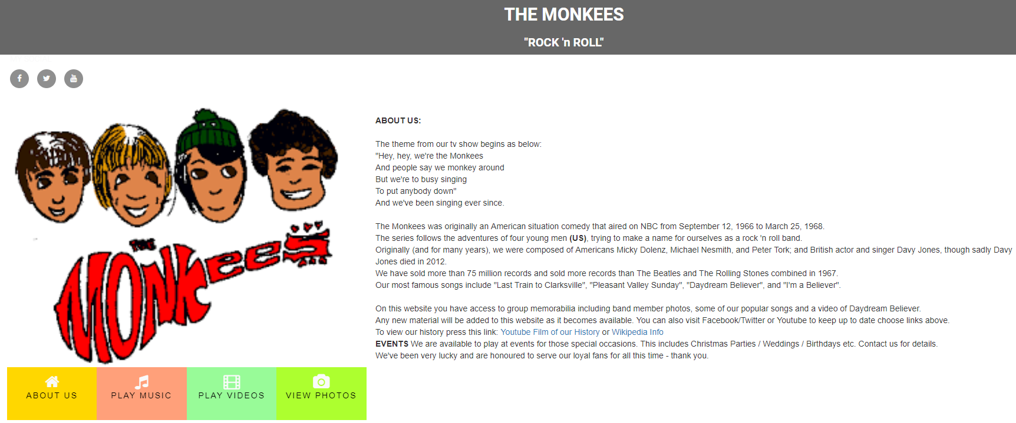

Press the facebook social media link. Link takes you to <https://www.facebook.com/>



Press the twitter social media link. Link takes you to <https://twitter.com/>



Press the youtube link. Link takes you to <https://www.youtube.com/>



Press PLAY MUSIC button 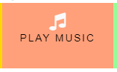

Page play_music.html opens:

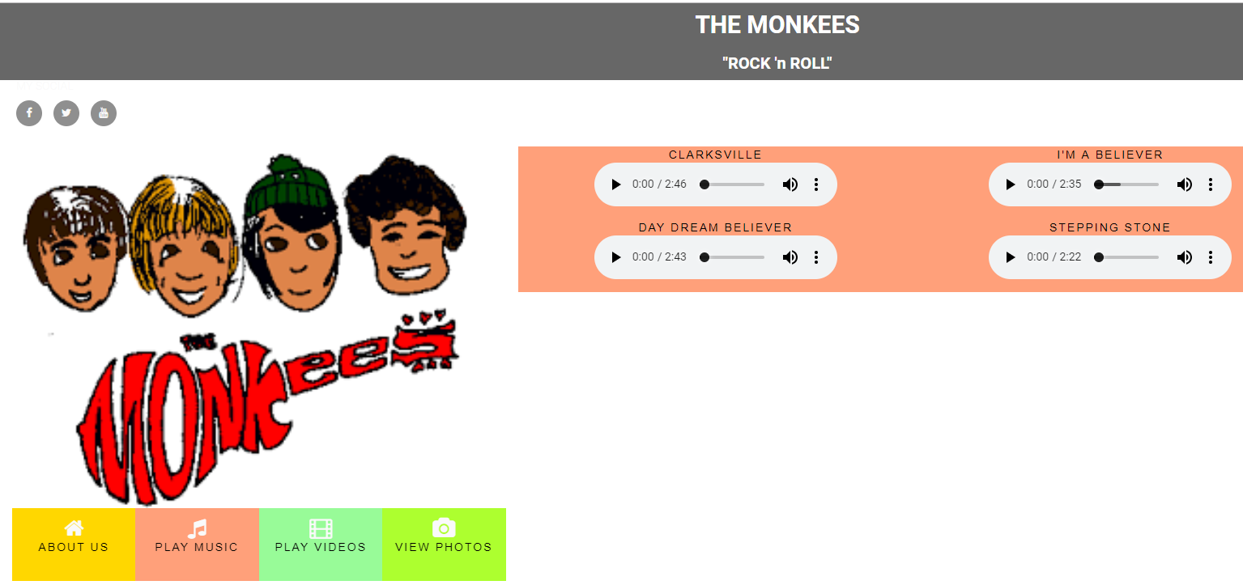

PLAY MUSIC page is returned.

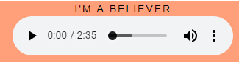

Press play on one of the media player entries – in this case, I’M A BELIEVER.

The track should play.

Press PLAY VIDEOS button: 

Page play_videos opens

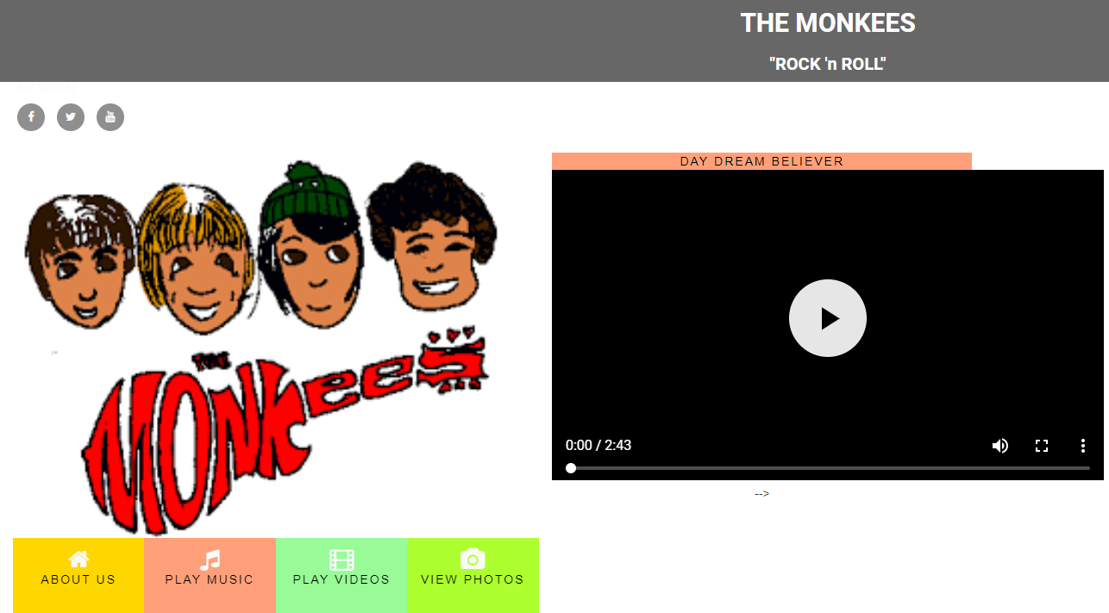

PLAY VIDEOS page is returned.

There is only one video available thus far.

Press play.

The video should play.

Press VIEW PHOTOS: 

Page view_photos.html opens.

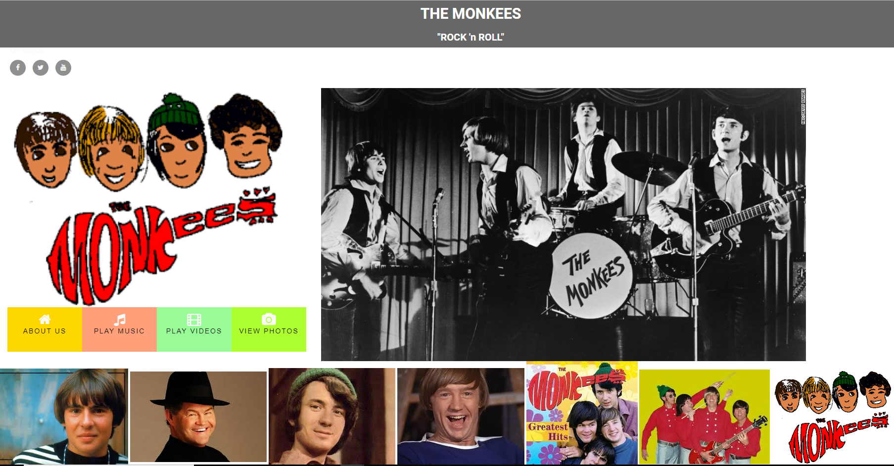

A list of photos is displayed.

There are further photos included which can be seen using the scroll bar.

So this proves that all of the pages / social media links and page navigation works.

Next, right click on the screen and choose inspect to prove that responsive design works.

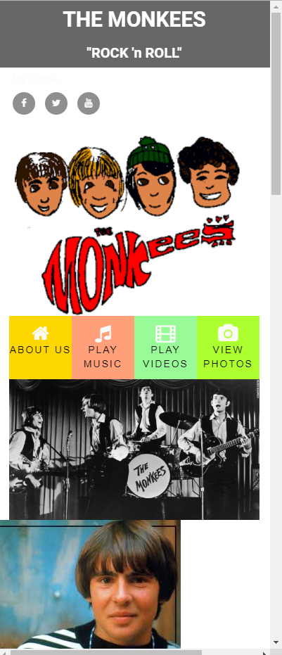

Choose another page eg. ABOUT US:

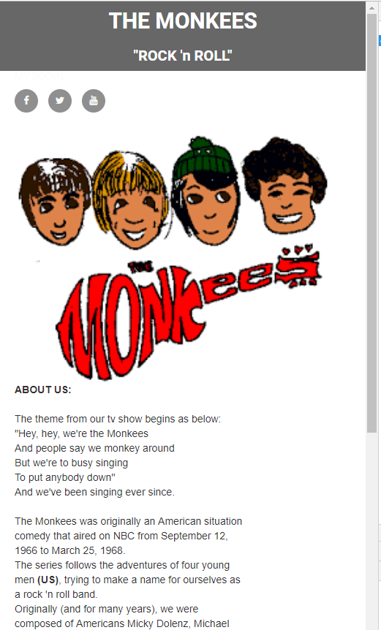

Choose page PLAY MUSIC

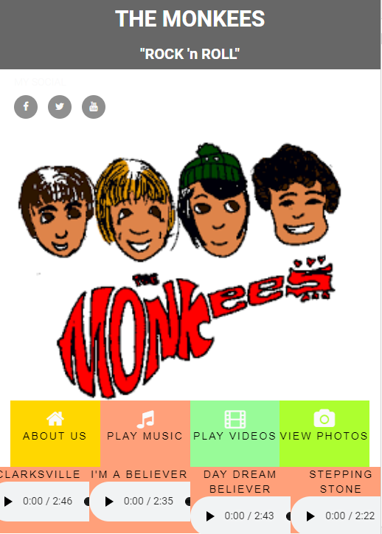

Press play on one of the tracks listed.

**Deployment**

**Credits**

* The Monkees

**Content**

* The material used in this project was available as part of the course
* The text for the ABOUT US / potted history was copied from Wikipedia

**Media**

* The photos / music / videos used in this site were as included in the band project

**Acknowledgements**