**U.S. Department of Energy**

The Gaming Project Demo Manual

Version 1.0

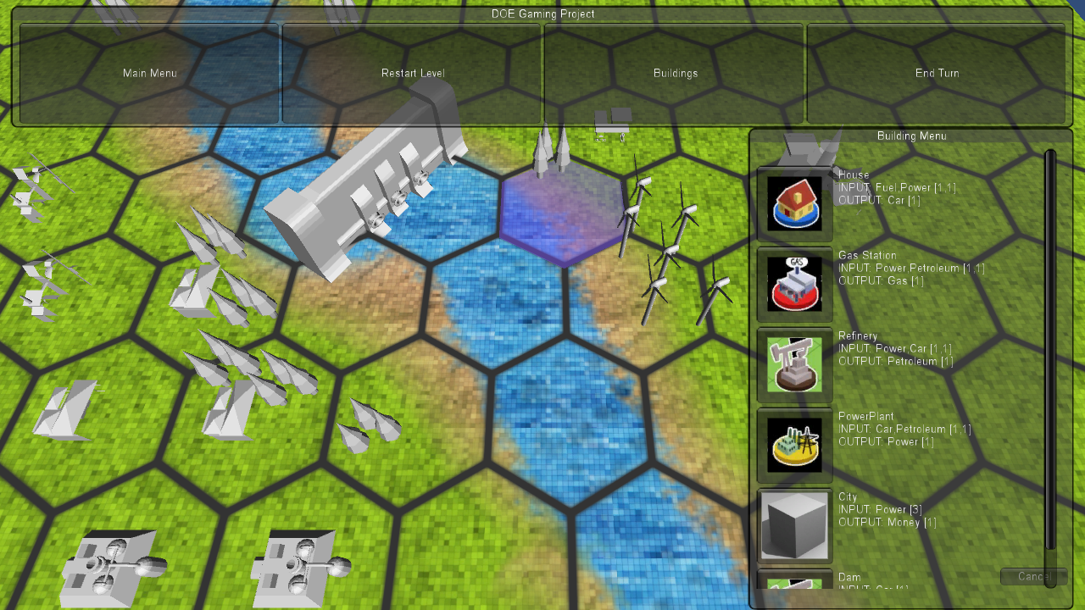

**Note**: The assets, fonts, textures, images and the features in this demo and not final. They are to show some core functionality only. This manual is for the PC version of the game hence uses the click interface which is similar to touch on a mobile device.

Contents

1. Starting the demo level 2

2. Knowing the scene 2

3. Restart Scene 2

4. Using Camera controls 2

5. Using building menu (GUI) 2

6. Placing buildings on terrain 3

7. Linking buildings 3

8. Actual demo run – for the presentation 3

# Starting the demo level

* Use the **demo.exe** in **DemoLevel** folder to start the demo. Select the appropriate screen resolution and graphics quality and start.

# Knowing the scene

* The demo has only one scene file so it will open up a sample terrain with some game objects placed. In the menu **main menu** and **end turn** is not available right now. This demo will have **building menu** which provides the option of selecting a building that can be placed on the terrain. Building placement is explained below. The building menu will open up a new window with all the information.
* 

*Building menu*

# Restart Scene

* **Restart level** in the menu will reset everything and remove all your placed and linked objects.

# Using Camera controls

* The camera control using mouse which is developed in such a way that it will be similar to touch events. So click and drag on PC screen using mouse will be using your finger on the phone screen.
* **Panning**: Click and drag on the screen (terrain)
* **Zoom**: Mouse wheel (will be pinch on phone)

# Using building menu (GUI)

* Click on **Buildings** to open up a new window.

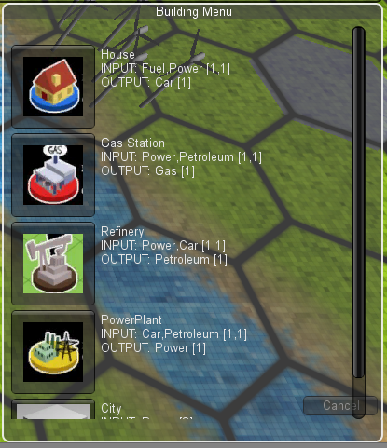

*Button to select the particular building*

*Information: input and output for the building that can be linked*

# Placing buildings on terrain

* Click on the buildings button and then select a building from the menu. Once clicked the buildings menu will go back to the terrain. Now if you click on any tile it will place the selected building. Follow the same procedure to place different buildings on the terrain.

# Linking buildings

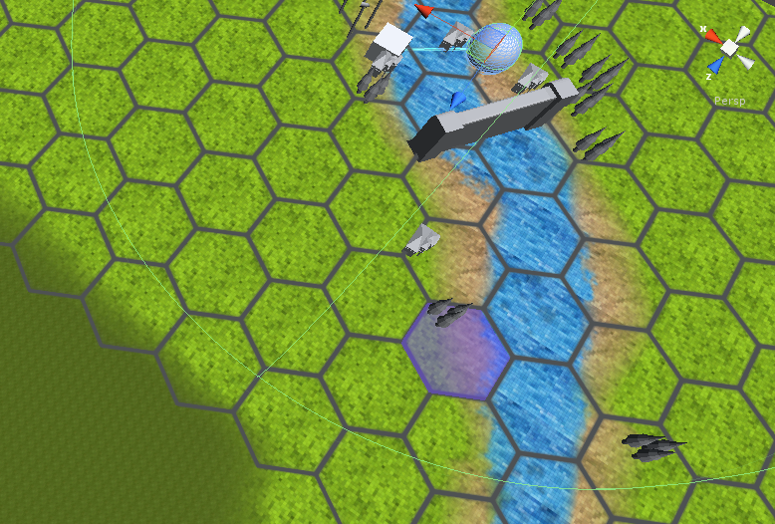

Link range

Link

Dds;d;dddsdsdsd

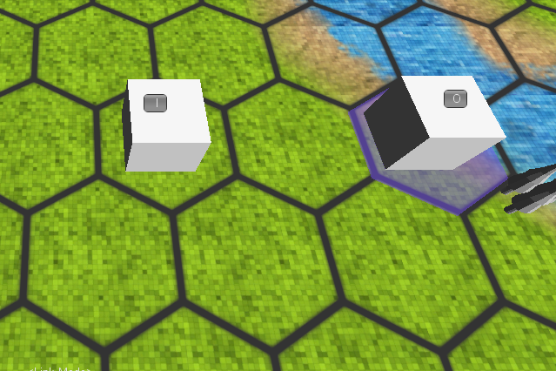

The link mode has been tested on two cubes on the terrain. The code has yet some configuration needs to be done. The link range and the links in between the buildings will be as shown in the above image. ‘I’ is input and ‘O’ is output.

# Actual demo run – for the presentation

* Start the **demo.exe**
* Span through the terrain using **camera** controls and zoom in and zoom out to see any particular game object on the terrain.
* Click on the **buildings** and select **House**. Click on the terrain to place a house. You can place many houses on the terrain on different locations.
* Click on the **buildings** again and select some other building say **power plant**. Place the building on the terrain.
* Select different buildings from the **buildings** menu and add them at different locations on the terrain.
* Check the **status marquee** below on the screen shows the mode. By default it is in **Explore mode** and will go to **Link mode** once you click on some building. For testing purpose we have used 2 huge cubes on the terrain that uses links.
* To check the **link mode** click on the 2 huge cubes on the terrain. It will show ‘**I**’ and ‘**O**’ on it indicating input and output. For now the link scripts have been disabled so linking different buildings won’t be possible and hence the blocks are added on the terrain in the demo for testing purpose.