Chapter 4: Price Reaction to USDA Reports

# Introduction

Some of the USDA reports contain very sensitive market information causing market prices to adjust rapidly to new information about supply and demand. Access to the contents of a market sensitive report would result in the ability to perform 'insider trading' and obtain nearly risk-less profits. This activity is illegal, and the USDA's NASS prepares the reports under lock-down conditions where during the process of finalizing estimates of the report's content, officials are locked in a secure area and not allowed to leave until the report is made known to the public.

# History - "The Great Data Leak of 1905"

This abundance of care can be traced to a particular event in history. The details of which are recounted in a historical publication by the NASS.

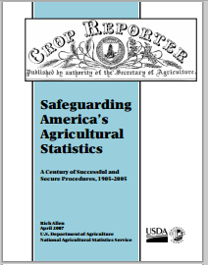

Source: [NASS: About Nass](http://www.nass.usda.gov/About_NASS/asb_historical.pdf)

## Excerpt From Chapter 1

The summary and release procedures for the USDA Bureau of Statistics’ reports in the early 1900s produced separate summary tabulations for each data source available (up to six sources, in some cases)... It is also relevant that the release time for cotton reports in those years was noon, Eastern Time, and that the commodity markets discontinued trading for an hour starting at noon on release days. The original procedures allowed the three people who had determined the final numbers to go about their business, or even leave the building if they wished, once a report’s contents had been set.

In 1904 there were rumors about insider trading. As came to light later, one of the three Bureau of Statistics people, E.S. Holmes, Jr., did have an outside partner, a NewYork cotton trader named Louis Van Riper. Shortly after an estimate was set, Holmes would meet Van Riper and tell him what cotton estimate was going to be published. Van Riper would take whatever market action would be most profitable based on the advance information.

The scheme came to light following the cotton acreage report issued on June 2, 1905. The three members met and adopted the state and national figures to be published. After Holmes had sent his signal, one of the other people who had worked on the report asked for reconsideration. After further review, the figures to be published were revised. At that point, the outside partner had already interpreted the original signal and proceeded to place trades. The scheme came to light when Van Riper charged in a telegram that a “fraudulent” report had been released. In explaining why he thought this was a false report, he unwittingly revealed that he had the information ahead of time. Evidently, Holmes’ outside partner had an overabundance of ego, but not a good balance of common sense in going public with his story. (Allen 2007)

# Hitorical Timeline of Report Release Times

Timing of report releases has important implications for the market reaction as well. Figure 2 below provides a brief history of report release times of major market sensitive reports.

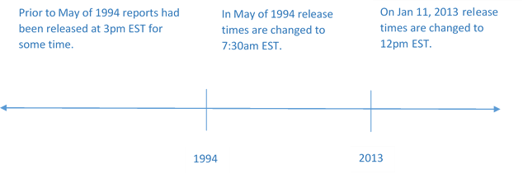

# Market Reactions to USDA Reports in Recent History

# References

Allen, R. 2007. *Safeguarding america’s agricultural statistics*. U.S. Department of Agriculture, National Agricultural Statistics Service.