Live Persona Card

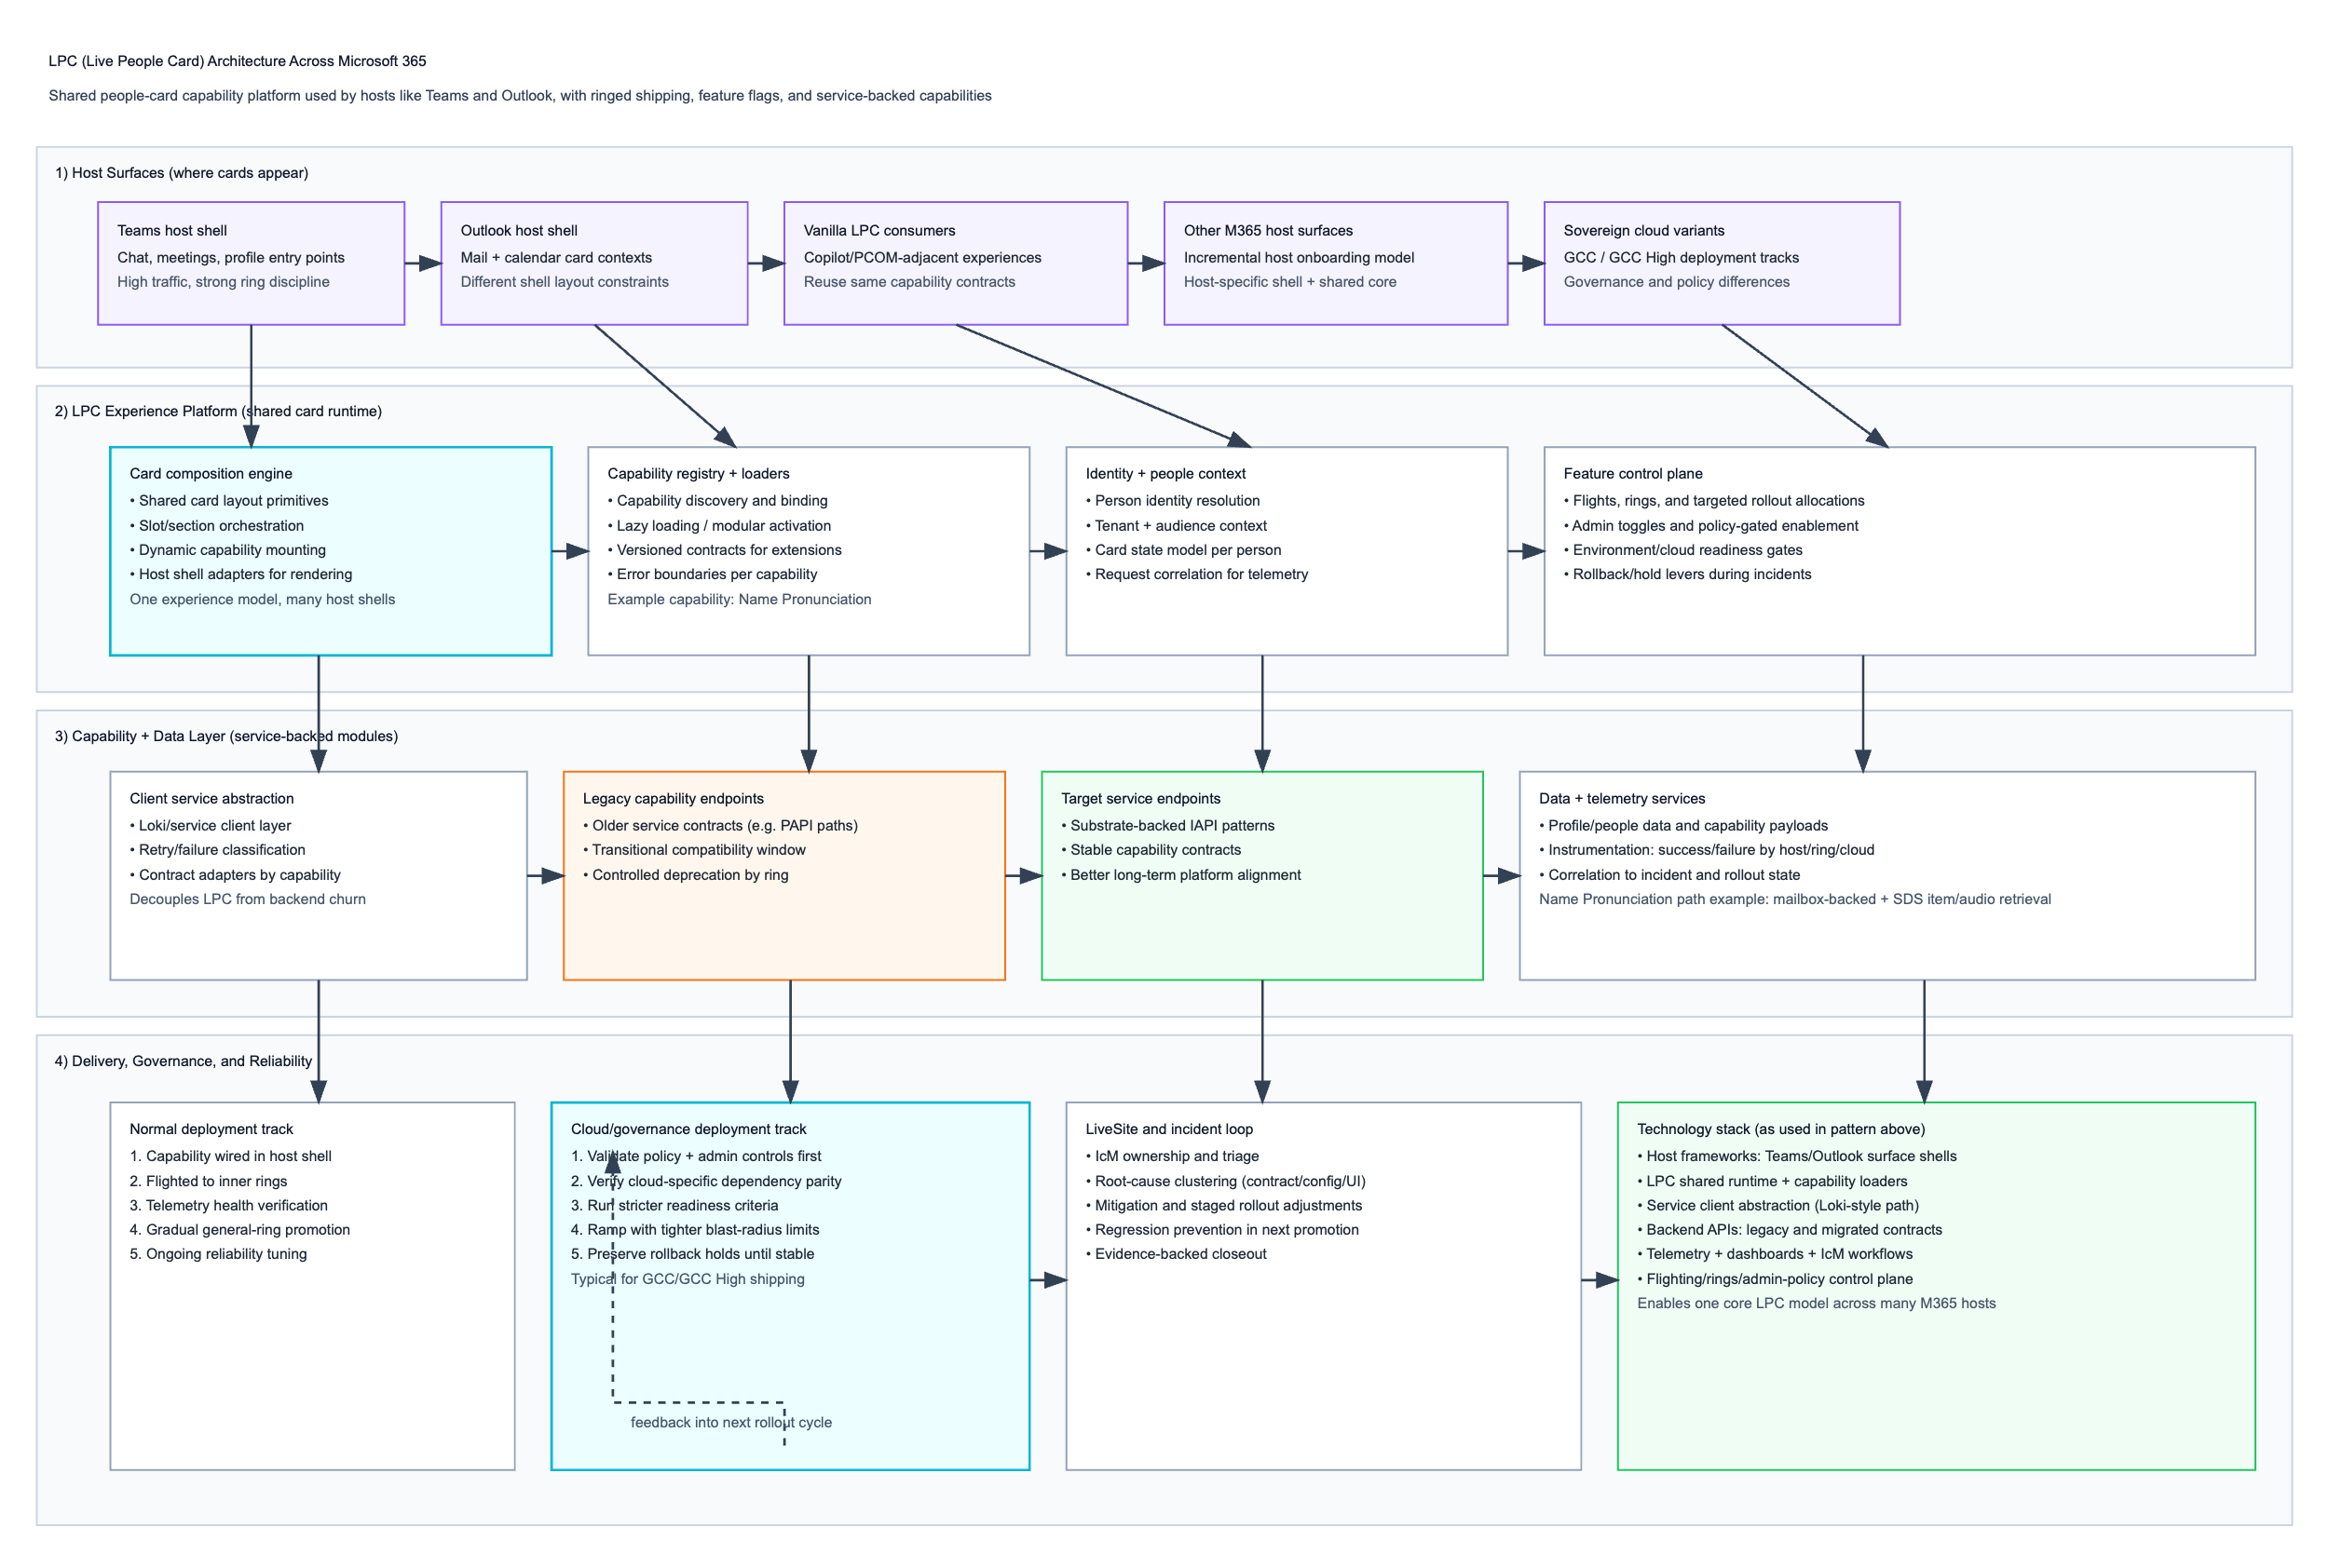

What LPC is LPC (Live People Card) is a shared people-profile experience platform used across Microsoft 365 hosts (for example Teams and Outlook). Instead of each host building separate “person card” logic, LPC provides a common runtime that renders person information and pluggable capabilities (like Name Pronunciation), while each host provides its own shell/container.
Think of LPC as: one core card platform + many host shells.

LPC architecture (logical model)
1) Host surface layer
Hosts trigger LPC from their native UI:
- Teams (chat, meetings, profile hovers/clicks)
- Outlook (mail/calendar people contexts)
- Other M365/Vanilla LPC consumers (including Copilot-adjacent surfaces)
Each host has different UX constraints (spacing, card anchoring, action layout, responsiveness), but delegates card capability logic to LPC.
2) LPC experience platform layer
This is the reusable core:
- Card composition engine: builds sections/slots of the card.
- Capability registry + loaders: discovers and mounts modular features (e.g., Name Pronunciation).
- Identity/context model: resolves person/tenant context and card state.
- Feature control hooks: evaluates flighting/admin/policy gates before enabling capabilities.
This layer is where consistency is enforced across surfaces.
3) Capability + data layer
Capabilities call backend services through a client abstraction:
- Service client path (Loki-style abstraction pattern from your context)
- Legacy endpoint support where needed (during migration windows)
- Target endpoint support (e.g., Substrate/IAPI-style paths)
- Capability data retrieval + response normalization
For Name Pronunciation specifically (from your earlier context): mailbox-backed data path, SDS item/audio retrieval semantics, and contract handling across migration versions.
4) Delivery/governance/reliability layer
LPC capability rollout is controlled by:
- Ring/flight rollout
- Admin toggles and policy controls
- Environment/cloud readiness checks
- Telemetry-driven promotion gates
- Incident (IcM) triage/mitigation loop
This is what makes LPC “live” and operable at M365 scale.

Technologies involved (as reflected by the pattern in this conversation)
At this level (without repo internals), the stack is best described as:
- Host frameworks: Teams/Outlook app shells embedding LPC experiences.
- Shared LPC runtime: modular card composition + capability loader system.
- Service client abstraction: common request path between LPC and backend APIs.
- Backend APIs: legacy + migrated capability endpoints (as seen in Name Pronunciation migration pattern).
- Data and identity services: person/context payloads and capability-specific data sources.
- Control plane: feature flags/flights/rings + admin/policy gates.
- Observability/operations: telemetry dashboards + IcM/LiveSite incident processes.

How LPC renders across different surfaces
LPC uses a two-part rendering contract:
- Shared core rendering
  - Capability layout logic, data states, and interactions are defined centrally.
  - Keeps feature semantics consistent (same capability behavior across hosts).
- Host shell adapter
  - Each host maps LPC output into its own UI container rules.
  - Handles host-specific constraints: card entry trigger, width/anchors, action-bar spacing, responsive breakpoints.
Why this pattern works
- Reuse: new capability once, available across many hosts.
- Safer shipping: one core behavior, host-specific presentation adjustments only.
- Faster expansion: onboard new surfaces by integrating adapter + control plane gates, not by rebuilding capability logic.

Shipping model across M365 (same pattern you used in Name Pronunciation)
- Wire capability into a host’s LPC adapter.
- Enable behind flights/rings and policy gates.
- Roll out to inner rings first.
- Validate telemetry + incident health.
- Promote progressively to broader rings/surfaces.
- Run separate governance track for sovereign clouds (GCC/GCC High) with stricter controls.
This is the operational pattern that lets LPC scale reliably across M365 without fragmenting into per-app implementations.

LPC is not just a UI component; it’s a feature distribution surface for M365. It lets you build a people-card capability once, then ship it repeatedly across Teams, Outlook, and other LPC hosts with controlled rollout, shared telemetry, and governance gating.
How LPC is used to ship features across M365
1) LPC as a platform, not a single app
LPC acts as a shared runtime + host adapter model:
- Shared runtime owns capability lifecycle: load, data binding, render states, errors, telemetry.
- Host adapters (Teams, Outlook, etc.) provide shell integration: entry points, layout constraints, host actions, and UX framing.
- Control plane (flights/rings/admin/policy) determines who sees what, where, and when.
So instead of “shipping feature X to Teams, then rebuilding for Outlook,” you ship capability X to LPC, then enable it per host via adapters and gates.

2) The feature shipping pipeline on LPC
Phase | What happens in LPC | Why it matters
Capability definition | Define contract (inputs, payload shape, UI states, fallback behavior) | Gives one canonical behavior across hosts
Runtime integration | Register capability in LPC loader/registry | Makes feature composable and discoverable
Host adapter hookup | Bind capability to Teams/Outlook host shells | Handles host-specific rendering and interaction differences
Control-plane wiring | Add flags/flights/rings/admin/policy checks | Enables safe staged exposure
Canary/inner ring rollout | Enable for small audiences first | Limits blast radius
Telemetry validation | Monitor success/fail, latency, missing-data patterns by host/ring | Detects regressions early
Incident loop | Triage IcMs, cluster failure modes, patch root causes | Stabilizes before expansion
Progressive promotion | Increase allocation and surface coverage | Drives scale safely
Cloud/governance track | Repeat with stricter controls for GCC/GCC High | Meets compliance and policy requirements
GA + sustain | Keep monitoring, tune, and deprecate legacy paths | Prevents drift and regressions

3) What LPC standardizes during shipping
When you use LPC as the shipping surface, these become centralized:
- Capability contract discipline
One definition for states like loading/available/not-available/error; shared handling of payload evolution.
- Cross-host behavior consistency
Same core feature semantics across Teams/Outlook, with only shell-specific visual adaptations.
- Rollout mechanics
Rings, flights, admin toggles, and policy gates are applied consistently per capability.
- Observability model
Host/ring/cloud segmented telemetry for confidence-based promotion decisions.
- Operational response
Shared incident vocabulary and triage flow (contract mismatch vs config drift vs host layout issue vs backend outage).

4) Why this is the preferred M365 shipping model
A) Speed to surface expansion
A new host can onboard faster because:
- Feature logic already exists in LPC capability form.
- Host work is mostly adapter + control-plane enablement + validation.
B) Lower duplication and fewer forks
Without LPC, each host implements and maintains its own variant. LPC avoids divergent code/behavior.
C) Safer migrations
Your Name Pronunciation pattern (legacy path to migrated path) is a textbook example:
- Keep one capability runtime.
- Evolve backend contract behind controlled rings.
- Validate per host before broad promotion.
D) Stronger governance posture
LPC’s gate-driven model naturally supports sovereign cloud and policy-sensitive rollouts.

5) Detailed mechanics of shipping a capability through LPC
A. Capability packaging
Each feature is treated as a pluggable module with:
- Identity/context requirements
- Data dependencies
- Render components
- Error/fallback policies
- Telemetry schema
B. Registration and discoverability
Capability is added to LPC’s loader/registry so hosts can mount it dynamically.
C. Host adapter mapping
Each host defines:
- Where the card appears (hover/click/profile entry points)
- Container constraints (width, action rows, responsive behavior)
- Host-specific interaction semantics
D. Release controls
Enablement is layered:
- Code path exists but hidden behind flags
- Ringed audience ramp (inner → broader)
- Admin/policy checks for tenant/cloud eligibility
E. Promotion gates
Feature is promoted only when metrics pass:
- Stability/error thresholds
- Host-specific UX quality
- Incident trend health
- Dependency readiness

6) Failure modes LPC helps isolate (and how)
Common shipping failures and LPC response pattern:
- Contract mismatch (client vs service)
Isolate at capability adapter, patch parser/mapper, hold ramp.
- Host shell UI regressions
Fix adapter/layout logic without forking core capability behavior.
- Tenant/environment config drift
Detect by ring/cloud segmentation; correct environment config before promotion.
- Backend migration instability
Keep dual-path compatibility during transition; remove legacy path only after evidence.
This is how LPC keeps failures local while preserving global feature momentum.

7) Cloud/governance deployments through LPC (vs normal)
In LPC terms, governance rollout adds stricter gate layers:
- Additional policy/admin prechecks
- Cloud-specific dependency parity validation
- Tighter promotion thresholds
- Slower, narrower ramp increments
- Longer hold periods before full promotion
So the same capability ships, but the promotion policy and evidence bar are stricter.

8) What this looked like in your Name Pronunciation workstream
Using LPC as shipping surface enabled you to:
- Integrate once as an LPC capability and reuse across hosts.
- Roll out through rings/flights instead of hard-cut.
- Manage PAPI → IAPI migration with compatibility staging.
- Catch and resolve host-specific UI and tenant/config issues without fragmenting core logic.
- Expand safely toward high-scale production usage and additional cloud tracks.
That is the core value proposition of LPC in M365: a reusable, governed, telemetry-driven feature delivery surface for people experiences at scale.

