Noise Triage Bench.

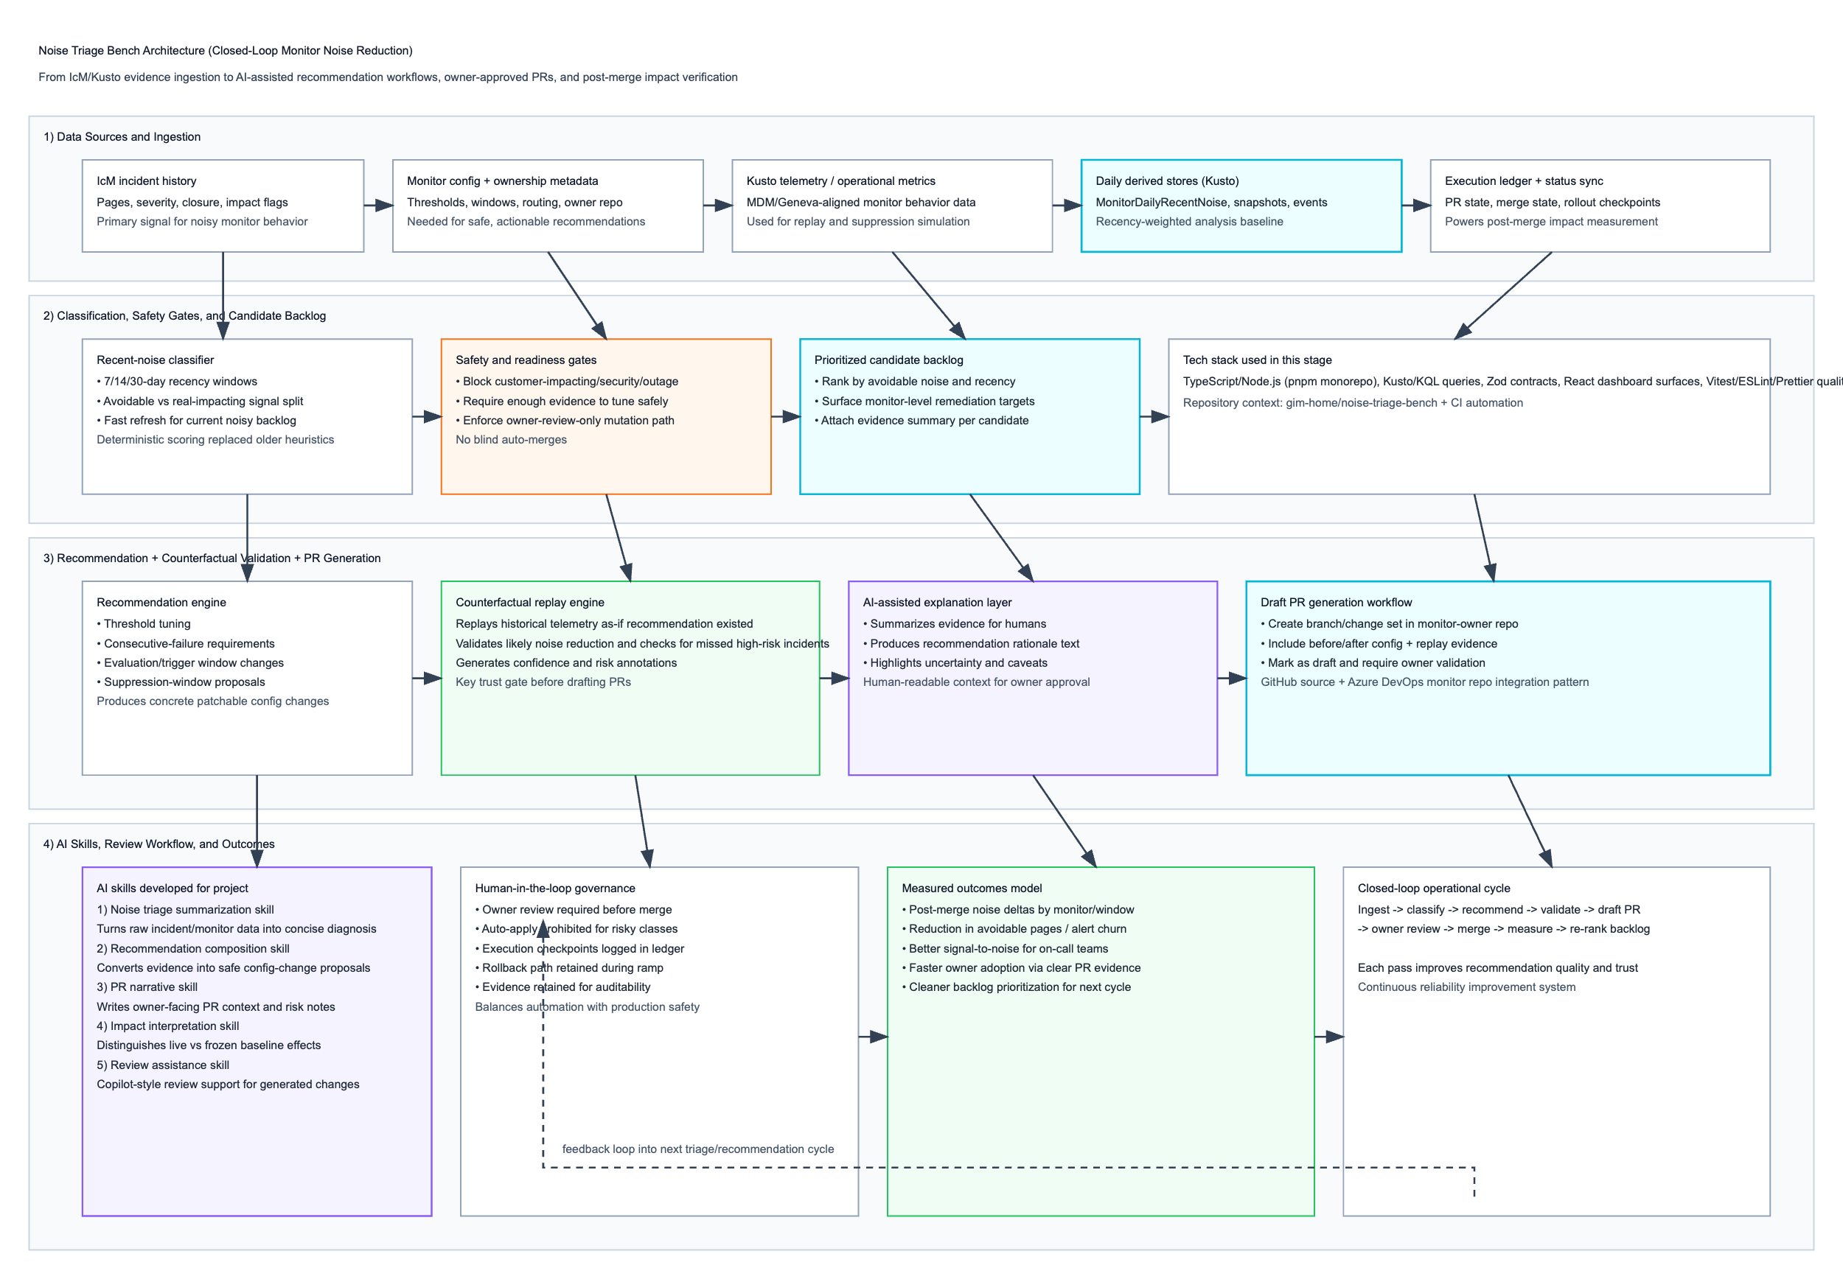

Noise Triage Bench: what the project was
Noise Triage Bench was a closed-loop monitor-noise remediation system: identify noisy monitors that generate avoidable incidents, recommend safe tuning changes, validate those changes against historical telemetry, generate owner-reviewable PRs, and then measure whether merged changes actually improved signal quality.
The goal was not “fewer alerts at any cost.” The goal was better signal-to-noise without suppressing real customer-impacting incidents.

Core problem the project addressed
Large monitor estates produce a lot of page volume, but much of that can be repetitive/non-actionable churn. That causes:
- On-call fatigue and slower response to true incidents
- Incident queues dominated by low-value noise
- Hard-to-prioritize monitor maintenance backlog
- Risky manual tuning done inconsistently across teams/repos
Noise Triage Bench created a systemized path from evidence -> recommendation -> safe change -> measured impact.

Architecture (deep detail)
1) Data Sources and Ingestion
Inputs came from several streams:
- IcM incident data: pages, severity, closure semantics, impact indicators
- Monitor configuration + ownership metadata: thresholds, windows, routes, owning repo/team
- Telemetry traces/metrics (Kusto/Geneva-aligned): behavior needed for replay
- Derived daily stores: recent-noise and snapshot tables for fast analysis
- Execution/PR ledgers: recommendation lifecycle, merge status, rollout checkpoints
This layer normalized disparate evidence into an analysis-ready model.

2) Classification + Safety Gating
The system then classified monitor behavior over recency windows (e.g., 7/14/30 day slices) to prioritize what’s noisy now, not just historically noisy.
Key design choice
It used a recency-weighted deterministic ranking model to avoid opaque scoring drift and make triage decisions explainable to owners.
Safety gates prevented bad automation
Before any recommendation advanced, gates blocked candidates associated with:
- Potential real customer impact
- Security-sensitive or outage-critical classes
- Insufficient evidence density for safe tuning
So the pipeline intentionally preferred “no recommendation” over unsafe recommendation.

3) Recommendation + Counterfactual Validation
For each eligible noisy monitor, the recommendation engine generated concrete config actions, such as:
- Threshold adjustments
- Consecutive-failure requirements
- Longer trigger/evaluation windows
- Suppression-window tuning
Then a counterfactual replay engine simulated historical behavior as if the proposed config had existed.
It answered:
- How much noise likely disappears?
- Would any high-risk/true-signal incidents have been missed?
- Is confidence high enough to draft a change?
This was the trust core of the system.

4) PR Generation + Owner Review Workflow
Validated recommendations became draft PRs (not auto-merged changes), including:
- Proposed config diff
- Evidence summary
- Replay impact/risk annotations
- Change rationale for reviewer context
Owners reviewed and approved changes in their own repos. This kept accountability with service owners while reducing their manual triage burden.

5) Post-merge Measurement (Closed loop)
After merge, Noise Triage Bench measured outcomes:
- Noise delta by monitor/window
- Avoidable page reduction
- Any regression in true-signal detection
- Net signal quality trend
Those outcomes fed the next cycle’s prioritization and recommendation tuning.

Technology stack (as used in this project pattern)
From your prior context, the stack was:
- Language/runtime: TypeScript/TSX + Node.js
- Workspace/tooling: pnpm monorepo
- Frontend/dashboard: React (with Vite-style modern frontend tooling pattern)
- Contracts/validation: Zod
- Analytics/query: Kusto/KQL (including IcM Data Warehouse and derived stores)
- Telemetry basis: Geneva/MDM-aligned data for replay and validation
- Quality gates: Vitest, TypeScript checks, ESLint, Prettier
- Automation/CI: GitHub Actions, Husky/lint-staged/commitlint, release tooling
- Repo ecosystem: GitHub source + integration path to Azure DevOps monitor repos for PR workflows
- Design/docs artifacts: Markdown specs, Mermaid/Excalidraw/HTML design artifacts

AI skills developed for the project
You built/used AI in a governed assistive mode, not a blind autopilot mode. The skills were essentially operational “copilots” in the workflow:
1) Noise triage summarization skill
- Converts raw incident and monitor evidence into concise diagnostic summaries
- Explains why a monitor is considered noisy right now
- Helps reviewers avoid scanning huge raw logs
2) Recommendation composition skill
- Proposes candidate tuning edits from structured evidence
- Produces rationale tied to observed patterns (e.g., repeated short-lived firing)
- Constrained by safety classes (won’t promote risky categories)
3) PR narrative skill
- Generates owner-facing draft PR descriptions
- Includes before/after behavior intent, replay evidence, and caveats
- Improves adoption by making machine suggestions understandable
4) Impact interpretation skill
- Interprets outcome metrics after merge
- Distinguishes baseline shifts vs real recommendation effect
- Clarifies “live” impact vs frozen/historical slices
5) AI-assisted review skill
- Supports code/config review of generated proposals
- Catches obvious inconsistencies before owner review
- Increases confidence without removing human approval controls

Governance model for AI usage (critical to trust)
Noise Triage Bench’s AI layer was structured with guardrails:
- Human-in-the-loop mandatory for merge decisions
- Evidence-first outputs (recommendations must cite observed behavior)
- Safety-gated candidate selection before AI narrative/recommendation steps
- Auditability via execution logs and replay artifacts
- No broad auto-mutation of monitor configurations in production paths
This design made AI practical for ops by pairing it with deterministic checks.

Implementation outcomes
Operational outcomes
- Reduction in avoidable/noisy pages on tuned monitors
- Better triage signal quality for on-call
- More consistent monitor tuning decisions across owners/repos
- Faster conversion from “known noisy monitor” -> “actionable PR”
Process outcomes
- Replaced ad-hoc tuning with a reproducible pipeline
- Improved owner trust through explainable recommendations + replay evidence
- Created measurable feedback loop instead of one-off cleanups
Platform outcomes
- Established reusable architecture for future reliability optimization workflows
- Demonstrated how AI-assisted ops can be governed safely at scale

Your contribution arc (from the context we discussed)
Your involvement appears strongest in:
- Driving recommendation/impact workflow improvements
- Clarifying live-vs-frozen impact interpretation
- Helping shape owner-reviewed PR generation and safer tuning flow
- Contributing implementation changes and review rigor in the bench ecosystem
So the project impact was both technical and operational: you helped turn noisy-monitor cleanup from reactive manual effort into a repeatable, evidence-backed engineering system.

Deep Dive on the Mono Repo and the AI skills

1) Repo organization (monorepo model)
Noise Triage Bench was effectively a pnpm TypeScript monorepo with clear separation between ingestion, decisioning, recommendation, and delivery.
A representative layout (matching the architecture and stack we discussed) looks like:

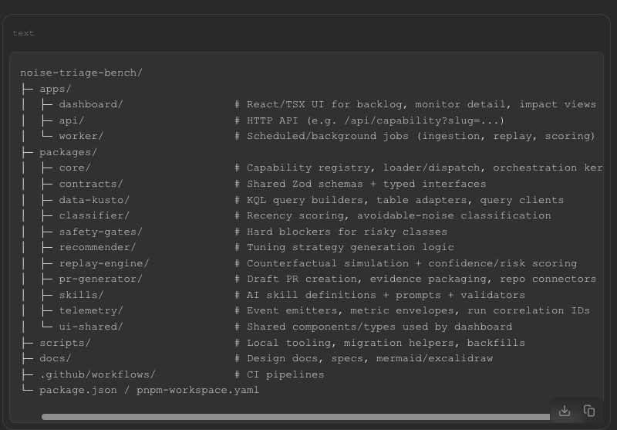

Why this structure worked
- core/contracts gave consistent dispatch + type safety.
- classifier/safety/recommender/replay separated “should we tune?” from “how to tune?”.
- skills stayed modular so AI behavior could evolve without destabilizing scoring/replay logic.
- api + worker split kept interactive UX fast while heavy jobs ran asynchronously.

2) How AI skills were written
The skills were typically written as schema-first, evidence-grounded modules (not free-form prompts).
Each skill generally had:
- Metadata
  - slug, version, owner, execution mode, supported actions
- Input schema (Zod)
  - monitor IDs, date windows, required evidence handles, risk class
- Prompt assembly
  - deterministic evidence blocks injected into controlled prompt templates
- Tool adapters
  - Kusto evidence fetchers, monitor config readers, replay outputs, PR context formatters
- Output schema (Zod)
  - strict shape for recommendation, rationale, caveats, confidence
- Policy validators
  - reject output if safety constraints violated or evidence missing
Conceptual module shape:

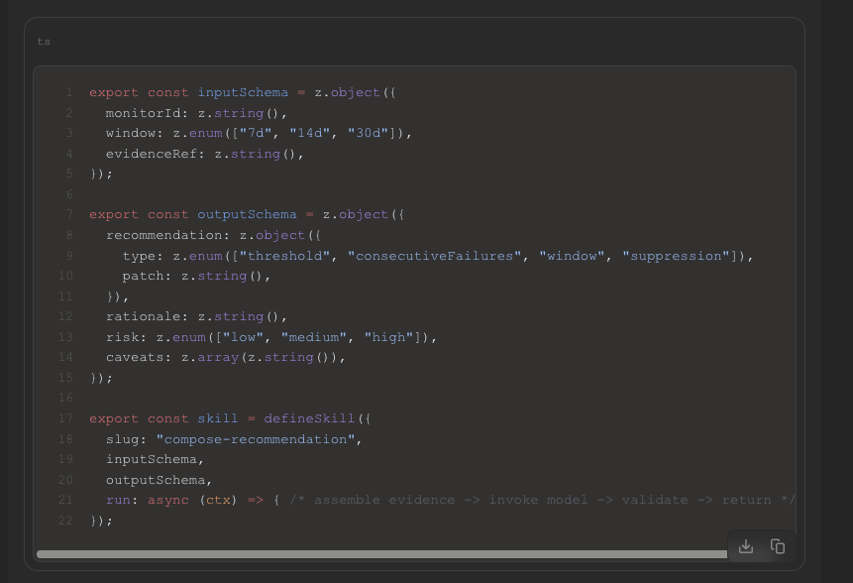

3) Pattern used to write the skills
The project used a strong deterministic-first, AI-second pattern:
- Compute hard facts first (KQL aggregates, incident stats, config snapshot).
- Run safety gates first (customer-impact/security/outage blockers).
- Generate candidate actions deterministically (bounded action space).
- Use AI for synthesis/explanation (why this action, expected effect, caveats).
- Validate AI output against schema + policy.
- Replay/simulate before drafting PR.
- Human owner review required before merge.
So AI was used where it adds value (reasoning/narrative/decision support), while deterministic components protected safety-critical behavior.

4) How skills integrated into the system
Integration was done through a capability registry + dispatch endpoint pattern (consistent with the /api/capability?slug=... style you referenced).
Integration flow
- Skill is registered in packages/core registry.
- API receives request with slug + payload.
- Core dispatcher resolves skill handler + validates input schema.
- Handler pulls evidence (Kusto + config + prior executions).
- Safety gate middleware runs.
- Skill executes (prompt/tool chain), output validated by schema.
- Replay engine evaluates proposal impact/risk.
- PR generator formats branch + draft PR with evidence.
- Execution event persisted for audit/impact tracking.
Operational integration points
- Dashboard: triggers runs, inspects evidence, compares outcomes.
- Worker jobs: scheduled backlog scoring and batched recommendation runs.
- PR systems: connector layer to create draft PRs in owner repos.
- Telemetry: per-run correlation IDs across ingest -> recommend -> replay -> PR lifecycle.

5) AI skills you likely had in this repo (mapped to architecture)
- Triage Summary Skill: converts noisy monitor evidence into concise diagnosis.
- Recommendation Composer Skill: proposes bounded config changes.
- PR Narrative Skill: writes owner-facing rationale and risk notes.
- Impact Interpreter Skill: explains post-merge deltas vs baseline.
- Review Assistant Skill: highlights suspicious recommendation edges before owner approval.
Each skill was pipeline-aware (consuming artifacts from prior stages) rather than standalone chat logic.

6) Practical engineering conventions that made this maintainable
- Versioned skill slugs (skill@vN) for safe rollout.
- Feature flags for skill behavior changes.
- Prompt templates in source control with tests.
- Golden-test fixtures for schema outputs.
- “Fail closed” behavior when evidence is incomplete.
- Explicit provenance in PR bodies (which run/evidence produced this suggestion).

7) Net effect of this design
This repo/skill architecture enabled:
- Reliable scaling of recommendations without unsafe automation.
- Faster owner adoption (clearer PR context, less manual analysis).
- Better repeatability (same evidence path, same gates, same output contracts).
- Continuous improvement loop from measured outcomes back into future ranking/recommendation quality.

Deep Dive into the AI Skills used in the Noise Traige Bench project

the core is that skills are treated as typed, versioned execution units, and the repo routes to them through a registry + dispatcher + stage policy.
That is how the system consistently calls the right skill, with guardrails, instead of ad-hoc prompt calls.
1) What each skill’s role is in the Noise Triage Bench pipeline
In this project shape, skills are usually aligned to pipeline stages:
Skill role | Primary job | Input artifact(s) | Output artifact(s)
Triage Summary | Turn raw monitor + incident evidence into a concise diagnosis | Incident slices, recency stats, monitor metadata | Structured diagnosis, suspected noise mode, confidence
Recommendation Composer | Propose bounded config changes | Diagnosis + current monitor config + policy constraints | Candidate change set (threshold/window/suppression/etc.)
Replay Analyst | Explain counterfactual replay results in human terms | Replay deltas, risk markers, misses/catches | Risk narrative, confidence bands, “safe to draft” decision
PR Narrative Writer | Produce owner-facing draft PR context | Final candidate patch + replay evidence | PR title/body/checklist/risk notes
Impact Interpreter | Explain post-merge effect vs baseline | Before/after windows, adoption/merge data | Outcome summary (noise reduced, risk unchanged/increased, caveats)
Review Guardrail Assistant | Catch suspicious recommendations before owner review | Proposed patch + policy set + known anti-patterns | Block/warn/allow annotations
So skills are not “random AI helpers”; each one has a narrow contract in the closed loop.

2) What a skill contains (internally)
A production skill module usually contains seven parts:
- Manifest/identity
  - slug (e.g., recommendation-composer)
  - version (e.g., v3)
  - stage (triage, recommend, replay, pr, impact)
  - owner, runtime, timeouts, cost budget
- Typed input schema (Zod)
  - Required IDs, time windows, evidence refs, policy mode, correlation ID.
- Prompt template bundle
  - System instructions
  - Task instructions
  - Evidence sections
  - Output format instructions
  - Refusal/uncertainty behavior rules
- Tool adapters
  - Kusto query fetchers
  - Config readers
  - Replay result readers
  - Repo/PR metadata readers
- Output schema (Zod)
  - Strict JSON shape for recommendation/rationale/risk.
- Policy validators
  - “Block if customer-impact class”
  - “Reject if insufficient evidence”
  - “Reject if action type not in allow-list”
- Telemetry hooks
  - Start/end events, token usage, latency, validation failures, final disposition.

3) How the repo knows which skill to call
Usually via stage-aware routing, not model intuition.
A. Registry
At startup, repo builds a registry map like:
- stage + intent + policy -> skill slug@version
- Example:
  - recommend + monitor-noise + strict -> recommendation-composer@v3
  - pr + draft -> pr-narrative@v2
B. Dispatcher
API/worker sends a request:
- POST /api/capability?slug=... (or equivalent internal dispatch call)
- Includes payload, run mode, policy profile.
Dispatcher then:
- Resolves slug/version from registry.
- Validates input schema.
- Executes preflight gates.
- Calls skill runner.
- Validates output schema.
- Applies post-policy checks.
- Persists artifacts + emits events.
C. Policy overlay
Even if a route resolves, policy can override:
- force stricter version
- deny execution in certain contexts
- require human checkpoint before next stage
So “right skill” = router decision + policy decision, not just slug lookup.

4) Execution lifecycle (step-by-step)
- Trigger
  - Scheduled worker run, dashboard action, or API call.
- Plan building
  - Build run DAG: triage -> recommend -> replay -> PR.
- Stage dispatch
  - For each stage, resolve skill from registry.
- Evidence assembly
  - Pull KQL outputs + config snapshot + prior stage artifacts.
- Skill execution
  - Render prompt + call model + parse raw output.
- Validation
  - JSON/schema validation, domain invariants, safety policies.
- Decision
  - allow, warn, block, or needs-human.
- Artifact persistence
  - Save stage result with correlation IDs and hashes.
- Handoff
  - Next stage consumes prior artifact by ID, not by free text.
- Terminal action
- Generate draft PR or stop with explainable block reason.

5) Pattern used to author skills (important)
The strongest pattern is:
Deterministic-first -> AI synthesis -> deterministic validation.
That means:
- Facts are computed by code (KQL, scoring, replay).
- AI explains/proposes within bounded action space.
- Code validates and can reject AI output.
This is why the system is reliable in operations: AI is powerful, but never sole authority.

6) How “right skill” selection is usually encoded
Common routing keys:
- pipelineStage
- signalClass (noise, outage-adjacent, security-adjacent)
- riskTier
- cloud/environment
- featureFlag cohort
- skillVersion policy
Example selection logic:
- If riskTier=high -> route to conservative recommender variant.
- If cloud=governed -> stricter PR narrative/guardrail skill variant.
- If evidenceDensity < threshold -> skip recommender, run “insufficient evidence” explainer skill.

7) What’s inside the prompt/context payload
For these skills, payloads are usually structured blocks, e.g.:
- monitor profile
- recent incident distribution (7/14/30)
- current threshold/window config
- owner/team metadata
- replay summary table
- blocked classes list
- allowed mutation types list
- output schema contract
This prevents prompt drift and keeps outputs machine-consumable.

8) Versioning and rollout of skills themselves
Skills are usually released like code:
- slug@v1, slug@v2, slug@v3
- canary percent routing (small percentage to new version)
- A/B compare outputs on same evidence
- promote only when quality/safety metrics improve
So the skill layer has its own ringed rollout model, similar to product features.

9) Failure handling model
When a skill fails:
- Schema fail -> retry with strict formatter once, else block.
- Policy fail -> hard stop and annotate reason.
- Tool/evidence fail -> mark run incomplete; no PR generation.
- Low confidence -> downgrade to “human review required.”
Critically, it fails closed for risky actions.

10) Testing pattern for skills
Typical suite:
- Schema tests (valid/invalid payloads)
- Prompt contract tests (required sections present)
- Golden output tests (stable artifacts for known fixtures)
- Policy tests (blocked scenarios actually blocked)
- Replay linkage tests (recommendation uses correct replay artifact)
- End-to-end DAG test (triage -> PR path with synthetic evidence)
This is what keeps skill behavior predictable across updates.

11) Why this architecture works for Noise Triage Bench
Because it converts AI from “chat output” into governed pipeline components:
- typed inputs/outputs,
- deterministic evidence,
- strict routing,
- policy enforcement,
- measurable outcomes.
That combination is what let the repo safely integrate skills into operational monitor tuning rather than treating AI as an unbounded decision-maker.

