Ian Montgomery
ISTA 352
HW3
- Translation matrix 1
translation matrix 2
translation matrix 3
translation matrix 4
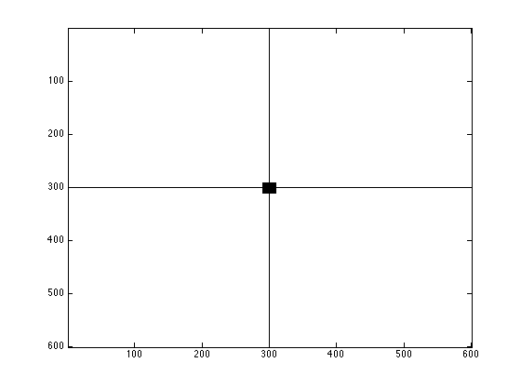
- See matlab code for exact computation*
I use the translation matrix of to adjust the coordinate system to the center of image. Using this we can make axises that go through the center of the image as well as a block in the center. As seen in image:Then, using this matrix, we can plot boxes around the points described by the provided matrix. To produce the image
in the center. As seen in image:Then, using this matrix, we can plot boxes around the points described by the provided matrix. To produce the image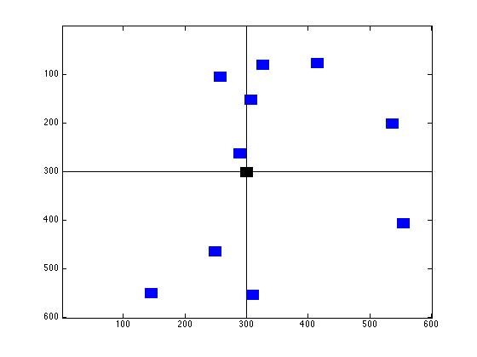
- The matrix that will scale the X value to 3/5 and the Y value to 5/4 is
as such, the top row represents to x vector, and the middle represents the y vector.
Next, to rotate these blacks by 30 degrees, we use the matrix which should be the representation of .
Finally the matrix that translates everything by (100,-200) is which produces the image:
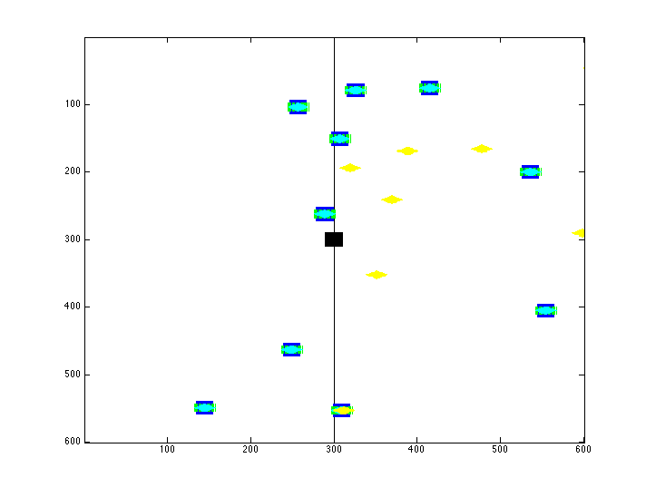
- This took some thinking, but I think I have it. If the logic that the top vector controls the x vector, the second row controls the y vector, and the third would control the z. So we should get something that looks similar to the previous . So working with this, the second row is a translation if sine and cosine in relation to the y axis. So knowing this, we should get . which produces an image of

 
 

