The World of Urld.
World and Story

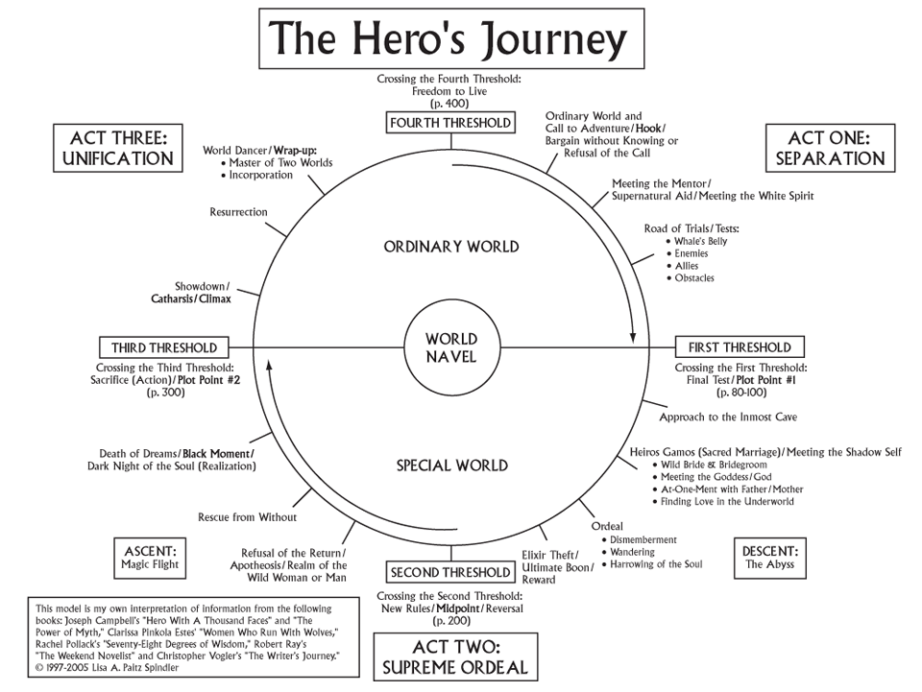

Campbells Hero's Story

Table of Contents
The World of Urld. 1
Gameworld Defenition. 3
- MetaWorld: 3
Gods & Magic 3
Pantheon of Gods 3
Elemental Structures 3
Fauna; Creatures & Animals 3
Flora; Plant & Trees 3
- GameWorld: 4
Nations 4
Characters & People 6
Hierarchy; Classes & Status 6
Organisations; Guilds, Groups & Regilions 6
Jobs; Commoners, Rulers & Hero's 6
Abilities; Skills & Attributes 6
Story Idea: 7
Summary: 7
WorldsNavel: 9
Acts Scetch 9
Act 1. Seperation. 11
1.0. GameStart "First Treshold" 11
1.1. Meeting Mentor 11
1.2. Road of Trials 11
Act 2. First Ordeal 12
2.0. 1st Threshold: Final Test (PlotPoint #1) 12
2.1. Approach to Inmost Cave 12
2.2. Meeting shadow self 12
2.3. Ordeal 12
2.4. Elixer Theft (Ultimate Boon) 12
Act 3. Supreme Ordeal 13
3.0. 2nd Threshold: New Rules, MidPoint 13
3.1. Real of the Wild 13
3.2. Rescue from without 13
3.3. Black Moment (Realization) 13
Act 4. Unification 14
4.0. 3th Threshold: Sacrifice (PlotPoint #2) 14
4.1. Showdown / Climax 14
4.2. Master of TwoWorlds 14
Act 5. Freedom 15
5.0. 4th Threshold 15
5.1. Incorporation 15

Gameworld Defenition.

Gameplay:
You are a townmember of one of four nations.
You grow up with your own Culture
Through the Guild in your town, you start exploring your Country

You meet someone from another Race for first time, and become Friends
You get drawn into wartime through your guild&nation
You explore the world, and meet other Country's
Whilest exploring you learn new Skills based on the Nations
Meanwhile you learn bits and pieces from Orange & the World (about OrangeNation & History)

Wartime get heavy, and someone you love get threatened/killed
Fueled by anger you commit (minor) warCrimes
You are confronted with your ShadowSelf
You Start your Redemption Quest

You unravel the Truth about the Start of the War
You confront your own Nation about the WarCrimes committed
You start the Change towards better tomorrow
You learn more about History and Cultural differences and the start of Creation

You are confronted by the Order of Chaos, you get hints of a sinister plan
You bring fight to the leaders of Order of Chaos, you understand the Sinisterplan
You are confronted/ you seek out the God Of Chaos, you get Guidence from Chaos
You confront the Beast/Entity/ThingemaWhatsit

- MetaWorld:

Gods & Magic
6 gods (hidden 7th)

4 Gods of Elements (Mage)
- Earth (& ? Body) Name of God "", Alignment
- Air (& Lightning) Name of God "", Alignment
- Water (& Frost) Name of God "", Alignment
- Fire (& ? Mind) Name of God "", Alignment
2 Gods of LifeCycle (Priests)
- Live Name of God "", Alignment
- Death Name of God "", Alignment
1 God of Chaos (Warlock)
Name of God "", Alignment

Pantheon of Gods
Live and Death came, and started the "SpaceTime"
The elements came, and created the "Elements"
The 6 created the "Creation"
The 7th came, and touched the creation starting "Life"
Life began on the creation, and for years it stayed

With the touch of chaos, Life started, but the perfect balance of the 6 was broken.
a? Part of the creation did not want to be "Reborn" and so the Creation starting crumbeling
b? His counterpart was born, Reaction. He was completed, Action -> Reaction

The 6 did not know, or did not care about the crumbeling of creation
the 7th tried to fix it without letting the 6 know, and started the Cult of Chaos
the Cult of Chaos should be fixated on "Purifying the Demented or Evil Chaos" aka Restoring the part of creation that refused to be "Reborn"

but without a steady guidance of the God of Chaos (duh its chaos) the Member of the Order where much more interesting in keeping their lives and powers (something Chaos will never understand, he wants change and unsteadyness. Life and Powers are fun for a while, but they have to change, keeping one life and one job and one set of powers is useless)

A new found order arose, with incorrect interpretations of the "Word of Chaos" (wich there where many of, most of which directly conflicted another, and some didnt even make sense)
They learned the way of Chaos, and used it for the Sake of Chaos (instead of repairing the Creation)

Order of Chaos envisions a "Iluminatie"-kind of PowerGrab, with people in High status places, manipulation the populace for their own Agenda.
They start a Ritual? Or They make something that needs "Power", Misinterpretation of the Repairing of the Creation?
This starts the division between People.
? Experiment gone wrong? Punishment from gods/ chaos?

Elemental Structures

Start of Creation:
- Gods came together: why?
- Gods made creation: why&how?
- 7th God started "Time": why(?)
- start Creation -> start Game: what, why & how? (Myth-Prehistory-History-Yesterday)
4.1. Color of the People: why&how?
4.2. Start of first rivalry between People (except only "Chaos for Chaos-sake")

World and Map
World is NOT devided by nation color, does exits out of A big island of GreenNation, and mainLand.
Terrain types, Grass&Meadows, Beach&Desert, Sea&Rivers, Dirt&Pavement, Rock&Mountains
"Normal world" where Flora&Fauna is based on Evolution (no "Fire"-animals in "Fire"lands only, but logical migrations and evolve to needs)

Fauna; Creatures & Animals

Flora; Plant & Trees

- GameWorld:

Nations
- 4 Nations, 4 Colors, Green,Orange,Red&Blue
Silent Racewar masked as .. religious(?) feud(?) war
Location & Towns
Church/Temples: Neutral location for Learning/Practice & Healing/Mourning Mages Training)
Village Center: MarketPlaces, TownScaffold (Announcements & Trials), QuestLocation
Inn/Pubs: Sleep, eat & QuestLocation (Rogue Training)
VillageHall: local Earl/Leader, townppl in need Questlocation

Military Encampements: For ongoing wars,(Figher Training)

Green Nation:
Summary | Name | ?
Summary | Magic: | Earth
Summary | Ruler: | Name?
Summary | Alignment: | Lawfull/neutral Good
Summary | Enemies: | Red Nation
[KnowWorld]
[1st Treshold]
[2nd Treshold]
[3th Treshold]
[4th Treshold]
[FinalWorld]

Orange Nation:
Summary | Name: | ?
Summary | Magic: | Air
Summary | Ruler: | Name?
Summary | Alignment: | Neutral
[KnowWorld] | Unkown
[1st Treshold]
[2nd Treshold]
[3th Treshold]
[4th Treshold]
[FinalWorld]

Blue Nation:
Summary | Name: | ?
Summary | Magic: | Water
Summary | Ruler: | Name?
Summary | Alignment: | Neutral
[KnowWorld] | Unkown
[1st Treshold]
[2nd Treshold]
[3th Treshold]
[4th Treshold]
[FinalWorld]

Red Nation:
Summary | Name:
Summary | Magic: | Fire
Summary | Ruler: | Name?
Summary | Alignment: | Neutral/Chaotic Evil
Summary | Enemies: | Green Nation
[KnowWorld]
[1st Treshold]
[2nd Treshold]
[3th Treshold]
[4th Treshold]
[FinalWorld]

The Player
Player start at birth, in a family with the choosen Class/Status
Parent, Siblings, Pet?
Pet of OrangeNation inheritence?
Meets Orange
Learns the Skills based on the Nation
?Becomes a "Sage" skilled at all kinds of techniques of all nations
?Start the "SagesGuild" Guild to learn skills from other nations, Aimed to "Repair"/"Stabelize" the Creation

Characters & People

Hierarchy; Classes & Status

Organisations; Guilds, Groups & Regilions

Jobs; Commoners, Rulers & Hero's

Abilities; Skills & Attributes

Story Idea:

Summary:
4 Nations at war one nation destroyed
All Nations are closed off for longest of time, Townpeople come to accept heavy patrols & closed town borders as normal day-to-day.
TownPeople largely forgot/choose to forget/purposly ignore exsistance of OtherNations

Player is of one nations
Player grows up in Protective bubble; No other nations, and no Other rule than own Nation
Player get pet at young age?
Player Learn the way of his people and trains in art of Combat/Magic/Stealth
Player joins/is accepted within new and higher ranks
Town has needs, and Guild is created to help with needs.
Player helps his Guild and by doing so helps his town
When Town needs are mostly met/ Player outranks the day-to-day Tasks;
Player is rewarded with Promotion to "FreeRoam/Freebird"-status, meaning he can travel freely
Player is introduced to the Lord of Green Nation (with guild / "Knighting ceremony " / approval of Promotion?)

First real Task from guild; "?" -> help out a neighboring town
On his way to the other Town, he meets Orange.

?Nice introduction to Orange?
Pet is hurt and Orange knows treatment? Pet is of OrangeNations Inheritence?
?backStory:?
Orange is one of few survivors of OrangeNation after destruction
Grand-Child or Grand-Grand(etc)-Child of people whom fought the last Orange War (and subsequentially OrangeNations destruction)
?reason to be "here": (in the path of the player)?
..
?reason to follow/Help player (Reason why player/orange do not mistrust)?
..
?Hidden reason to help/ alterior motives?
..
?Reason to like Orange / Accept their new found friendship?
..
?Key difference between Orange & Player / Background&Cultural difference(first suspision)?
..

Orange decides to help Player / Follow player
Orange does not enter the neighbor Town, second suspision of Player of Difference between them(orange and player/own nation)

With help of Orange, Player manages to help the Town, meet the TownElder & Have some time fucking about?
Meanwhile Orange is busy with "?"

Orange & Player have a moment together where they realize their combined strenght
Both drop their gaurd more, and start to begin good friendship
?This is shown & grown during NeighborTown Quest?

After Neighbor town is saved & Player got reward, its time to head home.
Orange decides to keep following Player (?reason?)

Once home Orange once again stays out of TownLimits (Player feels comfortable to ask why?)
?Orange Reaction to question?

Player is Summoned at Guild; War has been declared! First real notition of other nations
Nation Green and Red are at openwar, All guild assemble to prepare for wartime
"Start of the decent into abyss"

keypoints;
?1 Help own town, -> first attack by Red "I dont want to kill you"?
?2 Join the defensive line -> defend against Red "Dont make me kill you"?
  - Meeting Blue Nation for first time
  - Getting Trusted? Getting Hated? By Blue nation

?3 First skirmish -> first time attacking Red "I have to kill you"?
  - Hold of Red army seems to be unstoppable, Blue Nation is in dire Need

?4 First assault/ battle -> first bigger scale "I need to kill you"?
  - Big battle happens to close to home town?

?? 5 First Raid -> first time searching for Reds "I WANT to kill you"?
a. Hometown destroyed -> revenge? b. Hometown defended -> other reason?

Orange side of KeyPoints?

"Act 3"
GreenNation shows ulgy side
Slow boiling of questions and conflict in Player
GreenNation order something inhumane? Does something to question Allignment
Players World is Set upside down, RULES CHANGE
Player enter the deepest black stage
"Act 3"

"Act 4"
Sacrifice? Player needs to ammend? Start the Change?

Confrontation with GreenNation?
Reveal of Cult in Shadows? Altermotive? God of Chaos?

Starting the Cleaning & unifying the lands

"Act 5"
Divine intervention? Rising from man to myth?
Explanation of Gods? Ammendment? Confrontation of Chaos?
Final showdown? BossBattle?

"The creation was a still frame, a beautifull picture with the finest details, but without the "spark", without Life or "Freewill" as you call it. Everything was there but it was boring and too much though-out. Beautifull but bland, Genious but Lacking. So I touched it, and behold the "Spark", the chaos that ensueded will last till the end of Creation. And it was by that "Spark of Chaos" that Flora and Fauna started to battle eachother till the end of times. The still became a moving entity with dreams, hopes, feelings, entrigue. So to ask me to stop my heinous crimes would be the same as asking the gods to disassemble the creation. And be thankfull that I'm so reasonable, my brother would have lost it by now."
~ The God of Chaos, to unkown hero of that time called LePlayer

Final message?
"RGB screen? World zooms out to show the Whole RGB screen? All pixel in a greater world, and although we are not perfect. We shed the blood of our brothers and sister, and although the dead in the name of purification, religion or inheretence, will never rise to see a better day. We remaining pixels should learn and grown to see a bigger picture. And keep working to achieve that bigger picture and by doing so, build a everlasting memorial to the dead"

"Chaos is the Start of our life, without it we wouldnt exist. But that does not mean that chaos should be free, and we as a species/ as a lifeform should always fight the evil inherited in chaos. A fight without swords, daggers or spells, but a fight of fear, prejudice, intolerance. A fight of the mind. One of the hardest of fights"
?

WorldsNavel:

4Layer: Warbetween Nation
3Layer: Race War
2Layer: Conflict of the Gods
1Layer: Start of Creation

Layer4. "War between Nations"
What: War between the 3 Nations.
Why: Over Dispute/Feud/Religion?
OurRole: Defend your HomeNation, Learn through Guild
OurView: Our Nation done nothing wrong
SideQuests: Tasks for people & small things

Layer3. "Race war and Racism"
What: Underlying RaceWar between 4 Nations with 1being "Destroyed" as a Result
Why: Unkown = Fear? Cultural Difference? Old Feud?
OurRole: Exploring bigger Picture of War & Race
Creating Harmony? Or Creating Diversity? Fixing or Destroying?
OurView: Biased to GreenNation, HomeNation?
Or Biased to Harmony
or free choice?

Layer2. "Conflict of Believe"
What: Start point of Divide; One people became 4different colored people
Land & Believes Divided
Why: Misconception? Setup by GodofChaos? Violation of Trust/ Pact?
Chaos found out Creation is Crumbling, and start Order of Chaos to repair?
OurRole: Exploring Bigger Picture? Bringing light to misconceptions?
Or Finding & Challenging Chaos?
Finding MythicDawn-Like Cult underneath?
OurView: "Lets stop the End of the World" or "Bring Harmony to Land"?
Or "Lets help the evil fucker fuck everything?"

Layer1. "Start of Creation"
What: Arrival of the Gods (reason?), Start of the First Elements (reason?) -> Creating the God-Pact "Once all 6gods aligned they created matter and stills, then the 7th touched their creation and a never ending chaos ensued"

Acts Scetch

# Act 1. Introduction to Game & ClassChoice
- Player had normal childhood.
based on Class? Choose Class in Story (fallout3style)

Fighter; parent are Nobels (Rich)
Mage; parent are Druids/Priest (Middle)
Rogue; parent are fletchers/crafmen (Poor)

- Player get Intro & Tutorial based on Class

Meeting OrangeNation Girl/Boy (friend/ love-interest?)
first glimpse into first Treshold (Orange Nation Destroyed, More to the war then .. Feud/Politics/Religion)

- War between Green – Red as PlotPoint 1?
- Forbidden friendship as PlotPoint 1?
- Completion of Training as PlotPoint 1?
Call to Adventure?

# Act 2
a. being send to war?
b. eloping with Friend?
c. other?

First real Obstacle/Problem
Start of Decent into Abyss

Introduction to BlueNation

First obstalce overcome

# Act 3
Green nations Mask falls off, Reveal of Ongoing RaceWar

First Real Introduction to RedNation
Friend Dies or Leaves?

# Act 4
Showdown:
a. Green Nations Evil ways must be stopped?
b. God of Chaos is confronted?

# Act 5.
Resolve:
a. World is restored?
b. Nations life together?
c. Other Nation are destroyed?
?

Act 1. Seperation.

1.0. GameStart "First Treshold"
Introduction to World -> Introduction to Village -> introduction to Parents
"Player is born as selected gender (?) in the selected Class (?)"
    - The LowerClass: Rogues
    - The MiddleClass: Mages
    - The UpperClass: Warriors

1.1. Meeting Mentor

1.2. Road of Trials

Act 2. First Ordeal

2.0. 1st Threshold: Final Test (PlotPoint #1)

2.1. Approach to Inmost Cave

2.2. Meeting shadow self

2.3. Ordeal

2.4. Elixer Theft (Ultimate Boon)

Act 3. Supreme Ordeal

3.0. 2nd Threshold: New Rules, MidPoint

3.1. Real of the Wild

3.2. Rescue from without

3.3. Black Moment (Realization)

Act 4. Unification

4.0. 3th Threshold: Sacrifice (PlotPoint #2)

4.1. Showdown / Climax

4.2. Master of TwoWorlds

Act 5. Freedom

5.0. 4th Threshold

5.1. Incorporation

