**VBA_Stocks_Analysis**

In our earlier work for Steve we prepared an analysis of stocks, such that he was able to help his parents make a more informed decision about how to invest their money. Steve has asked us to prepare a workbook for him similar to the previous, but optimized in a way that it can handle more stock data, with greater efficiency of run-time. For this work we have refactored our previous project to be more efficient for Steve’s evolving need.

**Summary of project scope**

**Scope**

In our work for Steve, we have prepared an aggregated, alphabetically sorted list of all the green energy stock tickers in his data set. Additionally, we have totaled the daily trade volume for all associated tickers, and calculated their overall returns for the given year.

**Overall**

In developing this macro, we wanted to make sure that it gave Steve the flexibility to incorporate additional years of stock for comparison. To that end, we have added clickable buttons in the analysis worksheet that will allow for Steve to select the year he wants to view and that it will be formatted accordingly.

**Results**

Steve will ultimately be in charge of interpreting the results of the analysis for the end user. That said, two years of retrospective data should not be used a basis for decision making for long term stock purchases. None of the green energy stocks in this data set should be considered for purchase as a result the 2017 and 2018 analysis. From 2017 when the entire sector was up, to 2018 when the majority was down, nothing is even remotely conclusive with respect to safety of dollars to be invested, and should be considered extremely volatile from an institutional investment standpoint. 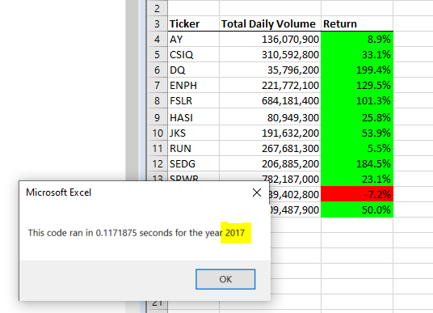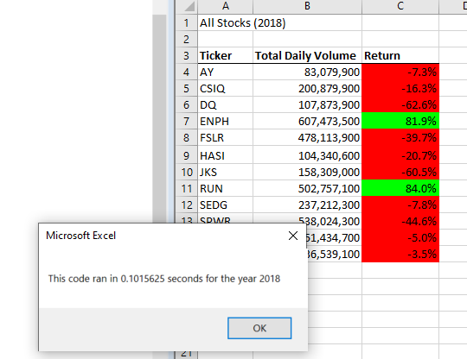

**Conclusion**

Refactoring our initial project should allow for Steve to perform additional longitudinal analysis to inform his advice. For our purposes, refactoring allowed us to be more efficient with code that had already been developed and even iterate on it to some degree.

A pitfall, or disadvantage thought is that if Steve were to require more flexibility than we have given him here, we would likely need to develop an entirely new macro. For example, the data provided was clean and neatly sorted by ticker and date. If that were not the case, what we have done here would not be functional for Steve’s need.