Oscillation detection in time series

Project partner: | RISE Research Institutes of Sweden
Project number: | <Project number>
Report number: | 1
Date: | 31.10.2019

Brief description
Data description for oscillation detection

Contact person(s) LCM | Contact person(s) project partner
HESCH, Clemens | MARSH, Ian
PICHLER, Kurt

Linz Center of Mechatronics GmbH
Altenberger Straße 69
A-4040 Linz

Phone: +43 732 2468 6002
Fax: +43 732 2468 6005

E-Mail: office@lcm.at
Net: http://www.lcm.at

Landes- als Handelsgericht Linz, FN 207547 t
UID-Nr.: ATU52054707

Content
Content 2
1 Introduction 3
2 Data 3

Introduction
The goal of this study is to find a reliable method for the detection of oscillations in time series. Therefore, real world data from machines containing oscillating periods are provided. For confidentiality reasons, the data are normalized in time and amplitude domain.

Data
The data are provided in form of the MatLab mat-File oscillationDataLCM.mat. This file contains two structs, namely
- signalsWithOscillations
- signalsWithoutOscillations
The struct signalsWithOscillations has length 20, i.e. it contains 20 time series containing oscillating periods. The struct signalsWithoutOscillations has length 7, i.e. it contains 7 time series without any oscillating periods.
Each instance of the structs contains 3 fields, namely
- time
- signal
- oscillation
The field time contains the time vector of the time series, the field signal contains the amplitude values of the time series. The field oscillation contains the ground truth about the oscillations in the signal as it is provided by the industrial partner. For each time instance, the vector oscillation defines whether this time instance lies within an oscillating period (oscillation = 1) or not (oscillation = 0).
Two examples of the data are given below.
Figure 1 shows the 8th signal of the struct signalsWithOscillations. The blue line shows the signal, while the red line shows the oscillation. It can be seen that the signal oscillates from time instance 960 to time instance 2750. Note that some signals might contain more than only one oscillating period.
Figure 2 shows the 3rd signal of the struct signalsWithoutOscillations. The blue line shows the signal, while the red line shows the oscillation. It can be seen that the signal oscillates nowhere.

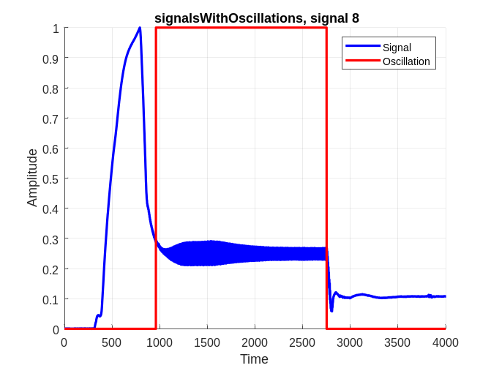
Figure 1. Signal with oscillations, number 8
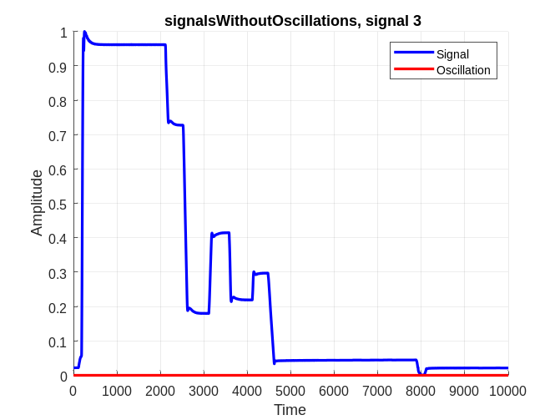
Figure 2. Signal without oscillations, number 3
The MatLab code for plotting the two signals above is shown in Figure 3.

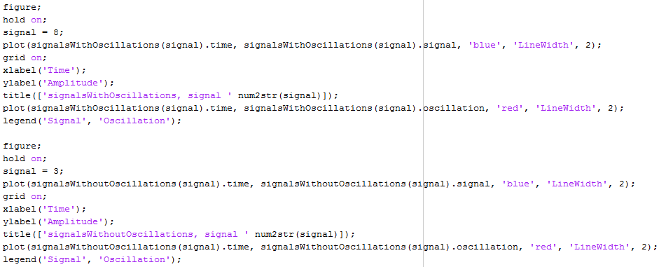
Figure 3. Matlab code for plotting Figure 1 and Figure 2

