**BURN-UP WEEK 2 PAP01**

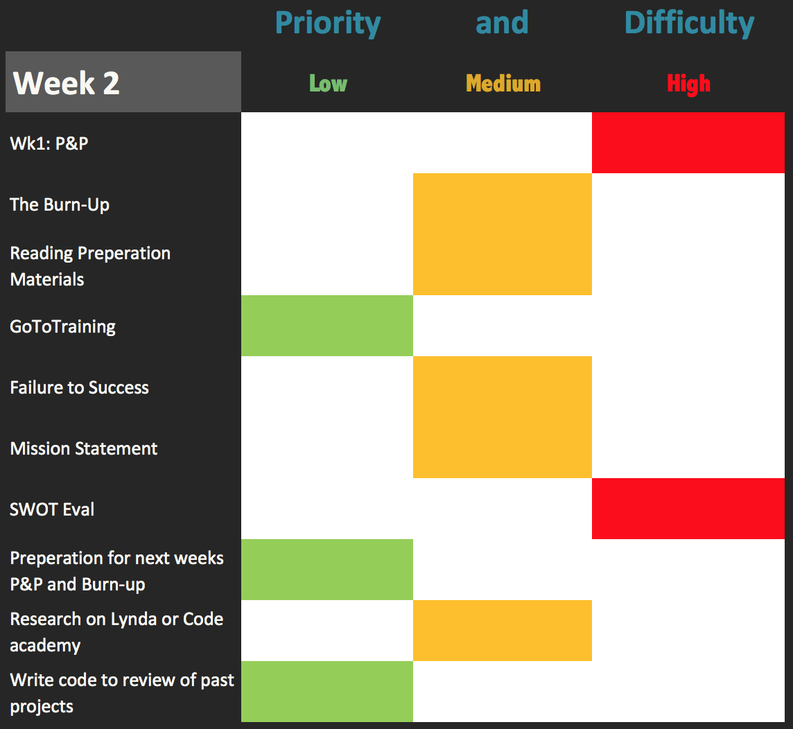

This graph shows the priority and difficulty level of each assignment or objective in the coming week. Items listed with a green marker are the least taxing on time, effort, and importance. Items listed in yellow require minimal time and effort, but require swift action. Finally, Items listed in red require the most amount of time and effort or are deemed to be an outlier, something unfamiliar that will take the most attention to understand. Projects and assignments will be dealt with my handling those in yellow first as they require the least effort and time, and then red to maximize time, and finally green if time is available.