**BURN-UP WEEK 4 PAP01**

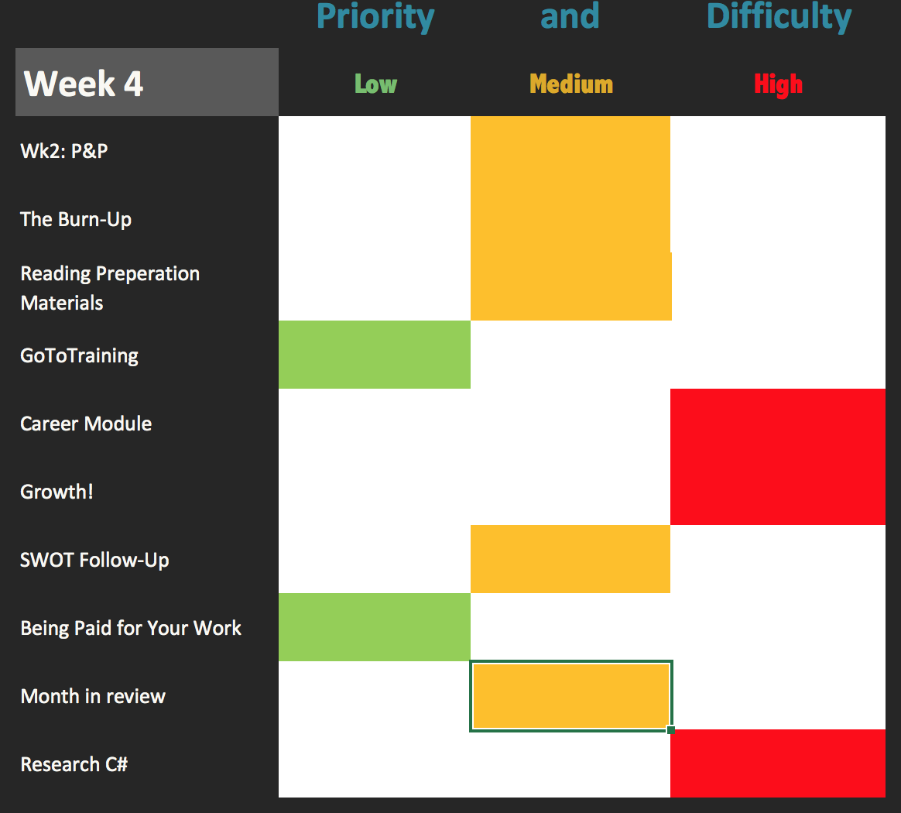

This graph shows the priority and difficulty level of each assignment or objective in the coming week. Items listed with a green marker are the least taxing on time, effort, and importance. Items listed in yellow require minimal time and effort, but require swift action. Finally, Items listed in red require the most amount of time and effort or are deemed to be an outlier, something unfamiliar that will take the most attention to understand. Projects and assignments will be dealt with my handling those in yellow first as they require the least effort and time, and then red to maximize time, and finally green if time is available.

Personal side note:

You failed to complete a quiz in the Career Module sacrificing 25% of your grade due to outside circumstances. You kept true to other assignments that you planned for but failed to complete your tasks on a professional level. You have to beware of outside forces, not everything is controllable.