employee (person_name, street, city)
company (company_name, city)
works (person_name, company_name, salary)

Figure 1. An Employee database.
A simple Employee database is shown in Figure 1. Please answer Questions 1-3 based on this schema.

- (20%) The attribute person_name is defined as the primary key of the employee relation for simplicity (假設沒有兩個人同名), and the attribute company_name is defined as the primary key of the company relation. The works relation describes which company(s) a person works for and the associated salary(s). Please determine what the best primary key of the works relation should be based on the following two assumptions, respectively. Note that you need to explain your answer.
  - An employee can work for only one company in this database.
person_name, 由於員工只可對應到單一公司，故名字只可以出現一次
  - An employee might work for many companies in this database.
(person_name, company_name), 同個員工可以為多間公司工作，意旨人名或公司名稱在works這table可以在同一欄出現很多次，但(person_name) x (company_name)這集合中的任一元素於works中必是唯一的。

- (20%) Suppose that the primary key of the works relation is (person_name, company_name).
  - Identify the two appropriate foreign keys of the works relation.
需要明確的是箭頭指向的是一table中的primary key, 又這三張table中屬性重複的也僅有person_name, company_name，可知works可透過兩個foreign key得知更多資訊。
1 foreign key (person_name) references employee
2 foreign key (company_name) references company
  - Construct a schema diagram for this database.
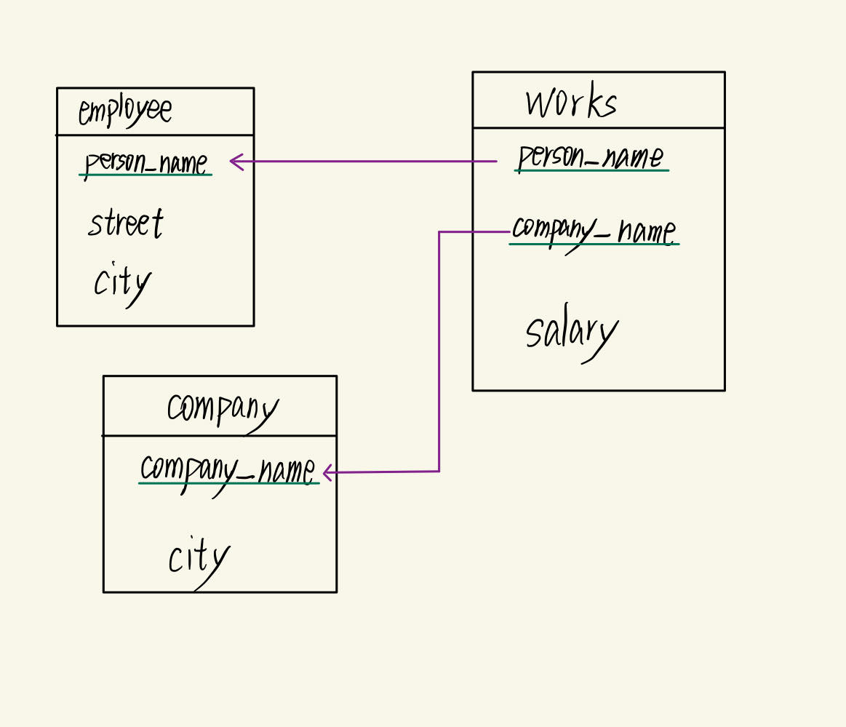

- (40%) Suppose that the primary key of the works relation is the attribute person_name. Give an expression in the relational algebra for each of the following queries, respectively.
- Find the name of each employee who lives in the city “Miami”.

- Find the name of each employee who lives in the city “Miami” and whose salary is greater than $100000.

- Find the name and the city of residence of each employee who works for “FirstBank”.

- Find the name of each employee who does NOT work for “FirstBank”.


- (10%) Explain the concept of physical data independence and its importance in database systems.
資料的儲存方式如檔案組織、索引結構、硬體設備等變更時，不需要修改資料庫的邏輯模式與應用程式。具有提高系統擴充性，降低維護成本的好處。

- (10%) 請問Oracle資料庫軟體的最新版本為何？並請詳述它三個最主要的特色或優點。

1 Oracle Database 23ai

2-1 AI 資料應用：內建向量型別與向量索引，支援 RAG 與企業級 LLM 應用。

2-2資料開發：JSON 擴充、內建 APEX 低程式碼平台，並支援容器化與可插拔資料庫，簡化微服務部署。

2-3 關鍵任務：True Cache 加速回應、SQL 防火牆防護、RAFT 全球分散式複製滿足資料駐留法規。

Note: 1. 請勿繳交和其他同學一模一樣的答案。請勿直接複製生成式AI (如ChapGPT) 所產生的答案。
2. Please submit your homework in a single PDF file to Tronclass before 2025/10/5 23:59.

