employee (ID, person_name, street, city)
works (ID, company_name, salary)
Figure 1

- (40%) Use MariaDB to declare the two relations in Figure 1, where the primary keys are underlined.
- For each relational schema, choose an appropriate domain for each attribute. Define the attribute “person_name” as “not null”. Other attributes except primary keys can have null values.
- Declare the primary key of each relation. Note that the primary key of the works relation consists of two attributes. After finishing steps (1)-(2), capture the corresponding Web page as the answer. (所抓之圖如PHP&MariaDB教學手冊 (lab25.pdf) 第20頁下方之圖).
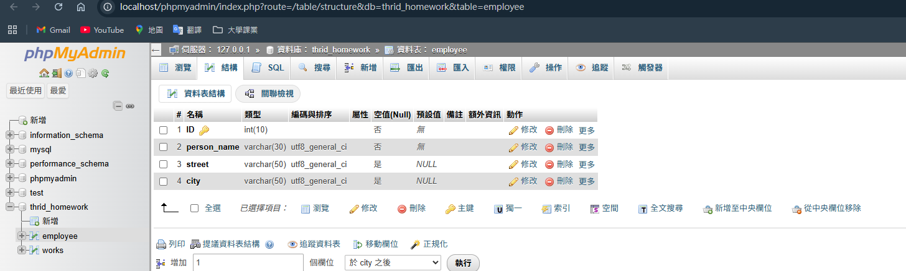
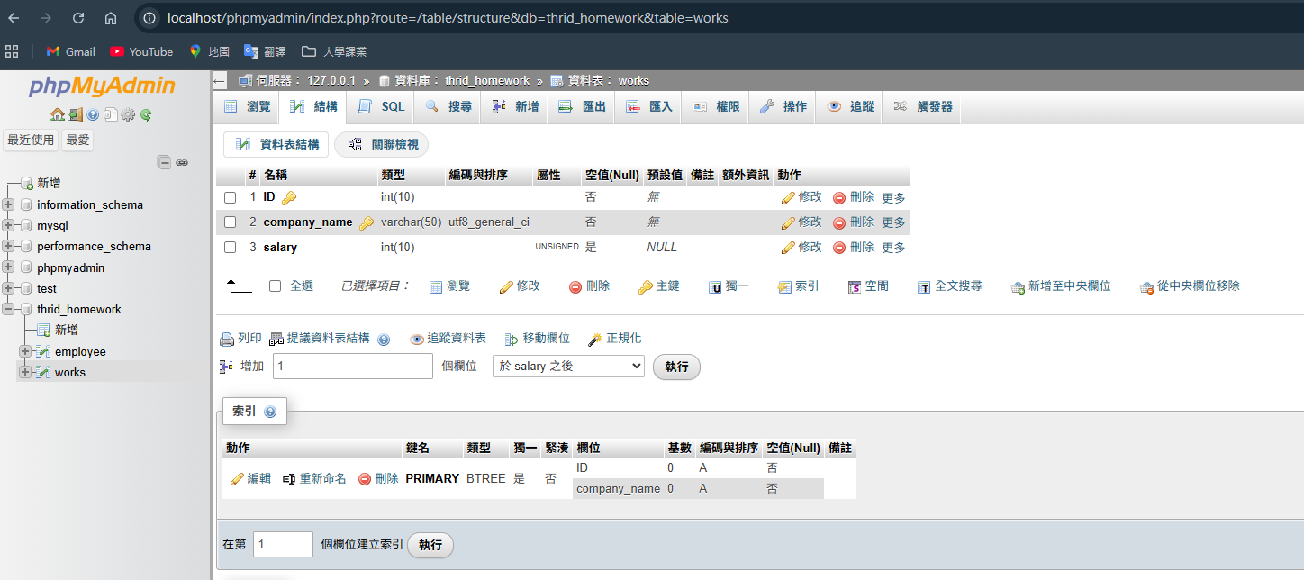

- Declare the attribute “ID” of the “works” relation as a foreign key referencing the “employee” relation. Please choose the option “restrict” for deletion and choose the option “cascade” for update. After declaration, capture the corresponding Web pages as the answers. (所抓之圖如教學手冊第23頁最下方之圖)
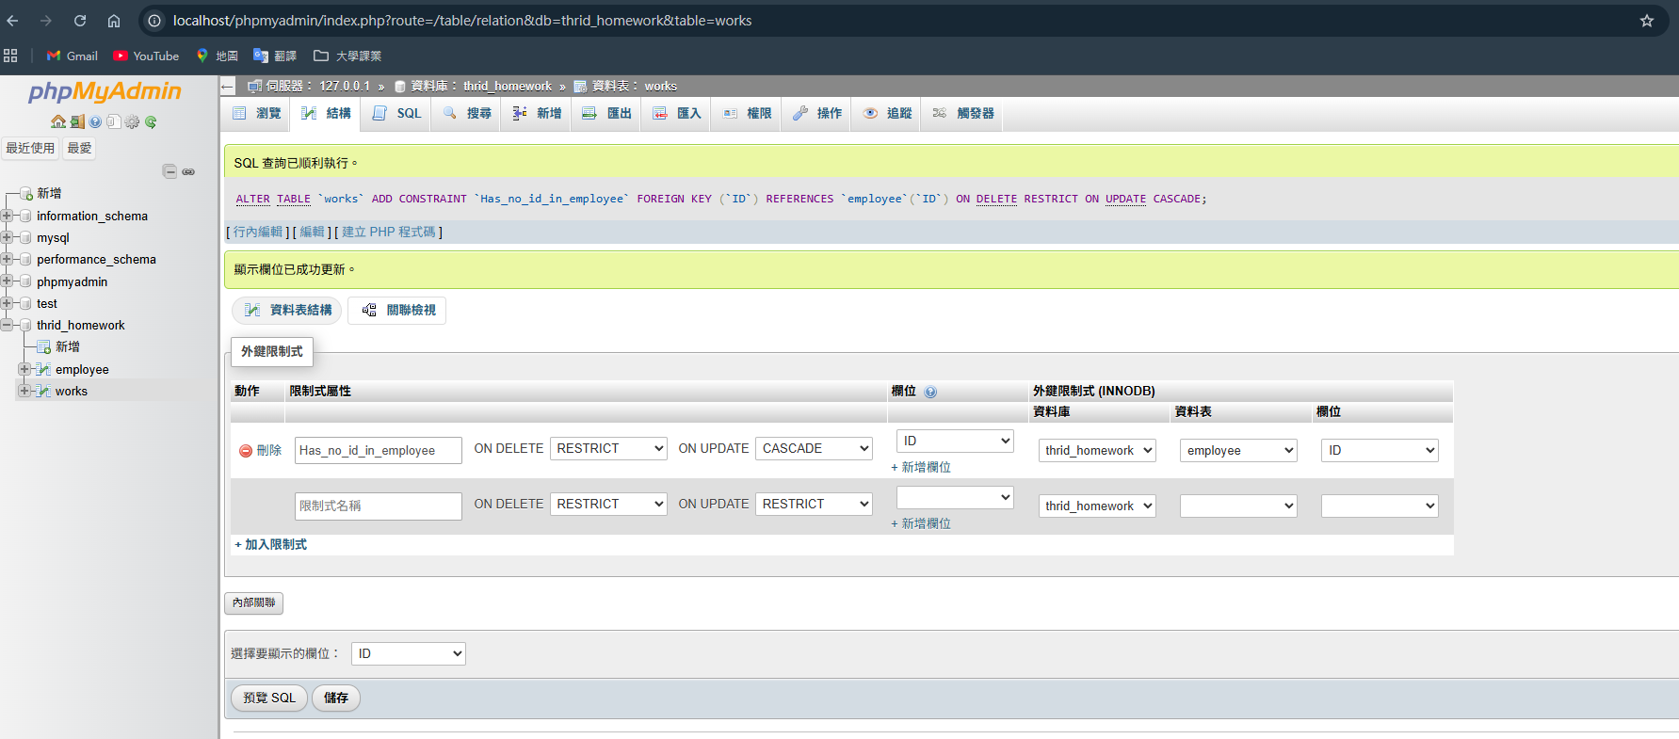

- Insert at least five tuples into the two relations, respectively. Capture the corresponding Web pages as the answers. (所抓之圖如教學手冊第18頁下方之圖)
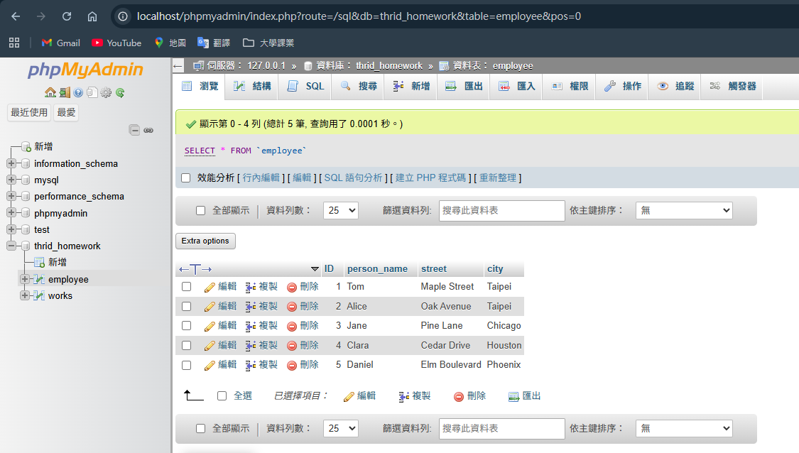
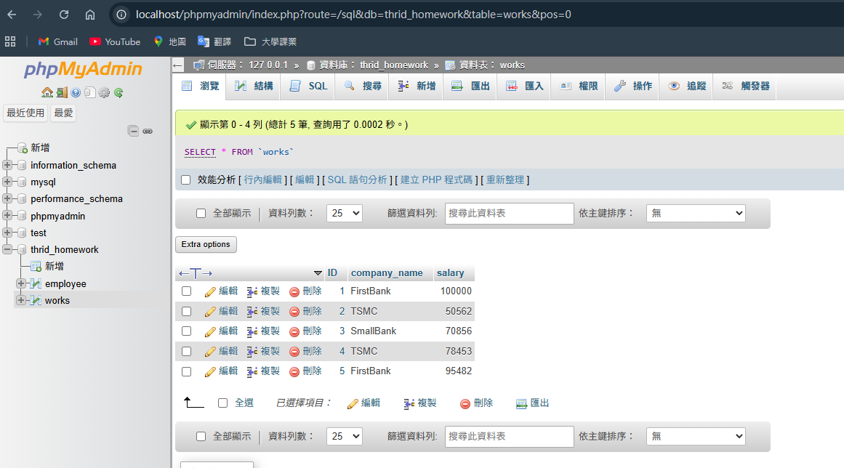

[學號最末碼為單數之同學] 學號：01257027
- (60%) Write a PHP program to show all the content of the “employee” relation for those who live in Taipei. The data should be displayed in a table. (注意：需用prepared statement的寫法，部分程式可參考教學手冊第30、32、37頁所示)
- Give the program listing.
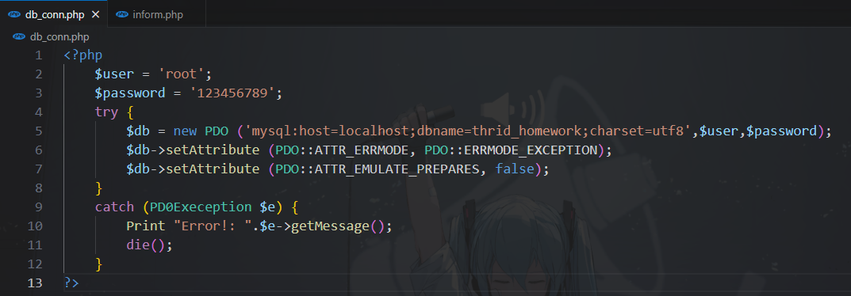
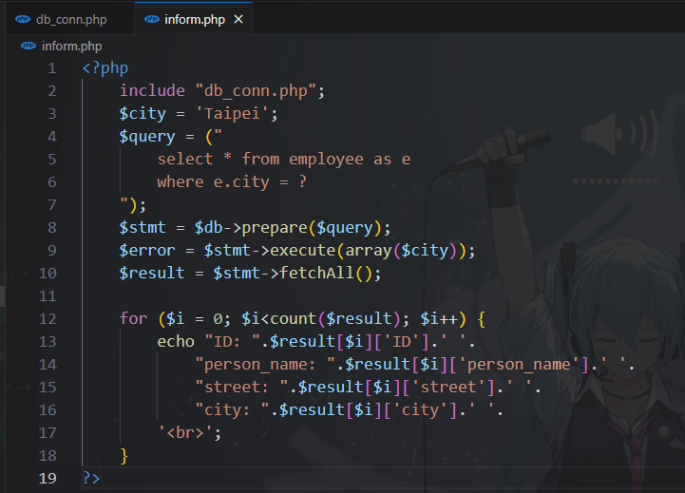

- Capture the screen which shows the answer based on your database content. (Your answer of Question 1(4).) (注意：畫面必須擷取到網址)
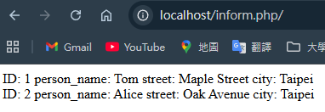

繳交作業方式：
- Please submit your homework in a single PDF file to TronClass by 11/23 11:59pm.
- 第2題依學號末碼區分，請同學注意勿答錯題。
- 注意：若作業答案有一模一樣者，則皆為零分，不論你是不是原始創作者。

