employee (ID, person_name, street, city)
company (company_name, city)
works (ID, company_name, salary)
manages (ID, manager_id)
Figure 1
Consider the database in Figure 1, where the primary keys are underlined. The manages relation describes the manager (manager_id) of a certain employee (ID). Each manager is also an employee himself (herself). Construct the following SQL queries for this relational database.

- Find the ID, name, and manager of each employee who works for “FirstBank”.
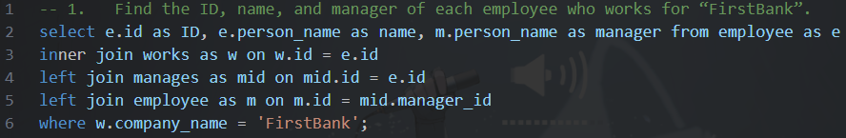
想法是從employee拿到名字，利用ID對應到manages拿到上司ID再對回去employee拿到上司名字，另外再對應題目提到的限制company_name=’FirstBank’。第三行本人覺得要用inner，想法是最終關注有再FirstBank上班的人，而人可能沒有工作。

- Find the ID of each employee who does not work for “FirstBank”.
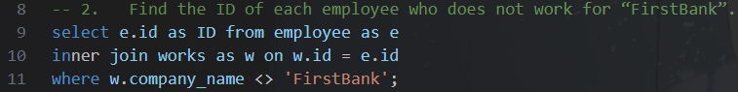

此題只要求找ID，因此可以不需要employee，只需要對work限制公司名 (解二)。至於出現解一，只是單純第一次沒想那麼多就寫了：Ｐ

- Find the ID and name of each employee who lives in the same city as the location of the company for which the employee works.
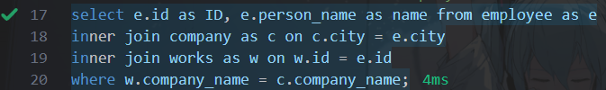
需要ID, name因此需要employee。先不管是否與工作地點相同，與居住城市相同的公司inner join進來，再從works考慮是否工作與居住城市相同(使用where條件篩選)。

- Find the ID of each employee who earns more than at least one employee of “SmallBank”.
- Please use “tuple variable”.
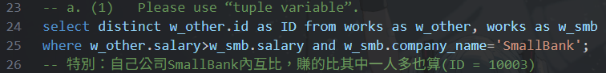
可以看到第24行最後引用兩相同來源表格(tuple variable)，且題目沒註明同公司內不能互比，可能存在通公司AB員工互相比較也算在結果內。使用distinct是因為如果SmallBank員工不只一位，假設我賺的比所有SmallBank員工多，我會出現SmallBank員工數量的次數。

- Please use “nested subquery” in the WHERE clause.
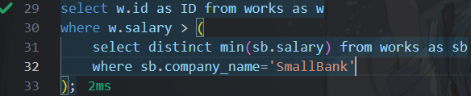
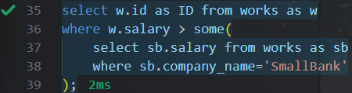
可以從where裡明顯看到包了一層select (nested subquery)，這裡引用min是因為內層select可能回傳多個值(我賺的比SmallBank員工多，且人數>=2)，因此取distinct min，依照題目要求，比一人多即可(比最低的高就好)。解二使用some使存在一筆資料符合就算。

Find the name of each company whose employees earn a higher salary, on average, than the average salary at “FirstBank”.
- Please use “having”
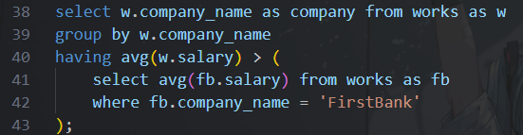
這題要取同公司名薪水的avg，因此必要的是group by company_name，第二個select意在取題目指名的FirstBank平均。

- Please use “with”.
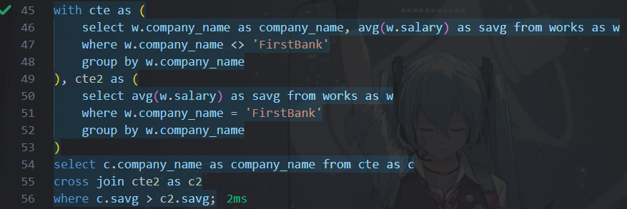
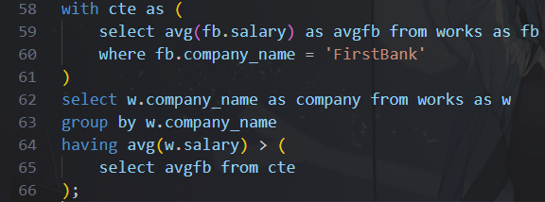
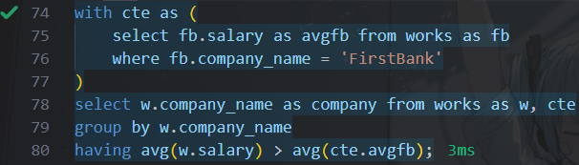
這裡提供兩個做法，可以看到第一種偏向暴力，個例處理，而使用cross join在這裡也不會使表格列數變多(cte2只有一列)，最後在比較的只有cte列數。第二種單純只是在with內做好需要的avg，需要的時候select。解三在with不使用avg，為符合having必用aggregate function。

- Delete all tuples in the works relation for employees of “SmallBank”.

單純選定一個要delete的表格works，刪除題目要求的「與SmallBank有關的列」。

- Add a new employee with the ID as “E01” and the name as “John”, but the address is currently unknown.
與題目要求的相同，於employee增加ID=E01, name=John, address=unknown者，未知者填入null(create table不能在address限制not null)。

- Give each employee of “FirstBank” a 10-percent raise of salaries unless the salary becomes greater than $100000; in such cases, give only a 3-percent raise.
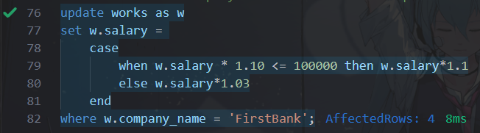
此題指對存在的資料更新，因此使用update，對於加薪10%<=十萬者就*1.10，否則只有*1.03，且題意限定公司為FirstBank。

Note:
1. Please submit your homework in a single PDF file to Tronclass before 2025/10/22 23:59 (星期三)。
2. 解答2025/10/23公布。We do NOT accept late submission for this homework.

