employee (ID, person_name, street, city)
works (ID, company_name, salary)
Figure 1
- (20%) Consider the employee database with two relations in Figure 1.
- Write a function avg_salary that takes a company name as an argument and finds the average salary of employees at that company.
create function avg_salary(the_company_name varchar(20))
returns integer
begin
declare e_avg integer;
select avg(salary) into e_avg
from works
where company_name = the_company_name;
return e_avg;
end;

- Write an SQL statement, using the avg_salary function, to find companies whose employees earn a higher average salary than the average salary at“FirstBank”.
解法1：
select distinct company_name
from works
where avg_salary(salary) > avg_salary(‘FirstBank’);

解法2：
select branch_name,
from account
group by branch_name
having avgb(balance) > avg_balance(‘FirstBranch’);

- (20%) Design a database using the ER-diagram for an airline. The database must represent the information of each flight (航班), including its flight number and schedules (起飛降落的日期時間). The database also needs to keep track of customers and their reservations on individual flights, including the status and seat assignments. (Design the proper entity sets and relationship sets. For each entity set, represent the proper primary key and attributes.)

解法1：
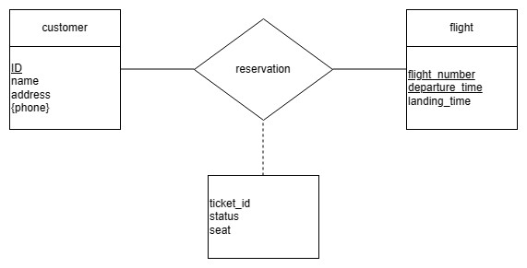

解法2：
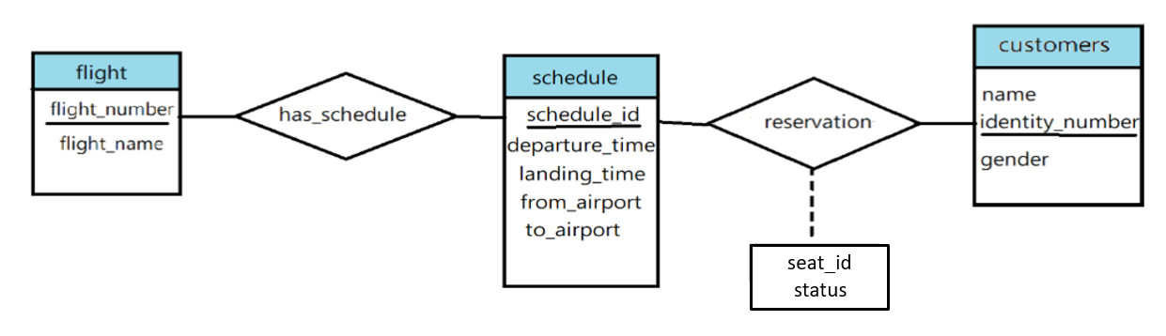

- (20%) Construct appropriate relational schemas for the E-R diagram in Figure 2. For each relational schema, represent the proper attributes and primary key.
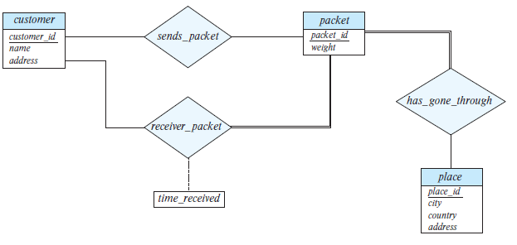
Figure 2

customer(customer_id, name, address)
packet(packet_id, weight)
place(place_id, city, country, address)
sends_packet (customer_id, packet_id)
receiver_packet (customer_id, packet_id, time_received)
has_gone_through(packet_id, place_id)

- (20%) List two nontrivial functional dependencies satisfied by the relation in Figure 3. Explain your answer.
A | B | C
a1 | b1 | c1
a1 | b1 | c2
a2 | b1 | c1
a2 | b1 | c3
Figure 3
  - A→B，
A=a1時，B=b1
A=a2時，B=b1。
同一個A值皆對應到同一個B值，故A→B成立
  - C→B，
C=c1時，B=b1
C=c2、c3時，B=b1
同一個C值皆對應到同一個B值，故C→B成立
- (20%) Consider the schema R = (A, B, C, D, E, G) and the set F of functional dependencies as follows:
{AB → CD, B → D, DE → B, DEG → AB, AC → DE}.
- Prove that AB is not a superkey.
$${\left(AB\right)}^{+}$$
Result = AB
Result = ABCD(AB→CD)
Result = ABCDE(AC→DE)
$${\left(AB\right)}^{+}=\{A,B,C,D,E\}≠R$$
所以AB 不是Superkey
- Prove that DEG is a superkey.
${(DEG)}^{+}$
Result=DEG
Result=ABDEG(DEG→CD)
Result=ABCDEG(AB→CD)
$${\left(AB\right)}^{+}=\left\{A,B,C,D,E,G\right\}=R$$
所以DEG is a Superkey

繳交作業方式：Please submit your homework in a single PDF file to TronClass by 1/9/2022 11:59pm.

