employee (ID, person_name, street, city)
works (ID, company_name, salary)
Figure 1
- (20%) Consider the employee database with two relations in Figure 1.
- Write a function avg_salary that takes a company name as an argument and finds the average salary of employees at that company.
create function avg_salary(company_name varchar(127))
return num
begin
declare avg_salary num;
select avg(salary) into avg_salary
from works
where works.company _name =company_name;
return avg_salary;
end

- Write an SQL statement, using the avg_salary function, to find companies whose employees earn a higher average salary than the average salary at“FirstBank”.
Select company_name
Form works
Where avg_salary(company_name)>avg_sa;ary(‘FirstBank’);

- (20%) Design a database using the ER-diagram for an airline. The database must represent the information of each flight (航班), including its flight number and schedules (起飛降落的日期時間). The database also needs to keep track of customers and their reservations on individual flights, including the status and seat assignments. (Design the proper entity sets and relationship sets. For each entity set, represent the proper primary key and attributes.
flight
customer
reservation
flight-number
name
flight-number
schedules

seat-number
status

- (20%) Construct appropriate relational schemas for the E-R diagram in Figure 2. For each relational schema, represent the proper attributes and primary key.
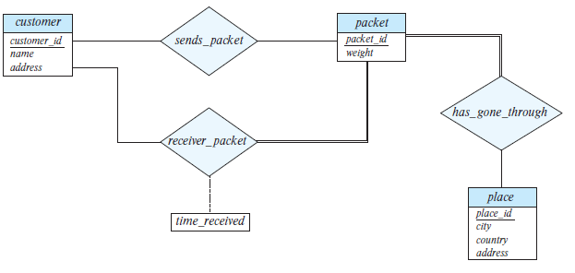
sends_packet( packet_id, customer_id)
receiver_packet(packet_id, customer_id, time_received)
has_gone_through(place_id, packet_id)

Figure 2
- (20%) List two nontrivial functional dependencies satisfied by the relation in Figure 3. Explain your answer.
A | B | C
a1 | b1 | c1
a1 | b1 | c2
a2 | b1 | c1
a2 | b1 | c3
Figure 3
*可以多對一或是一對一，但不可以一對多
所以:
C->B
B不被包含在C裡,但可以透過C推出唯一的B (c1->b1, c2->b1,c3->b1)
A->B
B不被包含在A裡, 但可以透過A推出唯一的B (a1->b1, a2 ->b1)

- (20%) Consider the schema R = (A, B, C, D, E, G) and the set F of functional dependencies as follows:
{AB → CD, B → D, DE → B, DEG → AB, AC → DE}.
- Prove that AB is not a superkey.
{AB}:
DEG → AB → CD, 因為AB具transitively dependent,所以AB不是superkey

- Prove that DEG is a superkey.
{DEG}:
DEG → AB , DEG →CD
且DEG不被包含在AB裡, DEG不被包含CD在裡, 所以DEG是superkey

Note: Please submit your homework in a single PDF file to TronClass by 12/20/2023 11:59pm.

