- Which level of a database system describes how data are stored and only visible to the D…

Ans: physical level

補充:
Physical level :
This is the lowest level of abstraction. It describes how data is actually stored in the database. We can get the complex data structures at this level.

Logical level :
This is the middle level of the data abstraction architecture. It describes what type of data structures, we are storing at this level. It includes description of their attributes, datatype along with fields and their relationship.

View level :
It is the highest level of data abstraction architecture. This level describes the user interaction with database system.

- Which term describes a collections that perform a single logical function and … should either complete or not happen at all?

Ans: transaction

補充:
transaction : A transaction can be defined as a group of tasks. A single task is the minimum processing unit which cannot be divided further.

Abstraction : Data Abstraction is a process of hiding unwanted or irrelevant details from the end user. It provides a different view and helps in achieving data independence which is used to enhance the security of data.

Integrity constraint: Integrity constraints are rules that help to maintain the accuracy and consistency of data in a database. They can be used to enforce business rules or to ensure that data is entered correctly.

3.Which of the following statement is NOT correct about the data stores in a database system … ?

Ans: The index is … to backup the database

補充:
Database backup is the process of creating a copy (backing up) of an organization’s structured data utilized by popular databases such as SAP HANA and Microsoft SQL Server.

Correct follow data stores in a database system:
- The data dictionary stores metadata
- The data files store the database itself
- Statistical data are used by the query optimizer

4.Which of the following is a NOSQL database?

Ans: MongoDB

補充:
NoSQL databases (aka "not only SQL") are non-tabular databases and store data differently than relational tables. NoSQL databases come in a variety of types based on their data model

SQL database or relational database is a collection of highly structured tables, wherein each row reflects a data entity, and every column defines a specific information field.
Ex: MySQL, Oracle, and Sybase, SQL server, mariadb

5.Which attribute(s) of the following table has (have) atomic values?
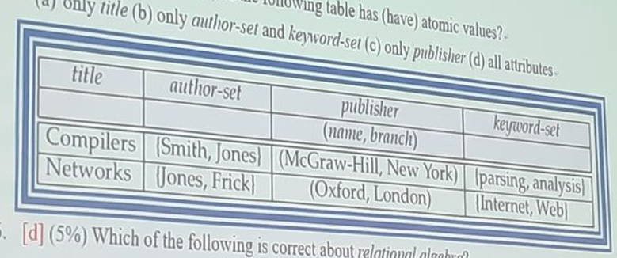
Ans: only title

補充:
Atomic data cannot be decomposed into smaller pieces

Wrong answer:


6.whiich of the following is correct about relational algebra?

Ans: it only supports the SET semantics

補充:
Relational Algebra is a procedural query language. Relational algebra mainly provides a theoretical foundation for relational databases and SQL.

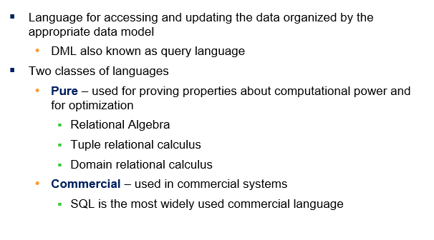
7.
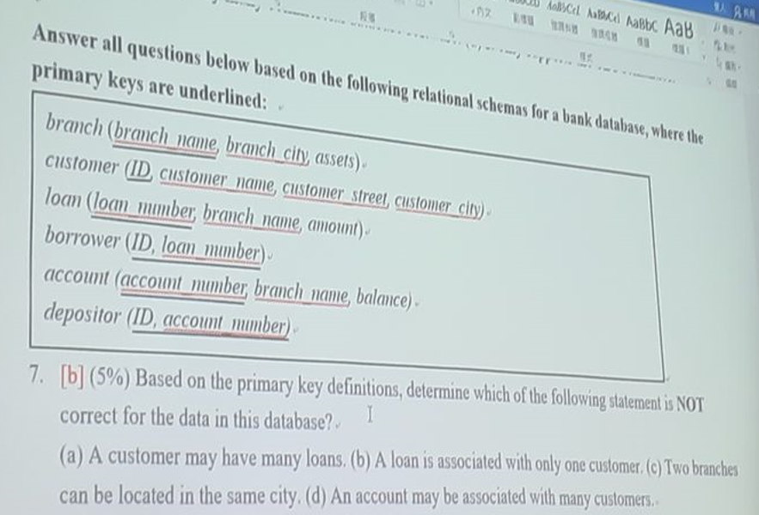

補充:
Borrower 的 PK 是兩個一起，不能只有一個 = > loan_number 不是唯一一人有關係

