Planning & Ontwerp

Click or tap here to enter text.

|  |  |
| --- | --- |
| Versienummer: | Click or tap here to enter text. |
| Auteur(s): | Click or tap here to enter text. |
| Datum: | Click or tap here to enter text. |

# Versiebeheer

|  |  |  |  |
| --- | --- | --- | --- |
| Datum | Versie | Wie | Wijzigingen |
| 23/05/2024 | 1 | Rico |  |
|  |  |  |  |
|  |  |  |  |
|  |  |  |  |

Inhoudsopgave

Versiebeheer 2

Planning 4

Ontwerp 4

Akkoord opdrachtgever 4

# Planning

# Ontwerp

Website: <https://www.figma.com/file/fpCvsq0DCmCbCrwbqEfMrd?node-id=0-1&t=XPbBxDgLKPOLF55B-0&fuid=1309475239783797446>

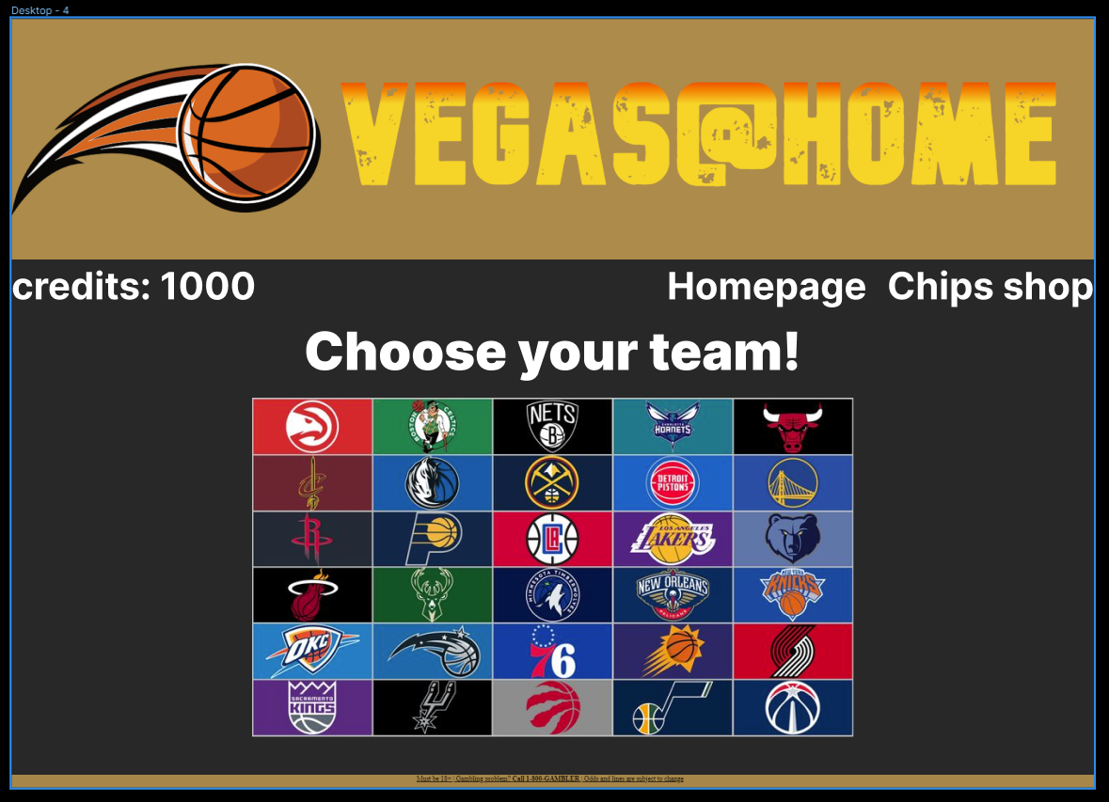ERD (Database)

Slot Machine (Sketch)

# Onderbouwing

*Licht de ontwerpen toe in relatie met de eisen en wensen. Denk hierbij aan een relatie met bijvoorbeeld ethiek, privacy en security, AVG.*

# Akkoord opdrachtgever

|  |  |
| --- | --- |
| Naam |  |
| Datum |  |
| Handtekening |  |