NightOwl User Manual

To run NightOwl locally from the provided files, do the following:

* Make sure to have [Node.js](https://nodejs.org/en/) and [MySQL](https://www.mysql.com/downloads/) installed on your machine,
* You need to make sure that the Node server can connect to MySQL as “root” user by doing one of two things:
  + You can change your MySQL root user’s password by following [these](http://dev.mysql.com/doc/refman/5.7/en/resetting-permissions.html) instructions.
  + You can navigate to the “server.js” file in the project’s root directory and find the MySQL connection object and change the “password” field (line 48 of server.js) to your current root user’s MySQL password.
* Once you have MySQL installed, create a table called “NightOwl” and execute the given “NightOwl.sql” file (also in the project’s root directory) to create and populate the necessary tables.
* Making sure MySQL is on and enabled, run the command “node server.js” in the project’s root directory. You should now be able to use a web browser (we suggest Google Chrome to ensure maximum browser compatibility) to navigate to “localhost:8000.” There you should find the NightOwl homepage!

The first thing you’ll want to do is create a user:

* On the header at the top of the screen, navigate to “Sign up”
* Fill in all the required fields and click on “Register”.
* You are now logged in! You can logout or view your account details using the buttons at the top of the screen.

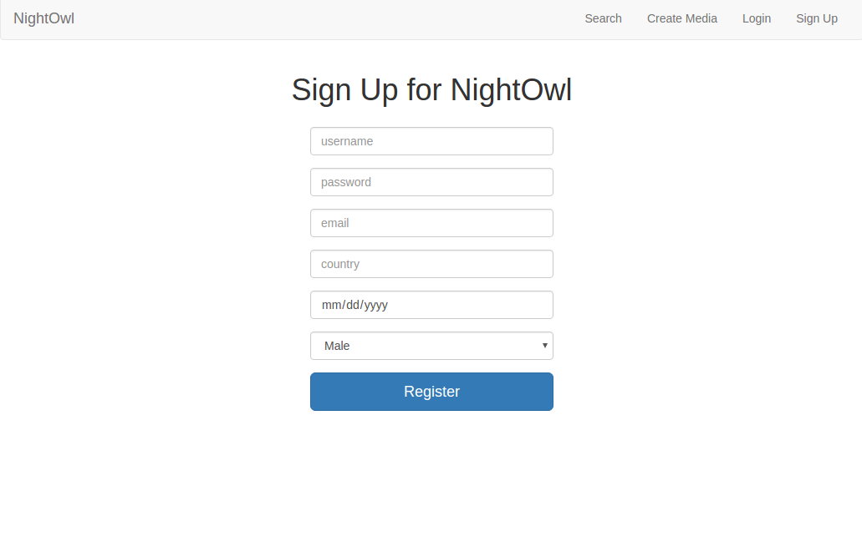

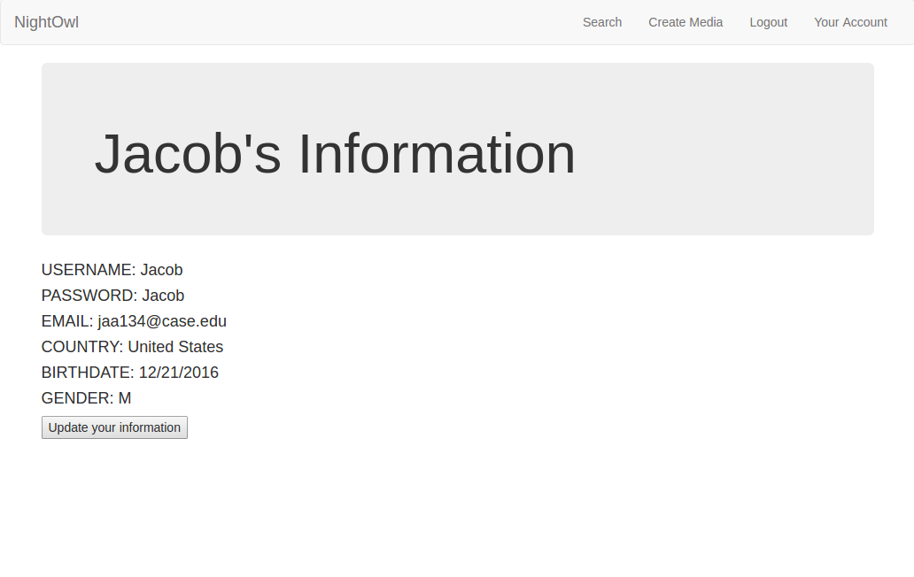

Now that you have made an account, you can create media!

* Click “Create Media” in the header at the top of the screen.
* Choose which type of media you wish to create, then click “Upload”
* Fill in the fields necessary for that media type, upload your file, then click “Upload”
* You should see your media on the screen with all its information

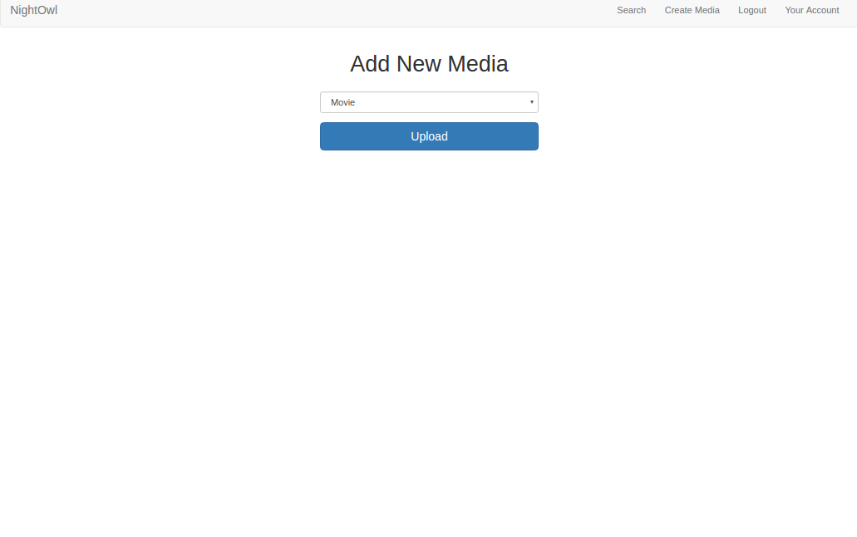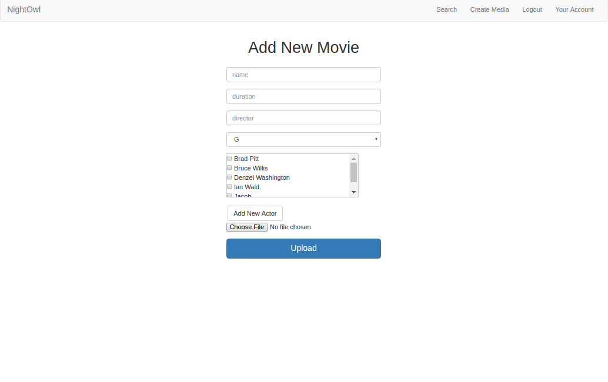

Let’s rate this media!

* At the bottom of the page that includes your media, click on the “Add a comment” button.
* Write a comment, give it a rating out of 10, then click “Add”
* You should see your comment at the bottom of the page.

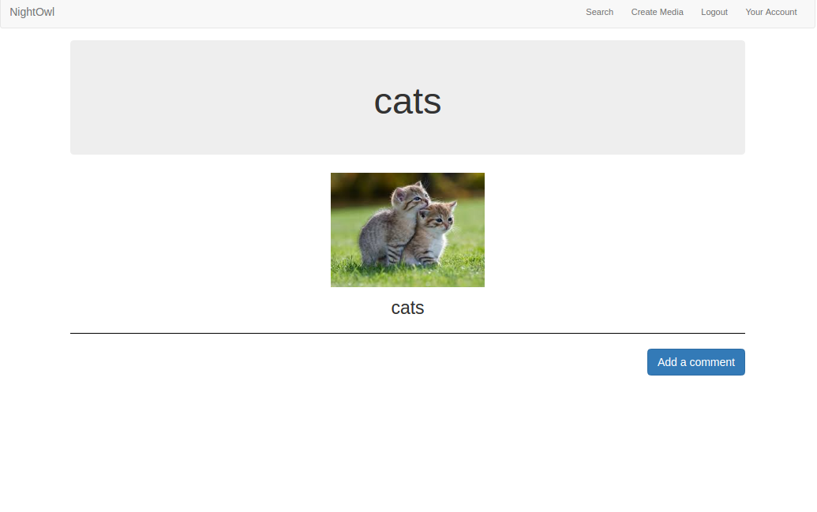

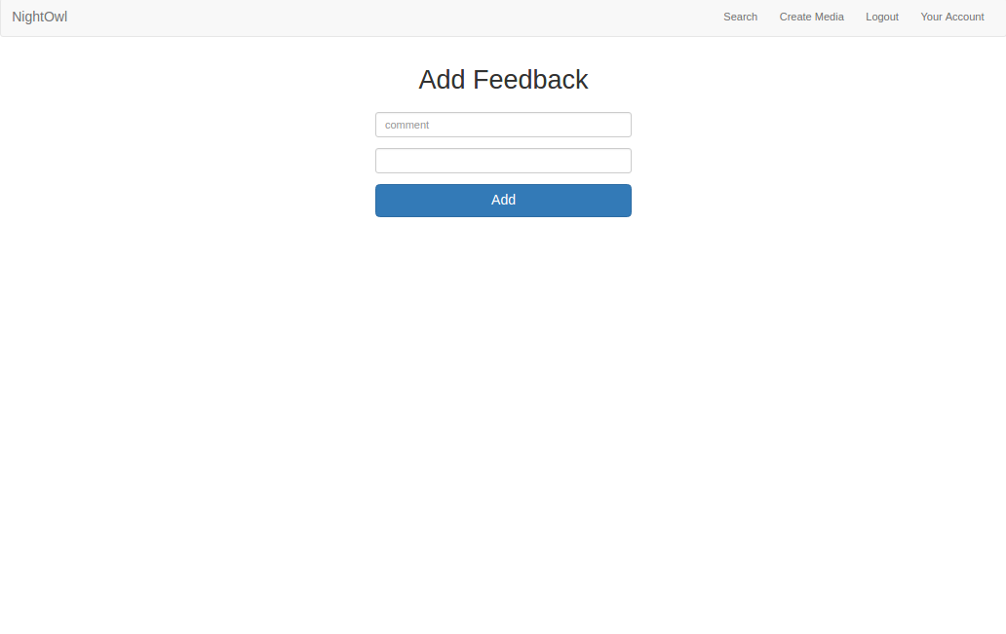

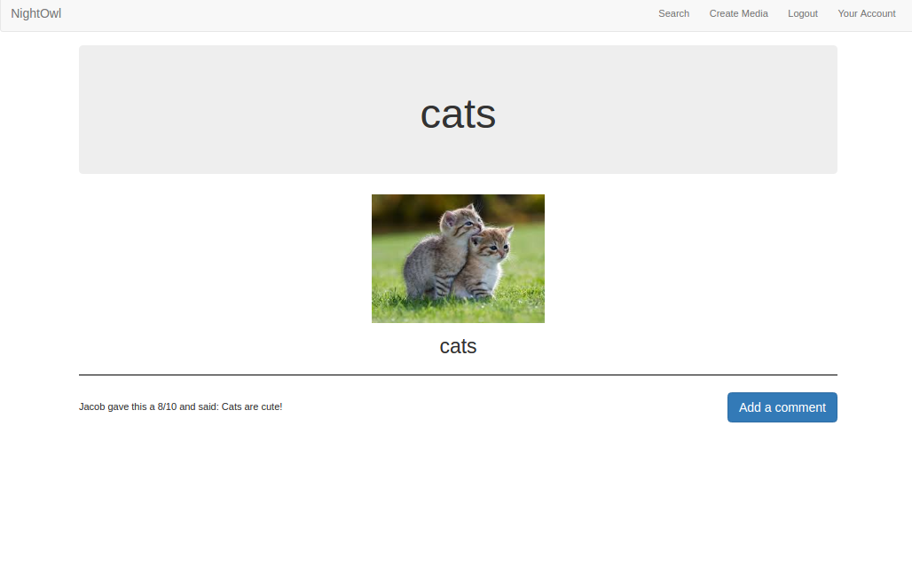

Now make sure you can find your media!

* Click “Search” at the top of the page and set your search criteria.
* You should see a list of all the media that fits your description.

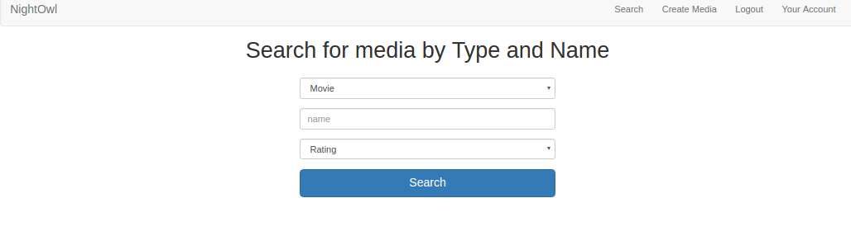

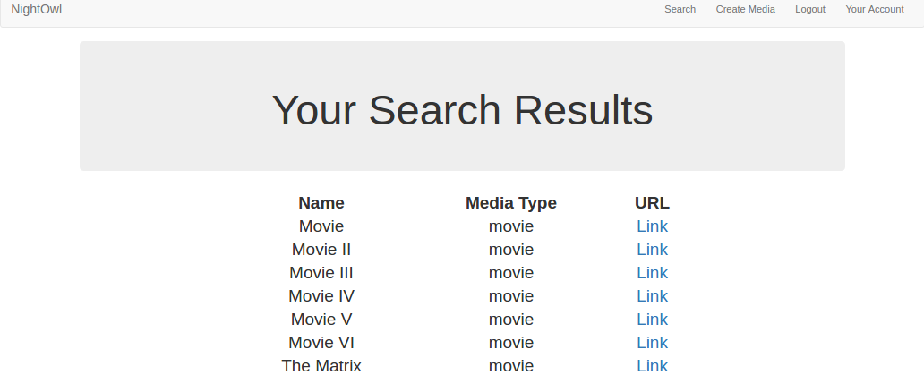

Once you and your friends have added and rated a bunch of media, you will notice recommendations on the homepage (accessed by logging in or clicking on “NightOwl” at the top of the screen) that show the most popular and most highly rated media, as well as a random piece of media you may like. Maybe you’ll find something new that you like!

