Ian Wood

IMW3821

A Strangely Small Waterspout Attacks a Campground and a Flock of Birds

**User Guide:**

The goal of this project was to create four unique particle simulations and to create 2 objects that will interact with the particles. I created a cloth simulation, a tornado, a fire, and boids.

Use WASD keys to move camera location and IJKL keys to change the cameras look. QE moves the camera up and down. Press “r” to reset the cloth, “P” to pause the simulation, and space to single step. Arrow keys will move the two objects along the x-y plane. There is a drop down box at the bottom which allows the user to switch between solvers. Most importantly use velocity Verlet to demonstrate stability and Adams-Bashforth or Euler to demonstrate instability. Note that the springs have a fixed separation which means it may be harder to make the cloth completely unstable.

**Results:**

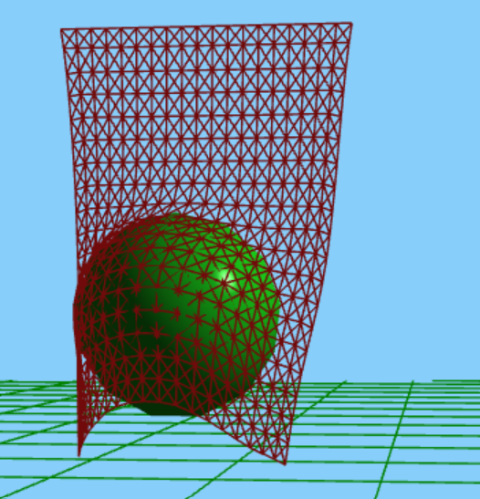

Figure 1: Sphere interacting with the cloth.

Figure 2: Tornado/waterspout in a box

Figure 3: Still shot of fire.

Figure 4: Boids demonstrating grouping.

Figure 5: Cloth interacting with cube

Figures 1 and 5 demonstrate how the cloth interacts with the solid objects. The cloth sits on top of both these objects. Both objects exert a friction on the cloth which prevents it from sliding off the surface.

Figure 2 shows the waterspout/tornado which forms a cone of particles. This is formed from position dependent forces acting on all the particles. In addition, they are also time dependent which allows the tornado to move about.

Figure 3 shows the fire simulation. Each particle is spawned at the floor and given a upwards velocity. Each particle is only allowed to “live” for a certain amount of time before which it is destroyed. The longer it has been alive the darker, smaller and slower it becomes.

Figure 4 shows flocking behavior. These “birds” demonstrate all 4 qualities. This results in them being repelled from walls, and clumping/moving together. However, separation causes them to not clump too close.

**Additional Solvers:**

1. Midpoint
2. Velocity Verlet
3. Adams Bashforth

**Additional Force makers:**

1. Random Force: used in the boid simulation to add some random movement. Looks more similar to birds which demonstrate some jitter/randomness when they flock.

**Additional Constraints:**

1. Fixed Points: used in the cloth to hold the top row of particles up
2. Max distance: used in addition to the springs to ensure that springs don’t get stretched to much. This greatly improves the interaction with objects because it prevents the objects from making the springs unstable.
3. Cube constraint: excludes any particle from being on the inside by putting the particle at the nearest face of the cube. Also, applies drag.
4. Sphere constraint: excludes any particle from being on the inside by putting the particle on the edge based on the vector between the particle and the center. Also, applies drag.

**Novel rendering methods:**

1. Show springs: instead of drawing the particles in the springs I drew the springs which makes it look more cloth-like.
2. DON’T count cube/sphere because the Phong shading was reused from my Project C in 151-1.