Ian Wood

IMW3821

Shapes Gathering for the Shininess Competition

User Guide:

Use WASD to move the camera around and the mouse to change look direction. Use the buttons at the bottom of the page to adjust the light position, turn the lights on and off, and increase/decrease recursion depth.

Results:

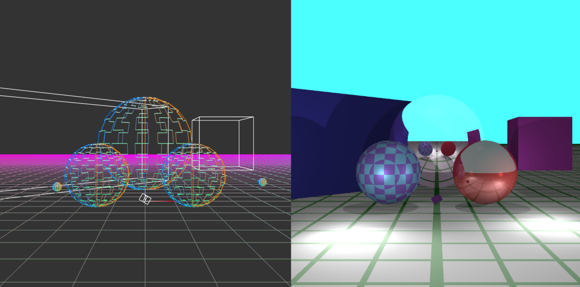

Figure 1: Scene One

Figure 2: Scene Two

Figure 3: Scene 3

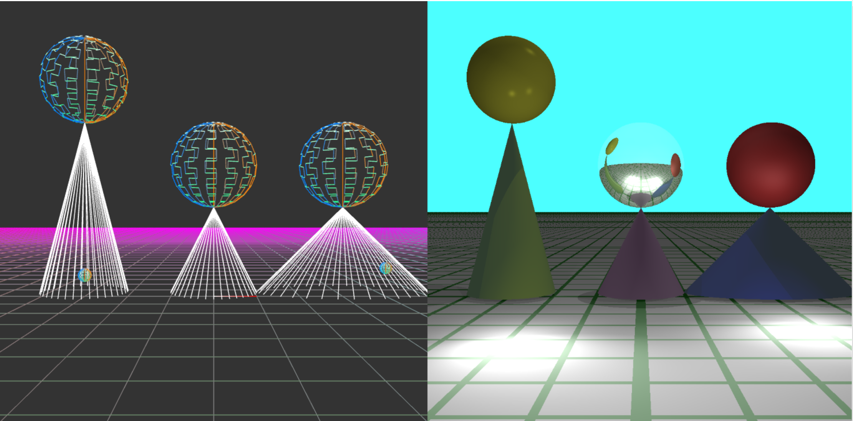

Figure 4: Scene 4

Figure 5: Scene 5

One important note for all the scenes is that the small spheres (two near the ground plane and 1 z = 10) represent the 3 light sources. Figure 1 demonstrates the sphere and cube object types as well as showing recursive reflection. It shows the checkered pattern on one of the spheres. Scene 2 has 2 adjacent mirrors which makes testing recursion depth easy. Scene three has 3 cylinders as well as a sphere with a ring pattern on its surface (to make it look like a zebra). One of the cylinders is a mirror to demonstrate proper normal for the cylinder. Scene four shows another shape, a cone, as well as another mirror sphere to demonstrate reflection. Scene 5 best demonstrates shadows as the balls cast a variety of overlapping shadows.

Optionals:

1. Checkered Sphere
2. Cone
3. Cylinder
4. Striped sphere