Extrasize

Get more from every workout.

Christopher Shannon

Brian Del Carpio

Ian Wu

Simon Fraser University

CMPT 276

Contents

Project Overview 2

Kanban Methodology 2

High-Level Features 2

Google Calendar Features 2

Strava Features 2

Code Testing 2

CICD Infrastructure 2

High-Level Data Flow Diagram 2

Lessons Learned 3

Challenges 3

Work Division 3

# Project Overview

Our project is centred on developing an innovative running workout application that integrates seamlessly with APIs like Google Calendar and Strava to enhance the user experience in planning and tracking fitness activities. Utilizing a dynamic Kanban methodology to manage our workflow, we can address the challenges posed by our team's relative inexperience with large-scale projects by allowing for flexible task management and prioritization. The application was built with a robust technology stack, leveraging the interactive capabilities of React for the front end, coupled with the foundational web technologies HTML and CSS for structure and style. This combination provides our users with a responsive and intuitive interface to schedule workouts, track their progress over time, and analyze their performance with visually engaging maps and statistics. Late in our build process, we discovered that Strava would not provide us with a map to display. Leveraging our flexibility, we implemented a third API, Leaflet, to be able to bring in what we believe is one of the highlights of the application, a visually appealing map. After struggling and attempting to use Heroku to manage our CICD process we had to resort back to using GitHub Actions alongside Docker (Since GitHub can not host servers), and Cyclic to iteratively run our web application.

# Kanban Methodology

Our intention originally was to make use of the Kanban Agile methodology. This was because it was an easy way to visualize which tasks need to be done, and which tasks are in progress or already done. We saw potential and researched about it in the beginning stages of the project. The member in charge of carrying out these tasks was Melvin who dropped out of the course without notice. Because we did not know he dropped the course until the TA check-in, we carried out as best as we could through messages for the whole of Milestone 1. After the first check-in, once we realized Melvin was not going to be part of the group, our priority shifted to making up for the tasks that should have been done. Throughout the whole project, however, we did maintain good communication and used Discord as our makeshift kanban board. Although there was no visual representation of the board, tasks were laid out clearly along with their priorities.

# 

# High-Level Features

The goal of our application is to provide a way for athletes to plan and track their workouts. To achieve this, users can perform one of two actions. The first of these actions is to plan a workout. The second of these is to input a completed workout. Along with these features they need to be able to see the workouts that they planned and completed.

# Google Calendar Features

The Google Calendar API allows access for our application to view and change the users’ calendars. Using the API, we can create events that store the name, date, time, location and description. Once an event is created it can be seen in any location that calendar is viewed in. 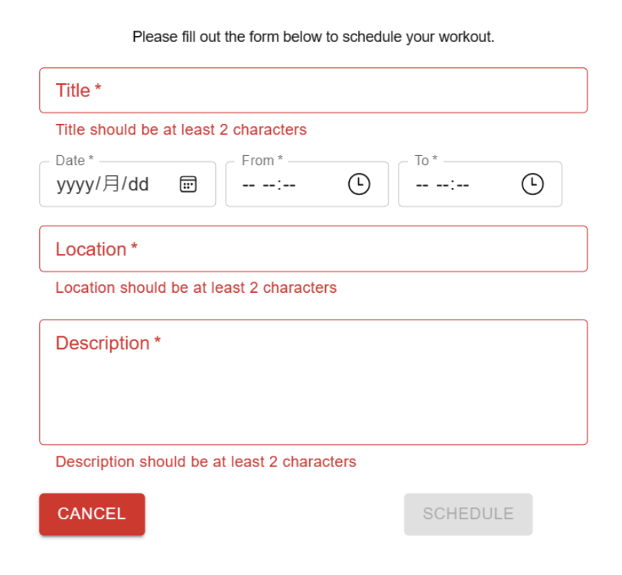

Another feature that the Google Calendar API provides is the ability to display calendars. In our application, we can use the Google Calendar API to display this calendar allowing the users to see the upcoming workouts. This allows the users to plan and see future workouts.

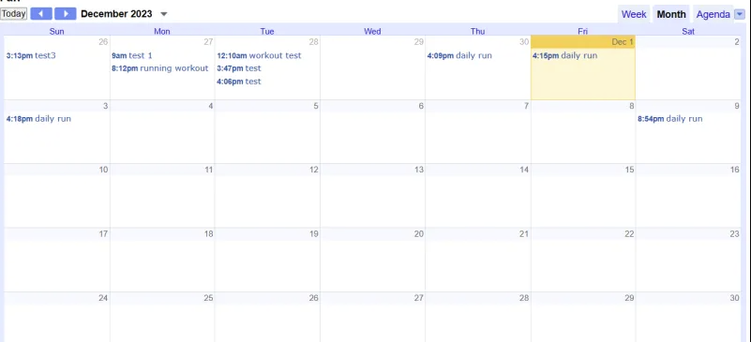

Strava Features

Connecting our application to the Strava API allows for users to upload their workouts to Strava. Users input the title, date, duration, distance, and location of the workout. The workout gets uploaded to their Strava account. Anyone who follows them on Strava can see their workout.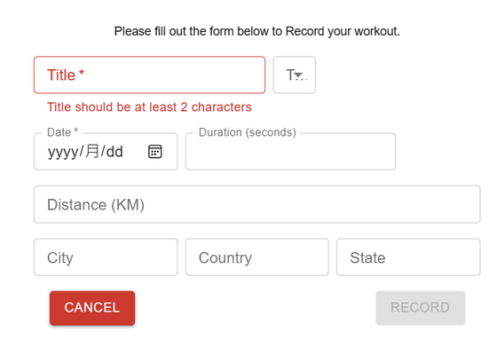

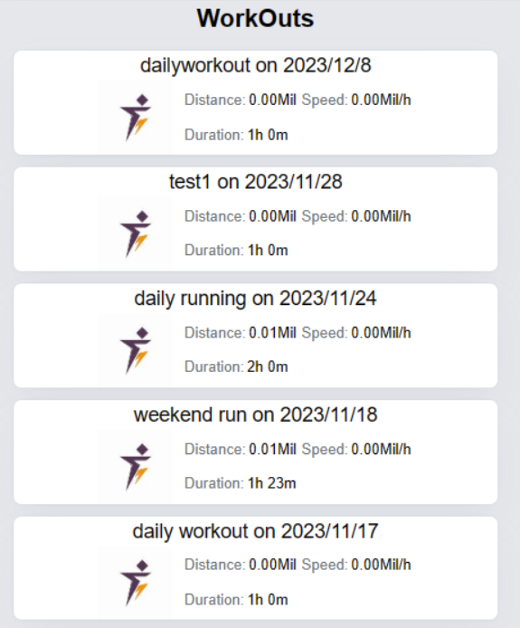

The Strava API allows for the recall of past

events. Using this feature, we provide our

users with a list of their past completed

workouts. This allows users to compare there

current results to their past to check for

improvement.

# Code Testing

# CICD Infrastructure

# High-Level Data Flow Diagram

Data Flow Diagram Level 0

[Link to larger image](https://www.figma.com/file/FkUgTRag6I912bowKIK9jA/DFD-level-0?type=design&node-id=0-1&mode=design&t=TShjKA5u3ArW48uR-0)

Our application (Center) is the link between the users Google Calendar and Strava. A client will be able to interact with both apps through a single interface saving them time, and providing an easier way to schedule runs into their Google Calendar app.

# Challenges

# Lessons Learned

Scope of project:

From this project, we learned that we must plan and set in stone exactly what our project will do before we start working on any other steps of the planning stage. This will ensure that we don’t fall victims of scope creep.

Kanban SDLC Methodology:

Perhaps the most important takeaway for our group was just how important following a proven SDLC methodology is. Although we did not purposefully ignore the creation of our Kanban board, we did try to follow one the best we could through our messaging platform. Safe to say, that we will always prioritize setting up an SDLC methodology in the planning phases of future projects.

Adaptability:

Through the many challenges we went through to complete this project, our group learned the power of being adaptable when unforeseen circumstances arise.

To list a few:

* A group member left
* Needed to find a third API to show us a map
* Switched from GitHub to Heroku and back to GitHub for our CICD
* Added a database to maintain the functionality of our APIs

Although we are bound to encounter many more issues throughout our careers, we learned why agile practices are the most popular methodologies in the workplace.

# Work Division

Brian – Planning, organization, Formatting Reports, Presentation Slides, Scheduling Meetings

Report: Project Over View, Kanban Methodology, Lessons Learned, Challenges

M1 Presentation Slides:

Ian – Programing, CICD, Testing

Presentation Slides:

Chris – Report: High-Level Features, Google Calendar Features, Strava Features, Code Testing,

CICD Infrastructure

Presentation Slides: