**Front End Web-Development**

‘Scoala Informala de IT’

Final Project – ‘My CV’, Documentation.

Developer: BUFNEA Iancu-Marius

Mentor: Andrei Dascal

Cluj-Napoca

2022

Contents

Introduction 3

General Structure and Common Areas 4

Technologies/ Libraries/ Frameworks to be Used 5

Responsiveness 6

Market Research 7

Tasks Prioritization and Scheduling 8

Bibliography 9

# Introduction

**GOAL:** The main goal of the Final Project is to apply and practice the theoretical aspects taught during the Front End Web Development Course, provided by ‘Scoala Informala de IT’. It represents a challenge in that as many concepts as possible should be implemented during the development process.

**SCOPE:** The Scope of the Project is to build a CV-like Web-Site. The project that I have implemented is unique in that the CV is going to be available for on-line use only, it will not be printable, which is going to make it one of the most easy to read and comprehensive CV Platforms. Towards this increased readability goal I have implemented a series of features and traits that are ground-breaking in the field. One of them is represented by the fact that, unlike static CVs, this one has a dedicated menu from which the user can chose exactly what information he desires to inspect. For instance, the Academic information are going to be displayed separately so they are not amalgamated with the Skills section, which makes it very easy to read and comprehend. This feature is going to help the Hiring Team as well, simplifying for them the navigation from one section to another. This is especially helpful taking into consideration the fact that, according to a 2018 eye-tracking study, *recruiters skim resumes for an average of 7.4 seconds* (O’Donnell, 2018).

Fig.1 Dedicated Menu for each of the CV Sections, which makes navigation facile.

# General Structure and Common Areas

**Project Structure:**

There will be a total of 5 Pages as follows:

- HOME

- WORK AND EDUCATION (as a Dropdown Menu with 2 options)

-ACADEMIC INFORMATION

-WORK EXPERIENCE

- PERSONAL INFORMATION AND SKILLS

- CONTACT ME

**Common Areas:**

* **HEADER** (contains an image of me with a link to HOME), some very basic info about me (age, gender etc.).



Fig.2 Header Section with basic information

* **NAVBAR MENU** (which will be used as a means of Navigation between Pages. –Fig1).
* **FOOTER** (with Link to the main Social Platforms).



Fig.3 Footer Section

# Technologies/ Libraries/ Frameworks to be Used

* HTML 5
* CSS 3
* JAVA-SCRIPT (ES2015)
* BOOTSTRAP 5
* GitHub
* Visual Studio Code
* Grid (General Layout of the Page)
* Media Queries (see *Responsiveness* section)

# Responsiveness

**Mobile first**, supported on all devices, via **MEDIA QUERIES**, Thresholds:

/* Extra small devices (phones, 600px and down) */

@media only screen and (max-width: 600px) {...}

/* Small devices (portrait tablets and large phones, 600px and up) */

@media only screen and (min-width: 600px) {...}

/* Medium devices (landscape tablets, 768px and up) */

@media only screen and (min-width: 768px) {...}

/* Large devices (laptops/desktops, 992px and up) */

@media only screen and (min-width: 992px) {...}

/* Extra large devices (large laptops and desktops, 1200px and up) */

@media only screen and (min-width: 1200px) {...}

(Bose, 2022)

The Solution will be **supported across all devices** that are currently in use, it being Responsive in the sense that content feature (such as *height, width, size etc.)* will alter according to the size of the view port. It will also be **Mobile First**, considering that nowadays **92.1 percent of the people going online are using mobile devices** (Statista.com, 2022)**.**

# Market Research

* The solution that I am going to implement will be better than the already existing options on the market, in that it will be exclusively for electronic devices, not for printing, which will add a unique dynamic strucure to the CV.
* It will be much easier to read and the information will be structured in such a way that you can see exactly what you are interested in at any given time. For instance, if you are interested in the Education information, you are only going to see that section, so you dont get distracted by irrelevant information
* The design will be clean, and it will not contain any unnecessary elements or items, so you can read and see only the information you are interested in.

# Tasks Prioritization and Scheduling

1. Creation of the General Structure (Backbone) of the Site using **HTML**.
2. Applying appropriate style to the elements by using **CSS** and cretaing some new elements with **Bootstrap**.
3. Using **JAVASCRIPT** to create interactive components (The Films and Qoutes section in the *Canvas* that can be accessed from the Home Page).
4. Final Revisal and Optimization.

**TIME-FRAME:**

* 1) + 2) = 2 Weeks;
* 3) = ½ Week;
* 4) = ½ Week;

# Solution Architecture and Visual Aids

Fig.4 Home Page

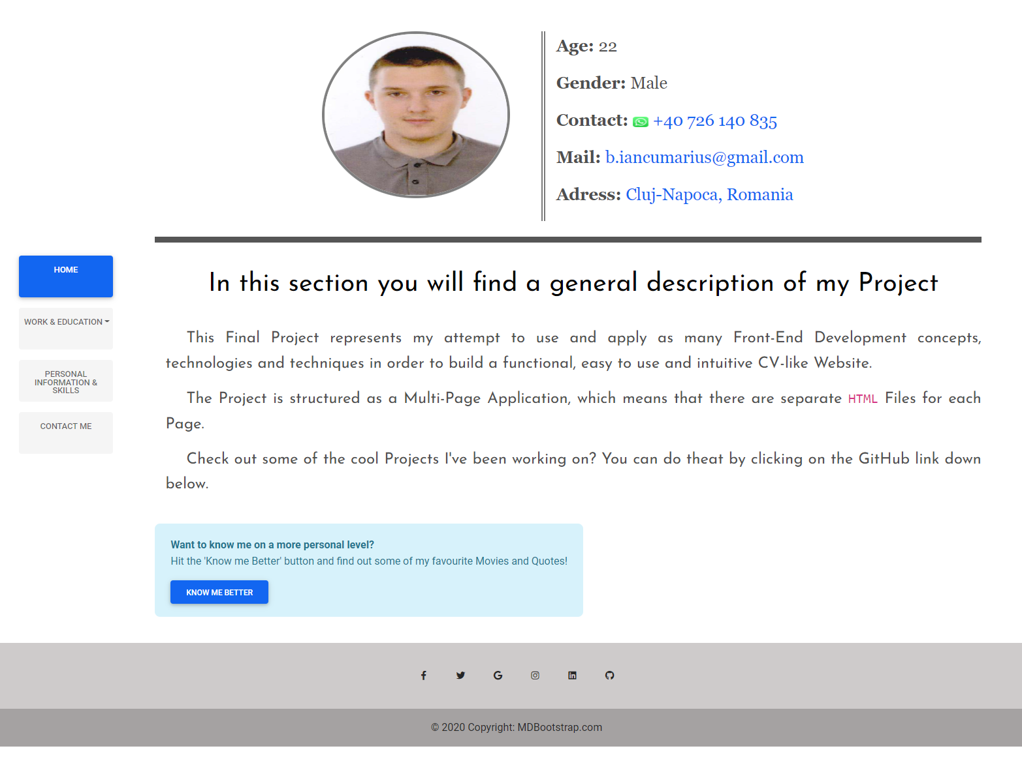

Fig.5 Academic Information Page

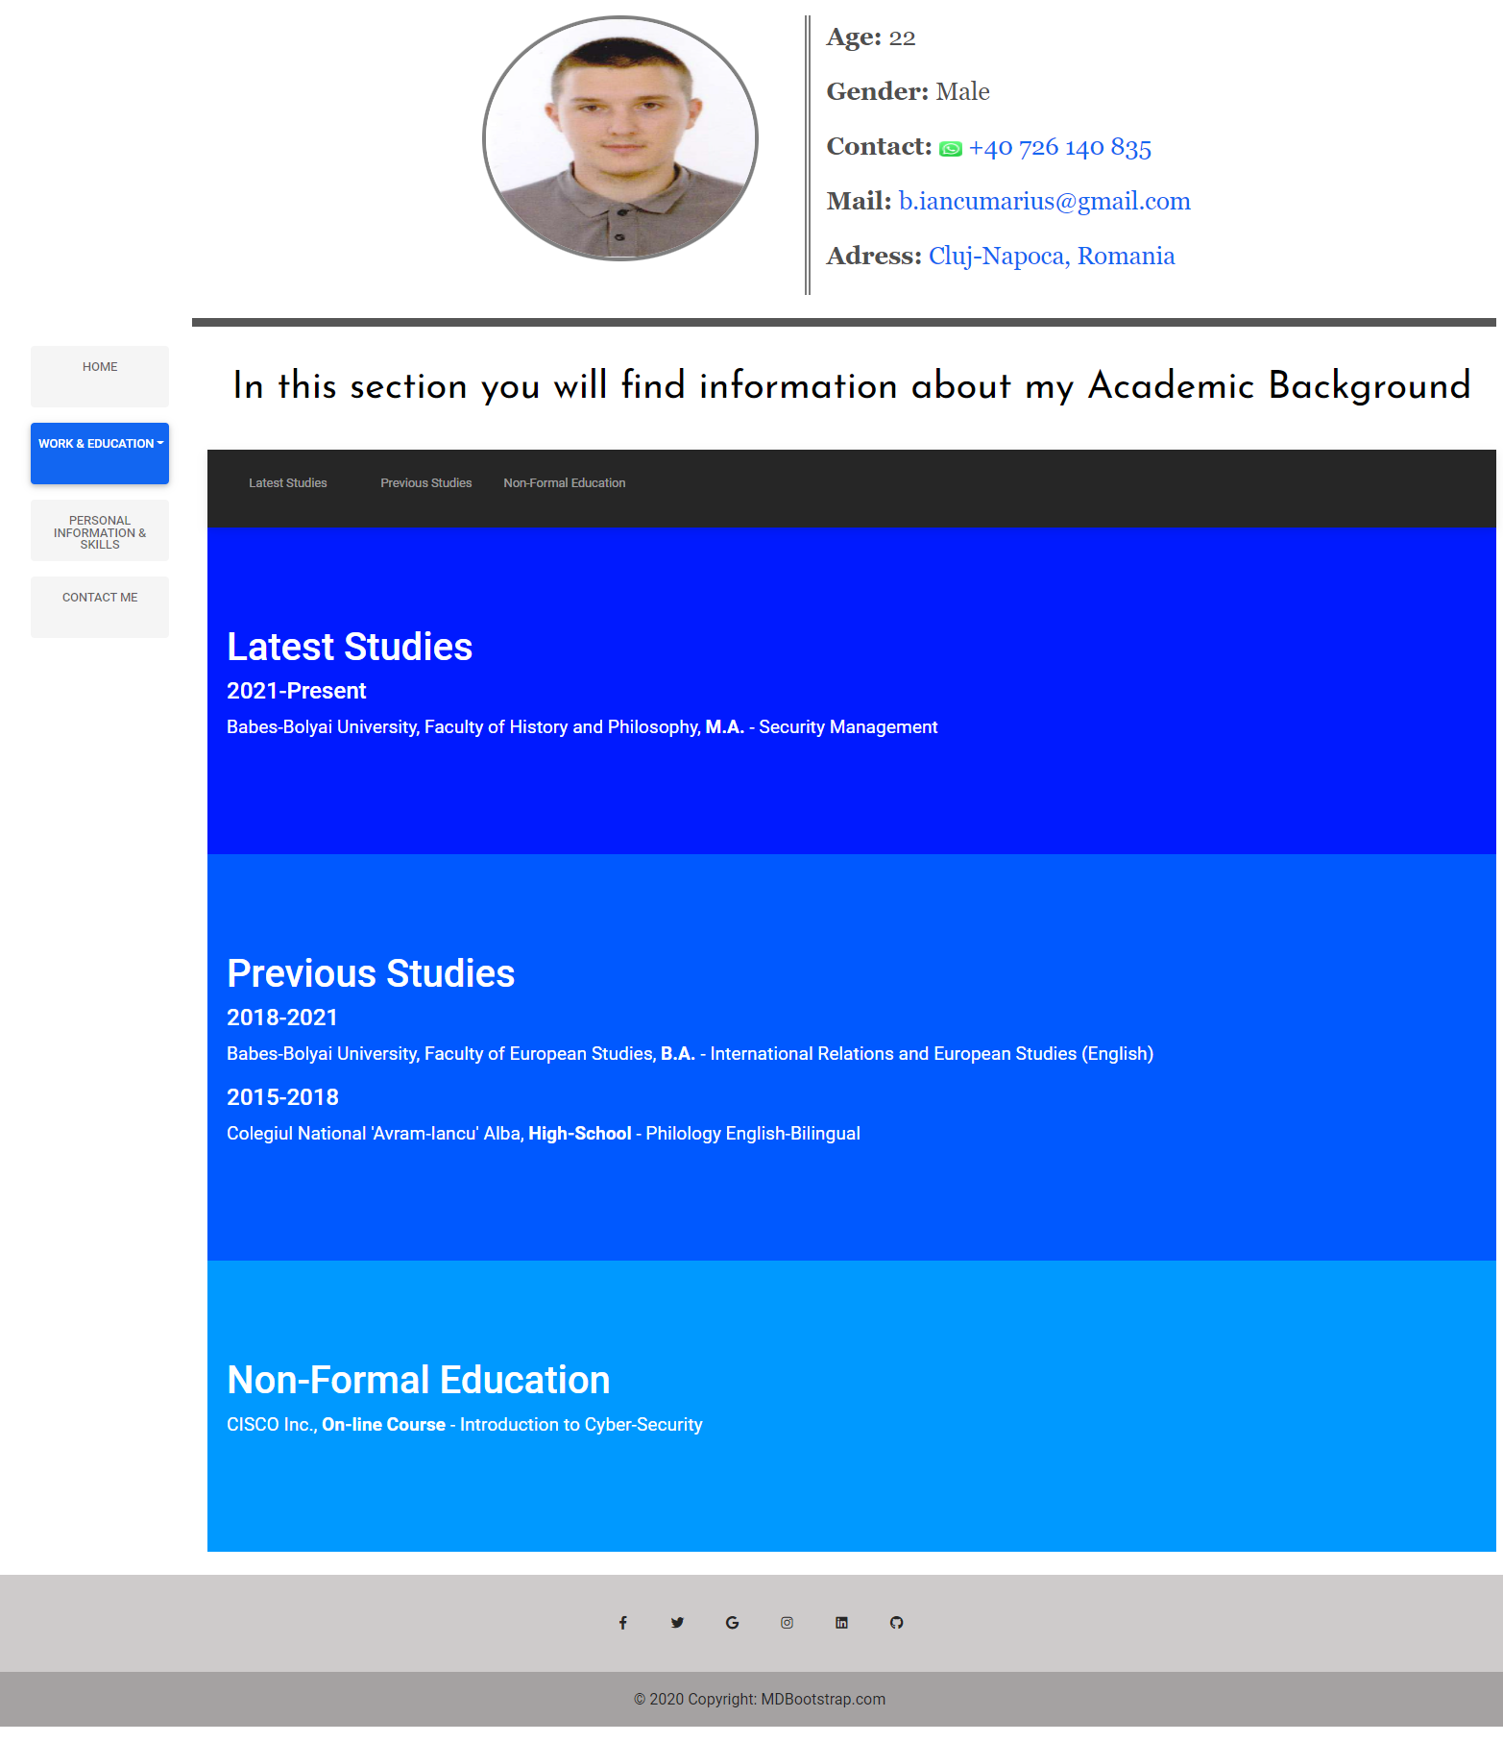

Fig.6 Work Experience Page

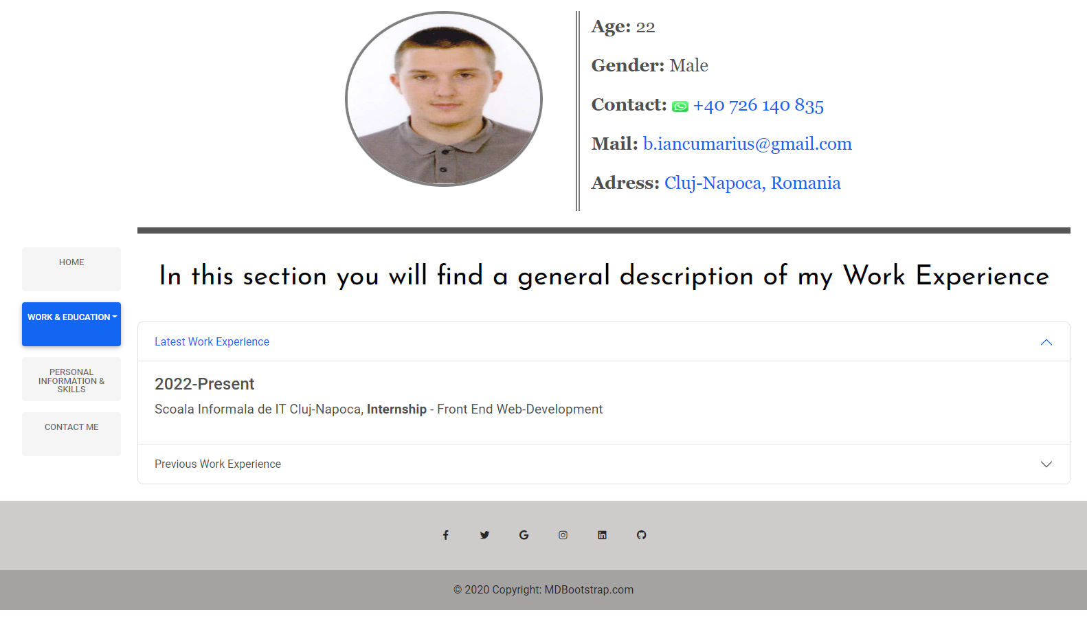

Fig.8 Contact Page

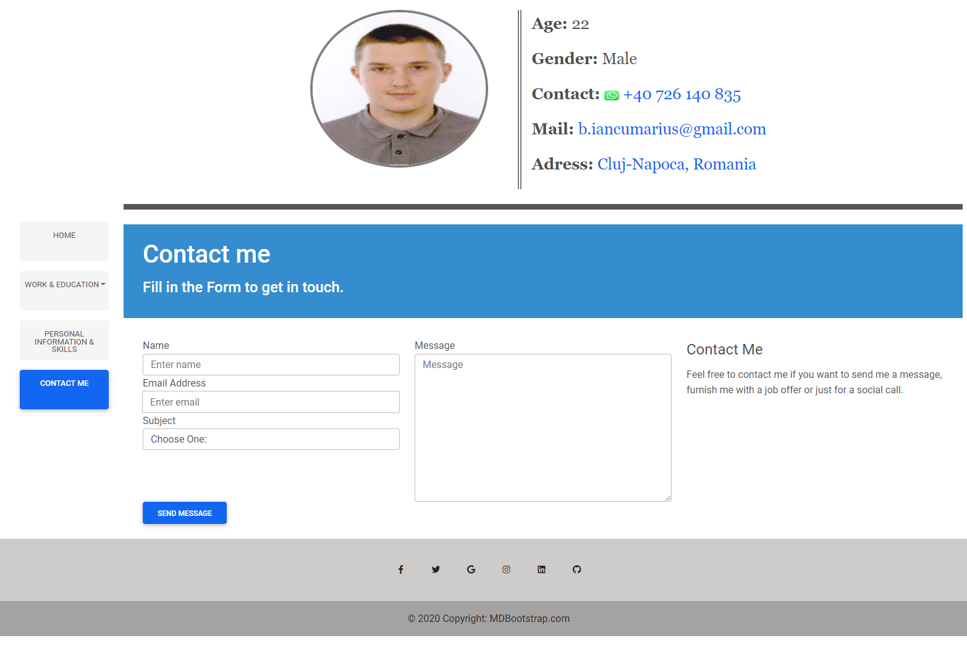

Fig.7 Personal Information Page

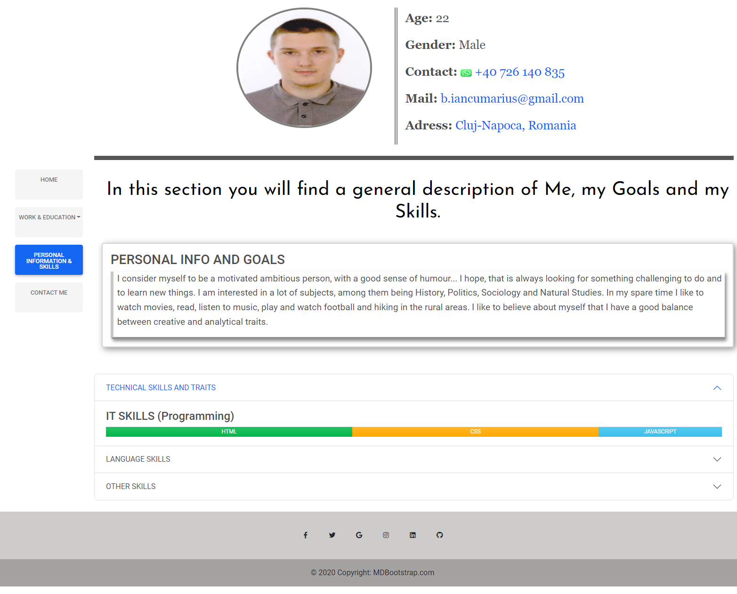

# Bibliography

Bose, S., 2022. *What are CSS Breakpoints and Media Query Breakpoints.* [Interactiv]   
Available at: https://www.browserstack.com/guide/what-are-css-and-media-query-breakpoints  
[Accesat 29 08 2022].

O’Donnell, R., 2018. *Eye tracking study shows recruiters look at resumes for 7 seconds.* [Interactiv]   
Available at: https://www.hrdive.com/news/eye-tracking-study-shows-recruiters-look-at-resumes-for-7-seconds/541582/  
[Accesat 22 08 2022].

Statista.com, 2022. *Share of users worldwide accessing the internet in 1st quarter 2022, by device.* [Interactiv]   
Available at: https://www.statista.com/statistics/1289755/internet-access-by-device-worldwide/  
[Accesat 30 08 2022].