Wage Disparity Amongst Genders in the Health Practitioner Industry

Data Overview:

* Analysed occupation codes 3000-3540, focusing on health practitioners.
* Created variables: gender (numeric binary), weekly wages, log of wages.

Descriptive Analysis:

* Wage distribution: Initially right skewed, normalized after log transformation.
* Earnings histogram by gender: Indicates higher average weekly earnings for males and a higher number of females in the sample.

Unconditional Wage Gap Analysis:

* OLS regression model indicated a significant wage gap, with females earning lower wages (decrease of 0.132 in log wages, p < 0.01).
* Model's low R-Squared (0.8%) implies gender alone is not a comprehensive indicator of wage disparities.

Impact of Education Levels:

* Analysed BA, MA, Professional, and PhD degrees.
* Higher education correlated with increased weekly earnings.
* Males out-earned females across all education levels, but with overlapping ranges, indicating some uncertainty in the exact disparity.

Regression Models Summary:

* Conducted 11 regression models, but will reflect on the last three here, which explore education levels, gender, and wages.
* Model 10 (Females): Education level positively impacts log wages, explaining 13.8% of variance.
* Model 11 (Males): Education level influences log wages (9.7% increase), professional degree significantly boosts wages.
* Model 12 (Gender Interaction): Education increases wages by 9.7%, but gender wage gap (27.6%) not statistically significant. Overall, degrees do not significantly affect gender wage disparities.

Predictive Modelling and Interpretation:

* Confidence intervals in predictive models indicate consistent higher earnings for males across all education levels.
* Professional degrees show the least overlap in gender earnings, suggesting a more pronounced disparity at this education level.

Conclusion:

* Clear wage disparities exist between genders in the healthcare practitioner industry.
* Further research needed to explore other factors influencing this gap and to develop better predictive models.
* Levels of education were found to not significantly affect gender wage disparities.

**Regression Models 10, 11, and 12**

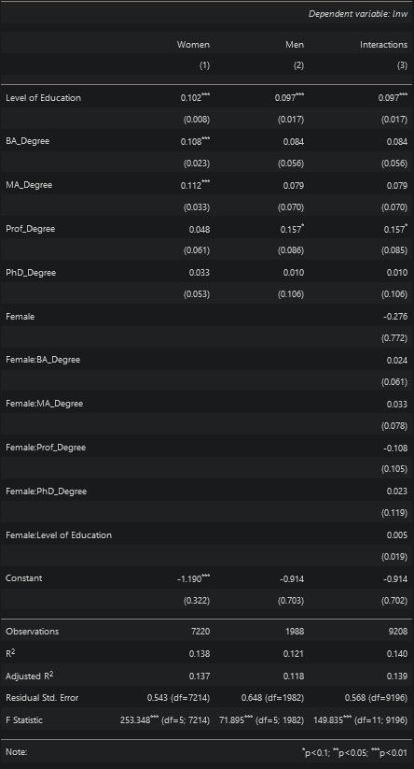

**Boxplot:**

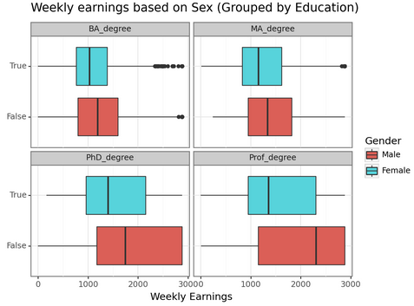

**Point Plot with Error Bars:**

