Data Process & Software Modelling

Assessment Phase 1: Project Progress Report and Presentation (50%)

Presented By:
Christian Danielle B. Cantos

Submitted To:
Abubakar Siddique

April 2026
Problem Statement
Air New Zealand currently manages its flight operations, reservations, and customer interactions through a combination of disconnected tools and manual processes. These fragmented systems create inefficiencies that impact stuff productivity, operation accuracy, and the overall passenger experience.

Air New Zealand lacks a unified, centralized flight booking system that allows both customers and internal staff to efficiently search, book, manage, and track flight reservations in one place. The absence of such a system leads to duplicated data entry, inconsistent booking records, delayed responses to cancellations or changes, and a substandard booking experience for passengers.

Key Features:

Admin:
- Add Flights
- Update Flights
- Remove Flights
- View all bookings
- View flight occupancy
Customer:
- Search Flights
- View flight details
- Book flights
- View their own bookings
- Cancel their own bookings
Guest:
- Search Flights
- View flight details
- Must log in to book

Task 1: Organizational and System Analysis

Overview of the Selected Organization
Air New Zealand is the national flag carrier of New Zealand, headquartered in Auckland and a member of the Star Alliance since 1999. The airline operates an extensive global network that supports both passenger and cargo services across domestic and international routes. Each year, Air New Zealand transports more than sixteen million passengers and operates over four hundred flights daily to forty-nine destinations worldwide.
As a modern airline, Air New Zealand relies heavily on a suite of digital systems that support critical business functions, including booking, ticketing, flight management, customer service, and revenue operations. These systems form the backbone of the airline’s operational efficiency and customer experience. The Customer & Digital Department is responsible for overseeing and maintaining these digital platforms, ensuring seamless service delivery across all customer touchpoints.
According to the airline’s 2025 annual report, Air New Zealand operates a fleet of 113 aircraft and employs approximately 11,700 staff globally. The scale of its operations underscores the importance of robust, reliable, and secure digital systems to support day-to-day activities and long-term strategic goals.

Departmental structure and responsibilities
Here are the key departments that are relevant to my flight booking system:
- Finance & Corporate Services Department – revenue management, fair pricing, payment processing, refunds, and financial reporting. The booking system handles transactions, fare classes, taxes, and booking revenue tracking.

- Operations Department – manages flight operations such as flight schedules, aircraft availability, gate assignments, and on-ground services. The booking system must reflect real-time flight status, capacity, and operational changes like delays or cancellations.

- Customer & Digital Department – responsible for technology platforms, digital innovation, customer-facing application, and data systems. The booking system is a core digital platform this team designs, builds, and maintains. It also handles passenger profiles, booking modifications, and booking history.

- People & Culture – manages staff roles, access permissions, and system user management. The booking system needs role-based access control to distinguish agents, admins, and customers within the platform.

Identification of stakeholders and user roles
In this system, there are 6 stakeholders that will be directly and indirectly involved which not only affects the main users through operations but heavily relies on the system’s output.
Stakeholders:
- Customers (Passengers) – they use the system to search & view flight details, book flights, manages their bookings.

- Admin – they use the system to control bookings, such as viewing bookings details, monitor seat availability and updates flights.

- Guest – they use the system to search flights, and view flights availability. They can only book flights when they register.

- System Developers – we as a developer we do not directly use the system but are affected by it. We are the once who build, test and maintain the system.

- Airline Management – they don’t use the system directly but highly affected by it. They rely on the system’s output for flight operations, revenue, scheduling, and customer experience.

- IT Support / System Administrator – they don’t use the system directly but highly affected by it. They are the ones who maintain and protect the system.

The Flight Booking System are going to be used by these 3 key user roles, each with different access levels.

User Roles:
- Admin – manages flight details, update flights, they exist to maintain accuracy and integrity of the flight database.

- Customers – a registered user who can book flight, check flight availability, manage their bookings.

- Guest – a non-registered user who has limited access.

System Scope, Boundaries, and Assumptions

System Scope
These are the features the system will include:
- User Authentication
- Login (Existing Customer)
- Register (New Customer)
- Role Identification (Admin, Customer, Guest)

- Flight Management (Admin-only Access)
- Add new flights
- Update existing flights
- Remove flights
- View all flights
- View flight occupancy

- Flight Search & Viewing
- Search flights by origin, destination, and date
- View flight details

- Booking Management
- Book flights
- View personal bookings
- Cancel bookings

- Data Storage
- Store users, flights, and bookings
- Database System (SQL)

- Input Validation
- Validate dates, seat availability, and user inputs

System Boundaries
This defines what the system will not do:
- Real-time airline integration
- No connection to actual airline APIs or databases

- Online Payment Processing
- No credit card, PayPal, or banking integration
- Only simulated booking confirmation

- Graphical User Interface
- Console Interface Only

- Seat Map Visualization
- No graphical seat selection

- Round Trip Bookings
- Only single-flight, one-way bookings

- Automatic pricing algorithms
- No dynamic pricing or revenue management

- Email or SMS notifications
- No external communication services

- Real-world security protocols
- No encryption, hashing, or enterprise-level security

System Assumptions

User & Data Assumptions
- User provides valid and truthful information (name, age, passport number, etc.)
- Admins are trusted and will not misuse their privileges.
- All users have basic knowledge of console navigation.

Technical Assumptions
- The console runs smoothly without any bugs.
- If used, data files must not be corrupted or altered.
- No multiple users can have access to the system.

Operational Assumptions
- No real-time updates are required (e.g., Flight delays, cancellations)
- The number of flights and bookings is manageable within console limitations.
- Flight data is manually maintained by Admin.

Environment Assumptions
- The system will run in a stable environment without unexpected shutdowns.
- System Administrators will handle:
  - Backup
  - Recovery
  - System Maintenance
  - Security Policies
Task 2: Requirements Engineering
Here we list down every functional and non-functional requirement of the flight

Functional Requirements

User Authentication & Account Management
FR1: The system shall allow users to login using valid username and password.
FR2: The system shall validate user credentials against the stored data.
FR3: The system shall determine the user’s role after successful login.
FR4: The system shall allow new users to create an account by providing required personal information.
FR5: The system shall prevent registration if the username already exists.
FR6: The system shall allow users to log out and return to the main menu.

Role-Based Access Control
FR7: The system shall display the admin menu when an admin logs in.
FR8: The system shall display the customer menu when a customer logs in
FR9: The system shall display the guest menu when no user is logged in.
FR10: The system shall restrict access to admin-only functions for non-admin users.

Flight Management (Admin only)
FR11: The system shall allow admins to add new flights by entering flight details (flight number, origin, destination, date, time, seat capacity, price).
FR12: The system shall allow admins to update existing flights from the system.
FR13: The system shall allow admins to remove flights from the system.
FR14: The system shall allow admins to view a list of all flights.
FR15: The system shall allow admins to view the number of booked and available seats for each flight.

Flight Search & Viewing
FR16: The system shall allow users to search for flights by origin, destination, and date.
FR17: The system shall allow users to view detailed information about a selected flight.

Booking Management (Customer Only)
FR18: The system shall allow customers to book a seat on a selected flight.
FR19: The system should validate that the number of seats requested does not exceed the available seats.
FR20: The system shall generate a booking record and confirmation code after a successful booking.
FR21: The system shall allow customers to view all their existing bookings.
FR22: The system shall allow customers to cancel their own bookings.
FR23: The system should update the number of seats booked after each booking or cancellation.
FR24: The system shall allow customers to view all their flight history.

Data Storage & Management
FR25: The system shall store user account information in a persistent storage medium.
FR26: The system shall store flight information in a persistent storage medium.
FR27: The system shall store booking information in a persistent storage medium.
FR28: The system shall load all stored data when the application starts.
FR29: The system shall save all updated data when the application closes.

Input Validation
FR30: The system shall validate all user inputs to ensure they are in the correct format.
FR31: The system shall validate that a selected flight exists before processing a booking or update.
FR32: The system shall prevent booking requests with zero, negative, or non-numeric seat values.

System Navigation & User Interface
FR33: The system shall display clear menus for each user role.
FR34: The system shall display meaningful error messages when invalid input is entered.
FR35: The system shall allow users to return to the main menu after completing an action.

Non-Functional Requirements

Performance Requirements
NFR1: The system shall load all required data within 3 seconds on startup.
NFR2: The system shall respond to user inputs within 1 second under normal operating conditions.
NFR3: The system shall process booking operations within 2 seconds.
NFR4: The system shall support up to 1,000 flights and 10,000 bookings without performance degradation.

Reliability Requirements
NFR5: The system shall maintain data integrity during all read/write operations.
NFR6: The system shall not lose data during normal operation.
NFR7: The system shall properly handle invalid inputs without crashing.
NFR8: The system shall recover gracefully from minor errors.

Availability Requirements
NFR9: The system shall be available for use whenever the host machine is operational.
NFR10: The system should not require an internet connection to function.
NFR11: The system shall allow users to resume normal operation after restarting the application.

Usability Requirements
NFR12: The system shall provide clear and readable text-based menus.
NFR13: The system shall display meaningful error messages for invalid inputs.
NFR14: The system shall allow users to return to the main menu from any submenu.
NFR15: The system shall require no prior technical knowledge beyond basic console navigation.

Security Requirements
NFR16: The system shall restrict admin-only functions to authenticated admin users.
NFR17: The system shall store user passwords in a secure format.
NFR18: The system shall prevent unauthorized access by validating all login attempts
NFR19: The system shall ensure that customers can only view and manage their own bookings.

Maintainability Requirements
NFR20: The system shall be modular, separating logic into components
NFR21: The system shall allow new features to be added without major restructuring.
NFR22: The system shall use clear and consistent naming conventions in code.
NFR23: The system shall allow flight, user, and booking data to be updated without modifying core logic.

Portability Requirements
NFR24: The system shall run to any machine that supports a standard console/terminal.
NFR25: The system shall not depend on platform-specific features.
NFR26: The system shall run on Windows, macOS, or Linux without require major changes.

Data Integrity Requirements
NFR27: The system shall prevent overbooking by validating seat availability before confirming a booking.
NFR28: The system shall update seat counts immediately after booking or cancellation.
NFR29: The system shall ensure that flight, user, and booking data remain synchronized across all operations.

Backup & Recovery Requirements
NFR30: The system shall save all data to persistent storage on exit.
NFR31: The system shall load the most recent saved data on startup.

Traceability between stakeholders and requirements
Stakeholders | Functional Requirements
Customers | FR1, FR2, FR3, FR4, FR5, FR6, FR8, FR10, FR16, FR17, FR18, FR19, FR20, FR21, FR22, FR23, FR24, FR25, FR27, FR28, FR29, FR30, FR31, FR32, FR33, FR34, FR35,
Admin | FR1, FR2, FR3, FR6, FR7, FR10, FR11, FR12, FR13, FR14, FR15, FR16, FR17, FR25, FR26, FR28, FR29, FR30, FR31, FR33, FR34, FR35
Guests | FR4, FR9, FR16, FR17, FR28, FR29, FR30, FR33, FR34, FR35
Developers | FR7, FR8, FR9, FR10, FR11, FR12, FR13, FR14, FR15, FR19, FR23, FR25, FR26, FR27, FR28, FR29, FR30, FR31, FR32
Airline Management | FR11, FR12, FR13, FR14, FR15, FR19, FR23, FR26, FR27, FR31, FR32
IT Supports | FR2, FR5, FR10, FR25, FR26, FR27, FR28, FR29, FR30

Stakeholders | Non-Functional Requirements
Customers | NFR1, NFR2, NFR3, NFR4, NFR5, NFR6, NFR7, NFR8, NFR9, NFR10, NFR11, NFR12, NFR13, NFR14, NFR15, NFR16, NFR17, NFR18, NFR19, NFR24, NFR25, NFR26, NFR27, NFR28, NFR29, NFR30, NFR31
Admin | NFR1, NFR2, NFR4, NFR5, NFR6, NFR7, NFR8, NFR9, NFR10, NFR11, NFR12, NFR13, NFR14, NFR15, NFR16, NFR17, NFR18, NFR23, NFR24, NFR25, NFR26, NFR29, NFR30, NFR31
Guests | NFR1, NFR2, NFR4, NFR7, NFR8, NFR9, NFR10, NFR11, NFR12, NFR13, NFR14, NFR15, NFR24, NFR25, NFR26, NFR30, NFR31
Developers | NFR1, NFR2, NFR3, NFR4, NFR5, NFR6, NFR7, NFR8, NFR16, NFR17, NFR18, NFR19, NFR20, NFR21, NFR22, NFR23, NFR24, NFR25, NFR26, NFR27, NFR28, NFR29, NFR30, NFR31
Airline Management | NFR4, NFR5, NFR6, NFR23, NFR27, NFR28, NFR29
IT Supports | NFR1, NFR2, NFR3, NFR4, NFR5, NFR6, NFR7, NFR8, NFR9, NFR10, NFR11, NFR16, NFR17, NFR18, NFR19, NFR20, NFR21, NFR23, NFR24, NFR25, NFR26, NFR29, NFR30, NFR31, NFR32

Task 3: UML Requirements Modelling

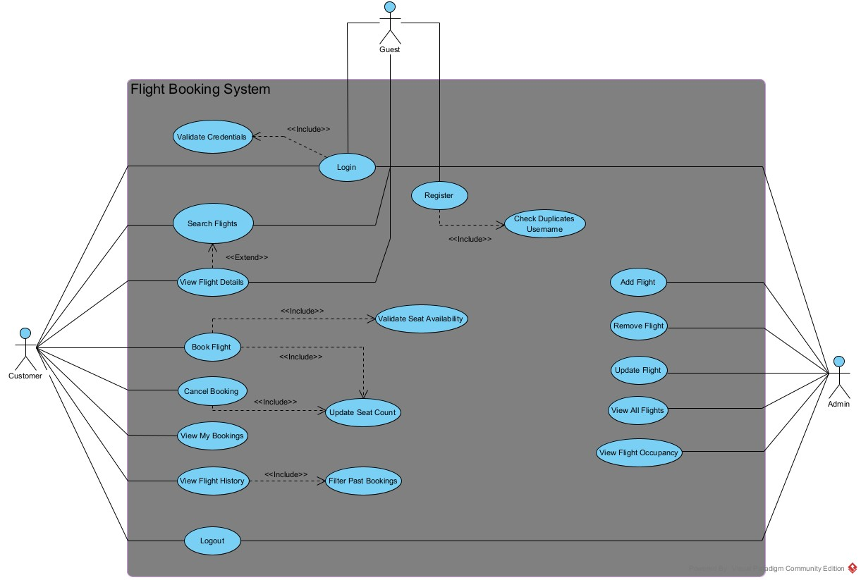
Use Case Diagram covering full system scope

The use case diagram for the flight booking system illustrates the interactions between three primary actors – Customer, Guest, Admin and the system’s core functionalities. Each actor represents a distinct role with different levels of access and responsibilities within the system.

Guests are unregistered users who can search for flights and view flight details, but they must be registered or log in if they want to book a flight. Customers are registered users who have access to all booking operations such as search flights, view flight details, booking flights, cancelling booking or even accessing their active bookings and viewing their previous flights. Admins have a high access control in the system, they operate flight operations such as adding flights, removing flights, updating flight information they can also view all existing flights and check flight occupancy.

The diagram uses includes relationships to represent mandatory sub-processes that must occur within certain use cases. Login includes validating credentials this sub-process makes sure that no one can have access to the system unless they are a registered user. Register includes checking duplicate usernames so that there will be no inconsistencies in data. Booking flights include validating seat availability, this checks if the seats are booked or not, this ensures data integrity and it includes updating seat count. Cancel booking includes updating seat count this sub-process makes sure that seat counts are accurate and avoid any double-booking. View flight history includes filter past bookings this is a sub-process where users can filter out their past bookings while viewing their flight history.

An extend relationships is used between search flights and view flight details this indicates that viewing flight details is an optional action that may occur after a user performs a flight search.

This use case diagram provides a high-level overview of how different users interact with the system and how internal processes support the main functionalities.

Minimum of 5 fully dressed user case descriptions

ID | UC01
Name | Login
Description | Users use their saved credentials to enter the system and to have access to a specific menu
Pre-conditions | Users must be registered in the system
Pre-conditions | System must be running
Event flow | 1. Users select “Login” from the main menu  2. System asks for username and password  3. Users enter credentials  4. System validates entered credentials  5. System identifies the user’s role (customer/admin)  6. System displays the appropriate menu for the role.
Post-condition | Success: User is logged in and session is created  Failure: User remains logged out
Extension points | None
Triggers | Users must run the system to login.

ID | UC05
Name | Book Flight
Description | Customers are allowed to reserve seats on a selected flight
Pre-conditions | Flight must be existing
Pre-conditions | Customers must log in with their accounts.
Event flow | 1. System prompt for number of seats  2. Customer enters seat count  3. System performs “Validate Seat Availability”  4. If seats are available, system creates a booking  5. System performs “Update Seat Count”  6. System stores the booking  7. System confirms successful booking.
Post-condition | Success: Booking is created and seat count updated.  Failure: No booking is created
Extension points | None
Triggers | Customer must search for flights.

ID | UC04
Name | View Flight Details
Description | Users view flight details after searching and entering flight information
Pre-conditions | Flights must exist.
Event flow | 1. Users must select “Search Flights”  2. System display search flight prompts  3. Users must enter flight information.  4. System checks if the flight based on the information entered does exists.  5. System Retrieves matching flights  6. System display list of flights.  7. User can optionally “View Flight Details”  8. If yes, system displays flight details.
Post-condition | Success: Users can view flight details  Failure: The flight does not exist.
Extension points | Use case 3 “Search Flights”
Triggers | Users must enter flight information.

ID | UC02
Name | Register
Description | Users must be registered to have access to a role-specific menu.
Pre-conditions | Users must enter username and password to create an account
Event flow | 1. The system displays main menu  2. Users selects “Register”  3. The system asks for username and password  4. The user must enter credentials.  5. The system checks if the username already exists.  6. The system creates the account and saves it.
Post-condition | Success: The system created a new account and saved it.  Failure: User remains Guest.
Extension points | None
Triggers | User must enter username and password

ID | UC03
Name | Search Flights
Description | Users search flights based on flight information
Pre-conditions | Users must enter flight information (date, time, origin, destination)
Event flow | 1. Users must select “Search Flights”  2. System prompts for search criteria  3. Users must enter flight information.  4. System checks if the flight based on the information entered does exists.  5. System retrieves matching flights  6. System display list of flights  7. User may optionally choose “View Flight Details”
Post-condition | Success: Users can pick from the list of flights displayed  Failure: There are no existing flights based on the flight information given by the user.
Extension points | Use Case 4 “View Flight Details”
Triggers | Users must enter existing flight information.

Task 4: Initial Structural Design and
Implementation Planning

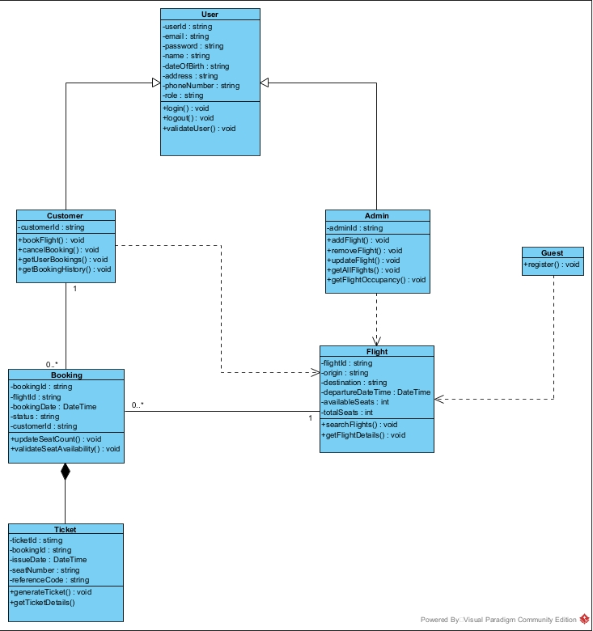
Initial UML Class Diagram

Mapping between UML classes and planned C# classes
Each UML classes directly maps to the planned C# implementation by treating each conceptual class a simple POCO. POCO or Plain Old CLR Object is basically a normal C# class with field or properties basically from my UML classes are all POCOs because it only contains fields with optional methods it does not connect to any framework or implements any required interfaces. User class in the UML class diagram is the foundational C# class that contains shared fields such as userId, email, password, name, dateOfBirth, address, phoneNumber, and role that is treated as a private field. Operates basic actions such as login(), logout(), and validateUser() that is implemented as public methods. Customer, Admin corresponds to each C# classes that inherits from the User class which shows generalization relationship in the UML. Customer class corresponds to a C# class methods that is related to booking operations such as bookFlight(), cancelBooking(), and getUserBookings, and getBookingHistory. Admin class corresponds to a C# class methods that is related to flight management operations such as addFlight(), removeFlight(), updateFlight(), getAllFlights(), getFlightOccupancy(). Guest are treated as a different entity that has only limited access to only searching flights, and view flight details which maps from the UML as a dependency towards Flight class. In UML Guest class corresponds to only one C# methods which is register(). The Flight Class maps to C# classes that contains flight attributes that is treated as private fields such as flightId, origin, destination, departureDateTime, availableSeats, totalSeats and operations such as searchFlights(), getFlightDetails() that are treated as public operations which shows dependency relationship from Customer and Guest classes this means Customer and Guest can temporarily use methods when they call it. The Booking class becomes a C# class holding booking data such as bookingId, flightId, bookingDate, status and also includes a simple validation operation like updateSeatCount(), and validateSeatAvailability(). Ticket class also corresponds to C# classes which shows ticket-attributes and treat as a private fields such as ticketId, bookingId, issueDate, seatNumber, referenceCode and implements simple methods such as generateTicket(), getTicketDetails(). The ticket class are shown in this UML class diagram to have a realistic approach on this system but will be implemented later on.

Identification of anticipated design weaknesses prior to OOP application

References:
https://www.airnewzealand.co.nz/executive
https://www.airnewzealand.co.nz/corporate-profile
https://p-airnz.com/cms/assets/PDFs/airnz-2025-annual-report.pdf

