NATIONAL UNIVERSITY — LAGUNA CAMPUS
Student Services Information System (SSIS)
System Diagrams and Database Design
Use case diagrams · Activity diagrams · Data flow diagrams · Class diagrams · ERD and 3NF
Development of a Web-Based Student Services Information System (SSIS) with Integrated Queuing, Clearance, and Document Request Modules Using Scrum Methodology
Course / section: CCS109 / 3IT-C
Document version: 1.0 (draft for team review)
Date: October 14, 2026
Project team (Scrum)
Villarosa, Cristina T. — Product Owner / Team Leader
Oca, Kenneth Ryan C. — Scrum Master
Rinon, Rojanne Aizach — Developer (front-end, UI/UX)
Manalo, Ian Israel C. — Developer (system design)
Ramos, Shan Kelvin Louise A. — Developer (database)
Alico, Cyreen G. — QA and documentation

Contents
1. Introduction Purpose, system summary, how the diagrams fit together, notation
2. Use case diagrams Actors, system diagram, use case catalogue, one diagram per actor
3. Activity diagrams Sign in, online enrollment, document request, digital queue
4. Data flow diagrams Data stores, context diagram, Level 1, Level 2, data flow dictionary
5. Class diagrams Users and roles, academic structure, enrollment, documents and payments, queue and security
6. Database design Overview and detailed ERDs, data dictionary, relationships, constraints, 3NF analysis
7. Traceability and open items Diagrams mapped to requirements; items for the team

List of figures
No. | Figure
1 | System use case diagram — all actors
2 | Student Portal use cases
3 | Registrar Module use cases
4 | Cashier Module use cases
5 | Department Module use cases
6 | Admin Module use cases
7 | Activity diagram — sign in with account lockout
8 | Activity diagram — online enrollment
9 | Activity diagram — document request
10 | Activity diagram — digital queue
11 | Context diagram (Level 0)
12 | Level 1 DFD, part 1 — accounts, enrollment, clearance, records
13 | Level 1 DFD, part 2 — documents, payments, queue, reports
14 | Level 2 DFD — process 2.0 Manage enrollment
15 | Level 2 DFD — process 3.0 Process document requests
16 | Level 2 DFD — process 5.0 Manage digital queue
17 | Class diagram 1 — users and roles
18 | Class diagram 2 — academic structure
19 | Class diagram 3 — enrollment and clearance
20 | Class diagram 4 — documents and payments
21 | Class diagram 5 — queue, notifications and security records
22 | Overview ERD — core tables grouped by area
23 | ERD 1 — accounts, departments and students
24 | ERD 2 — announcements, notifications, audit log, login attempts, settings
25 | ERD 3 — academic structure
26 | ERD 4 — enrollment, requirements and clearance
27 | ERD 5 — fees and payments
28 | ERD 6 — document requests
29 | ERD 7 — digital queue

1. Introduction

1.1 Purpose of this document
This document collects the system models and the database design of the Student Services Information System (SSIS) of National University — Laguna Campus. It contains the use case diagrams, activity diagrams, data flow diagrams, class diagrams, and the database design (entity-relationship diagrams and 3NF analysis) that the project paper requires.
The diagrams were drawn from the implemented system, not from the original plan: tables and columns come from the database schema in the code (server/schema.js), roles and rules from the server routes, and the processes from the working Student, Registrar, Cashier, Department and Admin portals. Where the implementation deliberately differs from a textbook design, the difference is stated.

1.2 The system in brief
SSIS lets students do school transactions online instead of lining up at several offices: they enroll, pay, track clearance, request documents and take a queue number. Registrar, Cashier, Department and Admin users process these services. It is a services system and not a learning-management system.
Module | Main users | What it does
Student Portal | Students | Subjects, schedule, grades, online enrollment, E-Clearance, balance, document requests, digital queue number
Registrar Module | Registrar staff | Student records, enrollment approval, subjects and grades, document requests, queue, reports
Cashier Module | Cashier | Payments and official receipts, fees, enrollment and document payment confirmation, collection reports
Department Module | Department staff | Subject review, academic requirements, department clearance, audited grade viewing
Admin Module | Administrators | Accounts and roles, departments, terms, settings, audit log, login attempts, reports
Document Request System | All of the above | Pending → For Payment → Processing → Ready for Release → Released
Digital Queue | Students and staff | Queue numbers per office, call next, estimated wait, notifications, reports

1.3 How the diagrams fit together
Diagram | Question it answers | Section
Use case diagrams | Who uses the system and what can each role do? | 2
Activity diagrams | In what order do people and the system act in the main processes? | 3
Data flow diagrams | What data moves between users, processes and data stores? | 4
Class diagrams | What are the main classes, their attributes, operations and relationships? | 5
ERD and 3NF | How is the data stored, related and normalised in the database? | 6

1.4 Notation
- Use case: ellipses inside the system boundary, stick figures outside; dashed arrows are «include» (always part of) and «extend» (optional extension).
- Activity: swimlanes for each actor; rounded boxes are actions, diamonds are decisions, the filled circle starts and the ringed circle ends the activity.
- Data flow (Yourdon / DeMarco): circles are processes, rectangles are external entities, open-ended boxes with an ID are data stores, arrows are labelled data flows.
- Class (UML): three-part boxes (name, attributes, operations); open triangles are inheritance; plain arrows are associations with multiplicities.
- ERD (crow’s foot): PK primary key, FK foreign key, UK unique; a crow’s foot marks the “many” side.
The diagrams are images generated from the system definition. They are drafts for the team to review; if the course requires a particular drawing tool, they can be redrawn there using this document as the reference.

2. Use case diagrams
Section 2.1 lists the actors, 2.2 shows the whole system, 2.3 catalogues every use case, and 2.4 gives one diagram per actor with the «include» and «extend» relationships.

2.1 Actors
Actor | Description | Signs in at
Student | Enrolled student who uses the services for their own record only | /login
Registrar | Registrar staff: records, enrollment approval, subjects, grades, document processing, queue | /registrar/login
Cashier | Collects payments, issues official receipts, confirms payments for enrollment and documents | /cashier/login
Department Staff | Reviews enrollment, verifies requirements and clears students of their own department only | /department/login
Administrator | Manages accounts, roles, structure and settings; reviews audit and login records | /admin/login

Common rule: every actor must sign in first. The server checks the role on every request, so a user can reach only the use cases of their own role. Department staff are further limited to students of their own department.

2.2 System use case diagram
The overview groups the use cases by actor. Every actor signs in before using any of them; the per-actor diagrams in section 2.4 show «include» and «extend» relationships.
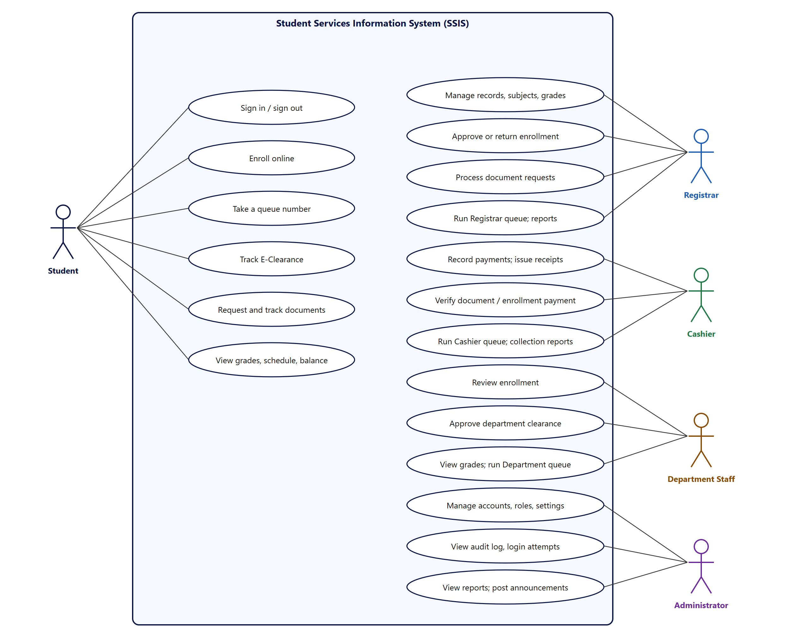
Figure 1. System use case diagram — all actors

2.3 Use case catalogue
Each use case has an identifier made of the actor letter (S, R, C, D, A) and a number. The rules column records the behaviour the system enforces.
ID | Actor | Use case | Summary and rules enforced
UC-S01 | Student | Sign in / sign out | Student number and password. Five wrong passwords lock the account for 15 minutes; failed attempts show how many are left.
UC-S02 | Student | View home dashboard | Next class, pending tasks, balance, queue number, E-Clearance and announcements.
UC-S03 | Student | View subjects, schedule, tracker | Enrolled subjects with instructors, rooms and times; weekly timetable; units earned.
UC-S04 | Student | View grades per semester | Prelim, Midterm, Finals; final grade only when all three are posted.
UC-S05 | Student | Enroll online | Choose subjects within the unit limit and submit; may be returned by the department or registrar and resubmitted.
UC-S06 | Student | Track enrollment progress | Five steps: Subject Selection, Department Review, Registrar Approval, Payment, Enrolled.
UC-S07 | Student | Track E-Clearance | Six offices with Cleared / Pending / Hold; the Cashier line follows the real balance.
UC-S08 | Student | View account summary | Assessment, fees, payments with official receipt numbers, balance and next due date.
UC-S09 | Student | Request a document | Choose type, copies, pickup date. Rejects past dates, bad copy counts and duplicates; Transcript and Diploma need full clearance.
UC-S10 | Student | Track document request | Status, history timeline and a notification at every step.
UC-S11 | Student | Cancel document request | Only while Pending or For Payment.
UC-S12 | Student | Take a queue number | Registrar, Cashier or own Department; one active ticket at a time; shows position and estimated wait.
UC-S13 | Student | Cancel queue number | Only while the ticket is Waiting.
UC-S14 | Student | Notifications and profile | Read notifications; update contact details, theme and password.
UC-R01 | Registrar | Manage student records | Add or edit students; new accounts get a one-time temporary password.
UC-R02 | Registrar | Verify student records | Marks a record verified; enrollment approval requires it.
UC-R03 | Registrar | Approve or return enrollment | After department review; approval creates the student’s subject list.
UC-R04 | Registrar | Manage subjects and schedules | Offer or hide subjects; room and instructor conflicts are rejected.
UC-R05 | Registrar | Enter and update grades | Grades must be 0–100; the student is notified.
UC-R06 | Registrar | Manage clearance lines | Library, laboratory, guidance and registrar lines.
UC-R07 | Registrar | Process document requests | Approve (moves to For Payment, or Processing when free) or cancel.
UC-R08 | Registrar | Mark ready and release | Ready for Release, then Released; steps cannot be skipped.
UC-R09 | Registrar | Run the Registrar queue | Name the counter, call next, mark done or skip.
UC-R10 | Registrar | Generate reports | Documents, enrollment, clearance and queue; CSV and print.
UC-R11 | Registrar | Post announcements | Students are notified of new posts.
UC-C01 | Cashier | View student balances | Assessed, paid, balance and percent paid.
UC-C02 | Cashier | Manage fee lines | Add, edit, remove fee lines.
UC-C03 | Cashier | Record payment | Amount cannot exceed the balance; issues a unique official receipt number.
UC-C04 | Cashier | Void a receipt | Reason required; the balance goes back up.
UC-C05 | Cashier | Confirm enrollment payment | Allowed only when the minimum percentage is paid.
UC-C06 | Cashier | Verify document payment | The exact fee is required; moves the request to Processing.
UC-C07 | Cashier | Run the Cashier queue | Same queue controls as the Registrar.
UC-C08 | Cashier | Collection reports | By period, document vs tuition, and payment method.
UC-D01 | Department | View department students | Only students of the staff member’s own department.
UC-D02 | Department | Review enrollment | Approve (to the Registrar) or return with a reason.
UC-D03 | Department | Verify academic requirements | Add, verify, mark missing or remove requirements.
UC-D04 | Department | Approve department clearance | Cannot clear while any requirement is unverified.
UC-D05 | Department | View student grades | Own department only; every view is written to the audit log.
UC-D06 | Department | Monitor clearance status | All six offices, read-only.
UC-D07 | Department | Run the Department queue | Same queue controls as the Registrar.
UC-A01 | Admin | Manage user accounts | Create staff, edit, disable or enable, unlock, reset password.
UC-A02 | Admin | Assign roles | Cannot change own role or remove the last administrator.
UC-A03 | Admin | Manage departments and programs | A department with students or staff cannot be deleted.
UC-A04 | Admin | Manage academic terms | Add terms and set the current one.
UC-A05 | Admin | Manage system settings | Maximum units, minimum payment percent, queue minutes, maximum copies; validated.
UC-A06 | Admin | View audit log | Who did what and when; searchable.
UC-A07 | Admin | View login attempts | Every sign-in attempt with time, address and reason; never the password.
UC-A08 | Admin | View reports and dashboard | Account counts, failed sign-ins, open requests, queue and collections.
UC-A09 | Admin | Post announcements | Same editor as the Registrar.

2.4 Use case diagrams per actor
The next five pages show the use cases of each actor. A dashed arrow marked «include» means the use case always contains the other; «extend» means the arrow’s source is an optional addition to its target.

Student
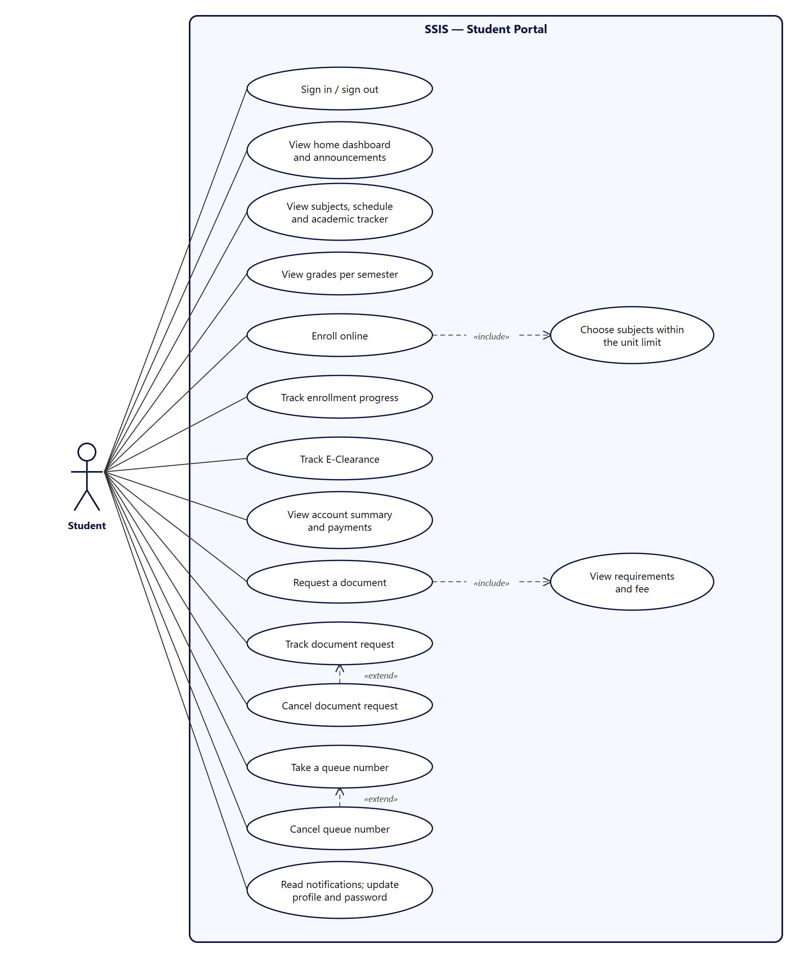
Figure 2. Student Portal use cases

Registrar
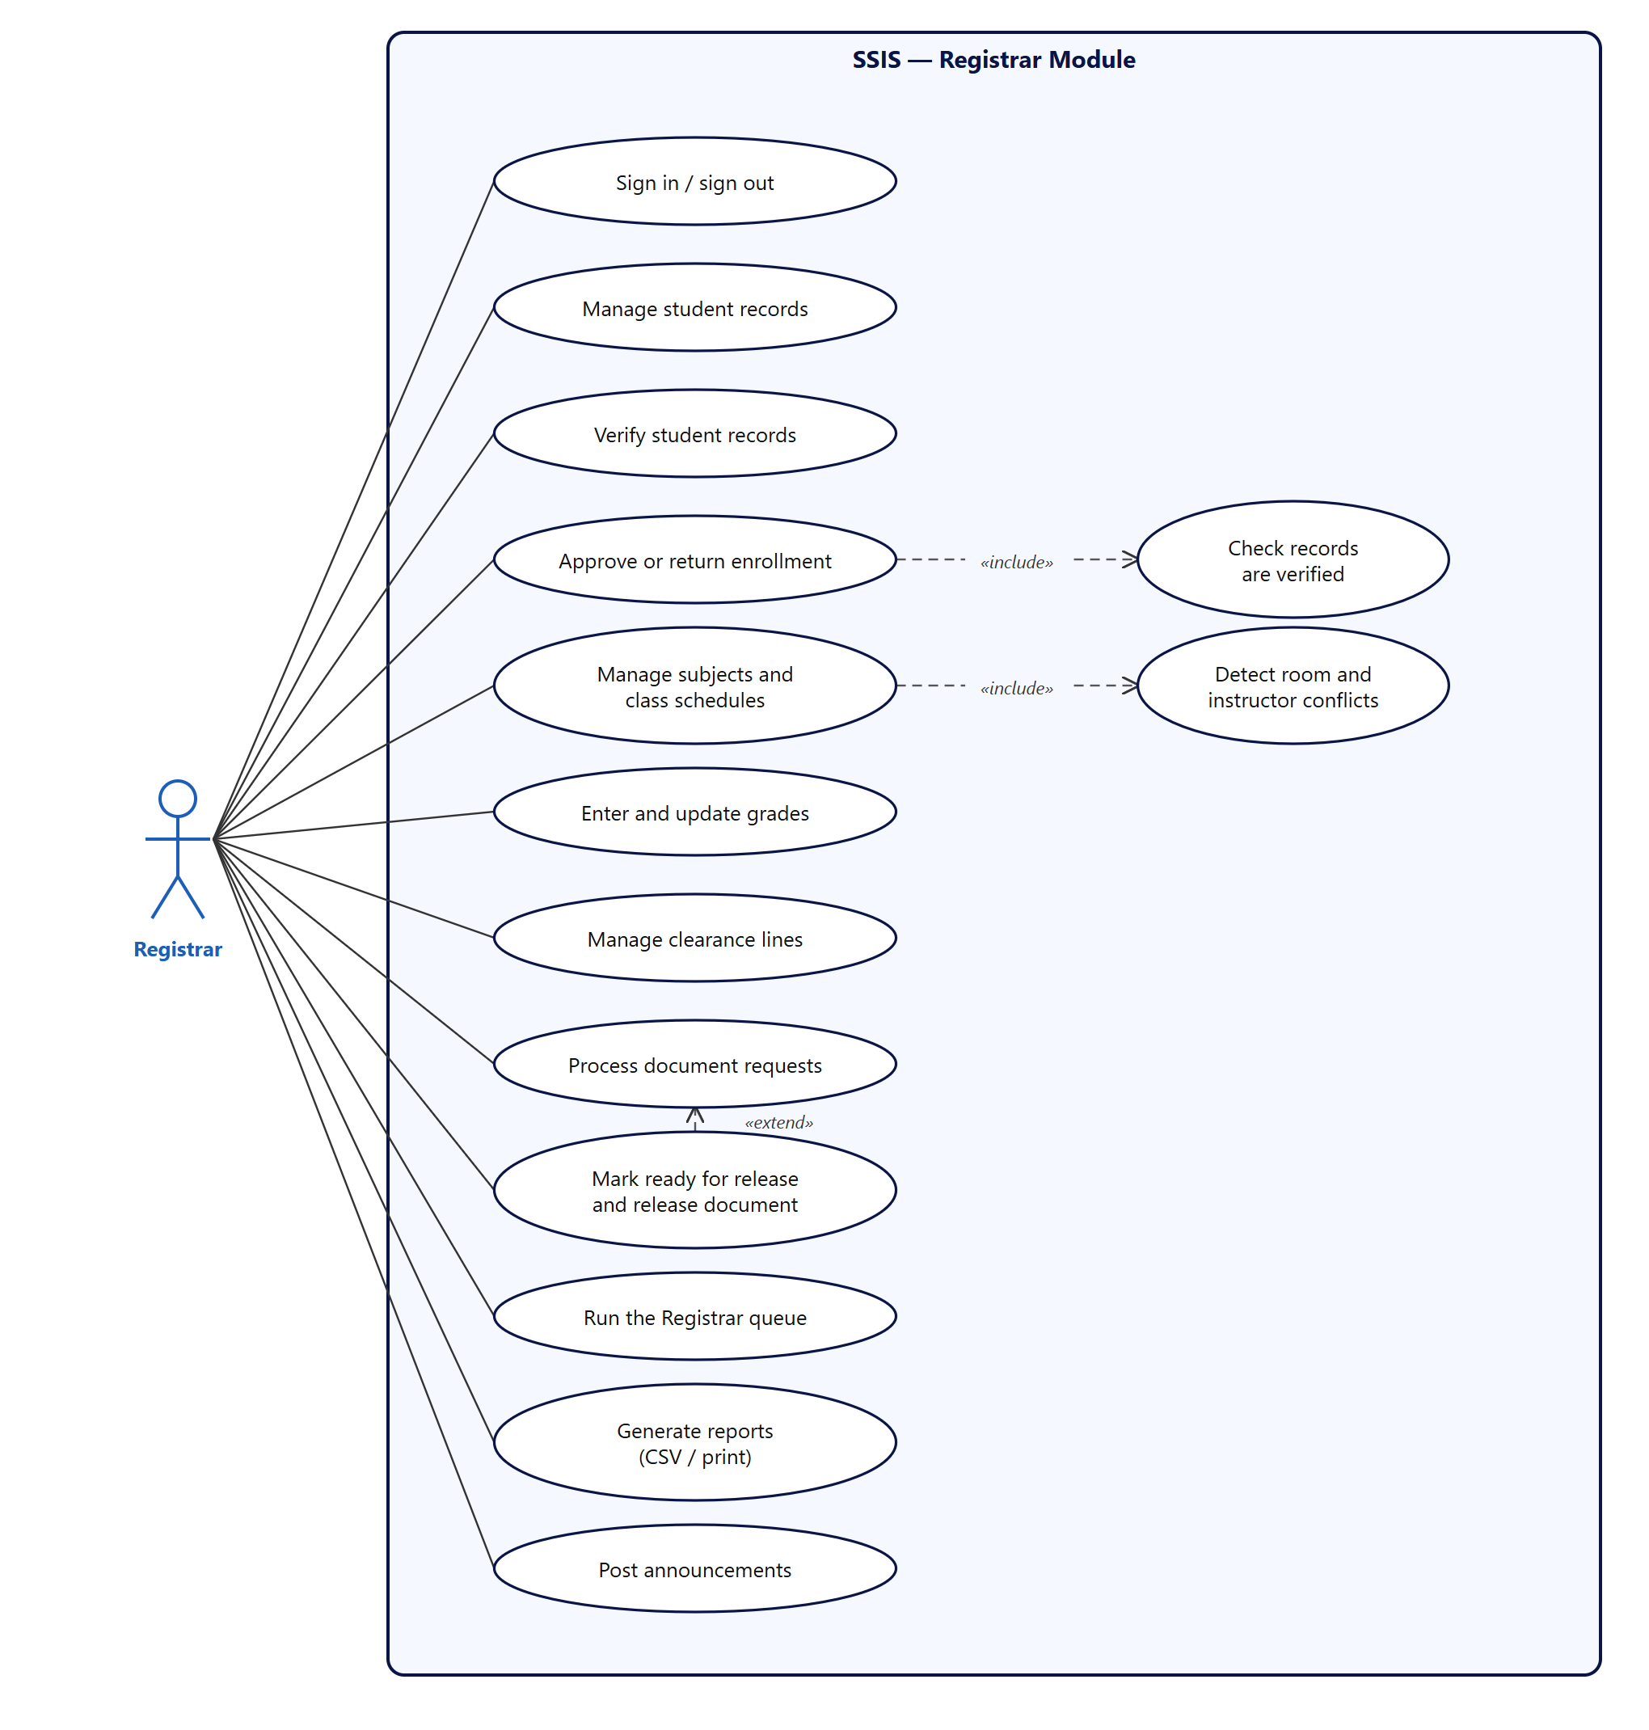
Figure 3. Registrar Module use cases

Cashier
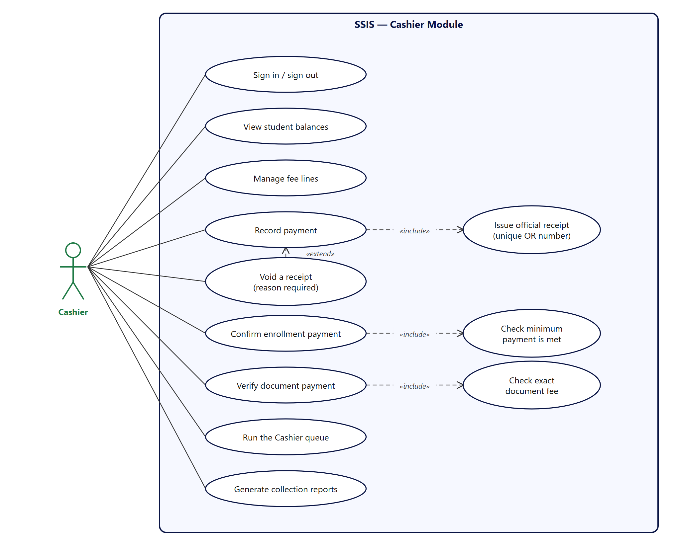
Figure 4. Cashier Module use cases

Department staff
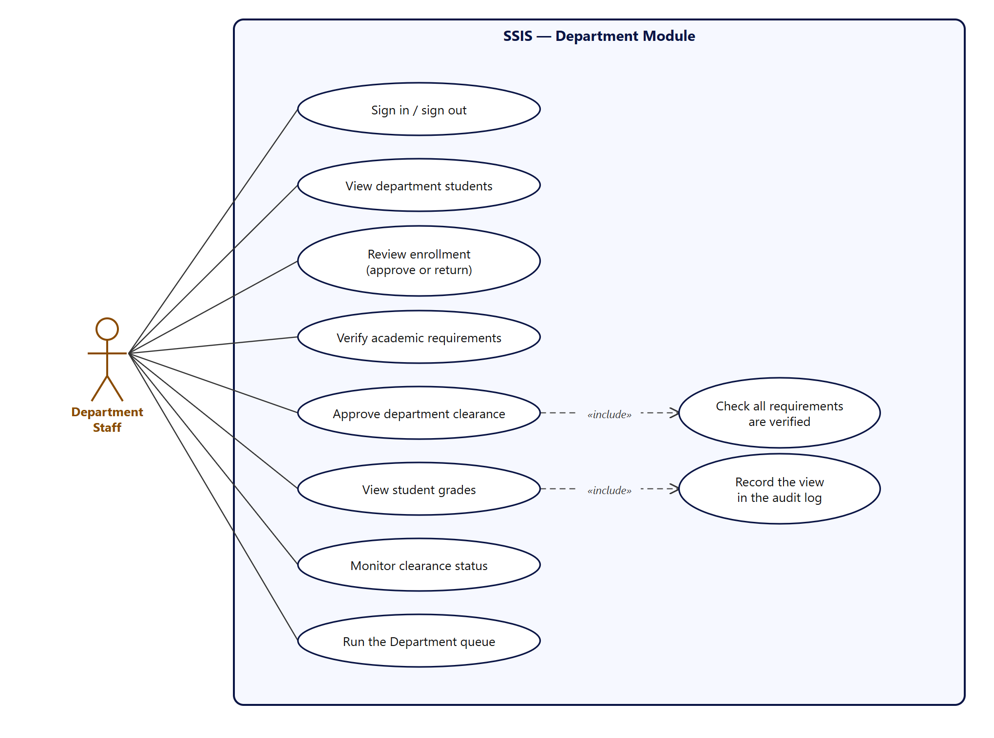
Figure 5. Department Module use cases

Administrator
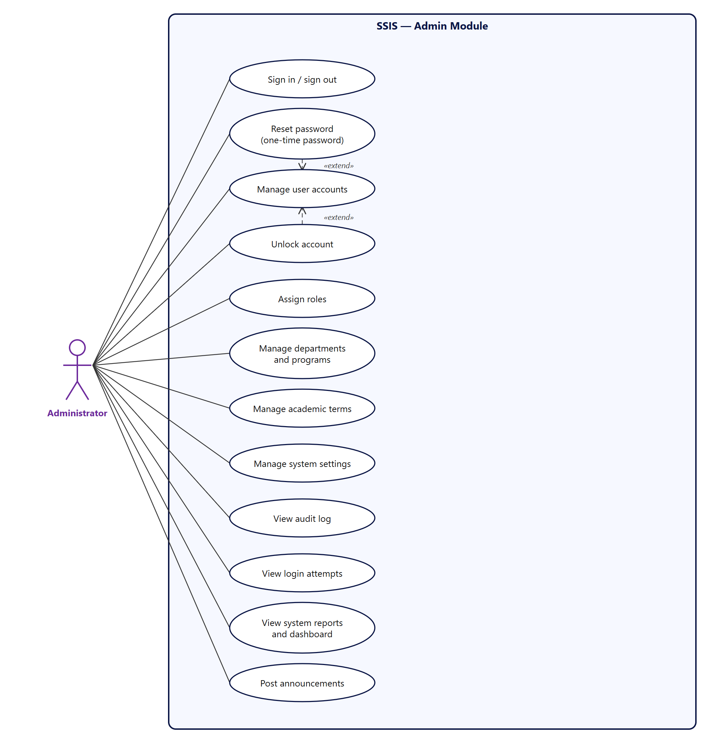
Figure 6. Admin Module use cases

3. Activity diagrams
Four processes are modelled with swimlanes. Each lane is an actor or the system, so the diagrams show who does what and where control passes between them.
Diagram | Lanes | Backlog items
3.1 Sign in with lockout | User, System, Database | SP-01, SQ-01, SQ-02
3.2 Online enrollment | Student, Department, Registrar, Cashier | SP-03, SP-04, RG-02, DP-02, CS-06
3.3 Document request | Student, System, Registrar, Cashier | DR-01 … DR-08
3.4 Digital queue | Student, System, Staff | QU-01 … QU-07

3.1 Sign in with lockout
A sign-in is checked against the per-IP throttle and the account lock before the password is verified. Wrong passwords are counted; the fifth one locks the account for 15 minutes. Every attempt, successful or not, is recorded for the administrator.
- The message for an unknown ID looks the same as for a wrong password, so it cannot be used to discover which accounts exist.
- A successful sign-in resets the failure counter and creates a 7-day session.
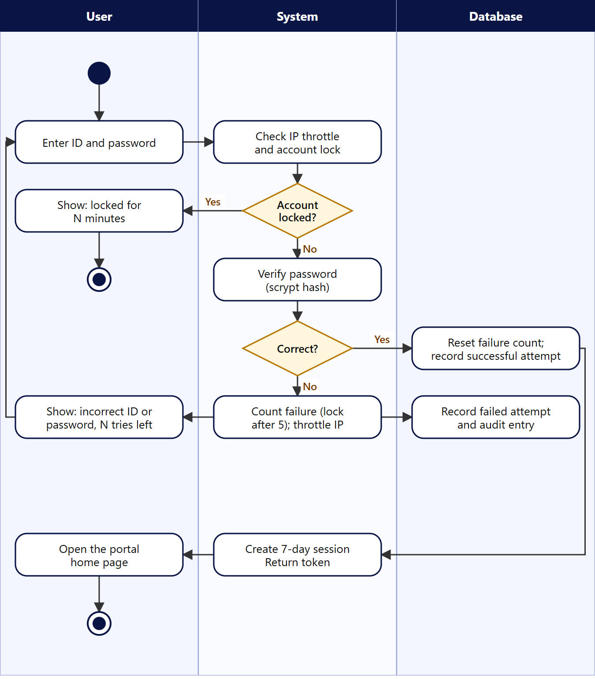
Figure 7. Activity diagram — sign in with account lockout

3.2 Online enrollment
Enrollment passes through three decision points: the department reviews the subject choice, the Registrar approves it (requires a verified record), and the Cashier confirms that the minimum payment is met.
- A return at either review sends the student back to edit and resubmit, with the reviewer’s reason.
- Payment below the minimum percentage keeps the request open; the student can pay more later.
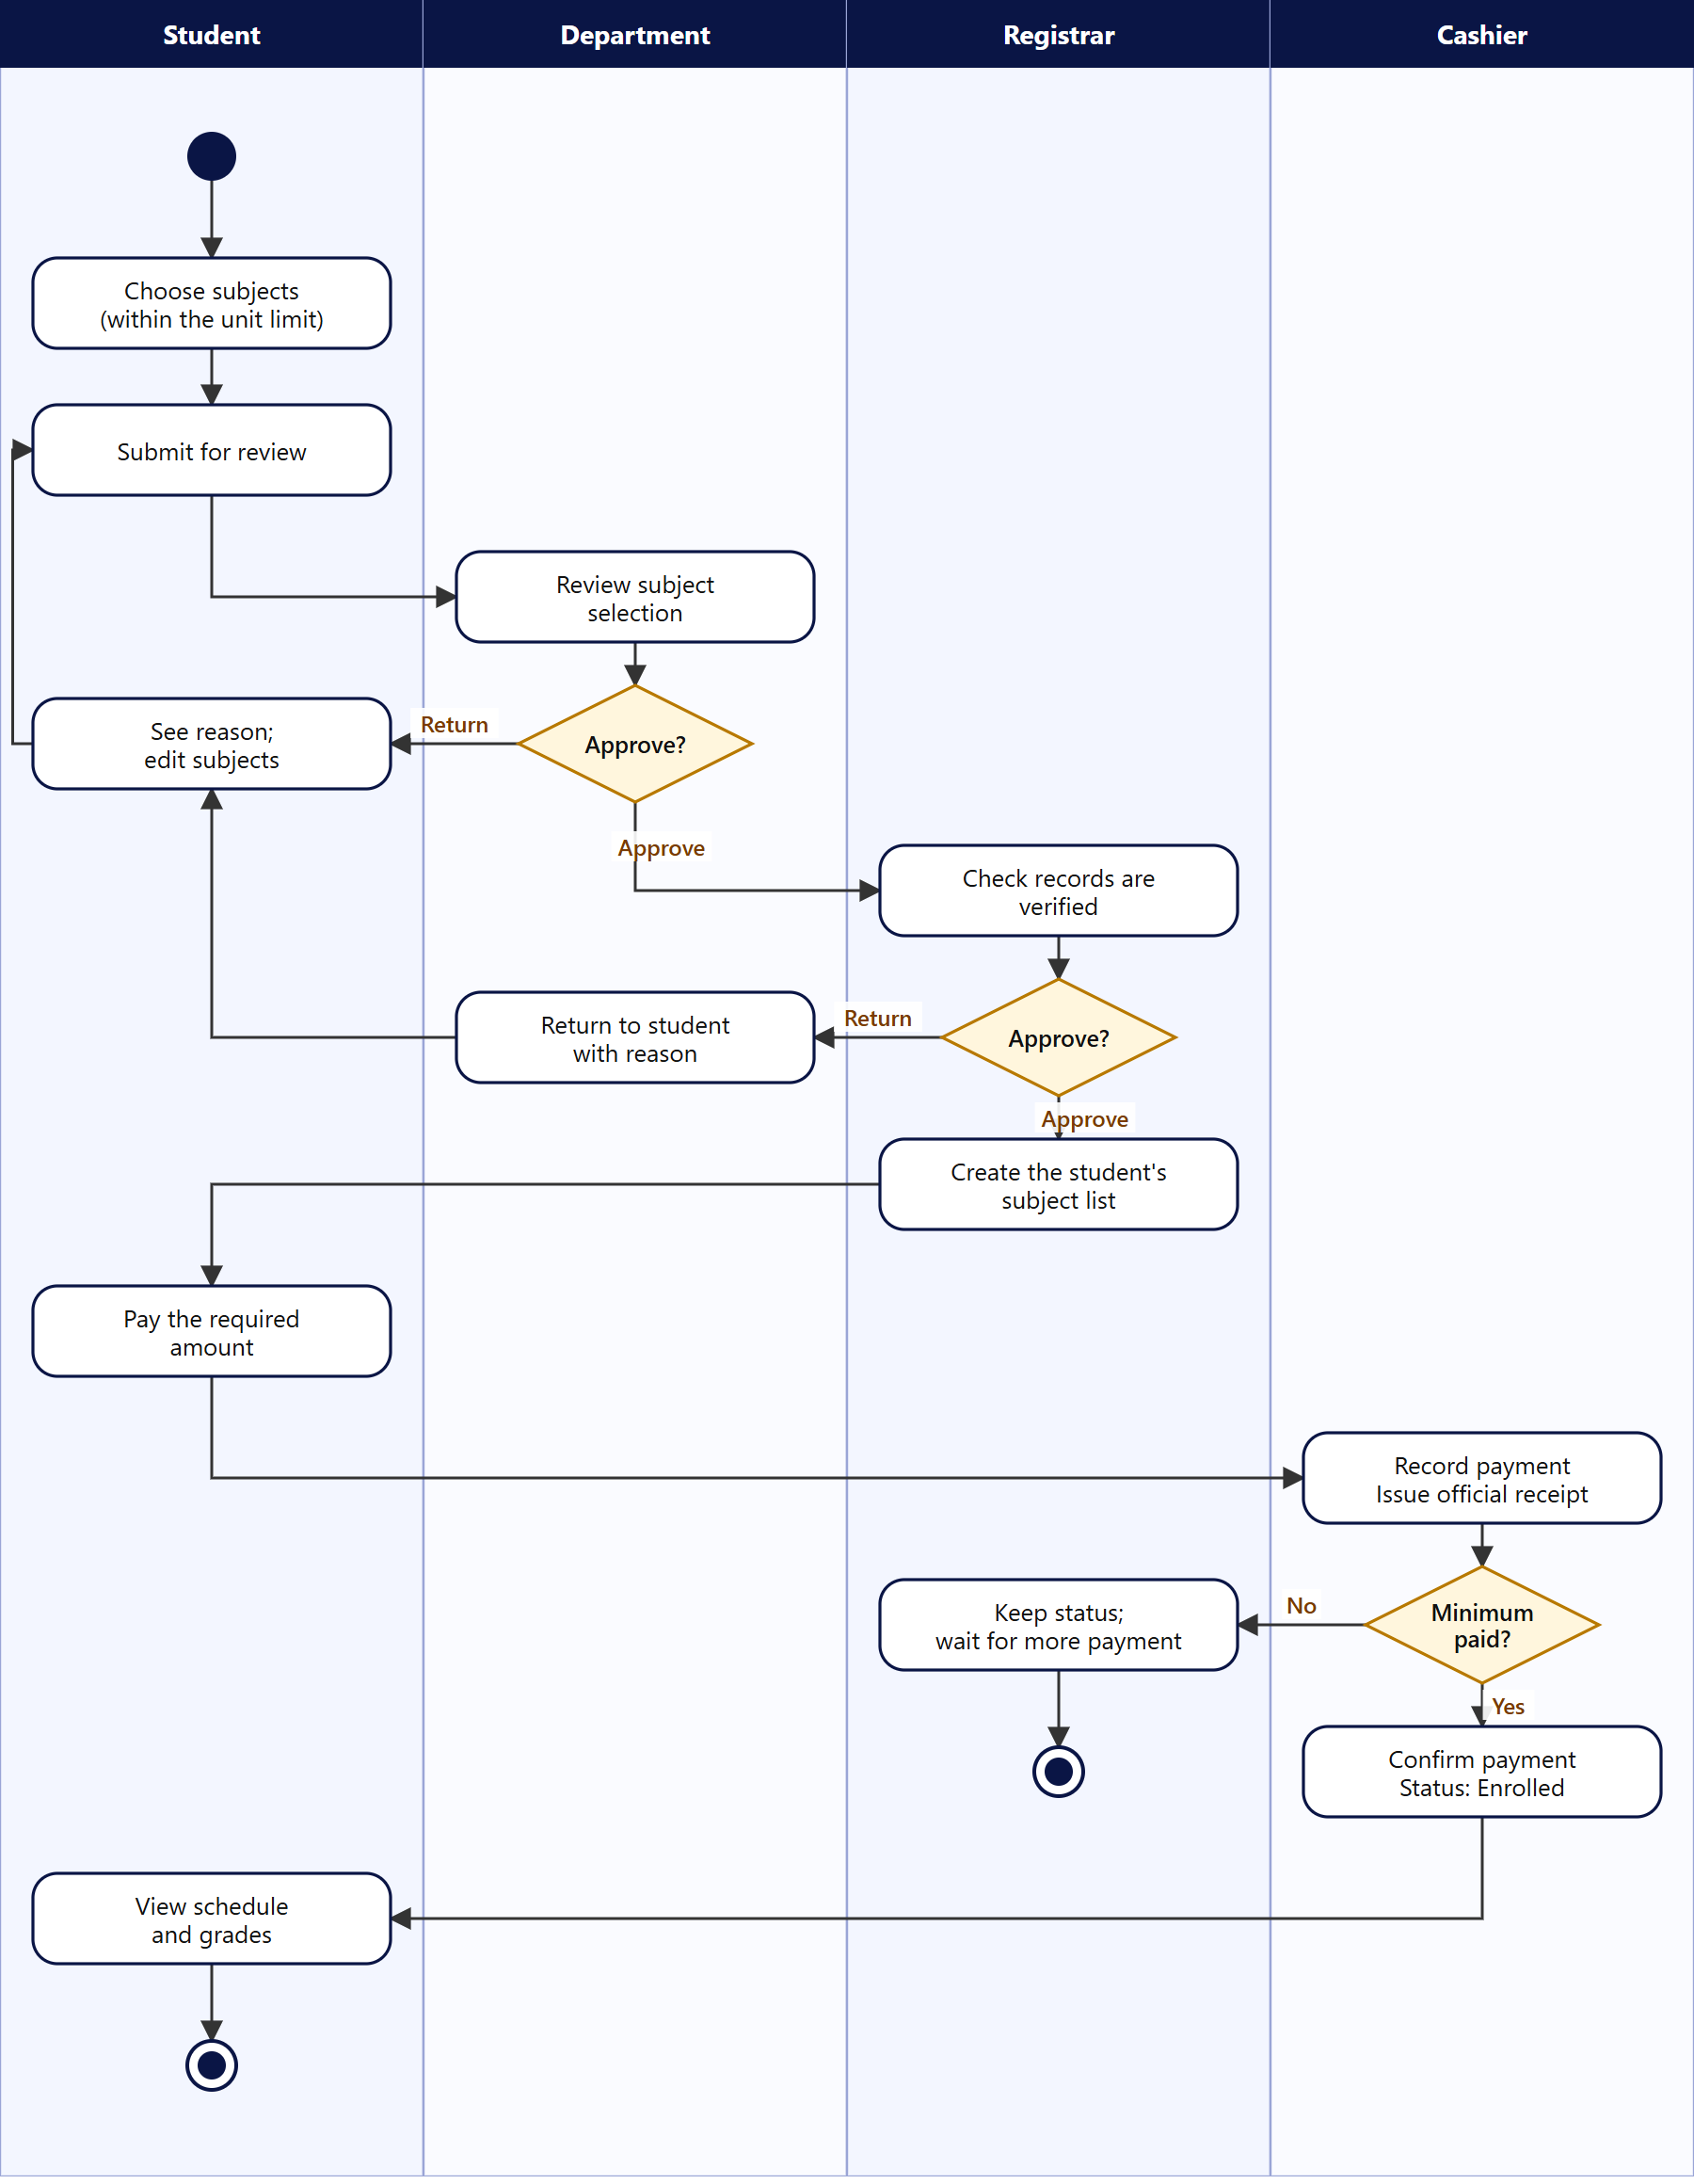
Figure 8. Activity diagram — online enrollment

3.3 Document request
Status moves Pending → For Payment → Processing → Ready for Release → Released. The server rejects any attempt to skip a step. A free document goes straight to Processing. The student may cancel while the request is Pending or For Payment.
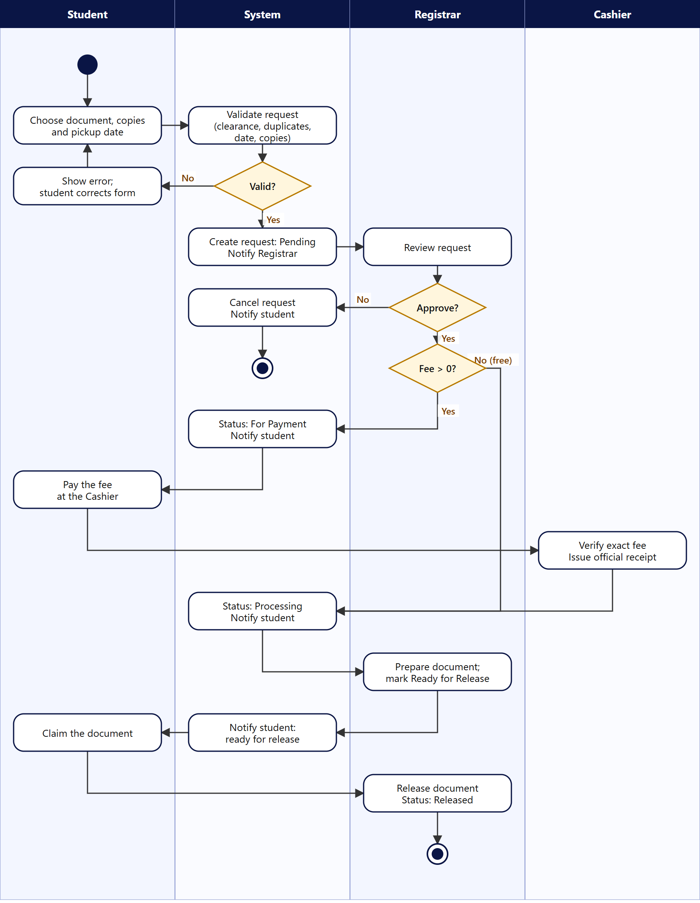
Figure 9. Activity diagram — document request

3.4 Digital queue
A student holds one active ticket at a time. Staff call the next ticket in order, then finish it or skip it. The student is notified when called and when three numbers away. A student may cancel while the ticket is still waiting.
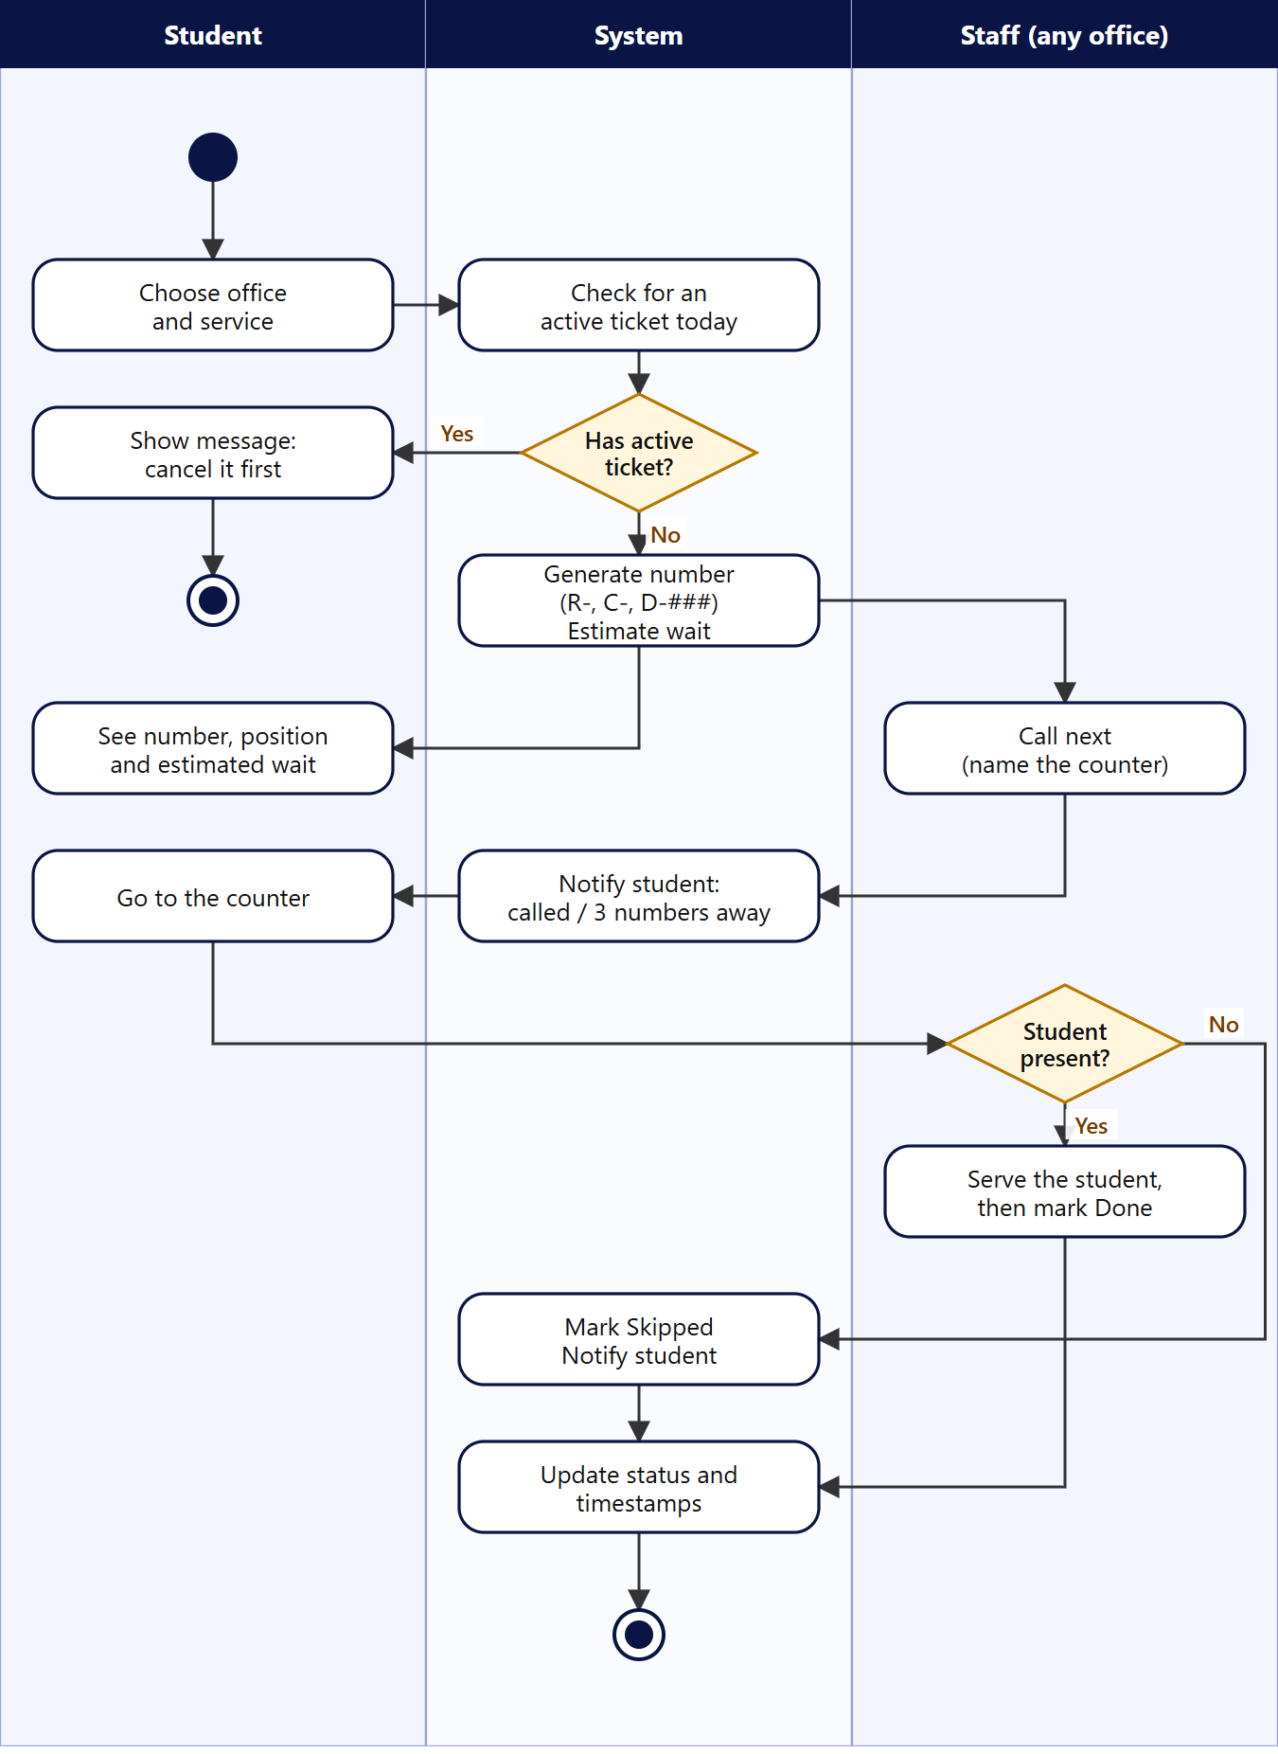
Figure 10. Activity diagram — digital queue

4. Data flow diagrams

4.1 Notation and data stores
Symbol | Meaning
Circle with number | Process (for example 3.0 Process document requests)
Rectangle | External entity — a person who sends or receives data
Open-ended box with ID (D1 …) | Data store — a group of database tables
Labelled arrow | Data flow
Dashed grey circle | Process drawn on another page (reference only)

Store | Name | Database tables
D1 | Users, sessions, login attempts, audit log | users, sessions, login_attempts, audit_log
D2 | Students and academic records | students, year_progress, subjects, meetings, student_subjects, terms, programs, departments
D3 | Enrollment requests | enrollment_requests, enrollment_items
D4 | Fees and payments | fees, payments
D5 | Document requests and history | doc_requests, request_history (document types: doc_types)
D6 | Queue tickets | queue_tickets
D7 | Clearances and requirements | clearances, academic_requirements
D8 | Notifications and announcements | notifications, announcements
— | Settings | settings (unit limit, minimum payment %, queue minutes, maximum copies)

Every process that changes a status also writes a notification (D8) and an audit entry (D1). To keep the diagrams readable, only the main flows are drawn; the second Level 1 diagram notes this where it matters.

4.2 Context diagram (Level 0)
The whole system is a single process with five external entities. Each entity sends and receives the data shown.
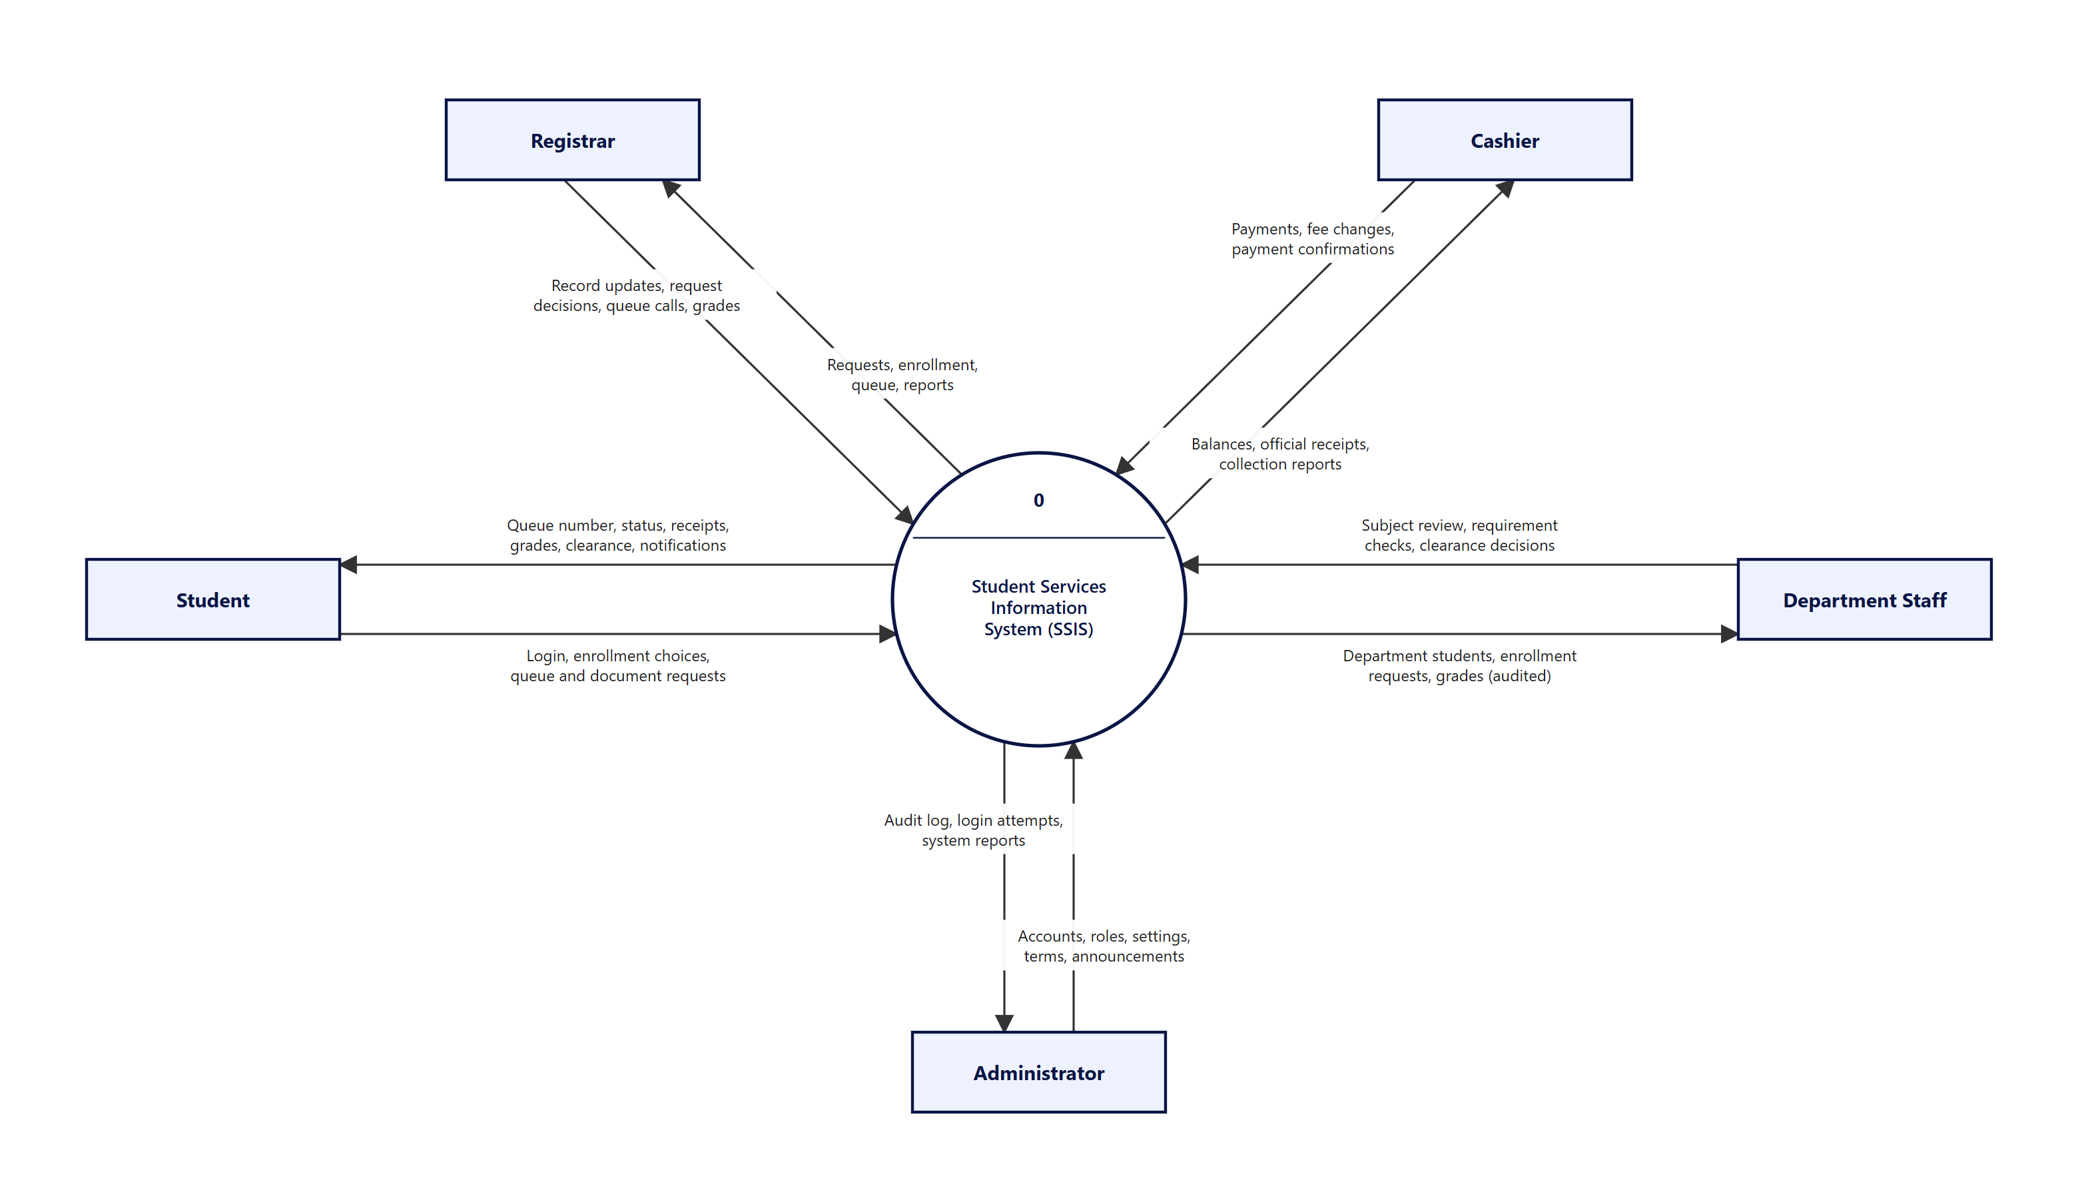
Figure 11. Context diagram (Level 0)

4.3 Level 1 diagram
Level 1 splits the system into eight processes. Part 1 covers authentication (1.0), enrollment (2.0), clearance (6.0) and records (7.0). The dashed circle marks a process drawn in part 2.
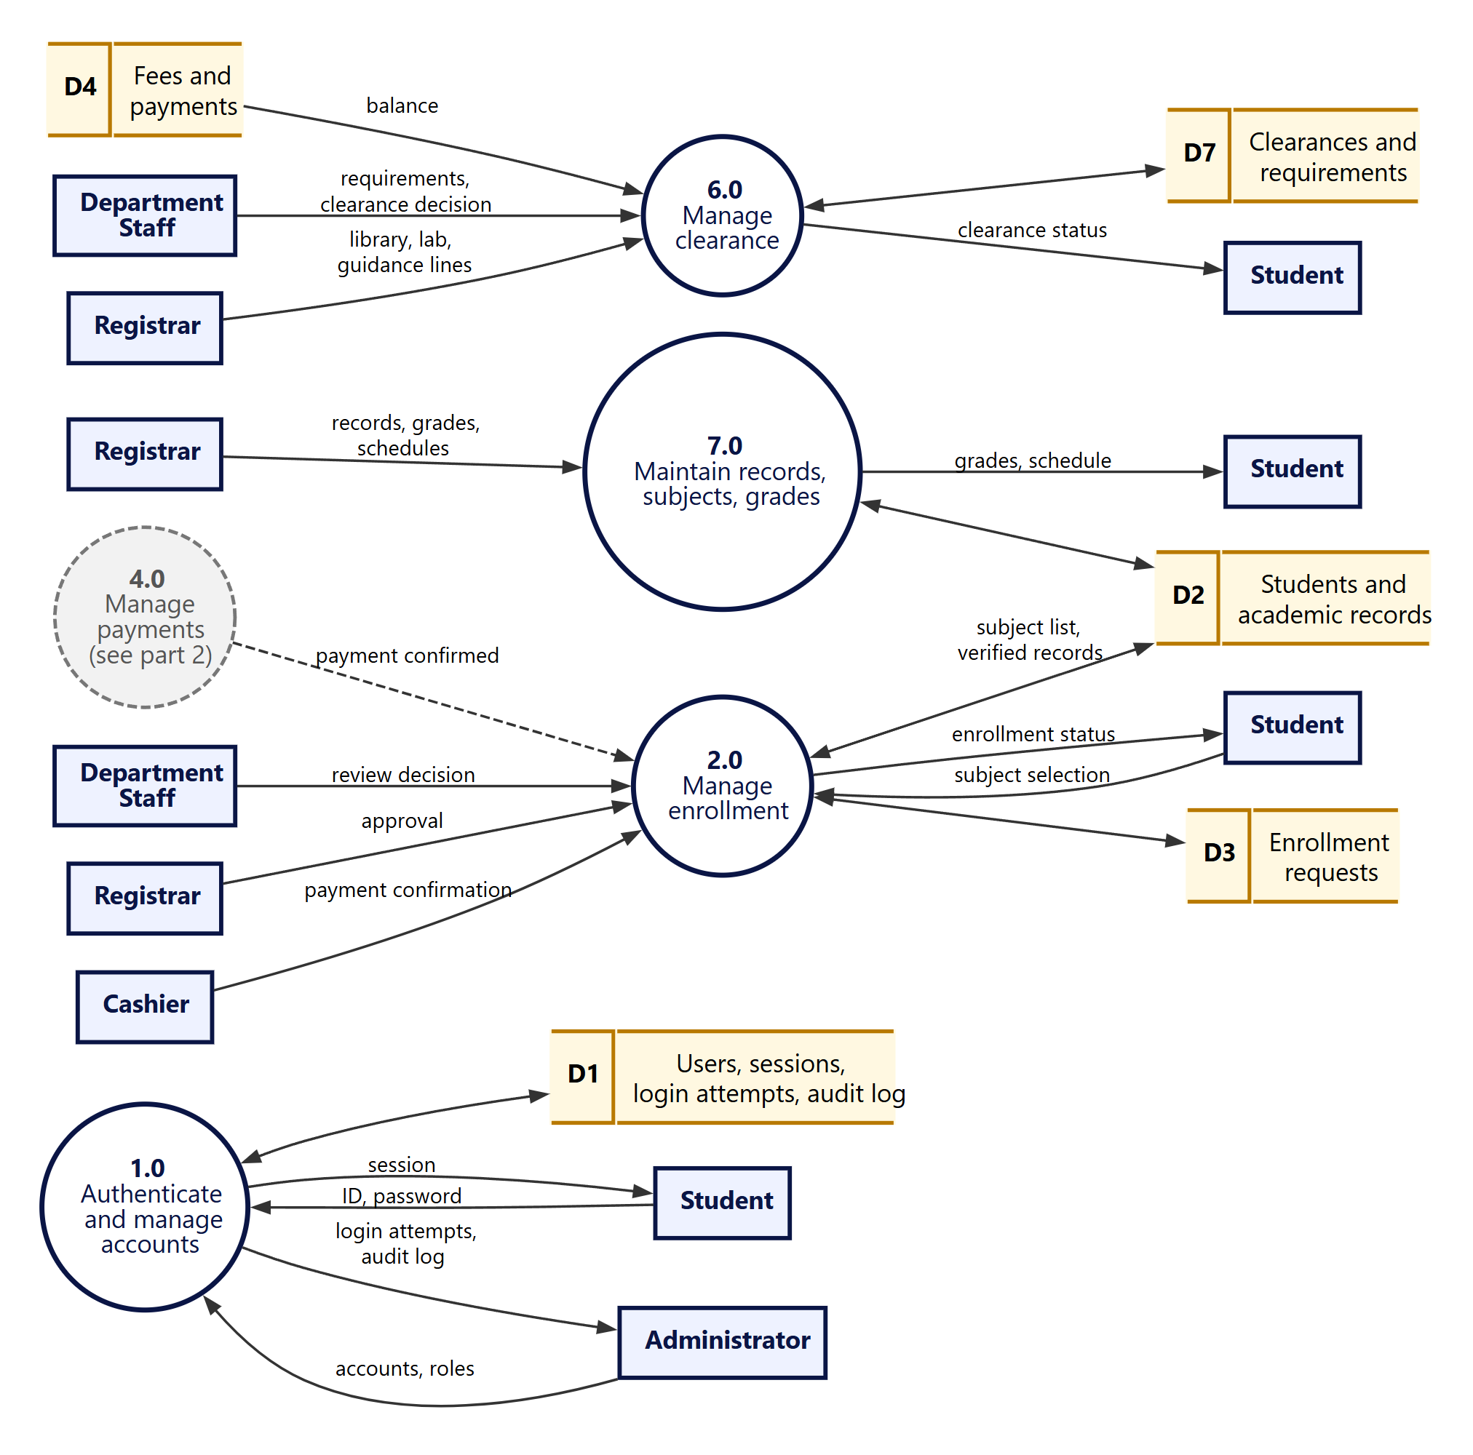
Figure 12. Level 1 DFD, part 1 — accounts, enrollment, clearance, records

Part 2 covers document requests (3.0), payments and receipts (4.0), the digital queue (5.0) and reports, announcements and notifications (8.0). Process 8.0 also reads D2, D4, D5 and D6 to build reports.
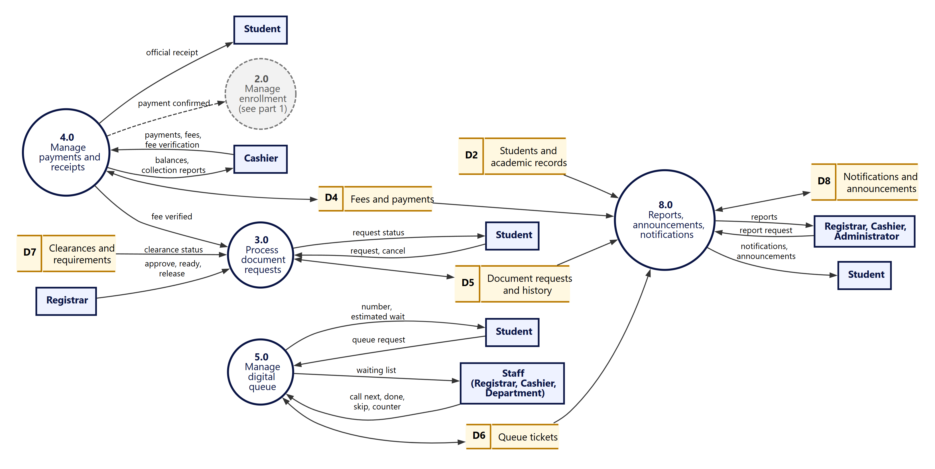
Figure 13. Level 1 DFD, part 2 — documents, payments, queue, reports

4.4 Level 2 diagrams
Process 2.0 Manage enrollment is decomposed into five sub-processes. The unit limit and minimum payment percent come from the system settings.
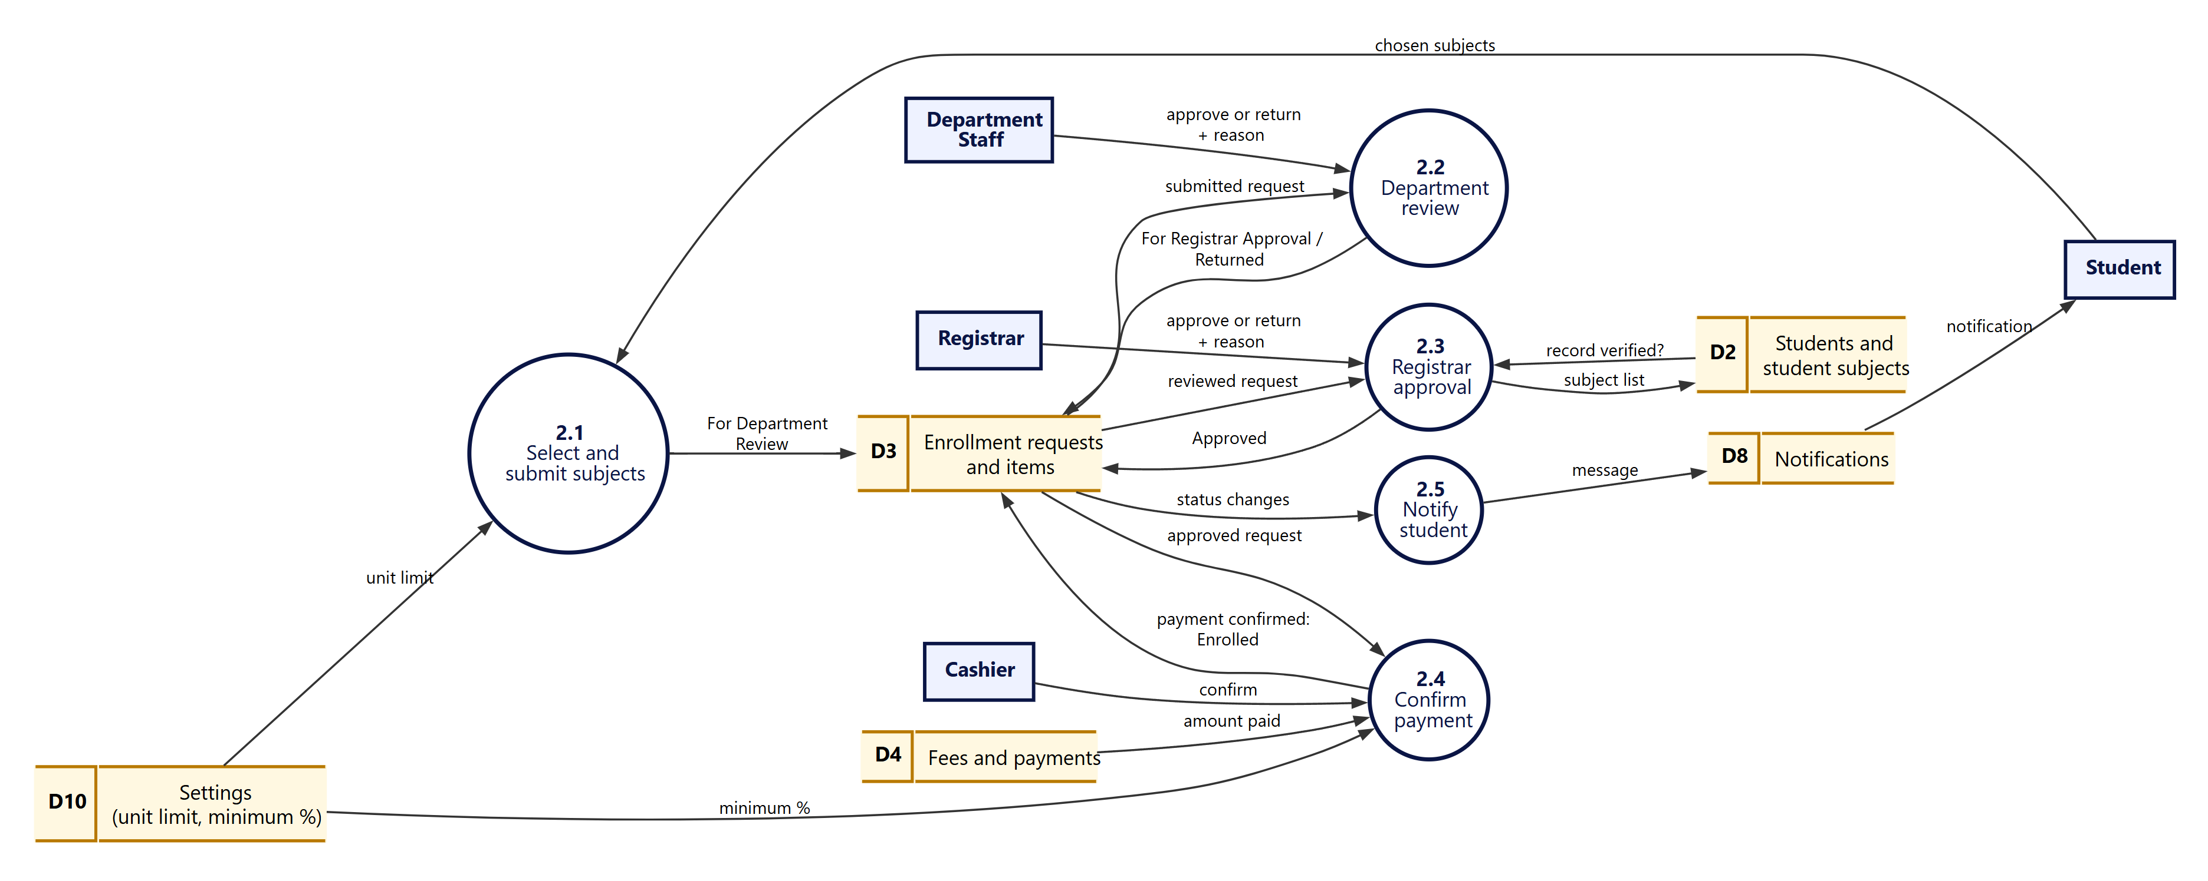
Figure 14. Level 2 DFD — process 2.0 Manage enrollment

Process 3.0 is decomposed into six sub-processes. Validation uses the document type fee, the student’s clearance status and the list of open requests.
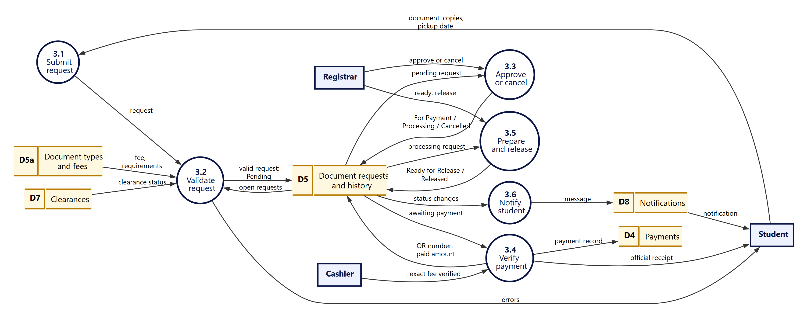
Figure 15. Level 2 DFD — process 3.0 Process document requests

Process 5.0 follows the queue data flow of the project requirements: register the entry, generate the number, monitor the status, manage and update the queue, notify the student, and report.
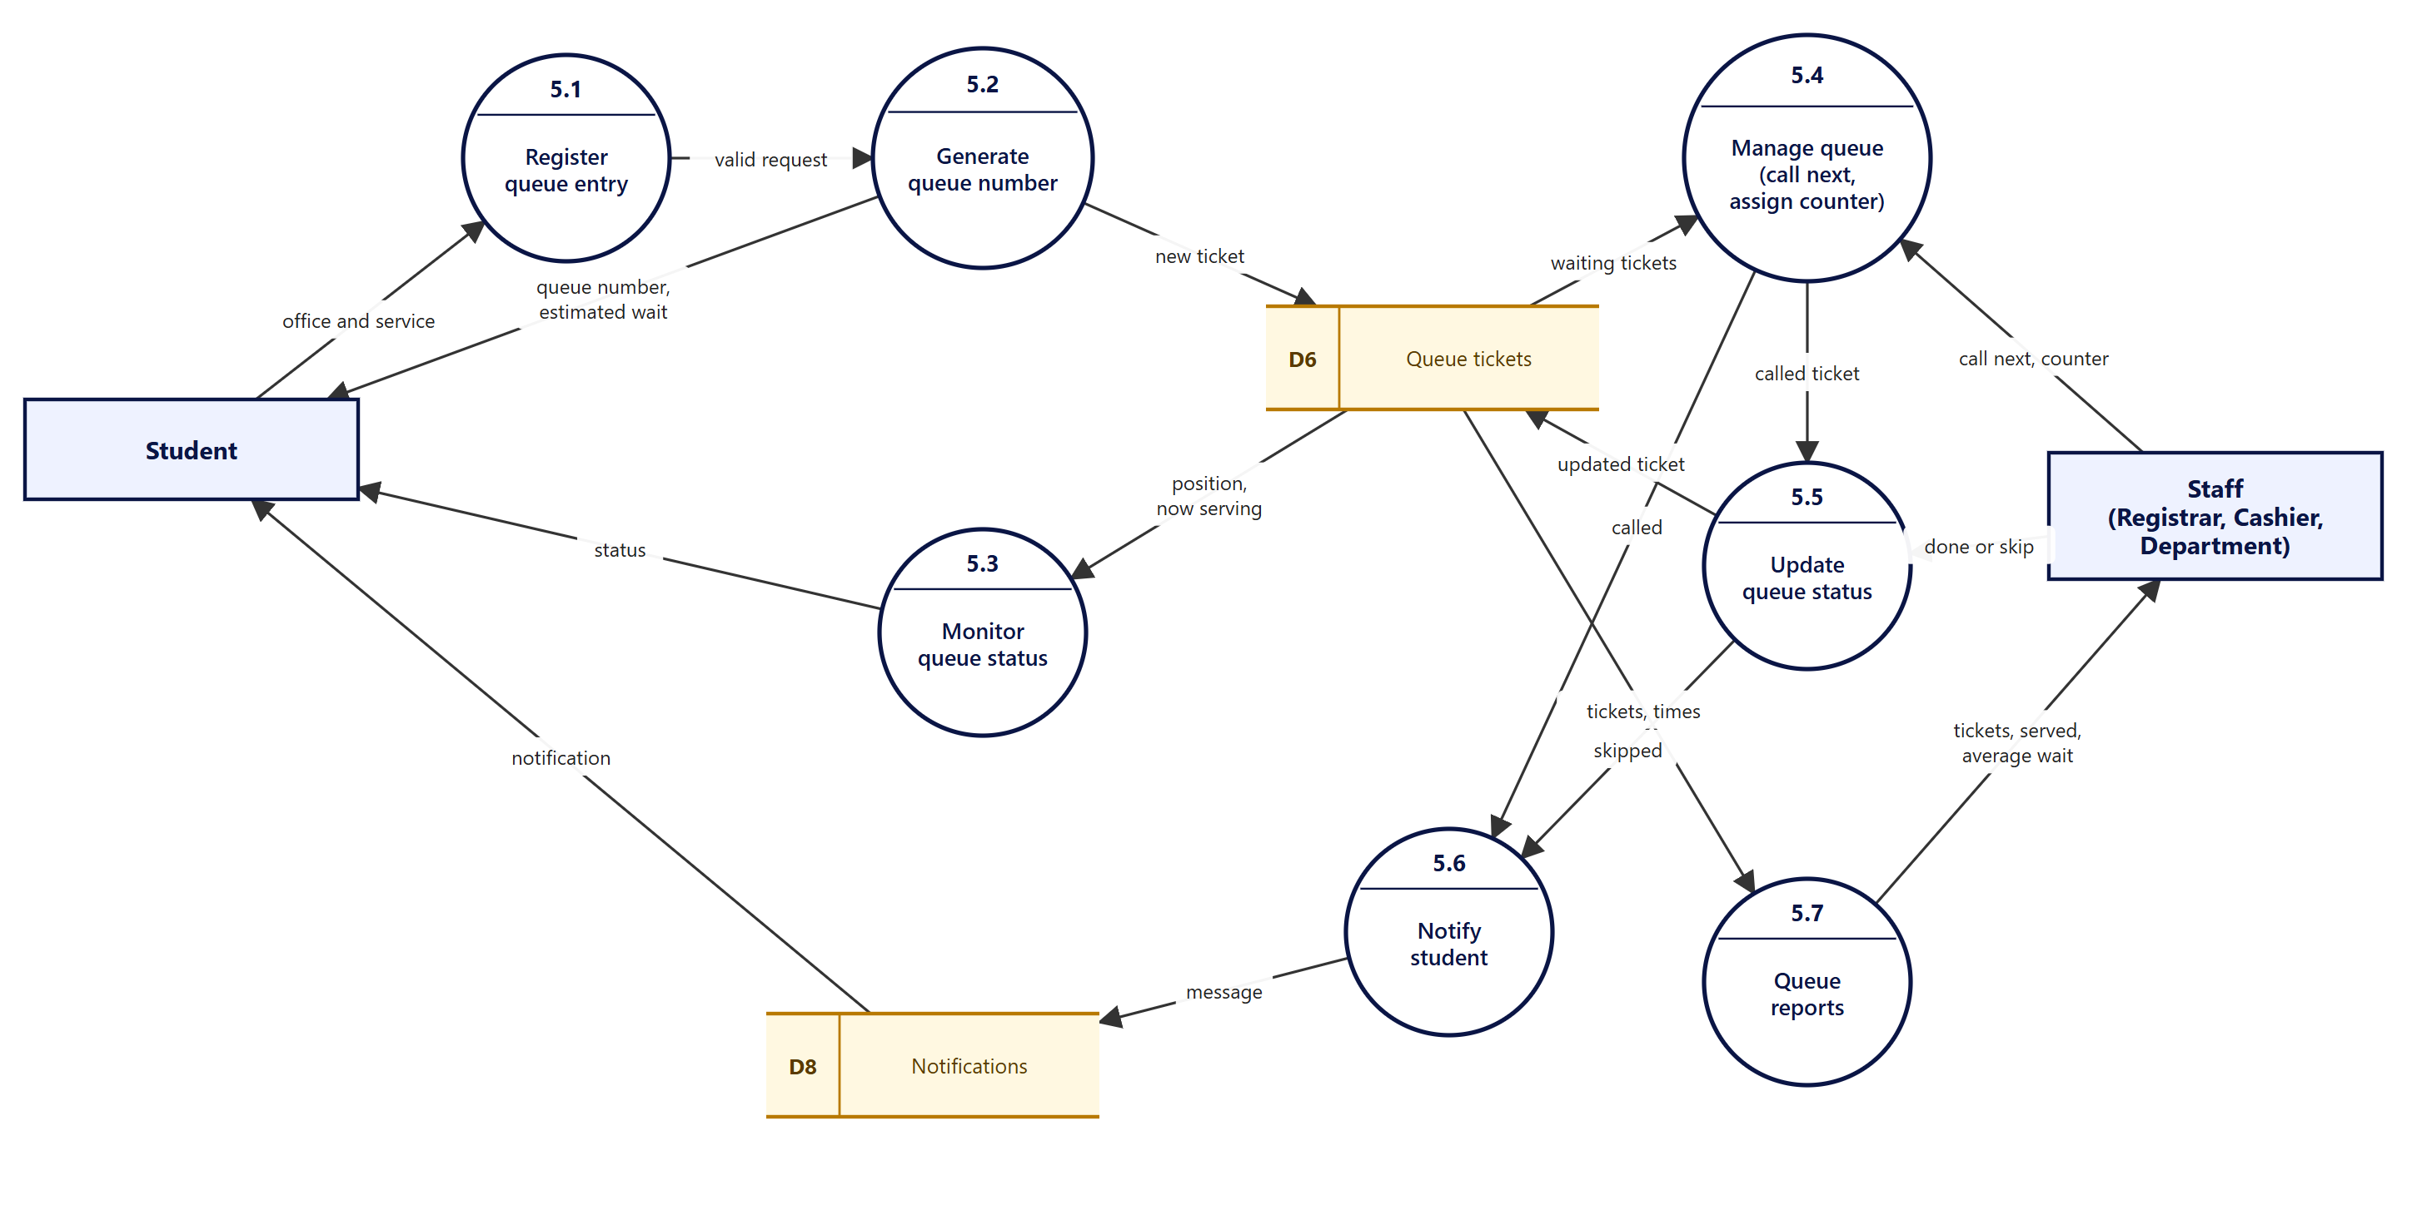
Figure 16. Level 2 DFD — process 5.0 Manage digital queue

4.5 Data flow dictionary (context level)
Flow | Data | Examples
Student → SSIS | Login, enrollment choices, queue and document requests | Sign in, subject selection, queue request, document request, cancellations
SSIS → Student | Queue number, status, receipts, grades, clearance, notifications | Enrollment tracker, ticket with position and wait, request history, official receipt
Registrar → SSIS | Record updates, request decisions, queue calls, grades | Student records, enrollment approval, approve / ready / release, call next
SSIS → Registrar | Requests, enrollment, queue, reports | Request lists, enrollment queue, queue state, reports
Cashier → SSIS | Payments, fee changes, payment confirmations | Recorded payments, fee lines, voids, exact-fee verification
SSIS → Cashier | Balances, official receipts, collection reports | Student balances, receipts, reports by period and method
Department → SSIS | Subject review, requirement checks, clearance decisions | Approve or return, verified requirements, clearance status
SSIS → Department | Department students, enrollment requests, grades (audited) | Own-department students only; grade views are logged
Administrator → SSIS | Accounts, roles, settings, terms, announcements | Create or disable accounts, role changes, rules, terms
SSIS → Administrator | Audit log, login attempts, system reports | Searchable logs, dashboard counts

5. Class diagrams
The class diagrams describe the domain model: the main classes, their attributes, their operations, and how they relate. They are split into five diagrams so each stays readable.
Design versus implementation: the code stores every account in one users table with a role column. The class diagrams show the five roles as subclasses of User, because that is how the roles behave. Operations are named after the actions the server performs; they are not method names in the code.
Class | Stored in table | Class | Stored in table
User | users | DocRequest | doc_requests
Student | students (1:1 with users) | RequestHistory | request_history
Department | departments | Fee | fees
Program | programs | Payment | payments
Term | terms | QueueTicket | queue_tickets
Subject | subjects | Notification | notifications
ClassMeeting | meetings | Announcement | announcements
StudentSubject | student_subjects | AuditEntry | audit_log
EnrollmentRequest | enrollment_requests, enrollment_items | LoginAttempt | login_attempts
AcademicRequirement | academic_requirements | Session | sessions
Clearance | clearances | Setting | settings
DocType | doc_types

5.1 Users and roles
Five roles specialise User. Each role’s operations correspond to the actions in its portal.
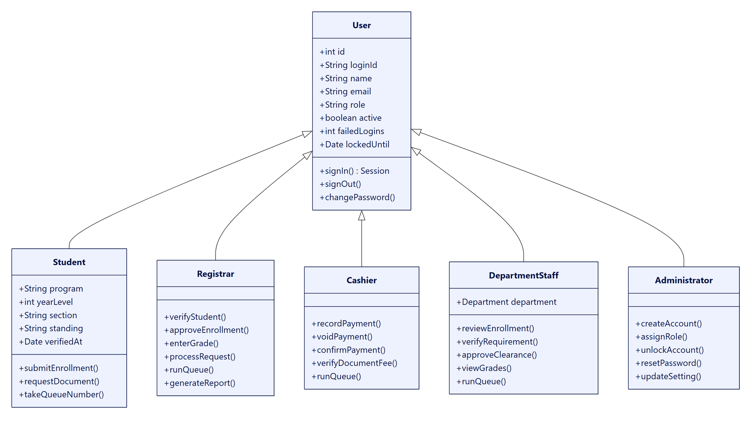
Figure 17. Class diagram 1 — users and roles

5.2 Academic structure
Departments own programs and subjects; students take subjects in a term and receive Prelim, Midterm and Finals grades.
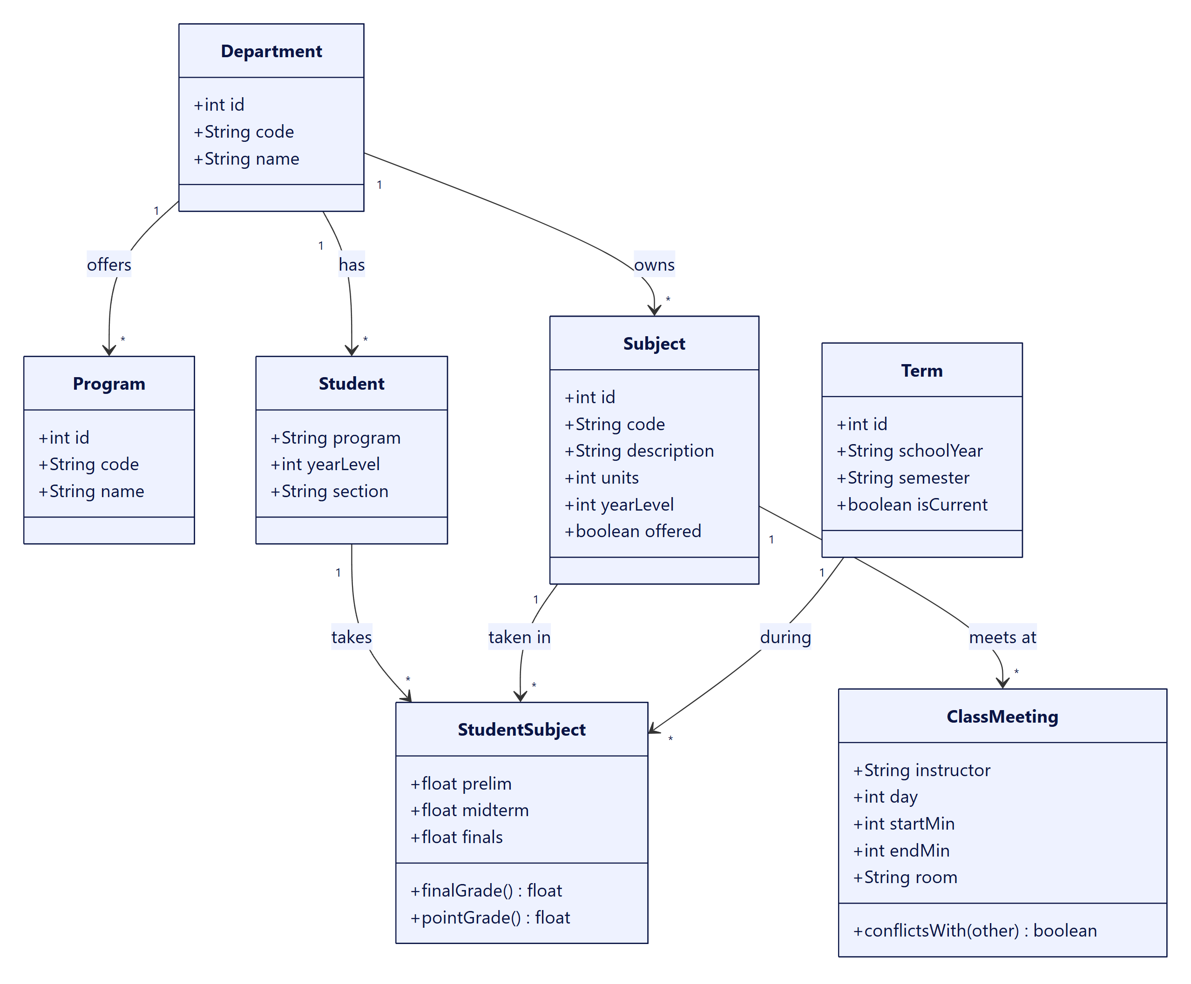
Figure 18. Class diagram 2 — academic structure

5.3 Enrollment and clearance
An enrollment request belongs to one student and one term and holds the chosen subjects. Academic requirements and clearance lines are kept per student.
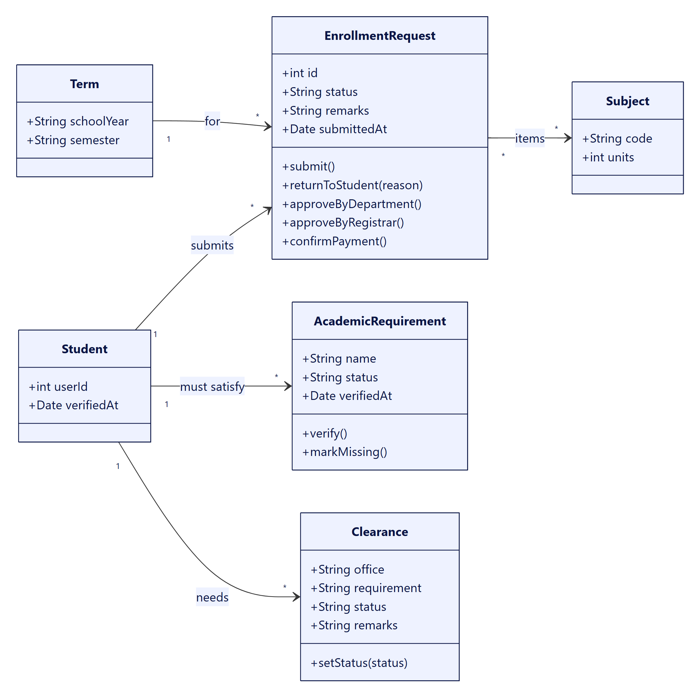
Figure 19. Class diagram 3 — enrollment and clearance

5.4 Documents and payments
A document request refers to one document type and keeps its own history. Fees are assessed to a student; payments record what was paid, with an official receipt reference.
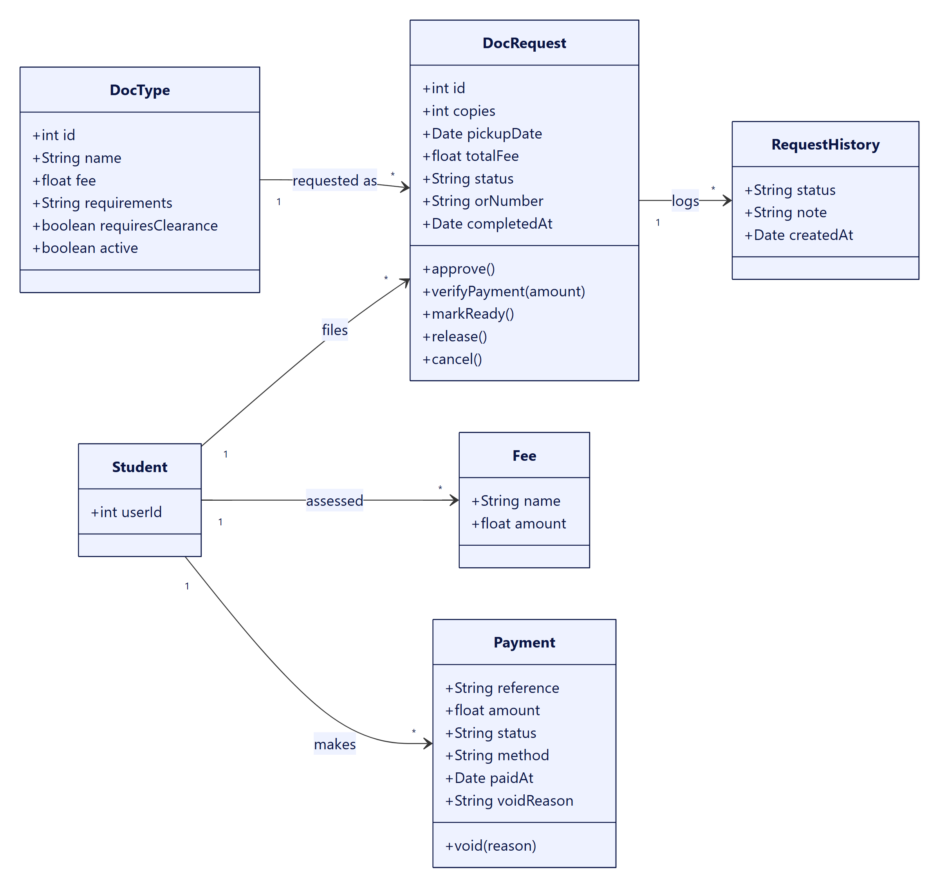
Figure 20. Class diagram 4 — documents and payments

5.5 Queue, notifications and security records
Queue tickets link a student with the staff member who serves them. Notifications, audit entries, login attempts and sessions all belong to a user.
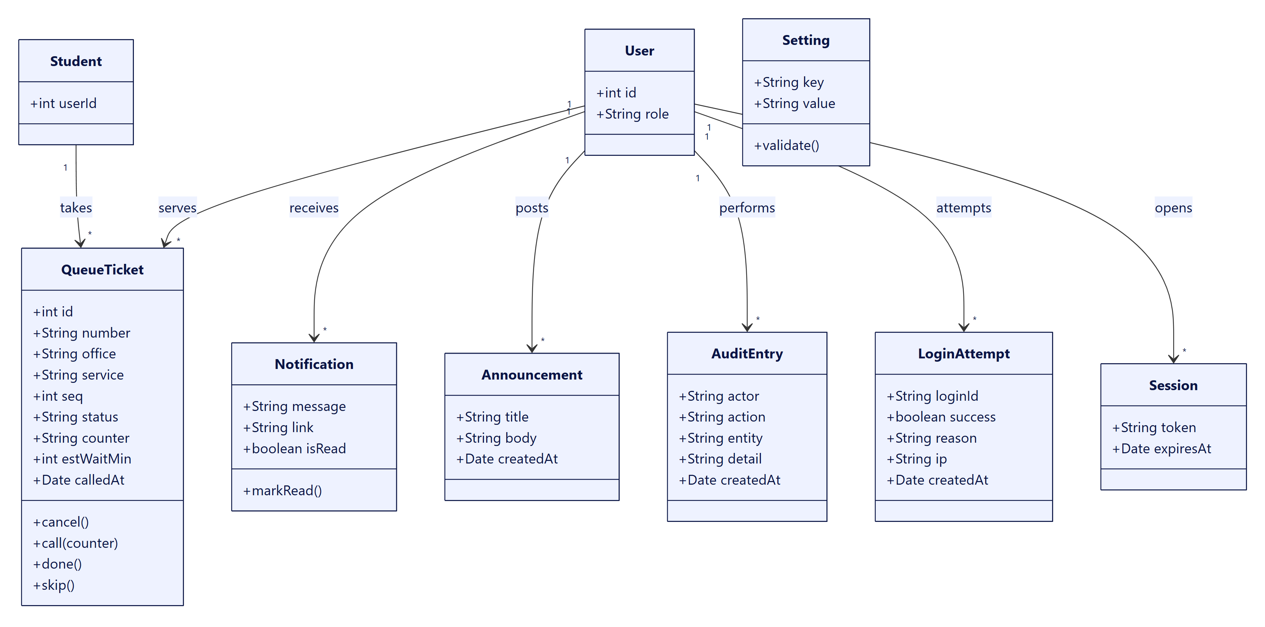
Figure 21. Class diagram 5 — queue, notifications and security records

6. Database design

6.1 Overview and conventions
The database is a single SQLite file with 25 core tables (plus 4 optional tables for LMS-style features that are switched off). The schema is created by server/schema.js; an older database is backed up and recreated when the schema version changes.
- Keys: integer primary keys (text for sessions and settings); foreign keys are declared with an explicit delete rule.
- Dates: stored as ISO-8601 text.
- Money: stored as REAL (pesos). A production system should store whole centavos as integers to avoid rounding drift; this is listed as an improvement in section 6.7.
- Status values: protected by CHECK constraints (for example document status, queue status, payment status).
- Balances: never stored. A student’s balance is computed from fees and payments, so it cannot drift out of step.
- Indexes: on document status and date, queue office/date/status, audit time, login attempt time and login ID.

6.2 Overview ERD
Each box is a table; a line is a foreign-key relationship, with the crow’s foot on the “many” side. Links that only record who performed an action (for example verified_by) are omitted here and shown in the detailed diagrams’ attribute lists.
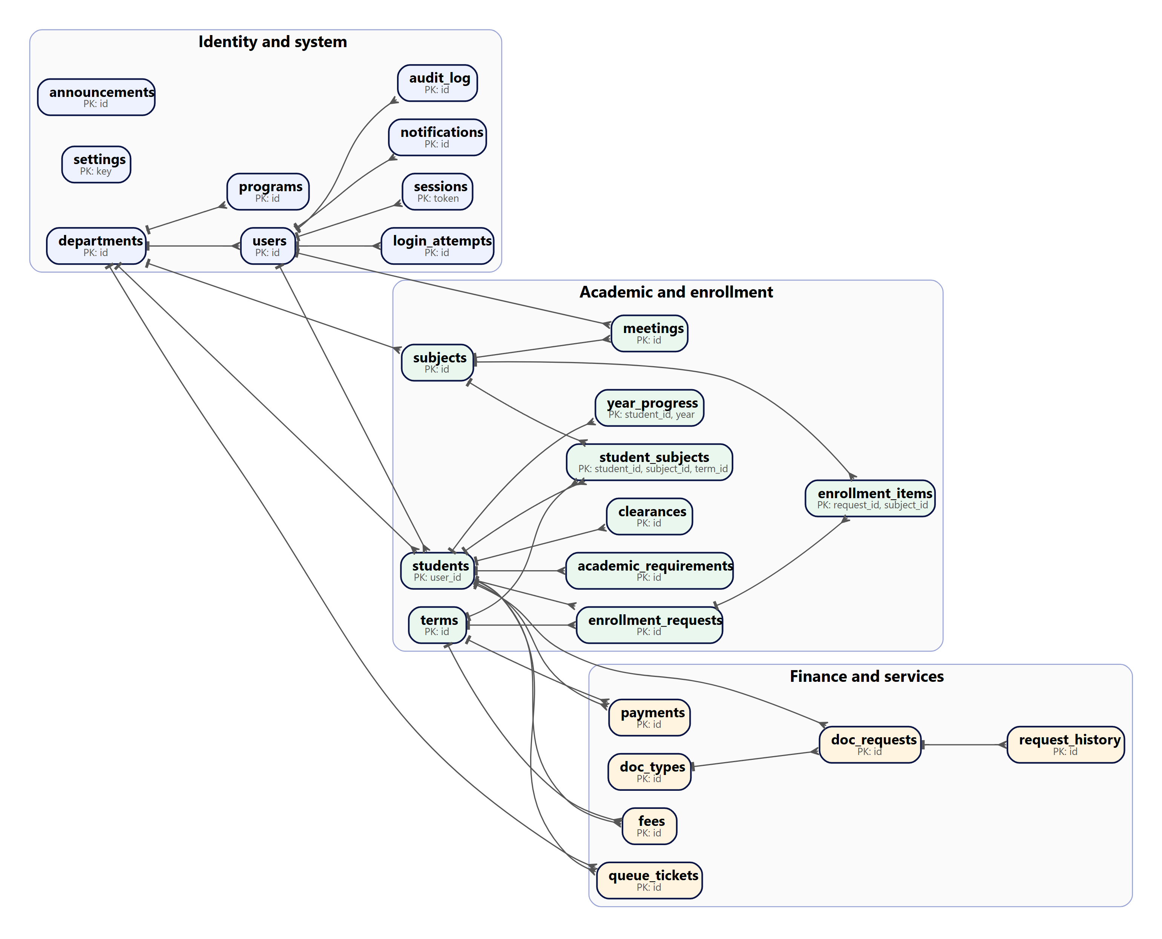
Figure 22. Overview ERD — core tables grouped by area

6.3 Detailed ERDs
The seven diagrams below show every table with its columns. Tables drawn with only a primary key belong to another diagram and are shown for the relationship.
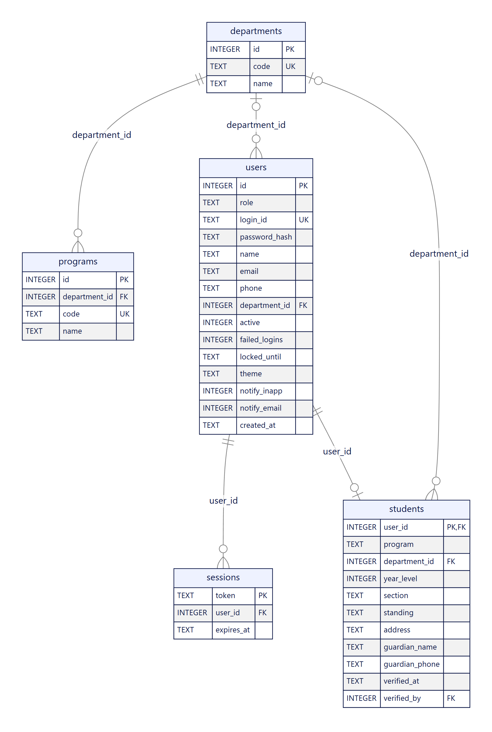
Figure 23. ERD 1 — accounts, departments and students

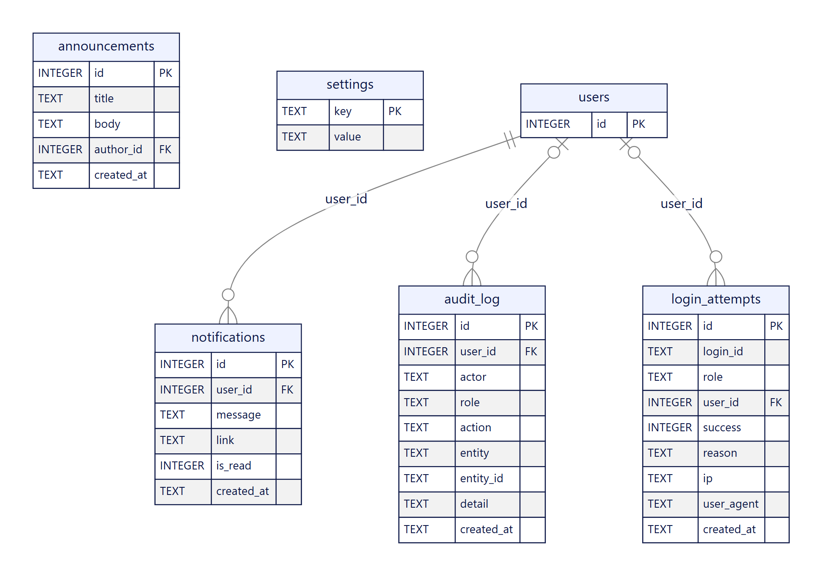
Figure 24. ERD 2 — announcements, notifications, audit log, login attempts, settings

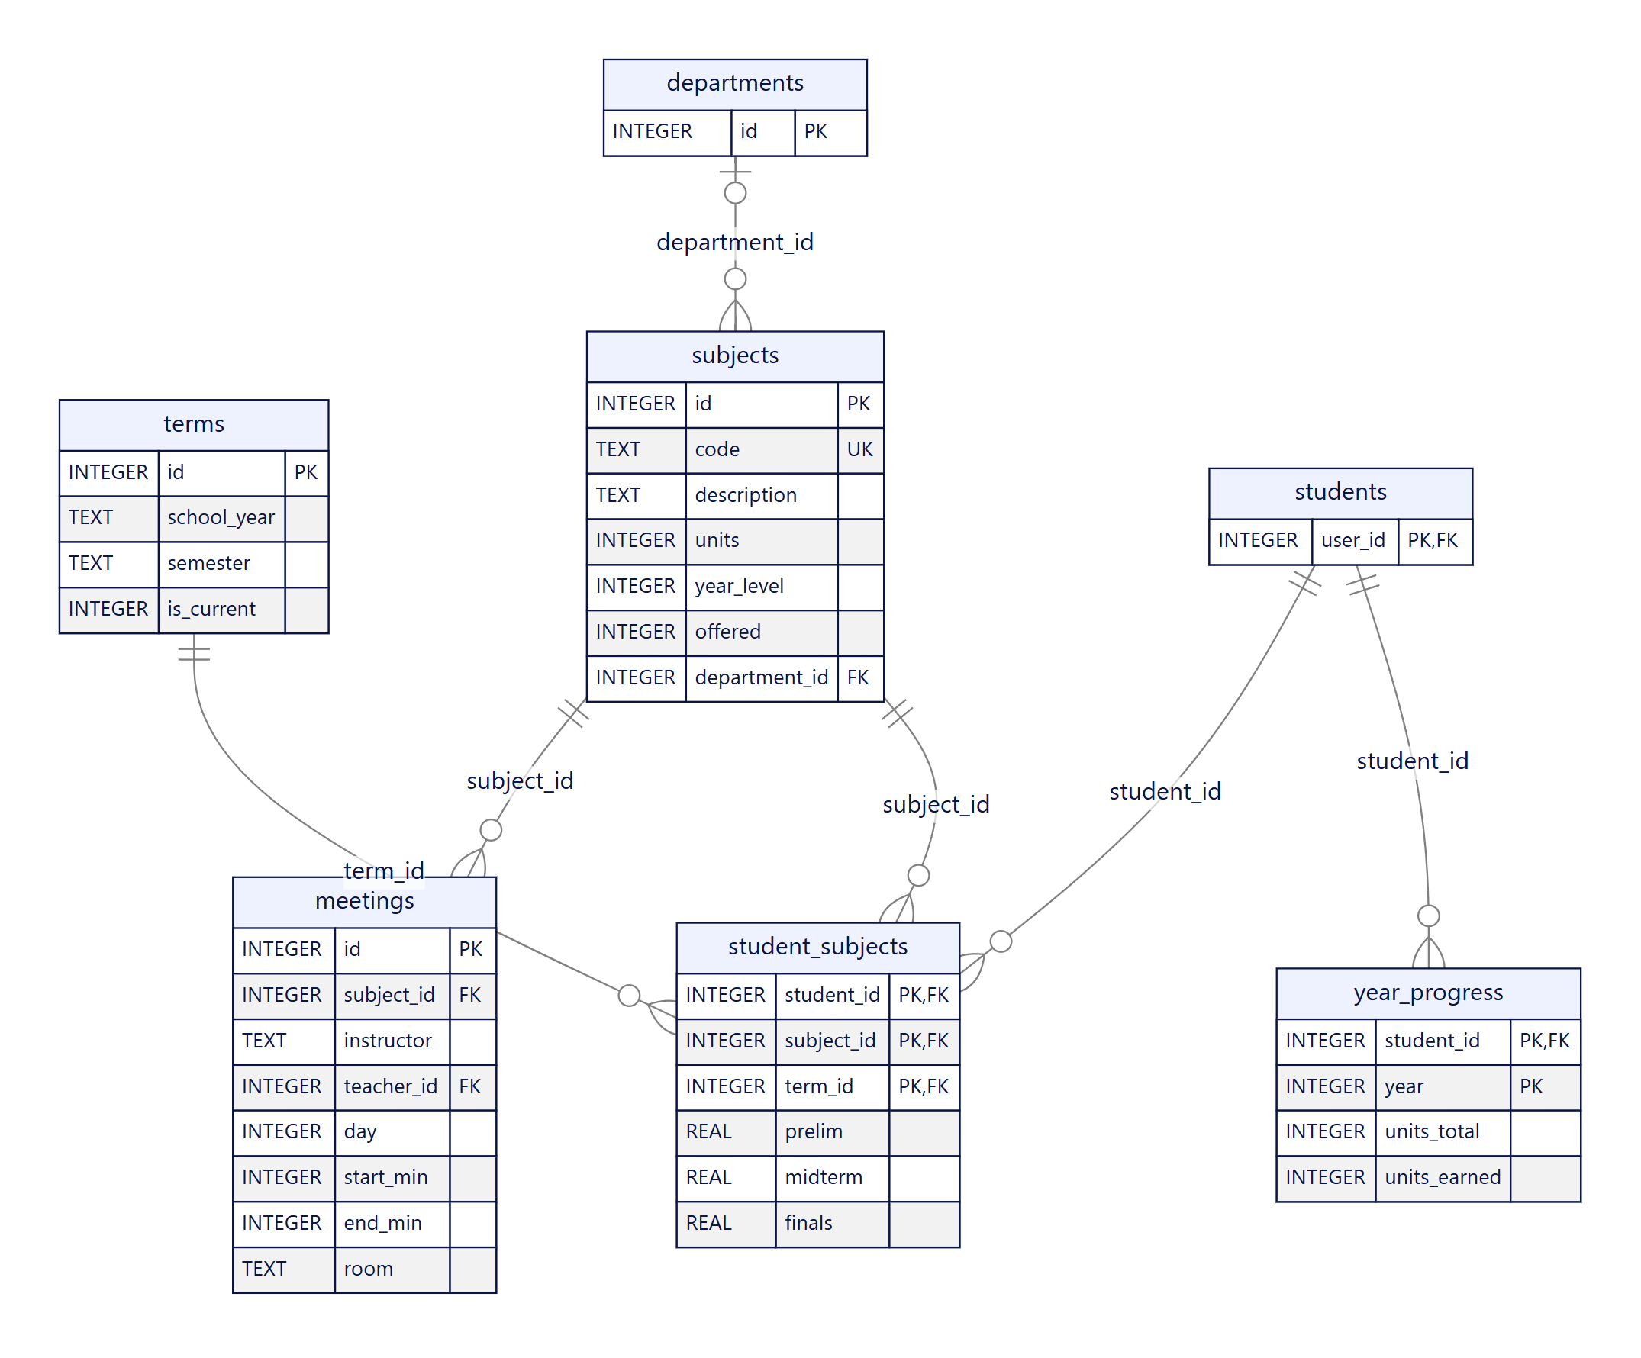
Figure 25. ERD 3 — academic structure

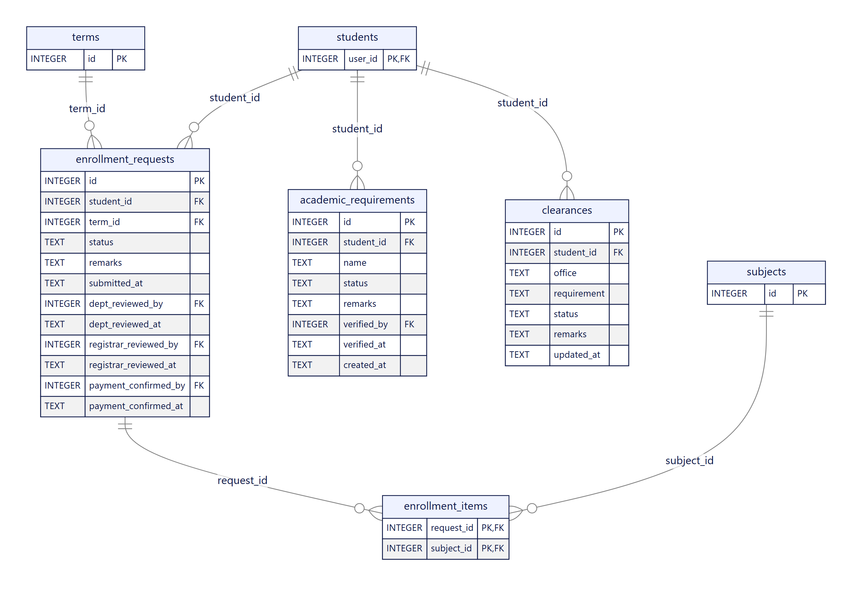
Figure 26. ERD 4 — enrollment, requirements and clearance

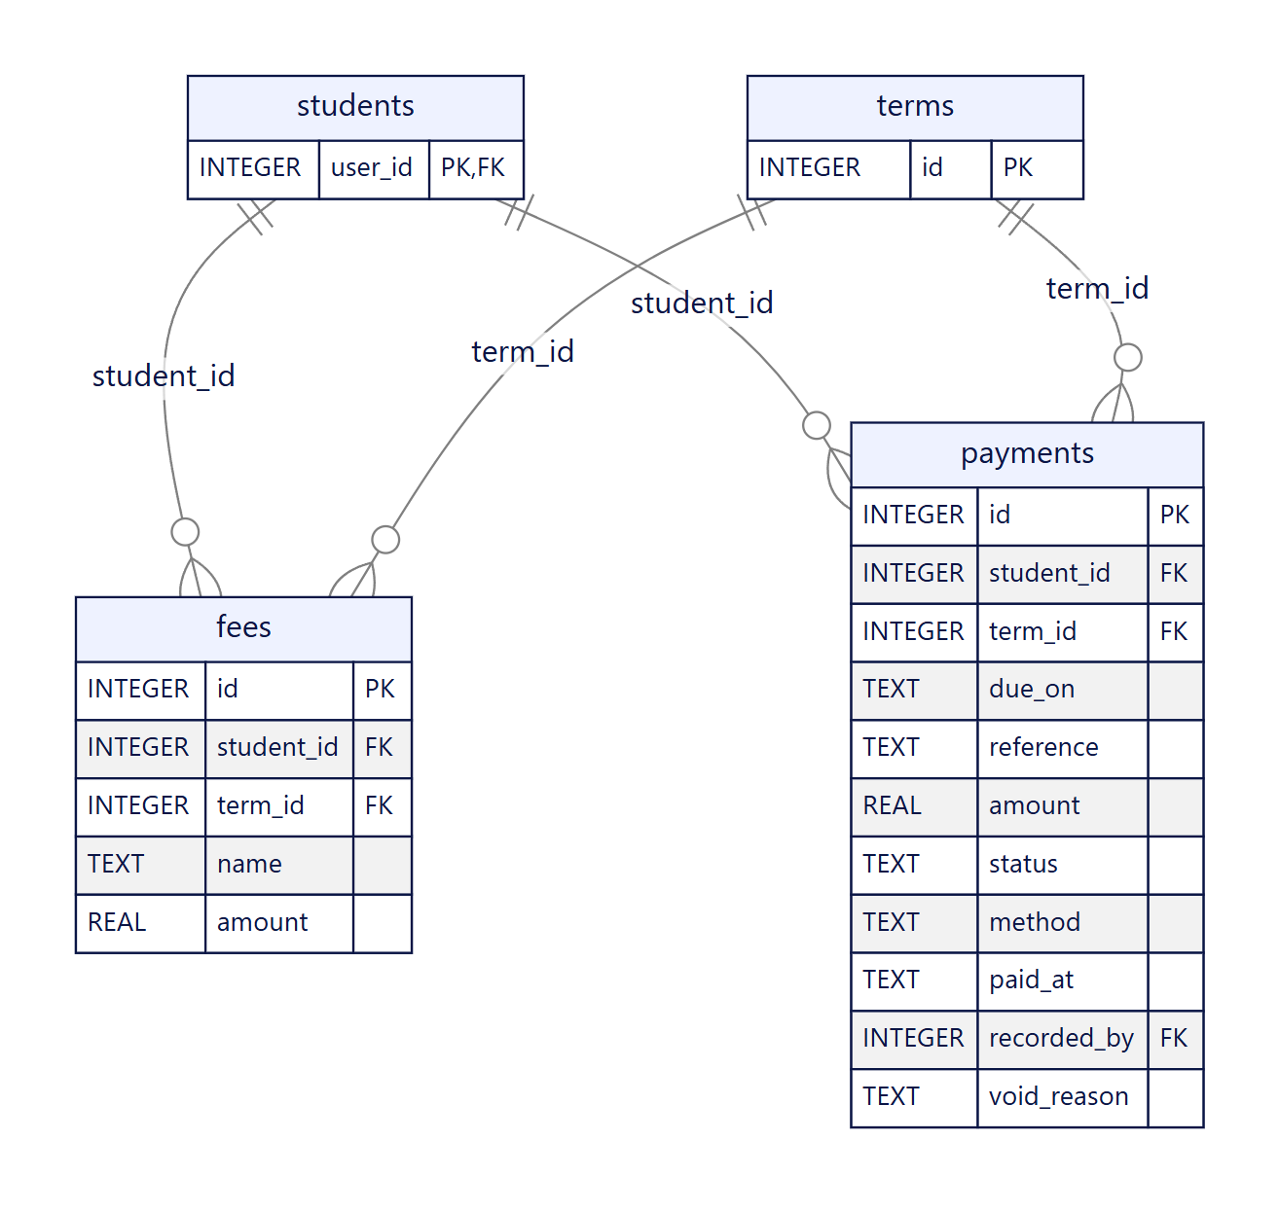
Figure 27. ERD 5 — fees and payments

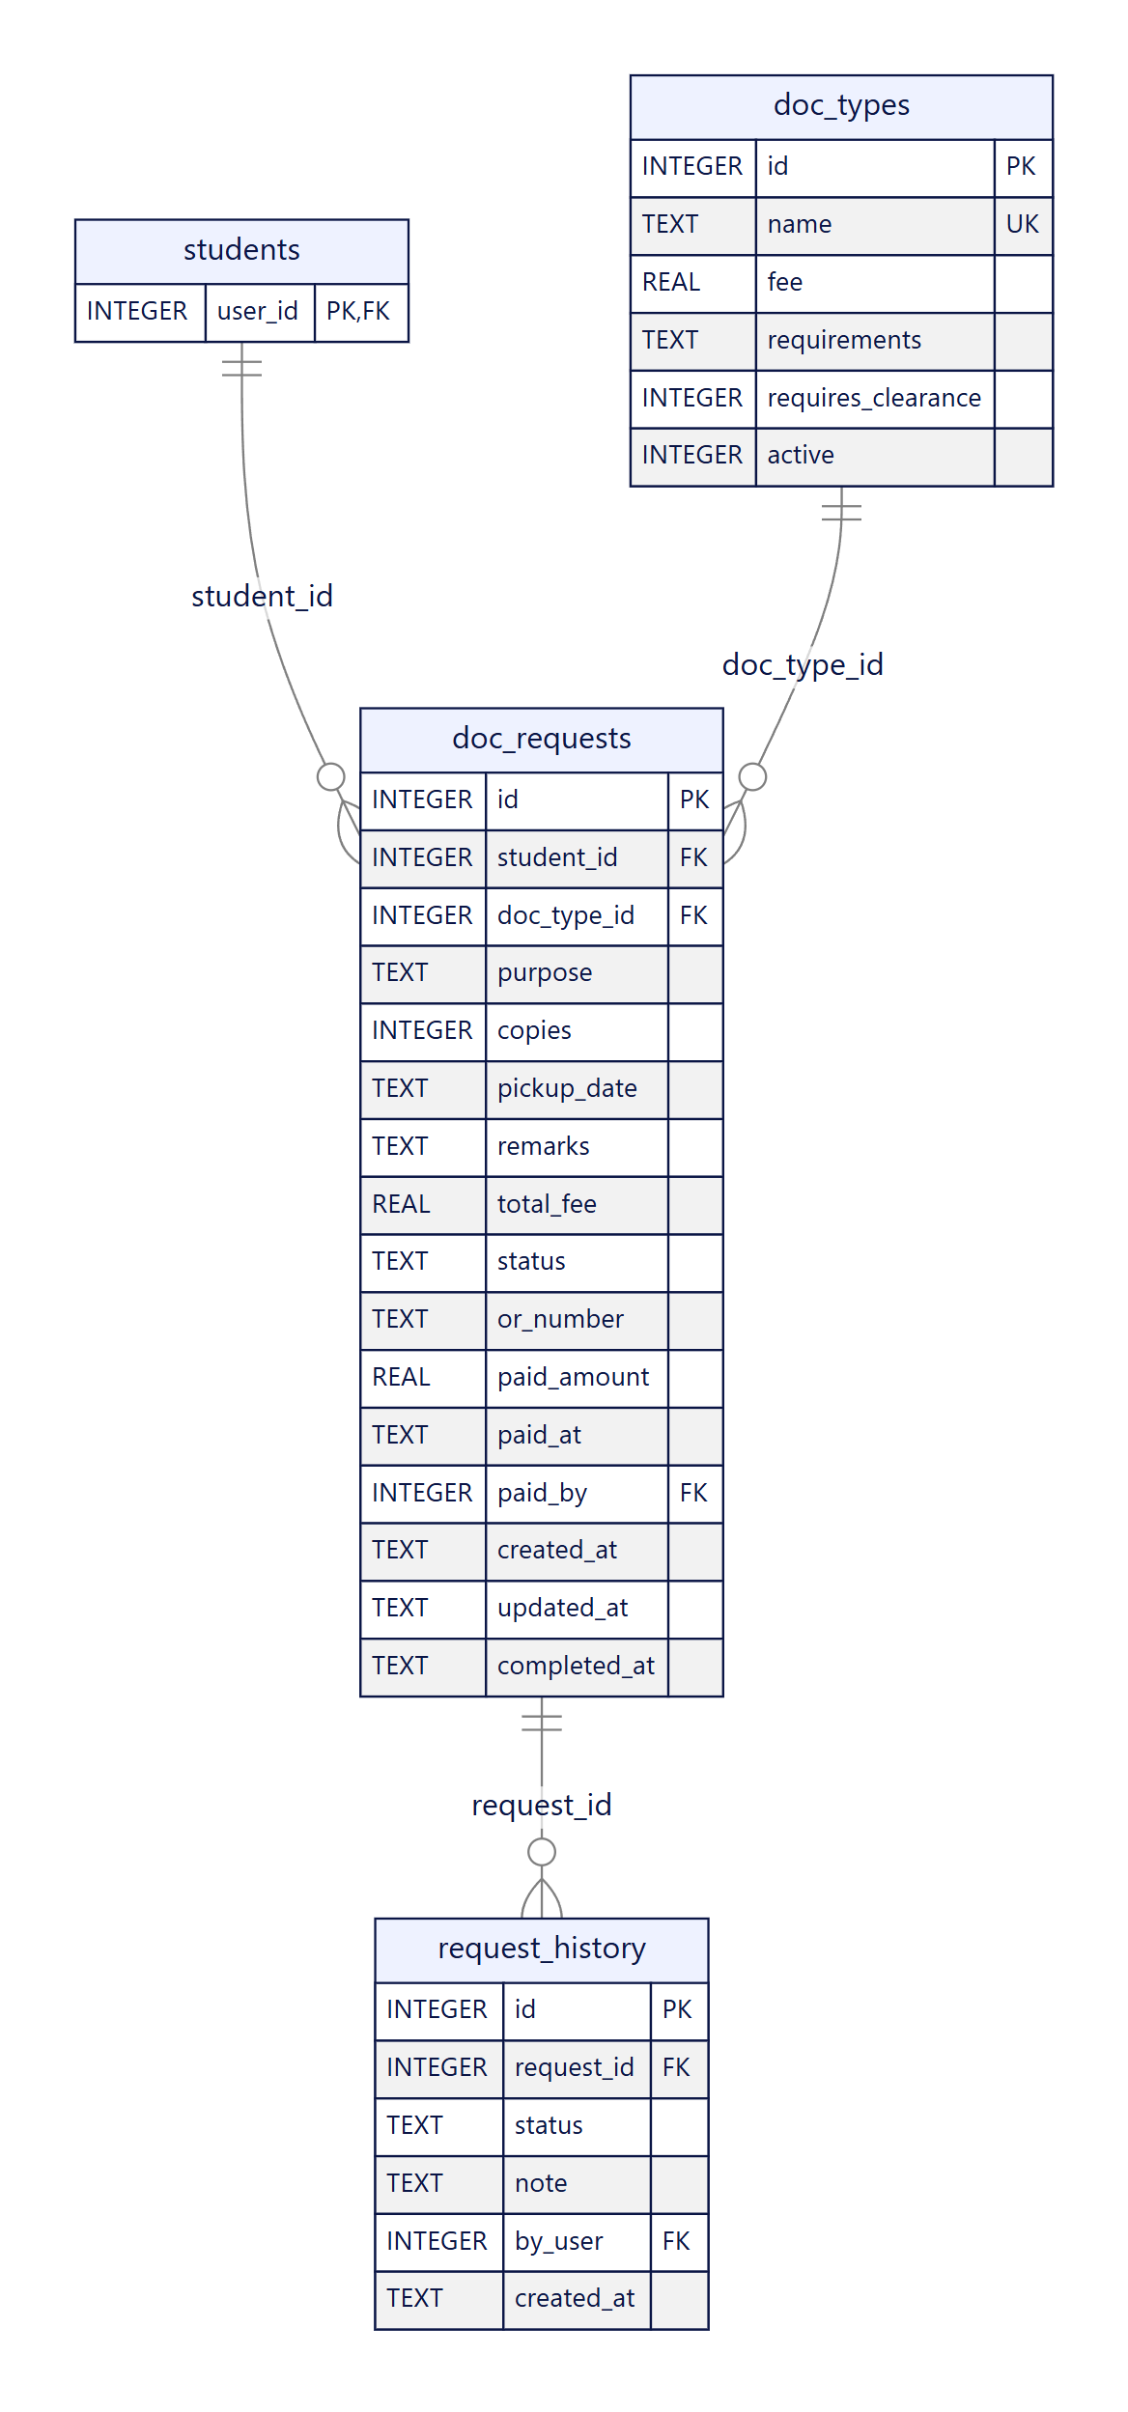
Figure 28. ERD 6 — document requests

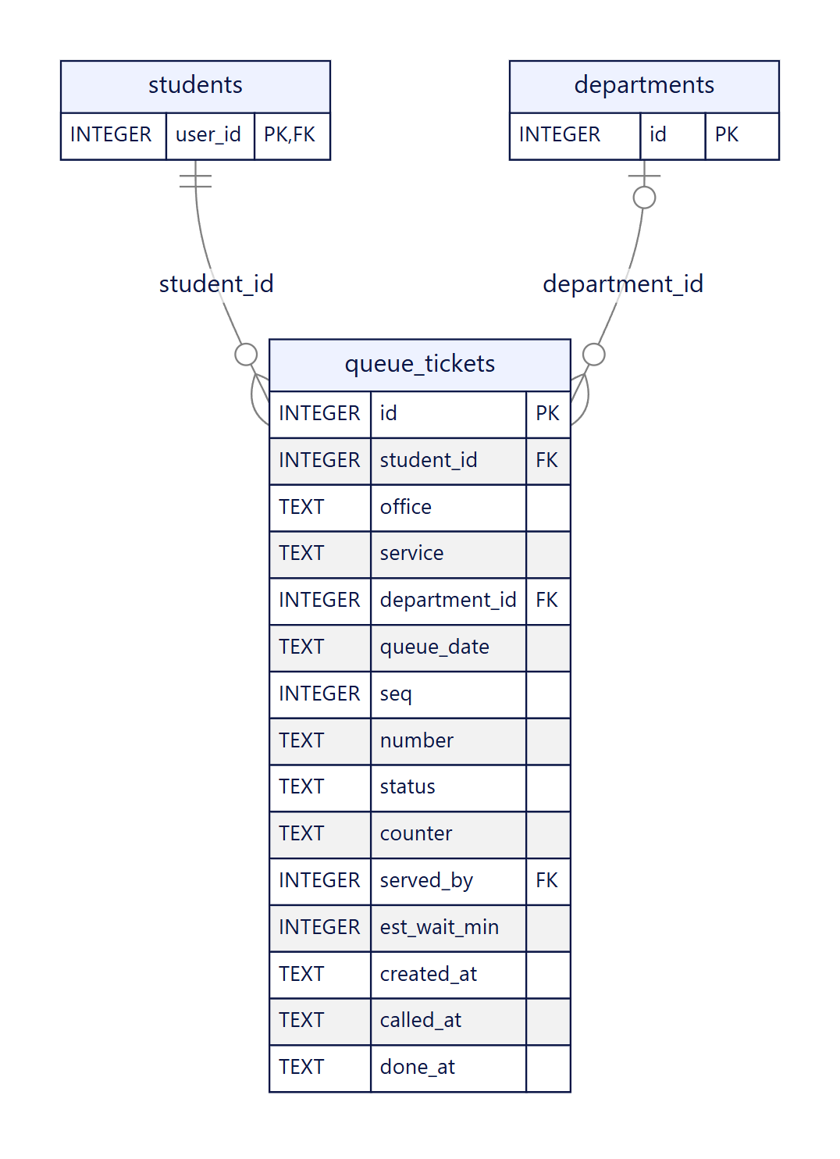
Figure 29. ERD 7 — digital queue

6.4 Data dictionary
Columns, types and constraints for every core table, taken directly from the schema. “Key” shows PK, FK or UK; “Rules” shows defaults, CHECK values and delete behaviour.

departments
Academic departments (for example CCIT, CBAA, CEAS)
Column | Type | Key | Null | Rules
id | INTEGER | PK | No
code | TEXT | UK | No
name | TEXT |  | No

programs
Degree programs offered by a department
Column | Type | Key | Null | Rules
id | INTEGER | PK | No
department_id | INTEGER | FK | No | → departments.id (cascade)
code | TEXT | UK | No
name | TEXT |  | No

users
Every account — students and staff — with role, password hash, lockout state and preferences
Column | Type | Key | Null | Rules
id | INTEGER | PK | No
role | TEXT |  | No | one of (student,registrar,cashier,department,admin,teacher)
login_id | TEXT | UK | No
password_hash | TEXT |  | No
name | TEXT |  | No
email | TEXT |  | Yes
phone | TEXT |  | Yes
department_id | INTEGER | FK | Yes | → departments.id (set null)
active | INTEGER |  | No | default 1
failed_logins | INTEGER |  | No | default 0
locked_until | TEXT |  | Yes
theme | TEXT |  | No | default light
notify_inapp | INTEGER |  | No | default 1
notify_email | INTEGER |  | No | default 0
created_at | TEXT |  | No | default CURRENT_TIMESTAMP

sessions
Sign-in sessions: random token with a 7-day expiry
Column | Type | Key | Null | Rules
token | TEXT | PK | No
user_id | INTEGER | FK | No | → users.id (cascade)
expires_at | TEXT |  | No

settings
Administrator-editable rules stored as key/value pairs
Column | Type | Key | Null | Rules
key | TEXT | PK | No
value | TEXT |  | No

terms
Academic terms; exactly one is current
Column | Type | Key | Null | Rules
id | INTEGER | PK | No
school_year | TEXT |  | No
semester | TEXT |  | No
is_current | INTEGER |  | No | default 0

students
Student details; one row per student account (shares the users key)
Column | Type | Key | Null | Rules
user_id | INTEGER | PK, FK | No | → users.id (cascade)
program | TEXT |  | No
department_id | INTEGER | FK | Yes | → departments.id (set null)
year_level | INTEGER |  | No
section | TEXT |  | No
standing | TEXT |  | No | default Regular
address | TEXT |  | Yes
guardian_name | TEXT |  | Yes
guardian_phone | TEXT |  | Yes
verified_at | TEXT |  | Yes
verified_by | INTEGER | FK | Yes | → users.id (set null)

year_progress
Units earned versus required for each year level
Column | Type | Key | Null | Rules
student_id | INTEGER | PK, FK | No | → students.user_id (cascade)
year | INTEGER | PK | No
units_total | INTEGER |  | No
units_earned | INTEGER |  | No
(composite key) |  | PK |  | student_id + year

subjects
Subject catalogue; offered subjects can be chosen at enrollment
Column | Type | Key | Null | Rules
id | INTEGER | PK | No
code | TEXT | UK | No
description | TEXT |  | No
units | INTEGER |  | No
year_level | INTEGER |  | No | default 0
offered | INTEGER |  | No | default 0
department_id | INTEGER | FK | Yes | → departments.id (set null)

meetings
Weekly class meetings: instructor, day, time and room
Column | Type | Key | Null | Rules
id | INTEGER | PK | No
subject_id | INTEGER | FK | No | → subjects.id (cascade)
instructor | TEXT |  | No
teacher_id | INTEGER | FK | Yes | → users.id (set null)
day | INTEGER |  | No | one of day BETWEEN 1 AND 6
start_min | INTEGER |  | No
end_min | INTEGER |  | No
room | TEXT |  | No

student_subjects
A student’s subjects in a term with Prelim, Midterm and Finals grades
Column | Type | Key | Null | Rules
student_id | INTEGER | PK, FK | No | → students.user_id (cascade)
subject_id | INTEGER | PK, FK | No | → subjects.id (cascade)
term_id | INTEGER | PK, FK | No | → terms.id (cascade)
prelim | REAL |  | Yes
midterm | REAL |  | Yes
finals | REAL |  | Yes
(composite key) |  | PK |  | student_id + subject_id + term_id

enrollment_requests
Online enrollment submissions and their review stages
Column | Type | Key | Null | Rules
id | INTEGER | PK | No
student_id | INTEGER | FK | No | → students.user_id (cascade)
term_id | INTEGER | FK | No | → terms.id (cascade)
status | TEXT |  | No | one of (Draft,For Department Review,For Registrar Approval,Returned,Approved); default Draft
remarks | TEXT |  | Yes
submitted_at | TEXT |  | Yes
dept_reviewed_by | INTEGER | FK | Yes | → users.id (set null)
dept_reviewed_at | TEXT |  | Yes
registrar_reviewed_by | INTEGER | FK | Yes | → users.id (set null)
registrar_reviewed_at | TEXT |  | Yes
payment_confirmed_by | INTEGER | FK | Yes | → users.id (set null)
payment_confirmed_at | TEXT |  | Yes
(unique together) |  | UK |  | student_id + term_id

enrollment_items
The subjects chosen in an enrollment request
Column | Type | Key | Null | Rules
request_id | INTEGER | PK, FK | No | → enrollment_requests.id (cascade)
subject_id | INTEGER | PK, FK | No | → subjects.id (cascade)
(composite key) |  | PK |  | request_id + subject_id

academic_requirements
Requirements a department verifies for a student
Column | Type | Key | Null | Rules
id | INTEGER | PK | No
student_id | INTEGER | FK | No | → students.user_id (cascade)
name | TEXT |  | No
status | TEXT |  | No | one of (Pending,Verified,Missing); default Pending
remarks | TEXT |  | Yes
verified_by | INTEGER | FK | Yes | → users.id (set null)
verified_at | TEXT |  | Yes
created_at | TEXT |  | No

announcements
Posts shown to students
Column | Type | Key | Null | Rules
id | INTEGER | PK | No
title | TEXT |  | No
body | TEXT |  | No
author_id | INTEGER | FK | Yes | → users.id (set null)
created_at | TEXT |  | No | default CURRENT_TIMESTAMP

clearances
Clearance lines per student and office
Column | Type | Key | Null | Rules
id | INTEGER | PK | No
student_id | INTEGER | FK | No | → students.user_id (cascade)
office | TEXT |  | No
requirement | TEXT |  | No
status | TEXT |  | No | one of (Cleared,Pending,Hold)
remarks | TEXT |  | Yes
updated_at | TEXT |  | No | default CURRENT_TIMESTAMP

fees
Fee lines assessed to a student for a term
Column | Type | Key | Null | Rules
id | INTEGER | PK | No
student_id | INTEGER | FK | No | → students.user_id (cascade)
term_id | INTEGER | FK | No | → terms.id (cascade)
name | TEXT |  | No
amount | REAL |  | No

payments
Installments and payments (Due, Paid, Void) with official receipt reference
Column | Type | Key | Null | Rules
id | INTEGER | PK | No
student_id | INTEGER | FK | No | → students.user_id (cascade)
term_id | INTEGER | FK | No | → terms.id (cascade)
due_on | TEXT |  | No
reference | TEXT |  | Yes
amount | REAL |  | No
status | TEXT |  | No | one of (Paid,Due,Void)
method | TEXT |  | Yes
paid_at | TEXT |  | Yes
recorded_by | INTEGER | FK | Yes | → users.id (set null)
void_reason | TEXT |  | Yes

doc_types
Document catalogue with fee, requirements and clearance rule
Column | Type | Key | Null | Rules
id | INTEGER | PK | No
name | TEXT | UK | No
fee | REAL |  | No
requirements | TEXT |  | Yes
requires_clearance | INTEGER |  | No | default 0
active | INTEGER |  | No | default 1

doc_requests
Document requests with status, copies, fee and payment details
Column | Type | Key | Null | Rules
id | INTEGER | PK | No
student_id | INTEGER | FK | No | → students.user_id (cascade)
doc_type_id | INTEGER | FK | No | → doc_types.id (no action)
purpose | TEXT |  | Yes
copies | INTEGER |  | No | default 1
pickup_date | TEXT |  | Yes
remarks | TEXT |  | Yes
total_fee | REAL |  | No | default 0
status | TEXT |  | No | one of (Pending,For Payment,Processing,Ready for Release,Released,Cancelled); default Pending
or_number | TEXT |  | Yes
paid_amount | REAL |  | Yes
paid_at | TEXT |  | Yes
paid_by | INTEGER | FK | Yes | → users.id (set null)
created_at | TEXT |  | No
updated_at | TEXT |  | No
completed_at | TEXT |  | Yes

request_history
Every status change of a document request
Column | Type | Key | Null | Rules
id | INTEGER | PK | No
request_id | INTEGER | FK | No | → doc_requests.id (cascade)
status | TEXT |  | No
note | TEXT |  | Yes
by_user | INTEGER | FK | Yes | → users.id (set null)
created_at | TEXT |  | No

queue_tickets
Digital queue tickets per office and day
Column | Type | Key | Null | Rules
id | INTEGER | PK | No
student_id | INTEGER | FK | No | → students.user_id (cascade)
office | TEXT |  | No | one of (Registrar,Cashier,Department)
service | TEXT |  | No
department_id | INTEGER | FK | Yes | → departments.id (set null)
queue_date | TEXT |  | No
seq | INTEGER |  | No
number | TEXT |  | No
status | TEXT |  | No | one of (Waiting,Serving,Done,Skipped,Cancelled); default Waiting
counter | TEXT |  | Yes
served_by | INTEGER | FK | Yes | → users.id (set null)
est_wait_min | INTEGER |  | Yes
created_at | TEXT |  | No
called_at | TEXT |  | Yes
done_at | TEXT |  | Yes

audit_log
Record of who did what and when
Column | Type | Key | Null | Rules
id | INTEGER | PK | No
user_id | INTEGER | FK | Yes | → users.id (set null)
actor | TEXT |  | Yes
role | TEXT |  | Yes
action | TEXT |  | No
entity | TEXT |  | Yes
entity_id | TEXT |  | Yes
detail | TEXT |  | Yes
created_at | TEXT |  | No

login_attempts
Every sign-in attempt with result, reason and address
Column | Type | Key | Null | Rules
id | INTEGER | PK | No
login_id | TEXT |  | Yes
role | TEXT |  | Yes
user_id | INTEGER | FK | Yes | → users.id (set null)
success | INTEGER |  | No
reason | TEXT |  | Yes
ip | TEXT |  | Yes
user_agent | TEXT |  | Yes
created_at | TEXT |  | No

notifications
In-app notifications for a user
Column | Type | Key | Null | Rules
id | INTEGER | PK | No
user_id | INTEGER | FK | No | → users.id (cascade)
message | TEXT |  | No
link | TEXT |  | Yes
is_read | INTEGER |  | No | default 0
created_at | TEXT |  | No

6.5 Relationships and delete rules
The schema declares 40 foreign keys. “cascade” removes dependent rows with the parent; “set null” keeps the row and clears the link (used for the staff member who performed an action, so history survives account removal); “no action” blocks deleting a parent that is still in use.
Child column | Parent | Link | On delete
programs.department_id | departments.id | required | cascade
users.department_id | departments.id | optional | set null
sessions.user_id | users.id | required | cascade
students.user_id | users.id | required | cascade
students.department_id | departments.id | optional | set null
students.verified_by | users.id | optional | set null
year_progress.student_id | students.user_id | required | cascade
subjects.department_id | departments.id | optional | set null
meetings.subject_id | subjects.id | required | cascade
meetings.teacher_id | users.id | optional | set null
student_subjects.student_id | students.user_id | required | cascade
student_subjects.subject_id | subjects.id | required | cascade
student_subjects.term_id | terms.id | required | cascade
enrollment_requests.student_id | students.user_id | required | cascade
enrollment_requests.term_id | terms.id | required | cascade
enrollment_requests.dept_reviewed_by | users.id | optional | set null
enrollment_requests.registrar_reviewed_by | users.id | optional | set null
enrollment_requests.payment_confirmed_by | users.id | optional | set null
enrollment_items.request_id | enrollment_requests.id | required | cascade
enrollment_items.subject_id | subjects.id | required | cascade
academic_requirements.student_id | students.user_id | required | cascade
academic_requirements.verified_by | users.id | optional | set null
announcements.author_id | users.id | optional | set null
clearances.student_id | students.user_id | required | cascade
fees.student_id | students.user_id | required | cascade
fees.term_id | terms.id | required | cascade
payments.student_id | students.user_id | required | cascade
payments.term_id | terms.id | required | cascade
payments.recorded_by | users.id | optional | set null
doc_requests.student_id | students.user_id | required | cascade
doc_requests.doc_type_id | doc_types.id | required | no action
doc_requests.paid_by | users.id | optional | set null
request_history.request_id | doc_requests.id | required | cascade
request_history.by_user | users.id | optional | set null
queue_tickets.student_id | students.user_id | required | cascade
queue_tickets.department_id | departments.id | optional | set null
queue_tickets.served_by | users.id | optional | set null
audit_log.user_id | users.id | optional | set null
login_attempts.user_id | users.id | optional | set null
notifications.user_id | users.id | required | cascade

6.6 Constraints and indexes

Business rules enforced by the database
- Unique login ID per account; unique department code, program code, subject code and document name.
- One enrollment request per student per term (unique student + term); one grade row per student, subject and term.
- CHECK constraints limit role, enrollment status, requirement status, clearance status, payment status, document status, queue office and queue status to the allowed values.
- Foreign keys let a department, term or subject be deleted only according to the rules in section 6.5.

Rules enforced by the server instead
Some rules need more than a column constraint, so the server enforces them inside transactions: no skipped document-status steps, one active queue ticket per student per day, official receipt numbers never duplicated, payments never above the balance, and room or instructor conflicts in schedules.

Indexes
Index | Table | Columns
idx_messages_task | task_messages | task_id, id
idx_requests_status | doc_requests | status, created_at
idx_history_request | request_history | request_id, id
idx_queue_lookup | queue_tickets | office, queue_date, status
idx_audit_time | audit_log | created_at
idx_login_attempts_time | login_attempts | created_at
idx_login_attempts_login | login_attempts | login_id, created_at

6.7 Normalisation to 3NF
The design was checked against the three normal forms. The sections below state what holds, show a worked example, and list the places where the design departs from strict 3NF on purpose or could be improved.

First normal form (1NF)
- Every column holds a single value; there are no repeating groups. Multi-valued facts live in their own tables: a student’s subjects in student_subjects, the subjects of an enrollment request in enrollment_items, and a request’s status changes in request_history.
- doc_types.requirements is a short descriptive text shown to students and is never searched or joined, so it is kept as one text value.

Second normal form (2NF)
- Tables with a composite key were checked for partial dependencies. In student_subjects (student, subject, term) the three grades depend on the whole key. In year_progress (student, year) both unit counts depend on the whole key. enrollment_items has no non-key columns.

Third normal form (3NF)
- No non-key column depends on another non-key column in the core design: department names live only in departments, document fees only in doc_types, subject details only in subjects, and a balance is computed instead of stored.

Worked example — document request
A paper form for a document request carries everything in one record. Normalisation separates it step by step:
Step | Structure | Problem solved
Unnormalised | Request(request no., student no., student name, program, department, document name, document fee, copies, pickup date, status 1, status 2 … ) | Repeating status columns; student and document facts repeated on every request
1NF | Status changes move to RequestHistory(request, status, note, user, time); each cell holds one value | Repeating group removed
2NF | Request key is the request number alone, so every column depends on all of it; student and document facts no longer depend on a part of a key | No partial dependencies
3NF | Student facts → students and users; document name and fee → doc_types; department name → departments. Request keeps only student id, document type id, copies, dates, status | Transitive dependencies removed: change a fee or a department name in one place

Deliberate departures and open points
Where | What | Why / recommendation
students.program | Plain text holding the program name, while a programs table exists and students.department_id is stored separately | Not linked, so the program → department dependency is not enforced. Improvement: replace with program_id referencing programs and derive the department from the program.
doc_requests.total_fee, paid_amount | total_fee equals fee × copies at the time of request | Deliberate snapshot: later fee changes must not alter old requests. Keep.
queue_tickets.number, est_wait_min | number is built from the office prefix and seq; the wait estimate is stored | Stored for display and a daily unique number; estimate is a snapshot at ticket time. Keep.
audit_log.actor, role | Name and role copied from the user | Deliberate: the log must stay readable after an account is changed or removed. Keep.
enrollment_requests review columns | Three pairs of reviewed_by / reviewed_at (department, registrar, payment) | Fixed process stages, so a repeating pattern is acceptable. If stages become configurable, move to an enrollment_events table.
clearances.office, requirement | Text values from a small fixed set | Could become lookup tables if offices become configurable.
Money columns | REAL for fees and payments | Improvement: store integer centavos to avoid floating-point rounding.
Roles in users.role | One role column with a CHECK list | Fine for five fixed roles. A roles and permissions table is the next step if custom permissions (backlog PL-06) are built.

Optional LMS tables
The tables activities, tasks, task_messages, thread_reads support class activities and private comments. They are created but unused while the LMS option is switched off, and are outside the project scope.

7. Traceability and open items

7.1 Diagrams and requirements
Requirement group (backlog) | Use cases | Activity | DFD | Classes | ERD
Student Portal (SP-01 … SP-11) | UC-S01 … S14 | 3.1, 3.2 | 1.0, 2.0, 6.0, 7.0 | 5.1, 5.2, 5.3 | ERD 1, 3, 4
Registrar Module (RG-01 … RG-10) | UC-R01 … R11 | 3.2, 3.3 | 2.0, 3.0, 7.0, 8.0 | 5.1 – 5.4 | ERD 3, 4, 6
Cashier Module (CS-01 … CS-07) | UC-C01 … C08 | 3.2, 3.3 | 4.0 | 5.4 | ERD 5
Department Module (DP-01 … DP-06) | UC-D01 … D07 | 3.2 | 2.0, 6.0 | 5.1, 5.3 | ERD 4
Admin Module (AD-01 … AD-09) | UC-A01 … A09 | 3.1 | 1.0, 8.0 | 5.1, 5.5 | ERD 1, 2
Document Request System (DR-01 … DR-08) | UC-S09 … S11, R07, R08, C06 | 3.3 | 3.0 and Level 2 | 5.4 | ERD 6
Digital Queue (QU-01 … QU-07) | UC-S12, S13, R09, C07, D07 | 3.4 | 5.0 and Level 2 | 5.5 | ERD 7
Security and quality (SQ-01 … SQ-07) | UC-S01, A06, A07 | 3.1 | 1.0 | 5.5 | ERD 2

7.2 Open items for the team
- Review every diagram against the team’s understanding and the instructor’s notation requirements; redraw in the required tool if needed.
- Decide whether to fix the departures listed in section 6.7 (program link, money as centavos) before the final paper, or to document them as known limitations.
- Confirm the Scrum roles and names in the final paper; this document only lists the project team from the progress report.
- The system still needs a live URL and user-acceptance sign-off; these are tracked in the product backlog and the test plan.

