Assignment 1 – Data Storage and Analysis
Couse name: Special Topics in Data Analytics
Student Name: Ianna Iaichkina
Student ID: 300234152

Part 1 – CSV vs Parquet Performance Comparison
In this experiment, I compared the performance of CSV and Parquet file formats on three dataset sizes: 1x, 10x, and 100x. I measured write time, read time, and file size.
The results show that CSV files become very slow and large as the dataset size increases. For the 100x dataset, CSV had the largest file size and the slowest read and write performance.
In contrast, Parquet performed significantly better. Both Snappy and ZSTD compression produced much smaller file sizes and faster read times compared to CSV. Among the Parquet options, ZSTD provided the best balance between file size and performance, producing the smallest files while still maintaining fast read speeds.
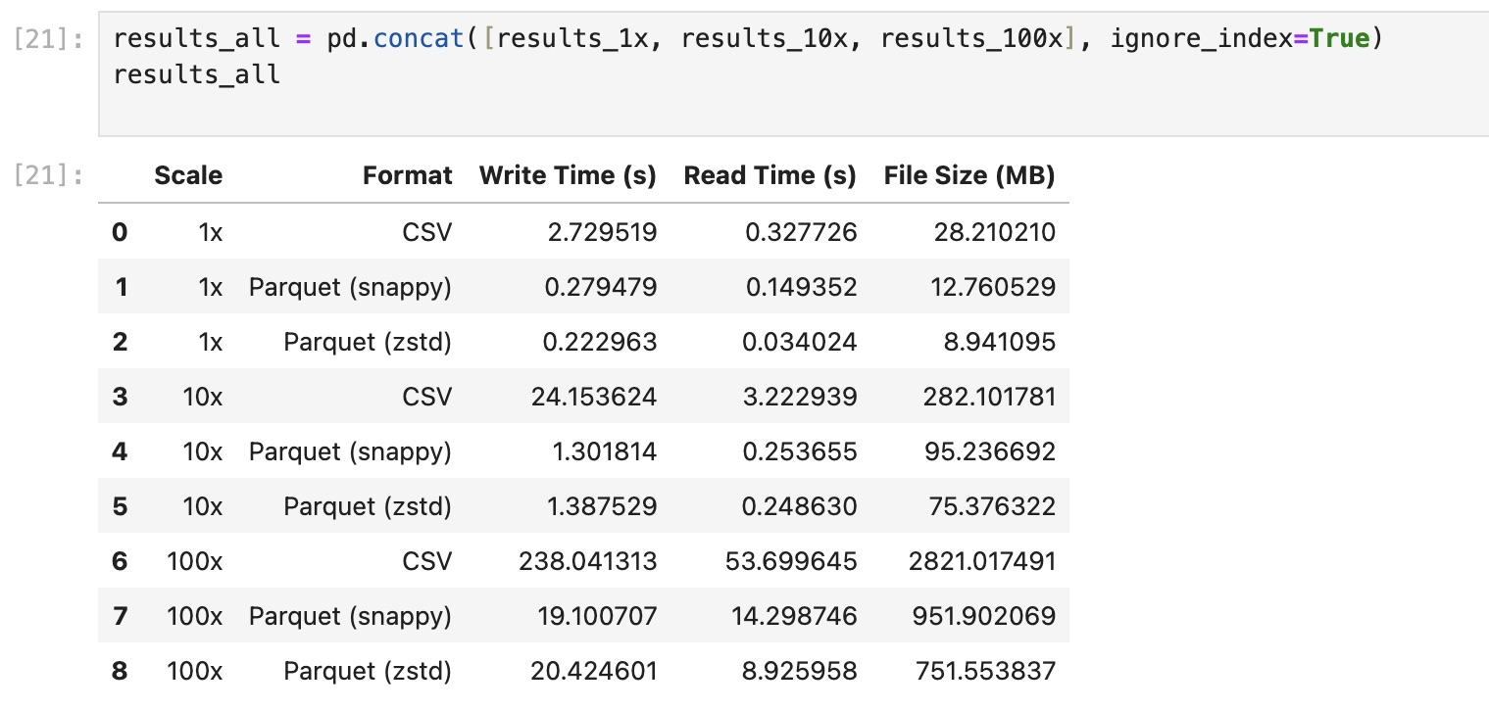
Overall, Parquet is more efficient and scalable than CSV, especially for large datasets.

Part 2 – Model Performance Analysis
Two regression models were trained to predict the next day’s closing price: Linear Regression and Random Forest.
The Linear Regression model performed very well, achieving a low MAE and RMSE, and an R² score close to 1. This indicates that the model was able to accurately capture the relationship between the current price, technical indicators, and the next day’s price.
In contrast, the Random Forest model performed poorly. It produced large prediction errors and a negative R² value, meaning it performed worse than a simple baseline model. This is likely because Random Forest models are not well suited for time-series forecasting with a small number of features, especially when trends need to be extrapolated.
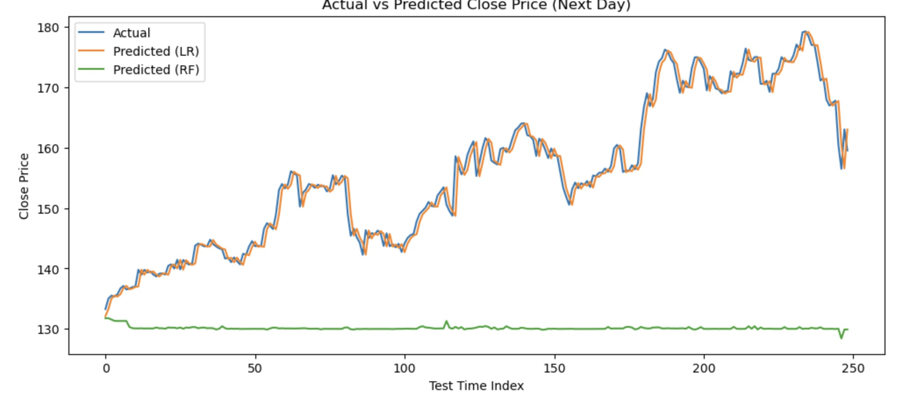
Overall, Linear Regression was the more suitable model for this task.

Model Evaluation Metrics
Model | MAE | RMSE | R²
Linear Regression | 1.31 | 1.89 | 0.975
Random Forest | 25.79 | 28.52 | -4.56

Linear Regression achieved strong performance with low error and high R². Random Forest performed poorly, producing large errors and a negative R² value. This indicates Linear Regression is more suitable for this time-series prediction task.

Part 3 – Pandas vs Polars Performance Comparison
Pandas vs Polars Performance Comparison
Pandas and Polars were compared using the same data preprocessing pipeline for one stock (AAPL). The pipeline included filtering the data, sorting by date, calculating technical indicators (SMA and RSI), and creating the prediction target.
The results show that Pandas completed the task faster than Polars on this dataset. This is likely because, after filtering for a single stock, the dataset became relatively small (around 1,200 rows). For smaller datasets, the overhead of using Polars can outweigh its performance benefits.
Polars is generally optimized for large-scale data processing and can outperform Pandas on bigger datasets. However, in this experiment, Pandas proved to be more efficient for the given data size and operations.
Library | Time (s) | Rows Output
Pandas | 0.044 | 1244
Polars | 0.109 | 1245

Pandas processed the dataset slightly faster than Polars in this experiment. Polars is generally more efficient for larger datasets, but for smaller datasets Pandas may perform better.

Conclusion
Parquet proved to be superior to CSV in performance and storage efficiency. Linear Regression was the most accurate predictive model. Visualization confirmed model performance, and Pandas showed slightly better performance than Polars for this dataset size.

