Server Coverage Reports

**Overview**: Coverage reports are based on a comparison between node inventory in ScienceLogic EM7 and Service Now. Raw data comes from manual exports from the two systems. The scripts and the raw data should be copied to a local drive on a laptop.

**Source for copying the scripts to a laptop**:

\\ent\aaa\IT\ESTM\Ian

**To run script:**

Step 1: Install Python

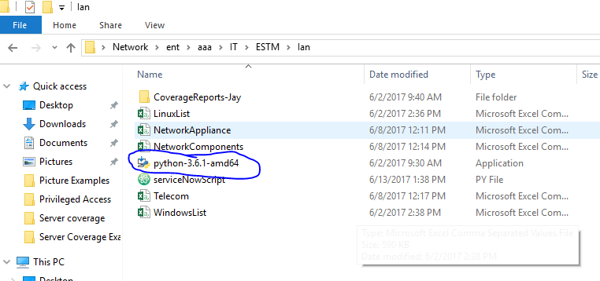

Step 2: Add python to PATH and then install

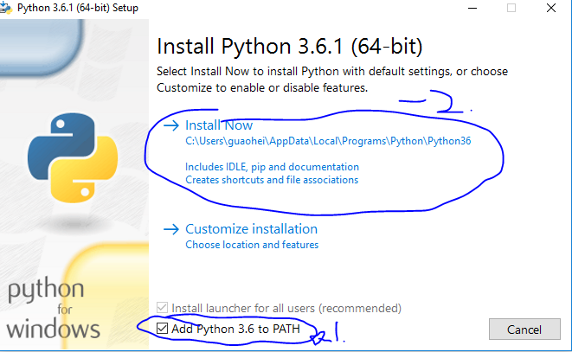

Step 3: Open powershell

Step 4: Type “pip install openpyxl” no quotations

Step 5: You may need certain permissions to install openpyxl and Python

**Extracting raw data from EM7:**

Login to EM7 and choose the Registry tab. For Telecom devices type Tel in the box filer above the Organization column, for all others leave it blank. Hit the Report button as below.

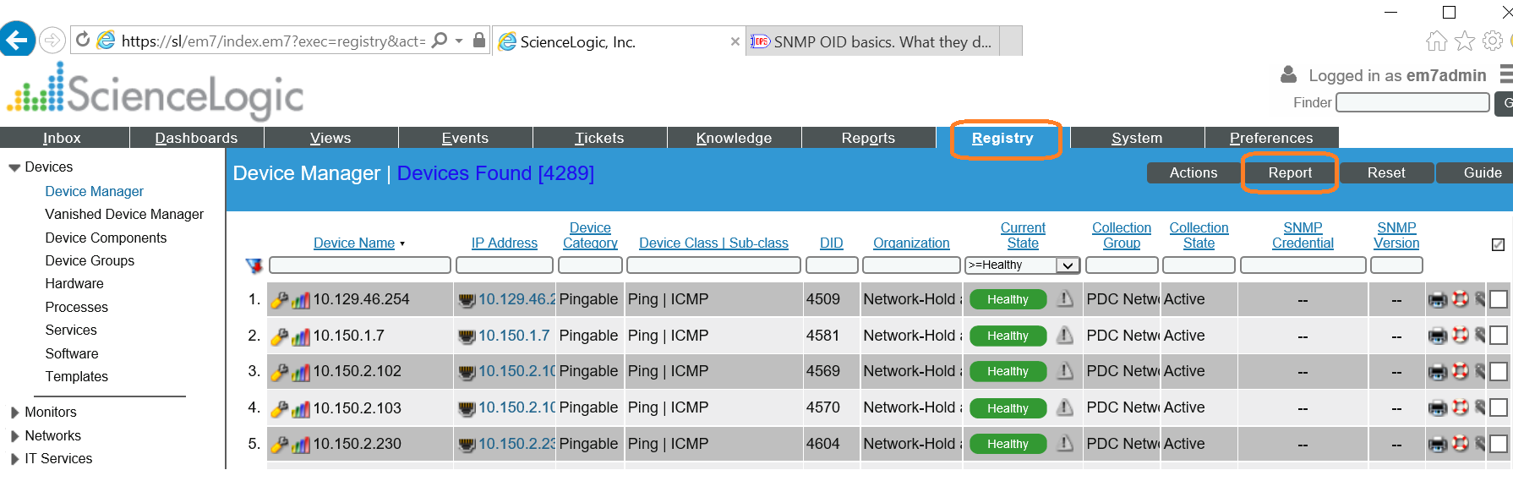

Choose the default of CSV, select the “Force browser to save to disk” option

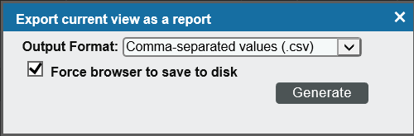

Once generated, rename the file to “sciencelogic.csv” or “telecomScienceLogic.csv” and copy to whatever directory the previous script is in

THE COLUMNS MUST BE IN THIS ORDER:

Device Name is Col 1

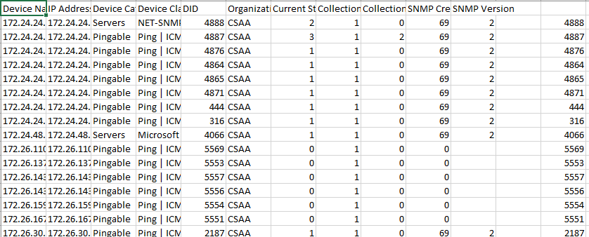

**Extracting raw data from ServiceNow:**

Login to ServiceNow and navigate to Reports -> View/Run. Choose the Group button and type “Exclude” in the search bar. There are five reports that are needed. “Exclude from Monitoring Check – Linux & Unix Platforms- In USE List Form”, “Exclude from Monitoring Check –Windows Platforms- In USE list form”, “Exclude from Monitoring Check – Network Appliance Hardware- In USE List Form”, “Exclude from Monitoring Check –Network Components- In USE list form”, “Exclude from Monitoring Check – Telecommunications Hardware- In USE List Form”

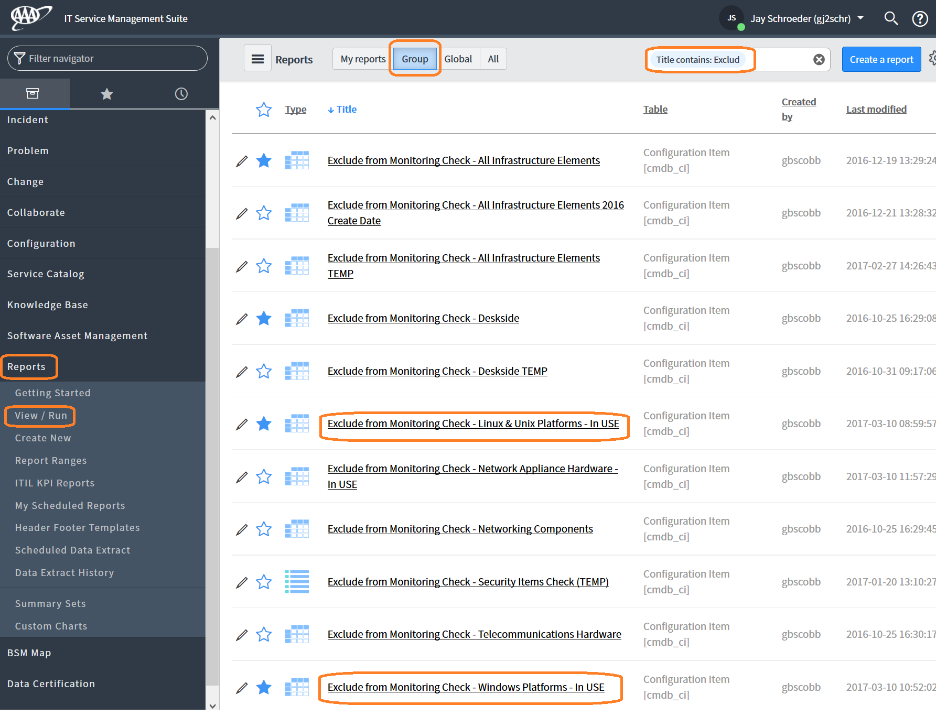

Individually, run each of these reports by clicking on it. The output will have a table at the bottom. Click on the value in the bottom “Total” row and “Total” column. Keep in mind that this is done twice. Once for the Windows exclusion report, once for the Unix/Linux exclusion report.

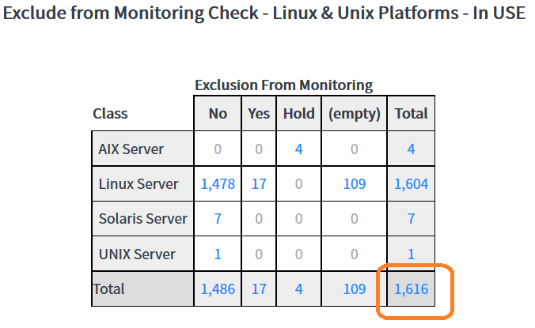 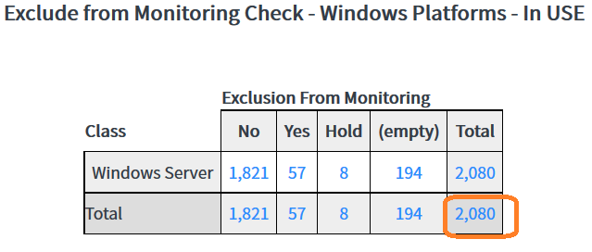

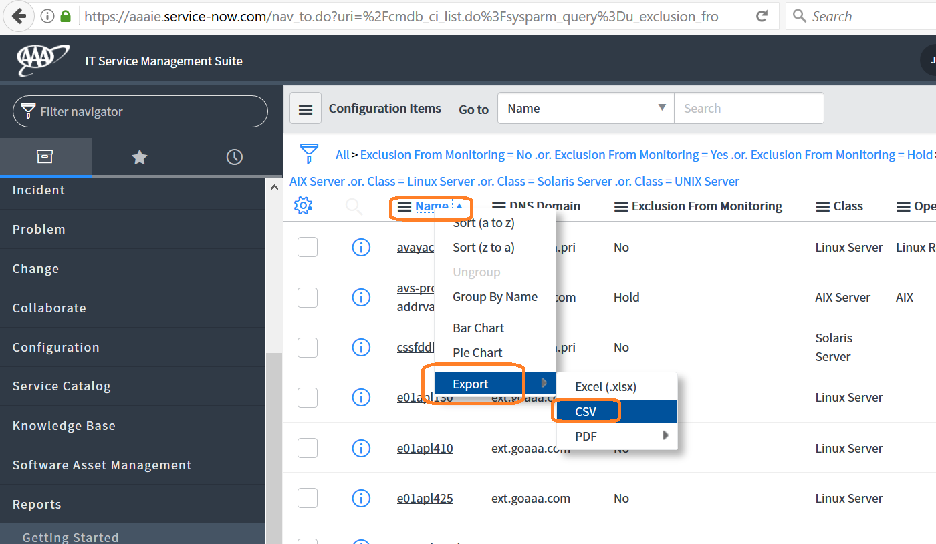

Once the bottom right cell is clicked, a new screen opens with contents of the report. Right-click the “Name” column and choose Export -> CSV. Save the report names in an appropriate manner such as:

Unix/Linux: LinuxList.csv

Windows: WindowsList.csv

Network Appliances: NetworkAppliances.csv

Copy each of these to the directory the script is in

THE COLUMNS MUST BE IN THIS ORDER:

Name is col 1

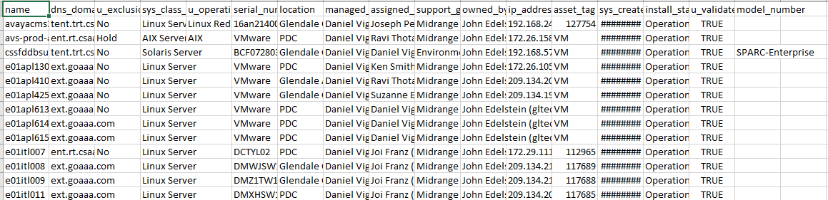

**Running the scripts**

As mentioned above, the source should be copied locally for running the scripts. Assuming this was done at C:\, the following should now be present:

C:\serviceNowScript.py

C:\LinuxList.csv

C:\WindowsList.csv

C:\NetworkAppliances.csv

The above directory should have the recently exported sciencelogic.csv or telecomScienceLogic.csv . Open powershell and go to the directory the script is in and type “python serviceNowScript.py” with no quotations.

The script will start by printing one line then asking for a prompt

The script analyzes ~80 machines in 60 seconds

Please enter the Sciencelogic file name including the file extension (EX:sciencelogic.csv):

Enter the name of the sciencelogic file you will be using. If you’re comparing a Telecom file, use the appropriate sciencelogic file. For example at this prompt you could put

The script analyzes ~80 machines in 60 seconds

Please enter the Sciencelogic file name including the file extension (EX:sciencelogic.csv): sciencelogic.csv

Afterwards you will be asked for another prompt and then you will enter the csv file from service now

Please enter the list name including the file extension (EX:WindowsList.csv): WindowsList.csv

The script will run for about 20-30 minutes depending on how many machines are being compared. After the script is done it will print out the start and stop time in powershell, while also creating a new excel file with information about the servers. The excel file will also be emailed to Suzanne. Below is a full example of running the script.

Step 1:

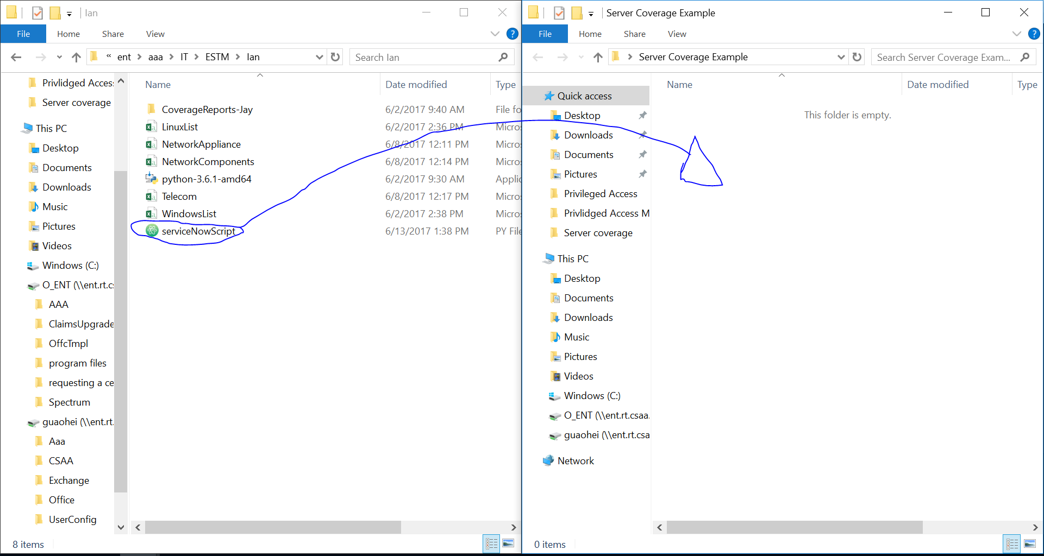

Step 2:

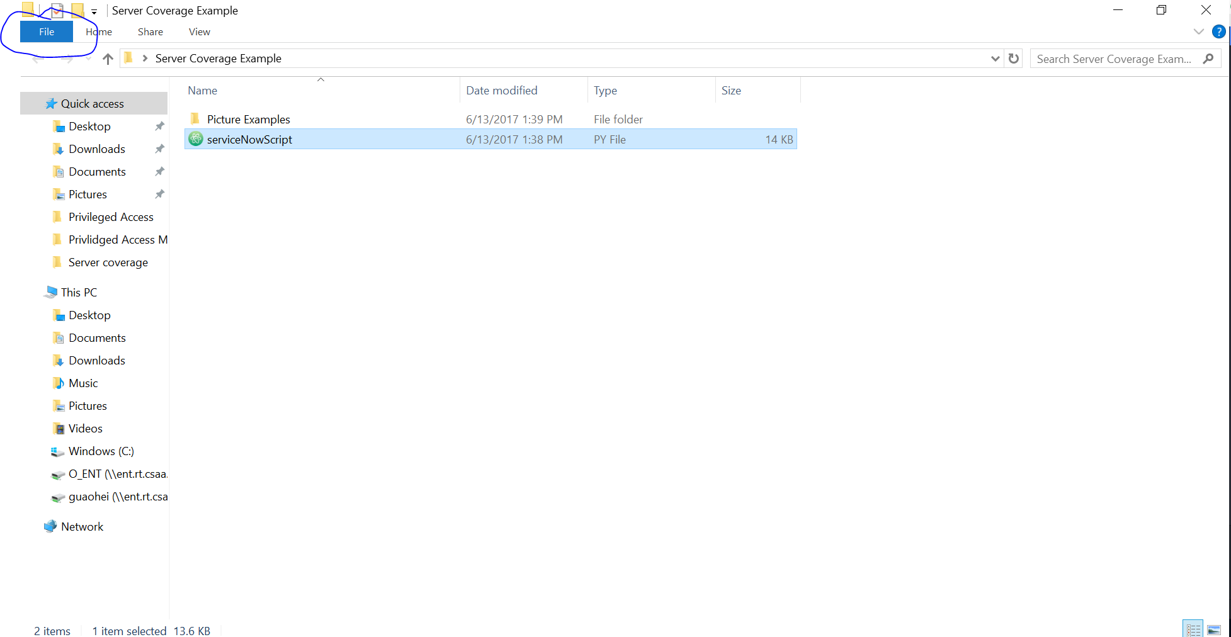

Step 3:

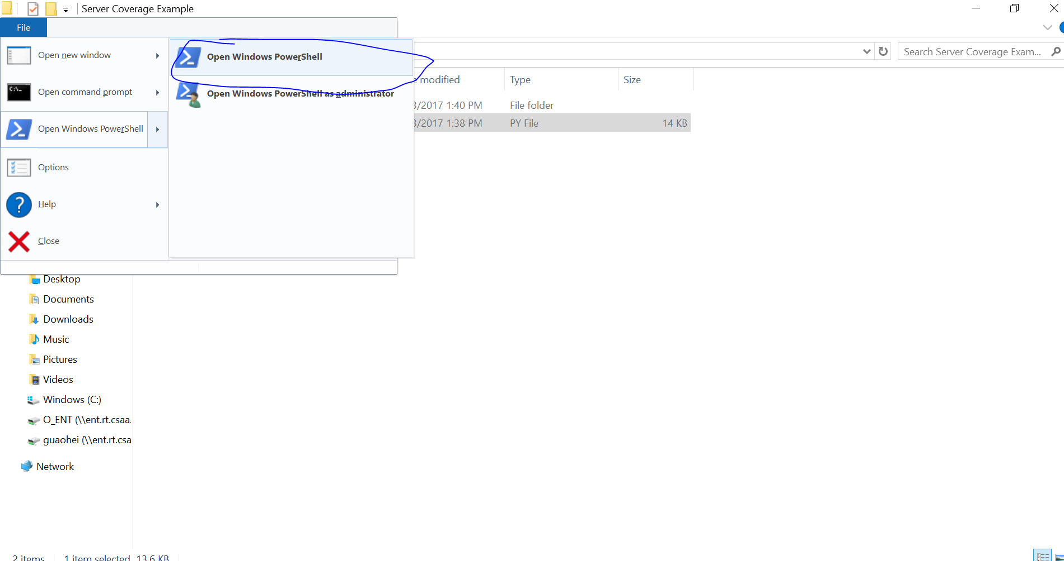

Step 4:

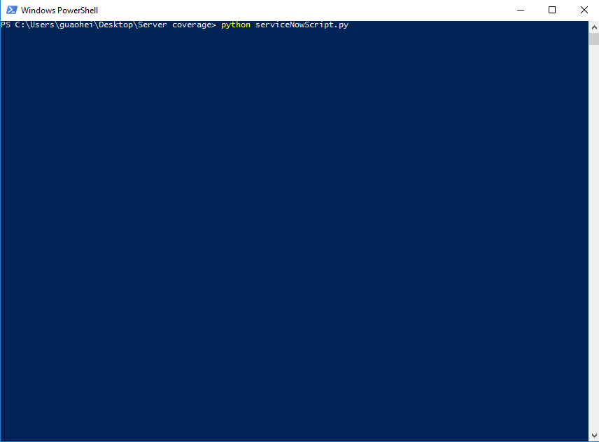

Step 5:

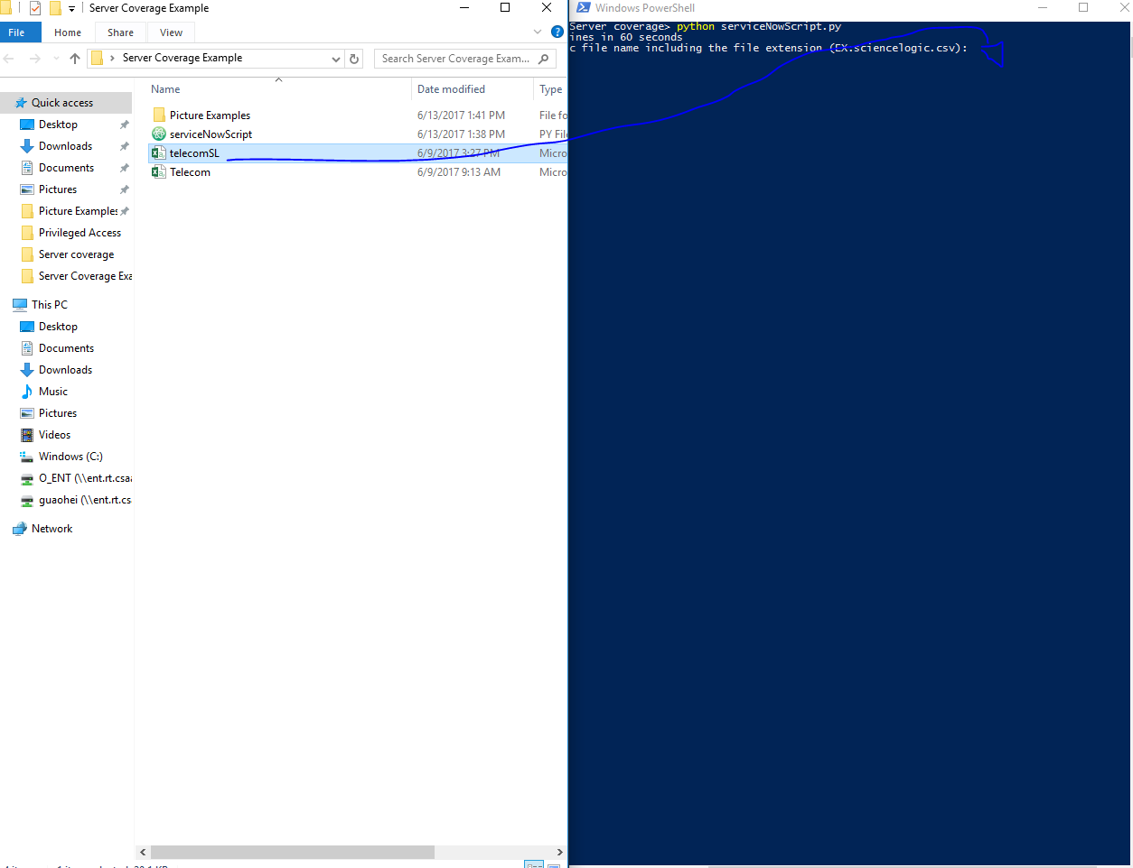

Step 6:

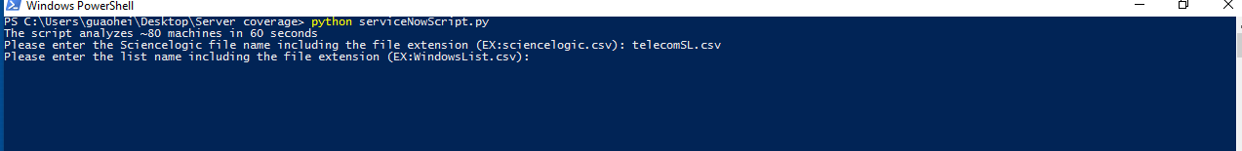

Step 7:

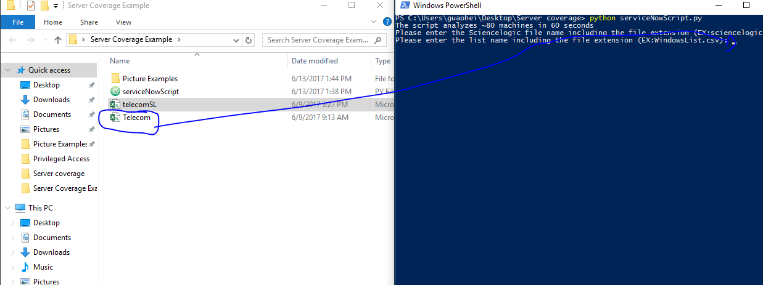

Step 8:

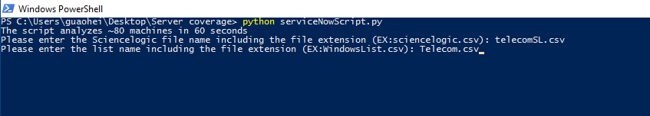

Step 9 (This step will run for the longest time and those bottom three messages will happen very often):

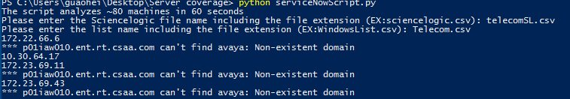

Step 10 (The email will be sent and the new excel sheet with the comparison will be made in the same directory):

