HW4 ICP LiDAR Localization 310512054 電控碩一 彭晨益

**(a) Publish and Visualize Point Cloud Map**

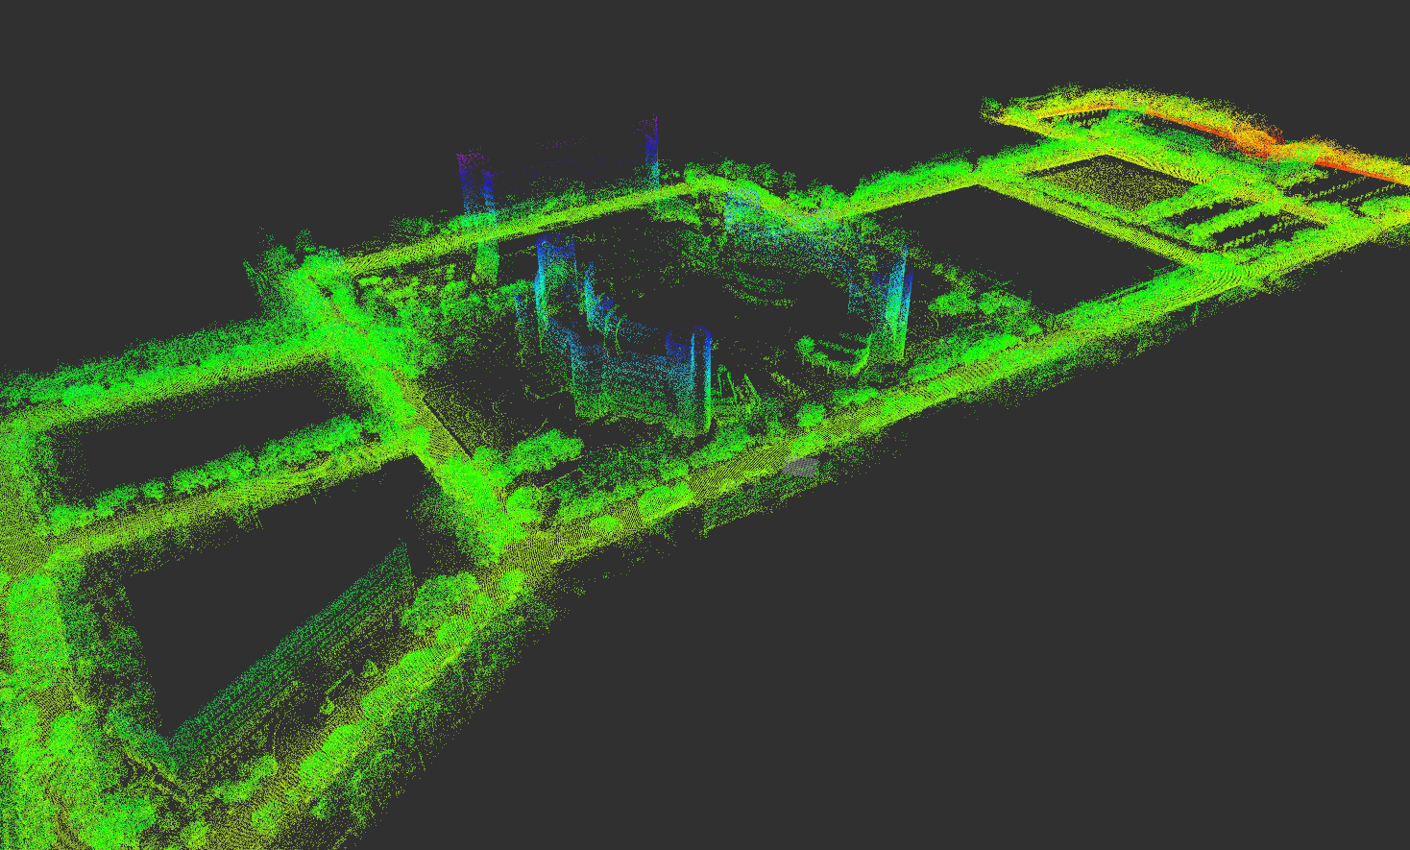

**(b)** **ICP Localization**

