**Software Requirements Specification**

**for**

Online Examination System

**Version 1.0 approved**

**Prepared by I Ravindra Varma,Yogesh Vishwakarma**

**National Institute of Technology Karnataka, Surathkal**

**17 Jan , 2019**

**Table of Contents**

**Table of Contents ii**

**Revision History ii**

**1. Introduction 1**

1.1 Purpose 1

1.2 Document Conventions 1

1.3 Intended Audience and Reading Suggestions 1

1.4 Product Scope 1

1.5 References 1

**2. Overall Description 2**

2.1 Product Perspective 2

2.2 Product Functions 2

2.3 User Classes and Characteristics 2

2.4 Operating Environment 2

2.5 Design and Implementation Constraints 2

2.6 User Documentation 2

2.7 Assumptions and Dependencies 3

**3. External Interface Requirements 3**

3.1 User Interfaces 3

3.2 Hardware Interfaces 3

3.3 Software Interfaces 3

3.4 Communications Interfaces 3

**4. System Features 4**

4.1 System Feature 1 4

4.2 System Feature 2 (and so on) 4

**5. Other Nonfunctional Requirements 4**

5.1 Performance Requirements 4

5.2 Safety Requirements 5

5.3 Security Requirements 5

5.4 Software Quality Attributes 5

5.5 Business Rules 5

**6. Other Requirements 5**

**Appendix A: Glossary 5**

**Appendix B: Analysis Models 5**

**Appendix C: To Be Determined List 6**

**Revision History**

|  |  |  |  |
| --- | --- | --- | --- |
| **Name** | **Date** | **Reason For Changes** | **Version** |
|  |  |  |  |
|  |  |  |  |

# **Introduction**

## **Purpose**

*This application is used to conduct online examination. The students can sit at individual terminals and login to write the exam in the given duration.The questions have to be given to the students.This application will perform correction, display the result immediately and also store it in database. This application provides the administrator with a facility to add new exams.This application provides the Instructor add questions to the exam, modify questions in the exam in a particular exam. This application takes care of authentication of the administrator,Instructor as well as the student.*

## **Document Conventions**

*This SRS is prepared in Google Docs. Font used in this SRS is ‘Arial’ and the font-size for paragraphs is 11pt whereas for sub-headings font-size of 14pt is used. All the Heading have 18pt font-size. Headings and sub-headings are bold in this SRS document*

## **Intended Audience and Reading Suggestions**

*This document is made by keeping in mind different types of students. This document will be useful for different students in various ways.*

|  |  |
| --- | --- |
| ***Audience*** | ***Use*** |
| *Developers* | *They will use this document as a guidance for design and implementation phase.* |
| *Managers* | *They will see all the constraints are covered properly. Time and cost is within limits or not.* |
| *User* | *By reading the SRS they can ensure whether their needs are being met by the Web app or not.* |
| *Testers* | *They will test the implementation of the project according to the SRS base.* |

## **Product Scope**

*The purpose of the document is to collect and analyze all assorted ideas that have come up to define the system, its requirements with respect to consumers. This SRS document is to provide a detailed overview of our software product, its parameters and goals. Developing an online platform is a job that requires equal share of technological expertise and sound decision making. This document will give detailed specifications of all the features, functional and non-functional requirements for our project along with suitable UML diagrams.*

# **Overall Description**

## **Product Perspective**

*online examinations contents providers to focus on creating effective assessment questions and focusing on exam’s feedback delivery to students. In the paper we present techniques that are pertinent to the elements of assessment process: answers submission, computerized grading, and feedback after submission.*

*. As the modern organizations are automated and computers are working as per the instructions, it becomes essential for the coordination of human beings, commodity and computers in a modern organization. The administrators ,instructor,Students who are attending for online examination can communicate with the system through this projects, thus facilitating effective implementation and monitoring of various activities of Online Examinations like conducting Exams as per scheduled basis and delivering result to that particular use or student.And the details of students who attempted Online Examination are maintained at administrator.*

## **Product Functions**

***Register:***

*Registration of new studentis done through this module. Here we enter the details new*

*student and they get stored in the database.This module is operated by Admin only.Admin is*

*only authorized to register new students and he provides login credentials to the student.*

***Login:***

*students logs into his account using this module. Here every student need to type his/her*

*login credentials in order to enter into his account.*

***Home:***

*Student gets into this module after logging in.This module contains four sections namely*

*ranking, history, quizzes, search. And student can access these sections, An exam can be started and also can be retaken through this module and results can be obtained finally.*

***Admin login:***

*Only admin can login through this module,changes like adding and removing exams can be done by admin*

***Feedback:***

*Students can give feedback to the admin about the tests taken it contains fields like name,subject and email.Admin can delete the feedback if it found irrelevant.*

***Test:***

*A new test can be added and an old test can be deleted by admin and for each test admin must consider subject,no of questions,marks for each question,negative marking,time limit and a tag for searching.*

***Search:***

*Search can be done by using the tags specified for each test,we can search using the name of the test or id of the test.*

***History:***

*It contains the previous tests taken by student,It contains the test,score,no of questions correct and wrong,no of questions solved.*

***Ranking:***

*Ranking is given among students who.are using this portal to take online tests,Students are displayed according to rank along with their details.*

## **User Classes and Characteristics**

**Data flow diagrams**

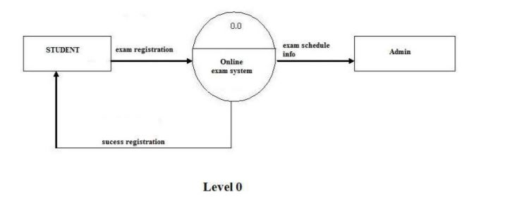

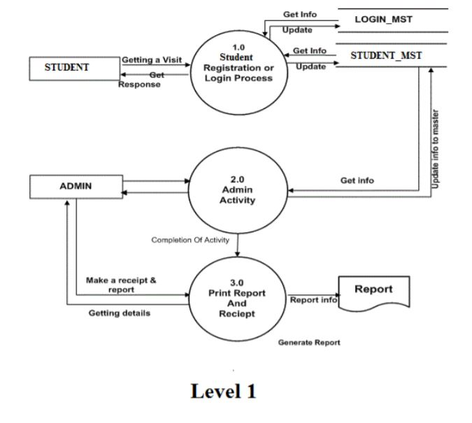

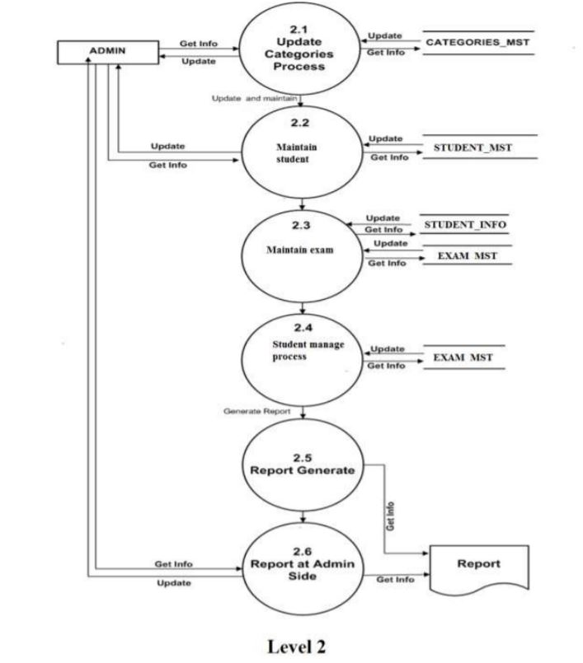

**ER-diagram**

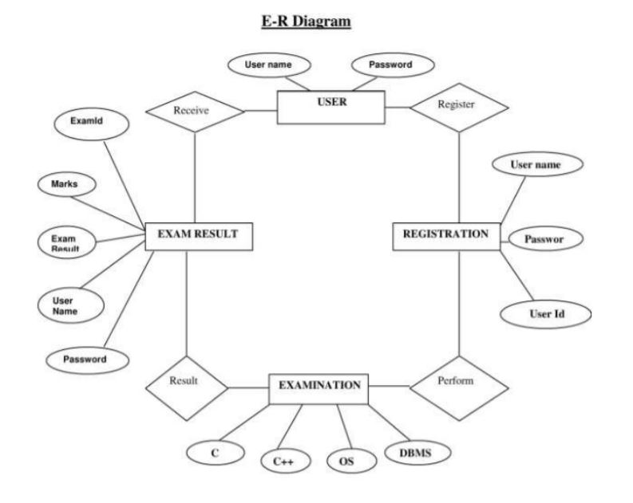

**Class diagram**

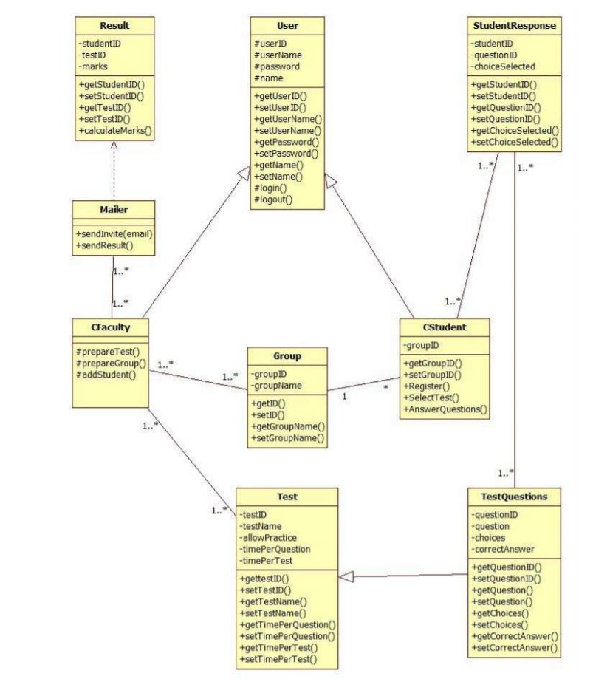

**Use Case Model**

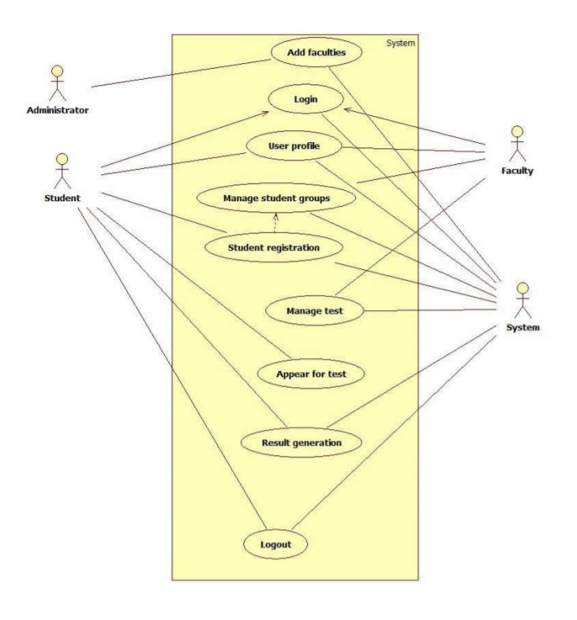

## **Operating Environment**

*Hardware Requirements*

*● Computer Machine with at least 2GB RAM and 32GB ROM*

*● External Disk*

*● Database at least 10 GB large for long run use of this application*

*● Reliable web server*

*Software Requirements*

*● Xampp*

*● Operating system : Windows XP or above,Ubuntu*

*● Frontend : HTML,Javascript,CSS*

*● Backend : PHP*

*● Database : Mysql*

*● Editor : Sublime text*

## **Assumptions and Dependencies**

*● Each Student must have a User ID and password.*

*● There must be an Administrator.*

*● Internet connection is a must.*

*● Proper browsers should be installed in the user’s system.*

# **External Interface Requirements**

## **User Interfaces**

*● Login or Signup page*

*● Homepage containing the tests that can be taken or to be retaken.*

*● Results are displayed at the end of the test*

*● History of all tests and ranking among others can be seen*

*● Students can give feedback abouts the standards of tests and other feedback*

## **Hardware Interfaces**

*Since the application must run over the internet, all the hardware requires is to connect to the internet. As for e.g. Modem, WAN – LAN, Ethernet Cross- Cable. The system requires Database,like MYSql to store any transaction. System also requires DNS (domain name space) for naming on the internet. The user needs web browser to interact with the system.*

## **Software Interfaces**

*● PHP*

*● MySQL*

*● Browser ( Google Chrome, Mozilla Firefox, Safari etc.)*

*● Operating System supporting the above browsers.*

## **Communications Interfaces**

*The online exam system shall use the HTTPS protocol for communication over the internet and for the intranet communication will be through TCP/IP protocol suite. The user must have SSL certificate licensing registered web browser*

# **System Features**

**4.1.Secure login to the interface**

**4.1.1 Description and Priority**

Secure login to the interface is a primary system feature which enables the privacy and security to the data of the pharmacy.It is of high priority.

**4.1.2 Stimulus/Response Sequences**

The pharmacy employee provides his unique username and password for which we verify the correctness of the data from database.To ensure secure login,the password is encrypted and stored.Use of CSRF token enables high security so that the same url cannot be opened in private browsing etc.

**4.1.3 Functional Requirements**

The login screen allows registered users to login to the site to access all of the features that their account gives them access to. If they type in their username and password and click submit the users credentials are validated and if correct they are logged in.If they are incorrect they get an error message.If the user has forgotten their password they click "Forgot Password?" which takes them to a password recovery screen. If the user does not have an account then they click the register button.Some of the functional requirements for secure login are

**Cryptographic Support (FCS) :** What operations use cryptography, what algorithms and key sizes are you using, and how are you managing their keys (including distribution and destruction)?

**Privacy (FPR) :** Need to support anonymity, pseudonymity, unlinkability, or unobservability. There conditions where you want or don’t want these (e.g., should an administrator be able to determine the real identity of someone hiding behind a pseudonym?). Note that these can seriously conflict with non-repudiation, if you want those too. If you’re worried about sophisticated threats, these functions can be hard to provide.

## **System Feature 2 (and so on)**

# **Other Nonfunctional Requirements**

## **Performance Requirements**

*● The product will be based on web and has to be run from a web server.*

*● The product will take initial load time depending on internet connection strength which also depends on the media from which the product is running.*

*● The performance will depend upon hardware components of the client/customer*

## **Security Requirements**

*● The customer’s web browser will never display a customer’s password. It shall always be echoed with special characters representing typed characters.*

*● The system’s back-end servers shall never display a customer’s password. The customer’s password may be reset but never shown.*

*● Password of the user is never misused by the administrator.*

*● The system’s back-end servers will only be accessible to authenticated administrators.(A password existence to access the database)*

## **Software Quality Attributes**

*● It should be equipped with current and active database.*

*● All records can easily be updated.*

*● It should have its personal firewall*

## **Business Rules**

*<List any operating principles about the product, such as which individuals or roles can perform which functions under specific circumstances. These are not functional requirements in themselves, but they may imply certain functional requirements to enforce the rules.>*

# **Other Requirements**

*<Define any other requirements not covered elsewhere in the SRS. This might include database requirements, internationalization requirements, legal requirements, reuse objectives for the project, and so on. Add any new sections that are pertinent to the project.>*

**Appendix A: Glossary**

*<Define all the terms necessary to properly interpret the SRS, including acronyms and abbreviations. You may wish to build a separate glossary that spans multiple projects or the entire organization, and just include terms specific to a single project in each SRS.>*

**Appendix B: Analysis Models**

*<Optionally, include any pertinent analysis models, such as data flow diagrams, class diagrams, state-transition diagrams, or entity-relationship diagrams*.>

**Appendix C: To Be Determined List**

*<Collect a numbered list of the TBD (to be determined) references that remain in the SRS so they can be tracked to closure.>*