1. Which job title has the highest average years of service among active employees? Among retired employees?

**Answer 1:**

**SS1:** Purchasing Agent IIIhas the highest average years of service among active employees and Sales Rep. II among the retired employees.

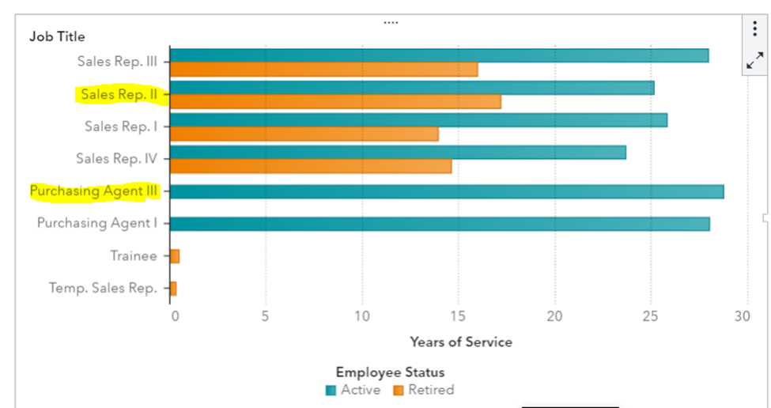

* + 1. Management has decided that one possible criterion for promotion is profit generated. Which two countries generate the highest profit?

**Answer 1:** United States and Germany

**SS1:**

* + 1. Why do they have such high profits?

**Answer 2:** Thesetwocountries have more employees.

**SS2:**

* + 1. In the upper right corner, click  (**Restore**).
  1. In the geo map, specify **Average Profit** for the **Size** role.
     1. Verify that the geo map is selected.
     2. In the right pane, click **Roles**.
     3. For the **Size** role, select **Total Profit** ⇨ **Average Profit**.
  2. Specify **Average Profit and Number of Employees by Country** as the name of the geo map.
     1. In the right pane, click **Options**.
     2. In the Object group, for the **Name** field, enter **Average Profit and Number of Employees by Country**.
  3. Maximize the geo map and answer the question.
     1. In the upper right corner of the chart, click  (**Maximize**) to view additional details.
     2. In the detail table, click **Average Profit** twice to sort by that column in descending order.

Answer the question.

3)Which country has the highest average profit?

**Answer 3:** France

**SS3:**

* + 1. Highest number of employees?

**Answer 4** United States

**SS4:**

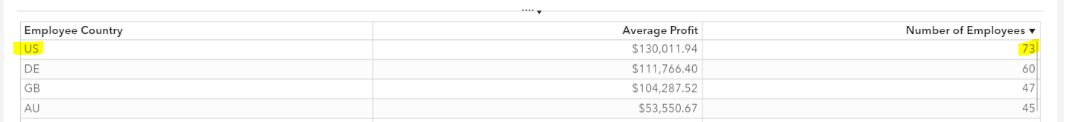

* + 1. In the upper right corner, click  (**Restore**).

Save the report.