**Report Analysis: US Leading Causes of Death**

**By Iara Krasnoff**

This report examines and compares 6 chosen US States using the US leading causes of death dataset. This study aims to find the State that displays the least number of deaths, or in other words, the highest longevity. The selected examined US States are Alabama, Delaware, Florida, Louisiana, Pennsylvania, and Texas.

**Analysis 1**:

In my first interesting finding (screenshot below from Tableau), I found that the current State where I live, Delaware, displays the least number of deaths by suicide. It came to me as a surprise.

To give you a little context, I am examining the 6 possible States my husband and I are considering moving (or perhaps staying) in the next 12 to 24 months. I would never guess that Texas would have this high number of death per suicide. Texas is sunny and wealthy, what could imply a better mental health occurrence. On the other hand, I would never have guessed that Delaware has this low number of suicides. In Delaware, the days are colder and darker half of the year, and I thought because of that people would get lonely and socially disengaged, what would increase the depression cases. Also, a surprise for me.

**Analysis 2**:

In my second interesting finding along with a screenshot, I am alarmed to see that heart diseases and cancer are the biggest reasons people die in all the States studied. In this scenario, Florida shows a slight advantage showing a lower number of heart disease and cancer deaths when compared to the other States that are being examined.

**Analysis 3**:

In my third interesting finding along with a screenshot, I am still surprised to learn that Delaware shows the lowest number of Sum of deaths amongst all the studied States when comparing all the cause of death combined together.

**Analysis 4**:

In my fourth interesting finding along with a screenshot, the Pie Chart demonstrates that Delaware has the lowest overall Sum of death among all the States examined.

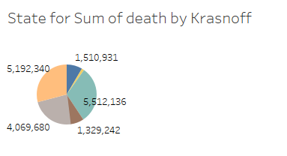 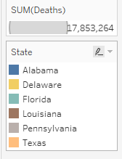

**Analysis 5**:

In my fifth and final interesting finding along with a screenshot the dataset confirms and displays below that Delaware has the lowest death rate amongst all the examined States.

Conclusion

Despite the misjudgment about Delaware longevity rate, the first State displays the higher rates in longevity when compared to the other States present in this analysis. The insights acquired from this dataset will help my family to take informed decisions when we decide to move, or in this case, maybe not.