|  |
| --- |
|  |

**Agile Architecture @ Scale Workbook**

**Tinkleman Coffee Roasters**

Version 1.1

Contents

1 Case Study – Tinkleman Coffee Roasters 2

1.1 Corporate Context 2

Mission 5

Company Summary and Ownership 5

Financial Plan 6

The Leadership Team 6

1.2 Corporate Facts and Figures 9

1.3 Competitive Environment 10

Coffee Drinking Statistics 10

1.4 Current Engagement Model 12

1.4.1 Principles 12

1.4.2 Concepts 14

1.4.3 Partner Profiles 15

2 Business & Technology Landscape 15

2.1.1 Executive Summary – Pub Rebranding Effort 15

2.1.2 Executive Summary – Pub Social Media Launch 16

2.1.3 Executive Summary – Custom Package Single Pound Sales 18

2.1.4 Executive Summary – B2B Technical Loan Repayment 18

2.1.5 Executive Summary – Custom Packaging Through Marketplaces 20

Appendix A – Additional Discoveries 20

Sequence diagram 21

Primary Requirements 22

Requirements Traceability Matrix 22

Critical Test Measures 22

Test Plans 23

Information Architecture 24

Infrastructure Architecture 25

Solution Architecture 25

Just Coffee Now 28

Coffee Now 29

Any Service Now 31

Threat Models 34

Solution Design 34

Reviews 35

Architectural Alternatives Considered 36

Alternate Project Drivers 36

Cost versus Performance 37

Feedback 38

# 1 Case Study – Tinkleman Coffee Roasters

## 1.1 Corporate Context

Tinkleman Coffee Roasters is a well-established regional coffee roaster that operates 225 coffee shops across the west coast of the United States, as well as Alaska and Hawaii. The foundation the company relies on for the continued success of their coffee shops is their attention to the location and ambiance of the coffee shop, water for brewing, and finely roasted coffee beans – this is essential and is represented in their core business values and company culture. They also recognize that by far, the most important key to success, the “secret sauce” that drives their success over competitors is employing well-trained, personable baristas. Even in locations like Hawaii, where most drinks come with a wedge of pineapple on the rim, Tinkleman has been able to establish a loyal following of customers by sticking to their foundations for success.

For the bulk bean portion of Tinkleman, they roast and sell over 5 million pounds of bulk beans for distribution through grocery stores wearing the Tinkleman branding. They also sell roasted beans with custom branding to hotel chains and gift shops. For this portion of the business, they use fair trade beans and try to purchase from smaller plantations rather than syndicated ones. The foundation the company relies on for continued success in their bulk bean business is maintaining a steady supply of quality beans at a pre-negotiated price that is fair to the plantation and to Tinkleman. The “secret sauce” for this portion of the business is maintaining a crew of roasters that take pride in their work and realize that recipes and process provide consistency, but experimentation produces innovation. Giving the crew the responsibility of maintaining a consistent flavor profile for their standard flavors is critical, as is experimenting with limited release flavors that take advantage of the roasters’ artistic abilities.

Tinkleman has optimized the operations of both sides of the business. They pay their baristas and roasters more than the industry standard but feel that results in their stores and bulk bean sales being higher than industry standards. Tinkleman also feels like they have a playbook for replicating success for both sides of the business and can quickly open as many new stores as they would like and would be able to replicate their success.

For the coffee shops, Tinkleman is determined to become a required daily stop for local coffee addicts, a place for dreaming and to escape the daily stresses of life. They also want to explore extending hours by transforming in the evening into a “coffee pub”, **the** destination for coffee drinkers whether they want a comfortable place to meet friends, play a board game, or read a book. They have researched that women also feel safer in a familiar coffee environment for an evening outing. They also want to establish themselves as the gathering place for college students that want to meet and study or argue philosophy on the finer points of living a worthwhile life.

Tinkleman’s first and primary source of revenue comes through the operation of their 225 coffee shops. Each coffee shop is located within walking distance from the center of town or a college campus. The locations are secured through a three-year lease with an option for extending. Most of the business comes in the morning and early afternoon, and by the end of the business day their sales are next to nothing. They feel that they can brand themselves as a “coffee pub” to draw in the evening crowd that are looking for a quieter place to socialize in the evening with a focus more on coffee than on alcohol. However, they are willing to investigate including alcohol sales if business research warrants.

Tinkleman also derives revenue from sales of their roasted coffee beans. The revenue from the bean business is about half that of the coffee shops. They package and sell their beans in gift and grocery stores around the region. Tinkleman generates additional revenue through sales of custom-branded bags of coffee to other businesses, such as hotel and motel chains, and individuals renting rooms and homes for weekend getaways. For the customers that want their own label, they collaborate to create a unique roast and flavor profile, and package the coffee using labeling and branding the business provides. For this portion of the business, they sell over three million pounds of coffee per year.

As mentioned, Tinkleman currently operates 225 coffee shops. Each is operated in a building that provides approximately 2,000 square feet with the customer seating area comprising 1,100 square feet. Each coffee shop also has approximately 800 square feet of outdoor seating. The shops are located within walking distance from the center of town or a college campus. The locations are secured through a three-year lease with an option for extending.

The lease is typically $3000 per month and utilities cost approximately $800 per month. Each store has two full time baristas and four part time baristas with the goal of always having two baristas working. There are also typically 8 full and part time staff that run the cash register, stock, clean, and bus. The part time baristas make on average between $12.50 and $15.00 per hour. The full-time baristas make between $15.00 and $20.00 per hour. The support staff make between $8.00 and $10.00 per hour.

The expected revenue for each coffee shop varies by longevity and location of the coffee shop. Younger stores are expected to earn revenue between $215,000 and $250,000 annually from coffee sales and $50,000 to $75,000 in food sales. The more established stores are expected to generate between $250,000 and $300,000 through coffee sales and between $75,000 and $100,000 from food sales. The coffee sales are based on selling between 250 and 300 cups of coffee per day. Tinkleman leadership has defined success in transforming the coffee shops into coffee pubs for coffee addicts and people wanting a place to socialize without alcohol involved as being measured through increased sales revenue of 20% with additional costs of 12%. This approach will make the coffee shops more profitable overall with limited risk or additional expense. As part of the transformation, Tinkleman plans to add coffee bean roasters to each coffee shop to drive more sales of beans in each store.

They are also considering expanding the packaged bean business by providing custom packaging for individuals, enabling someone to buy a pound of coffee labeled with custom names and labels that people can order as gifts. This portion of the coffee roasting will come from the additional bean production they plan to make available as the coffee shops are transformed into coffee pubs. Each coffee shop will have a 30 to 35-pound coffee roaster. They have not generated projections or expectations for what this effort might cost, potential sales revenue, and profit margins that might surface.

The roasting centers each have the capacity to roast up to 1 million pounds of coffee annually. The roasting centers are distributed throughout the region to lower the cost of delivery while providing the freshest coffee possible. Each is operated in a building that provides approximately 3,500 square feet of roasting and packing space and 500 square feet of office space. The roasting facilities are in industrial parks, so the lease is typically $2800 per month and utilities cost approximately $1400 per month. The cost of raw beans is negotiated annually for a specified amount, and any additional beans needed are purchased at fair market value. The rate negotiated for this year is $2.80 per pound, and the typical fair market price paid fluctuates between $3.20 and $3.50 per pound.

Each facility employees approximately 40 people. The roasters are considered the talent and make between $40,000 and $50,000 annually. This is above the industry standard pay that averages $33,000 to $39,000 for roasters. There are three full time roasters and three roaster apprentices per facility. The rest of the supporting staff in the facility make between $8.00 and $15.00 per hour.

### Mission

Tinkleman will make its best effort to create a unique coffee pub experience where customers can socialize with each other in a comfortable and relaxing environment while enjoying the best brewed coffee or espresso and pastries in town. Rather than having a brewing or distilling operation onsite, we will have a bean roasting operation. We will be in the business of helping our customers to relieve their daily stresses by providing piece of mind through great ambience, convenient location, friendly customer service, and products of consistently high quality. We will invest profits to increase employee satisfaction while providing stable return to its shareholders. We feel that happy employees in the coffee shop will yield happy customers and driver loyalty in our customer base.

### Company Summary and Ownership

Tinkleman Coffee Roasters, a Washington-based limited liability company, sells coffee, other beverages, and snacks in each of its 2,000 square feet premium coffee shops. Tinkleman’s major investors are a venture capital company named Dead President’s Investment, with Arthur Garfield and James Polk being the investment company’s representatives that manage the Tinkleman investment. John Frum, the CEO, and Jaylene Ruth, the CFO are the other two major investors. Cumulatively, the three own over 70% of the company. The start-up loss of the company has been recovered and for the last three years the company have provided a 25% return on investment to the ownership through distributions.

At the last company meeting, John Frum announced that the Dead Presidents are investing $100,000,000 to start and fund a new franchise line of business. Some of the investment will be used to fund franchisee loans to start their business. The rest will be used to develop the people, process, and technology components for the franchise-in-a-box that enables the franchise to be successful. To give some idea of what they envision the Tinkleman online experience, they point to Ziggi’s Coffee (<https://www.ziggiscoffee.com/>) to give an idea what they are thinking. They don’t know what is possible but think this should be used as a minimum bar.

As with the Tinkleman-owned stores, the company’s foundation principle and culture, as well as the “secret sauce” must be enabled in the franchise. After all, the Tinkleman brand and reputation are counting on the franchisee being able to deliver a measurable high-quality experience. They plan on using the franchise initiative to grow in visibility and have presence across the United States with plans to open stores in other countries in the near future.

### Financial Plan

Tinkleman Coffee Roasters will capitalize on the strong demand for high-quality gourmet coffee and the need for non-alcohol related gathering places for the local rural-based communities. Management is aimed at establishing and growing a loyal customer base, and optimistically having its net worth doubling in two years. They will maintain a 25% gross margin for the coffee shops and healthy 65% gross margin for the roasting facilities. The profits from the packaged bean business will be used to finance additional coffee pubs. The additional roasting capability at each coffee shop will be used to start the custom packaging of 1-pound and 3-pound bags for individuals. The franchise projects and costs will be separated from the current roasting and coffee shop lines of business, though resources from across Tinkleman will be used to put together the resources needed to enable the franchise business capability.

### The Leadership Team

John Frum, the CEO is a savvy businessman who is as passionate about quality as he is about sales. While the rest of the company is a coffee addict’s paradise John focuses on the business and makes sure that the team has all the support it needs while providing a deep understanding of market trends. “I think the move from coffee shops to coffee pubs, and a digital approach to attracting younger people that are in school are the most critical areas of focus for us to move forward.” John was responsible for driving Tinkleman away from the pure packaged coffee market and making their products available in coffee shops. Now that the coffee and social gathering dynamic is changing John is very eager to find their next strong market position. This shows in his every day and his approach to business management and use of technology. He is also the one that came up with the idea of transforming the coffee shop into a “coffee pub”. He feels that there are large opportunities to further distinguish the Tinkleman Coffee Pub brand through digital products and feels both the packaged coffee business and the coffee pub business lines will benefit from a strong focus on adding digital products. He also is on board with shifting to agile product delivery of physical products and digital capability that enables those products. He is also open to new innovations and digital products that do not have a physical product aspect to them.

For Jaylene Ruth, the CFO, the picture is a little different. “While we are doing better than the competition, our operational efficiency does not meet my expectations. We absolutely, positively must use additional revenue with flat facilities costs and reduced or stable operational costs in the coming fiscal year to automate process.” She feels like adding any additional coffee shops before the coffee pub transformation is complete is too risky. She feels a better use of resources is to automate process so we are not limited in our scalability by the number of people we can hire. She also feels that she has not seen numbers that tie the value of digital products to customer value and loyalty, or to achieving Tinkleman’s business objectives over the next few years.

As you might guess, Harry Pearson, the CIO is nearing his wit’s end. “With the expansion and acquisitions we’ve made, and the regulatory constraints privacy, online sales and taxing, changes to environmental standards and concerns, and changes to how brick-and-mortar stores operate based on health concerns and restrictions, I am surprised we can keep this company running from an IT perspective. With the shift of some product teams to more agile development approaches, it seems that I spend all my time putting out fires and have completely lost control or even awareness of what we have. Each B2B solution we have is customized, each new product uses all new or different technology, we use different authentication methods for different organizations, and now I hear we want to add a new digital experience that goes with the entire transformation to coffee pubs?” Harry feels like he doesn’t know what the as-is stated of his digital solution is, how reliable and scalable it is, whether licenses and usage across the company are consolidated, or how operation and recovery are being managed.

Elise Morrison, owner of the coffee shop line of business, has the ear of the CEO and is in a constant state of agitation. “We built our reputation on good coffee and a good value, excellence in delivery and operations and dependability”, she states. “And now we cannot even meet the time-in-line expectations of our most loyal coffee drinkers. I need to know exactly how long our customer wait in line, what drinks take the longest to create and get in the hands of the customer, whether they are frustrated with the service and experience or not. I also need an automated way to allow our customers to pre-order, reserve a table, and interact with other patron in their “circle of caffeine”. Our relationships with our best customers are at risk and nothing can come before we fix our current problems. What’s more, I have no way of training new baristas or determining if the quality and experience are the same from coffee shop to coffee shop.” What Elise has been telling her people that run the stores is harsh, but her message to the technology is even more abrasive. She doesn’t understand why her world-renowned design team is not being effectively in leveraging social media and online communities, and why they cannot give her details of order placement and fulfillment times and the satisfaction of the customer. She doesn’t understand how Tinkleman can be looking so hard at transformation and additional investment in facilities and yet be so antiquated in their operations, sales, marketing, and customer feedback. She is pleased with the new features and capabilities of the point-of-sales system but is not getting any of the additional business insight she expected. She leads the line of business that is changing the most and is expected to become the primary cash cow and feels justified in voicing her needs.

Lewis Curtis, owner of packaged bean product lines, has different needs. “With our transformation into coffee pubs and the added be roasting capacity, I can explore new markets. My people tell me that vanity packaging is all the rage for people that want have beans with their name on the package or people that want to get custom packaging as gifts. This will be bigger than the custom coffee mug craze!” He has a reputation as an innovator and wants to move the organization into a B2C model that taps the market for customer that want their own custom labels and packaging to use as gifts or feed their vanity. He feels that this market can provide Tinkleman much-needed visibility in the region and can provide greater margins for the packaged coffee bean business enable through additional bean roasting capacity. Since the market for this specific customer segment is primarily untapped, especially for high-quality beans, he feels Tinkleman can charge a premium for this new line of product. But Lewis feels he needs better access to and interaction with the target customers through social media and needs an easy-to-use and automated way of letting his customer create labels and order packaged coffee. And then he needs a way to get the order to the coffee pubs for packaging and sending the coffee to the customer. He also needs a way to know or estimate how long it will take to get the product from order to shipped and keep the customer informed of the progress.

Abigale Smith, a sales leader, is seriously concerned about growth and the ability to compete with Starbucks and other competitors in the premium coffee business. They have difficult times identifying leads for bulk sales and they consistently miss opportunities based on their slow and difficult sales technology. Tinkleman has inhouse sales tools which do not scale, much less provide real time data or and mobile access packages for their sales and marketing staff. Although Tinkleman’s customers love the quality and range of coffee flavors they do not feel that they are able to interact with Tinkleman or get preferential treatment when they have an emergency. Abigale believes that with new technology they would be able to achieve up to 13% market growth in package bean sales. She has already brought in two CRM vendors and is poised to decide about their products with or without support from IT.

Yvette Ramirez from the marketing team has some great ideas around increasing the visibility of Tinkleman’s baristas with the customers that frequent their stores and spotlighting their coffee roasters. She wants to set up YouTube channels and podcasts and wants to host online “live” events. She has not spoken to the head of marketing yet and has no support but is asking if and how it is possible to get some of her ideas going. Most of what she wants to do seems like she, or any other end user should be able to do it if the approval process were clearly defined and a set of generic tools and guidance available so she could try things on her own.

## 1.2 Corporate Facts and Figures

Tinkleman had gross revenues of $120.9 million last year. They have two primary revenue streams, one for selling and reselling roasted coffee beans, the other for operation coffee shops. The roasting business line has gross revenue of $47,025,000 with a 67% profit margin. The coffee shop business line has a gross revenue of $73,875,000 with a 26% profit margin. Key figures:

|  |  |
| --- | --- |
| Total Revenues $120.9 Mil | $73.875 Mil from coffee shops $47.024 Mil from coffee roasting |
| Total Employees 3090 | Coffee Shops - 2475 employees Roasting – 210 Finance/Legal/HR – 35 Marketing – 5 Sales – 300 IT - 65 |
| Additional IT staff | Plans are to add 10 – IT leadership (dev leads and architects) 40 - Developers |

The Organization chart currently looks like this:

The leadership team is open to distributing the new development staff into the two business divisions to enable an agile approach to product development. They have heard this will speed up delivery of replacement software as well as new features and capabilities.

The IT group has a budget of $3.87 million, or about 3% of sales. The budget is a little low but has been sufficient to get Tinkleman where it is now. They realize that they have incurred technical debt by doing what was necessary to run the business in the past and that many systems are end of life, or costly because of when and how they were built. They also realize that the coffee shop transformation and doing their part for the “franchise-in-a-box” effort will be significant. The coffee shop transformation will force them to focus on technology and leading with digital products to drive customer loyalty, barista visibility, and break into the new markets they are considering. With the new point-of-sale system, they feel they can pair it with a mobile app to catch and surpass the experience provided by larger coffee companies. They have asked for and been approved to double the staffing based on the investment for franchising, if that opportunity is pursued.

The CFO has researched and discovered that average IT expenditures in industry are 3% of sales, is not sure if they go up or down by using cloud-based services and is sure that IT is sunk cost. She is adamant that IT cost are part of the cost of doing business and considered overhead. Her typical argument with expanding IT budget is that she knows that each new coffee shop she invests in will cost just over $200,000 annually, she is confident that once established, each coffee pub will generate between $300,000 and $350,000 per year. For IT spend she is unsure of the risk and based on her experience chances are 50/50 whether the team can deliver as promised. In her opinion, it feels like Tinkleman re-invents the wheel for each new B2B agreement signed with suppliers or resellers. She heard about a B2C play to sell custom packed coffee beans directly to customers, but with her experience with business-to-business, she is genuinely questioning whether a coffee business should be in the business of IT and should expand the staff to try some of the newly proposed initiatives.

For employees, most of the staff work in the coffee shops or in the coffee roasting facilities. There is a small IT staff that work in the offices along with the leadership team. They develop the B2B integrations as new suppliers, customers, and partners are brought onboard, maintain the point-of-sales systems in coffee shops, and the backend systems for the organization. While they have done a good job building and maintaining what they have, the leadership team knows it is time to replace the current systems and software. They do have multiple development teams that work for their areas of the business and have a centralized team of architects. However, other than Harry Pearson, the CIO, the leadership have little insight into the team or what they do and get little info on the value that the IT team provides. They realize that there needs to be a significant investment in IT and are willing to invest, once they have an idea of what to invest in, how much it should cost, and are confident the team knows enough to accomplish the tasks.

The leadership team is getting a bit frustrated with Harry and the entire IT staff. For the coffee shops, they know how many employees they need to run the shop and what the revenue per employee ratio is. With the IT team there are no metrics for how many they need or what the overall cost of IT should be based on budgets or gross revenue. They’ve heard 3% of either the revenue or budget should be spent on IT and that they IT staff should be 10% of the overall staff but are unsure whether that is true for all businesses or if coffee shops should be different. Since they haven’t been focused on IT they haven’t researched hard, but now that they are about to invest in IT and bet part of the business on digital products and franchising, they feel they might need to bring in consultants to give them better insight. If they get decent business insight from Harry and his team, they will likely be comfortable using that, but it feels to them like the IT staff is reactionary and only does what they are told to do.

Based on the shift of adding digital products to every aspect of the company, the company has tentatively agreed to triple the size of the IT staff, primarily adding talent in the form of developers, and growing current staff into team leads. Tinkleman knows that timing is everything for them and that the new IT solutions must be in place as the store remodeling is complete and the new coffee roasting equipment is turned on. Tinkleman leadership is planning on having an IT staff of 135 (not including customer support/help desk) by the end of the current year, adding 40 developers and 10 IT leadership positions. Development leads and architects are considered IT leadership.

## 1.3 Competitive Environment

Tinkleman knows something about the coffee business but has completed limited research on other coffee shops. They recognize that the elephant in the room is Starbucks but feel relatively safe from Starbuck having a significant impact on their business. They recently been investigating Tinkleman feels like Starbucks is becoming more like a fast-food restaurant in their coffee shops, and that their roasting and reselling beans is targeted at mass production with a quality level that is acceptable but doesn’t inspire. They base their business more on the numbers they have discovered for the overall coffee and hot drink industry:

# Coffee Drinking Statistics

|  |  |
| --- | --- |
| **Coffee Drinking Statistics** | **Coffee Drinking Statistics** |
| Total percentage of Americans over the age of 18 that drink coffee everyday | 54% |
| Average size of coffee cup | 9 ounces |
| Average price of an espresso-based drink | $2.45 |
| Average price for cup of brewed coffee | $1.38 |
| Total percentage of coffee drinkers who prefer their coffee black | 35% |
| Total percentage of coffee consumption that takes place during breakfast hours | 65% |
| Total amount of money spent by importing coffee to U.S. each year | $4 billion |
| Total percentage of coffee Brazil produces of entire worlds output | 30% |
| Total amount of cups of coffee (9 ounces) a coffee drinker consumes daily | 3.1 |
| Total average of money spent on coffee each year by coffee drinker | $164.71 |
| Total number of U.S. daily coffee drinkers | 100 million |
| Total number of U.S. daily coffee drinkers who drink specialty beverages (lattes, cappuccinos, mochas, etc.) | 30 million |
| Total percentage of coffee drinkers who drink 13 or more cups of coffee each week | 24% |
| Percent of coffee drinkers who go to premium places (Starbucks, Coffee Bean) when they get coffee | 34% |
| Percent of people who go to lower-price outlets (McDonalds, Dunkin Donuts, etc.) when they get coffee | 29% |
| Total percentage of coffee consumed between meals | 30% |
| Total percentage of coffee drinkers who add cream and/or sugar | 65% |
| Total amount of U.S. coffee drinkers who claim to need a cup of coffee to start their day | 60% |
| Total percentage of coffee drinkers who say coffee makes them feel more like their self | 54% |
| Total percentage of coffee drinkers who have a cup within the first hour of waking up | 68% |
| Total amount of yearly money spent on specialty coffee in the U.S. | 18 billion |

|  |  |
| --- | --- |
| **Coffee Brewing** | **Costs** |
| Brewed Coffee Cost SPECIALTY COFFEE ASSOCIATION OF AMERICA STANDARDS |  |
| 2 tablespoons (1/3 oz) of ground coffee per 6 oz of water.  3.75 oz of ground coffee per 64 oz (1/2 gallon) of brewed coffee.  1 lb of ground coffee per 273 oz of brewed coffee. | $8.50 per lb (average cost) of ground coffee = 3.1 cents per ounce of brewed coffee. |
| 8 OZ cup | 24.8 cents |
| 12 oz cup | 37.2 cents |
| 16 oz cup | 49.6 cents |
| 20 oz cup | 62.0 cents |
| Espresso Coffee Cost SPECIALTY COFFEE ASSOCIATION OF AMERICA STANDARDS |  |
| 11 grams of ground coffee per single shot of espresso.  17 grams of ground coffee per double shot of espresso.  448 grams per pound. | $8.20 per lb (espresso cost) of ground coffee. |
| 41 single shots per pound | 20 cents per shot |
| 26 double shots per pound | 32 cents pre double shot |

This information is based on a report from the Statistic Brain Research Institute (<https://www.statisticbrain.com/coffee-drinking-statistics/>) and Pikes Perk Coffee (<https://www.pikesperkcoffee.com/cost-analysis>). While some of the data is getting old, it has provided good business insight to base their business plans on.

They have some initial research that show custom-labeled packaged products for direct-to-customer sales is realizing tremendous growth, so they feel that might be a good area to invest in, especially if they can expand their roasting capability by adding small-batch roasting to each coffee shop.

Tinkleman also feels like the marketing approach to transforming their coffee shops into coffee pubs and adding other hot drinks will further separate them from the competition.

## 1.4 Current Engagement Model

When Tinkleman decided to go ahead with architecture the chief architect documented their current architecture engagement model.

### 1.4.1 Principles

**Industry**

------------------

*Fairness*– All trading partners are to be treated fairly. No strike price is ever to be below that established by the Fair-Trade Organization. Additionally, farm workers’ wages must be verifiable fair, working conditions must be humane and basic health must be made available.

*Longevity*– Long-term commitments are to be established with all coffee sources, thereby providing a more certain future for our trading partners.

*Opportunity*– Priority is given to nations, regions, and farmers with the greatest need and where our purchases can make the greatest impact.

*Water*– Access to clean drinking water must be provided by the farmer to the families associated with our supplier farms.

*Strictly Earth Conscious*

<http://www.lacolombe.com/ethics>

**Tinkleman**

------------------

*Our Coffee*

It has always been, and will always be, about quality. We’re passionate about ethically sourcing the finest coffee beans, roasting them with great care, and improving the lives of people who grow them. We care deeply about all of this; our work is never done.

*Our Partners*

We’re called partners, because it’s not just a job, it’s our passion. Together, we embrace diversity to create a place where each of us can be ourselves. We always treat each other with respect and dignity. And we hold each other to that standard.

*Our Customers*

When we are fully engaged, we connect with, laugh with, and uplift the lives of our customers – even if just for a few moments. Sure, it starts with the promise of a perfectly made beverage, but our work goes far beyond that. It’s really about human connection.

*Our Stores*

When our customers feel this sense of belonging, our stores become a haven, a break from the worries outside, a place where you can meet with friends. It’s about enjoyment at the speed of life – sometimes slow and savored, sometimes faster. Always full of humanity.

*Our Neighborhood*

Every store is part of a community, and we take our responsibility to be good neighbors seriously. We want to be invited in wherever we do business. We can be a force for positive action – bringing together our partners, customers, and the community to contribute every day. Now we see that our responsibility – and our potential for good – is even larger. The world is looking to Starbucks to set the new standard, yet again. We will lead.

*Our Shareholders*

We know that as we deliver in each of these areas, we enjoy the kind of success that rewards our shareholders. We are fully accountable to get each of these elements right so that Starbucks – and everyone it touches – can endure and thrive.

**BOSS**

--------------------

*Work Together*

*Build the industry and community*

*Be an ambassador for the Coffee Culture*

**IT**

--------------------

*Mobile first, Microservices first, Cloud first*

*Configure before Customize*

*Outcomes not Products or Solutions*

### 1.4.2 Concepts

*Artifacts* – The artifacts captured and maintained will be data models that represent the flow of existing and unique (to the product team) data entities and their flow across the integrated microservices environment. Collection will be an automated solution that is built into the release pipeline and is enforced through governance. The repository used to maintain the artifacts must be easily discovered and access by all product teams across the organization. The repository will also be used to host industry standard architectural style and patterns that support Tinkleman’s IT environment.

*Automation Pipeline* – The release to production pipeline will be common across all Tinkleman. The pipeline must enforce adherence to all legal, security, governance, and quality requirements and constraints. Security and design review are managed as manual process either in meetings, or in the case of security, a review of design and code by someone in a different product team that has been certified by the security team to perform reviews. Data model and as-built diagram submission to the centralized repository is to be automated, as is the testing to meet the key quality attributes of operational excellence, security (of code), reliability, performance efficiency, and cost optimization.

*Onboarding, Discovery, and Employee Productivity* – Tinkleman is requiring everyone to be able to use self-service to become productive, discover the information they need, and to get whatever provisioning they need. They have agreed to use a company-wide wiki to document each product and overhead team. They use a single ticketing service to support customer requests and internal requests. For example, if a new salesperson is onboarded, they use a wiki to discover what team manages their client relationship management (CRM) service. They use the ticketing service to request an account and an automated workflow is used to approve the request. With the addition of 60+ developers, the teams must put a wiki (or other mechanism) to collect information that new hires can use to get up-and-running in the company and understand what the teams are working on and how microservices are integrated.

*Hands-on* – The architects are expected to be present and engaged with all the product teams and the teams working on IT capability used to operate the business. They are also expected to be the connection point between teams, knowing what capabilities have been developed by each team. In short, the architect team is meant to provide everything the delivery teams need to remove friction and maximize velocity and reuse while maintaining the high bar for quality, governance, and legal that Tinkleman aspires to.

### 1.4.3 Partner Profiles

Tinkleman is a small concern for the larger partners so works with locally based consultants when they need help with design and implementation. As for suppliers, Tinkleman operates in a hybrid IT environment and does not feel they live up to the” mobile first, microservices first, cloud first” principle.

Most of the B2B interfaces that support interactions with partners and supplies are custom, one-off solutions with the servers in a small, on-premises computer closet. For the point-of-sale (POS) system, Tinkleman still uses the POS they started with when they opened their first store. IT get the job done but provide nothing more that capturing transactions that occur in each store. They do realize that as part of their transformation, the IT environment will be the focus on major investment.

Tinkleman is concerned with tradeoffs as they start taking advantage of cloud services. On one hand, a single cloud provider limits the training and number of people needed. If they have multiple cloud providers, they feel they will have to have skilled practitioners for each cloud provider they use. On the other hand, if they use products and services from multiple cloud providers, they’ll get best-of-bread service from each provider and be able to take advantage of the maximum number of cloud product features available.

For on-premises hardware, Tinkleman has settled on using Dell hardware. They have no compelling reason to choose one companies hardware over another, they just started with Dell and see no reason to rethink that approach.

# 2 Business & Technology Landscape

Tinkleman has three primary business objectives they feel are related to their IT team and are already planning on investing heavily in their IT environment and staff. They are open to doing more than they have listed but want to make sure they have the greatest impact on achieving their objectives – it will come down to the numbers and the probability of being successful. IT will also come down to how effectively they can hire additional staff and they realize that doing IT for a coffee business might not be as attractive to potential new hires as a cloud startup might be.

### 2.1.1 Executive Summary – Pub Rebranding Effort

Tinkleman wants to transform from a coffee shop to a coffee pub. While they want to retain their morning and daytime patrons, they want to expand so they attract people in the evening. They feel the best approach is to try and provide a pub feel that people will want to come to, but without the alcohol.

The coffee shops are a known quantity for Tinkleman. There is little risk to the existing business revenues. The risk comes in not meeting the new revenue projections based on the additional time the shop is open.

**Anticipated Outcomes**

This is a big bet for Tinkleman. Part of the renovation effort is replacing the POS registers to a newer, state of the art solution that can provide more business intelligence about their customers purchasing habits. Tinkleman wants to better understand whether the morning and daytime customers are the same or different, and if they will also come in for an evening cup of coffee.

The renovations will take between eight and twelve months and the IT capability are expected to be ready when renovations are complete. However, the leadership team would like to try the new POS system as soon as it is available and try to understand their current customers before the rebranding is launched.

### 2.1.2 Executive Summary – Pub Social Media Launch

As mentioned, Tinkleman wants to transform from a coffee shop to a coffee pub. They have static web pages for each of their coffee shops that are pretty cookie cutter, providing a picture of the inside of the shop and hours of operation. They know they need more, and likely need social presence and a mobile app, or at least something more than static web pages.

Elise Morrison, owner of the coffee shop business line suggests “The primary complaint our customers have is that they get good coffee from their barista, in their local, community-based coffee shop, but they don’t get any of the convenience that they might get at a larger coffee chain. When they stop in one of the other Tinkleman Coffee Roasters coffee shops, they would like the staff to know what they regularly order but would also like to have a more unique experience that they only get at that store.” She is not sure of the solution but feels like more interactive web pages and a mobile app are probably necessary to the point where we reach out to a consultant and this is what the following primary use case and UI wireframe:

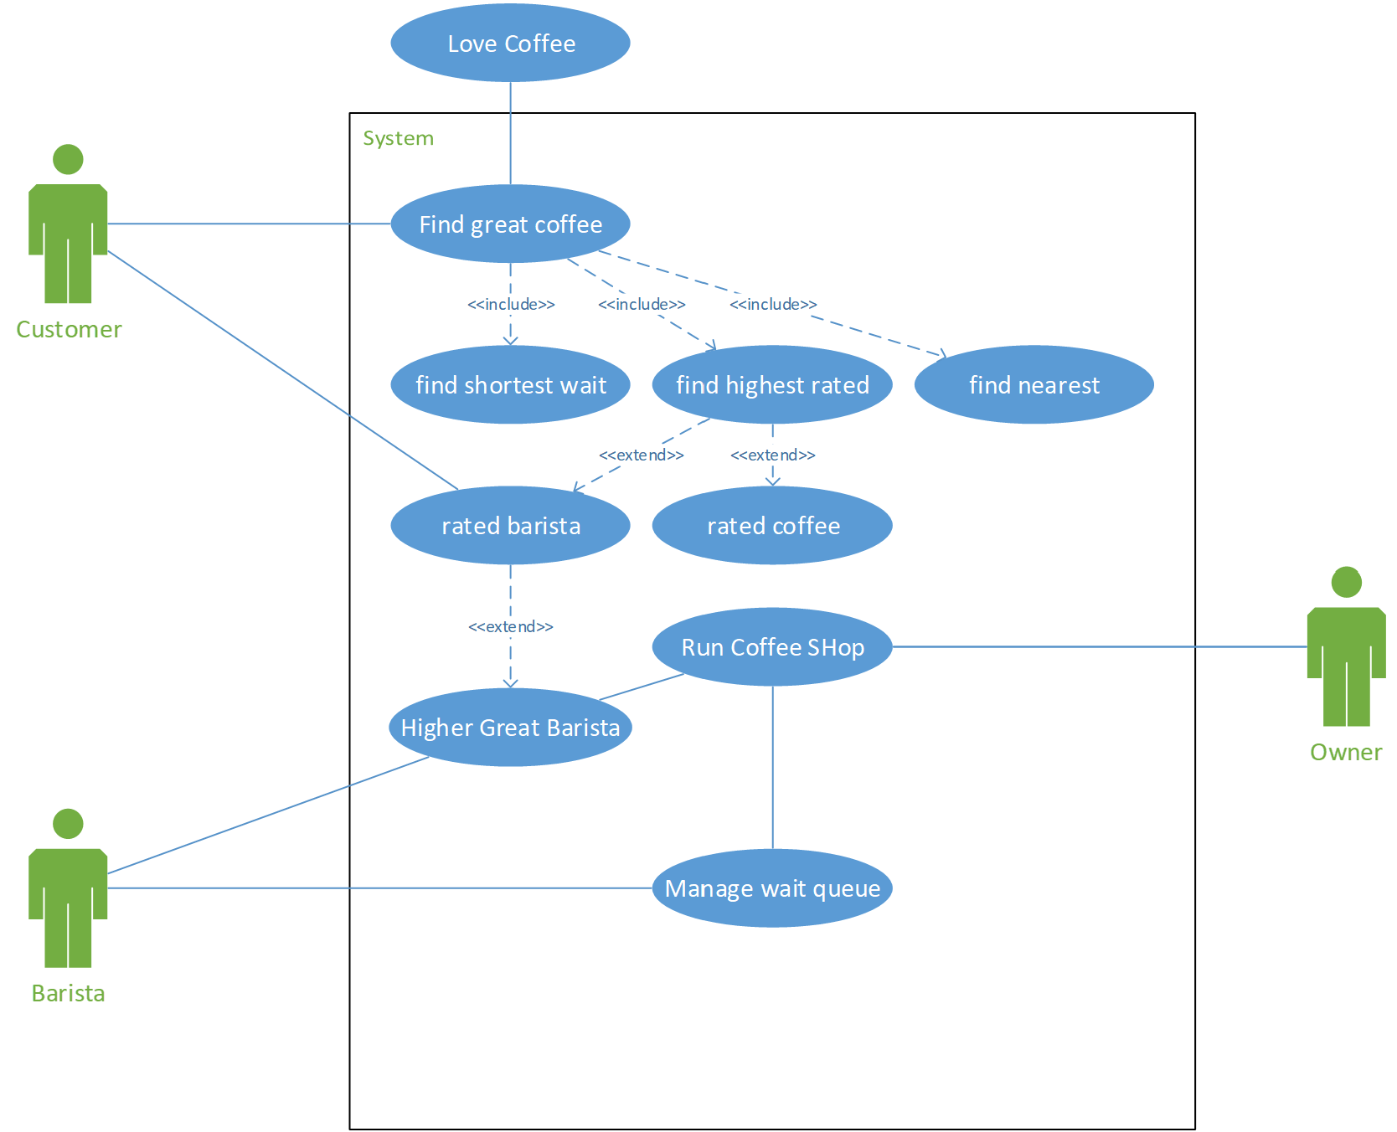

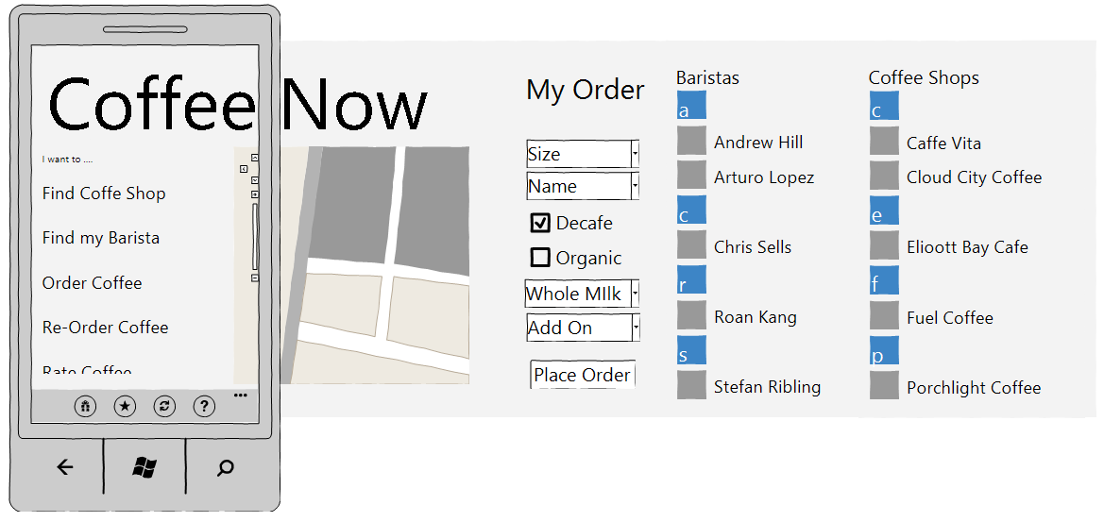

Elise also knows that her baristas are her secret sauce. Her loyal customer base is attached to a specific barista and the baristas are building a following that is larger than just the loyal customers. As part of the social media and mobile work, she wants to spotlight the baristas. She is not sure just what that looks like but sees this as a key to business growth and Tinkleman’s reputation.

*note – additional planning that the consultant provided are in Appendix A.

**Anticipated Outcomes**

Tinkleman expects the product team to create a mobile app that enables customers to order coffee in advance, order food, see if there are any specials, and receive special offers through. The expect to have a Tinkleman presence through all the social media outlets and expect to grow a faithful following. They want to reward that following with special offerings using codes on various social media outlets so they can better understand what social media tools their customers most use. Ideally, the mobile app will integrate with the new POS so that the orders are automatically fed to the right coffee pub and can be ready when the customer arrives, but not too much before they arrive so the coffee is the right temperature when the customer picks it up.

### 2.1.3 Executive Summary – Custom Package Single Pound Sales

Part of the renovation will be to add coffee bean roasting to each of the coffee pubs. Tinkleman the addition of roasting will help give more of a pub feel to the coffee shop. They have seen their custom packaging for roasted beans line of business explode with growth and feel like they can have the same success with the coffee pub customers. The idea is to roast coffee in the store, the customer design a custom label for their coffee bean bag, and watch as hot, freshly roasted beans are added to their bag and sealed. Tinkleman feel this could double the total money 35% of their customers spend per visit.

**Anticipated Outcomes**

Tinkleman expects the product team to create a feature in the mobile app or have a terminal available in each coffee pub that customers can use to create and print their custom label or coffee bean bag. When the bag is printed, the customer will be called to pick up their order and will watch as their personal pound of coffee is scooped into their custom designed bag.

### 2.1.4 Executive Summary – B2B Technical Loan Repayment

**Issue**

When Tinkleman started in the wholesale bean distribution business, they started with this simple solution: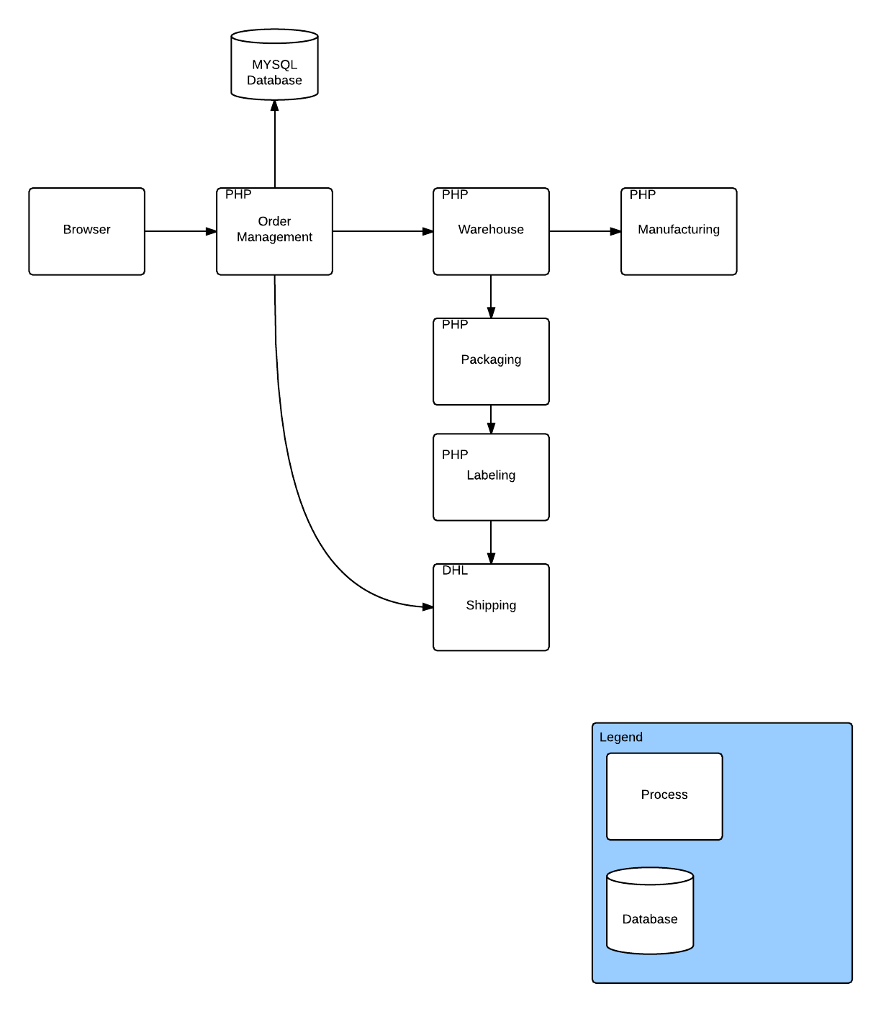

Tinkleman created custom interfaces for each of the major suppliers and partners they work with that needed something other than a webpage to work with Tinkleman. They knew at some point they would need to invest in creating a common B2B solution and feel that with the other changes they are investing in feel that getting thew B2B portion of the business on sound IT footing will pay dividends for this business line and might help with the vanity packaging B2C solution they are planning at the coffee shops. The solution is still in use, but for major distributors Tinkleman

In a survey with suppliers, partners, and customer that are part of the coffee bean roasting and packaging business line, the most frustrating part of the relationship is getting set up to do business. The process is manual and prone to challenges that make it take three times as long as expected. Then, the system seems to have limited availability with they interact with Tinkleman. Most of the suppliers, customers, and partners have expressed the desire to have a working relationship that is as high quality as Tinkleman’s roasted coffee beans.

**Anticipated Outcomes**

As new partners and suppliers are brought on, the company expects there will be a common interface that makes the integration as easy as filling out a form and going through an approval process to onboard the new partner or supplier. They hope that the new B2B solution can be used by the custom packaging business line in each of the coffee pubs since they already do something similar for larger businesses that want their own labels of bulk coffee they purchase.

# Appendix A – Additional Discoveries

In mining various repositories set up around Tinkleman the following additional information was discovered, but with no real understanding of where it came from and if any of this is part of existing capability. These items were found, but there is know knowledge of where they came from, whether any were implemented, or even who created them. They are provided simply as lost artifacts from unknown origins:

## Sequence diagram

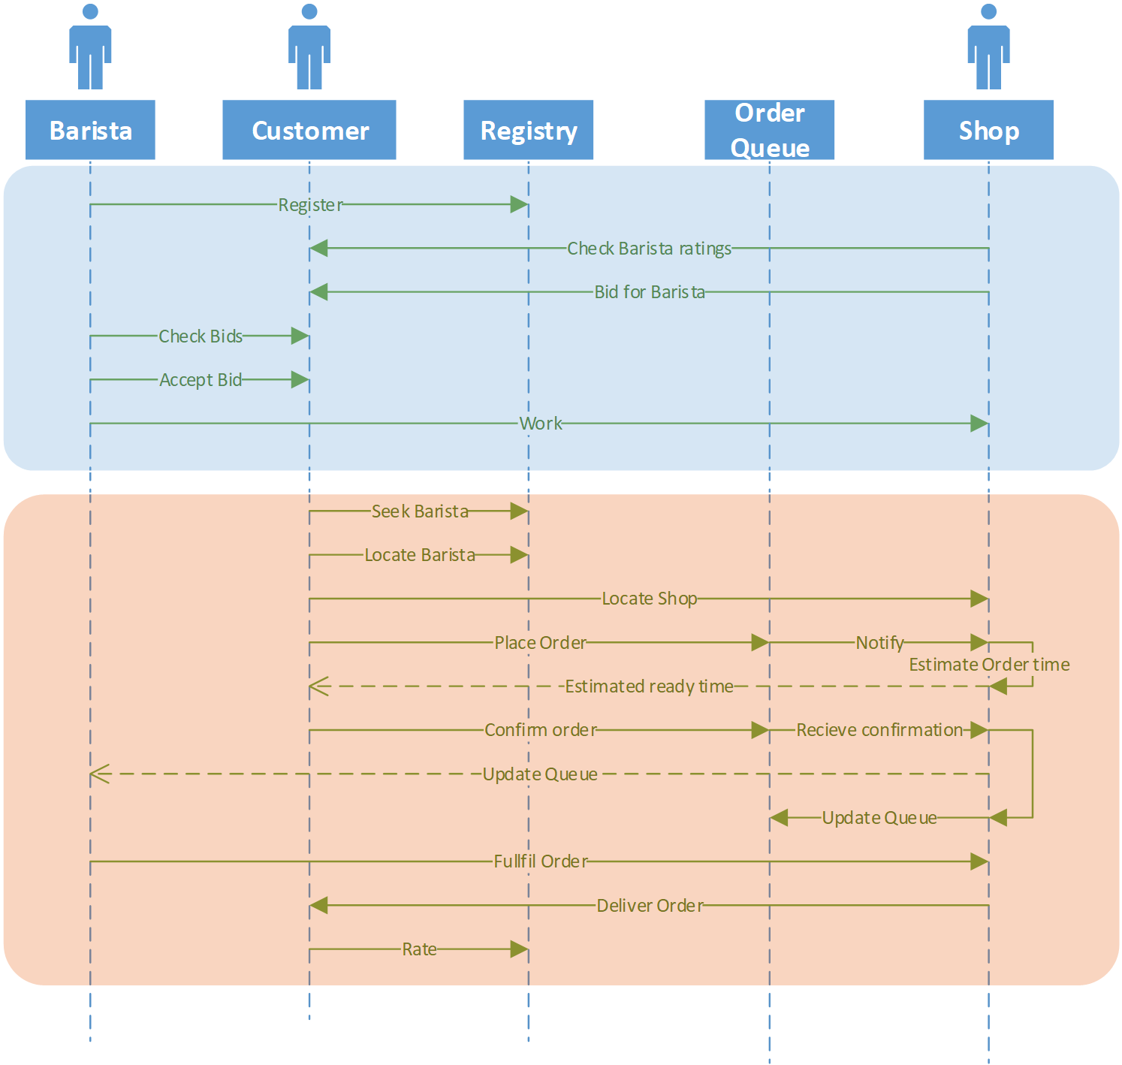

## Primary Requirements

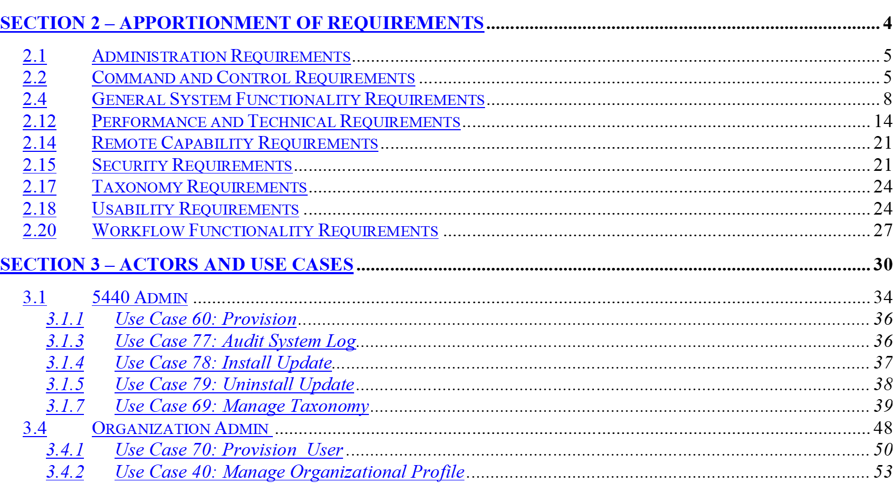

## Requirements Traceability Matrix

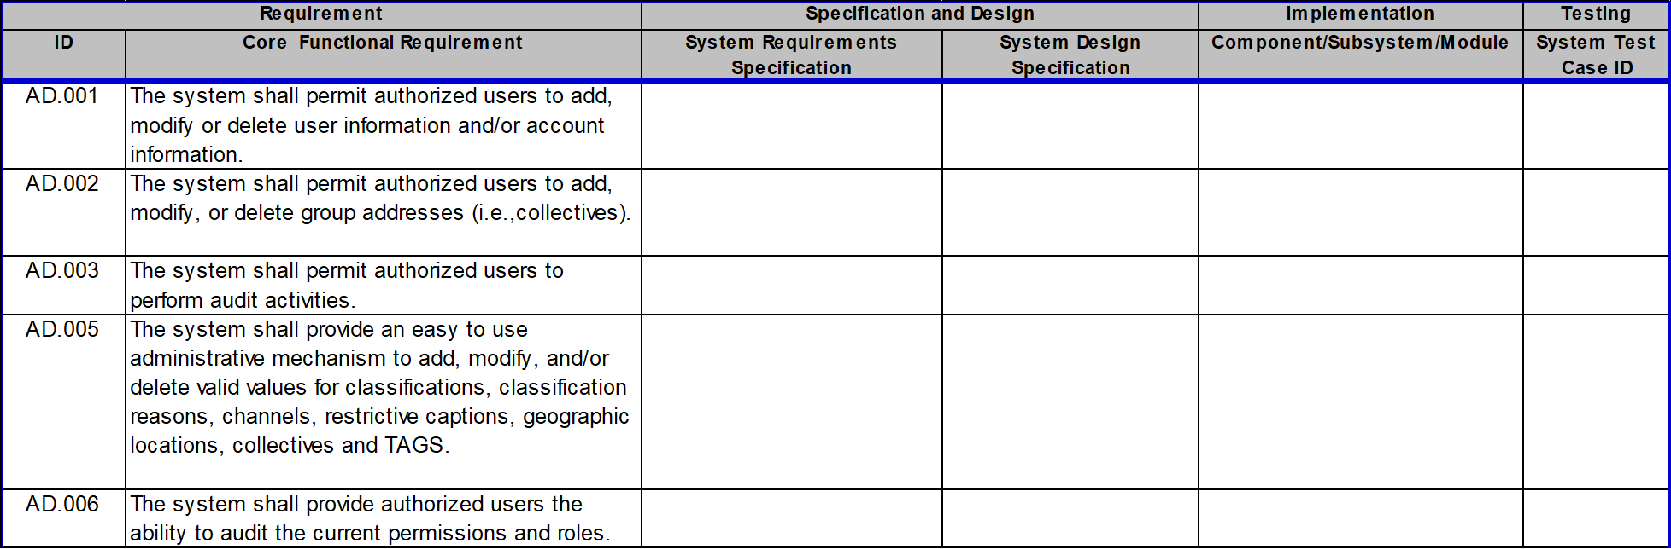

## Critical Test Measures

Shop

----------------------

|  |  |  |  |  |  |
| --- | --- | --- | --- | --- | --- |
| Measure | Direction | Value | Unit | Time | Current Value |
| Shop visits | Increase | 10 | Customers | Per hour |  |
| return customers | Increase | 10 | percent | Per week |  |
| customer complaints | Reduce | 25 | percent | Per week |  |

Barista

--------------------

|  |  |  |  |  |  |
| --- | --- | --- | --- | --- | --- |
| Measure | Direction | Value | Unit | Time | Current Value |
| Billable time | Increase | 20 | hours | Per month |  |
| hourly rate | Increase | 20 | Percent | Per year |  |
| customer rating | Increase | .5 | Star | Per month |  |

Customer

--------------------

|  |  |  |  |  |  |
| --- | --- | --- | --- | --- | --- |
| Measure | Direction | Value | Unit | Time | Current Value |
| Time to find shop | Reduce | 50 | Percent | Per attempt |  |
| Time order | Reduce | 20 | Percent | Per attempt |  |
| queue time | Reduce | 30 | Percent | Per visit |  |

## Test Plans

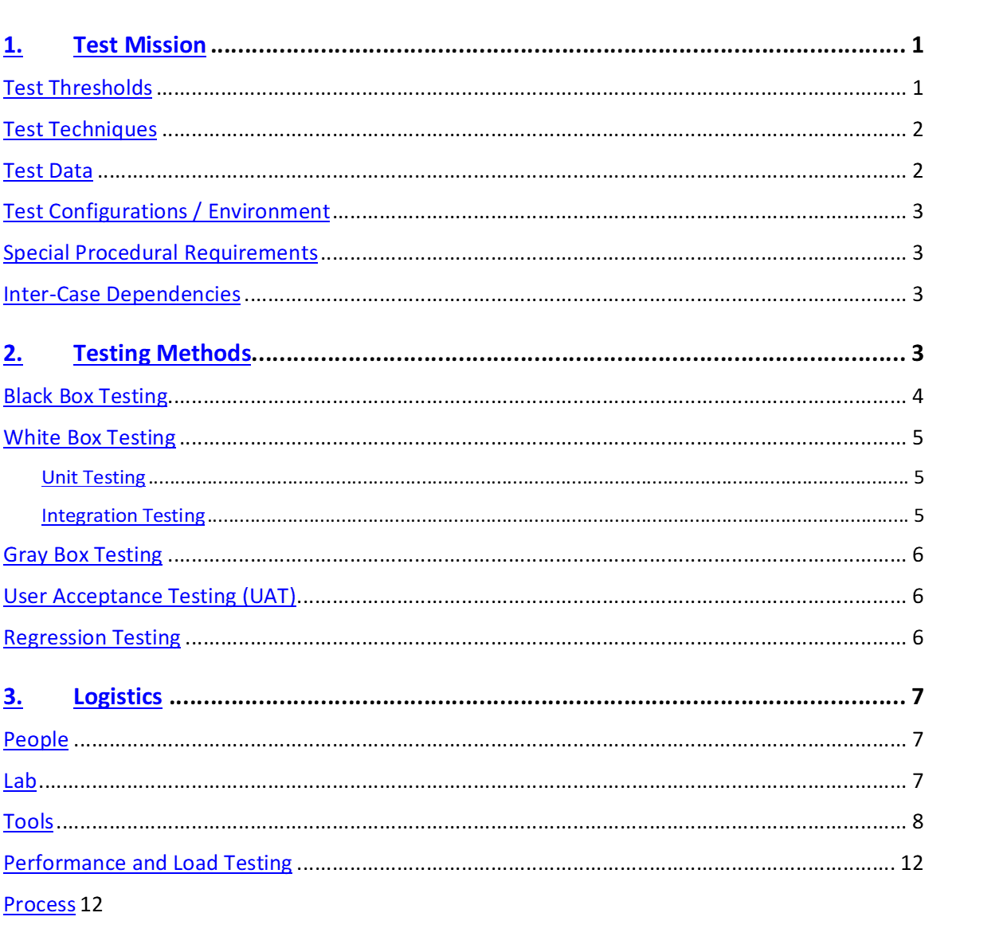

[Test Plan](https://d.docs.live.net/ca57705891d85f36/TR19/Hardcore/Presentation/Real%20Examples%20to%20Show/Test%20Plan.docx)

## Information Architecture

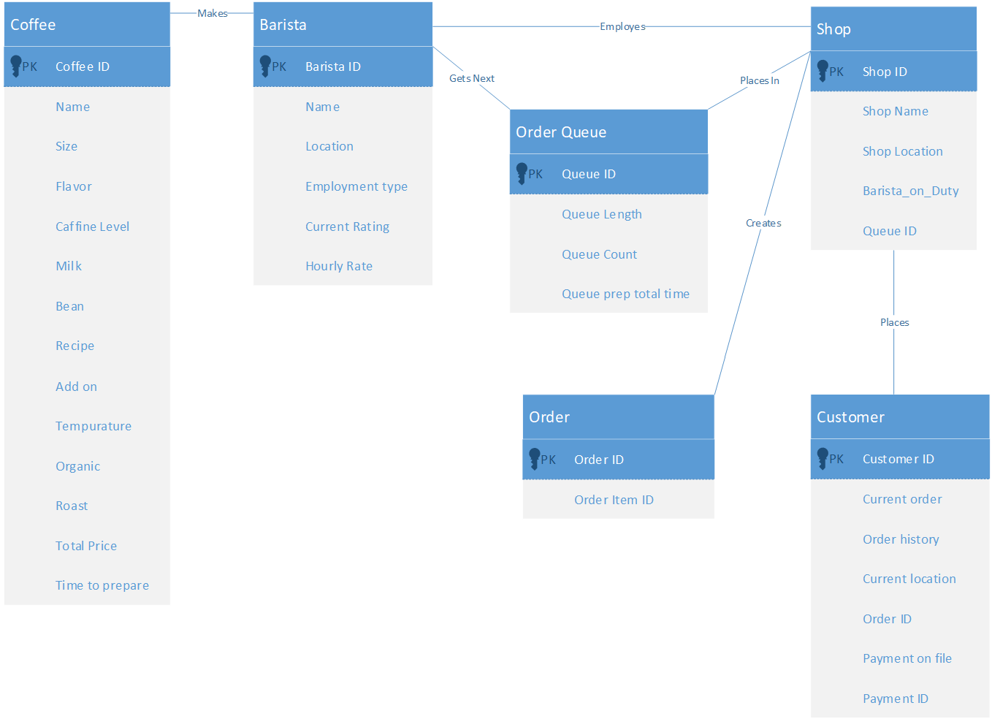

## Infrastructure Architecture

None.

Devices connect on consumption services (4G or http)

Azure hosts SaaS without exposing the underlying hardware

What is a cloud admin -relationship manager, operations expert, engineer e.g. how do you achieve a higher SLA than a cloud provider can provide?

## Solution Architecture

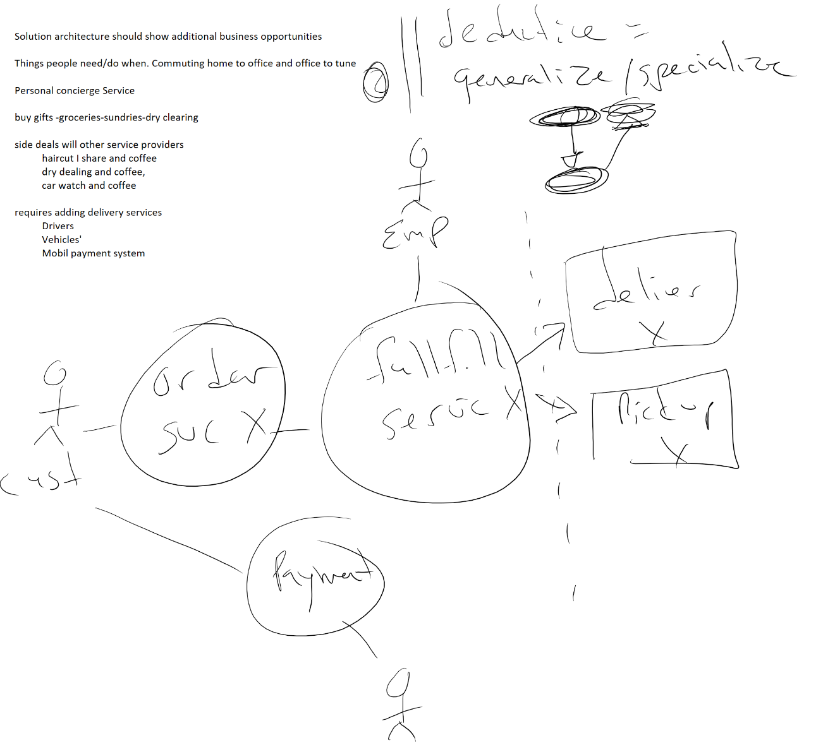

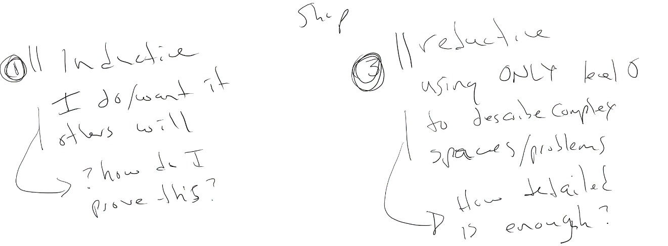

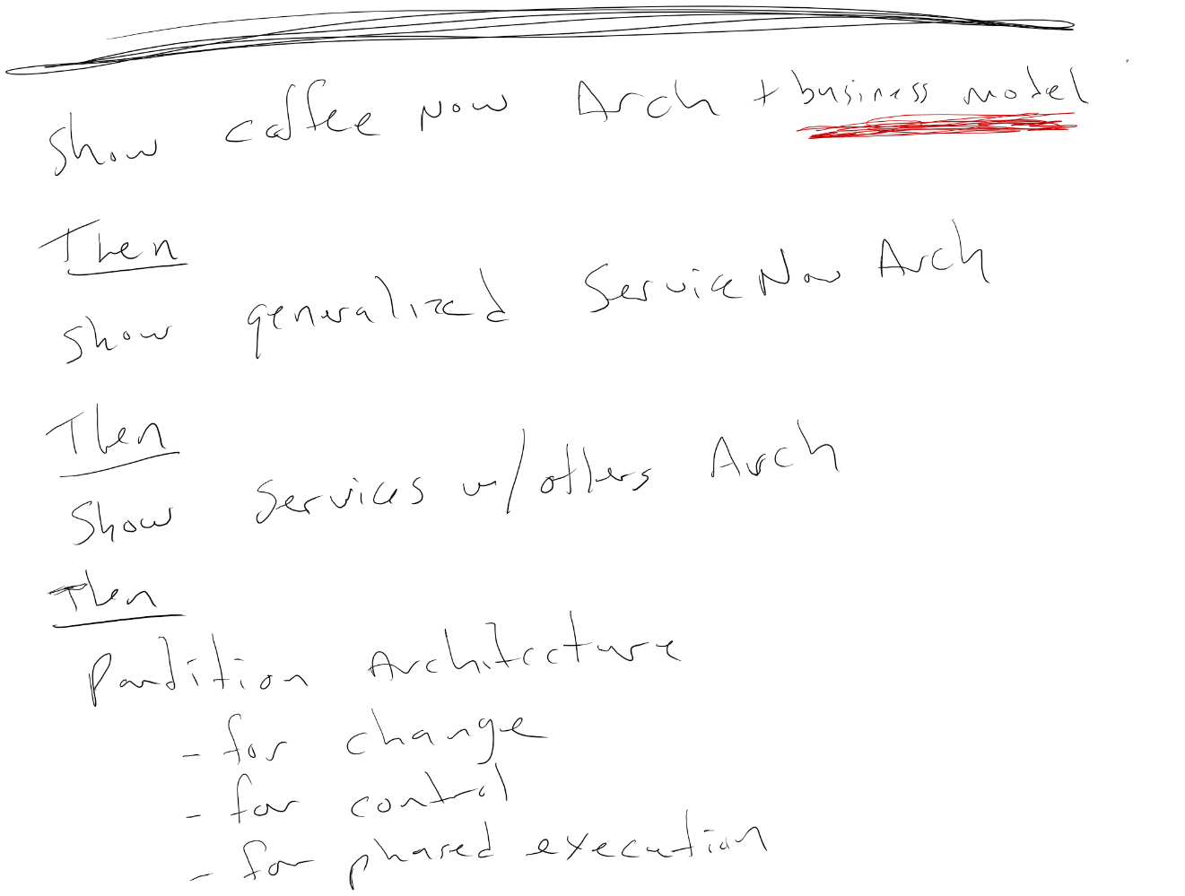

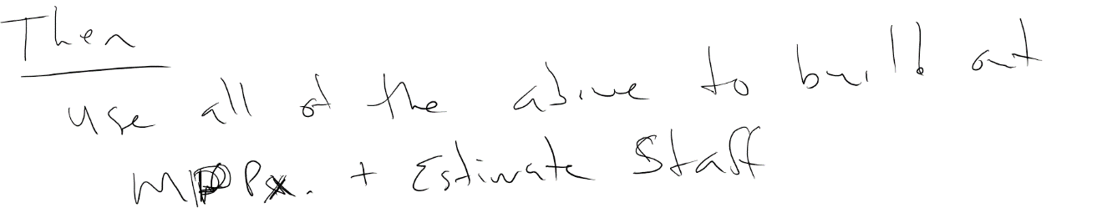

## Just Coffee Now









## Coffee Now

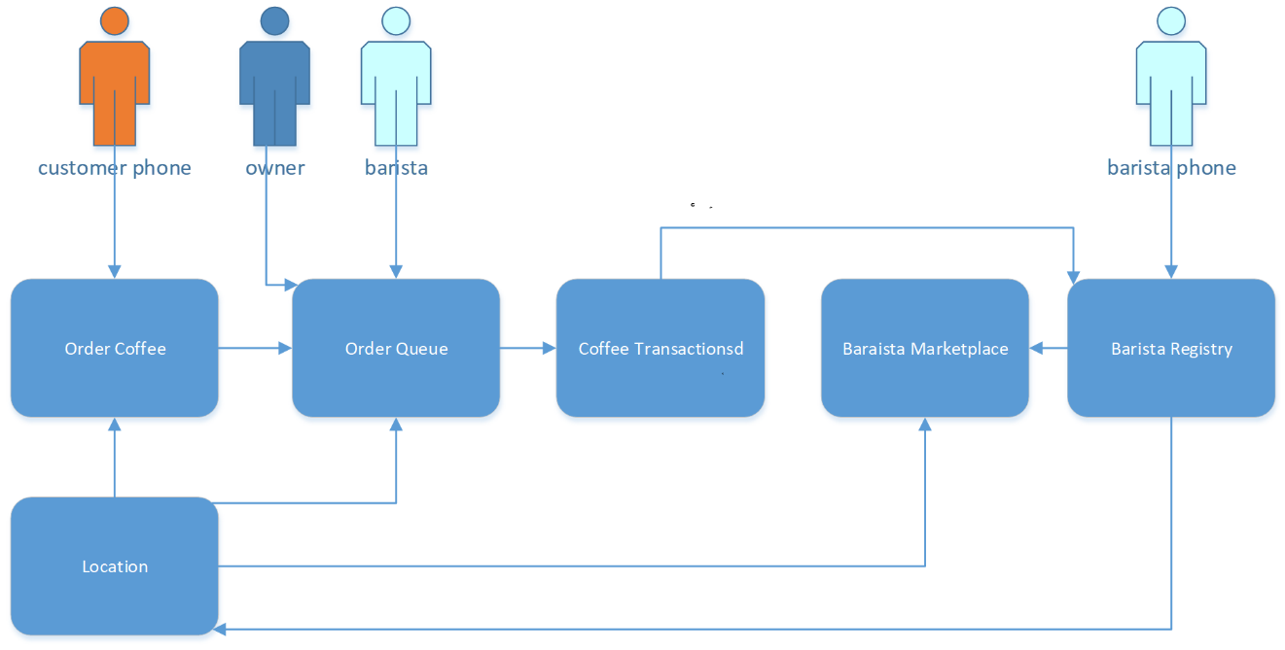

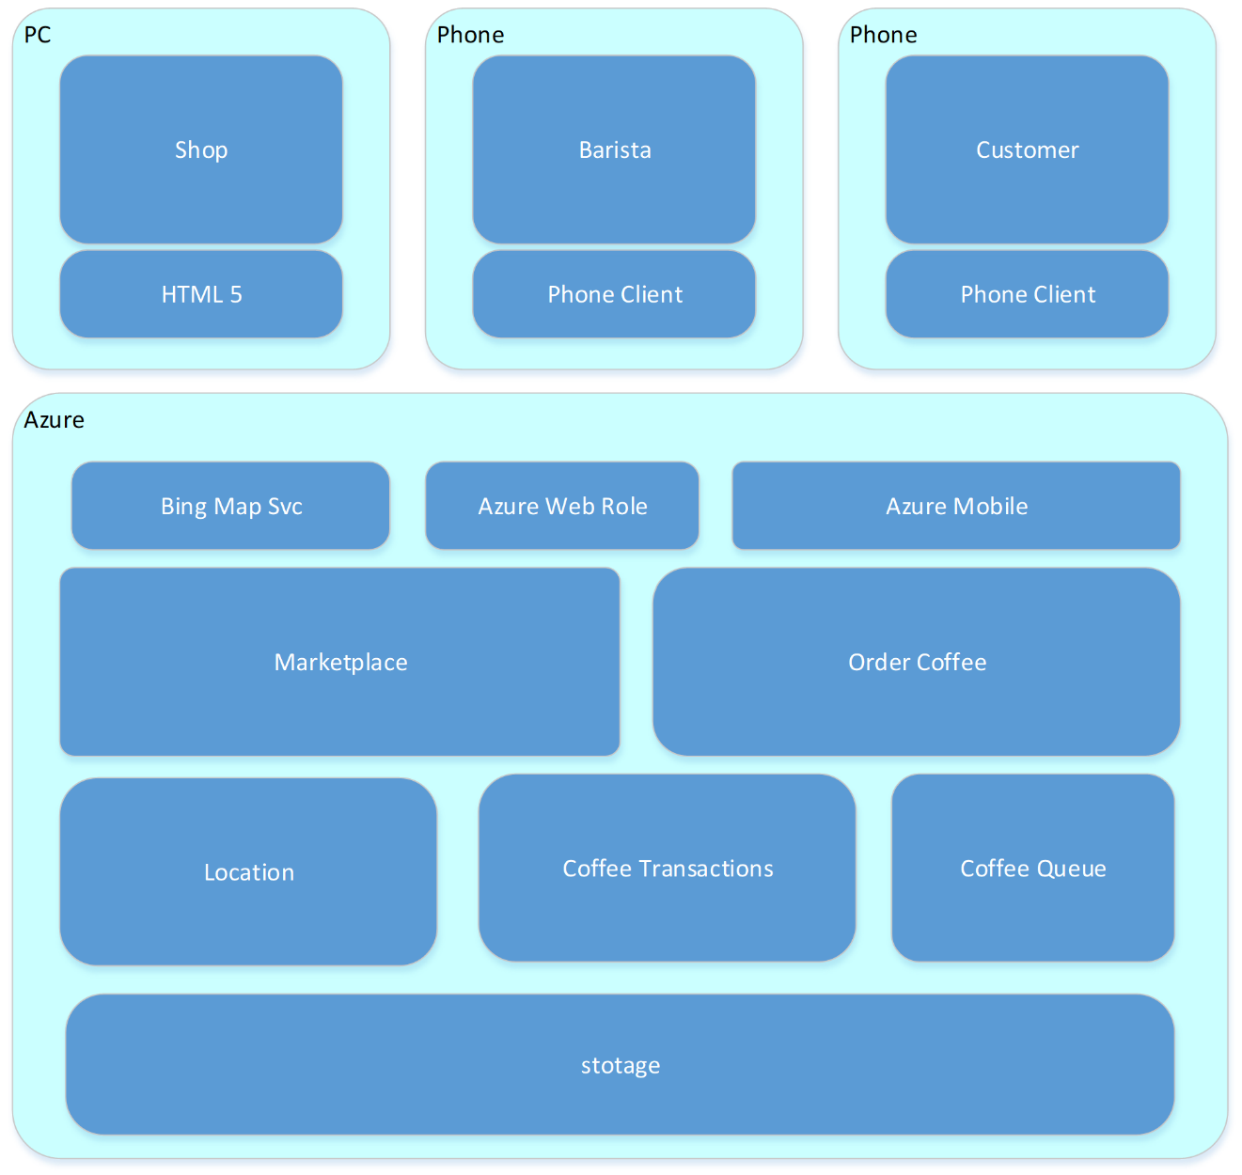

## Any Service Now

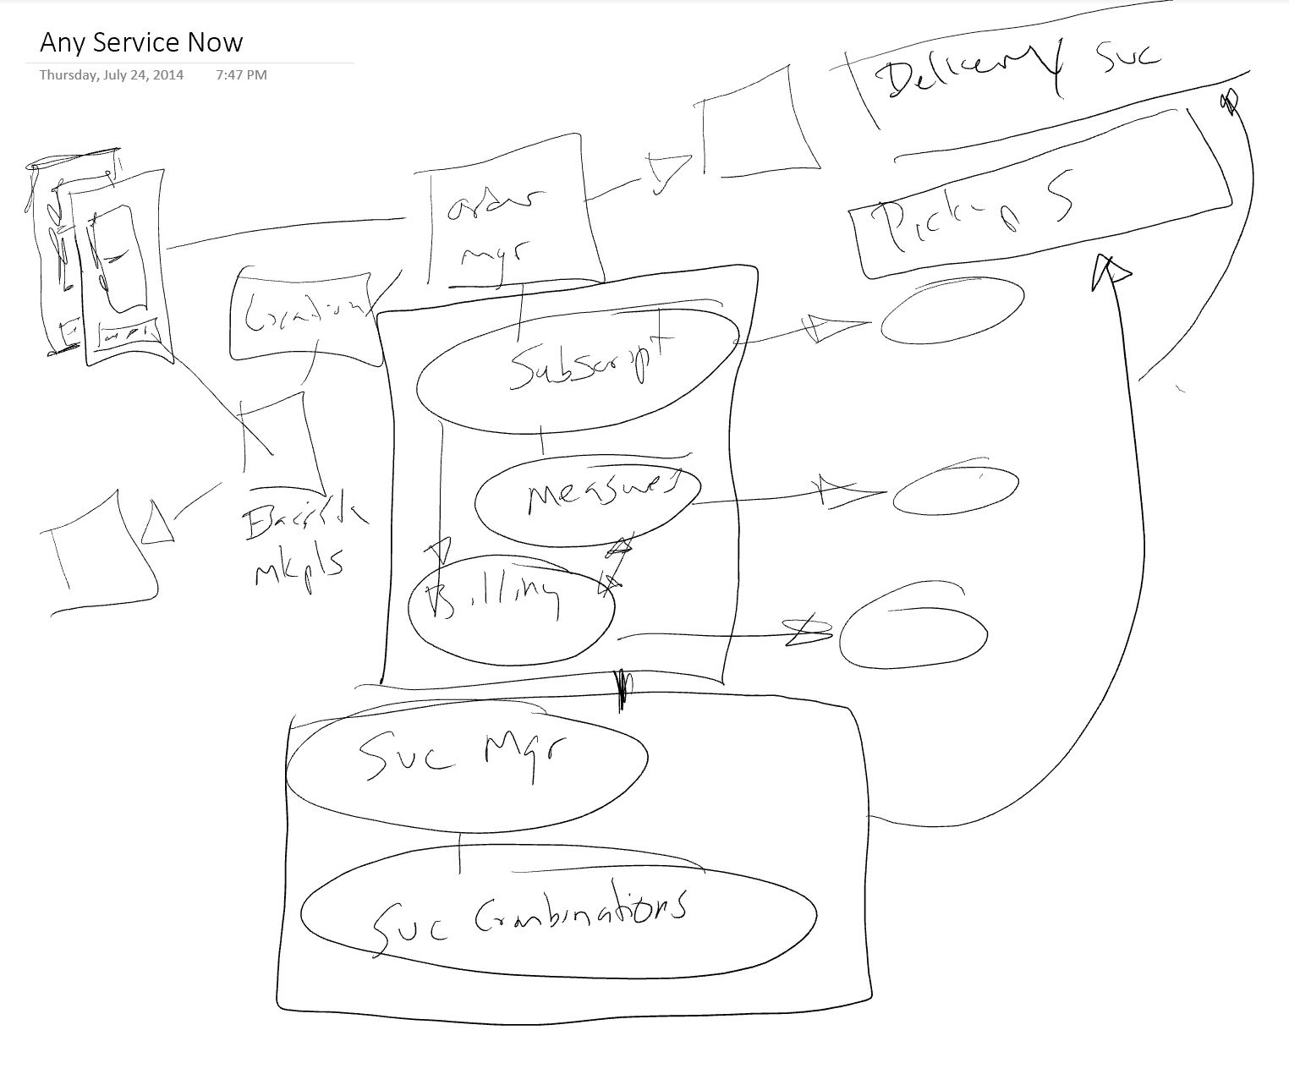

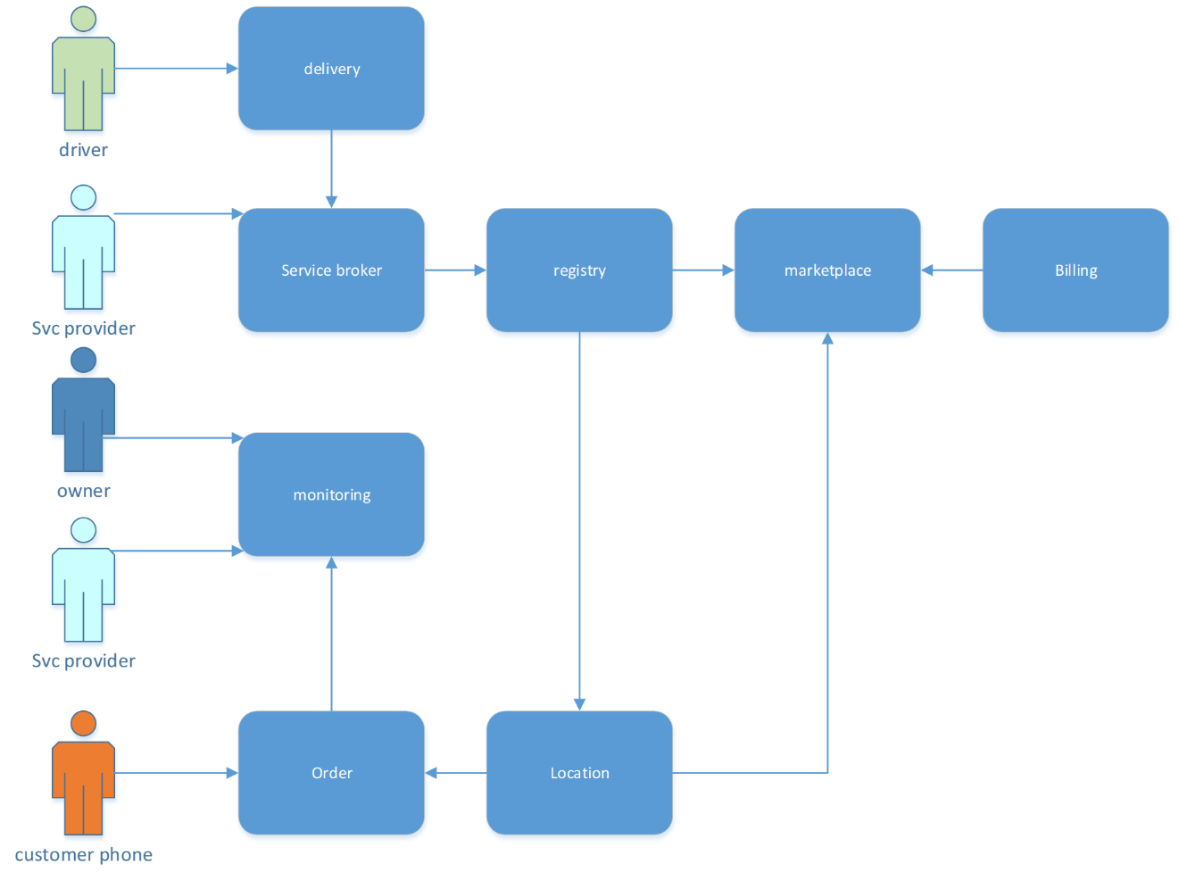

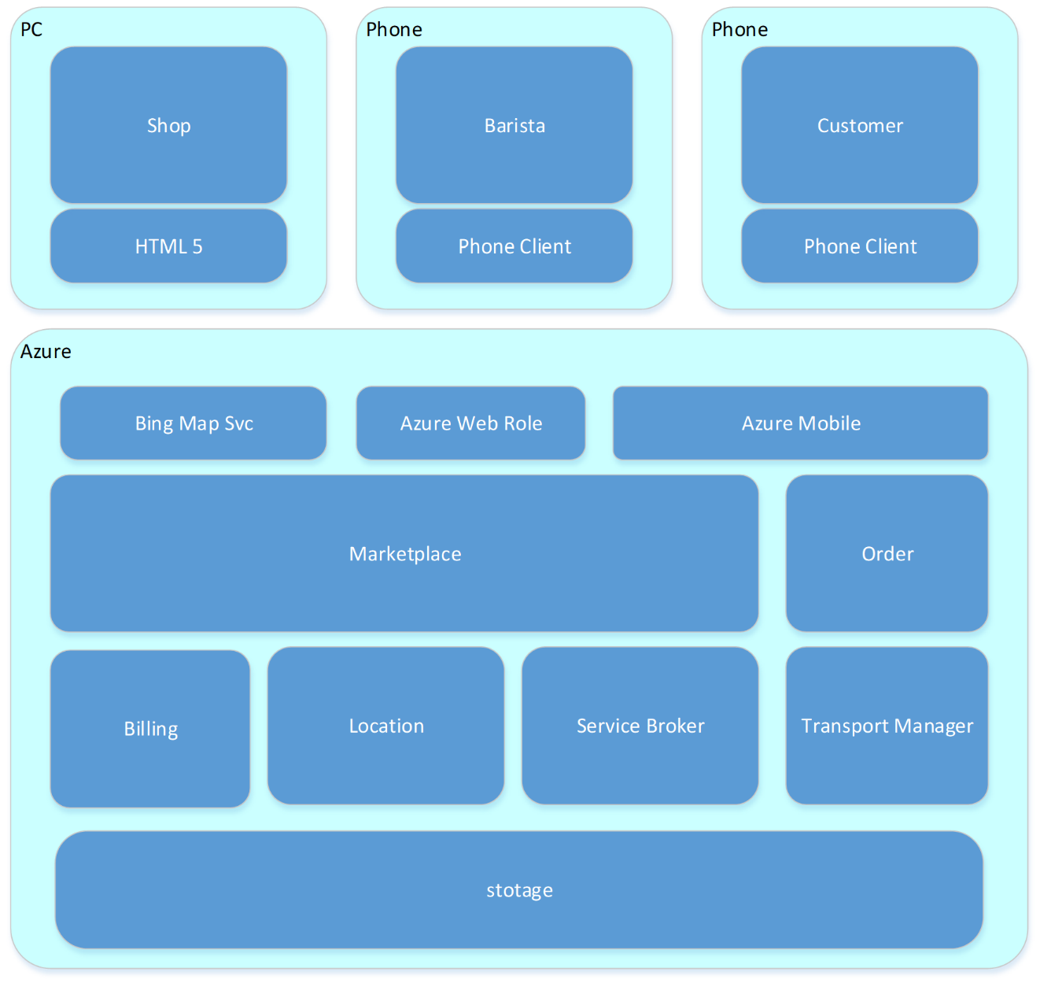

## Threat Models

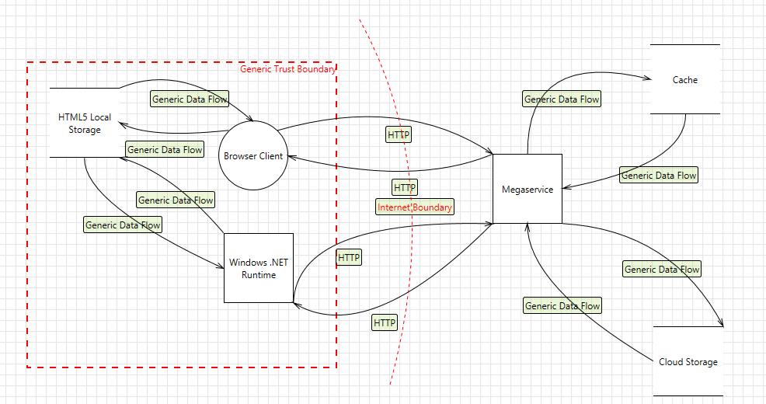

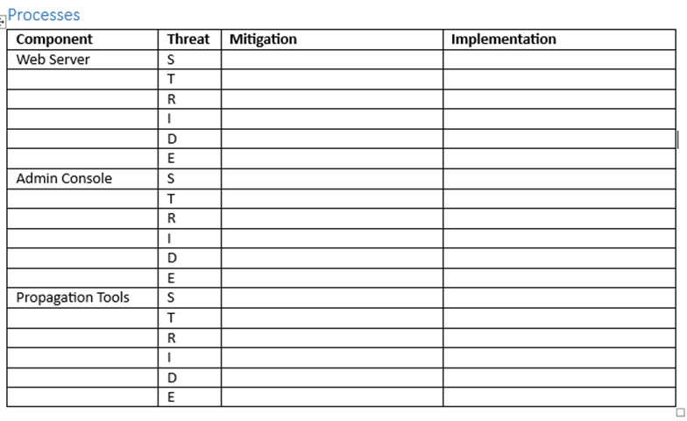

## Solution Design

10:32 PM

WindowsAzure.MobileServices.SQLiteStore

Microsoft.WindowsAzure.MobileServices.Sync

MobileServiceClient MobileService = new MobileServiceClient(

"<https://your-mobile-service.azure-mobile.net/>",

"Your AppKey"

App.MobileService.GetTable

Push and Pull

App.MobileService.SyncContext.PushAsync();

App.MobileService.SyncContext.PullAsync()

Use the Pull and Push buttons to synchronize the local store with the server

the app to call MobileServiceClient.SyncContext.PushAsync and then RefreshTodoItems to refresh the app with the items from the local store. This push operation results in the mobile service database receiving the data from the store.

Windows.Devices.Geolocation.Geolocator()

geolocator.GetGeopositionAsync()

## Reviews

Informal – meet your goal

Rhythm

Tools - Unit test

Peer – meet provided goal well

Rhythm

Roles

Structured – meet provided goals properly

Rhythm

Roles

Tools - FXCop [styleCop]

* Static code analysis VSTS (turn it on)
* Code analysis at Build time
* Code profilers
* Complexity analysis

Response

Formal - meet provided goals properly and fully integrates with others

Rhythm

Roles

Response

Outcome

## Architectural Alternatives Considered

NONE.

No servers allowed in shops

No dedicated IT staff

A preference for consumption pricing

A desire to make the solution "universally available"

Cloud first, Mobile first.

## Alternate Project Drivers

Cost driven

Customers and Baristas are not likely to pay for an app to engage each other and the shops. Therefore the cost to develop must be minimized and any return on the investment needs to come from other income sources.

By leveraging a fully hosted solution up-front costs are low but there will be ongoing costs from the moment of initial development until the application is fully deprecated.

Schedule driven

Version 1 of the solution is not really driven to be released by a particular date. Given the development costs are likely to be born as investment by the development team every effort should be made to minimize the duration of the first release.

Scope driven

Both cost and schedule concerns above drive scope to its smallest possible form. The features as described a generally self-standing allowing the development team to be be selective as to which features are added after the initial release.

## Cost versus Performance

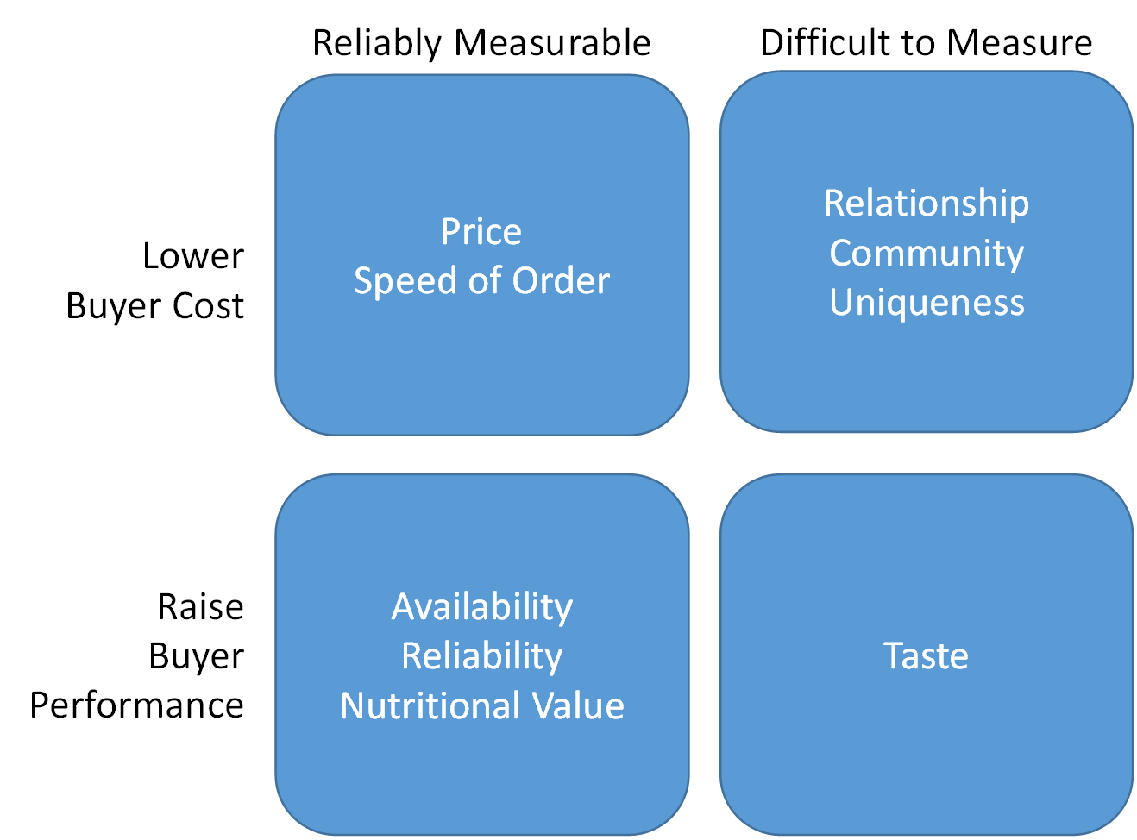

## Feedback

