# File permissions in Linux

## Project description

[Throw the linux commands we can manage many things fast and more affective and can access more deep work like change the permission for files .]

## Check file and directory details

[First of all you must write (pwd) to check where are you.

After that you can check the files by typing (ls -l) after write it the files and details will show with permissions and details about the files]

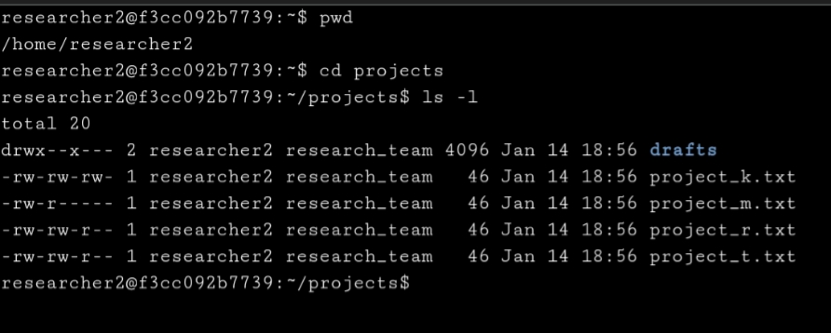

## Describe the permissions string

[drwxrwxrwx this 10 characters describe the permissions for files or directories .

* The (d) stand for directory if there is no (d) and instead there is a (-) that’s mean it’s a file not a directory
* The second and third and fourth letters are four user permissions : (r) stands for read,(w)stands for write , (x) stands for execute
* The fifth and sixth and seventh letters for group permissions
* The eighth ninth and ten letters are four others permissions ]

## Change file permissions

[As show in the picture we change the permissions for the file called (project_k.txt) .

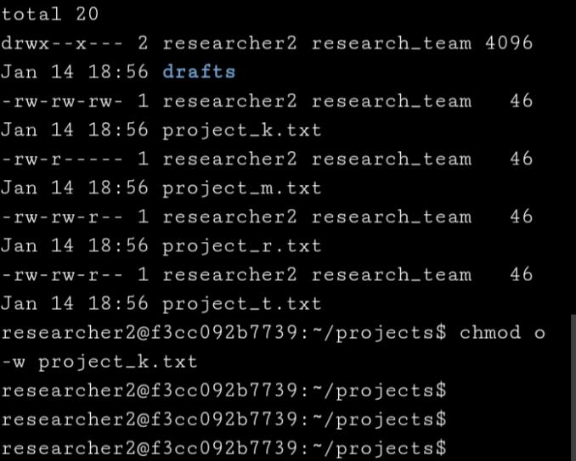 so to do it we use the command (chmod) to change the permissions so type (chmod o-w project_k.txt) to delete the write permissions for the (other)

## Change file permissions on a hidden file

[ First to show the hidden file we write the command (ls -la) to show both the hidden files and them permissions and the hidden files always start with (.) And change them same command (chmod) but we have to notice to write the (.) In the begging of the hidden file name .]

## directory permissions

[Its so important to check the permissions. Why? Because its one of the Security way to protect files from unauthorized persons or maybe got deleted by wrong or give permissions to people don’t must have it .]

## Summary

[In the end knowing how to manage permissions is important for Security Analysts because they can avoid the wrong editing and see by wrong people or people see sensetive data they not must see it ]