# Apply filters to SQL queries

## **Project description:**

[ I discovered some potential security issue involve login attempts and employee machines , so I will examine the organization’s data in their examine the organization’s data in their examine the organization’s data in their **employees** and **log_in_attempts** tables

**Retrieve after hours failed login attempts:**

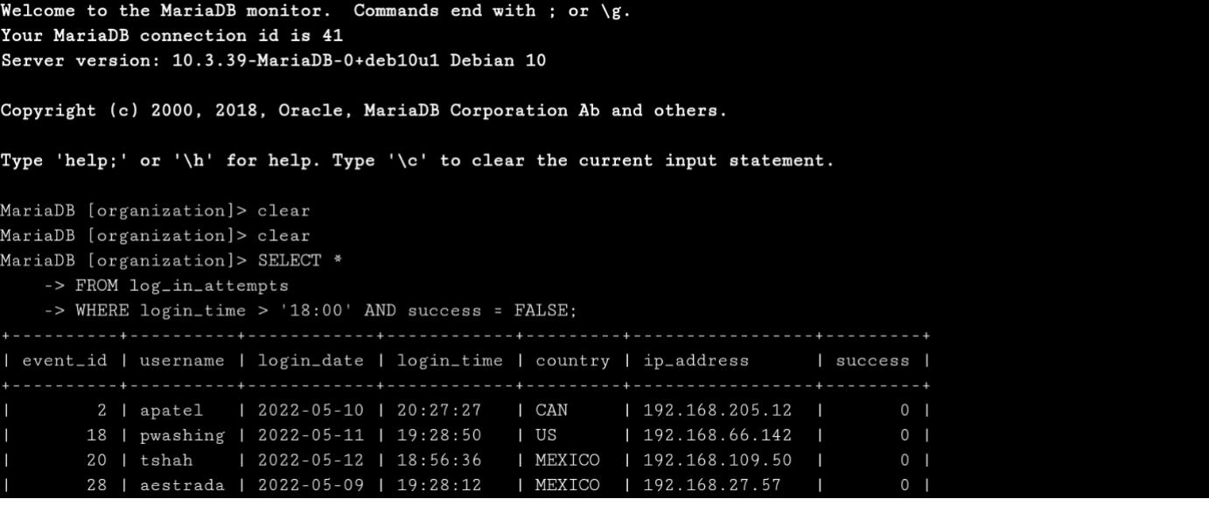

As showed in the Photo I used the command:

SELECT *

FROM log_in_attempts

WHERE login_time > ’18:00’ AND success = FALSE;

This command will show us any login unsuccessful attempts after 6pm or 18:00 from the log_in_attempts table and choose the login_time row by using the command WHERE then put the AND to write another condition so every false login attempt after 6 pm will show

**Retrieve login attempts on specific dates** **:**

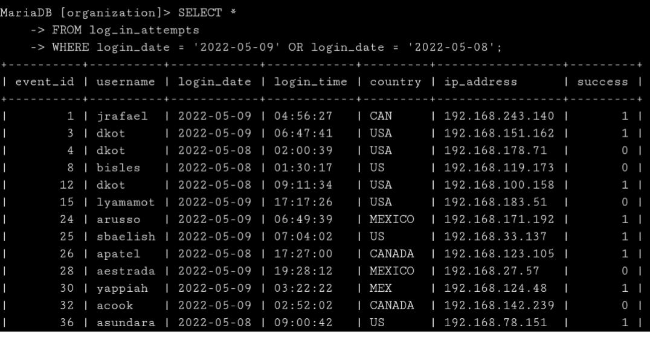

As see in the photo I used this command:

SELECT *

FROM log_in_attempts

WHERE login_date = ‘2022-05-09’ OR login_date = ‘2022-05-08’;

So after select all from the table (log_in-attempts) I specified the login_date by use the WHERE and put specific date or another date, that’s mean all attempts happened in these 2 days will show.

**Retrieve login attempts outside of Mexico :**

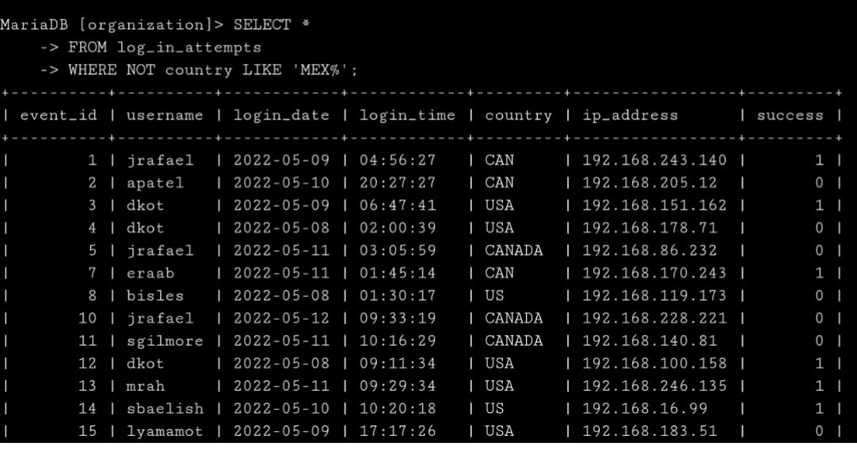So here in this photo I used the command:

SELECT *

FROM log_in_attempts

WHERE NOT country LIKE ‘MEX%’;

Here I ask for all countries only without MEXICO but I use ‘MEX%’ because any word start with these letters (MEX) will removed also.

## **Retrieve employees in Marketing :**

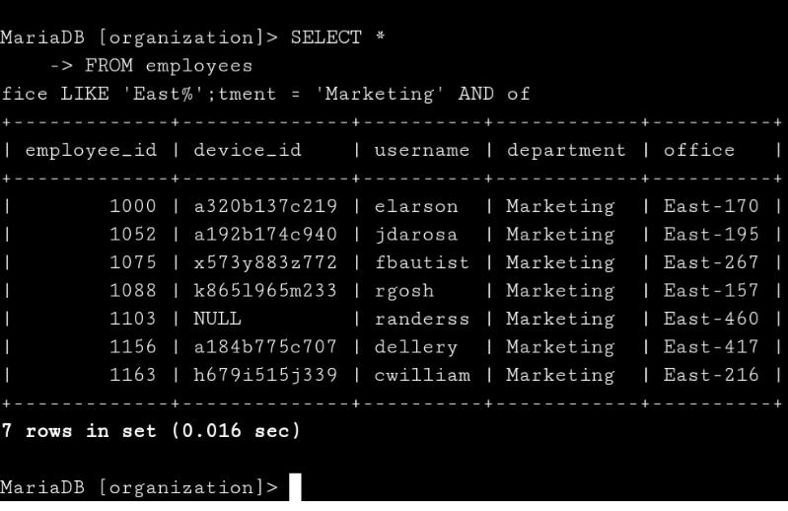So here I used the command:

SELECT *

FROM employees

WHERE department = ‘Marketing’ AND office LIKE ‘East%’;

So here I choose here who has 2 conditions it must be in the Marketing department and the office name start with East.

## **Retrieve employees in Finance or Sales :**

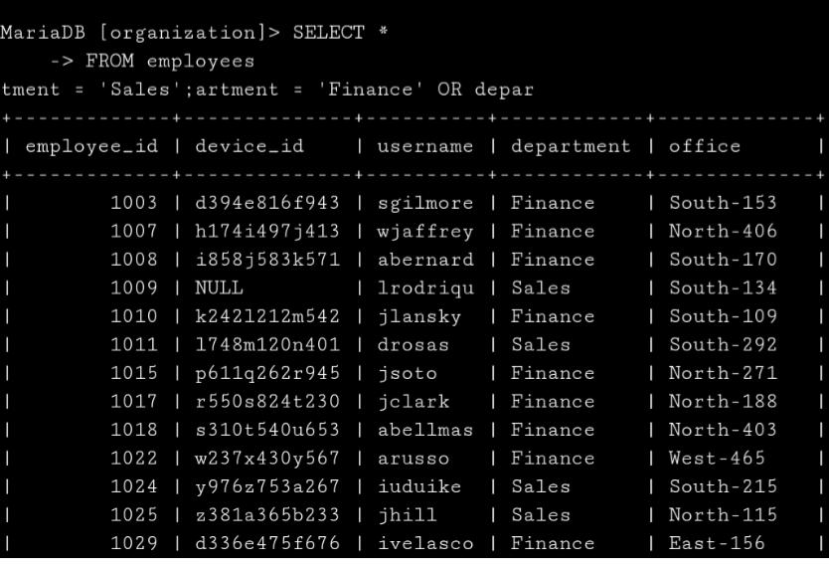Here I used the command:

SELECT *

FROM employees

WHERE department = ‘Finance’ OR department = ‘Sales’;

So here any employee from finance or sales department will appear.

## **Retrieve all employees not in IT :**

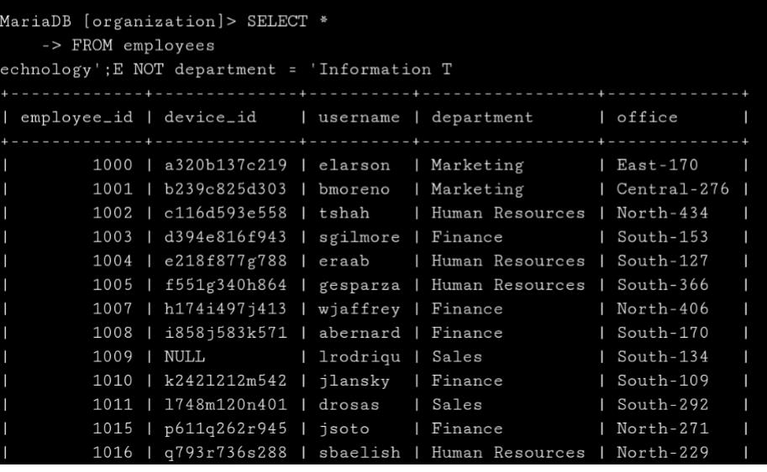I use the command:

SELECT *

FROM employees

WHERE NOT department = ‘Information Technology’;

So here only the information technology got updates so I type the command that will show all without the information technology.

## **Summary :**

So using SQL is benefit as saw in the photos I used the SQL filter command to filter the output in the way will help me more and make it easier so see what I’m looking for and put specific conditions to filter or expect some condition.