# ***Algorithm for file updates in Python***

## ***Project description:***

[Creating a algorithm for remove some ip addresses allow list because they don’t need to have more access for it.]

## ***Open the file that contains the allow list :***

[first we want to open the file allow_list.txt to do that first;

1. We must create a variable (import_file) and give it the file name as a string value
2. We create another variable (remove_list) and give it the ip addresses that we want to remove as a list value
3. To open the file : we use the (with) to close it directly after we done , and use the method open(import_file, “r”) as file: so we put in the open() method the name of the variable that we put the file as a value in it , and the way we want it (“r”) that stands for read to read the file and save it as variable (file) .]

***Read the file contents :***

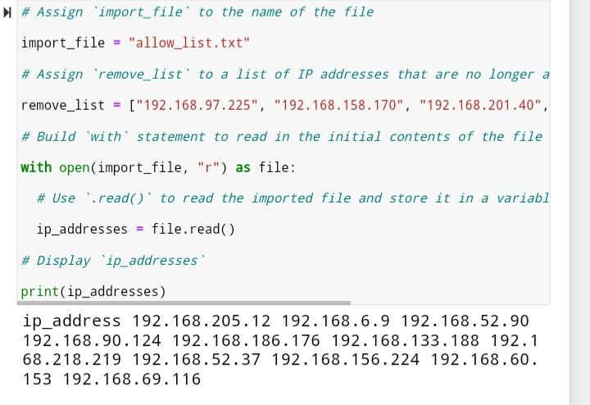

Now to read the file content :

1. We have to create new variable to save the contents of the .txt file (ip_addresses) and give it a value the file we set to read
2. Print the ip_addresses variable to see the content.

## ***Convert the string into a list :***

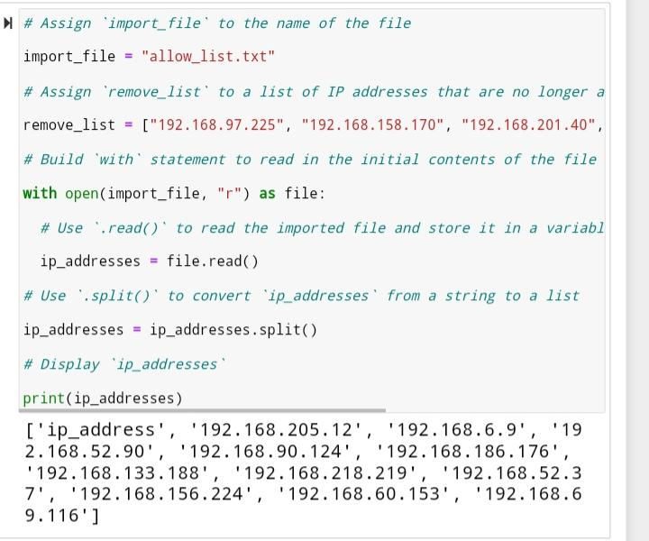

Now change the string value to list by :

1. Give the variable ip_addresses new value with .split() method to change the string value into list value
2. Then print the variable to see the new value

## ***Iterate through the remove list :***

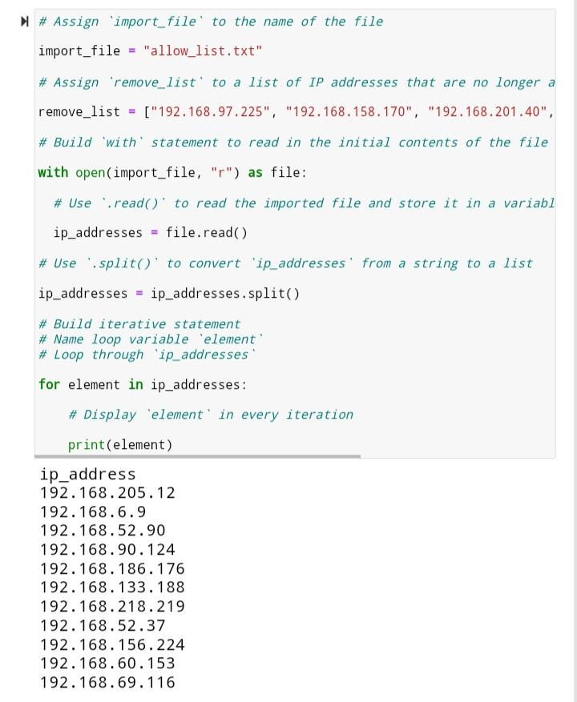

Now we make a loop using for with new variable called (element) then print it to make sure that its has the value.

## ***Remove IP addresses that are on the remove list :***

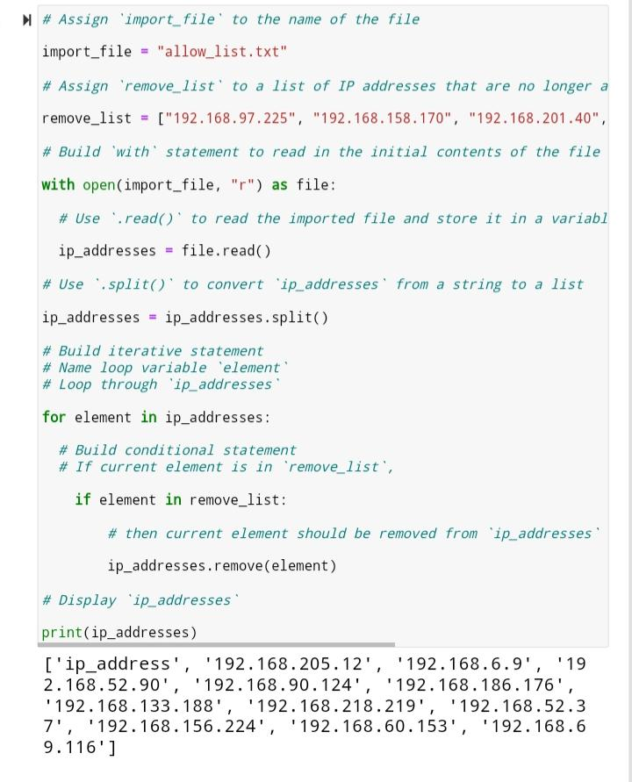

Now we remove the ip_addresses that we don’t want it to have access any more by:

1. Have condition statement by using (if) if the element variable value in the remove_list
2. And use the( remove()) method to remove the value
3. Print the variable (ip_addresses) to make sure .

## ***Update the file with the revised list of IP addresses :***

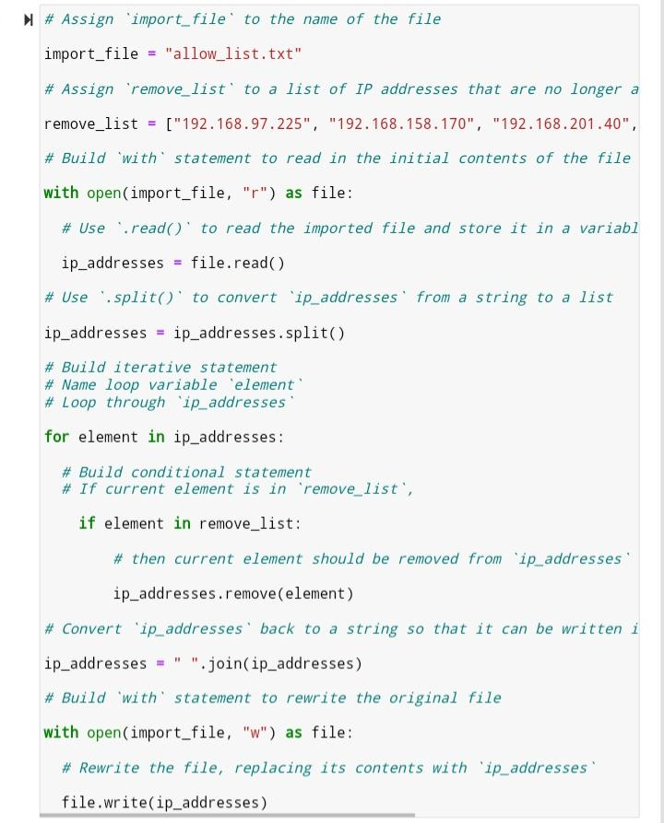

Now we update the ip_addresses variable to back into string by using .join() method

* Open the import_file again with “w” that stands for write to write over it and save as a file
* Set the file variable into .write() method and write the ip_addresses over it.

## ***Summary :***

I created an algorithm that removes IP addresses identified in a remove_list variable from

The “allow_list.txt” file of approved IP addresses. This algorithm involved opening the

File, converting it to a string to be read, and then converting this string to a list stored in the

Variable ip_addresses. I then iterated through the IP addresses in remove_list. With each

Iteration, I evaluated if the element was part of the ip_addresses list. If it was, I applied the

.remove() method to it to remove the element from ip_addresses.. After this, I used the

.join() method to convert the ip_addresses back into a string so that I could write over

The contents of the “allow_list.txt” file with the revised list of IP addresses.