<https://stackoverflow.com/questions/55451438/how-can-i-connect-to-my-redshift-cluster-using-node-js>

<https://www.npmjs.com/package/node-redshift>

npm install node**-**redshift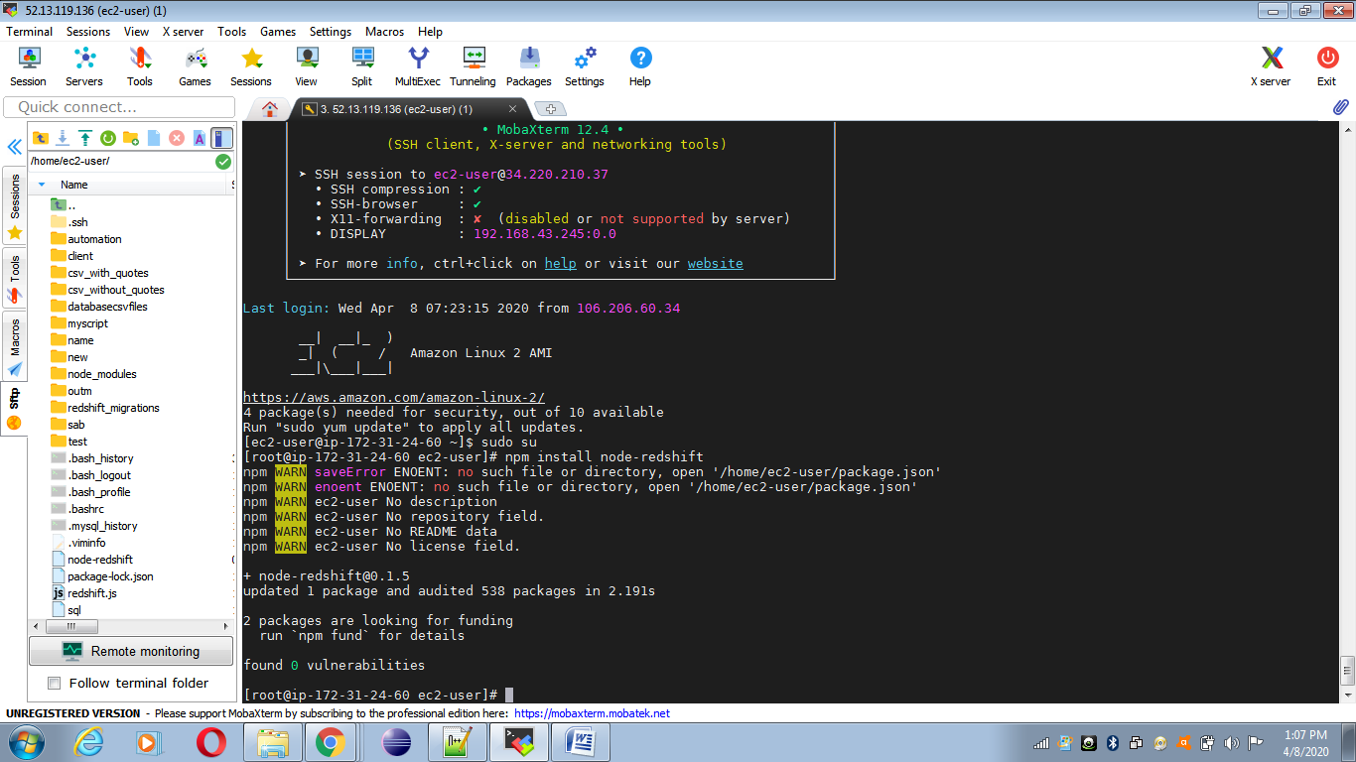

redshift.js

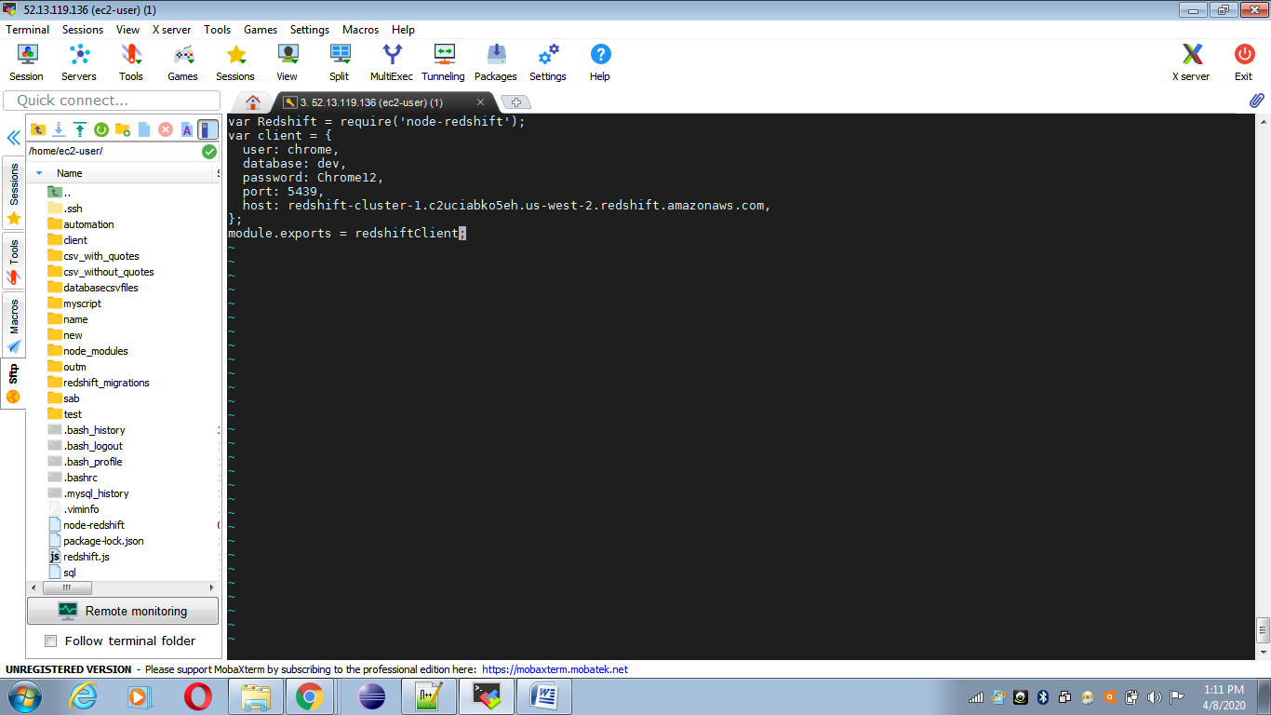

[Connection Pooling](https://github.com/dmanjunath/node-redshift#connection-pooling) - you can open a connection pool and open connections to Redshift which will be managed by pg-pool (https://github.com/brianc/node-pg-pool)

[Raw Connection](https://github.com/dmanjunath/node-redshift#raw-connection) - a one time connection you must manually initialize and close to run queries

var redshiftClient = new Redshift(client, {rawConnection: true});

<https://medium.com/@ly.lee/connecting-aws-lambda-node-js-to-redshift-or-postgresql-try-aws-lambda-layers-78e60c27f39b>

npm install pg

