CREATE DEFINER=`chrome`@`%` PROCEDURE `sync_events`(IN `num_days` INT)

CREATE PROCEDURE sync_events(num_days IN int)

==================================================================================

DELIMITER $$ DELIMITER ;

AS $$ $$ LANGUAGE plpgsql SECURITY DEFINER SET search_path = chrome; (FOR CHROME DEFINER)

==================================================================================

SELECT CONCAT('Syncing events tables for # days: ', num_days) __;

SYNTAX: CONCAT ( string1, string2 );

==================================================================================

DECLARE min_ts INT;

SET min_ts = UNIX_TIMESTAMP(CURRENT_DATE);

**SYNTAX : DECLARE cursor_name CURSOR FOR query**

DECLARE min_ts int for SELECT extract(epoch from current_date);

==================================================================================

Insert statement with select query totally 4 tables (datas from events)

1. Evt_ent
2. Evt_snd
3. Evt_os
4. Evt_devices

For all tables, select query is same

SELECT SUM(activeTime) AS activeTime,

SUM(inactiveTime) AS inactiveTime,

timestamp,

orgId, entityId, domainId, type,

**date(from_unixtime(timestamp)) AS dt**

FROM events

WHERE timestamp >= min_ts

GROUP BY entityId, domainId, dt

HAVING activeTime > 0

**“date(from_unixtime(timestamp)) AS dt”**

**Here they store the values of timestamp column(in events) in date format to dt column (in evt_tables)**

**Ths syntax is used in mysql to convert the timestamp to date.**

**In mysql, the timestamp format is in integer format (**1528398544**)**

**In redshift, the timestamp format is in date with time format (**2018-06-07 00:00:00.000000**)**

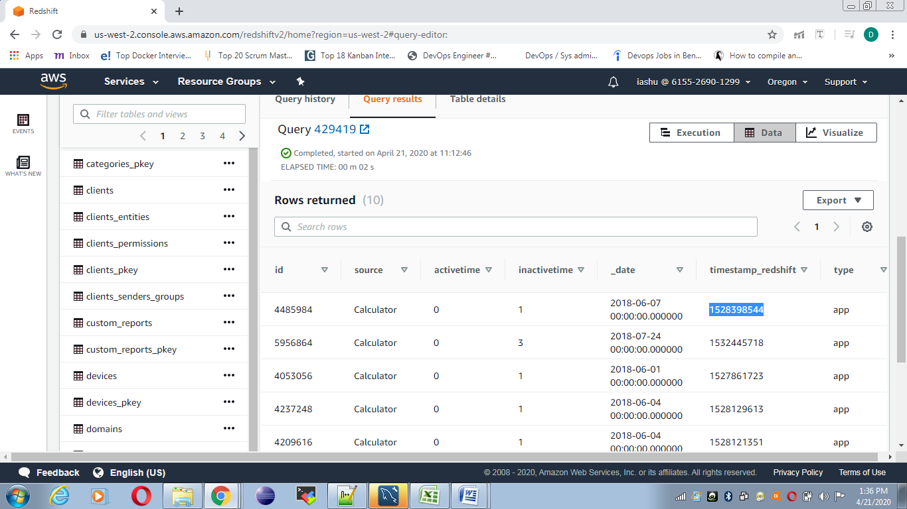

**We have to change the timestamp column datatype to timestamp instead of integer type in events table.**