COPY chrome_staging.events

from 's3://mysqltoredshiftmigration20.03/client/events_p2.csv'

iam_role 'arn:aws:iam::615526901299:role/redshiftcopy'

delimiter '|' IGNOREHEADER 1

timeformat 'auto';

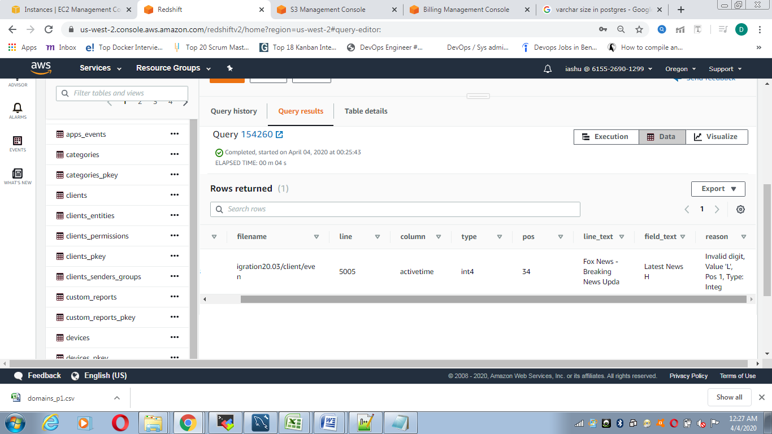

COPY chrome_staging.events

from 's3://mysqltoredshiftmigration20.03/client/events_s2.csv'

iam_role 'arn:aws:iam::615526901299:role/redshiftcopy'

delimiter ';' IGNOREHEADER 1

timeformat 'auto';

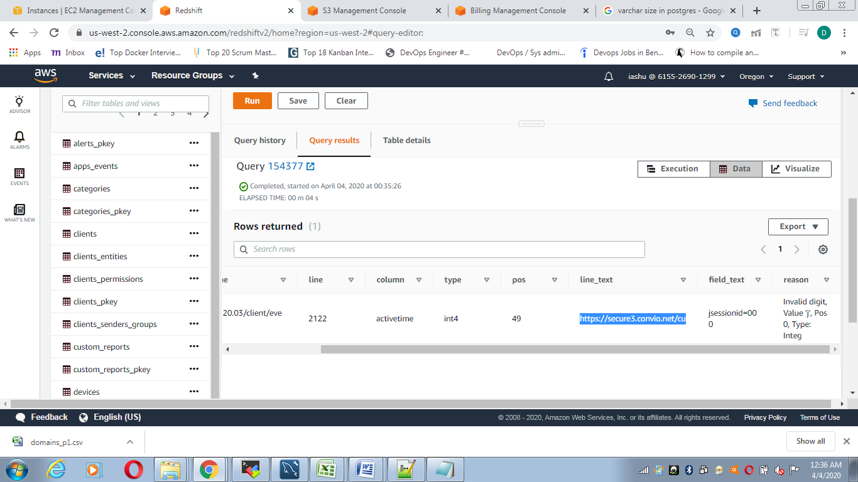

COPY chrome_staging.events

from 's3://mysqltoredshiftmigration20.03/client/events_n2.csv'

iam_role 'arn:aws:iam::615526901299:role/redshiftcopy'

delimiter '\t' IGNOREHEADER 1

timeformat 'auto';

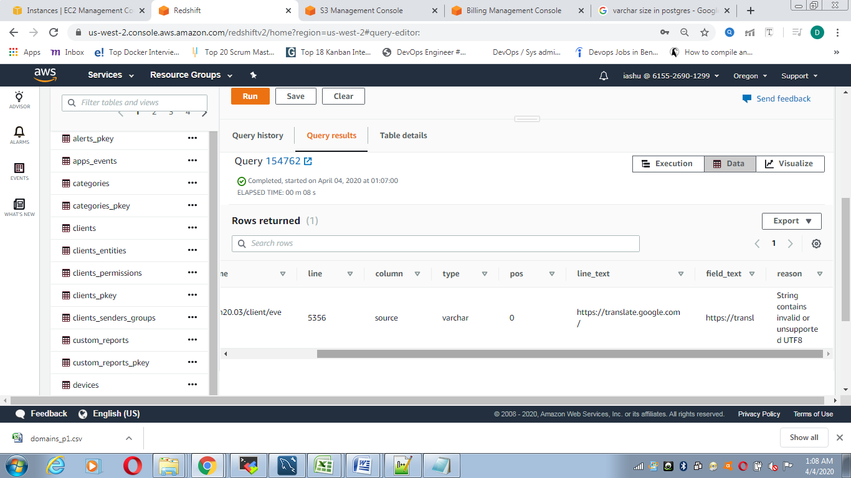

COPY chrome_staging.events

from 's3://mysqltoredshiftmigration20.03/client/events_n2.csv'

iam_role 'arn:aws:iam::615526901299:role/redshiftcopy'

delimiter '\t' acceptinvchars ESCAPE IGNOREHEADER 1

timeformat 'auto';

