COPY chrome_staging.evt_snd

from 's3://mysqltoredshiftmigration20.03/client/evt_snd_t1.csv'

iam_role 'arn:aws:iam::615526901299:role/redshiftcopy'

delimiter '\t' IGNOREHEADER 1

timeformat 'auto';

COPY chrome_staging.evt_snd

from 's3://mysqltoredshiftmigration20.03/client/evt_snd_p1.csv'

iam_role 'arn:aws:iam::615526901299:role/redshiftcopy'

delimiter '|' IGNOREHEADER 1

timeformat 'auto';

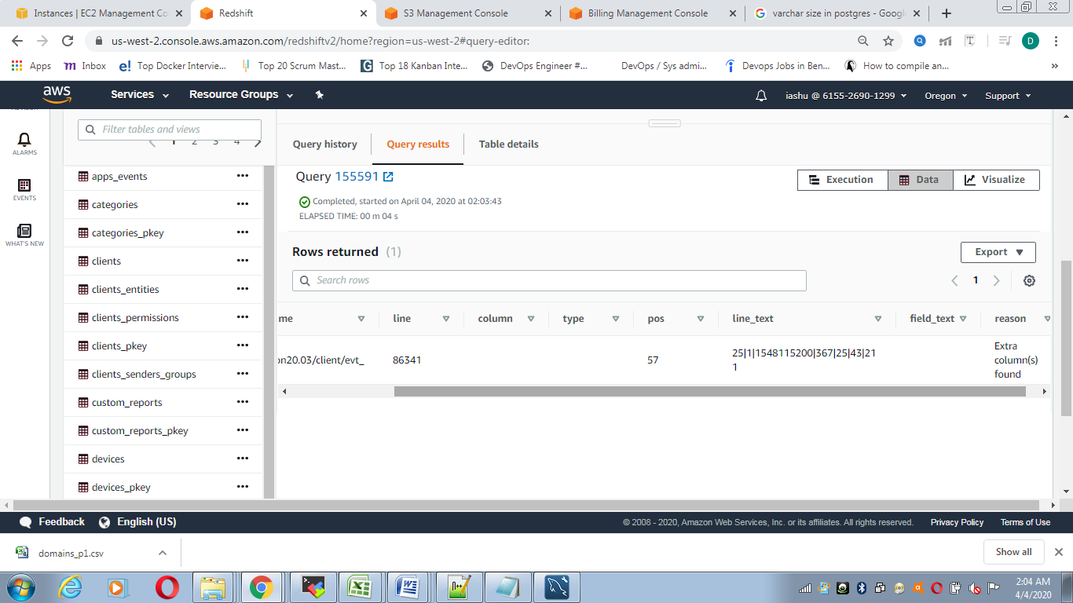

COPY chrome_staging.evt_snd

from 's3://mysqltoredshiftmigration20.03/client/evt_snd_s1.csv'

iam_role 'arn:aws:iam::615526901299:role/redshiftcopy'

delimiter ';' acceptinvchars ESCAPE IGNOREHEADER 1

timeformat 'auto';

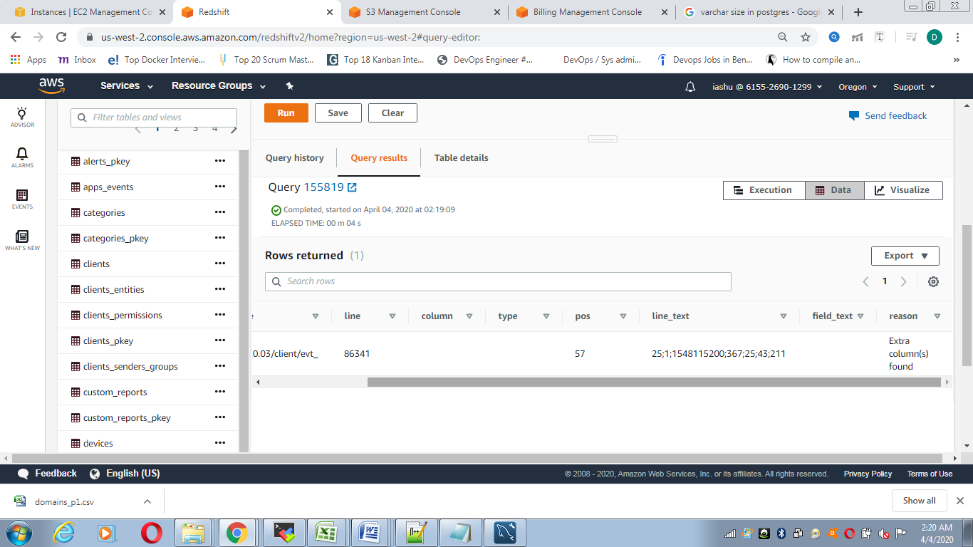

COPY chrome_staging.evt_snd

from 's3://mysqltoredshiftmigration20.03/client/evt_snd_t1.csv'

iam_role 'arn:aws:iam::615526901299:role/redshiftcopy'

delimiter '\t' IGNOREHEADER 1

timeformat 'auto';

