|  |  |
| --- | --- |
|  | **FPT ACADEMY INTERNATIONAL**  **FPT – APTECH COMPUTER EDUCATION** |

**Centre Name: ACE-HCMC-2-FPT.**

**Address: 590 Cach Mang Thang 8, District 3, Ho Chi Minh City, Viet Nam.**

**ORAL HEALTH**

|  |  |  |
| --- | --- | --- |
| **Supervisor.** | Mr. Nguyen Phat Tai | |
| **Batch.** | T1.2011.M0 | |
| **Group.** | 7 | |
| **Serial No.** | **Enrollment Number** | **Student Name** |
| 1. | Student1287967 | Trinh Le Minh Thai |
| 2. | Student1286083 | Tran Trung Nghia |
| 3. | Student1286084 | Duong Ngoc Duy Hung |
| 4. | Student1286089 | Tang Ngoc Duy Anh |

Month March Year 2021

**This is to certify that**

**Mr.:**

Trinh Le Minh Thai

Tran Trung Nghia

Duong Ngoc Duy Hung

Tang Ngoc Duy Anh

**has successfully designed & developed**

eProject: Oral Health website

**Submitted by: Trinh Le Minh Thai**

**Date of issue: 29-Mar-2021**

**Authorized Signature: Thai**



**TABLE OF CONTENTS**

FPT – APTECH COMPUTER EDUCATION 1

ACKNOWLEGMENT 4

SYNOSIS 4

PROBLEM DEFINITION 4

CUSTOMER'S REQUIREMENTS SPECIFICATIONS (CRS) 5

Business/Project Objective: 5

Hardware/ Software Requirements: 6

SCOPE OF THE WORK (IN BRIEF) 7

Architecture and design of the system 8

Diagram of the website 9

TASK SHEET REVIEW 1 10

# ACKNOWLEGMENT

On behalf of all the members of group 7, I would like to thank you all for the hard works, supports to make this eProject complete successfully. Especially, Mr. Nguyen Phat Tai, our teacher, he helped us a lot from the day that we started to study at FPT Aptech. With this eProject, he has guided us with his enthusiasm and rigorous, because of him guiding, we would be able to finish this project. Besides, I want to thank all the team member of group 7, each of the team members has been working continuously in 4 weeks in order to complete this project. The last but not least, we would like to say thank you to our family for always supporting us, creating the best conditions for us to focus on the project, and putting faith in the dreams we pursue.

# SYNOSIS

We need to create a website that meets all the requirement of our customers, Oral Health. They want to have a oral health. The main purpose of this website is to reach to the customers, who have interest in oral health.

# PROBLEM DEFINITION

The Web site is to be created based on the following requirements.

1. The Home Page should be created making use of Sections with the header section can be added which will show images of various creative products.
2. The site must contain the links to navigate through any category for the information.
3. The education should be categorized according to the type patient/professional
4. Links of accessories can be categorized like
5. Specification and issues should be added along with the images.
6. Gallery section should be added for viewing different images Contact us page: contact us details with location should be displayed using GeoLocation API (eg. GoogleMaps).
7. Navigation should be smooth and images should be clear.
8. Site map, Gallery, about us, Queries link, Contact us link must be added. Address of the Company should be displayed using GeoLocation API (eg. GoogleMaps) and the email address which when clicked will invoke the local mail client from where they can send an email.
9. The complete description must be allowed to get download as pdf or doc file. The advertise section with various facilities provided should be mentioned.

# 

# CUSTOMER'S REQUIREMENTS SPECIFICATIONS (CRS)

**Client: ORAL HEALTH**

### Business/Project Objective:

Oral Health is having for people who want some information about. Now with the changing environment, they want their presence on Internet. Hence they need to have a website with all their products listed on the website. Consumers should find it easy to view various products and decide upon purchasing the right product to meet their requirements.

A website needs to be designed to display various related product available with the store. Details of locations using GeoLocation API (eg. GoogleMaps), feedback must be included.

The website is to be developed for the Windows Platform using HTML5, JavaScript and Geolocation. The site should work well in all leading browsers including Chrome, IE, Firefox etc.

**Input to the system:**

* + - * Based on type of oral issue.

**Output from the system:**

* A menu that will categorize all the functions of the site.
* Display the list of available albums category wisely.
* Perform the search based on a particular: type of dental issues
* Site should be able to provide brief introduction/history about the showroom under About Us page.
* The location of the showroom under Contact-Us page.
* Besides the above requirements, the site should have look and feel as per the industry standards.

**Expected delivery date:** 29-March-2021.

**List of deliverables:**

* + - * Document Word.
      * User Guide.
      * Source code.

### 

### Hardware/ Software Requirements:

**Hardware**

* A minimum computer system that will help you access all the tools in the courses is a Pentium 166 or better
* 64 Megabytes of RAM or better

**Software**

* Notepad/HTML editor
* Dreamweaver
* IE 5.0/ Netscape 6.0

# SCOPE OF THE WORK (IN BRIEF)

After a long and detailed discussion, our group has decided to create a website contain the following webpages:

1. ***Homepage***: Display information about newest-selling products, an introduction about OralHealth.
2. ***Education***: Display all models of brands based on category (Patient education and professional educaiton).
3. ***Research***: New research about oral health.
4. ***Product***: Some product to take care of oral.
5. ***Type of dental issues***: Give information about etc.
6. ***About Us***: Display the information of the company and about us.
7. ***Contact***: Display the address of the company, allow customers to request any information they want from Oral Health.

# Architecture and design of the system

Webpage request

**JS CODE**

dfdasddf

**CLIENT**

**SERVER**





Requested Page

**RENDERING**

**ENGINE**

**CSS CODE**

**HTML CODE**

**WEB SERVER**

**WEB BROWSER**

**BOOTSTRAP**

**& JQUERY**

dfdasddf

# Diagram of the website

.

HOME

PRODUCT

CONTACT US

ABOUT US

RESEARCH

PATIENT EDUCATION

PROFESSIONAL EDUCATION



# TASK SHEET REVIEW 1

|  |  |  |  |  |  |  |  |
| --- | --- | --- | --- | --- | --- | --- | --- |
| **Project Ref. No.:**  **eP/Advertisement Portal Management**  **System/01** | | **Project Title:** | **Activity Plan Prepared By:** | **Date of Preparation of Activity Plan:** | | | |
| **Sr.**  **No.** | **Task** | **Actual**  **Start Date** | **Actual Days** | **Team**  **Mate Names** | **Status** |
| 1 | Problem Statement | OralHealth | Thai | 3-Mar-21 | 1 | Anh | Completed |
| 2 | Analysis of Oral Health requirements about the website | 3-Mar-21 | 1 | Hung | Completed |
| 3 | The scope of the work (in brief) | 3-Mar-21 | 1 | Thai | Completed |
| 4 | Architecture and design of the system | 3-Mar-21 | 1 | Hung | Completed |
| 5 | Diagram of the website | 3-Mar-21 | 1 | Nghia | Completed |
| 6 | Task Sheet | 3-Mar-21 | 1 | Anh | Completed |

|  |  |
| --- | --- |
| **Date:3/3/2021** | |
| Signature of Instructor:  **Mr. Nguyen Phat Tai** | Signature of Team Leader:  **Mr. Duong Ngoc Duy Hung** |

# SITE MAP

PRODUCT PAGE

PATIENT

EDUCATION

CONTACT US PAGE

PRODUCT

ABOUT US PAGE

ABOUT US

HOME PAGE

CONTACT US

RESEARCH

PATIENT EDUCATION PAGE

PATIENT

EDUCATION

RESEARCH PAGE

PATIENT EDUCATION PAGE

# MOCK OF THE WEBSITE

1. **Homepage**

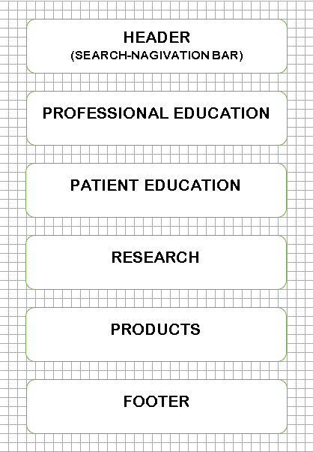

1. **ABOUT US**

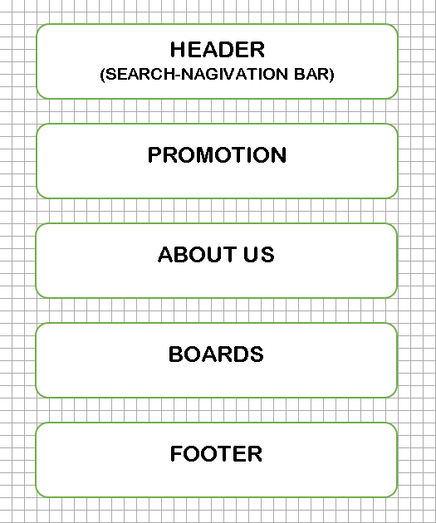

1. **CONTACT US**

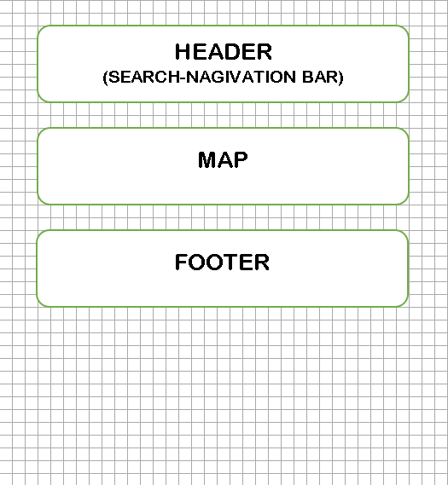

1. **PRODUCTS**

# 

# TASK SHEET REVIEW 2

|  |  |  |  |  |  |  |  |
| --- | --- | --- | --- | --- | --- | --- | --- |
| **Project Ref. No.:**  **eP/Advertisement**  **Portal Management System/01** | | **Project Title:** | **Activity Plan Prepared By:** | **Date of Preparation of Activity Plan:** | | | |
| **Sr.**  **No.** | **Task** | **Actual Start Date** | **Actual Days** | **Team Mate Names** | **Status** |
| 1 | Site map | OralHealth | Hung | 17-Mar-21 | 1 | Hung | Completed |
| 2 | Mock of the website | 17-Mar-21 | 2 | Nghia | Completed |
| 3 | Task sheet | 17-Mar-21 | 2 | Anh | Completed |

|  |  |
| --- | --- |
| **Date: 22/3/2021** | |
| Signature of Instructor:  **Mr. Nguyen Phat Tai** | Signature of Team Leader:  **Mr. Duong Ngoc Duy Hung** |

# 

# WEBSITE DESCRIPTION

1. **Home Page**

* Description

Home page displays following information:

* Feature promotion product.
* Patient Education
* Professional Education.
* Screenshot

[images]

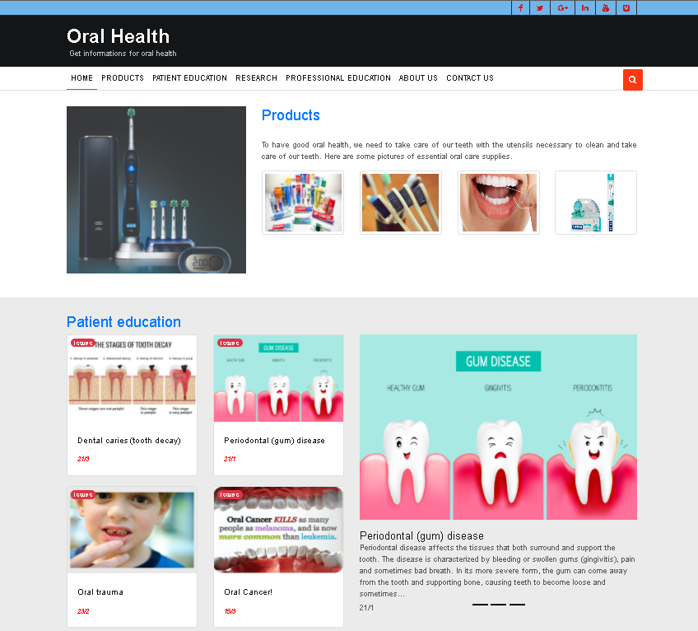 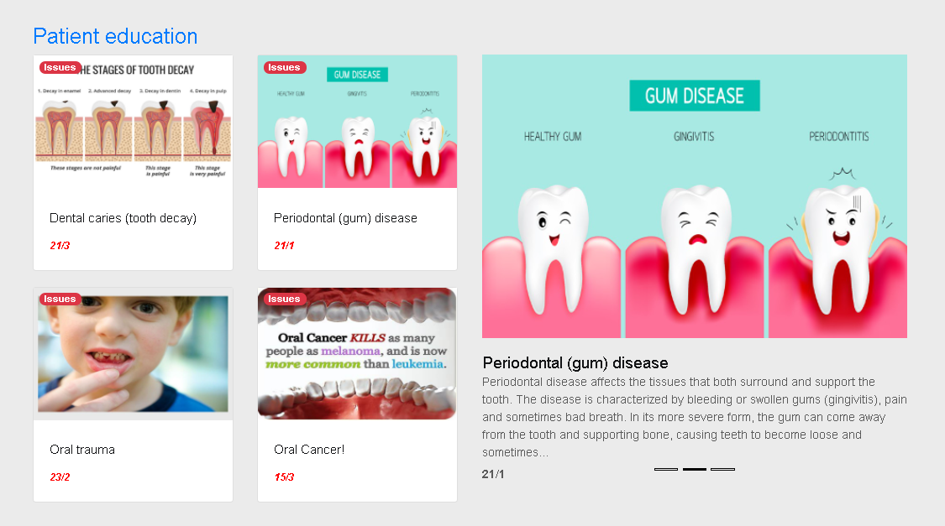

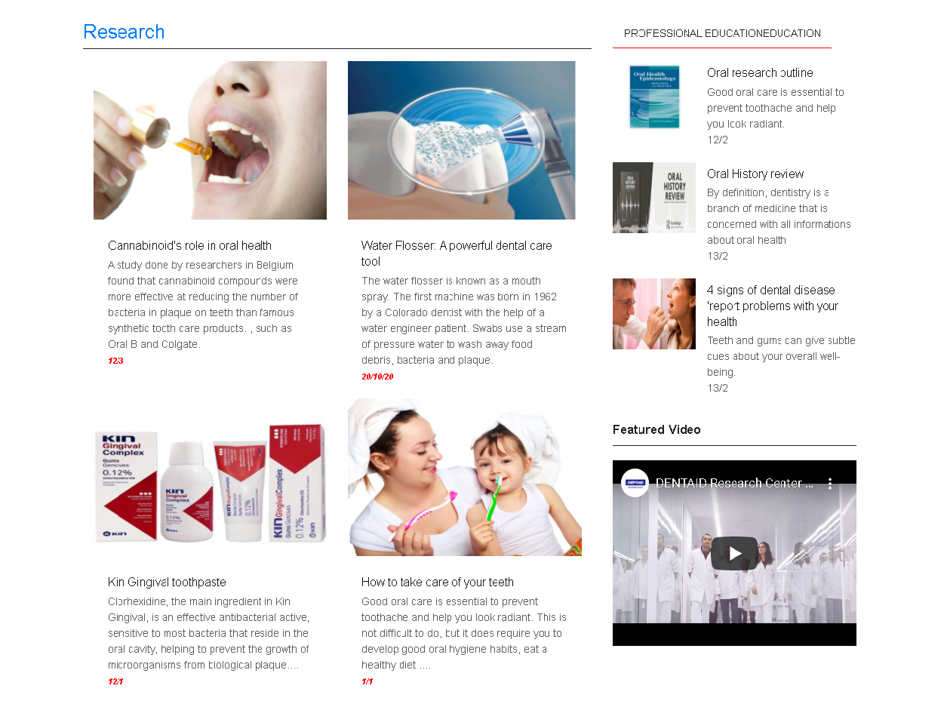



1. **About us**

* Description

This page displays information about our team member.

* Screen shot

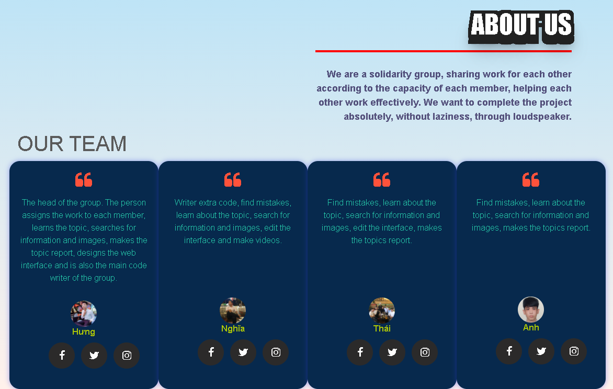

Code:

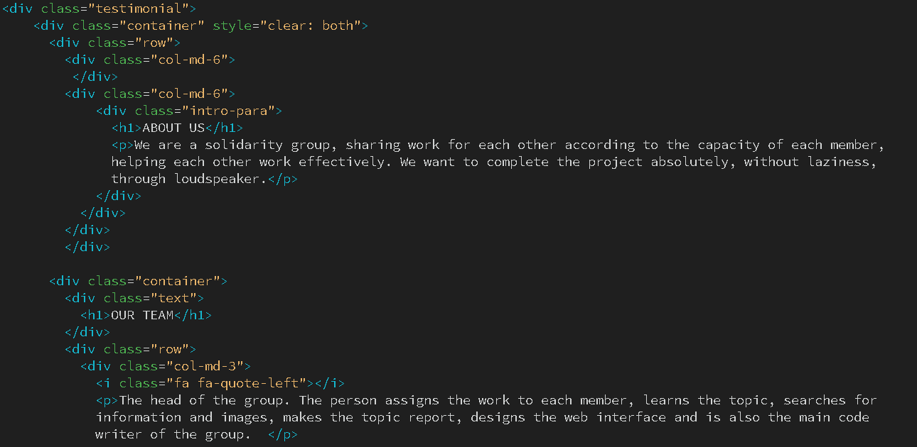

1. **Contact us:**

* Description

This page displays contact information: location, telephone number, email and a quick contact form for customer.

* Screen shot

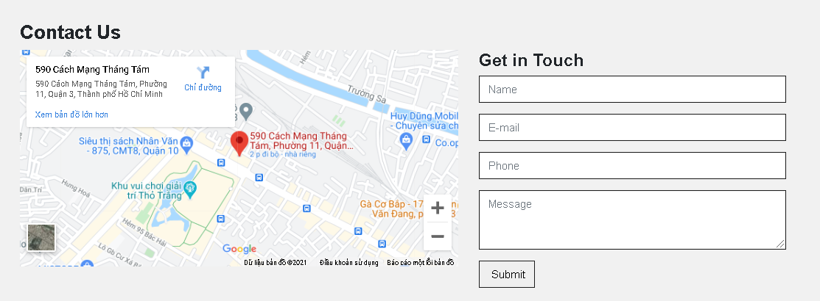

Code

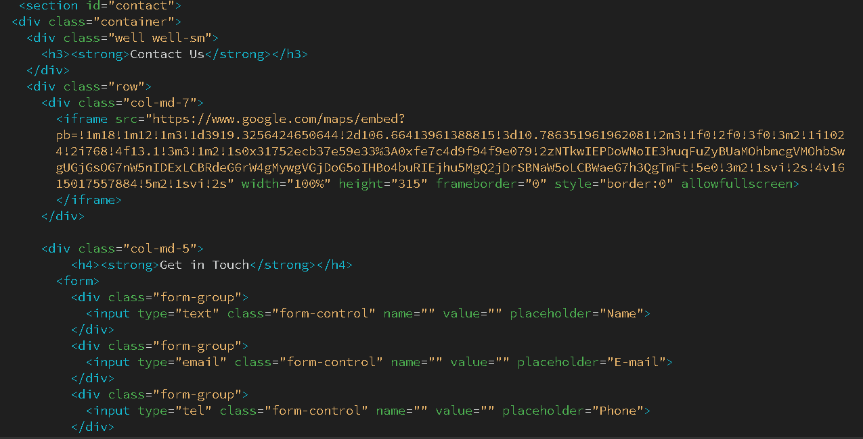

# HTML, CSS, JAVASCRIPT DESCRIPTION

This html to create the header for the:

> home page

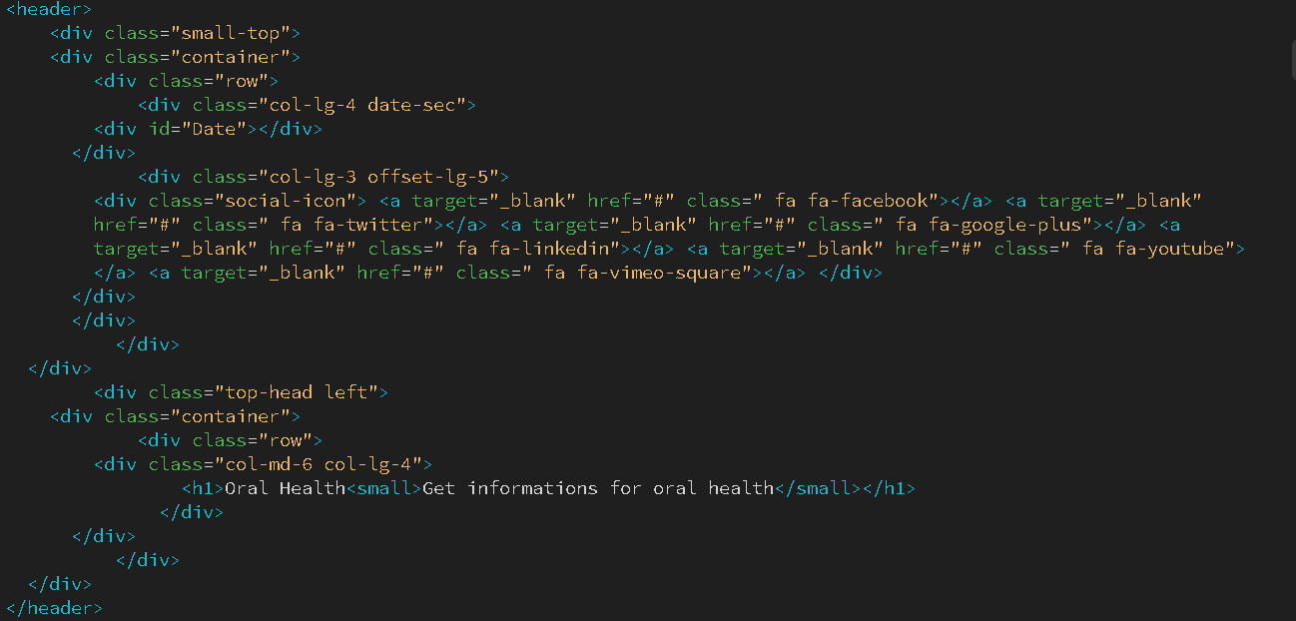

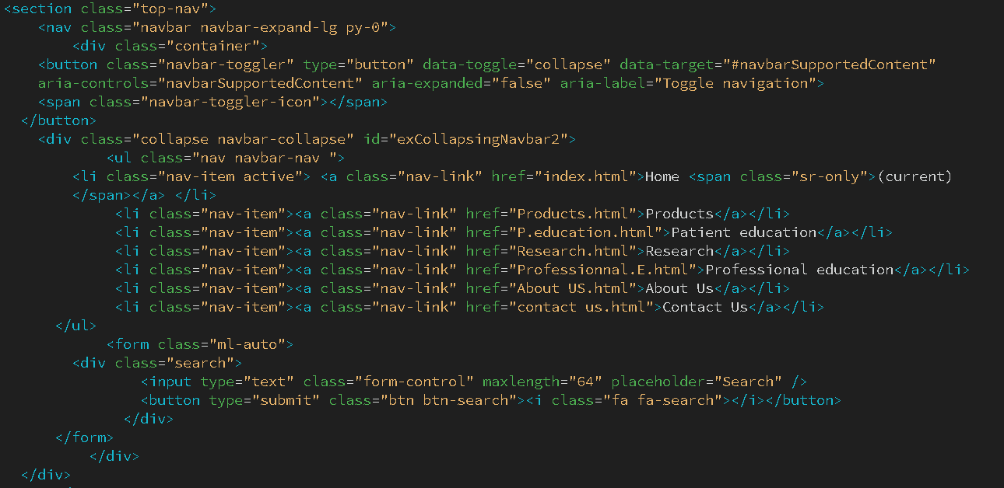

> Patient education

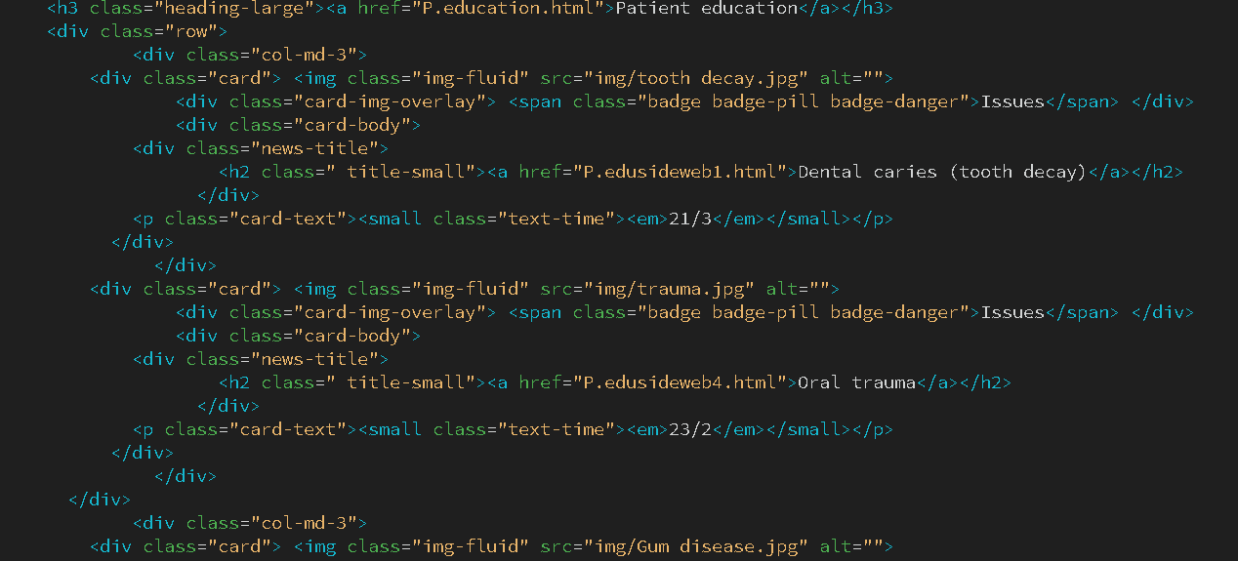

> Research & Professional education

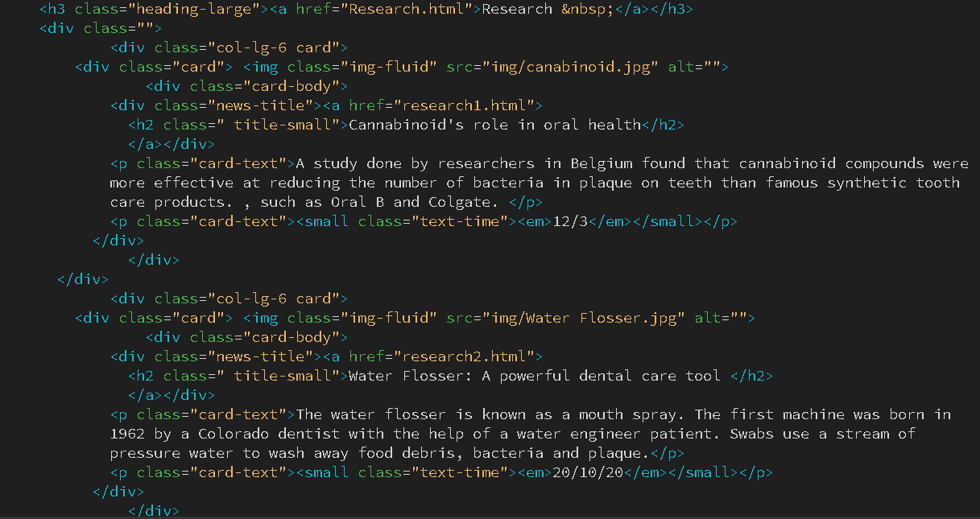

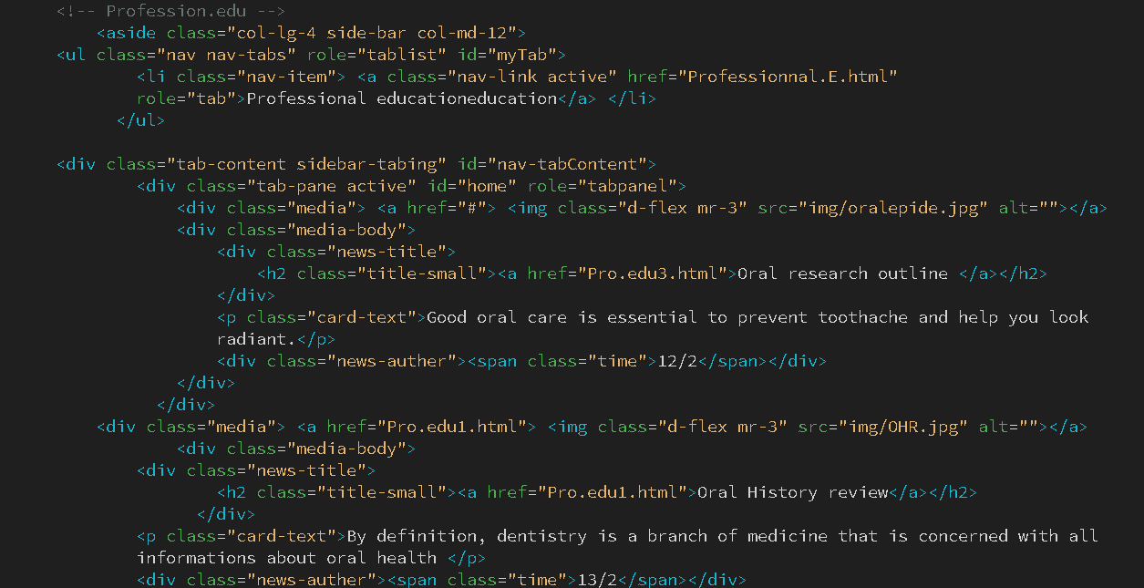

>Footer:

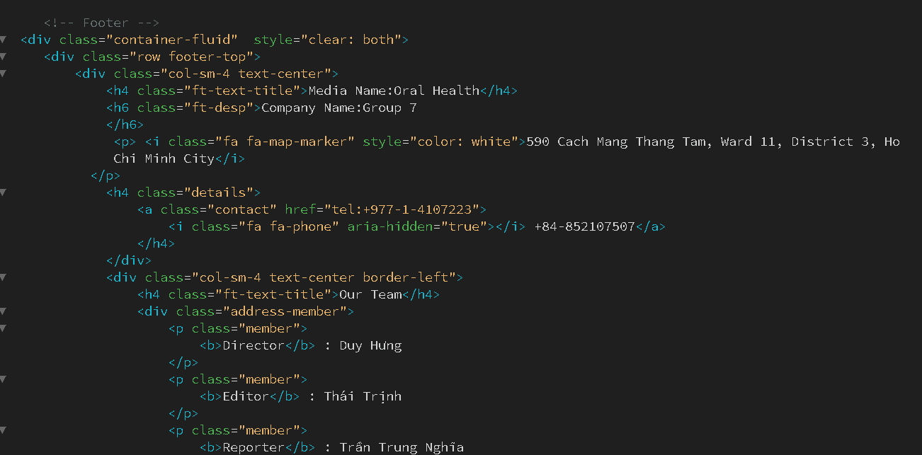

This css to create style:

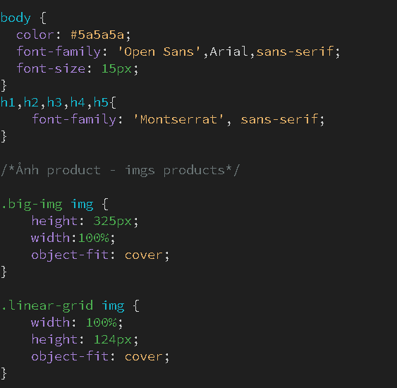

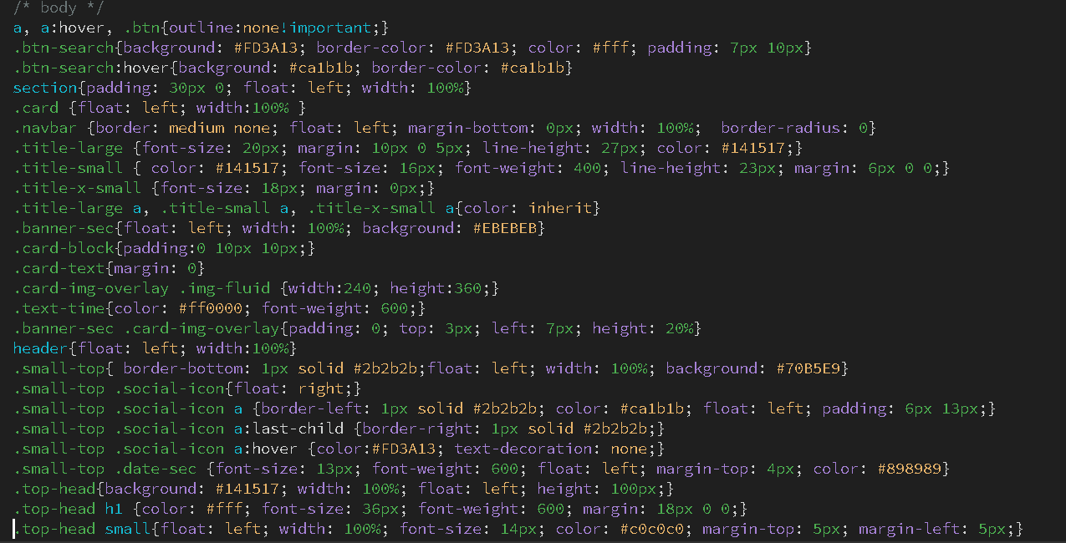

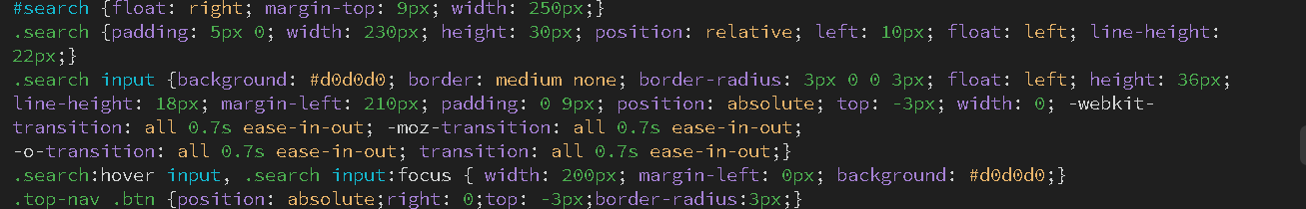

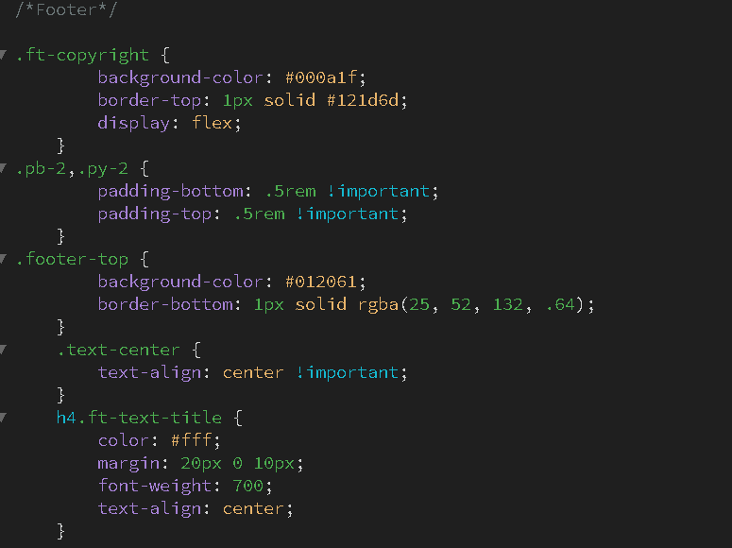

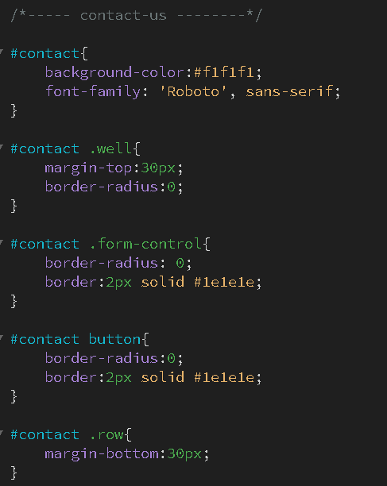

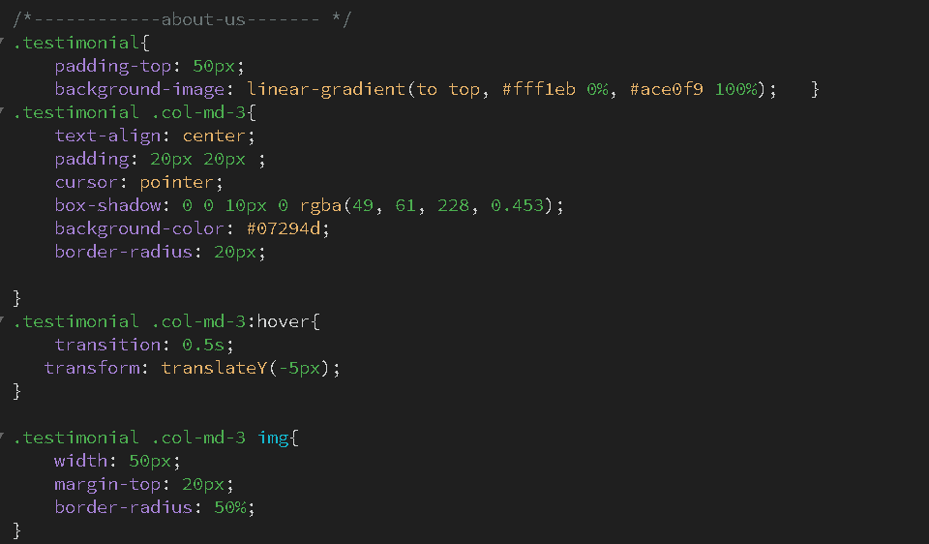

This is Javascript :

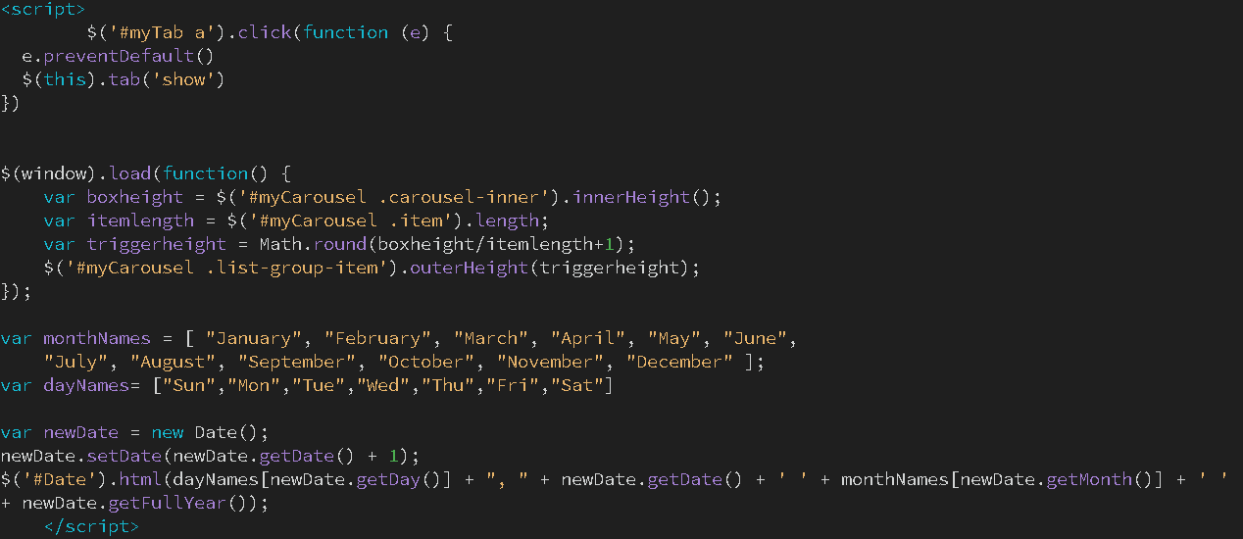

# TASK SHEET REVIEW 3

|  |  |  |  |  |  |  |  |
| --- | --- | --- | --- | --- | --- | --- | --- |
| ***Project Ref. No.:***  ***eP/Advertisement Portal Management System/01*** | | ***Project Title:*** | ***Activity Plan Prepared By:*** | ***Date of Preparation of Activity Plan:*** | | | |
| ***Sr.***  ***No.*** | ***Task*** | ***Actual Start***  ***Date*** | ***Actual Days*** | ***Team Mate***  ***Names*** | ***Status*** |
| *1* | *Home page (navigation bar)* | ***Oral Health*** | ***Hung*** | 13-Mar-21 | *1* | *Hung* | *Completed* |
| *2* | *Contact Us* | 14-Mar-21 | *1* | *Hung* | *Completed* |
| *3* | *About us* | 14-Mar-21 | *1* | *Hung* | *Completed* |
| *4* | *Products* | 15-Mar-21 | *1* | *Nghia* | *Completed* |
| *5* | *Patient Education* | 16-Mar-21 | *1* | *Hung* | *Completed* |
| *6* | *Professional Education* | 17-Mar-21 | *1* | *Hung* | *Completed* |
| *7* | *Research* | 19-Mar-21 | *1* | *Thai* | *Completed* |
| *8* | *Sitemap* | 21-Mar-21 | *1* | *Hung* | *Completed* |
| *9* | *Video* | 24-Mar-21 | *1* | *Nghia* | *Completed* |
| *10* | *Tasksheet* | 24-Mar-21 | *1* | *Anh* | *Completed* |

|  |  |
| --- | --- |
| **Date: 22/3/2021** | |
| Signature of Instructor:  **Mr. Nguyen Phat Tai** | Signature of Team Leader:  **Mr. Duong Ngoc Duy Hung** |