# Welcome

Press <space bar> to move to next slide

Press <shift> <space bar> to move to previous slide

%load_ext autoreload %autoreload 2

%matplotlib inline  
  
#from ipywidgets import interact,Dropdown,Checkbox  
#from IPython.display import display, clear_output,Latex, Markdown  
from IPython.display import clear_output  
import pandas as pd  
from tqdm.auto import tqdm   
  
#from modelinvert import targets_instruments  
from modelclass import model  
model.widescreen()  
model.scroll_off()  
from inject import inject # monkey patch special methods and properties   
  
model.modelflow_auto()

<IPython.core.display.HTML object>

<IPython.core.display.HTML object>

<IPython.core.display.HTML object>

# The impact of increasing carbon tax

Simulate the model for different levels of a global carbon tax

Wait until all simulations are finished

Then press <space bar> to move on

# select if the model is simulated for all experiments or the experiments are loaded   
solve_experiments = True   
# If the all experioments are performed, theese variables will be saved.   
keep_var = '*_CO2 *_yer *_hic *_head?? *_LNN *_GCARBR'  
  
# Make experiments   
if solve_experiments:  
 if True or not 'masia' in locals():  
 print('Load model')  
 masia,baseline = model.modelload('Asia_19nov.pcim',run=1,silent=1,progressbar=1,ljit=0,stringjit=False)  
 inject(masia)   
 masia.keep_solutions={}  
 thisdf = baseline.copy()  
 ambnames = [ ambname for country in masia.countries_ASEAN if (ambname := f'{country}_AMB') in masia.allvar.keys()]  
   
 masia(thisdf,keep = f'Business as usual',keep_variables=keep_var,progressbar=0)  
 rate_var = [f'{country}_GCARBR_A' for country in masia.countries_GCARBR_A]  
 experiments = list(range(50,360,50))[:]  
 bars = '{desc}: {percentage:3.0f}%|{bar}|Experiment {n_fmt}/{total_fmt}'  
 with tqdm(total=len(experiments),desc='Simulating different taxrates',bar_format=bars) as pbar:  
 for rate in experiments:  
 thisdf = baseline.copy()  
 thisdf.loc[2022,rate_var] = thisdf.loc[2021,rate_var] + rate  
 thisdf.loc[:,ambnames] = 5   
 masia(thisdf,keep = f'\\${rate}/tonne of $CO^2$',keep_variables=keep_var,progressbar=1)  
 pbar.update()  
 clear_output()  
 masia.modeldump('co2impact.pcim',keep=1)  
else:   
 print('Load model and saved solutions ')  
 masia,baseline = model.modelload('co2impact.pcim',run=0)  
 masia.basedf=baseline   
 masia.lastdf=baseline   
 inject(masia)   
  
print('Finished ')

Finished

# The emissions in the different scenarios

with masia.set_smpl(2010,2050):  
 masia.keep_plot('wld_co2',legend=0)['WLD_CO2']

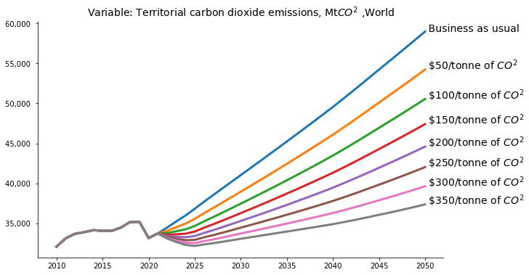

endvalues_ser = pd.Series({rate:df.loc[2050,'WLD_CO2'] for rate,df in masia.keep_solutions.items()})  
endvalues = pd.DataFrame(endvalues_ser,columns = ['Global $CO^2$ emission']  
 ).rename(index={'Business as usual': 'Business as u.'}).pipe(lambda df:df.rename(index={i:i.replace('of $CO^2$','') for i in df.index}))

# What happens to the global emissions in 2050

endvalues.plot(xlabel = 'Taxrate increased from 2021',ylabel = 'Mt',title='Emission vs carbon taxrate',figsize=(12,9));

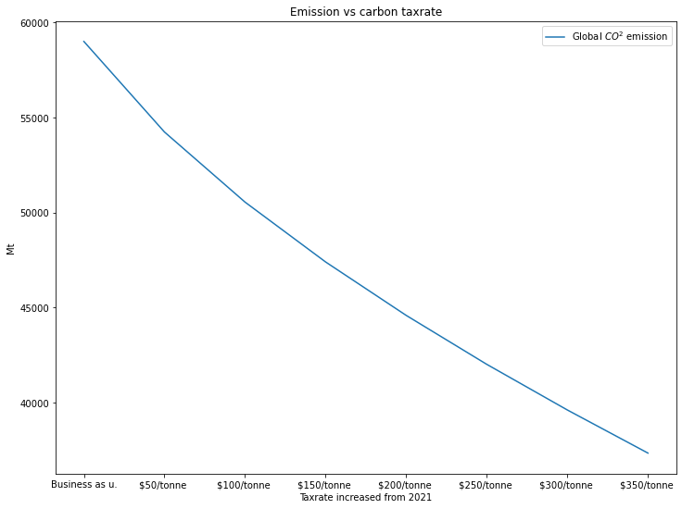

# The marginal impact of the 50 extra tax in each simulation

endvalues.diff().plot(xlabel = 'Taxrate',ylabel = 'Mt',title='Impact of a taxhike of 50',figsize=(12,9));

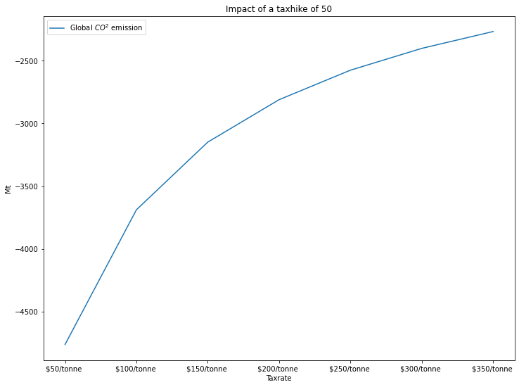

# Impact on different variables

ASEAN_dict = {c:masia.iso_dict[c] for c in masia.countries_ASEAN}  
other_dict = {c:d for c,d in masia.iso_dict.items() if c not in masia.countries_ASEAN}  
prefix_dict = {**ASEAN_dict,**{'--':'--'},**other_dict,**{'':'ALL countries'}}  
with masia.set_smpl(2010,2050):  
 masia.keep_viz_prefix(pat='WLD_CO2',use_descriptions=True ,legend=0,prefix_dict= prefix_dict);

{"model_id":"d85e64a0cd50479cbacd7328f6551fc6","version_major":2,"version_minor":0}

{"model_id":"c93f8caf259c46a8926e9bc0f7168f47","version_major":2,"version_minor":0}

# Trace preceding variables.

# Just for the testing

masia.IDN_CO2.tracepre(filter = 1)



masia.smpl(2021,2030)  
masia.modeldash('WLD_CO2',jupyter=1,port=5004)

Still worlking on the layout of this  
Dash app running on http://127.0.0.1:5004/

masia.ind_enab

Exogeneous : IND_ENAB: Average score on enabling factors (index 0.5=5) ,India   
 Values :   
 2021 2022 2023 2024 2025 2026 2027 2028 2029 2030  
Base 2.625 2.625 2.625 2.625 2.625 2.625 2.625 2.625 2.625 2.625  
Last 2.625 2.625 2.625 2.625 2.625 2.625 2.625 2.625 2.625 2.625  
Diff 0.000 0.000 0.000 0.000 0.000 0.000 0.000 0.000 0.000 0.000