An example report file from modelflow

Ib Hansen

2024-05-14

# First a chart

Here we se the growth rates in the different scenarios

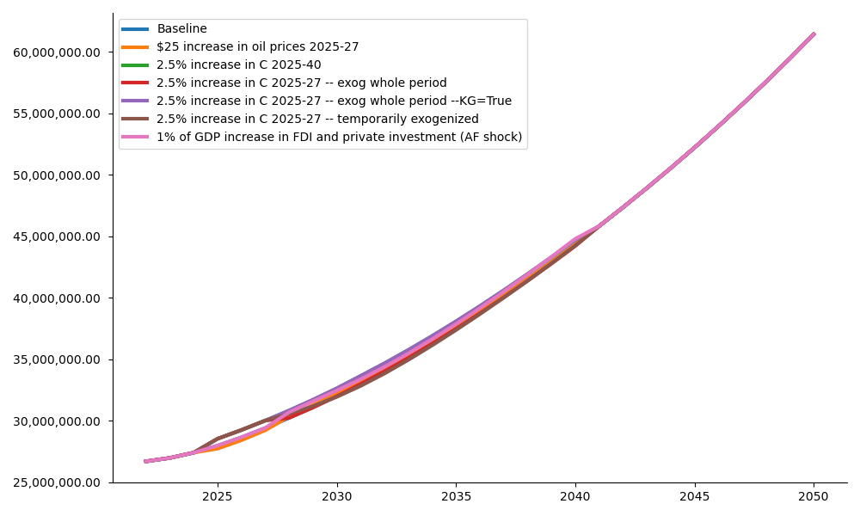

Level: Real GDP

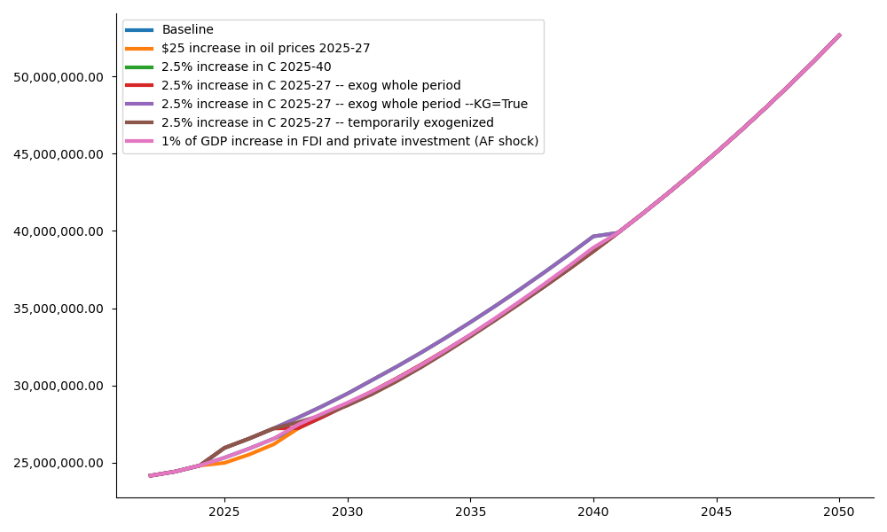

Level: HH. Cons Real

# then a chart

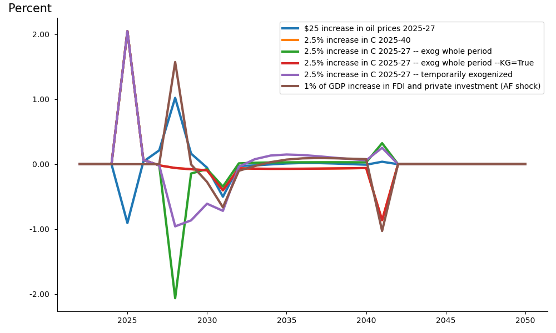

Difference to "Baseline" for Growth: Real GDP

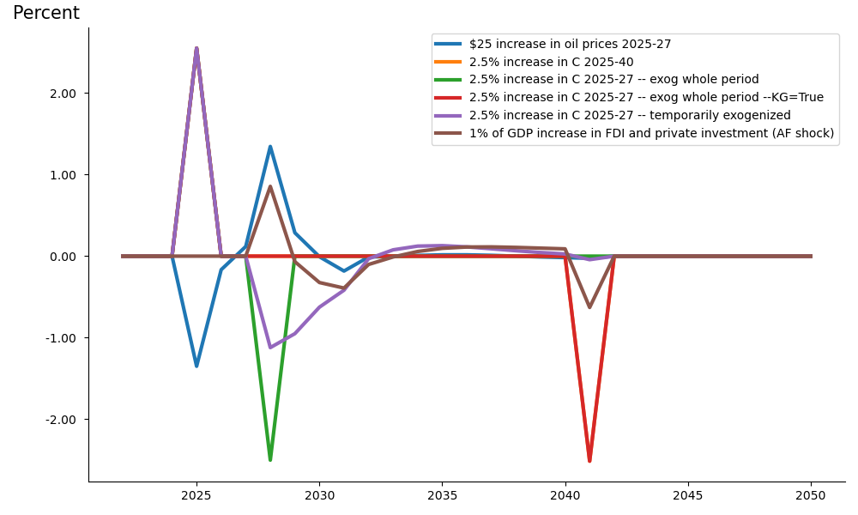

Difference to "Baseline" for Growth: HH. Cons Real

# And a table

Table

|  | 2025 | 2026 | 2027 | 2028 | 2029 |
| --- | --- | --- | --- | --- | --- |
|  | Baseline | | | | |
|  | — Percent growth — | | | | |
| Real GDP | 2.08 | 2.42 | 2.64 | 2.79 | 2.91 |
| HH. Cons Real | 2.03 | 2.32 | 2.48 | 2.59 | 2.69 |
| Investment real | 1.10 | 1.46 | 1.82 | 2.17 | 2.51 |
| Exports real | 4.37 | 4.20 | 4.04 | 3.90 | 3.77 |
| Imports real | 3.10 | 3.10 | 3.02 | 2.89 | 2.78 |
|  | — Percent of GDP — | | | | |
| General Government Revenue, Deficit, LCU mn | -3.05 | -2.98 | -2.95 | -2.92 | -2.91 |
| General government gross debt millions lcu | 57.02 | 57.26 | 57.69 | 58.26 | 58.94 |
| Current Account Balance, US$ mn | -3.55 | -3.46 | -3.40 | -3.37 | -3.36 |
|  | Alternative | | | | |
|  | — Percent growth — | | | | |
| Real GDP | 2.08 | 2.42 | 2.64 | 4.36 | 2.91 |
| HH. Cons Real | 2.03 | 2.32 | 2.48 | 3.45 | 2.62 |
| Investment real | 1.10 | 1.46 | 1.82 | 12.46 | 2.98 |
| Exports real | 4.37 | 4.20 | 4.04 | 3.88 | 3.72 |
| Imports real | 3.10 | 3.10 | 3.02 | 4.68 | 2.84 |
|  | — Percent of GDP — | | | | |
| General Government Revenue, Deficit, LCU mn | -3.05 | -2.98 | -2.95 | -2.81 | -2.84 |
| General government gross debt millions lcu | 57.02 | 57.26 | 57.69 | 57.11 | 57.55 |
| Current Account Balance, US$ mn | -3.55 | -3.46 | -3.40 | -3.48 | -3.43 |
|  | Impact | | | | |
|  | — Impact, Percent growth — | | | | |
| Real GDP | 0.00 | 0.00 | 0.00 | 1.57 | -0.00 |
| HH. Cons Real | 0.00 | 0.00 | 0.00 | 0.86 | -0.07 |
| Investment real | 0.00 | 0.00 | 0.00 | 10.29 | 0.47 |
| Exports real | -0.00 | -0.00 | -0.00 | -0.02 | -0.05 |
| Imports real | 0.00 | 0.00 | 0.00 | 1.79 | 0.06 |
|  | — Impact, Percent of GDP — | | | | |
| General Government Revenue, Deficit, LCU mn | -0.00 | -0.00 | -0.00 | 0.11 | 0.07 |
| General government gross debt millions lcu | -0.00 | -0.00 | -0.00 | -1.15 | -1.39 |
| Current Account Balance, US$ mn | 0.00 | -0.00 | -0.00 | -0.11 | -0.06 |

Source: World bank

|  | Real GDP | HH. Cons Real | Investment real | Exports real | Imports real |
| --- | --- | --- | --- | --- | --- |
|  | — Percent growth — | | | | |
| 2022 | 0.66 | 0.80 | 0.70 | 4.71 | 3.00 |
| 2023 | 1.04 | 1.09 | 0.63 | 4.66 | 2.86 |
| 2024 | 1.60 | 1.60 | 0.79 | 4.53 | 2.99 |
| 2025 | 2.08 | 2.03 | 1.10 | 4.37 | 3.10 |
| 2026 | 2.42 | 2.32 | 1.46 | 4.20 | 3.10 |
| 2027 | 2.64 | 2.48 | 1.82 | 4.04 | 3.02 |