**Problem 1 #Mygroup command doesn’t work**

**9.3 Groups**

This command failed to execute

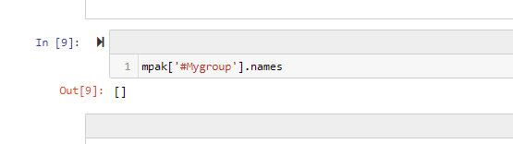

This means the following commands that use #Mygroup also failed..

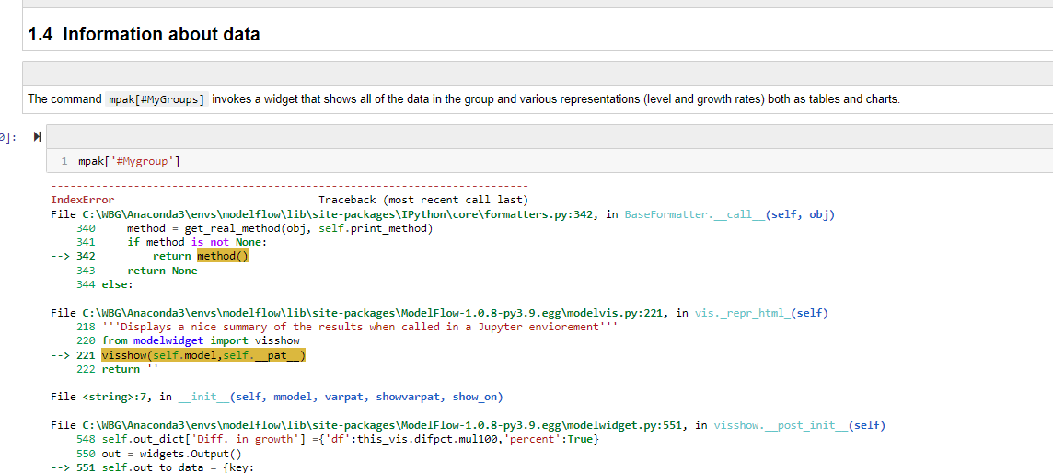

**Problem 2 Eviews command doesn’t work**

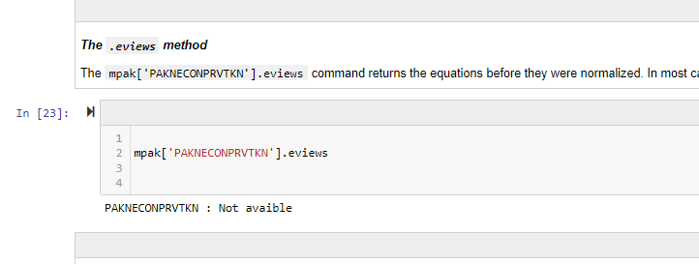

**Problem 3**

**PAK consumption shocks scenarios – the shocks don’t come through properly**

Note that Oil price shocks and investment shocks run fine and produce same results in JN and pdf.

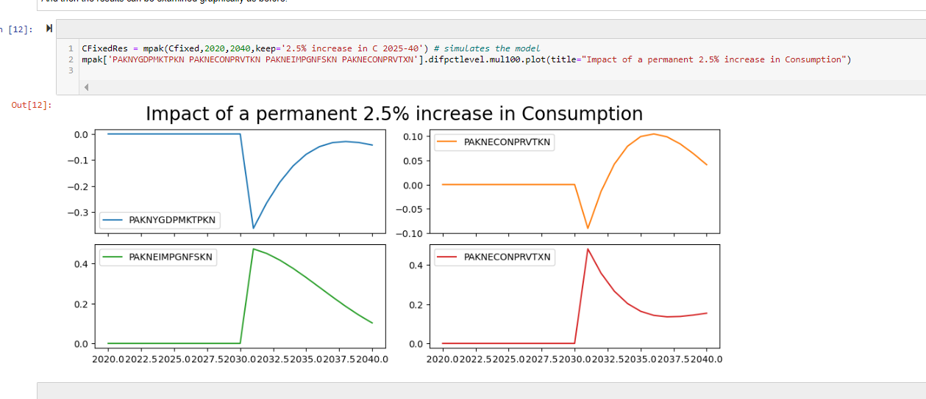

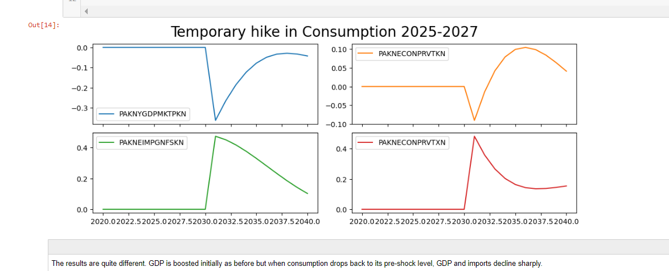

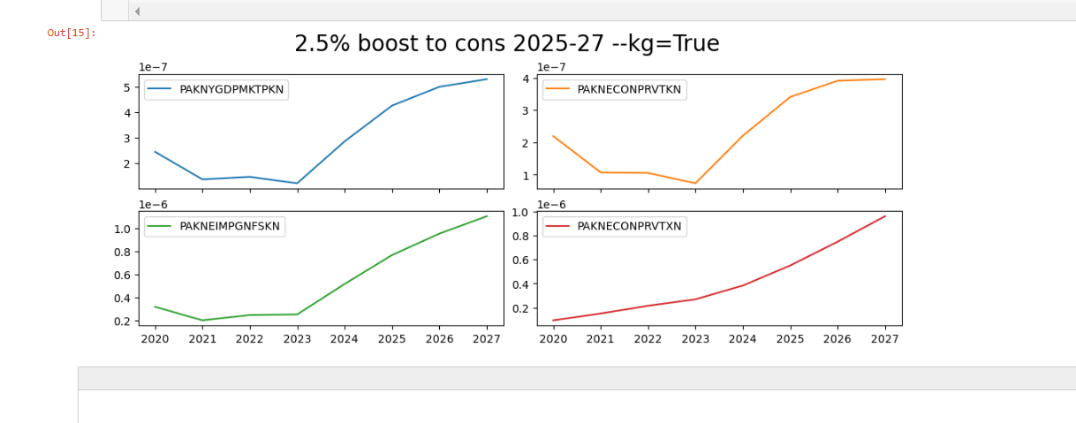 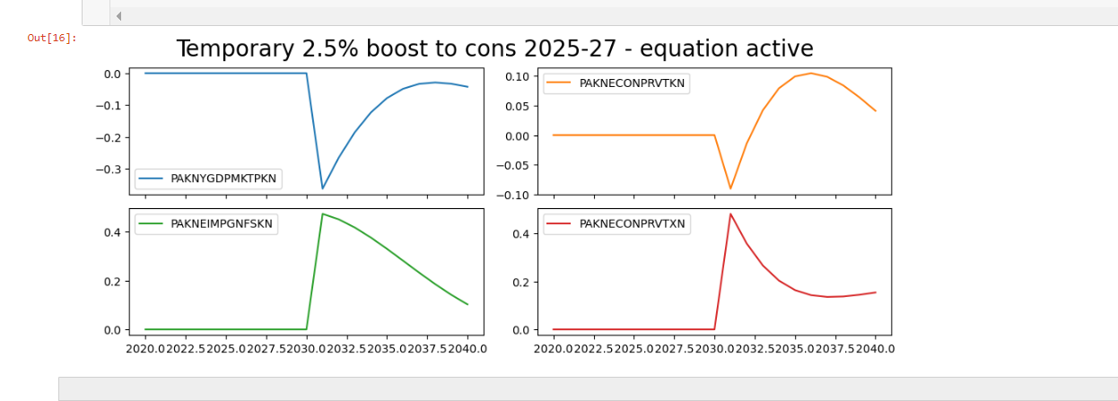

**Problem 4: Eviews command doesn’t work**

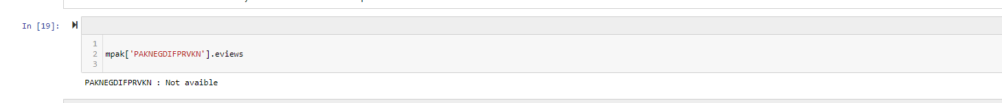

**Problem 5: KEEP_plot examples won’t display chart unless I ran the visualization widget first then go back to run keep_plot charts then they work fine.**

**Problem 6: Can’t run modeldash command in JN (does nothing)**

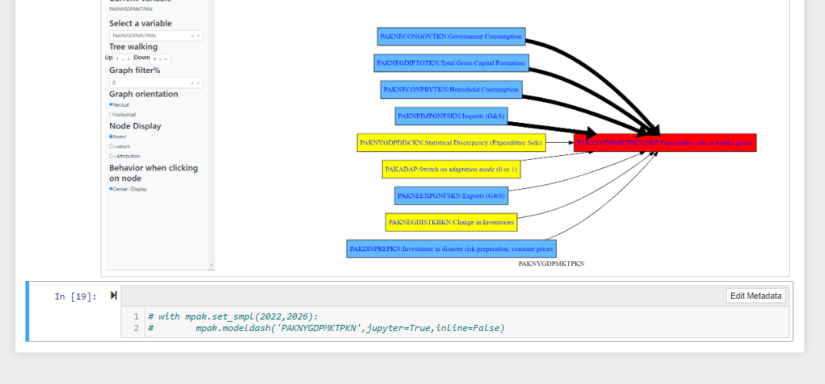

**Problem 7: Dekomp_ loop doesn’t work**

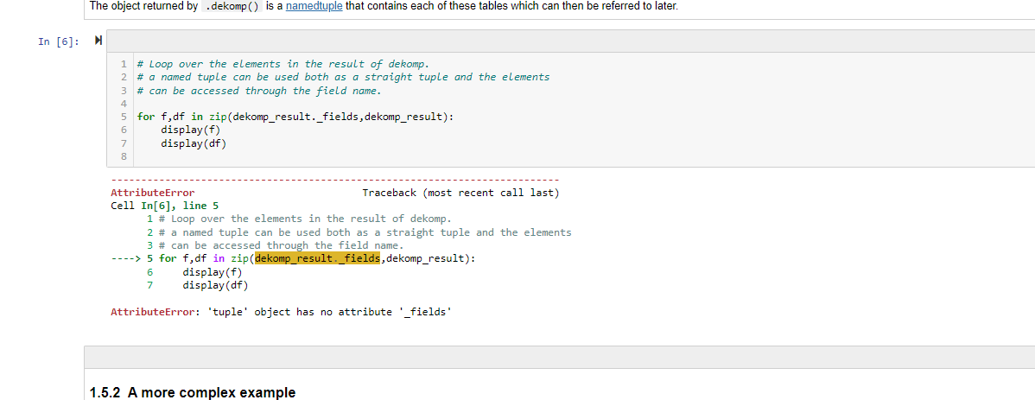

**Problem 8: .eviews doesn’t work**

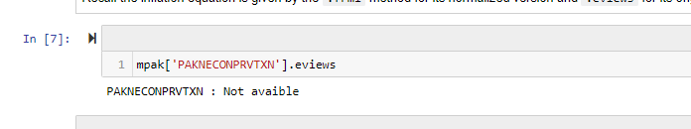

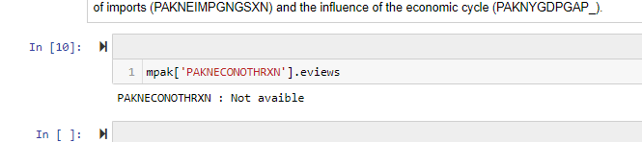

**Problem 9: Get_att**

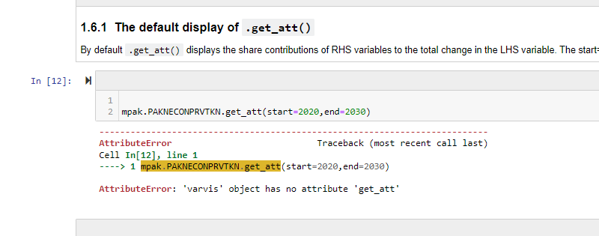

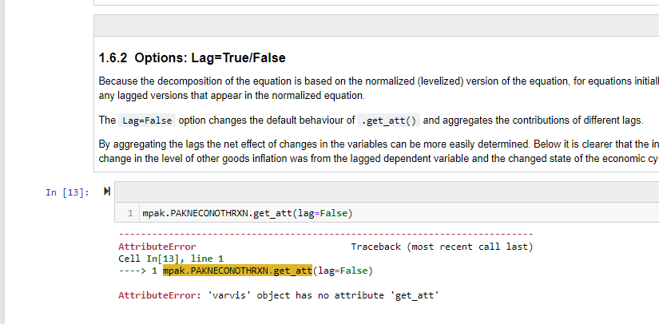

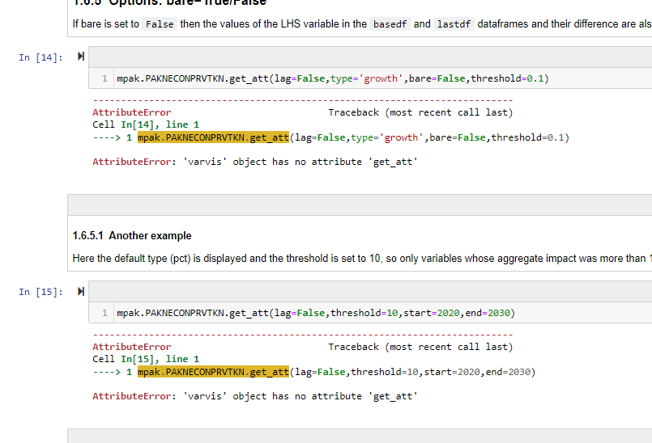

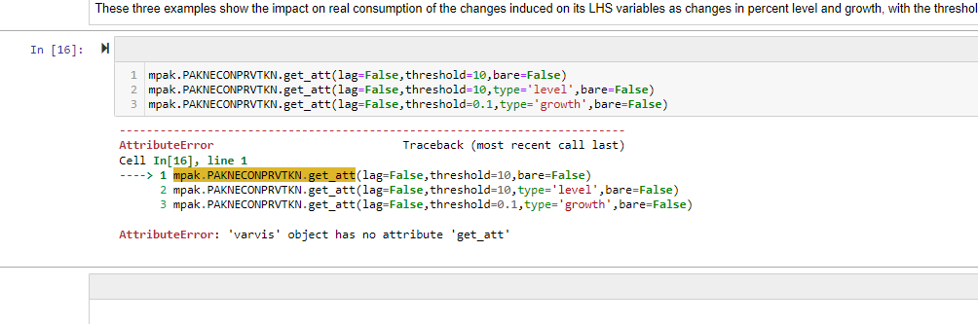

**Problem 9: Tracepre**

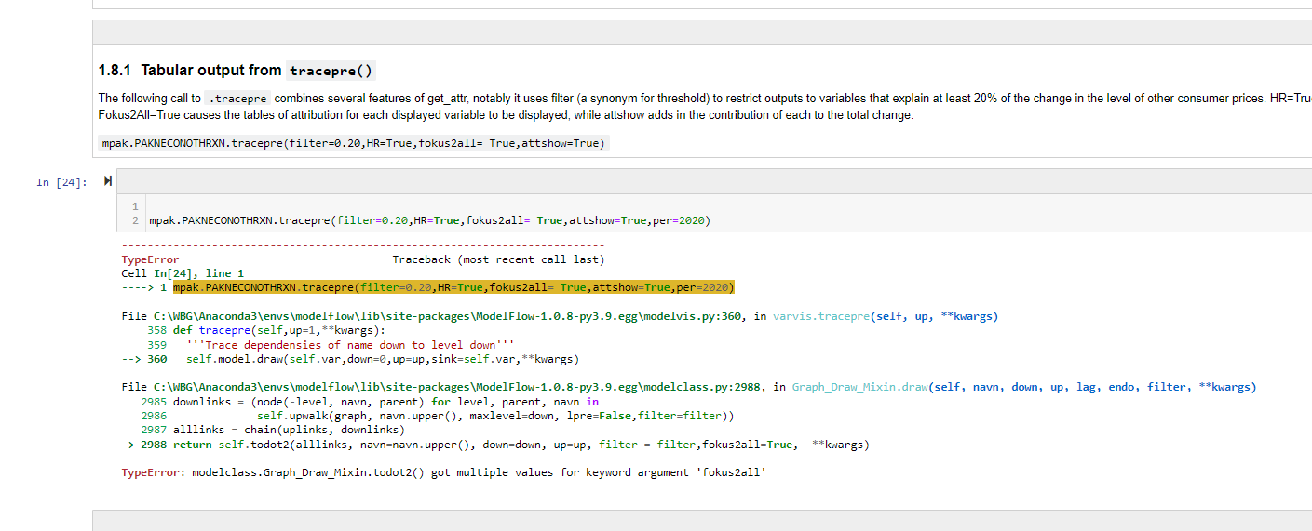

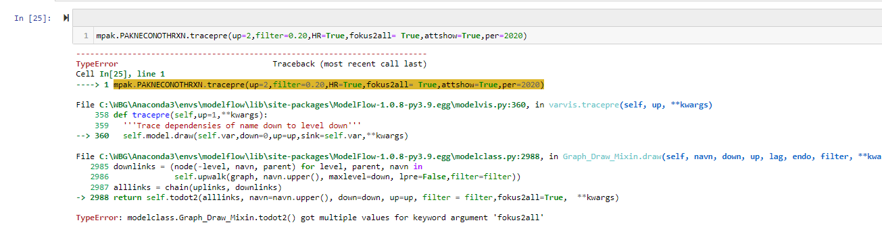

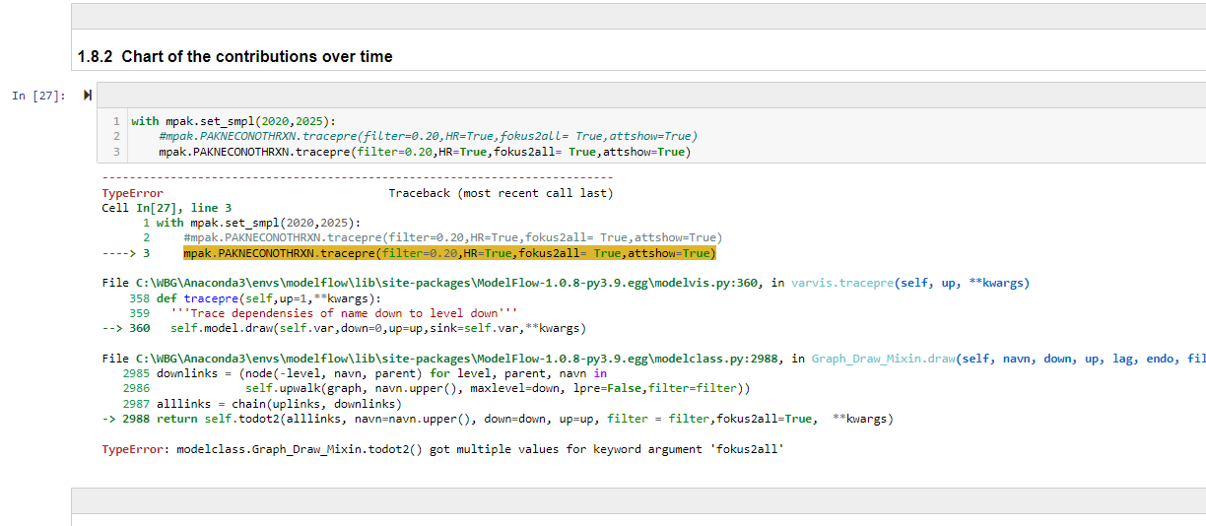

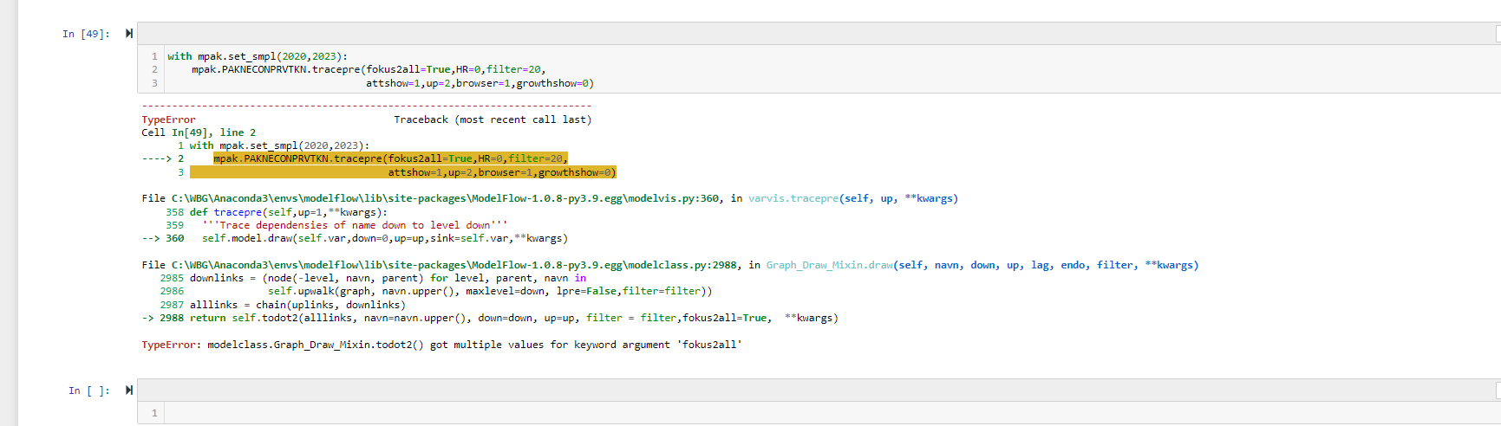

**Problem 10: Sorting waterfall chart**

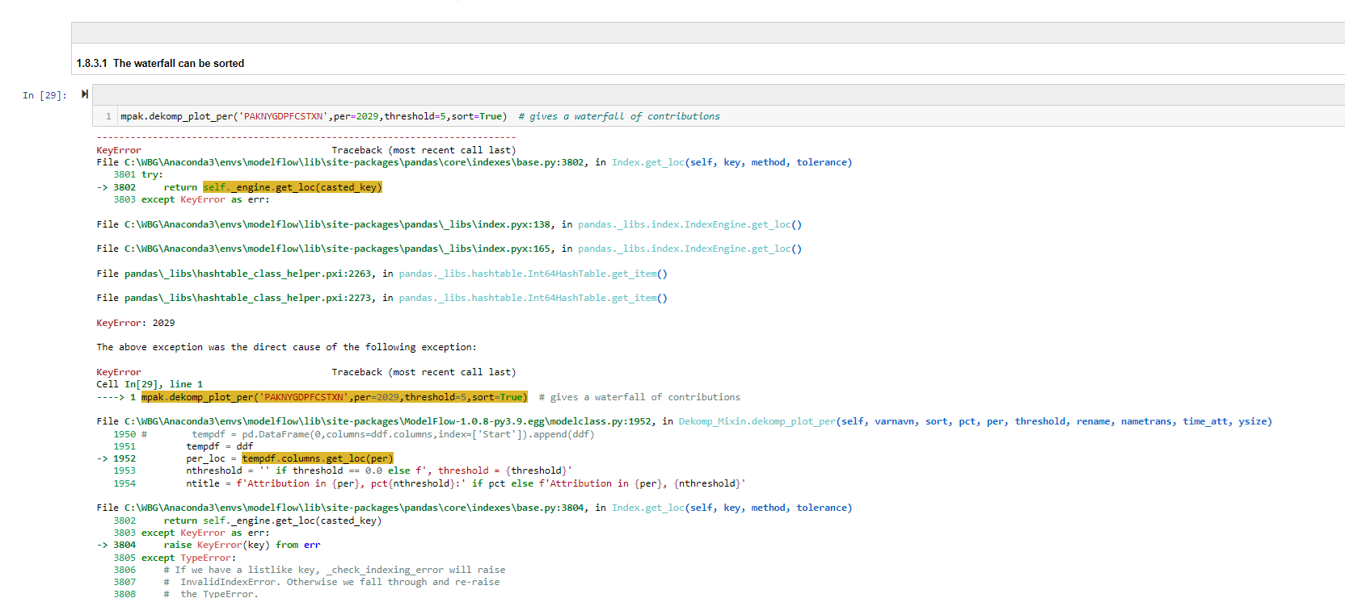

**Problem 11: Attribution of the last year, accumulated**

