**REST API DESIGN**

**User Authentication API’s**

**1.Register a User**

* **Method**: POST
* **Endpoint**: /auth/register
* **Purpose**: Register a new user and issue a JWT token.
* **Payload**:

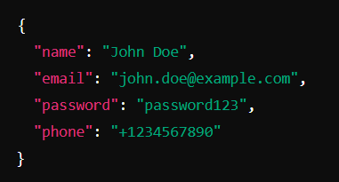

**Response:**

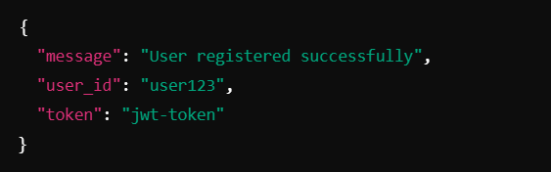

**2.)Login**

* **Method**: POST
* **Endpoint**:/auth/login
* **Purpose**: Authenticate user and issue a token.
* **Payload**:

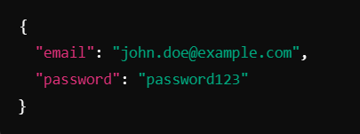

Response:

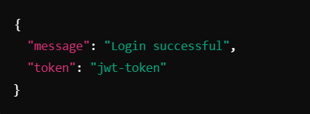

3.) **Forgot Password**

* **Method:** POST
* **Endpoint:**/auth/forgot-password
* **Purpose:** Send a password reset link or OTP to the user's email.
* **Payload:**

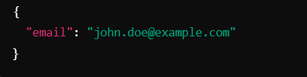

**Response:**

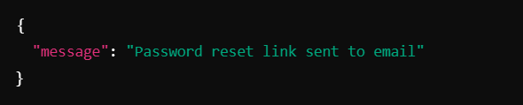

**4.) Reset Password**

* **Method:**POST
* **Endpoint:** /auth/reset-password
* **Purpose:** Allow users to reset their password using a token.
* **Payload:**

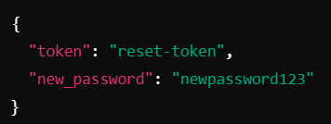

* **Response:**

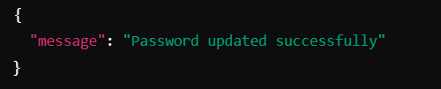

1. **Get User Profile**
   * **Method: GET**
   * **Endpoint:** /users/me
   * **Headers:** Authorization: Bearer <jwt-token>
   * **Purpose**: Retrieve user details.
   * **Response:**
   * 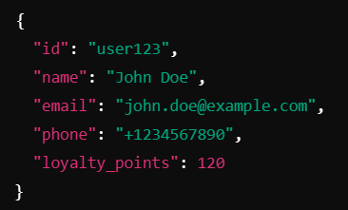

**6. Update User Profile**

* **Method: PUT**
* **Endpoint:**/users/me
* **Purpose**: Allow users to update their personal details.
* **Payload:**
* 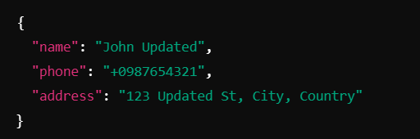
* **Response:**
* 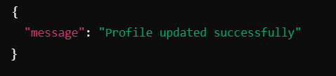

**Product API’s**

* + 1. **Get All Products**
* **Method**: GET
* **Endpoint**: /products
* **Purpose**: Fetch a list of products with optional filters.
* **Query Parameters**:
  + category: Filter by category.
  + sort: price_asc, price_desc, rating.
  + limit: Number of products to return.
* **Response**

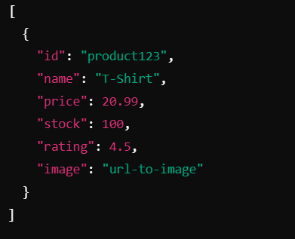

2. **Get Product Details**

* **Method**: GET /products/{id}
* **Purpose**: Fetch detailed information about a specific product.
* **Response:**

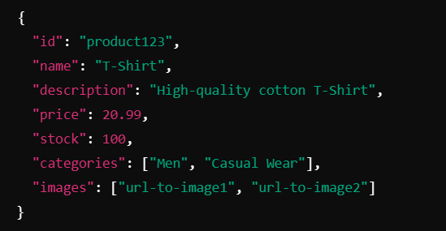

3. **Add Product (Admin Only)**

* **Method**: POST
* **Endpoint**/products
* **Purpose:**Add new products to the store.
* **Payload:**
* 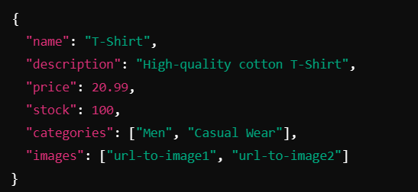
* **Response:**
* 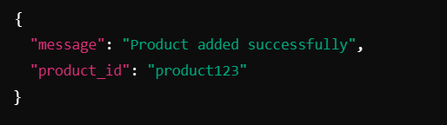

4. **Update Product (Admin Only)**

* **Method**: PUT
* **Endpoint**: /products/{id}
* **Payload**: Similar to Add Product.
* **Purpose** :Update a product.

5. **Delete Product (Admin Only)**

* **Method**: DELETE
* **Purpose**: Remove a product from the store
* **Endpoint**:/products/{id}
* **Response**:
* 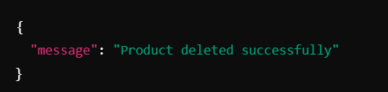

**CART API’s**

**1.Add to Cart**

* **Method:** POST
* **Endpoint:** /cart
* **Purpose:** Adding product to cart
* **Payload:**
* 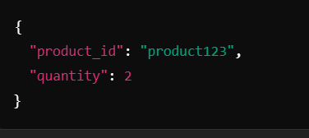
* **Response:**
* 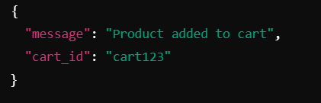

**2. Get Cart Items**

* **Method: GET**
* **Endpoint:**/cart
* **Purpose:** Retrving Cart
* **Response:**

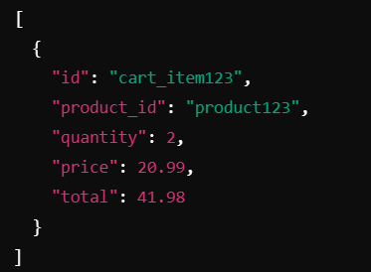

**3. Update Cart Item**

* **Method: PUT**
* **Endpoint:** /cart/{item_id}
* **Purpose:** Update an entry in cart

**4. Remove from Cart**

* **Method: DELETE**
* **Endpoint:** /cart/{item_id}
* **Purpose:** Remove Product from Cart

**ORDER API’s**

**1.Place Order**

* **Method**: POST
* **Endpoint**: /orders
* **Purpose:** Making an order by cart confirmation
* **Payload**
* 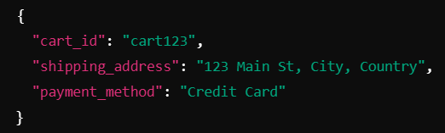
* **Response**
* 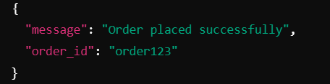

**3.** **Get Order Details**

* **Method: GET**
* **Endpoint:** /orders/{id}

**4. Get All Orders (Admin Only)**

* **Method: GET**
* **Endpoint:**/orders

**5. Update Order Status (Admin Only)**

* **Method: PUT**
* **Endpoint:** /orders/{id}

**PAYMENT API’s**

**Payment APIs**

1. **Initiate Payment**
   * **Method**: POST
   * **Endpoint**: /payments
   * **Purpose**: Confirming Payments
   * **Payload:**
   * 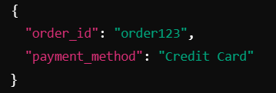
   * Response
   * 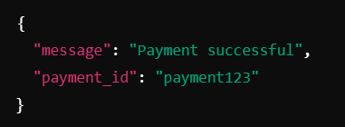

**2.Get Shipping Options**

* **Method**: GET
* **Endpoint**: /shipping/options
* **Purpose** : Retriving all possible payments methods
* **Response:**
* 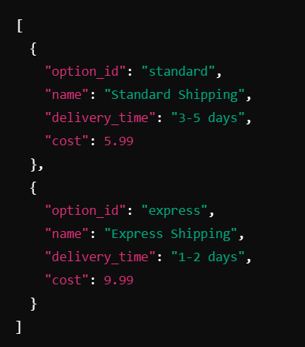

3. **Track Shipment**

* **Method**: GET
* **Endpoint**: /shipping/track/{tracking_id}
* **Purpose**: Provide real-time shipment tracking information.
* **Response**:
* 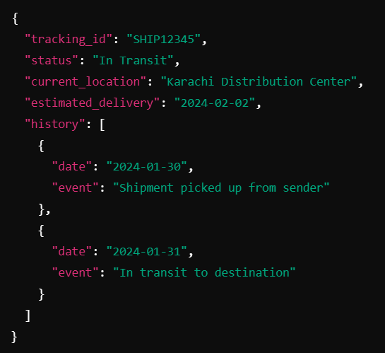

4. **Create Shipping Label**

* **Method**: POST
* **Endpoint**: /shipping/labels
* **Purpose**: Generate a shipping label for the courier.Payload
* **Payload**:
* 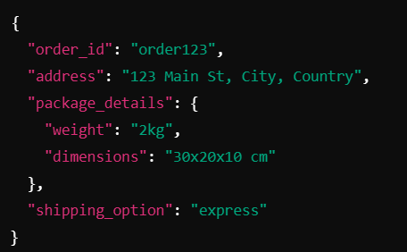
* Response:
* 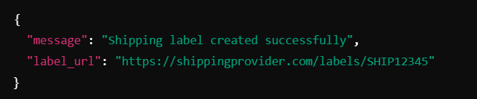

5. **Get Shipping Costs**

* **Method**: POST
* **Endpoint**: /shipping/costs
* **Purpose:** Calculate shipping costs based on package and location
* **Payload**
* 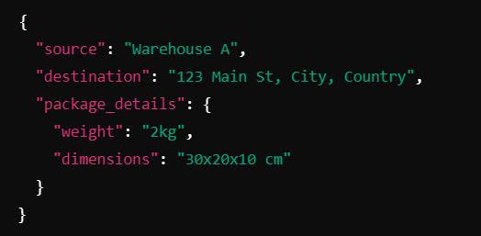
* Response:
* 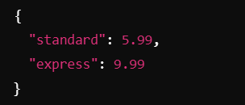

6. **Verify Payment**

* **Method**: GET
* **Endpoint** : /payments/verify/{payment_id}
* **Purpose**: Verify the status of a specific payment.
* **Response:**
* 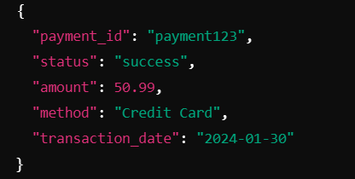

7. **Refund Payment**

* **Method**: POST
* **Endpoint**: /payments/refund
* **Purpose**: Allow refunds for completed payments.
* **Payload:**
* 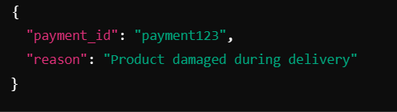
* Response
* 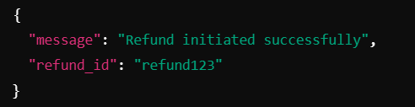

9. **Get Payment Methods**

* **Method**: GET
* **Endpoint**: /payments/methods
* **Purpose**: Retrieve supported payment methods for the platform
* **Response**
* 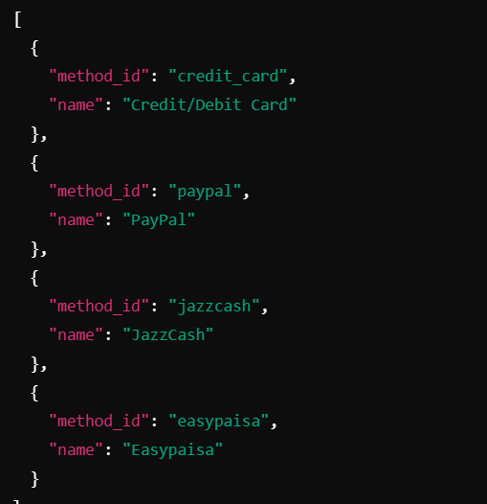

10. **Payment History**

* **Method**: GET
* **Endpoint**: /payments/history/{user_id}
* **Purpose**: Retrieve a user's past payment transactions.
* **Response**:

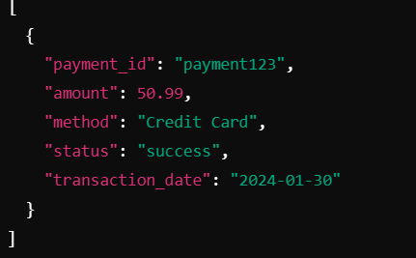

**ORDER TRACKING API’s**

**1. Get Order Status**

* **Method: GET**
* **Endpoint :** /orders/status/{order_id}
* **Purpose:** Retrieve the current status of an order.
* **Response:**
* 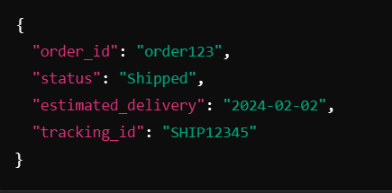

**2. Cancel Order**

* **Method: POST**
* **Endpoint:** /orders/cancel
* **Purpose**: Allow users to cancel an order and initiate a refund
* **Payload**
* 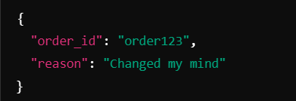
* **Response**
* 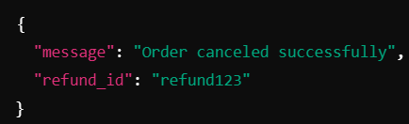

**3. Reorder**

* **Method: POST**
* **Endpoint:**  /orders/reorder
* **Purpose**: Allow users to quickly reorder previous purchases
* **Payload:**
* 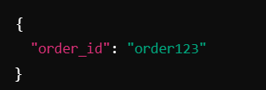
* **Response :**
* 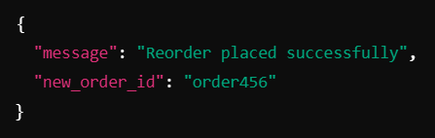

**REVIEWS API’s**

1. **Submit Product Review**

* **Method**: POST
* **Endpoint**: /reviews
* **Purpose**: Allow users to review purchased products.
* **Payload:**
* 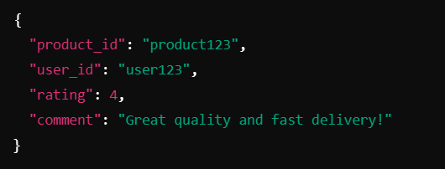
* **Response:**
* 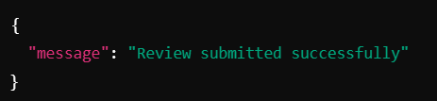

2. **Get Product Reviews**

* **Method**: GET
* **Endpoint**: /reviews/{product_id}
* **Purpose**: Fetch all reviews for a specific product.
* **Response**
* 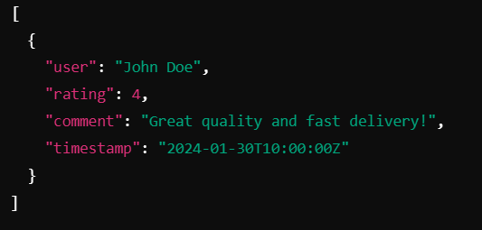

**ANALYTICS API’s**

1. **Order Statistics (Admin Only)**

* **Method**: GET
* **Endpoint**: /analytics/orders
* **Purpose**: Provide insights into order performance.
* **Response**:
* 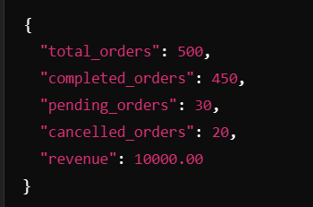

2. **Customer Activity**

* **Method**: GET
* **Endpoint**: /analytics/users
* **Purpose**: Monitor customer activity trends
* **Response:**
* 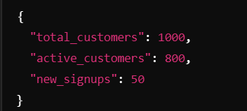

**WISHLIST API’s**

**1. Add to Wishlist**

* **Method: POST**
* **Endpoints:** /wishlist
* **Purpose :** User can add products in their wishlist for checking out later
* **Payload:**
* 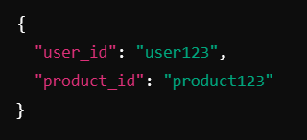
* **Reponse:**
* 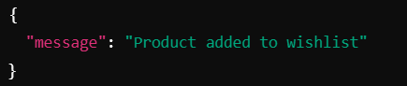

**2. Get Wishlist**

* **Method: GET**
* **Endpoint :** /wishlist/{user_id}
* **Purpose:** User can retrieve their wish listed items
* **Response**
* 