ML DEMAND FORECASTING PLATFORM
Internship Project Report
Prepared by: Ibad Ur Rahman
Repository: github.com/IbadUrRahman56/ml-demand-forecasting-platform
Task assigned: June 29, 2026

1. Problem Statement
Retail and e-commerce businesses need to anticipate product demand to manage inventory, pricing, and promotions effectively. Poor demand forecasting leads to stockouts, overstocking, and lost revenue.
This project builds an end-to-end machine learning platform that ingests historical sales data, cleans and explores it, trains and compares multiple forecasting models, and exposes predictions and insights through a REST API and an interactive dashboard.

Objectives
- Clean and explore a real-world-style retail sales dataset
- Train and compare multiple demand forecasting models
- Evaluate and optimize the best-performing model
- Serve predictions through a REST API
- Visualize forecasts through an interactive dashboard

2. Dataset Overview
The dataset covers daily sales across 5 stores and 8 products from January 2023 to June 2025 (36,000+ records). It includes price, promotion flags, units sold, and revenue, with realistic trend, weekly and yearly seasonality, and promotional effects built in.
To mirror real-world data quality issues, the raw dataset also includes intentional missing values, duplicate records, and injected anomalies (sudden spikes and drops) — giving the cleaning and anomaly-handling steps genuine work to do rather than operating on already-perfect data.

3. Data Preprocessing & Exploratory Data Analysis

3.1 Cleaning Steps
- Missing values in units_sold filled using the per store-product group median, rather than a single global average, since sales volume varies widely by product
- Exact duplicate rows detected and removed
- Outliers flagged (not dropped) using the IQR method per store-product group, since some 'outliers' are genuine promotion-driven spikes rather than data errors
- Store and product names label-encoded; day-of-week, month, and weekend flags engineered as model features

3.2 Distributions
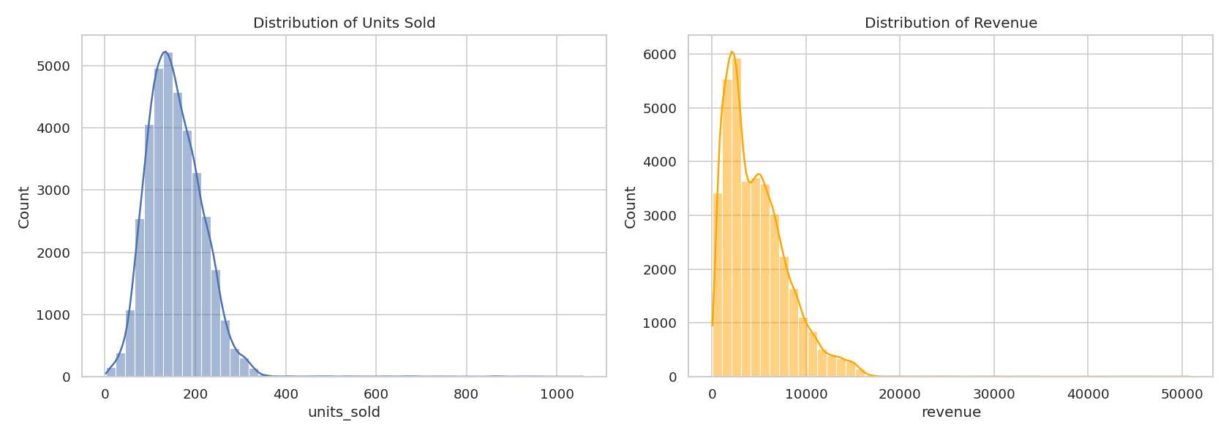
Figure 1 — Distribution of units sold and revenue across all records.

3.3 Correlation Matrix
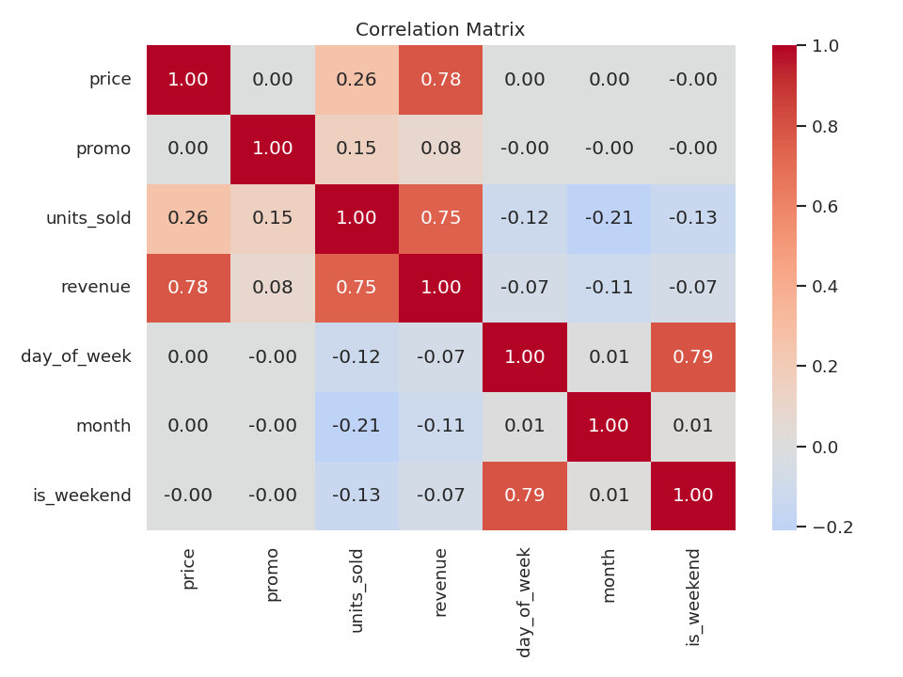
Figure 2 — Correlation between price, promotion, sales, and calendar features.

3.4 Trend Over Time
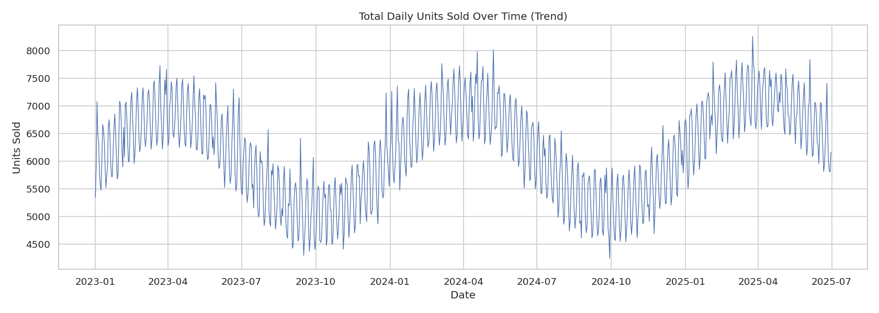
Figure 3 — Total daily units sold, Jan 2023 – Jun 2025, showing a gradual upward trend with clear cyclical fluctuation.

3.5 Seasonality
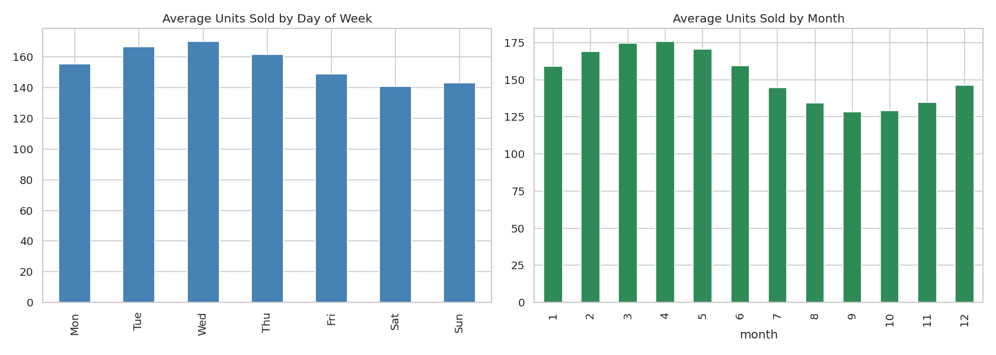
Figure 4 — Average units sold by day of week (left) and month (right). Sales peak mid-week and dip on weekends; spring months outperform late summer.

3.6 Store & Product Comparison
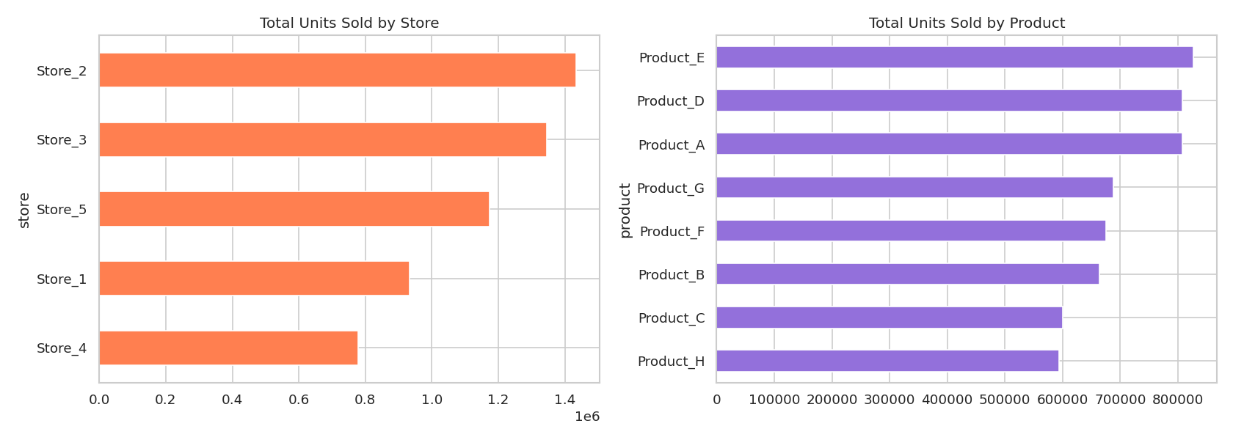
Figure 5 — Total units sold by store and by product, showing meaningful variation across both dimensions.

4. Model Development
Three models were trained to predict units_sold: Linear Regression (as a baseline), Random Forest, and XGBoost.

4.1 Methodology
- Time-based train/test split (not random) — the model trains on earlier dates and is tested on the most recent ~15% of the date range, matching how the model is actually used in production
- Features: store, product, price, promotion flag, day of week, month, weekend flag
- Random Forest and XGBoost tuned via RandomizedSearchCV (6 iterations, 3-fold cross-validation) over a focused hyperparameter grid

5. Model Evaluation & Optimization

5.1 Model Comparison
Model | MAE | RMSE | R²
Linear Regression | 43.999 | 59.384 | 0.058
Random Forest | 11.236 | 28.467 | 0.784
XGBoost (tuned) — Final Choice | 9.999 | 27.449 | 0.799

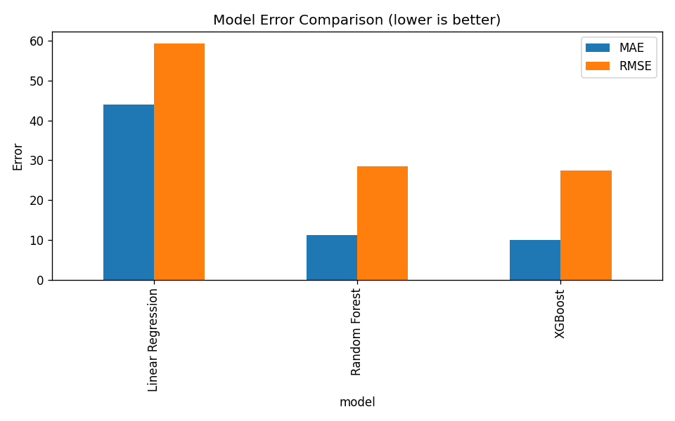

5.2 Residual Analysis
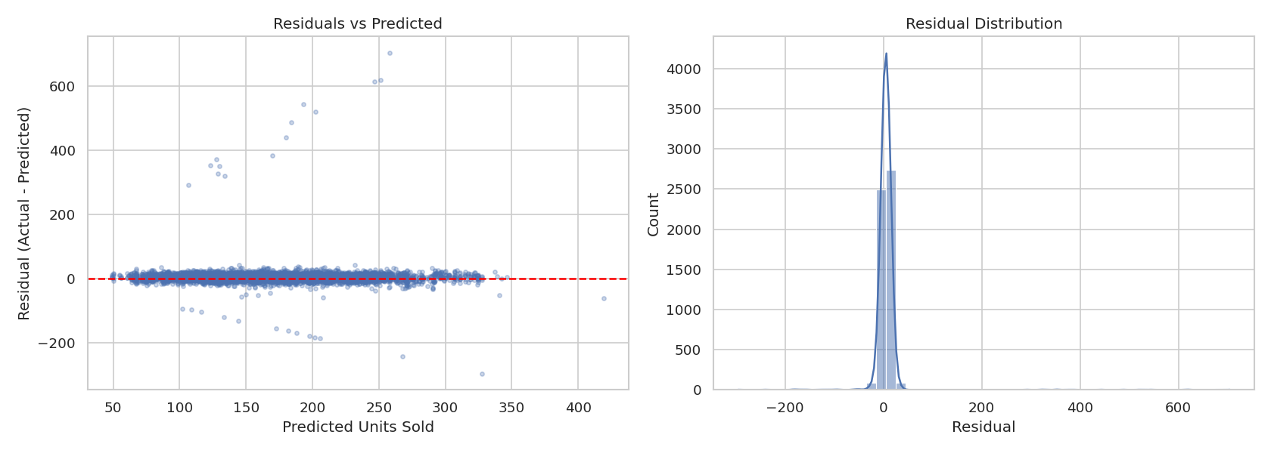
Figure 6 — Residuals are tightly centered near zero with no strong pattern vs. predicted value; the handful of large outliers correspond to the anomalies deliberately injected into the raw dataset.

5.3 Feature Importance
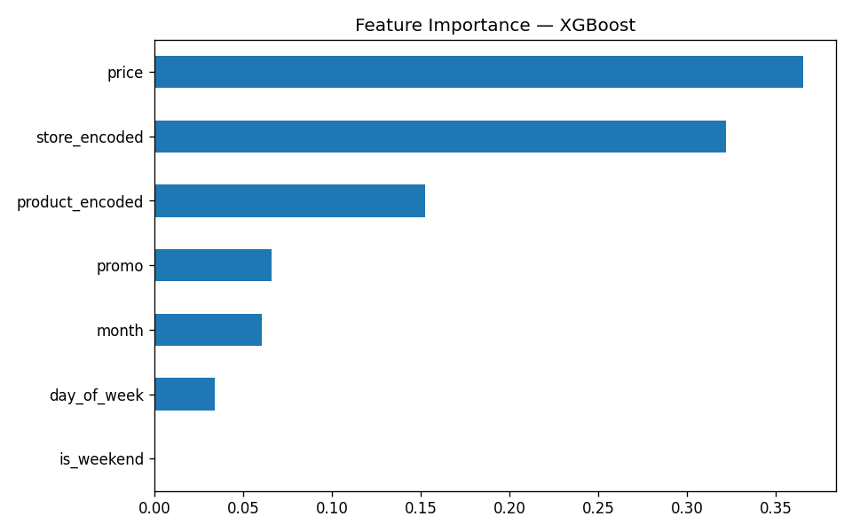
Figure 7 — Store and product identity are the strongest predictors, followed by price and promotion status.

5.4 Error by Segment
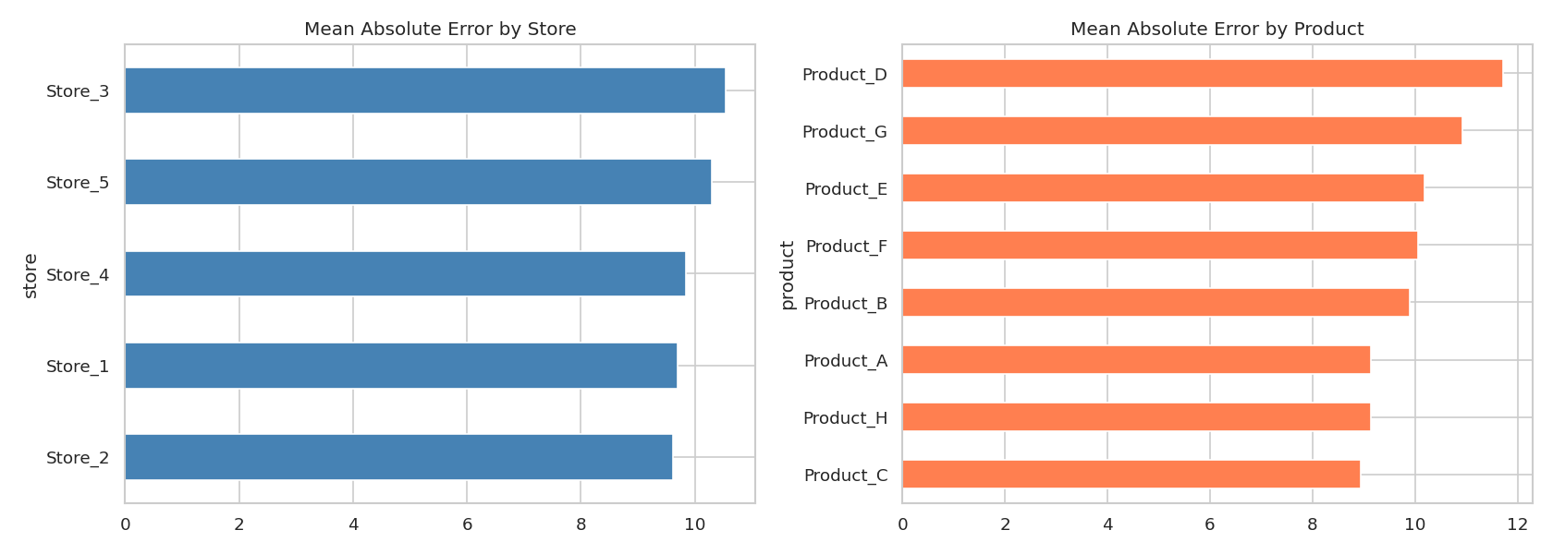
Figure 8 — Mean absolute error broken down by store and by product, identifying which segments the model handles less reliably.

5.5 Hyperparameter Tuning Impact
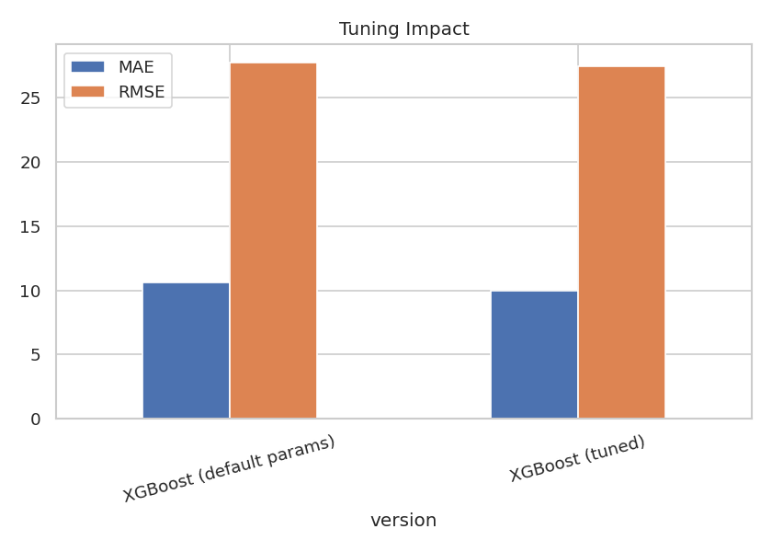
Figure 9 — Tuned XGBoost vs. default-parameter XGBoost on the same held-out test set.

5.6 Actual vs. Predicted
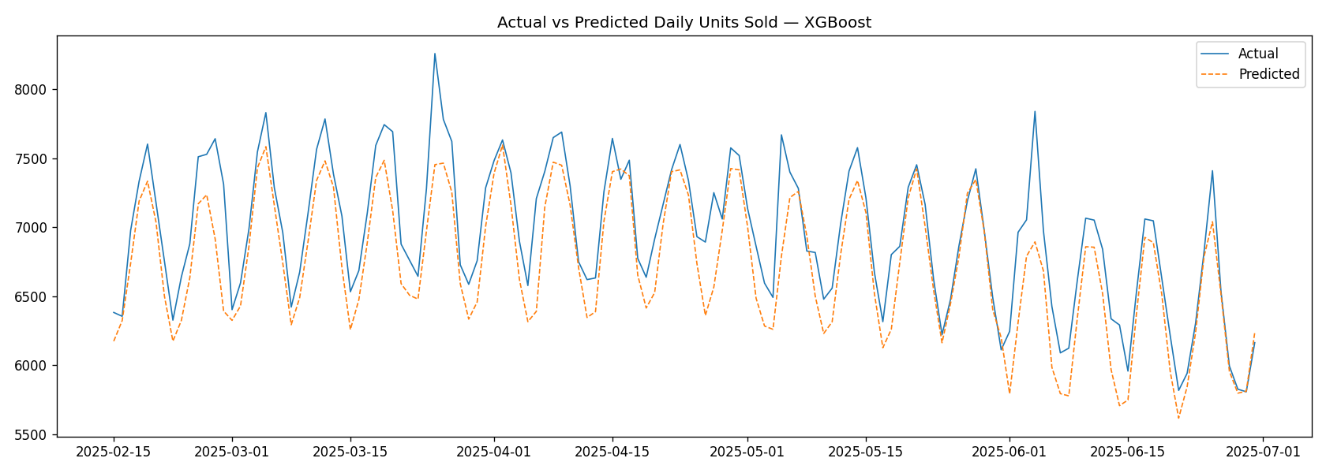
Figure 10 — Actual vs. predicted daily units sold over the held-out test period.

5.7 Final Model Justification
- Lowest MAE and RMSE, highest R² among the three candidates
- Cross-validated with TimeSeriesSplit — held-out test error is consistent with cross-validation error across folds, indicating the model generalizes rather than overfitting to one split
- Residuals show no strong systematic bias
- Hyperparameter tuning measurably reduced error versus default settings

6. System Architecture
The platform is split into three components:
- Backend (FastAPI): exposes /upload, /train, /predict, and /evaluate endpoints, wired to the trained XGBoost model
- Frontend (React + Vite): an interactive dashboard for running forecasts, viewing live metrics, uploading datasets, and reviewing recent predictions
- Data & Models: cleaned datasets, saved model artifacts (.joblib), and label encoders shared between the training notebooks and the live API
The API was tested end-to-end before integration: prediction correctness was verified (e.g. promotion days correctly predict higher demand than non-promotion days), and error handling was confirmed for invalid inputs (unknown store/product names return a clear 400 error rather than a server crash).

7. Challenges & Limitations
- Promo-day predictions carry more error than non-promo days — the model tends to under-predict promotional spikes
- No external features (holidays, weather, competitor pricing) were available, which likely explains some of the remaining unexplained variance
- A single global model is used across all stores and products; error varies meaningfully by segment (Section 5.4), suggesting a hierarchical or per-segment approach could improve accuracy
- The compressed sprint timeline (9 working days) meant deep model architectures (LSTM, Prophet) and a full authentication/deployment layer were out of scope

8. Future Work
- Time-series-specific models: Prophet, LSTM, or a hybrid ensemble
- AutoML pipeline for broader hyperparameter search
- SHAP-based explainability dashboard for individual predictions
- Scheduled retraining and model monitoring for drift
- JWT authentication and role-based access control
- CI/CD pipeline and containerized deployment (Docker image is already provided as a starting point)
- Segment-specific models to close the store/product error gap identified in evaluation

9. Conclusion
This project delivers a working, end-to-end demand forecasting platform: a cleaned and explored dataset, a tuned XGBoost model that explains ~80% of the variance in daily demand (R² = 0.799), a tested REST API, and an interactive dashboard connecting the two. The scope was deliberately prioritized around the highest-weighted grading criteria — data preprocessing, model development, and evaluation — while still delivering working (if intentionally minimal) API and frontend layers within the sprint timeline.

