

***Fuse AutomationRun Book***

**Revision History**

|  |  |  |  |
| --- | --- | --- | --- |
| **DATE** | **REV** | **AUTHOR** | **DESCRIPTION** |
| 06/01/2017 | 0.1 | Mohamed Ibrahim | Initial Draft |

Table of Contents

1 Software Pre-requisites 3

1.1 Network LAN Access for Automation Files/Utilities 3

1.2 Java setup 4

1.3 Eclipse 4

1.4 IE Settings 5

1.5 Bitbucket Configuration 5

1.6 Jenkins 5

2 Script Development 6

2.1 Page class 6

2.2 Process class 9

2.3 Test data setup 10

3.4 Test case configuration 11

3 Test Script and suite execution 12

4.1 From Eclipse 13

4.2 From Maven pom.xml 16

4.3 From Jenkins 18

# 

# Software Pre-requisites

Software required to create and execute Selenium automation requires several packages.

## Network LAN Access for Automation Files/Utilities

Send a mail to [**ServiceDeskSupport@advanceamerica.net**](mailto:ServiceDeskSupport@advanceamerica.net) for getting access to

\\aacss\cssfiles\QA\Automation QFund

And make sure that you are able to accces below mentioned files

\\aacss\cssfiles\QA\Automation QFund\Project on Sandbox\QFX Hybrid FW_PF\QFund_Test Data

\\aacss\cssfiles\QA\Automation QFund\Project on Sandbox\QFX Hybrid FW_PF\QFund_OutputData

\\aacss\cssfiles\QA\Automation QFund\Project on Sandbox\QFX Hybrid FW_PF\QFund_Config

## Java setup

Right click on My computer->Properties->Advanced system settings->Advanced->Environment Variables -> Set system variable – JAVA_HOME and add Java path as below

JAVA_HOME – C:\Program Files)\Java\jre xxx

eg:- C:\Program Files (x86)\Java\jre1.8.0_121

PATH – add C:\Program Files)\Java\jre xxx\bin

eg:- C:\Program Files (x86)\Java\jre1.8.0_121\bin

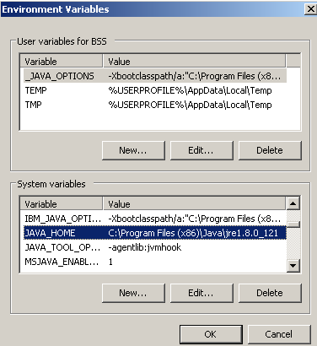

## Eclipse

Eclipse is a development IDE for Java and is used to create Selenium Open source automation components. The IDE is sophisticated platform to improve development activities and debugging.

Please find the Eclipse installer in the below url and choose latest version.

<https://www.eclipse.org/downloads/>

## IE Settings

@Sameer kindly update

## Bitbucket Configuration

Send a mail to [**ServiceDeskSupport@advanceamerica.net**](mailto:ServiceDeskSupport@advanceamerica.net)for getting access tothe bitBucket URL

<https://code.advanceamerica.net/projects>

Make sure that you are able to login into bit bucket using your LAN credantials and able to see following projects

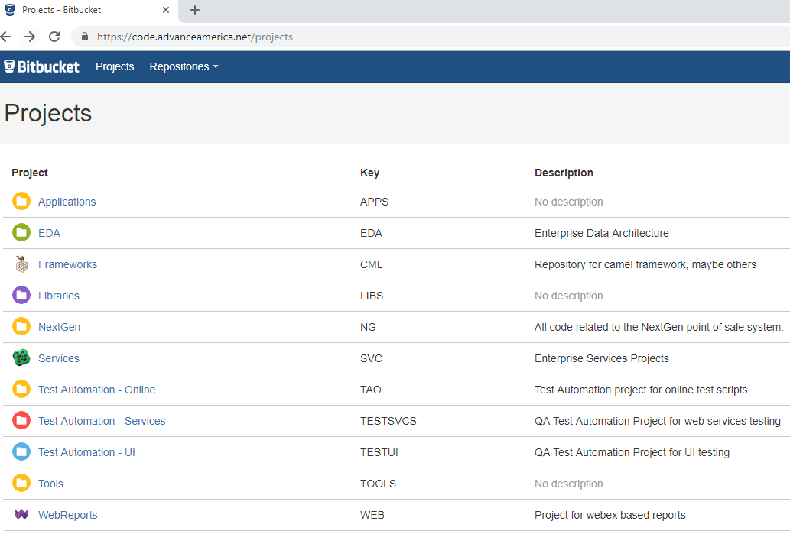

## Jenkins

Send a mail to [ServiceDeskSupport@advanceamerica.net](mailto:ServiceDeskSupport@advanceamerica.net) for getting access to the jenkins URL

<http://cssqc.advanceamerica.net:8000/>

Make sure that you are able to login into jenkins using your LAN credantials and able to see following page

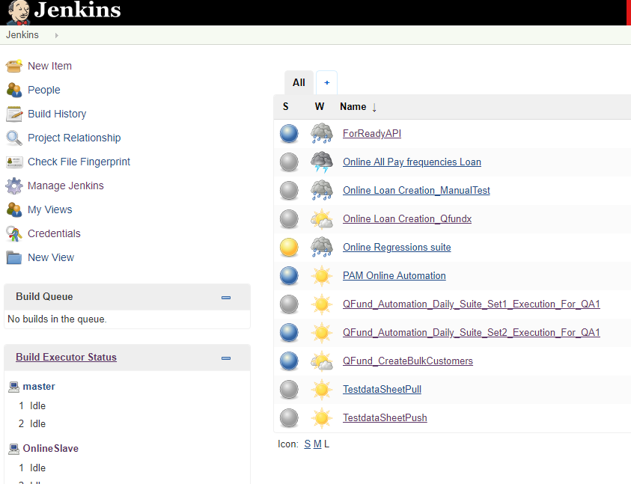

# Script Development

## Page class

**Page classes** can be referred to the concept of **page object model in selenium**.

**page object model** is an object repository design pattern with selenium web driver in test automation for beter test manintaince and reduce code duplication.

Page classes contains all the locators(web elements) of a particular web page. We maintain saperate page class for each web page.

**Example –** Al fields pertaining to Login page of Qfund Application will be mailntained in a page class

Below image shows the page classes of QFUND appalication in page classes.Qfund package.

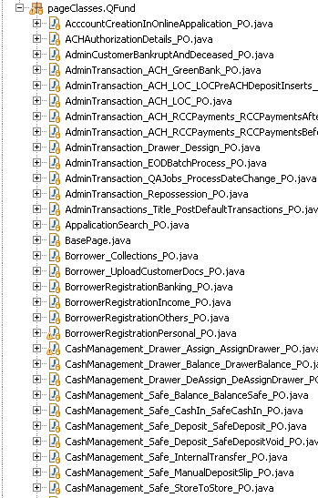

**Elements :**

Each Locator(Web element) is written in a page class in below format.

**Example-** Login page User name locator.



Locators are declared as private in page classes.

All the locators(web elements) are stored in a page class in below format.

**Example:** Qfund login page locators in page class.

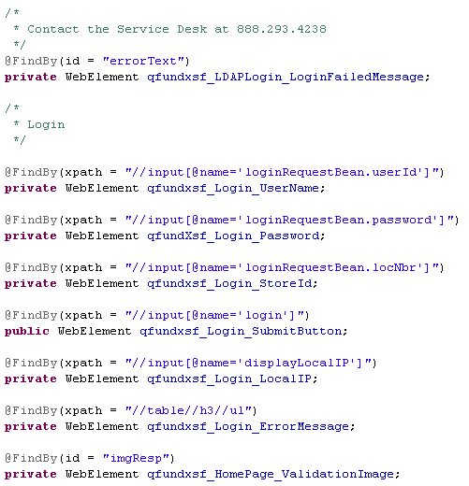

We generate Getter’s and Setters’s for each locator (web element) so that we access these locators (web elements) through these getter and setter method’s.

**Example :** Login page locator getter setter menthod’s.

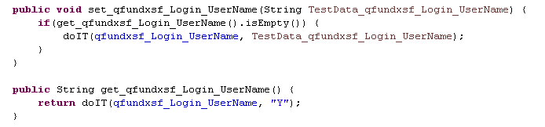

**Constructor:-**

We create a constructor in each page class to initialize all the loactors by using page factory.

**Example:**



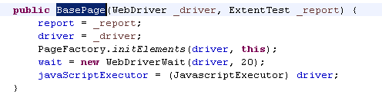

## Process class

Process Classes are maintained in a saperate package.



Process classes contains multiple processes as methods and each method is actual functionality.

Each process class contains a constructor.



We use the getter setter methods in the page class by creating the object to the page class.

**Example:**

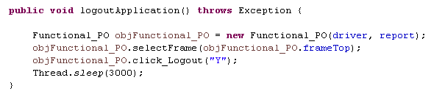

## Test data setup

Test data is maintained in saperate excel workbook.

Each method in process class has saperate sheet and each sheet have multiple rows of data with data name based on the requirement we use required test data.

**Example:**

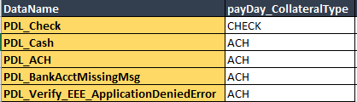

## 3.4 Test case configuration

Test case confiquration is done in saperate excel workbook.

Test case config workbook consists of different sheets.

**Config sheet :**

Config sheet contains all the details required for all the test cases like environment details, Appalication Url’s and login Credintials.

**Example :**

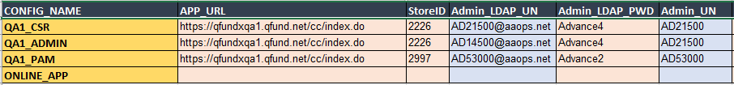

**ProcessDetails :**

We have multiple processes in different process class. In this Process details sheet we map the process name with the class name in which it is present.

Example:

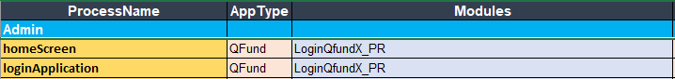

**Test Cases :**

We maintain all the test cases in Test cases sheet.

Example:

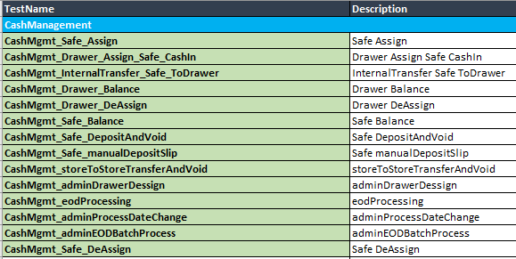

**Test Case :**

* Test case covers the end to end flow based on the requirement.
* Each test case is a combination of multiple process. Every process have saperate sheet in test

Data workbook. Each process data sheet contains of multiple rows of test data that are used based on the test case requirement.

* Test case is a combination of multiple process. Test data for the process are maped in the next column of the process name.

Example:



**Execution Suite:**

* Execution suite contains all the test cases with end to end flow that covers all the major

functionalities required for regressions testing.

* Test cases included in the execution suite are executed daily and reports are shared to all the required mail id’s.

# Test Script and suite execution

## 4.1 From Eclipse

To Run the Test Script from the Eclipse. Click on the **Run button drop down** from Tool bar menu, then Select the **Run configurations** from that.

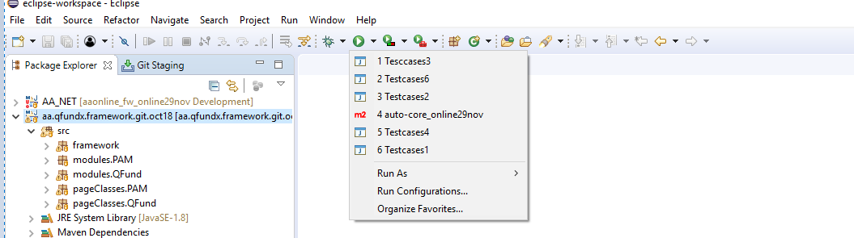

Then the Run configurations dialog box will displayed as below screenshot. In Project Field Confirm that your project framework name is selected correctly or not. If not browse and select your project framework accordingly.

After that, go to the arguments tab in that and Pass the Four(4) arguments .

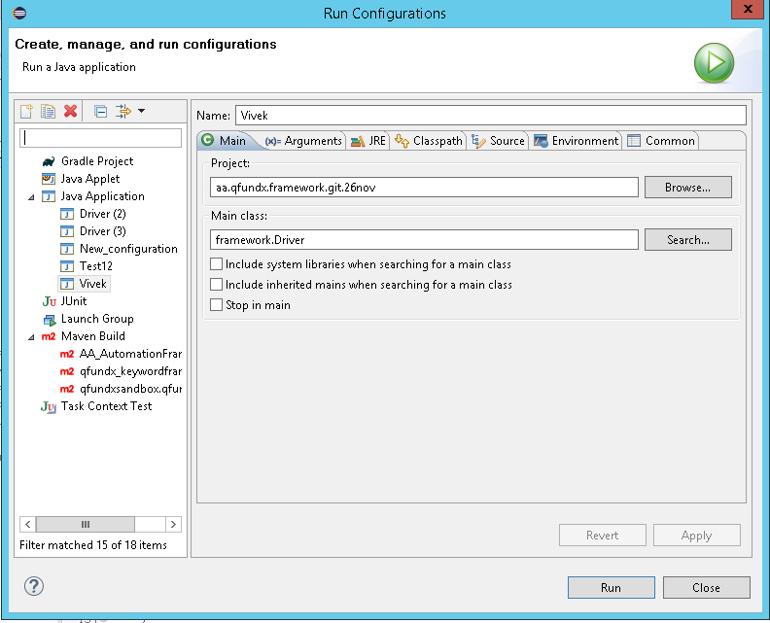

Below is the Arguments for Running the **Title_LoanFunding_Cash** Test case in **Automation Enviornment** using **IE Browser** where the **Reruning the Failed Testcases** was **NO**

Arguments to be Passed in the Run confiugurations before running the testcase or Test suite level.

**IE**

**AUTOMATION_CSR**

**RERUN_FAILED-NO**

**LoanMgmt_Title_LoanFunding_Cash**

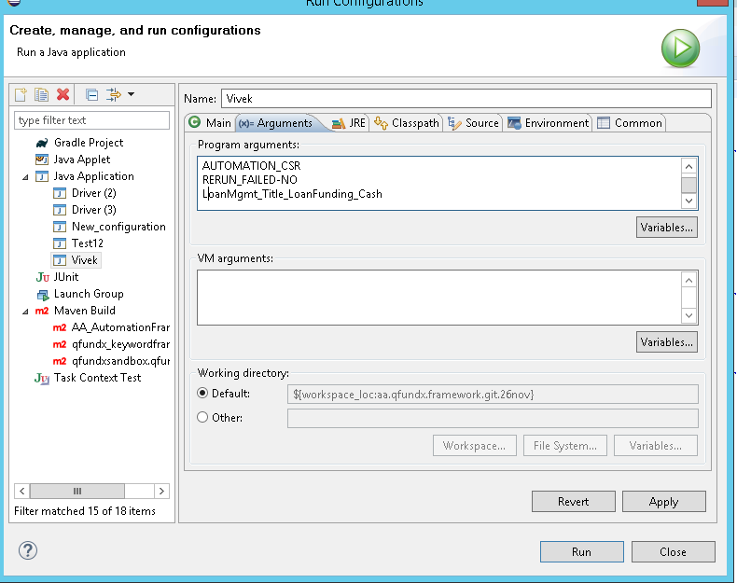

**Detail description of the Arguments :**

**IE 🡪** Describe which browser to run for the particular Testcase or Test Suite

**AUTOMATION_CSR 🡪** Describe which Environment to be used for executing the Testcase or Test Suite.

**RERUN_FAILED-NO 🡪** Describe that it would Re-run the Failed Testcase/Testcases from the Suite or not.

**LoanMgmt_Title_LoanFunding_Cash 🡪** Describe the Testcase Name or Test Suite Name to be Executed.

**Running the Test Suite Level:**

Below is the Arguments for Running the Test Suite Level Testcases . if any testcase failed in that suite level then it will rerun those testcases alone.

IE

AUTOMATION_CSR

RERUN_FAILED-YES

DailyExecution_Suite1

After Passing the arguments in the Run configurations dialog box, Click apply and Run Button to run that Testcase/Test Suite with arguments that we passed.

## 4.2 From Maven pom.xml

To run the Testcase or Test Suite from pom.xml then click on the pom.xml from the Project Framework, Pom Overview wil be displayed, in the below you could see the pom.xml tab click on that to navigate to the source code of the pom.xml.

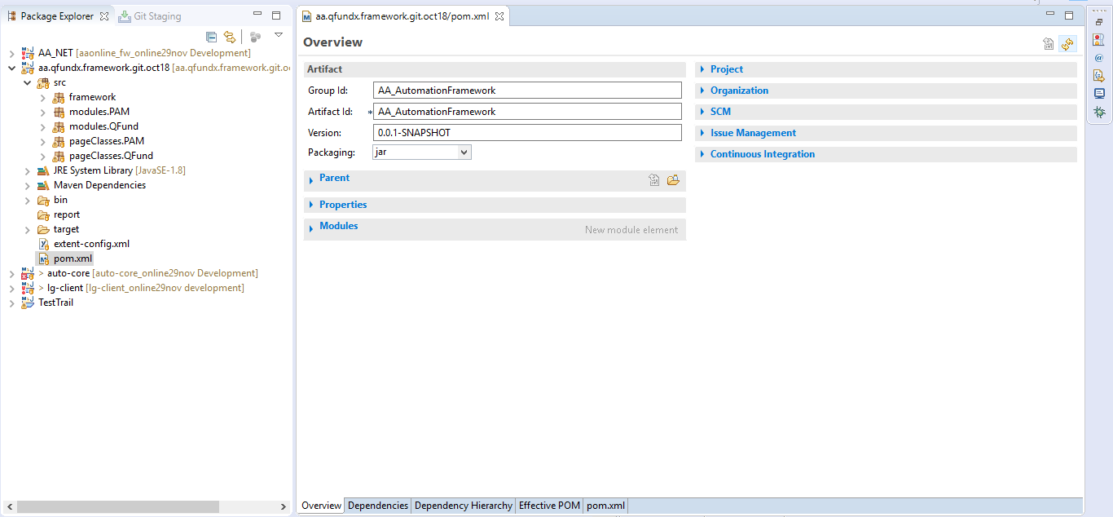

You could see the below code in that, So you need to pass the arguments in that xml tags direcly.

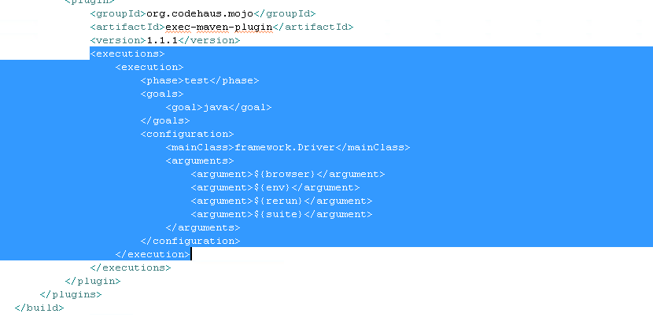

After updating the 4(four) arguments in the pom.xml, it would be like the below.

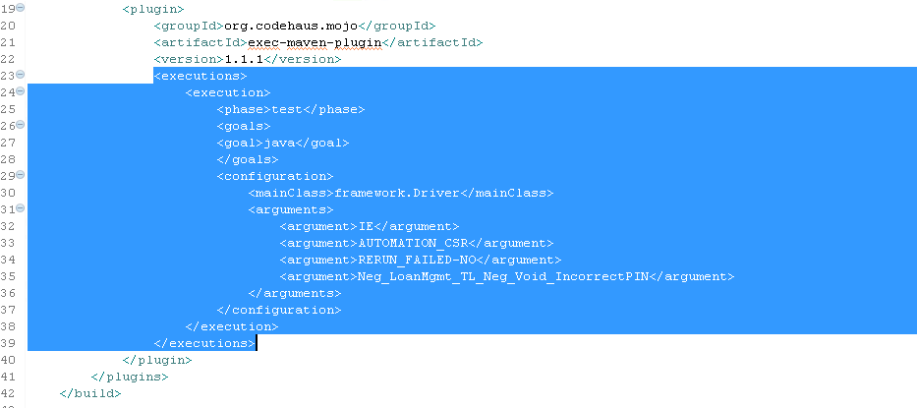

Then save the pom.xml, Right click the pom.xml select the Run as **Maven test**

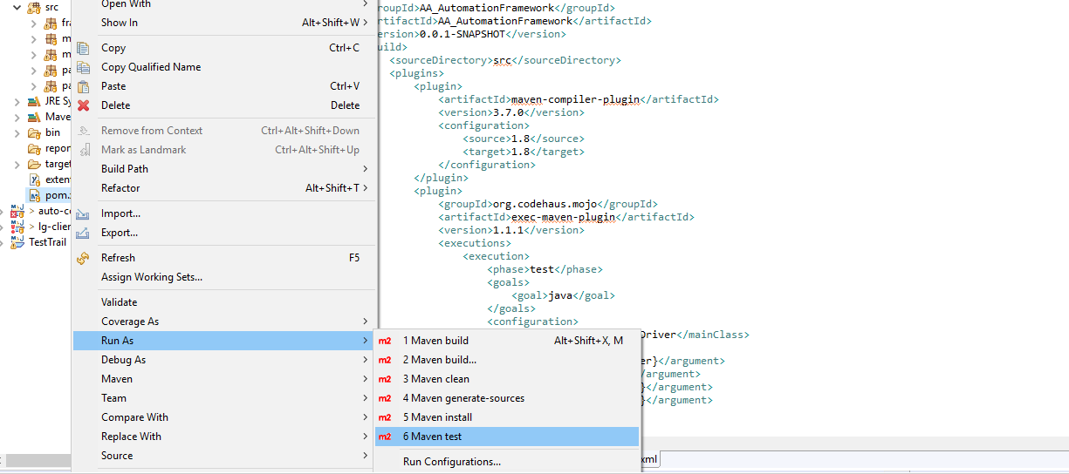

Then it will run the Testcases or Test Suite Tescases accordingly that we have specified in the arguments.

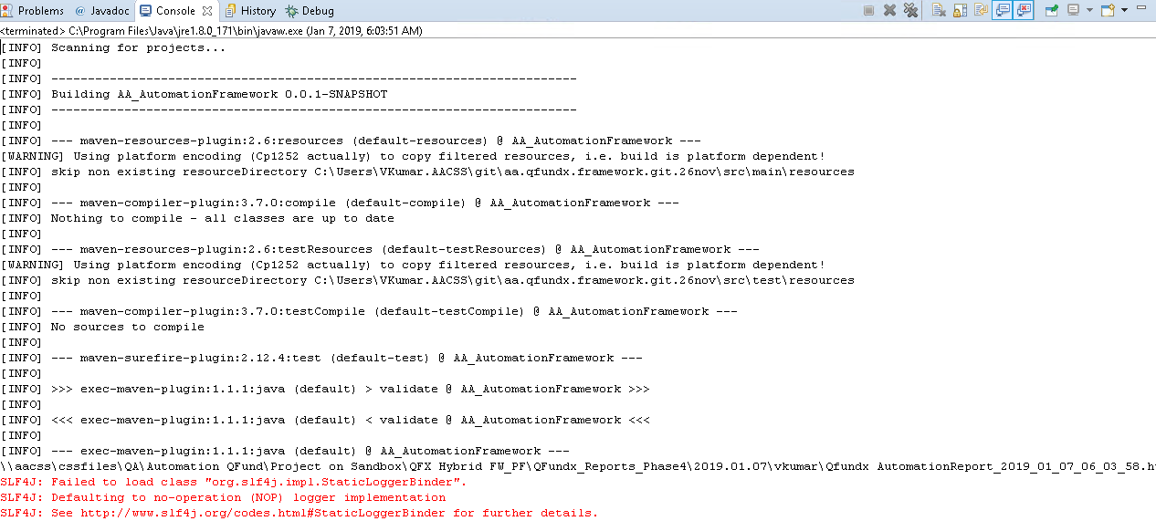

## 4.3 From Jenkins

Login to the below Jenkins URL with your credentials.

http://cssqc.advanceamerica.net:8000/login?from=%2F

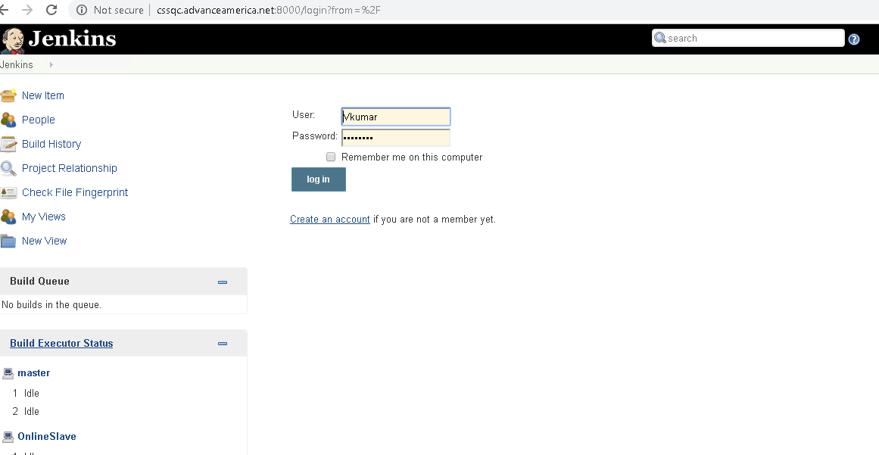

Click on the appropriate Jenkins Job and then detailed descrption of the job will be shown.

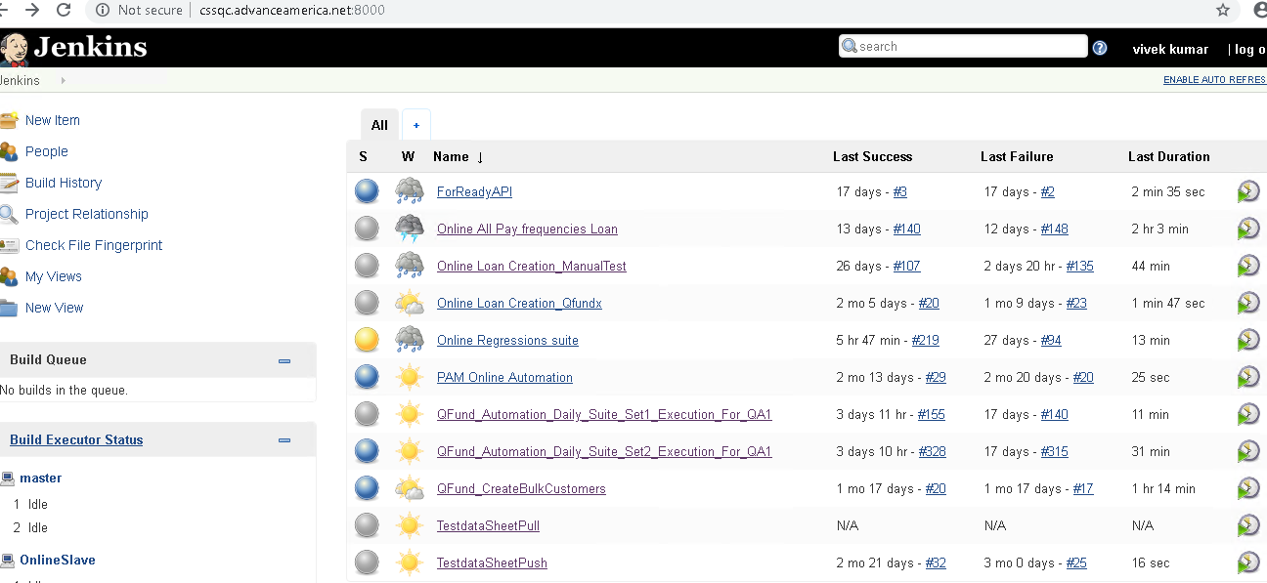

Click on the Configure button, to change the configuration details in the Jenkins job.

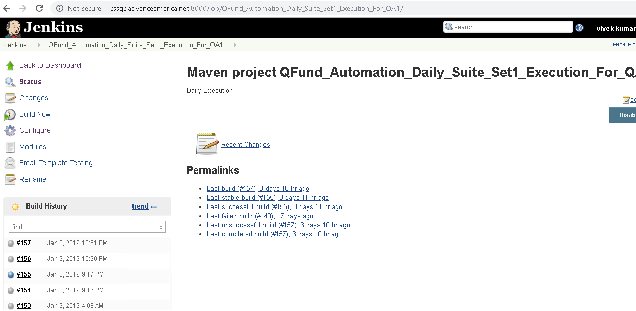

If you need to change arguments to the testcase or test Sutie then change it in the Goals and options and it will run accordingly.

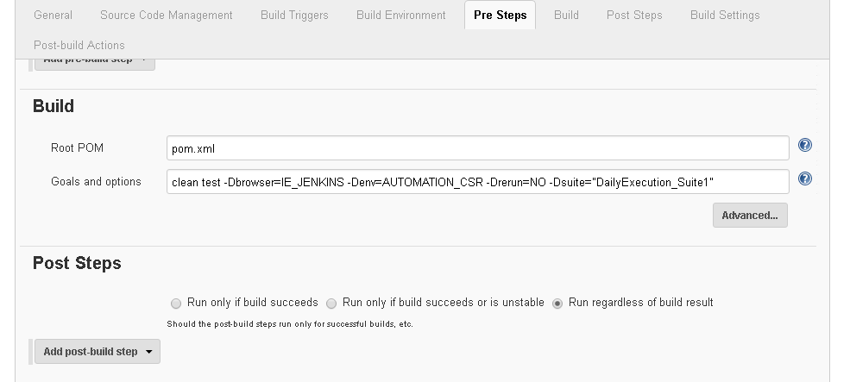

If you need to change the email configuration, go through below screenshots.

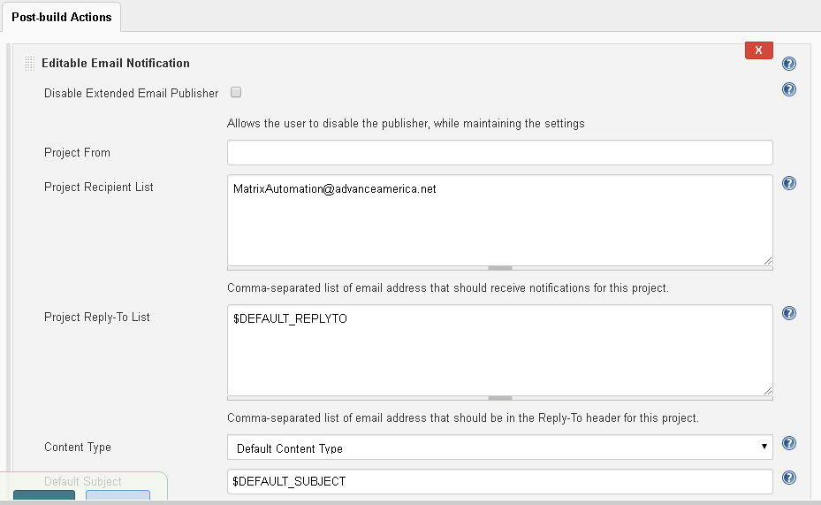

Click on Build Now to trigger the jenkin job execution. All the Build history are visible on the left side.

