

**Consumer Web**

**Selenium Automation**

**Run Book**

**Revision History**

|  |  |  |  |
| --- | --- | --- | --- |
| **DATE** | **REV** | **AUTHOR** | **DESCRIPTION** |
| 06/01/2017 | 0.1 | Mohamed Ibrahim | Initial Draft |
| 06/12/2017 | 4.0 | Jim Sears | Font, grammar correction |
| 06/13/2017 | 5.0 | Mohamed Ibrahim | Modified heading and font to TFS- TCOE template |
| 06/14/2017 | 5.1 | Jim Sears | Swapped Maven steps due to proxy settings preventing install |
| 08/11/2017 | 5.2 | Jim Sears | Updated Eclipse version to Oxygen. Updated Eclispe Run parameter list. |
| 2/13/2017 | 5.3 | Saranya BS | Paths and reference screenshots relevant to MobileFirst |

Table of Contents

[1. Software Pre-requisites 4](#_Toc490199881)

[1.1 ALM Access 5](#_Toc490199882)

[1.2 Network LAN Access for Automation Files/Utilities 5](#_Toc490199883)

[1.3 ODBC Driver install 5](#_Toc490199884)

[1.4 HP ALM Client Registration 5](#_Toc490199885)

[1.5 TAF Data – Excel Workbook 6](#_Toc490199886)

[1.5.1 Configure Excel Macro User Settings 6](#_Toc490199887)

[1.6 DB Schema Access 6](#_Toc490199888)

[1.6.1 Workbook Errors/Exceptions 6](#_Toc490199889)

[1.7 Perfecto Access 7](#_Toc490199890)

[1.8 Eclipse 8](#_Toc490199891)

[1.9 Automation Coding Standards 8](#_Toc490199892)

[1.10 Chrome Settings 10](#_Toc490199893)

[1.11 GitHub Configuration 10](#_Toc490199894)

[1.GitHub request 10](#_Toc490199895)

[2.GitHub installation Userguide 10](#_Toc490199896)

[3.GitHub desktop application installation user guide 10](#_Toc490199897)

[1.12 Java setup 11](#_Toc490199898)

[1.13 Eclipse – Maven Install Software 11](#_Toc490199899)

[2. Execute Automated Tests in ALM 12](#_Toc490199900)

[3. Local test execution requires updating the Jar files 17](#_Toc490199901)

[3.1.1 Local Test Execution from TAF Data Workbook 18](#_Toc490199902)

[4. Developer Execution – Selenium & Eclipse with Java 18](#_Toc490199903)

[5. Automated Test Cases 22](#_Toc490199904)

[5.1.1 Automation re-usable Component (Created by automation testers) 22](#_Toc490199905)

[5.1.2 Test Data Creation for Automation Test Script 25](#_Toc490199906)

[5.1.3 Automation Test Script Creation 25](#_Toc490199907)

[5.1.4 Test Set Creation from ALM 27](#_Toc490199908)

[6. Mailing Summary Report 28](#_Toc490199909)

[7. Automatic Test script documentation(TBC): 30](#_Toc490199910)

[8. Scheduling Test set execution 31](#_Toc490199911)

[9. Reference Documents 32](#_Toc490199912)

# Software Pre-requisites

Software required to create and execute Selenium automation requires several packages. Automation developer requires all software where Tester does not need development tools.

* testers someon whom provides data and builds and executes automated tests using automated components.
* An automation engineer is someone who builds data driven automation components.

The role separation creates a symbiotic relationship that improves productivity regardless of the SDLC is Waterfall or Agile. Each role allows he/she to focus on their tasks thus improving overall quality of automated testing.

|  |  |  |
| --- | --- | --- |
| **Tools Access/Software installation** | **Automation Engineer** | **Testers** |
| 1.1 ALM Access | Yes | Yes |
| 1.2 Network LAN Access for Automation Files/Utilities | Yes | Yes |
| 1.3 ODBC Driver install | Yes | Yes |
| 1.4 HP ALM Client Registration | Yes | Yes |
| 1.5 TAF Data – Excel Workbook | Yes | Yes |
| 1.6 DB Schema Access | Yes | Yes |
| 1.7 Perfecto Access | Yes | Yes |
| 1.8 Eclipse | Yes | No |
| 1.9 Automation Coding Standards | Yes | No |
| 1.10 Chrome Settings | Yes | Yes |
| 1.11 GitHub Configuration | Yes | No |
| 1.12 Java setup | Yes | Yes |
| 1.13 Eclipse – Maven Install Software | Yes | No |

## ALM Access

Open a “Sec1” request for HP ALM specifically for your for your Domain and Project.

**Domain Name**: CONSUMER\_WEB

**Project Names**: CP2557\_Mobile\_First

1. Navigate to URL: <https://sec1.tfs.toyota.com/ECM/workflowmanagement/requesthome?menu=1>
2. Choose the category as HP Quality center

## 

## 1.2 Network LAN Access for Automation Files/Utilities

Open request Sec1 to modify LAN and request access to Group TFS\_BTS\_QA\_R (TMS\TFS\_BTS\_QA\_R) follow the below steps

1. Open https://sec1.tfs.toyota.com if browser didn't open automatically.
2. Click 'Request access for myself
3. Enter 'Data Share’ in search box located to the right in the webpage in the webpage
4. Locate 'Data Share’ in the list and click Select Access
5. Scroll to the bottom of the page and click Continue
6. Enter “Requesting access to group TFS\_BTS\_QA\_R (TMS\TFS\_BTS\_QA\_R)” for Access Requirements.
7. Click Submit to complete the request
8. After the request is approved, verify access to the share path

[\\tfs.toyota.com\bts\Quality Assurance\Automation\Selenium+Eclipse](file:///\\tfs.toyota.com\bts\Quality%20Assurance\Automation\Selenium+Eclipse)

## 1.3 ODBC Driver install

Request the ODBC driver (mysql-connector-odbc-5.3.4-win32.msi) from Automation CoE and install it in your machine. The install is 32 bit binary (86x) on purpose. Don’t install 64 bit (64x)

1. Run installer as admin.
2. When prompted for install options then choose “Complete”. “Typical” install option will not always work.

## 1.4 HP ALM Client Registration

* 1. Open the Internet Explorer in Administrator Mode
  2. Type the following URL in IE opened as Administrator

<https://tfsqualitycenter12.tfs.toyota.com/qcbin/start_a.jsp>

* 1. Login into the “CONSUMER\_WEB” Domain and “CP2557\_Mobile\_First” project
  2. Goto Help🡪ALM Tools🡪 Click on HP ALM Client Registration
  3. Click on the “Register HP ALM” url

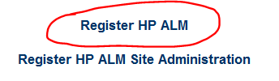

* 1. This will enable you to deploy and register the following ALM components on a client machine

## 1.5 TAF Data – Excel Workbook

Request the test data sheet (macro enabled) along with the Excel Add in from Automation CoE

### 1.5.1 Configure Excel Macro User Settings

### 

Excel macro settings must be enable to load VBA from the network drive at startup of the workbook.

1. Click “File” then “Options”
2. Click “Trust Center” on the left
3. Click “Trust Center Settings” on the right
4. Click “Macro Settings” on the left
5. Select the radio option for “Enable all macros”
6. Enable the checkbox “Trust access to the VBA project object model”
7. Click Ok
8. Click OK
9. Close Excel the program and all open workbooks.

## 1.6 DB Schema Access

Request access to the following automation test data DB schema access from Automation COE for editing the testdata. Send LAN ID via email to Automation CoE.

**CW**

### 1.6.1 Workbook Errors/Exceptions

If error occurs while opeing any TAF Workbook then follow these steps.

* + 1. Clear the temp directory
* Click Start then Run and type %temp% and press Enter.
* Delete all files and click “Skip” if prompted to delete files that are locked.
  + 1. Open the workbook
    2. If error “Can’t find project” appears then click OK
    3. Press ALT+F11 to open VB project
    4. Press the stop button, blue square at the top

cid:image003.png@01D2BDAA.49FA8310

* + 1. Click Tools
    2. Click References
    3. Uncheck any reference that has the word “MISSING”.
    4. Click OK
    5. Save and close workbook.
    6. If prompted, save again.
    7. Reopen workbook and error should be gone.

## 1.7 Perfecto Access

Send Request to Jim D Sears [**Jim.Sears@Toyota.com**](mailto:Jim.Sears@Toyota.com) in the below format

|  |  |  |  |  |  |  |  |  |  |  |
| --- | --- | --- | --- | --- | --- | --- | --- | --- | --- | --- |
| Toyota Email | Group Name (CP Project name or similar name) | Group Description | Project Start Date | Project End Date | First Name | Last Name | Vendor (Vendor name or Toyota for Full-time employees (ZeroChaos is not valid unless direct hire) | Business Phone Number or On-shore QA Lead’s Phone Number | Country | Role (Toyota-manual testing/ Automation-automated testing) |
| [John.Doe@Toyota.com](mailto:John.Doe@Toyota.com) | CP 2423 MFA | Biometric validation for handset device | 10/11/2016 | 03/21/2017 | John | Doe | Hexaware | +19722419595 | India | Toyota |
| [David.Smith@Toyota.com](mailto:David.Smith@Toyota.com) | CP 2423 MFA | Biometric validation for handset device | 10/11/2016 | 03/21/2017 | David | Smith | TCS | +19722419511 | United States | Toyota, Automation |

## 1.8 Eclipse

Eclipse is a development IDE for Java and is used to create Selenium Open source automation components. The IDE is sophisticated platform to improve development activities and debugging.

Please find the Eclipse installer in the below path and choose Oxygen (or the latest version).

[\\tfs.toyota.com\bts\Quality Assurance\Automation\Selenium+Eclipse\](file:///\\tfs.toyota.com\bts\Quality%20Assurance\Automation\Selenium+Eclipse\)Selenium

**Perfecto Plugin**

Please find the installer in the below path.

[\\tfs.toyota.com\bts\Quality Assurance\Automation\Selenium+Eclipse\PerfectoCloud](file:///\\tfs.toyota.com\bts\Quality%20Assurance\Automation\Selenium+Eclipse\PerfectoCloud)

Refer the URl below for Perfecto – Eclipse setup

<http://developers.perfectomobile.com/display/PD/Eclipse>

## 1.9 Automation Coding Standards

**Code Formatting**

Import this XML file of code formatting for Eclipse located on the Network Share drive with Eclipse install.

1. Open Eclipse
2. Click Preferences
3. Expand Java\Code Style
4. Select Formatter
5. Click Import and select file on Network Share

[\\tfs.toyota.com\bts\Quality Assurance\Automation\Selenium+Eclipse](file:///\\tfs.toyota.com\bts\Quality%20Assurance\Automation\Selenium+Eclipse)

1. Click Apply
2. Update Java code while coding at any time by pressing the shortcut key CTRL+SHIFT+F.

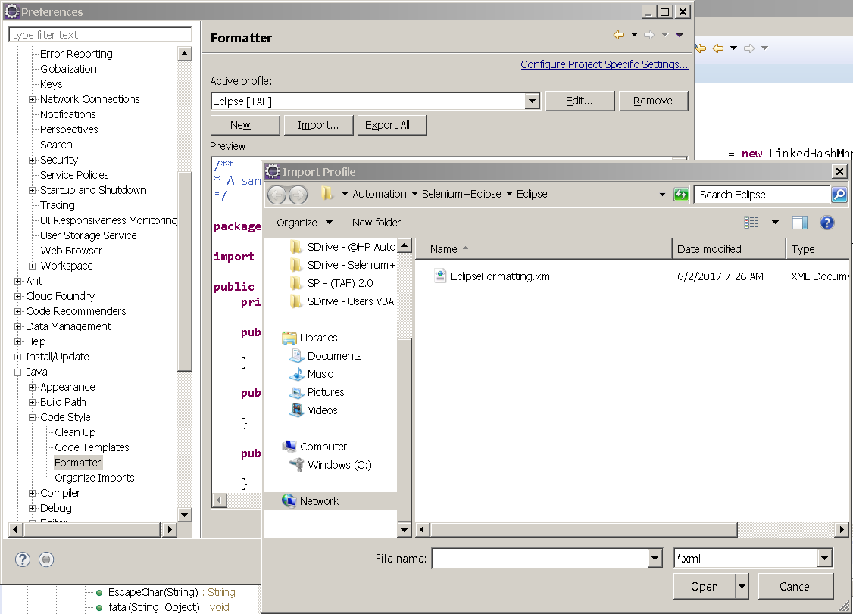

## 1.10 WebDriver Settings

Browser drivers are a specific program used to communicate to browsers and it is used by Selenium. The Selenium browser drivers can be found in below path

\\tfs.toyota.com\bts\Quality Assurance\Automation\Selenium+Eclipse\TAF\ARTS

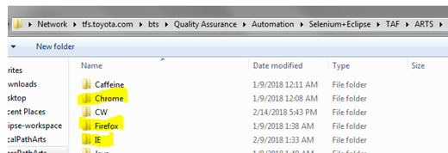

According to the browser selection test will run on the browser. Browser configuration can be configured in web.config.propertiesfile which can be found in \\tfs.toyota.com\bts\Quality Assurance\Automation\Selenium+Eclipse\TAF\ARTS

and In local C:\TAF\ARTS

**Example**

**Chrome:**

browserName=Chrome

ChromeBinary=C:\\TAF\\ARTS\\Chrome\\v59\\chrome.exe

ChromeDriver=C:\\TAF\\ARTS\\Chrome\\chromeDriver\\2.35\\chromedriver.exe

**Firefox:**

browserName=Firefox

FirefoxBinary=C:\\Program Files\\Mozilla Firefox\\firefox.exe

FirefoxDriver=C:\\TAF\\ARTS\\Firefox\\geckodriver\\19\_64x\\geckodriver.exe

**IE:**

browserName=IE64

IE64Driver=C:\\TAF\\ARTS\\IE\\IEDriverServer\_Win64\_3.8.0\\IEDriverServer.exe

## 1.11 GitHub Configuration

GitHub is an enterprise wide implementation and separate access must be requested and approved. Toyota’s GitHub is private and it not accessible outside of the Toyota network. Access credentials are your LAN ID user id and password but acces must be granted.

### 1.GitHub request

Please refer the document in the below share path

[\\tfs.toyota.com\bts\Quality Assurance\Automation\Selenium+Eclipse\RunBook\Git\GHE Access Request Guide v1.1.docx](file:///\\tfs.toyota.com\bts\Quality%20Assurance\Automation\Selenium+Eclipse\RunBook\Git\GHE%20Access%20Request%20Guide%20v1.1.docx)

### 2.GitHub installation Userguide

Please refer the document in the below share path

[\\tfs.toyota.com\bts\Quality Assurance\Automation\Selenium+Eclipse\RunBook\Git\GitHubInstallation\_Version Control.docx](file:///\\tfs.toyota.com\bts\Quality%20Assurance\Automation\Selenium+Eclipse\RunBook\Git\GitHubInstallation_Version%20Control.docx)

### 3.GitHub desktop application installation user guide

Please refer the document in the below share path

[\\tfs.toyota.com\bts\Quality Assurance\Automation\Selenium+Eclipse\RunBook\Git\GitHub Desktop UserGuidde.docx](\\\\tfs.toyota.com\\bts\\Quality Assurance\\Automation\\Selenium+Eclipse\\RunBook\\Git\\GitHub Desktop UserGuidde.docx)

**Note**: The automation source code for CP2557\_MobileFirst project is available in the below GIT Path,

<https://xpvapl0170.tfs.toyota.com/TFS/CW>

## 1.12 Java setup

Right click on My computer->Properties->Advanced system settings->Advanced->Environment Variables -> Set system variable – JAVA\_HOME and add Java path as below

**JAVA\_HOME – C:\Program Files)\Java\jre xxx**

eg:- C:\Program Files (x86)\Java\jre1.8.0\_121

PATH – add C:\Program Files)\Java\jre xxx\bin

eg:- C:\Program Files (x86)\Java\jre1.8.0\_121\bin

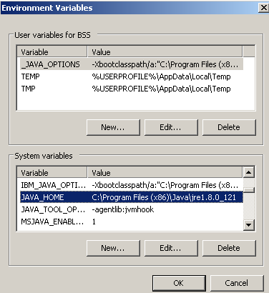

Contact person for automation CoE is Jim D Sears [**Jim.Sears@Toyota.com**](mailto:Jim.Sears@Toyota.com)

## 1.13 Eclipse – Maven Install Software

**Configure Maven Settings.xml**

Please find the reference document in the path below

[\\tfs.toyota.com\bts\Quality Assurance\Automation\Selenium+Eclipse\RunBook\Maven\Eclipse\_Maven\_Configurations.docx](\\\\tfs.toyota.com\\bts\\Quality Assurance\\Automation\\Selenium+Eclipse\\RunBook\\Maven\\Eclipse_Maven_Configurations.docx)

**Refer the link for Maven installation**

<http://toolsqa.com/java/maven/how-to-install-maven-eclipse-ide/>

# Execute Automated Tests in ALM

1. Open HP ALM URL (<https://tfsqualitycenter12.tfs.toyota.com/qcbin> ) in Internet Explorer.
2. Enter your LAN ID and Password and click “Authenticate”
3. Select “CONSUMER\_WEB” domain and “CP2557\_MobileFirst” project from the dropdown and click “Login”

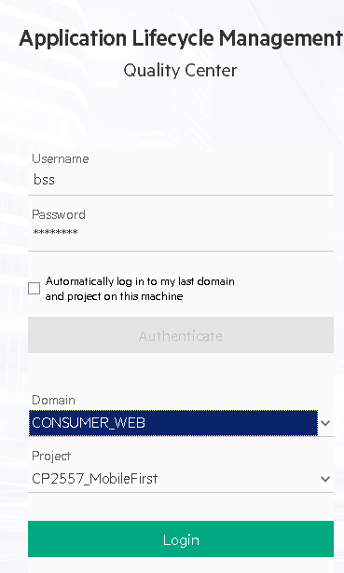

1. Locate ALM Test Lab on the left select appropriate folder and test sets to run.

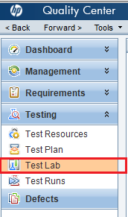

1. The executable automated test scripts are stored in ALM🡪Test Lab under CP2557\_MobileFirst Phase1 and test sets are organized as per the specific project/functions as shown below:

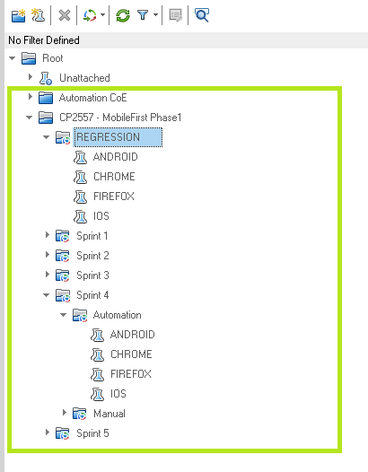

1. The test set folders are further categorized as follows:

* Regression / Sprint 1,Sprint 2…Sprint n
* ANDROID, CHROME, FIREFOX and IOS
* For instance, to execute Sprint 4 test scripts in IOS
* Root->-CP2557- MobileFirst Phase1>Sprint 4->IOS
* At the end of each sprint all the testcases automated in that sprint will be moved to REGRESSION folder
* Select the test cases and click Run(To run selected test scripts) or Run test set(to run all test scripts).

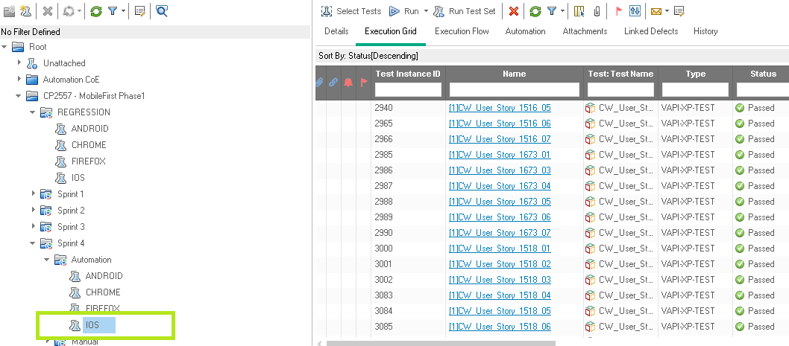

1. The execution grid in the right pane contains list of all automated testcases those are selected from the test plan.
2. To run all the automated testcases in the Execution grid, click ‘Run Test Set’ at the top of the right pane or to run selected test cases; highlight the test cases you want to run and click “Run” button.

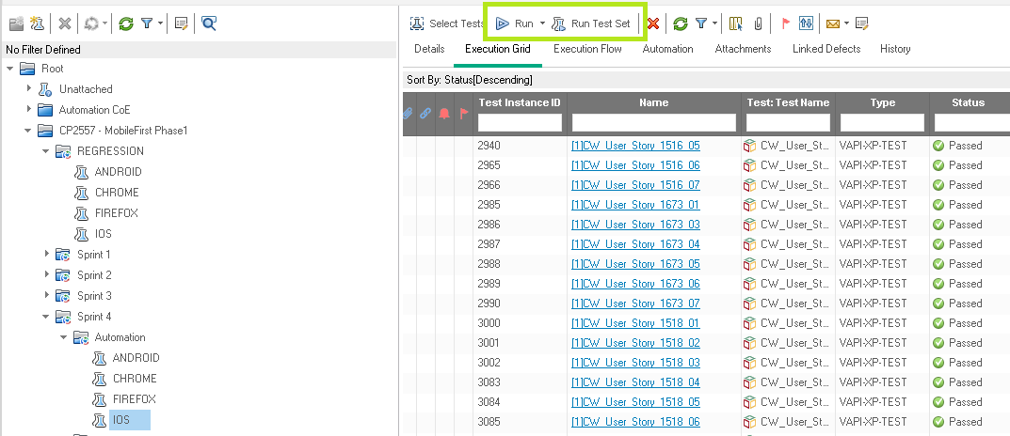

1. On Clicking Run, the Automatic Runner Window opens
2. Select a Host Name from the list or “TAF LAB”
3. Runner window can contain multiple PCs.

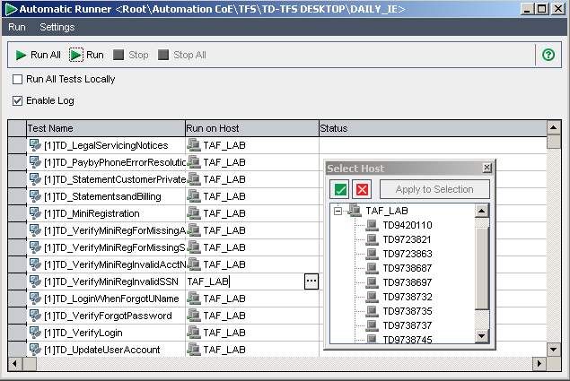

1. Choose ‘Run on Host’ as TAF\_LAB if it is not selected already and Click on “Run All”.
2. Alternately, select only the test scripts that you want to run and click “Run”.
3. Check the ‘Run all test locally’ checkbox only if you are planning to run the test locally.
4. Once the Execution is completed, close the “Automatic Runner” window and go to “Execution Grid” in the automation lab to see the execution status (Passed/Failed).
5. To see the detailed step results ,select a test case and goto test instance details ->Runs->Steps.

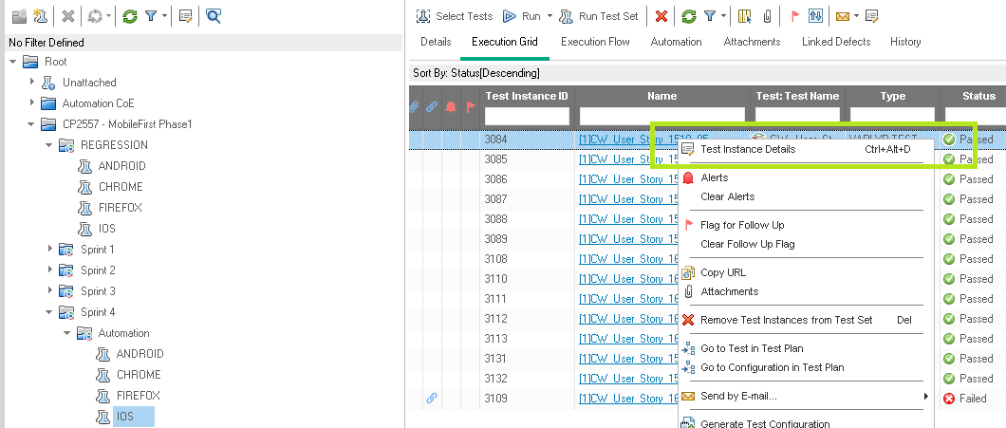

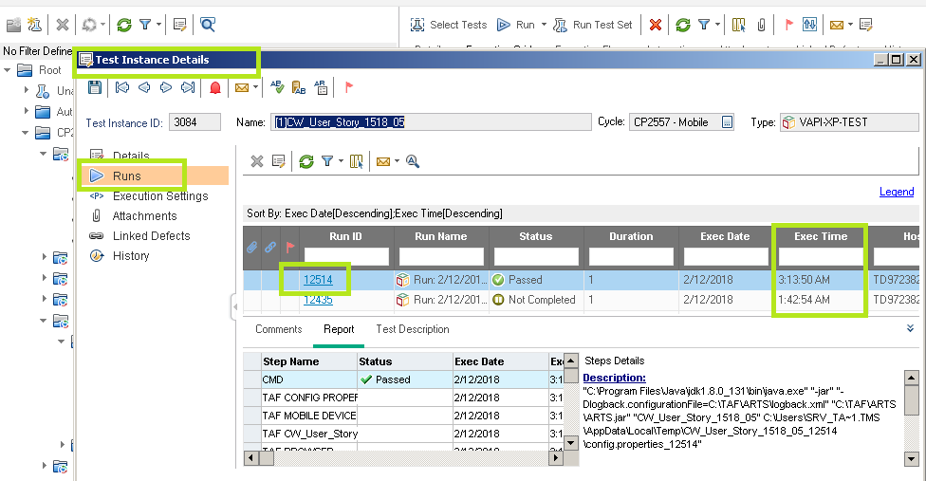

1. Click the latest run id with the help of Execution time for detailed step results

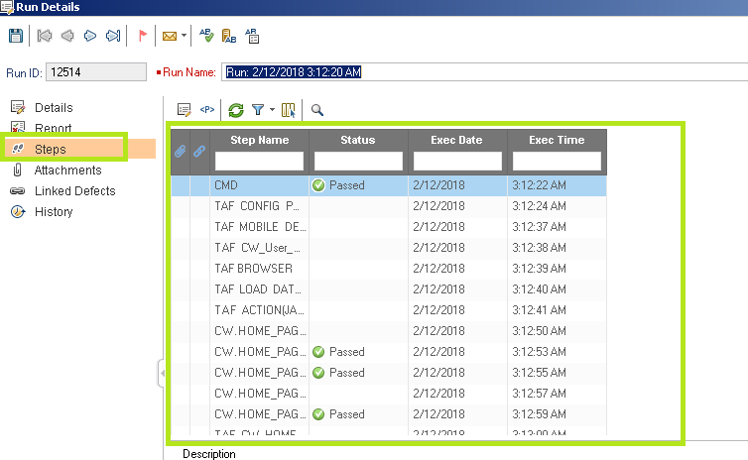

1. Screenshots will be available only for the failed teststeps. This can be configured in config.properties file as below

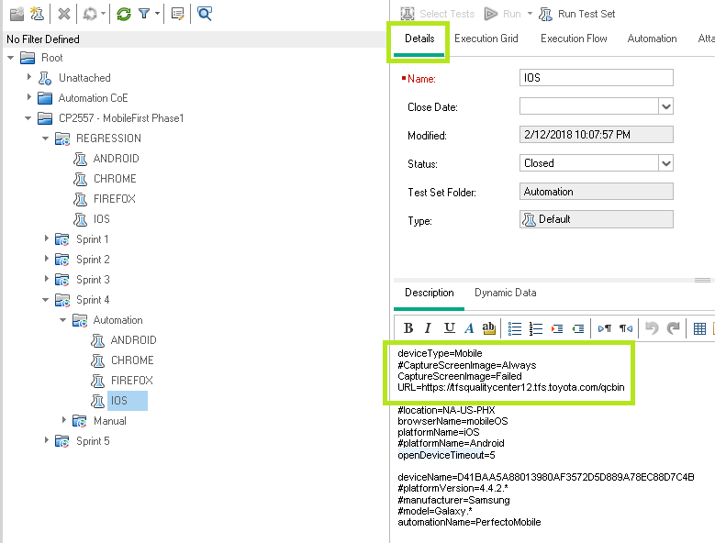

If CaptureScreenImage = Failed , screenshots will be captured only for failed teststeps

If CaptureScreenImage= Always , Screenshots will be taken for each and every step

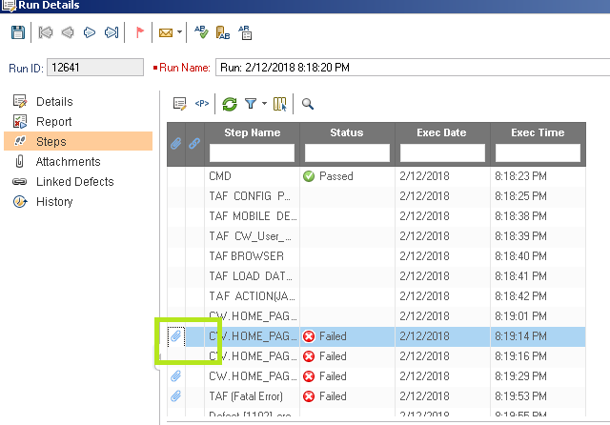

# Local test execution requires updating the Jar files

The automation developers create automation components that the Selenium TAF 2.0 can execute. The only requirements prior to executing tests is to ensure that the components are current.

Acquire the latest version of the components by downloading the Jar files from the network share. The QC Test Case was created to simplify this process. Run the following test as outlined below to update Jar files locally or update Jar files on the automation Lab PCs.

Contact person for automation CoE is Jim D Sears [Jim.Sears@Toyota.com](mailto:Jim.Sears@Toyota.com)

1. Goto Test Lab->Root-> Automation CoE->LAB Maintenance
2. Select Tests->Add CopyJarFilesToLab Test to TestLab as below

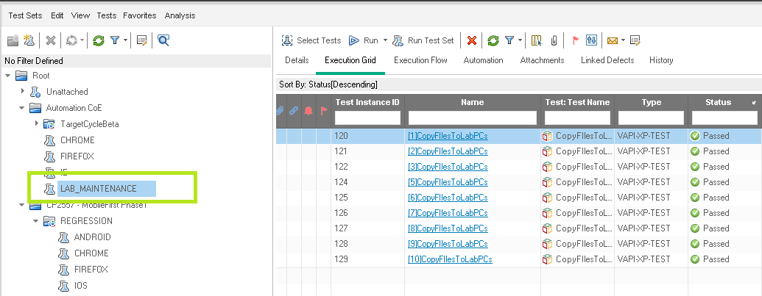

1. Run the test by Clicking the ‘Run All tests locally’ to update local PC or run on the Automation Lab to update those PCs.

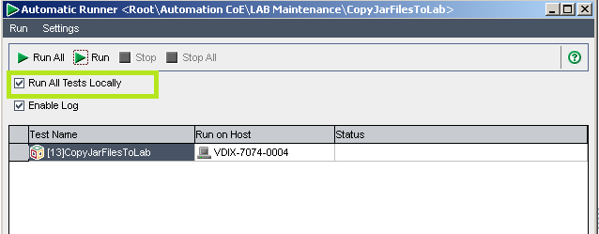

1. Once the Test is passed and the files have updated then it is possible to run the Test Case from ALM.
   1. Tests can be executed locally.
   2. Tests can be executed on the Lab.

## Local Test Execution from TAF Data Workbook

1. Open a TAF Workbook
2. Select data sheet “TEST\_SCENARIO”
3. Select the test case name or test case names to execute.
   * + Multiple tests can be executed at once for Selenium based tests.
     + HP UFT tests will not execute tests in parallel.
4. Press “CTRL+R” as in RUN.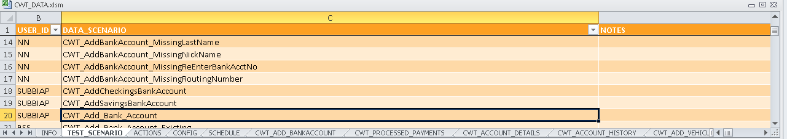

# Developer Execution – Selenium & Eclipse with Java

Developing and executing TAF 2.0 selenium requires environment setup for the tools and database data for the location of the reusable components.

Automation

Application automation is created and managed at the component level. Each component represent one screen of the application. In rare situations, the business process is automated instead of the screen. The difference between those two approaches is beyond the scope of this document. Please refer to the Toyota Automation Strategy document on SharePoint for details.

**Eclipse Configuration for TAF 2.0**

1. **Add Arts.Jar as reference to the Build Path to the Application Project in Eclipse.** 
   1. The Arts.Jar contains all methods for the TAF 2.0 solution such as data management, component loading and execution for test case, reporting and error handling.
   2. Right click the Application Project in Eclipse Project Explorer and select Build Path then Configure Build Path.
   3. Click the tab “Libraries” and click button “Add External Jars”.
   4. Navigate to the Arts.Jar and click OK
2. 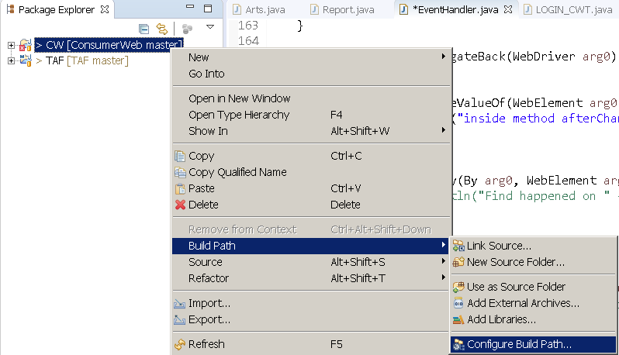
3. **Create Debug Configuration/ Run Configuration**

Note - Debug and Run are the same but when run as “Debug”, the breakpoints are active the Eclipse allows for debugging the java code.

* 1. Click the drop down arrow next to the icon for Debug or Run Configuration in Eclipse IDE tool bar across the top. cid:image001.png@01D2E694.AC678760
     1. Select “Java Application” from the list on the left.
     2. Click the new icon in the top left corner the looks like a blank page.
     3. Enter a name for your configuration. I.E. “CWT\_LOGIN\_TEST web” . Typical names include test name and target platform.
     4. Enter “arts.Arts” for main class. The main is located in the Arts.jar file and handles all test execution.

1. 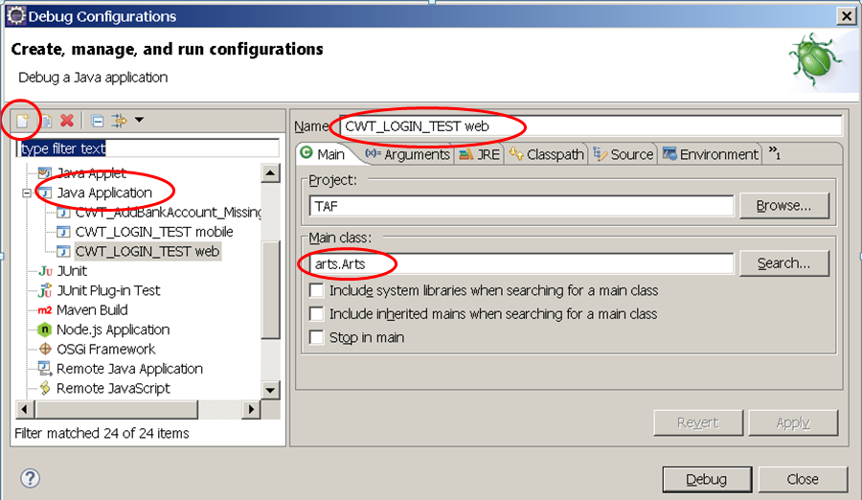
   1. Program Arguments (Parameters)
      1. Test Name - Test Case to run by name
      2. Configuration Properties File - The Config file contains the “capabilities” and is a text file that specifies:
         1. Target Platform (Browser type, version, etc.)
         2. Mobile Device
         3. Reporting Tags
      3. Example: “**CWT\_LOGIN\_TEST**”
      4. Example: “**C:\Users\searsj\git\TAF\src\web.config.properties**”
   2. The VM arguments defines the logger file configuration.
      1. The logger file is not in use at this time but the parameter must be defined in the file located in this path to reduce the log “DEBUG” details.
      2. Example: **“–Dlogback.configurationFile=C:\TAF\ARTS\logback.xml”**
2. 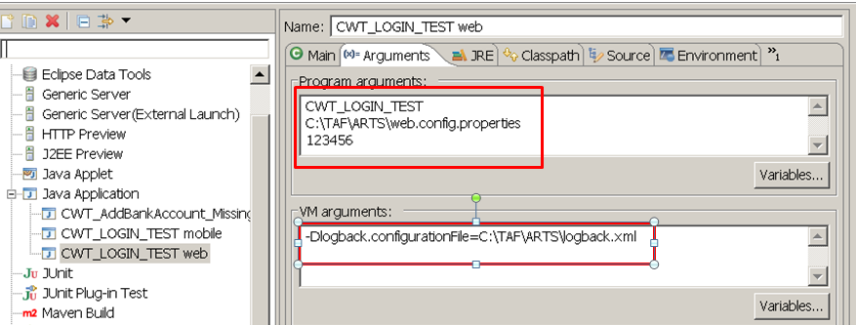
3. **Debug/Run Test**
   1. The configurations are done once and then can be executed from the drop down for Debug or Run.
   2. Run results, steps, etc. are displayed in the Eclipse console to assist with debugging and run verification.

Note - Test Execution from Eclipse is how developers verify their code. It is not normal practice for testers to execute from Eclipse.

* 1. 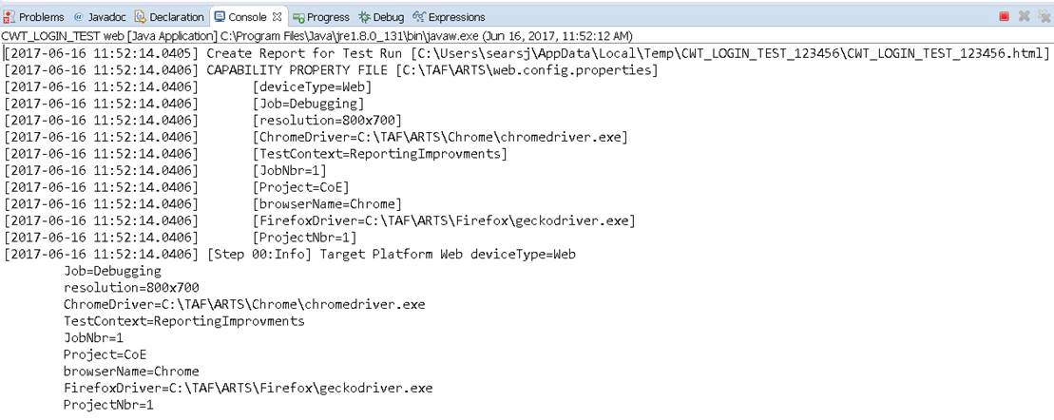

# Automated Test Cases

In TAF 2.0 framework, the automation scripts (using reusable components) and test data set are created using the excel work book. This will enable the manual testers to create automation scripts easily without any tool or scripting knowledge.

## Automation re-usable Component (Created by automation testers)

This section explains creating automation components by the automation team and how they are made available for testing. Each page in an application/module/ functionality is created as a component.

In the below example, the home page is identified for component creation, the Selenium code is created as a component named “CW\_HOME\_PAGE” as shown below:

##### Note: Manual tester need does not create automation reusable components

**Home Page:**



**Selenium Code:**

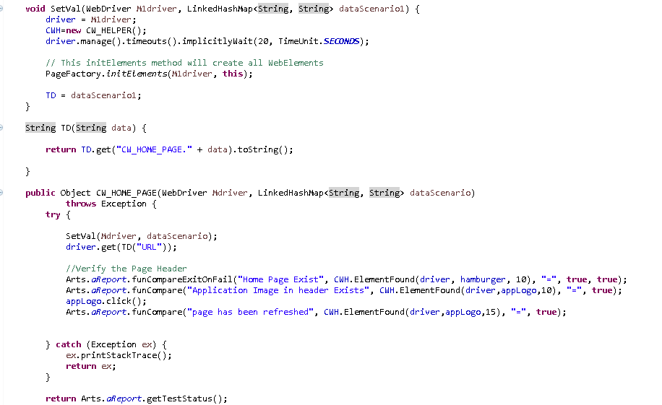

Upon completion of a component (I.E. CW\_HOME\_PAGE) by the automation team, the component is ready for use by the manual team to create a Test Case. Test Cases are prepared and mapped to ALM Test plan

## Test Data Creation for Automation Test Script

After the automation component is created and uploaded to ALM by automation team, we need to prepare the test data in the test data sheet.

**Note:**

* **Request the TAF Workbook from automation CoE**
* **Rquest test data DB access for managing the test data from Automation CoE**

(Refer Section 1 for more details on how to get access for test data sheet/DB Access)

As seen in the below table, the data sheet name will be same name as the component name. These sheet are created by automation testers. Go to the respective sheet that has the component name and populate the test data in a new row against each column header. Multiple test dataset can be created for a single component. The field ‘DATA\_SCENARIO’ is the reference name or the “name” of the data set.

The dataset name is reference on the Test Scenario sheet when creating a new test case.

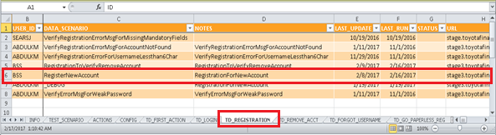

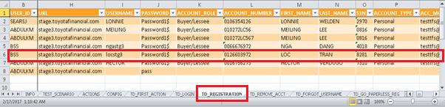

## Automation Test Script Creation

Test data setup is a pre-requisite for Test Script creation

Component name and Data Scenario name that you created are required for creating test script.

1. Go to the sheet name ‘TEST\_SCENARIO’ and fill in the details like Test Script Name, User ID, Notes (short description of what test script is doing), component name and data scenario name (created in the test data setup).
2. Test script name is mentioned in the “Data Scenario” column which is user defined. The name should be meaningful and reflect a “Test Objective”.

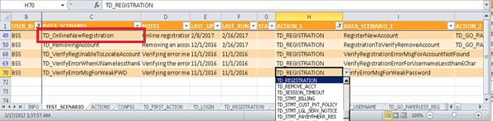

1. In the column “ACTION\_1” select the newly created component name from the dropdown list.
2. In the column “DATA\_SCENARIO\_1” select the data scenario name from the dropdown list
3. Make sure to select the appropriate components and relevant data sheet that you created to form an executable functional scenario.

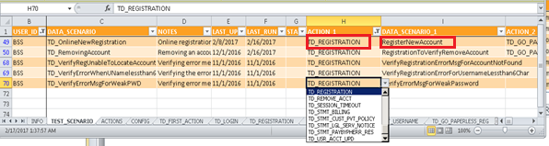

1. Similarly, multiple test cases can be created using different components and different testdata sets.
2. Map created test script to ALM –> Test Plan
3. Go to “Automation COE->TFS->TESTS->Registration” folder in Test Plan and copy the template that is already available in ALM and rename the test script name. It is also acceptable to copy/paste an existing test case and rename. The QC Test is a template test and can be used for any test.

NOTE: The Test Name is the driver that executes the data in the TAF database.

1. QC Test name must be same as the test name in the DATA\_SCENARIO column of the TEST\_SCENARIO worksheet.

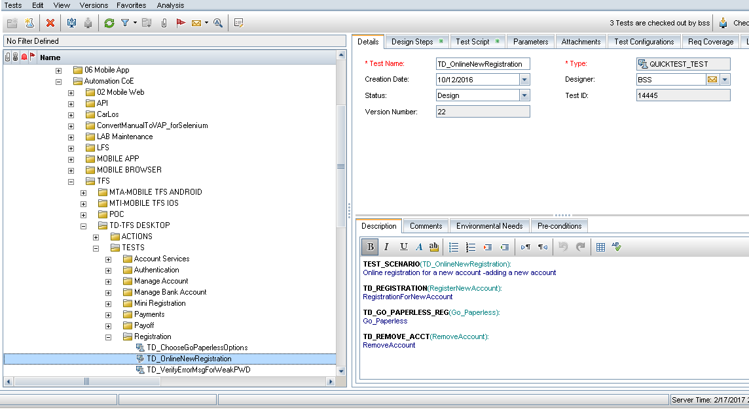

## Test Set Creation from ALM

1. Go to ALM TestLab to create a new TestSet and create your own folder structure or select an existing folder.
2. Right click and select New Testset and name the testset.

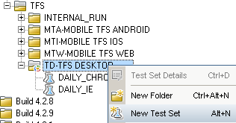

1. Highlight your TestSet to add test scripts to your testsets by clicking “Select Tests” option
   1. The QC view must be the “Execution Grid” view.
2. Select the Test Cases from Test Plan and add to the QC Test Sets.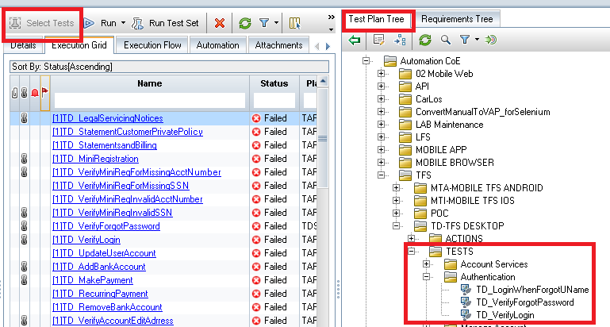

# Mailing Summary Report

This feature in ALM allows users to setup a Test Summary Report that is sent to a pre-defined user list after each Test Set execution. Email is not set for individual executions.

Select the Automation tab and configure the Execution Summary” with “Selected Fields” and “To” emails. 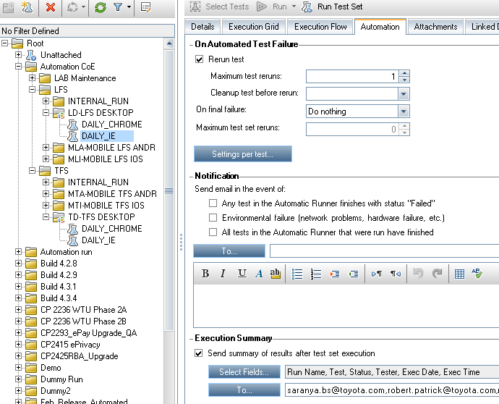

#### A Sample Summary Report

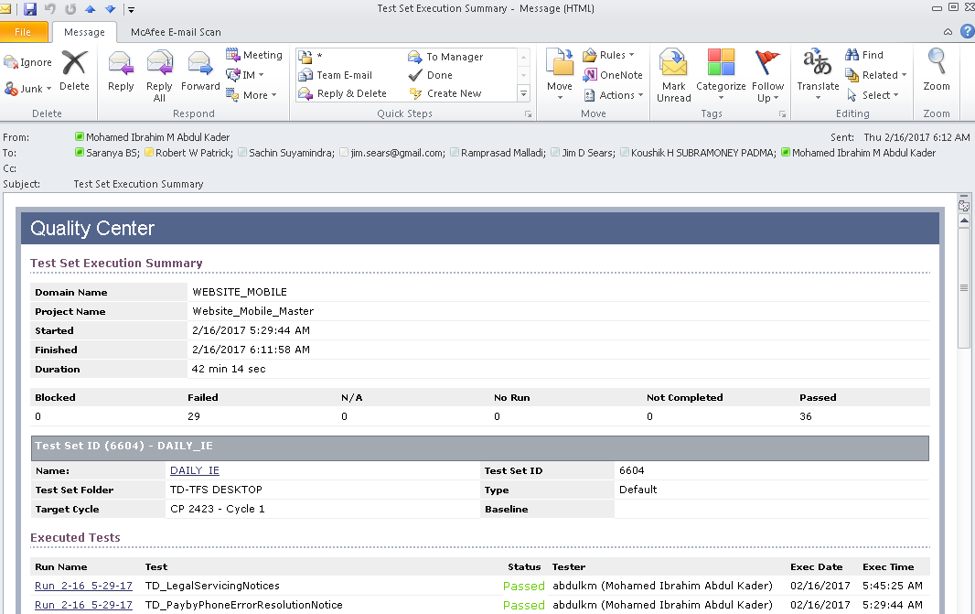

# Automatic Test script documentation(TBC):

#### HP UFT TAF 2.0

HP Solution automatically updates Test Plan Test Steps using registered functions. This feature enables self-documenting Test Cases and users (Testers, Business Analysts) do not have to document or update Test Steps.

#### Selenium TAF 2.0

Selenium solution uses the WebDriver event handler to create Test Steps so that Selenium based tests will be self-documenting.

To Be Completed: The Selenium feature is under development.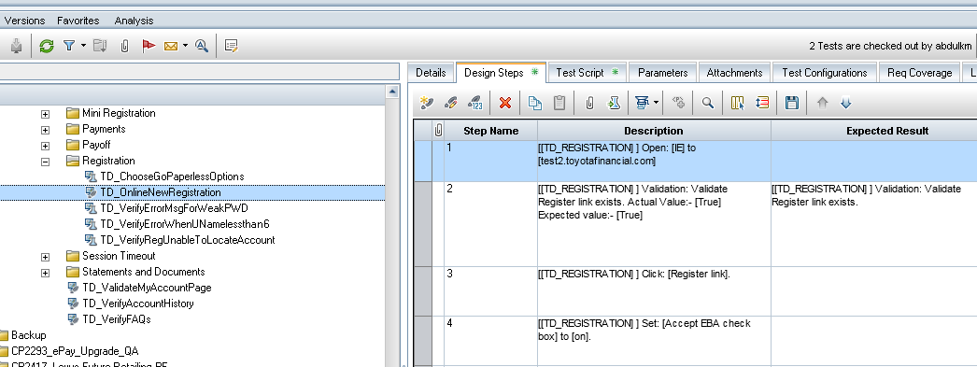

# Scheduling Test set execution

The scheduler executes QC Test Sets by Target Cycle. The target cycle is assigned to the parent folder of each Test Set. The scheduler is a simple way to run multiple Test Sets that are linked to a HP QC Target Cycle. A Target Cycle can represent a “Sprint” or a monthly release.

**Example**: The Target Cycle “DAILY\_TEST\_EXECUTION” is executed every day. The 5 Test Sets listed below are executed because they are “Assigned to cycle”.

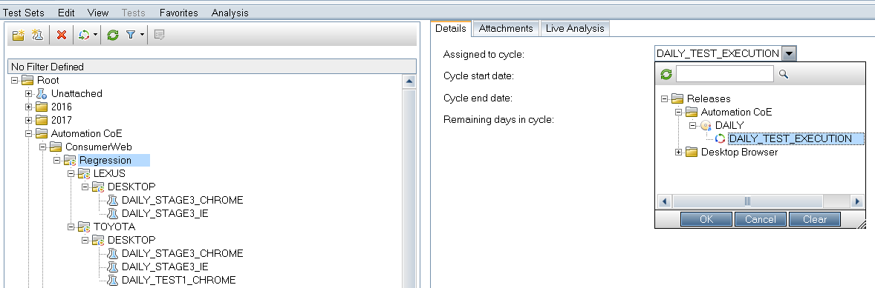

The Data workbook sheet tab “SCHEDULE” configures the Target Cycle Execution for all QC Domain and Projects. This is accessible from any workbook.The SCHEDULE is a database schema by itself so it can be modified if you have access to the SCHEDULED\_TESTSETS.

**Note**: the “ENABLED” column to turn on or turn off scheduled execution.

EXECUTION\_TIME is the start time. EXECUTION\_LIMIT is the run time limit of the Test Set in minutes.

QC\_TARGET\_CYCLE matches substring so if the QC Target Cycle contains the word “DAILY” then it will run all Test Sets assigned to that Target Cycle.





Turn off all Test Set Execution - Disable Target Cycle Test Run

Set ENABLED column to FALSE in the workbook if you created the row or if you have access to the database schema then  you can go into MySQL Workbench and update the field values there.

Disable One or more Test Sets from running (But not all Test Sets). Move the Test Set outside of the folder so that it isn’t assigned the Target Cycle or set the Assigned Target cycle to blank.

# Reference Documents

|  |  |
| --- | --- |
| Document Name | Location |
| Toyota Automation Strategy – Detailed explanation on processes surrounding tool selection, process design and benefits of Toyota’s automation framework built by Automation CoE | [http://tfskm.tfs.toyota.com/sites/TFS\_BTS\_QA - Strategy](http://tfskm.tfs.toyota.com/sites/TFS_BTS_QA/QA%20Knowledge%20Base/Forms/AllItems.aspx?RootFolder=%2Fsites%2FTFS%5FBTS%5FQA%2FQA%20Knowledge%20Base%2FQA%20Tools%20Info%20and%20Training%2FToyota%20Automation%20Framework%20%28TAF%29%202%2E0%2FStrategy&FolderCTID=0x012000742D6DDDBDCE324B856126B23339395D&View=%7b392B690B-AFAB-43BB-B2F7-EDAB39D600A3%7d) |
| TAF Data Management – Utility for building data driven automation | [http://tfskm.tfs.toyota.com/sites/TFS\_BTS\_QA - Data Management](http://tfskm.tfs.toyota.com/sites/TFS_BTS_QA/QA%20Knowledge%20Base/Forms/AllItems.aspx?RootFolder=%2Fsites%2FTFS%5FBTS%5FQA%2FQA%20Knowledge%20Base%2FQA%20Tools%20Info%20and%20Training%2FToyota%20Automation%20Framework%20%28TAF%29%202%2E0%2FData%2FData%20Mgmt&FolderCTID=0x012000742D6DDDBDCE324B856126B23339395D&View=%7b392B690B-AFAB-43BB-B2F7-EDAB39D600A3%7d) |
| ARTS Swim Lane – Illustrates collaboration between automation and manual team. | [http://tfskm.tfs.toyota.com/sites/TFS\_BTS\_QA - ARTS Swim Lane](http://tfskm.tfs.toyota.com/sites/TFS_BTS_QA/QA%20Knowledge%20Base/Forms/AllItems.aspx?RootFolder=%2Fsites%2FTFS%5FBTS%5FQA%2FQA%20Knowledge%20Base%2FQA%20Tools%20Info%20and%20Training%2FToyota%20Automation%20Framework%20%28TAF%29%202%2E0%2FStrategy&FolderCTID=0x012000742D6DDDBDCE324B856126B23339395D&View=%7b392B690B-AFAB-43BB-B2F7-EDAB39D600A3%7d) |

# 