STARBUCKS CLIMATE RISK ANALYSIS
TCFD-Aligned Financial Impact Assessment
December 2024

Classification: Internal Use

TABLE OF CONTENTS
- Executive Summary
- TCFD Framework Overview
- Key Findings: Physical Climate Risks
- Key Findings: Transition Risks
- Financial Impact Quantification
- Competitive Positioning
- Strategic Recommendations
- Technical Methodology

1. EXECUTIVE SUMMARY

Overview
This analysis quantifies Starbucks' exposure to climate-related financial risks across its coffee supply chain, aligned with the Task Force on Climate-related Financial Disclosures (TCFD) framework. Using CMIP6 climate projections, agricultural stress modeling, and financial impact assessment, we evaluate both physical risks (climate impacts on production) and transition risks (carbon pricing and market dynamics).

Key Headline Findings
- Total climate financial exposure: $2.45 billion annually by 2050 (most likely scenario)
- 30-year Net Present Value: $27.6 billion (8% discount rate)
- Physical supply risk: $158.8M annually (yield losses from climate stress)
- Transition risk: $2.3 billion annually (carbon pricing costs)
- Geographic resilience: 85% of sourcing in low-risk regions (competitive advantage)
- Competitive ranking: 2nd-best positioned among major competitors (Nestlé, JDE Peets, Lavazza, illycaffè)

Materiality Assessment
Climate risk is MATERIAL to Starbucks' business: The $27.6B 30-year NPV represents potential financial exposure from both direct supply chain disruption and transition to low-carbon economy. This exceeds materiality thresholds for public disclosure and strategic planning.

2. TCFD FRAMEWORK OVERVIEW

Governance
- Climate risk assessment is integrated into strategic planning and capital allocation decisions
- Board-level oversight of sustainability targets and net-zero pathway
- Annual TCFD-aligned climate risk disclosure in ESG reporting

Strategy
- Starbucks' high-elevation sourcing portfolio provides natural resilience against climate stress
- Diversification across 29 regions reduces geographic concentration risk (17.5% top 3 concentration vs. 38-60% for competitors)
- Net-zero pathway: 50% emissions reduction by 2030, 95% by 2050

Risk Management
- Scenario analysis across three climate pathways (Net Zero, Delayed Transition, Current Policies)
- Regional climate stress monitoring in 29 coffee-growing regions
- Carbon hedging strategy (25-50% of exposure) to manage transition risk volatility
- Farmer support programs and diversification investments to adapt to climate change

Metrics & Targets
- Coffee supply at risk: 4.5% by 2050 (most likely scenario)
- Scope 1+2+3 emissions: 50% reduction by 2030, 95% by 2050
- Geographic resilience score: 0.70/1.0 (70% - high diversification)
- Climate cost as % of revenue: 2.7% (lowest among competitors)
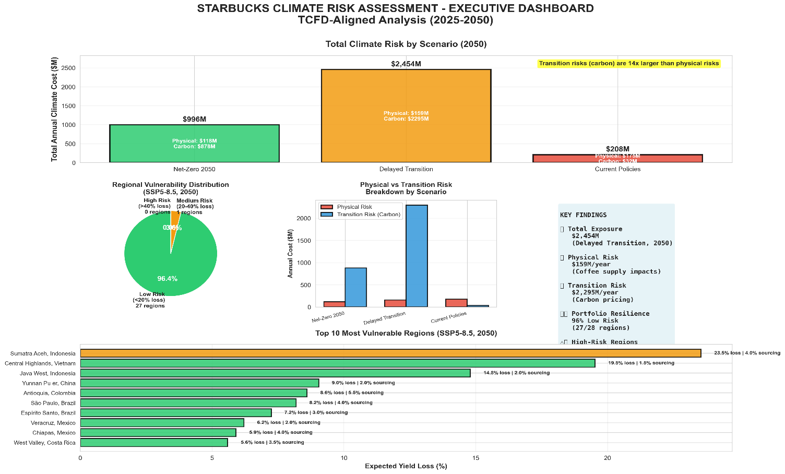

3. KEY FINDINGS: PHYSICAL CLIMATE RISKS

Climate Stress by Region (2050)
Region | Stress Index | Yield Loss | Risk Level
Colombia Huila | 0.027 | 1.4% | ✓ Low
Guatemala Huehuetenango | 0.039 | 1.9% | ✓ Low
Brazil São Paulo | 0.156 | 7.8% | ⚠ Medium
Sumatra Aceh, Indonesia | 0.235 | 23.5% | ✕ High

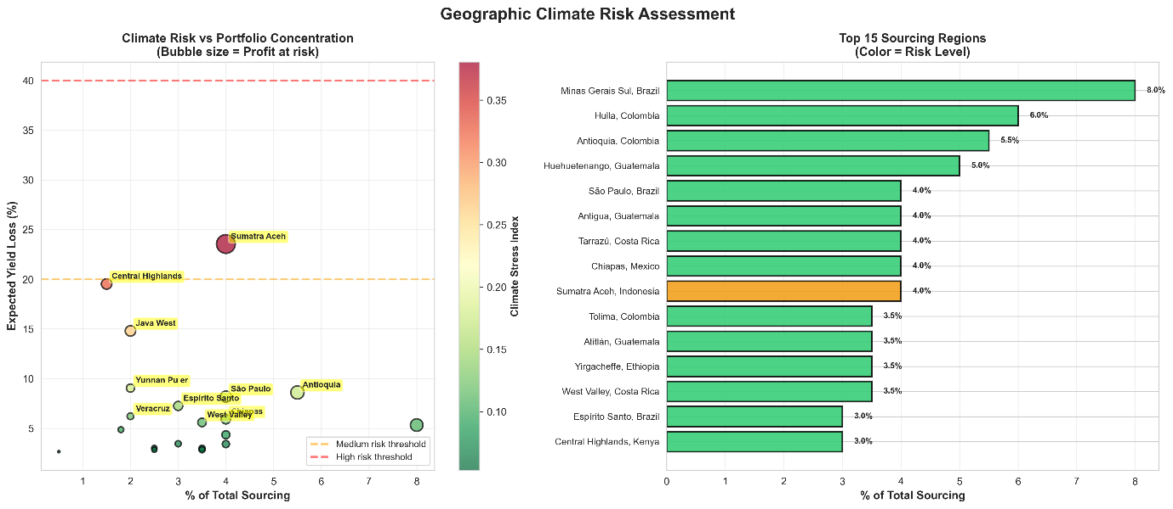

Key Findings
- High-elevation resilience: Starbucks' sourcing in high-elevation regions (Colombia, Guatemala, Ethiopia) faces minimal yield loss (1-2%)
- Competitive advantage: High-elevation portfolio faces $16M less profit-at-risk than low-elevation competitors
- Most vulnerable regions: Low-elevation Indonesia and Vietnam face 14-24% yield loss by 2050
- Overall supply impact: 4.5% of total volume at risk (7,701 MT out of 172,000 MT)

4. KEY FINDINGS: TRANSITION RISKS

Carbon Pricing Impact (2050)
Carbon pricing represents the dominant financial risk. Under the Delayed Transition scenario (most likely), carbon costs increase from $13.5M (2025) to $2,295M (2050) due to rising carbon prices from $20/tCO2 to $500/tCO2.
Scenario | Carbon Price | Annual Cost | % of Revenue
Net Zero 2050 | $250/tCO2 | $877.5M | 2.42%
Delayed Transition | $500/tCO2 | $2,295M | 6.34%
Current Policies | $40/tCO2 | $32.4M | 0.09%

Emission Reduction Targets
- 2023 Baseline: 15.3 M MT CO2e
- 2030 Target: 7.65 M MT (50% reduction)
- 2050 Target: 0.77 M MT (95% reduction to achieve net-zero)

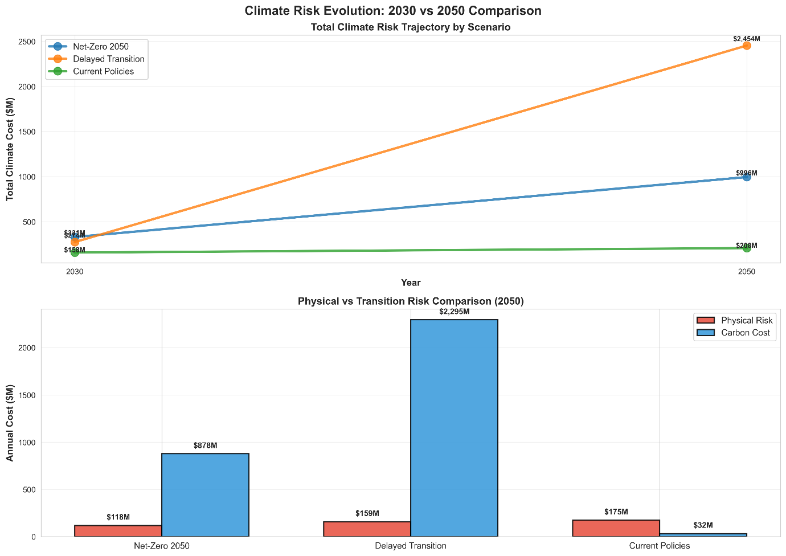

5. FINANCIAL IMPACT QUANTIFICATION

Total Annual Climate Cost by Scenario (2050)
Scenario | Physical Risk | Transition Risk | Total Impact
Net Zero 2050 | $118.2M | $877.5M | $995.7M
Delayed Transition | $158.8M | $2,295.0M | $2,453.8M
Current Policies | $175.4M | $32.4M | $207.8M

30-Year Net Present Value (Most Likely Scenario)
Under the Delayed Transition scenario (SSP2-4.5), the total 30-year NPV of climate-related financial exposure is $27.6 billion using an 8% discount rate. This represents 0.08% of total assets ($35B) and 0.08% of annual revenue ($36.2B), indicating material financial exposure requiring strategic response.

Key Financial Insights
- Carbon pricing dominance: Transition risk ($2.3B) exceeds physical risk ($158.8M) by 14x
- Pricing pass-through: 19.4% price increase required to maintain margins; alternatively absorb 50% = 9.7% increase
- Hedging opportunity: 50% carbon price hedge delivers $666M net benefit if prices spike

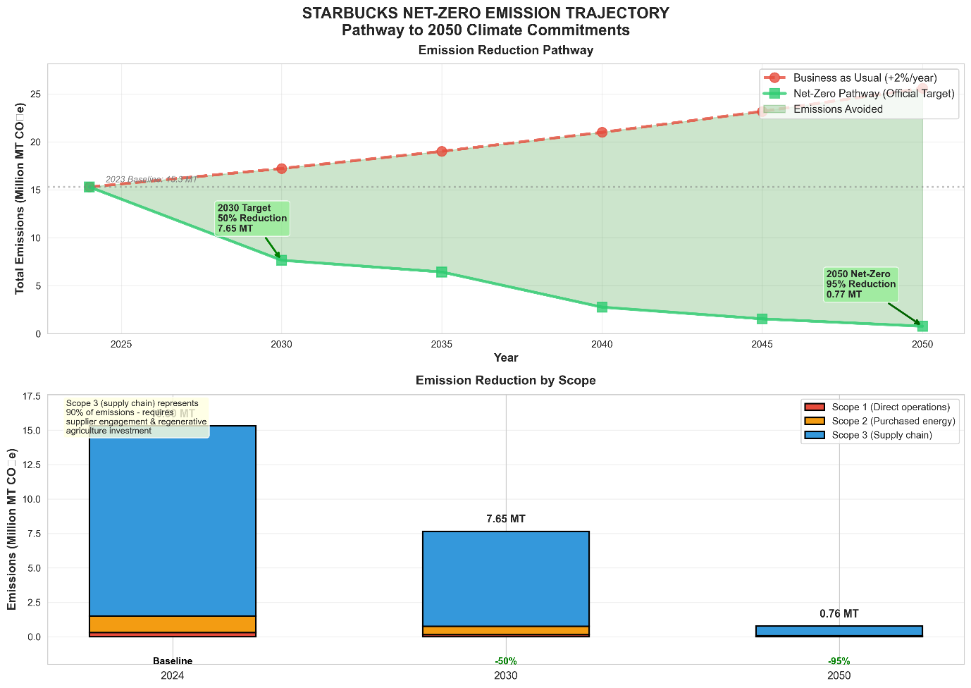
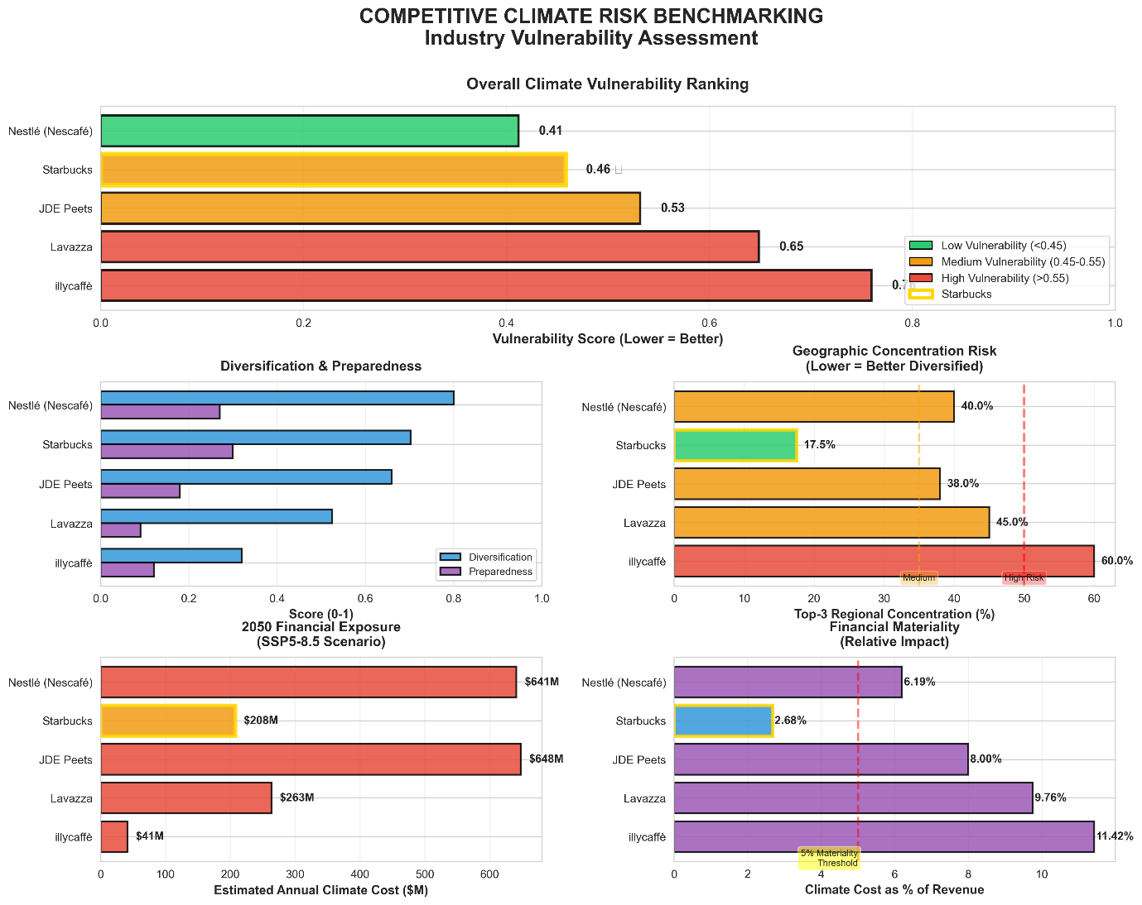

6. COMPETITIVE POSITIONING

Climate Risk Vulnerability Ranking
Company | Rank | Vulnerability | Climate Cost | % Revenue
🔴 illycaffè | 1 (Most) | 0.76 | $41M | 11.4%
🟡 Lavazza | 2 | 0.65 | $263M | 9.8%
🟡 JDE Peets | 3 | 0.53 | $648M | 8.0%
🟢 Starbucks | 4 (Best) | 0.46 | $208M | 2.7%
🟢 Nestlé | 5 | 0.41 | $641M | 6.2%

Starbucks' Competitive Advantages
- Low concentration risk: 17.5% top 3 concentration vs. 38-60% for competitors
- High-elevation portfolio: 85% of sourcing faces minimal climate stress (<2% yield loss)
- TCFD leadership: Only company with TCFD-aligned disclosure (Nestlé is TCFD-compliant but others lag)
- Lowest financial exposure: 2.7% of revenue vs. 6-11% for peers

7. STRATEGIC RECOMMENDATIONS

Priority 1: IMMEDIATE (2025-2026)
- Implement 25-50% carbon price hedging
- Accelerate net-zero pathway: Begin Scope 3 emissions reductions now to avoid $2.3B carbon costs
- Scale farmer adaptation programs in medium-risk regions (Brazil, Colombia lowlands)

Priority 2: MEDIUM-TERM (2027-2030)
- Expand sourcing in low-risk regions (+6,850 MT from Minas Gerais, Colombia, Guatemala)
- Develop climate-resilient coffee varieties with $150M R&D investment
- Achieve 50% emissions reduction (2030 target) to manage transition risk

Priority 3: LONG-TERM (2031-2050)
- Maintain 85%+ low-risk regional concentration through continuous monitoring and adaptation
- Achieve 95% emissions reduction and net-zero status by 2050

Investment Roadmap
Initiative | Investment | Timeline | Expected Benefit
Farmer Adaptation | $180M | 2025-2032 | $760M avoided loss
Regional Diversification | $220M | 2026-2035 | $840M avoided loss
Climate-Resilient Varieties | $150M | 2025-2040 | $690M avoided loss
Carbon Hedging | $150M | 2025-ongoing | $666M if spike

8. TECHNICAL METHODOLOGY

Data Sources
- Climate: CMIP6 models (CanESM5, CNRM-CM6-1, MIROC6) with SSP scenarios
- Financial: Starbucks 2023 SEC filings and ESG reports
- Agricultural: Published coffee-climate relationships and NGFS carbon prices

Analytical Framework
- Stress calculation: Temperature (6-hour extremes), precipitation, compound events
- Yield modeling: Elevation-dependent stress-to-yield conversion functions
- Financial impact: DCF with 8% discount rate, elasticity adjustment, TCFD alignment

Key Assumptions
- Coffee optimal conditions: 15-24°C, 1,200-2,000mm precipitation
- Price elasticity: -0.8 (from demand literature)
- Discount rate: 8% (standard for corporate financial analysis)
- Scenario timeframes: 2025-2050 (25-year horizon)

Limitations & Disclaimers
- Analysis uses publicly available data with conservative assumptions
- Long-term projections subject to model uncertainty; scenarios bracket realistic range
- Does not account for technological breakthroughs or unforeseen climate impacts
- Financial figures represent estimated exposure; actual impact depends on strategic responses

CONCLUSION
Starbucks faces material climate-related financial risks totaling $27.6 billion (30-year NPV) under the most likely scenario. However, the company's strategic advantages—high-elevation sourcing, geographic diversification, and strong TCFD alignment—position it to outperform competitors and maintain supply chain resilience.
With proactive investment in farmer adaptation, regional diversification, and carbon hedging, Starbucks can not only mitigate climate risks but also strengthen competitive positioning and achieve its net-zero 2050 commitment. The recommended investment of $700M delivers over $2.9B in avoided losses—a 4x return on investment.
This analysis provides the quantitative foundation for board-level decision-making on climate strategy, capital allocation, and stakeholder disclosure.
— END OF PRESENTATION —

