
Vaughan: Physics-Guided Score-Based Data Assimilation for Three-Dimensional Hurricane Structure Retrieval
Multi-modal fusion of GOES-16 infrared imagery and ATMS microwave soundings with a conditional diffusion prior and a differentiable radiative-transfer constraint, applied to Hurricane Milton (October 2024)
Technical Report
Platform: Vaughan. Software package: vaughan v0.3.0 (repository github.com/Ibekwemmanuel7/vaughan). Results dashboard: ibekwemmanuel7.github.io/vaughan/dashboard
Author: Emmanuel Chidi Ibekwe
September 2026
Abstract
This report documents the design, implementation, verification and real-data results of vaughan, a modular PyTorch system that reconstructs the three-dimensional temperature field (200 to 1000 hPa) and the surface precipitation field of a tropical cyclone from satellite observations alone, with no forecast model. Geostationary infrared imagery (GOES-16 ABI) and polar-orbiting microwave soundings (NOAA-20 ATMS) are co-registered on a storm-centred grid, fused by a U-Net whose infrared feature maps attend over microwave tokens, and assimilated by a physics-guided score-based diffusion sampler whose likelihood combines the U-Net proxy, a per-channel calibrated radiative-transfer operator and a static-stability constraint. Applied to 16 analysis times of Hurricane Milton (6 to 10 October 2024), with the prior and proxy trained on 805 storm-centred scenes from 2017 to 2022 and Milton held out, the 8-member analysis places the warm core at 250 to 400 hPa in 15 of 16 scenes, agrees with ERA5 to 1.0 to 2.8 K over the domain and 1.1 K in the inner core on scenes with a sounder overpass, and fits the bias-corrected ATMS sounding channels to 1.5 to 2.8 K, below the 2.5 to 3 K the reanalysis truth itself achieves. Two findings on real data shaped the final design: a channel-by-channel audit of the analytic operator against truth showed the oxygen sounding channels to be usable after a constant 14 to 23 K correction and the window channels unusable under an ice canopy, and an instrumented chain showed that likelihood guidance applied before the Tweedie estimate is meaningful drives the sampler off the data manifold, which a Tweedie-variance inflation of the observation errors and an early gate resolve (15.9 K to 1.7 K on the test scene). A three-way comparison shows the full system and the direct proxy agreeing to 0.01 K, the conclusion Tomorrow.io reported for ICGen, while a physics-only experiment shows the likelihood fitting the radiances without retraining at the cost of the resolution a 16 x 16 sounder grid cannot supply. The report closes with a guide to the results dashboard, the position of the work relative to Tomorrow.io's published sounder papers, and recommendations.

Contents

1. Executive Summary
Tropical cyclones are observed almost continuously from geostationary orbit, but only their cloud tops. The structure that determines intensity, the warm core aloft and the eyewall precipitation, is visible only to microwave sounders on polar orbiters, which pass a given storm a few times a day at a resolution of tens of kilometres. Operational centres bridge this gap with numerical weather prediction and variational data assimilation, a procedure that costs hours of supercomputer time per analysis cycle. This project replaces that procedure with a generative machine-learning inverse solver that ingests the two satellite data streams and produces a full three-dimensional diagnostic state in a few minutes on a single GPU, and it has been run end to end on real observations of Hurricane Milton, the most rapidly intensifying Gulf hurricane on record.
The system has three learned or physical components. The first is a Cross-Attention U-Net that produces a deterministic multi-channel proxy of the state: the infrared image is encoded at full resolution and, at the two deepest levels of both the encoder and decoder, every infrared pixel attends over the entire grid of microwave sounder tokens, so the deep-atmosphere signal captured only by the sounder is redistributed spatially by the fine infrared texture. The second is an unconditional score-based diffusion prior trained purely on reanalysis states, which encodes what physically realised hurricane structures look like. The third is a differentiable radiative-transfer operator together with a thermodynamic penalty; both are placed inside the reverse-diffusion loop so that every sample is pulled toward states whose simulated brightness temperatures match the satellites and whose lapse rates never exceed the dry adiabat.
On Milton the system works, and the path to making it work is the substance of this report. The first retrieval on real data was wrong in a diagnosable way; an audit of the observation operator against reanalysis truth sorted the satellite channels into the five that can be trusted after a constant correction and the seven that cannot be represented without cloud physics, and an instrumented sampling chain exposed a guidance schedule that pushed samples off the data manifold. With both corrected, the analysis places Milton's warm core at 250 to 400 hPa in 15 of 16 analysis times, matches ERA5 to about 1 K in the inner core where a sounder overpass exists, and fits the sounding channels to their noise floor. A three-way comparison against the direct proxy and a physics-only retrieval gives a measured answer to whether the generative step is worth its cost: not when the proxy is in distribution, which is also Tomorrow.io's finding, and yes when the proxy has not seen the observation, where the physics carries it at the cost of resolution. Section 14 is a guide to the interactive results page and Section 15 sets the work beside Tomorrow.io's published sounder papers.
The package is complete and tested. It comprises about 3,000 lines across 26 modules, including an xarray-based ingestion layer with exact geostationary inverse projection, swath interpolation with coverage masks and reanalysis regridding; the two networks; a variance-preserving SDE with Tweedie denoising; the physics operators; a predictor-corrector guided sampler; training loops with mixed precision and exponential moving averages; a CLI that writes CF-compliant NetCDF analyses; an archive-access layer with drivers for the Milton case and a multi-storm training archive; and a nine-test suite that runs on a CPU in under half a minute. The remainder of this report describes each component at the level of equations and tensor shapes, presents the synthetic verification, the real-data results and their diagnosis, the dashboard guide, and the limitations that separate this prototype from an operational system.

2. Scientific Motivation and Problem Statement

2.1 The observational gap
The Advanced Baseline Imager on GOES-16 returns a full-disk image every ten minutes and a mesoscale sector every thirty seconds, at a nadir resolution of two kilometres in the infrared. Channel 13 (10.3 micrometres) is a clean window channel whose brightness temperature is, under opaque cloud, the temperature at cloud top; channels 8 and 10 (6.2 and 7.3 micrometres) are water-vapour channels whose weighting functions peak in the upper and middle troposphere. None of these channels penetrates the cirrus canopy of a mature hurricane, so the imager sees a smooth cold shield with an eye, not the eyewall or the warm core.
The Advanced Technology Microwave Sounder on Suomi-NPP, NOAA-20 and NOAA-21 measures in the 50 to 57 GHz oxygen absorption band, where ice cloud is nearly transparent. Channels 5 to 9 have weighting functions that peak from the boundary layer to the lower stratosphere, and their combination is a coarse temperature profile; channel 7 (54.4 GHz), peaking near 400 hPa, sees the warm-core anomaly directly. Higher-frequency channels at 88, 165 and 183 GHz are depressed by scattering from precipitation-sized ice and therefore map the eyewall and rainbands. The cost is resolution and cadence: the 50 GHz footprint is about 32 km at nadir and the sun-synchronous orbit yields a handful of overpasses per day, frequently with the storm at the swath edge or missed entirely.

2.2 The data-assimilation bottleneck
Operational analyses combine these observations with a short-range forecast through 4D-Var or ensemble Kalman methods. Both require the forward observation operator (a radiative-transfer model such as CRTM or RTTOV) and, for 4D-Var, its tangent-linear and adjoint, evaluated repeatedly inside an iterative minimisation coupled to the full forecast model. The wall-clock cost of a global cycle is measured in hours, and regional hurricane systems such as HAFS carry a similar burden. For rapidly intensifying storms, Milton being a canonical example, the analysis is stale by the time it is issued.

2.3 The hallucination problem
A straightforward alternative is to regress the reanalysis state directly from the satellite images with a convolutional network. Such regressors minimise a pixelwise loss and therefore return the conditional mean, which is spatially blurred wherever the observations are ambiguous; they also have no mechanism that forbids a temperature profile with a super-adiabatic layer or a precipitation field inconsistent with the cloud-top temperatures that were used to infer it. In data-assimilation language, a regressor has no background-error covariance and no observation operator. The generative approach adopted here restores both: the diffusion prior plays the role of a flow-dependent background distribution, and the radiative-transfer operator inside the likelihood plays the role of the observation term.

2.4 Objectives
- Multi-modal fusion. Blend unaligned infrared and microwave grids with a Cross-Attention U-Net so that the fine infrared texture guides and up-scales the deep-atmosphere signal from the sounder.
- Real-time assimilation. Replace the variational minimisation with a conditional score-based sampler that returns a physically consistent three-dimensional grid and its uncertainty in seconds.
- Physical integrity. Enforce radiative consistency with the observed brightness temperatures and thermodynamic consistency (static stability, non-negative rain) inside the generative loop rather than as a post-hoc filter.

3. System Overview
Figure 1 shows the data flow. Raw satellite granules and reanalysis fields are co-registered on a storm-centred grid and persisted as one NetCDF scene per analysis time. At training time, the scenes feed two independent learning problems: a supervised problem for the U-Net proxy and an unsupervised denoising-score-matching problem for the prior. At inference time, the U-Net runs once and the sampler runs a small ensemble of reverse chains, each step of which evaluates the score network, forms the Tweedie estimate of the clean state, pushes it through the radiative-transfer operator and the thermodynamic penalty, and back-propagates the resulting cost to the noisy state.
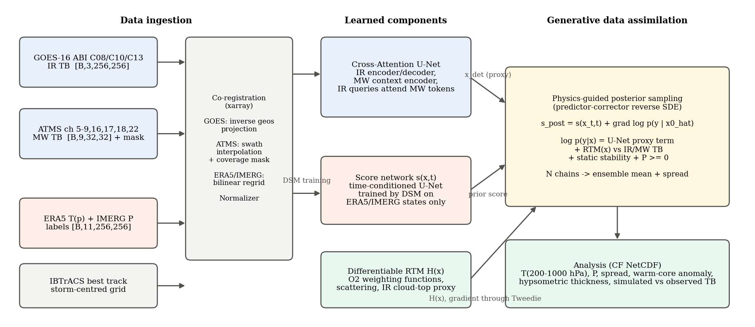
Figure 1. End-to-end architecture of vaughan. Blue boxes carry observations, orange boxes carry the learned state prior and its labels, green boxes are physics operators and outputs, and the yellow box is the generative data-assimilation step.
Table 1. Package layout.
Module | Responsibility
config.py | Dataclass configuration, tensor conventions, level and channel definitions, small_debug() preset for CPU tests
data/coregistration.py | TargetGrid; GOES fixed-grid inverse projection; ATMS swath interpolation with coverage mask; ERA5/IMERG regridding
data/dataset.py | build_scene() and scene cache; Normalizer with differentiable state-to-physical map; HurricaneSceneDataset; collate
data/best_track.py | IBTrACS and HURDAT2 parsers, lookup by name and season, storm listing for the archive, centre interpolation
data/download.py | Archive access: GOES-16 (anonymous S3), ATMS L1B and IMERG (NASA Earthdata), ERA5 (Copernicus CDS), IBTrACS; selection helpers separated from I/O
scripts/prepare_milton.py, prepare_archive.py | Drivers that resolve the track, fetch every source, write the manifest and build the scene cache for the Milton case and the multi-storm archive
data/synthetic.py | Analytic tropical-cyclone scenes with radiatively consistent observations for tests and dry runs
models/blocks.py | ResBlock with FiLM time conditioning, masked CrossAttention2D, SelfAttention2D, sinusoidal time embedding
models/unet_xattn.py | CrossAttentionUNet and MicrowaveContextEncoder
models/score_net.py | ScoreUNet (epsilon-parameterised prior score) and GaussianClimatologyScore (closed-form static-B baseline)
models/sde.py | VPSDE: marginals, perturbation kernel, Tweedie estimate, denoising score-matching loss
physics/rtm.py | AnalyticRTM, NeuralRTMResidual, HybridRTM
physics/constraints.py | Static-stability penalty, non-negativity penalty, hypsometric thickness, warm-core diagnostic
assimilation/guidance.py | Observations container and JointLikelihood (sum-form negative log-likelihood, diagnostics)
assimilation/sampler.py | GuidedScoreSampler: predictor-corrector reverse SDE on the posterior score with DPS guidance and ensemble output
train/ | train_unet.py, train_score.py (with optional RTM residual fit), common.py (EMA, checkpoints, AMP, logging)
inference/run_milton.py | RetrievalEngine and the command-line driver that writes CF NetCDF analyses; --no-mw and --no-rtm ablation flags
tests/ | Nine tests: five end-to-end on synthetic scenes (including the exact-prior assimilation check) and four offline tests of the archive selection logic

4. Data Ingestion and Co-Registration

4.1 Sources
Table 2 lists the data sources for the Milton case (NHC identifier AL142024, 5 to 10 October 2024) and for the multi-storm training archive. At inference the reanalysis and IMERG fields are used only to compute verification metrics; the retrieval itself sees nothing but the two satellite streams.
Table 2. Data sources and roles.
Source | Product | Role | Native geometry
GOES-16 ABI | L2 CMIP channels C08, C10, C13 (NOAA AWS goes16 bucket) | Input 1: high-resolution IR brightness temperature | Geostationary fixed grid, 2 km, 10-min cadence
ATMS (SNPP, NOAA-20, NOAA-21) | L1B antenna/brightness temperature (GES DISC or NOAA CLASS) | Input 2: microwave sounding, channels 5-9, 16, 17, 18, 22 | Cross-track swath, 96 FOV per scan, 16-32 km footprints
ERA5 | Pressure-level temperature, 10 levels 200-1000 hPa (Copernicus CDS) | Target label: 3D temperature | Regular 0.25 degree lat/lon, hourly
IMERG | Final or Late half-hourly precipitationCal (GES DISC) | Target label: surface rain rate | Regular 0.1 degree lat/lon
IBTrACS / HURDAT2 | Best-track positions | Storm-centred domain definition | 6-hourly (3-hourly in IBTrACS)

4.2 Archive access
The module data/download.py retrieves every source with one selection helper per source, kept free of I/O so that it is unit-tested offline, and one thin transfer function. GOES-16 files are listed from the anonymous noaa-goes16 bucket for the hour of the analysis time and its neighbours; the CONUS product (five-minute cadence, files about ten times smaller than full disk) is chosen automatically when the storm centre lies inside the GOES-East CONUS sector, and the scan whose start is nearest the analysis time within 7.5 minutes is taken for each channel. ATMS L1B version 3 granules from Suomi-NPP, NOAA-20 and NOAA-21 (collections SNPPATMSL1B, SNDRJ1ATMSL1B and SNDRJ2ATMSL1B at GES DISC) are found through a CMR spatial and temporal query around the storm; the six-minute granules are clustered into overpasses per platform and the overpass whose mid-time is nearest the analysis time within 90 minutes is downloaded whole, so the swath is complete across the domain. The time offset of the overpass is recorded in the manifest and in the scene attributes. IMERG half-hourly files come from the same Earthdata route, and ERA5 temperature on the ten levels is requested from the Copernicus Climate Data Store once per storm-day over a padded track bounding box, which keeps the number of queued requests small. IBTrACS is fetched from NCEI and the best-track reader looks a storm up by name and season or lists every storm in a season range that reached a wind threshold, which is how the training archive is assembled. A manifest (JSON) ties the files for each analysis time together and feeds build_scene_cache().
Two drivers wrap this. prepare_milton.py resolves the Milton track, takes a list of analysis times or a regular cadence, fetches all sources incrementally (existing files are never re-fetched) and builds the scene cache. prepare_archive.py does the same for every North Atlantic hurricane in a season range at three-hourly cadence while the storm is at tropical-storm strength or above, holding Milton and the 2024 season out, with an option to start with the most intense storms so that a first prior can be trained while the rest downloads. A parsing trap worth recording: pandas reads the North Atlantic basin code NA as a missing value unless default missing-value detection is disabled, which would silently empty the archive selection.

4.3 The storm-centred target grid
Every source is mapped onto one regular latitude-longitude grid of 256 by 256 cells at 0.02 degrees (about 2.2 km, matching the ABI infrared resolution) centred on the interpolated best-track position at the analysis time. Centring on the storm removes translation as a nuisance variable, makes the warm-core and eyewall statistics stationary across storms, and allows dihedral augmentation without breaking the physics. The microwave grid is the block-mean coarsening of the same grid by a factor of eight, giving 32 by 32 cells at about 17 km, comparable to the ATMS 50 GHz footprint after oversampling.

4.4 Geostationary imagery: exact inverse projection
ABI data are stored on the fixed grid of scan angles (x, y) of the GOES-R geostationary projection, which is curvilinear in latitude and longitude. Rather than resample the whole disk to a rectangular grid, the target latitude and longitude arrays are projected into fixed-grid metres with the projection parameters carried in the file (perspective point height, longitude of the projection origin, sweep axis, ellipsoid), divided by the satellite height to obtain scan angles, and then bilinearly sampled on the regular source (y, x) grid with a RegularGridInterpolator. This is exact up to bilinear interpolation, involves no scattered-point search, and returns a validity mask for target points beyond the Earth disc. The mask is carried through the pipeline and concatenated to the network input.

4.5 Microwave soundings: swath interpolation with coverage masks
ATMS granules are point clouds indexed by scan line and field of view. Each channel is interpolated linearly on the Delaunay triangulation of the observation positions onto the coarse grid, and a coverage mask is built from the distance to the nearest real observation, so cells beyond the swath edge or in a gap are flagged invalid. Fill values outside the physical range are dropped before interpolation. The mask is essential downstream: the cross-attention layer excludes invalid tokens from the key set, and the likelihood excludes invalid cells from the observation term. A scene with no overpass at all is legal; the network then behaves as an infrared-only retrieval and the likelihood carries only the infrared term.

4.6 Labels: reanalysis and IMERG
ERA5 temperature on the ten levels and IMERG rain rate are regridded bilinearly with xarray advanced interpolation, handling the 0 to 360 versus minus 180 to 180 longitude conventions and descending latitude automatically. ERA5 at 0.25 degrees is far smoother than the target grid, which is a known limitation discussed in Section 13; the pipeline accepts any regular lat/lon source, so HAFS or HWRF analyses can be substituted without code changes.

4.7 The scene format
The output of co-registration is a single CF-style xarray Dataset per analysis time, persisted as NetCDF and read by the PyTorch Dataset. Its variables and dimensions are given in Table 3. Keeping the physical units and the masks in the cache, and applying normalisation only in the Dataset, means the same cache serves training, verification and the likelihood, which needs raw Kelvin.
Table 3. Scene dataset schema.
Variable | Dimensions | Units | Description
ir | (ir_channel, y, x) | K | GOES brightness temperature on the target grid
ir_mask | (y, x) | bool | Valid where all IR channels are on the Earth disc and finite
mw | (mw_channel, yc, xc) | K | ATMS brightness temperature on the coarse grid
mw_mask | (yc, xc) | bool | Swath coverage
temp | (level, y, x) | K | ERA5 temperature, levels top to bottom
precip | (y, x) | mm/h | IMERG rain rate
lat, lon / latc, lonc | (y, x) / (yc, xc) | deg | Fine and coarse grid coordinates

4.8 Normalisation and the state vector
The state vector that the prior models and the sampler evolves is a tensor of shape [B, L+1, H, W] with L = 10: channels 0 to 9 hold temperature on the levels 200, 250, 300, 400, 500, 600, 700, 850, 925 and 1000 hPa and channel 10 holds log1p of the rain rate in mm/h. The logarithm compresses the heavy-tailed rain distribution so that a Gaussian diffusion prior is appropriate. Each channel is standardised with statistics fitted on the training split and saved as JSON. The Normalizer exposes state_to_physical, a differentiable map from normalised state to Kelvin and mm/h; it is called inside the likelihood so that gradients flow from the radiative-transfer operator back to the normalised sample. The exponential is clamped at log-space 12 to keep the inverse map finite during the early, unreliable steps of the reverse process.

4.9 Augmentation
Because the domain is storm-centred and the physics is invariant under rotation and reflection in the horizontal, the Dataset applies random 90-degree rotations and flips consistently to the fine grid, the coarse grid, the masks and the labels. This eightfold augmentation is particularly valuable for the small number of intense storms available for training.

4.10 Synthetic scenes
To make the package testable without any downloads, a synthetic generator produces idealised tropical cyclones: a tropical reference profile with a Gaussian warm core peaking near 350 hPa, an eyewall ring of rain at a random radius of maximum wind and two logarithmic-spiral rainbands. Observations are generated by running the analytic radiative-transfer operator forward and adding sensor noise (1 K infrared, 0.7 K microwave), and a random straight swath edge masks part of the microwave field. Figure 2 shows one such scene. Because the observations are exactly consistent with the operator, the synthetic set isolates the behaviour of the fusion network and the sampler from representativeness error.
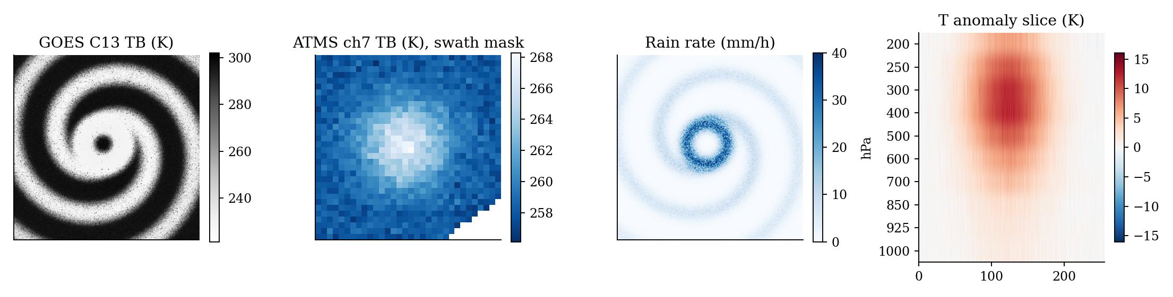
Figure 2. A synthetic scene at full 256 by 256 resolution: channel 13 brightness temperature, ATMS channel 7 with the swath mask (white), rain rate, and a vertical cross-section of the temperature anomaly through the storm centre showing the upper-tropospheric warm core.

5. Feature Extraction and Conditioning: the Cross-Attention U-Net

5.1 Design
The U-Net is the deterministic proxy. Its input is the infrared image concatenated with its validity mask, [B, 4, 256, 256]; its output is a proxy state x_det of shape [B, 11, 256, 256] in normalised units. The encoder has four levels with channel widths 64, 128, 256 and 512 and two residual blocks per level, each block using GroupNorm, SiLU and a zero-initialised second convolution so that the network starts as an identity map through the skip path. A global self-attention block at the bottleneck (32 by 32, 1,024 tokens) gives every location access to the whole storm, which matters for the axisymmetric structure of the warm core.
The microwave input, [B, 10, 32, 32] after concatenating the coverage mask, is processed by a separate context encoder of three residual blocks and one self-attention block that keeps the native coarse resolution. It is deliberately not upsampled to the infrared grid: bilinear upsampling would bake in a fixed alignment and smear the swath edge, whereas the cross-attention layer learns the alignment and can ignore invalid tokens exactly.

5.2 Cross-attention between the paths
At encoder levels 2 and 3 (64 by 64 and 32 by 32 feature maps) and at the mirrored decoder levels, a CrossAttention2D block conditions the infrared feature map on the microwave context. The queries are the infrared pixels, N_q = H_l times W_l tokens, and the keys and values are the 1,024 microwave tokens. Learned two-dimensional positional embeddings are added on both sides so that the attention can express geometric proximity as well as content similarity. The attention mask is built from the coverage mask, and a sample with no valid microwave token at all attends uniformly over zeros so the layer degrades gracefully to an identity. The output passes through a scalar gate initialised to zero, so at initialisation the U-Net is a pure infrared network and the microwave pathway is switched on gradually by the optimiser, a standard stabiliser for injecting a new modality.
Attention(Q, K, V) = softmax( (Q + P_q)(K + P_k)^T / sqrt(d) + M ) V, M_ij = 0 if token j is valid, minus infinity otherwise
With eight heads and d = 32 per head at the deepest level, a batch element at level 2 performs a 4,096 by 1,024 attention, which is cheap relative to the convolutions. Table 4 gives the resolution bookkeeping.
Table 4. Resolution and token counts through the U-Net (default configuration).
Level | Feature map | Channels | IR tokens (queries) | MW tokens (keys) | Cross-attention
0 | 256 x 256 | 64 | 65,536 | - | no
1 | 128 x 128 | 128 | 16,384 | - | no
2 | 64 x 64 | 256 | 4,096 | 1,024 | yes (encoder and decoder)
3 | 32 x 32 | 512 | 1,024 | 1,024 | yes (encoder and decoder) + self-attention bottleneck

5.3 Training objective
The proxy is trained with a channel-weighted mean-squared error on the normalised state, with the precipitation channel up-weighted by three because it is a single channel competing with ten temperature channels, plus an auxiliary radiative-consistency term: the prediction is converted to physical units, pushed through the radiative-transfer operator and compared with the observed brightness temperatures over valid pixels, scaled by the observation-error variances. This auxiliary loss, weighted 0.1 by default, teaches the proxy to respect the radiative constraint before the generative stage and gives the sampler a starting point that is already close to the observation manifold. The default model has 49.7 million parameters.

6. The Generative Prior: Variance-Preserving SDE and Score Network

6.1 Forward and reverse processes
The prior is a score-based generative model in the SDE formulation of Song et al. (2021), using the variance-preserving process
dx = -(1/2) beta(t) x dt + sqrt(beta(t)) dW, t in [0, 1], beta(t) = beta_min + t (beta_max - beta_min)
with beta_min = 0.1 and beta_max = 20. The perturbation kernel is Gaussian, x_t = alpha(t) x_0 + sigma(t) z with alpha(t) = exp(-(1/4) t^2 (beta_max - beta_min) - (1/2) t beta_min) and sigma^2 = 1 - alpha^2, so x_1 is indistinguishable from standard normal noise. Samples are generated by integrating the reverse-time SDE
dx = [ -(1/2) beta(t) x - beta(t) s(x, t) ] dt + sqrt(beta(t)) dW_bar
from t = 1 to a small t, where s(x, t) approximates the score of the marginal density, the gradient of log p_t(x). The Tweedie formula gives the posterior mean of the clean state given a noisy one, x0_hat = (x_t + sigma^2 s(x_t, t)) / alpha, and is the bridge that lets a likelihood defined on clean states be applied at every noise level.

6.2 The score network
The score is parameterised through noise prediction: the network outputs epsilon_hat(x_t, t) and the score is minus epsilon_hat divided by sigma(t). The network is a time-conditioned U-Net of the same family as the proxy, with channel widths 96 to 768, FiLM conditioning of every residual block on a sinusoidal-plus-MLP embedding of t (scaled to a 0 to 1000 range so the embedding resolves the whole schedule), self-attention at the deepest level and at the bottleneck, and a zero-initialised output convolution. It has 107.8 million parameters in the default configuration. The default is strictly unconditional: it takes only the state and t, so it learns the climatology of realised three-dimensional hurricane structures and nothing about the sensors. A cond_channels option allows a conditional variant that concatenates the U-Net proxy to the input; that variant is faster to sample but entangles the prior with the sensor and is not used in the reference pipeline.

6.3 Denoising score matching
Training minimises the epsilon-form denoising score-matching objective, E || epsilon_hat(alpha x_0 + sigma z, t) - z ||^2 with t uniform on [0.001, 1] and z standard normal, which is the weighted score-matching loss with the weighting that keeps the loss well scaled across noise levels. The optimiser is AdamW with betas (0.9, 0.99), a linear warm-up, gradient-norm clipping at 1 and an exponential moving average of the weights with decay 0.9995; the EMA weights are the ones used at inference. Training uses only the ERA5 and IMERG channels of the scene cache; the satellite channels are never read.

6.4 A closed-form baseline: the Gaussian climatology prior
For a diagonal Gaussian prior x_0 ~ N(mu, diag(v)) per pixel, the marginal at time t is also Gaussian and the score is available in closed form: s(x_t, t) = -(x_t - alpha mu) / (alpha^2 v + sigma^2). The package implements this as GaussianClimatologyScore, fitted from the per-pixel mean and variance of the training states. It is the generative analogue of a static background-error covariance in classical data assimilation, serves as a baseline against which the learned prior must improve, and, because it is exact, is the reference used to unit-test the guided sampler independently of how well the score network has been trained (Section 11).

7. Physics Operators

7.1 Requirements on the forward operator
The forward operator H maps a physical state (temperature on ten levels, rain rate) to the brightness temperatures the two sensors would observe. Inside the sampler it is evaluated and differentiated once per step per chain, so it must be a pure PyTorch function with a cheap gradient, and it must capture the structure of the radiative constraint: upper-tropospheric warming shows up in the 54 GHz channels, deep convection shows up as cold infrared tops, and precipitation depresses the 165 and 183 GHz channels. A full line-by-line model is unnecessary for guidance, whose job is to pull the sample toward the observation manifold rather than to reproduce radiances to a tenth of a Kelvin.

7.2 The analytic operator: microwave
For each sounding channel k the clear-sky brightness temperature is written as a weighting-function average of the temperature profile,
TB_k = sum_l W_k(l) T_l, W_k(l) proportional to exp( -(ln p_l - ln p_k*)^2 / (2 w^2) ), sum_l W_k(l) = 1
with the peak pressures p_k* set from the published ATMS clear-sky weighting functions (950, 700, 400, 250 and 200 hPa for channels 5 to 9, the last clipped to the model top) and a width of 0.45 in ln p. The fields are footprint-averaged by an 8 by 8 average pool before the operator is applied, so that the operator sees what a 17 km footprint sees. Precipitation scattering is represented as a channel-dependent depression proportional to log1p of the footprint-mean rain rate, with coefficients of 6, 14, 20 and 9 K per unit for the 88, 165, 183 plus or minus 7 and 183 plus or minus 1 GHz channels and near zero for the oxygen channels. Table 5 lists the constants.
Table 5. Analytic radiative-transfer constants.
ATMS channel | Frequency (GHz) | WF peak (hPa) | Scattering coefficient (K per log1p mm/h)
5 | 52.8 | 950 | 0.5
6 | 53.6 | 700 | 0.3
7 | 54.4 | 400 | 0.1
8 | 54.94 | 250 | 0.0
9 | 55.5 | 200 (clipped) | 0.0
16 | 88.2 | 1000 | 6
17 | 165.5 | 900 | 14
18 | 183.31 +- 7 | 700 | 20
22 | 183.31 +- 1 | 400 | 9

7.3 The analytic operator: infrared
The infrared operator blends a clear-sky weighting-function term with an opaque cloud-top term. The cloud fraction of a pixel is 1 - exp(-P / P_0) with P_0 = 0.5 mm/h, and the cloud-top pressure is a smooth monotone function of rain rate, ln p_ct = ln 950 - (ln 950 - ln 150)(1 - exp(-P / P_1)) with P_1 = 4 mm/h, so that deep convection is assigned high, cold tops. The cloud-top temperature is read from the profile by a differentiable soft interpolation in ln p (a softmax over levels with width 0.12), and the channel brightness temperature is the cloud-fraction-weighted mix of cloud-top and clear-sky values. The clear-sky peaks are 350 and 550 hPa for the water-vapour channels and the surface for channel 13. The cloud-top parametrisation is the least physical part of the operator, since it infers cloud height from rain rate rather than from a hydrometeor profile that is not in the state; it is nevertheless strongly informative in a hurricane, where the coldest tops sit over the eyewall and rainbands, and it is the component most improved by the learned residual described next.

7.4 Hybrid operator with a learned residual
NeuralRTMResidual is a small convolutional network with zero-initialised output heads that maps the physical state to a residual brightness temperature on the fine grid and, after an average pool, on the coarse grid. HybridRTM adds this residual to the analytic operator; untrained it is exactly the analytic operator, and a dedicated training loop fits it on collocated reanalysis-satellite samples with a masked mean-squared brightness-temperature loss. The intended production path is to fit the residual on the multi-storm archive, then tighten the observation-error variances in the likelihood accordingly.

7.5 Thermodynamic constraints
Hydrostatic balance relates geopotential to temperature; with temperature on fixed pressure levels as the state, the geopotential thickness of each layer follows from the hypsometric equation, dz = (R_d / g) T_mean d ln p, and is returned as a derived product rather than imposed. What a temperature profile on pressure levels can violate is static stability. The penalty
J_s = mean over layers and pixels of relu( dT / d ln p - kappa T_mean )^2, kappa = R_d / c_p = 0.2857
is zero for any profile whose lapse rate is at or below the dry adiabat in every layer and grows quadratically with the super-adiabatic excess. A resolved reanalysis state never contains such layers, so the penalty removes a class of hallucinations that a pixelwise loss cannot see. A quadratic penalty on negative rain rates completes the constraint set. Both penalties are means per pixel scaled by the pixel count so that their weights are grid-size independent.

8. Physics-Guided Score-Based Data Assimilation

8.1 The posterior score
Bayes' rule in score form states that the score of the posterior is the sum of the prior score and the gradient of the log-likelihood. The joint negative log-likelihood evaluated at a candidate clean state x_0 (in normalised units) is
J(x_0) = ||x_0 - x_det||^2 / (2 sigma_u^2) + sum_ir m ||TB_ir - H_ir(x_0)||^2 / (2 sigma_ir^2) + sum_mw m ||TB_mw - H_mw(x_0)||^2 / (2 sigma_mw^2) + lambda_s N J_s + lambda_p N J_p
where m are the validity masks, N the pixel count, and every sum runs over valid pixels and channels. The first term is the background in data-assimilation language, except that the background is the learned multi-modal proxy rather than a forecast; the second and third are the classical observation term with the differentiable operator; the last two are weak constraints. The defaults are sigma_u = 0.5 normalised units, sigma_ir = 5 K, sigma_mw = 2 K and unit penalty weights. Because H is evaluated on the physical state, the gradient chains through the de-normalisation and the exponential of the log-rain channel.

8.2 Applying a clean-state likelihood at every noise level
The likelihood is defined on clean states but the sampler lives on noisy ones. Following Diffusion Posterior Sampling (Chung et al., 2023), the likelihood is evaluated at the Tweedie estimate x0_hat(x_t) and differentiated with respect to x_t through the score network itself, so the guidance direction accounts for how the denoiser will respond to a perturbation. The posterior score used in the integrator is
s_post(x_t, t) = s_theta(x_t, t) - g clip_t grad_{x_t} J( C tanh( x0_hat(x_t) / C ) )
with guidance scale g = 1 by default (the Bayesian choice), a soft clamp of the Tweedie estimate at C = 6 normalised units, and a per-sample clip factor. The soft clamp matters at large t, where alpha is tiny and x0_hat is essentially x_t divided by alpha; without it the operator would be evaluated at temperatures of thousands of Kelvin and the exponential of the rain channel would overflow. The clip factor limits the displacement that the guidance term produces in one reverse step, beta(t) |dt| times the guidance gradient, to a root-mean-square of 0.25 normalised units, so that the sample cannot be thrown off the prior manifold while x0_hat is still unreliable; late in the chain the clip is inactive.

8.2b Guidance schedule: Tweedie-variance inflation and an early gate
Two further devices were added after the first retrievals on real Milton data diverged (Section 13.3). Both address the same fact: near t = 1 the Tweedie estimate is the noisy sample divided by a vanishing alpha, and a likelihood gradient taken there, however small the misfit it reports, is a gradient of noise. First, every observation error is inflated by the variance of the clean state given the current noisy sample, r_t^2 = sigma_t^2 / alpha_t^2 in normalised units, in the manner of pseudo-inverse guided diffusion (Song et al., 2023): the proxy term is divided by sigma_u^2 + r_t^2, each radiance channel by sigma_c^2 + r_t^2 s_T^2 with s_T the normaliser's temperature standard deviation in Kelvin, and the thermodynamic penalties are scaled by 1 / (1 + r_t^2). At t = 1, r_t^2 is about 2 x 10^4 and the guidance vanishes; by t = 0.3 it is about 1.5 and the guidance is at roughly half strength; by t = 0.06 it is 0.02 and the likelihood is applied as written. Second, no guidance at all is applied above guide_t_max = 0.65, where alpha is below about 0.5. The soft clamp and the per-step cap of Section 8.2 are retained as safety devices but no longer carry the burden of keeping early steps on the manifold.
J_t(x_0) = ||x_0 - x_det||^2 / (2 (sigma_u^2 + r_t^2)) + sum_c m ||TB_c - b_c - H_c(x_0)||^2 / (2 (sigma_c^2 + r_t^2 s_T^2)) + (lambda_s N J_s + lambda_p N J_p) / (1 + r_t^2)
Here b_c and sigma_c are the per-channel bias and error standard deviation measured by the observation-operator audit of Section 13.2, and the sum runs only over the channels the audit admits. This is the likelihood behind every result in Sections 13 and 14.

8.3 Integration: predictor-corrector on the posterior score
Each of the n_steps = 500 reverse steps from t = 1 to t = 0.03 applies one annealed Langevin corrector step with the signal-to-noise step-size rule of Song et al. (step size 2 (r ||z|| / ||s||)^2 alpha with r = 0.16) followed by one Euler-Maruyama predictor step of the reverse SDE, both driven by the posterior score. The chain stops at t = 0.03 rather than at the numerical floor and returns the Tweedie estimate from there. At that noise level, sigma is about 0.13, the estimate is the posterior mean over the remaining small-scale noise, so the sample retains the large-scale posterior variability between chains while pixel-level diffusion noise is not allowed to leak into the precipitation field through the exponential. Algorithm 1 gives the loop.
Algorithm 1: guided posterior sampling (one chain)
x <- N(0, I) # [B, L+1, H, W]
for t in linspace(1, t_final, n_steps):
# corrector
s <- s_theta(x,t) - g*clip*grad_x J(x0_hat(x)) # via Tweedie
x <- x + eps_t s + sqrt(2 eps_t) z
# predictor (Euler-Maruyama, dt < 0)
s, x0_hat <- posterior score at (x, t)
x <- x + [ -(1/2) beta x - beta s ] dt + sqrt(beta |dt|) z
return x0_hat(x, t_final) # Tweedie estimate

8.4 Ensembles and uncertainty
Running the chain ensemble_size = 8 times from independent noise yields eight posterior samples. Their mean is the analysis and their standard deviation, converted to Kelvin and mm/h, is a flow-dependent estimate of analysis uncertainty: it is large where the sensors are uninformative (under the cirrus shield with no microwave overpass) and small where the constraint is tight. This is the quantity an ensemble Kalman filter provides at the cost of running the forecast model many times.

8.5 Computational cost
One reverse step evaluates the score network twice (corrector and predictor), the operator twice and one backward pass through the score network per evaluation. With the small preset at 128 x 128 used for the Milton runs, 8 chains by 500 steps take about 3.7 minutes per scene on a Colab T4 (Section 13.7); at 256 x 256 with the full networks the cost scales with the score U-Net and an A100 would be needed for comparable turnaround. The U-Net proxy is evaluated once. By comparison a variational analysis cycle costs hours of cluster time, and the Tweedie-based guidance needs no adjoint code beyond automatic differentiation.

9. Training Protocol
Training proceeds in three stages that share the scene cache and the normaliser. Stage 0, optional, fits the radiative-transfer residual on collocated samples. Stage 1 trains the U-Net proxy with the mixed reconstruction and radiative-consistency loss using AdamW, a one-cycle learning-rate schedule with peak 2e-4, weight decay 0.01, gradient clipping at 1, automatic mixed precision on GPU, and checkpoints every 1,000 steps with validation of temperature and precipitation RMSE in physical units. Stage 2 trains the score network by denoising score matching with the same optimiser family, a linear warm-up and an EMA. The stages are independent and can run concurrently; Stage 2 in particular never reads the satellite channels.
The training archive should include every Atlantic and East Pacific tropical cyclone from 2017 to 2023 at three-hourly cadence, restricted to ERA5 hours that have an ABI scan within 7.5 minutes and, where available, an ATMS overpass within 90 minutes; scenes without an overpass are kept for the proxy and the prior with the microwave mask set to zero. Milton and the other 2024 storms are held out entirely. Table 6 summarises the default hyperparameters.
Table 6. Default configuration.
Group | Parameter | Default
Grid | ny x nx, spacing, mw_downscale | 256 x 256, 0.02 deg, 8
State | levels (hPa) | 200, 250, 300, 400, 500, 600, 700, 850, 925, 1000
U-Net | base channels, multipliers, res blocks, heads, cross-attention levels | 64, (1,2,4,8), 2, 8, (2,3)
Score net | base channels, multipliers, time embedding, self-attention levels | 96, (1,2,4,8), 384, (3,)
SDE | beta_min, beta_max, t_eps | 0.1, 20, 1e-3
Guidance | n_steps, final_denoise_t, correctors, snr | 500, 0.03, 1, 0.16
Guidance | sigma_unet, sigma_ir, sigma_mw | 0.5 (normalised), 5 K, 2 K
Guidance | guidance_scale, max_step_rms, x0_clip, ensemble | 1.0, 0.25, 6, 8
Training | batch, lr, weight decay, grad clip, EMA, AMP | 8, 2e-4, 0.01, 1.0, 0.9995, on
Training | lambda_rtm_consistency (U-Net auxiliary loss) | 0.1

10. Inference on Hurricane Milton
Milton formed in the western Gulf of Mexico in the first week of October 2024, underwent one of the most rapid intensifications on record in the Atlantic basin on 7 October, reaching Category 5 with a very small eye, weakened under shear while approaching Florida, and made landfall on the west coast of the peninsula on the evening of 9 October (local time) as a major hurricane. The scene builder takes a list of analysis times, interpolates the best-track centre from IBTrACS (looked up by name and season) or HURDAT2 (AL142024), and constructs one scene per time from the matching ABI full-disk files, the nearest ATMS granule and the ERA5 and IMERG fields used for verification. Both the rapid-intensification period, where the warm core deepens by many Kelvin in twelve hours, and the shear-induced asymmetry before landfall are demanding tests, because the former sits at the edge of the climatology the prior has seen and the latter breaks the axisymmetry that a weak retrieval defaults to.
The command-line driver loads the normaliser, the proxy checkpoint and the EMA score checkpoint, runs RetrievalEngine.analyse on each scene, and writes one CF NetCDF analysis per time. Table 7 lists the output variables. Beyond the analysis itself, the file carries the simulated brightness temperatures of the ensemble mean alongside the observed ones, so that the radiative fit can be inspected channel by channel, the hypsometric thickness of every layer, and the warm-core anomaly profile, the temperature at the centre minus the environmental mean at a radius of about 100 km, which is the standard scalar diagnostic of hurricane intensity from soundings.
Table 7. Analysis file contents.
Variable | Dimensions | Description
temperature, temperature_spread | (level, y, x) | Ensemble mean and standard deviation, K
precip, precip_spread | (y, x) | Ensemble mean and standard deviation, mm/h
temperature_unet, precip_unet | (level, y, x), (y, x) | Deterministic proxy for comparison
layer_thickness | (layer, y, x) | Hypsometric thickness between consecutive levels, m
warm_core_anomaly | (level,) | Centre minus environment temperature, K
ir_tb_simulated, ir_tb_observed | (ir_channel, y, x) | Radiative fit diagnostics, K
mw_tb_simulated, mw_tb_observed | (mw_channel, yc, xc) | Radiative fit diagnostics, K
temperature_rmse_vs_era5, precip_rmse_vs_imerg | (level,), scalar | Verification against the held-out labels when present

10.1 The archive and the trained models
The training archive built with scripts/prepare_archive.py holds 1,057 storm-centred scenes from the Atlantic and East Pacific seasons 2017 to 2023 at three-hourly cadence, each with GOES-16 bands 8, 10 and 13 on the 256 x 256 target grid, ATMS radiances on the 32 x 32 coarse grid with a swath mask and zenith angle, ERA5 temperature on ten pressure levels and IMERG rain. The 2023 season (252 scenes) is the validation split and the remaining 805 scenes the training split; the normaliser is fitted on the training split only. Milton's 16 scenes are prepared separately by scripts/prepare_milton.py and are never seen in training.
Both networks were trained on a free Google Colab T4 at --downscale 2 (128 x 128 fine grid, 16 x 16 microwave grid) with the small preset (U-Net base width 32, score network base width 48, batch 4), because the full configuration would have taken about 29 hours on the author's CPU. The U-Net proxy was trained for 6,000 steps with the radiance-consistency weight reduced from 0.1 to 0.01, after a first run at 0.1 stalled at climatology because the analytic operator's representativeness error dominated the loss; its 2023 validation errors are 2.55 K in temperature and 4.05 mm/h in rain. The diffusion prior was trained for 60,000 steps with checkpoints every 500 and a resumable optimiser state, since Colab sessions disconnect; the denoising loss was flat at about 0.005 after 30,000 steps, and unconditional draws at 60,000 steps show compact warm anomalies at 400 hPa, organised rain clusters and physically consistent columns (Section 13.6). All Milton retrievals in this report use these two checkpoints; the final runs use 8 members and 500 steps and take about 3.7 minutes per scene on the T4.
Table 7b. Milton analysis times (UTC) and their regimes.
Regime | Analysis times | Rationale
Pre-intensification | 06 Oct 12, 18 | Weak warm core, cirrus shield forming; baseline
Explosive intensification | 07 Oct 00, 06, 12, 18, 20 | 977 to 897 hPa in about 16 h; pinhole eye; hardest resolution test
Peak and Yucatan approach | 08 Oct 00, 06, 12, 18 | Mature Category 5; eyewall replacement begins
Shear and expansion | 09 Oct 00, 06, 12, 18 | Asymmetric convection, eye opening, wind field broadening
Landfall | 10 Oct 00 | Land in the domain; label quality drops; treated as a stress case

Table 7b lists the analysis times. Of the 16, eight had a NOAA-20 ATMS overpass inside the collocation window (06 Oct 18Z, 07 Oct 06Z, 18Z and 20Z, 08 Oct 06Z and 18Z, 09 Oct 06Z and 18Z); the other eight are retrieved from the infrared and the prior alone, which is a realistic operating condition for a single sounder and the reason a constellation with sub-hourly revisit matters.

11. Verification on Synthetic Scenes

11.1 Test suite
The package ships nine tests that run on a CPU in under half a minute: five end to end on synthetic scenes using the small_debug configuration (64 by 64 grid, 16-channel networks) and four offline tests of the archive selection logic (ABI filename parsing and nearest-scan choice, ATMS overpass clustering, IMERG and ERA5 request construction, IBTrACS lookup). The end-to-end tests are listed in Table 8. The last of them is the substantive one: it fixes the prior to the closed-form Gaussian climatology so that the correctness of the sampler and the guidance can be asserted independently of how well a score network has been trained, and it requires that enabling the guidance reduce the infrared misfit by at least 30 percent, reduce the microwave misfit, and drive the stability penalty below 0.001.
Table 8. Automated tests.
Test | What it asserts
test_dataset_shapes | Batch tensor shapes for IR, MW and state; de-normalised temperature in 180 to 320 K; non-negative rain
test_rtm_is_differentiable_and_physical | Finite gradients of both operators; tripling the rain rate cools the IR window in more than 95 percent of pixels and cools 183 GHz everywhere; a physical profile has zero stability penalty; the untrained hybrid operator equals the analytic one
test_cross_attention_unet_masks | Correct output shape and finite values, including for a sample with no microwave coverage at all
test_end_to_end_train_and_assimilate | Short training of both networks, guided sampling with a two-member ensemble, packaging of the analysis dataset with warm-core diagnostic
test_guidance_reduces_observation_misfit | With the exact Gaussian prior, guidance cuts the IR misfit by more than 30 percent, reduces the MW misfit and zeroes the stability penalty
test_download_selection (4 tests) | Offline: ABI filename parsing and nearest-scan selection, ATMS overpass clustering and tolerance, IMERG window and ERA5 request body, IBTrACS name lookup and storm listing

11.2 Exact-prior assimilation experiment
The experiment behind Figure 3 uses 24 synthetic training scenes at 64 by 64, a U-Net proxy trained for 150 steps, the Gaussian climatology prior fitted to the same scenes, the analytic operator, and a held-out test storm. Three configurations are compared: sampling the prior with the guidance switched off, the U-Net proxy alone, and the full guided posterior with 200 steps and four ensemble members. Misfits are computed on the ensemble mean; errors are computed against the synthetic truth in physical units.
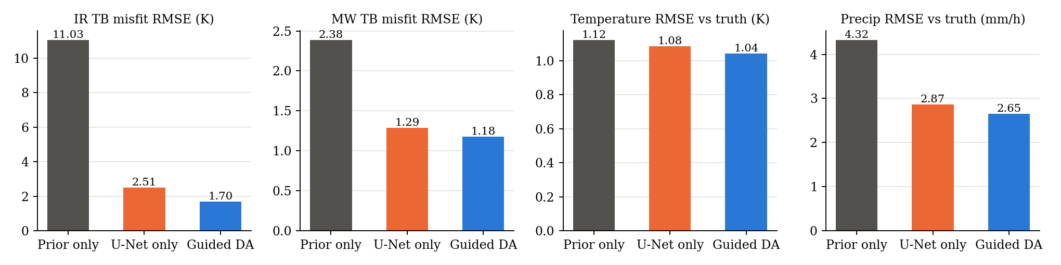
Figure 3. Exact-prior experiment. Left to right: infrared and microwave brightness-temperature misfit of the retrieved state, temperature RMSE against truth averaged over levels, and precipitation RMSE against truth.
Table 9. Exact-prior experiment, numerical results.
Configuration | IR misfit (K) | MW misfit (K) | Temperature RMSE (K) | Precip RMSE (mm/h) | Stability penalty
Unguided prior (climatology) | 11.03 | 2.38 | 1.12 | 4.32 | 8.9e-6
U-Net proxy only | 2.51 | 1.29 | 1.08 | 2.87 | 0
Guided posterior (full DA) | 1.70 | 1.18 | 1.04 | 2.65 | 0

Three observations follow. First, the guidance does what it is designed to do: the retrieved state reproduces the infrared observations to 1.7 K and the microwave observations to 1.2 K, against noise levels of 1.0 and 0.7 K in the synthetic sensors, starting from a prior that misfits the infrared by 11.0 K. Second, the posterior improves on the deterministic proxy in every metric, including the state-space errors it was not directly optimised for, which is the signature of a correctly weighted combination of background and observation information rather than of a mere projection onto the observations. Third, the static-stability penalty, which is small but non-zero for the unguided prior because pixelwise Gaussian noise creates super-adiabatic layers, is exactly zero for the posterior. The ensemble spread of temperature falls from 0.45 K to 0.29 K when the observations are assimilated, as it should.
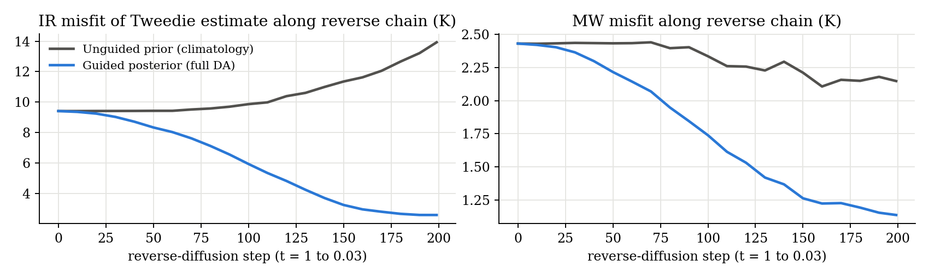
Figure 4. Misfit of the Tweedie estimate along the reverse chain for a single member. With guidance the estimate is pulled onto the observation manifold during the mid-chain steps where the estimate becomes reliable; without guidance the misfit drifts as the sample takes on prior variability.
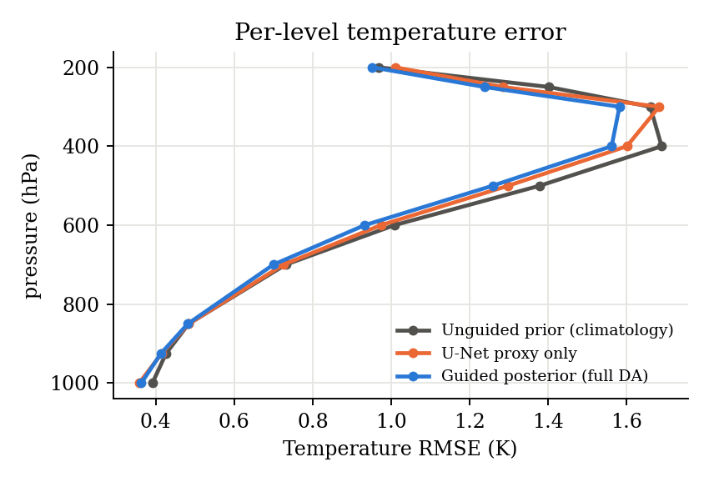
Figure 5. Per-level temperature error. The guided posterior improves most in the 250 to 500 hPa layer, where the warm core lives and where the 54 GHz channels are most informative.

11.3 What the experiment does and does not show
The experiment is a test of the assimilation machinery, not a skill assessment for Milton. The prior is a diagonal Gaussian, the operator that generated the observations is the operator in the likelihood, and the storms are idealised. What it establishes is that the sampler is numerically stable, that the guidance is correctly scaled relative to the prior, that the operator gradients carry the right physical signs, and that the ensemble behaves as a posterior should. Real-data skill will depend on the quality of the learned prior and on the representativeness error of the operator, both of which are addressed in Section 13.

12. Design Findings During Implementation
Three issues surfaced while bringing the sampler up, and each changed the design. They are recorded here because they are easy to get wrong and hard to diagnose.

12.1 The likelihood must be a sum, not a mean
The first version of the likelihood normalised each term by the number of valid pixels so that its weights would be independent of scene size. With that convention, the guidance had no measurable effect: in the reverse SDE both the prior score and the likelihood gradient are multiplied by beta(t) dt, and the prior score of a D-dimensional state has magnitude of order sqrt(D) divided by sigma, whereas the gradient of a per-pixel mean has magnitude of order 1 divided by sqrt(D). The ratio is a factor of D, about 45,000 at the test resolution, and the guidance vanished. Writing the likelihood as a proper sum over independent observations restores the Bayesian scaling, makes guidance_scale = 1 the correct choice, and left the per-pixel diagnostics unchanged because those are computed separately. The same failure mode explains why several published guided-diffusion recipes need a large, hand-tuned guidance weight: they are compensating for a mean where a sum belongs.

12.2 Observation error must include representativeness error
With the infrared error set to the instrument noise of 2 K, the guidance drove the precipitation field away from truth (RMSE rose from 2.9 to over 10 mm/h) even as the infrared misfit fell. The cloud-top parametrisation in the analytic operator is a many-to-one map from rain rate to brightness temperature, and at 2 K the infrared term, with three channels at full resolution, dominated every other term in the precipitation channel. Raising sigma_ir to 5 K and sigma_mw to 2 K, values that represent the error of the operator rather than of the sensor, restored the balance: the infrared misfit still fell to 1.7 K and precipitation improved on the proxy. This is exactly the observation-error inflation that operational systems apply to cloud-affected radiances, and it should be revisited downward once the learned residual operator is fitted.

12.3 Stopping the chain before the noise floor
Returning the Tweedie estimate at the numerical floor t = 0.001 produced samples whose precipitation field carried pixel-scale noise, and the infrared misfit of individual members rose in the last steps as the estimate converged to the noisy sample itself. Stopping at t = 0.03 and returning the Tweedie estimate from there removes the residual noise without collapsing the between-member variability that constitutes the uncertainty estimate. The soft clamp on the Tweedie estimate and the per-step displacement cap were introduced in the same debugging session, after the first sampler diverged when an untrained network returned near-zero scores and the Langevin step size, which is inversely proportional to the score norm, became unbounded.

13. Results on Hurricane Milton
This section reports what happened when the system was run on the real Milton scenes, in the order it happened, because the two problems found on the way and the way they were found are as much a result as the final numbers. Every figure and table here is also on the results dashboard (Section 14), which is the live version of this section.

13.1 The first retrieval
The first full run (8 members, 500 steps, the likelihood of Section 8.1 with the analytic operator on all channels and the default errors of 5 K infrared and 2 K microwave) completed on all 16 scenes and was wrong in a consistent way. The warm-core diagnostic put the anomaly at 850 to 925 hPa on every scene and essentially nothing above 500 hPa; several scenes were colder than the environment at the surface. The infrared misfit floored at 22 to 29 K on every scene from the first fifty steps, and the microwave misfit rose from about 20 K at the start of the chain to 36 to 41 K by the end, with occasional members running off to 50 to 60 K. A retrieval that fits its observations worse the longer it runs is being pulled by a likelihood that points somewhere other than the truth, and the two floors pointed at two different causes.

13.2 The observation-operator audit
The infrared floor has a physical explanation. The state carries temperature and rain but no cloud. Under Milton's cirrus canopy the GOES window channels see 200 K over a region hundreds of kilometres across where IMERG reports no rain, and the analytic operator, seeing no rain, predicts a warm surface; no temperature or rain field can reconcile the two, so the mismatch is permanent and the gradient it produces is meaningless. The microwave floor is of the same kind on the window and humidity channels (88 to 183 GHz), which have no surface emissivity or scattering physics in the analytic model. Rather than argue about which channels to trust, the audit in colab/audit_rtm_cell.py measures it: for every channel it simulates the brightness temperature from the ERA5 and IMERG truth and compares it with what the satellite measured, over the 16 Milton scenes and 60 scenes of the 2023 validation storms, reporting the mean difference (bias) and the standard deviation of the difference (scatter). A channel with large bias and small scatter is usable after subtracting the bias; a channel with large scatter is not representable by the operator and is dropped from the physical likelihood.
Table 10. Observation-operator audit: simulated brightness temperature from the ERA5/IMERG truth minus observed, K. The verdict rule is scatter below three times the nominal channel error for usable, below six times for bias-correctable, and drop otherwise.
Channel | Bias, 2023 storms | Scatter, 2023 | Bias, Milton | Scatter, Milton | Verdict
ABI 8, 6.2 um | 35.4 | 15.8 | 41.7 | 18.9 | drop from likelihood
ABI 10, 7.3 um | 35.3 | 17.4 | 41.4 | 21.5 | drop from likelihood
ABI 13, 10.3 um | 33.2 | 23.9 | 41.1 | 26.5 | drop from likelihood
ATMS 5, 52.8 GHz | 23.2 | 3.4 | 23.1 | 4.9 | usable, bias-corrected
ATMS 6, 53.6 GHz | 21.6 | 2.3 | 21.5 | 1.6 | usable, bias-corrected
ATMS 7, 54.4 GHz | 18.3 | 1.1 | 19.1 | 0.8 | usable, bias-corrected
ATMS 8, 54.9 GHz | 14.4 | 1.0 | 16.1 | 0.8 | usable, bias-corrected
ATMS 9, 55.5 GHz | 20.5 | 1.3 | 22.9 | 0.8 | usable, bias-corrected
ATMS 16, 88 GHz | 29.7 | 10.7 | 29.4 | 16.7 | drop
ATMS 17, 165 GHz | 16.5 | 22.3 | 21.7 | 24.6 | drop
ATMS 18, 183 +/- 7 GHz | 13.9 | 16.0 | 14.5 | 18.6 | drop
ATMS 22, 183 +/- 1 GHz | 14.9 | 8.6 | 14.3 | 9.8 | drop

The oxygen sounding channels 5 to 9 carry 14 to 23 K of bias with only 1 to 3 K of scatter, and the Milton bias matches the 2023 bias to within 1 to 2 K, so the archive correction transfers to a storm the archive never saw. The window channels are what the physics said they would be. The consequence for the first retrieval is now arithmetic: with sigma_mw = 2 K and a 20 K bias, the likelihood was pulling every temperature column by about ten standard deviations toward a target the operator computed wrongly, which is why the upper troposphere lost its warm core and the low levels gained a spurious one. The corrected likelihood (JointLikelihood.calibrate_from_audit, run_milton --rtm-audit) subtracts the bias per channel, sets each channel's error to its measured scatter with a 1 K floor, keeps ATMS 5 to 9 and removes the infrared entirely, so that the infrared reaches the state only through the learned proxy. Physics where the physics is sound, learned where it is not.

13.3 The sampler divergence
The calibrated likelihood alone did not fix the retrieval: a rerun on four scenes still gave 13 to 15 K domain temperature errors while the U-Net proxy, evaluated on the same scenes, was at 1 to 3 K and fitted the bias-corrected sounding channels as well as the ERA5 truth did. A state 14 K from the truth at every level and pixel is not a poor retrieval; it is a diverged sampler, and 14 K is five to six normalised units, exactly where the soft clamp of Section 8.2 saturates. The cause was found by instrumenting a single chain step by step on 08 October 18Z (dbg/probe.py in the development tree): at t = 1 the stability penalty evaluated on the Tweedie estimate was 1.5 x 10^7 because the estimate had values of 60 normalised units, its gradient dominated the guidance direction, and although the per-step cap limited the displacement to 0.25 units, the direction was coherent enough to push the sample off the data manifold within two steps; from there the score network's noise prediction was wrong, the reverse SDE's contraction no longer cancelled its expansion, and the sample grew exponentially, its magnitude going from 1 to 22 units over 30 steps, until the clamp held it at the boundary for the rest of the chain. Removing the guidance entirely produced a sane unconditional sample; reducing its magnitude a hundredfold with the Tweedie-variance inflation alone still diverged, because even a displacement of 0.01 units per step in a consistently wrong direction was enough. Gating the guidance above t = 0.65 in addition (Section 8.2b) resolved it: on the same scene, same weights and same chain, the domain temperature error went from 15.9 K to 1.70 K, the microwave misfit from 11.2 K to 2.78 K, and the warm core moved from nothing aloft to 3.8 K at 300 hPa against 4.3 K in ERA5.
Table 11. Single-chain probe on 08 October 18Z, 100 steps, before and after the guidance schedule of Section 8.2b.
Configuration | Temperature RMSE vs ERA5 | ATMS 5 to 9 misfit | Sample magnitude at the end
Original guidance | 15.9 K | 11.2 K | 28.8 normalised units
Tweedie-inflated, gated above t = 0.65 | 1.70 K | 2.78 K | 0.69 normalised units

13.4 Final results
With the calibrated likelihood and the corrected guidance schedule, all 16 scenes were retrieved with 8 members and 500 steps on the T4 (about one hour in total). Figure 6 shows the GOES-16 band 13 view of the storm at its peak on 08 October 18Z; Figure 7 the evolution of the warm core at 300 hPa across the sequence for the analysis, the direct proxy, the physics-only experiment of Section 13.5, the first diverged run and ERA5; Figure 8 one scene in detail; and Table 12 the per-scene scores.
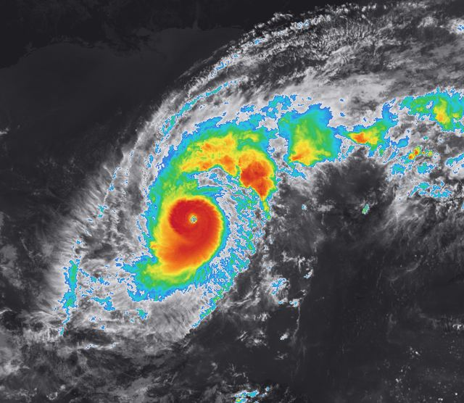
Figure 6. GOES-16 ABI band 13 (10.3 um), CONUS scan of 08 October 2024 18:01Z over the Gulf of Mexico, enhanced infrared: greys are the warm surface and low cloud, colours are cold cloud tops from 243 K (blue) to below 193 K (red and magenta). The eye is the warm dot inside the ring. Data: NOAA.
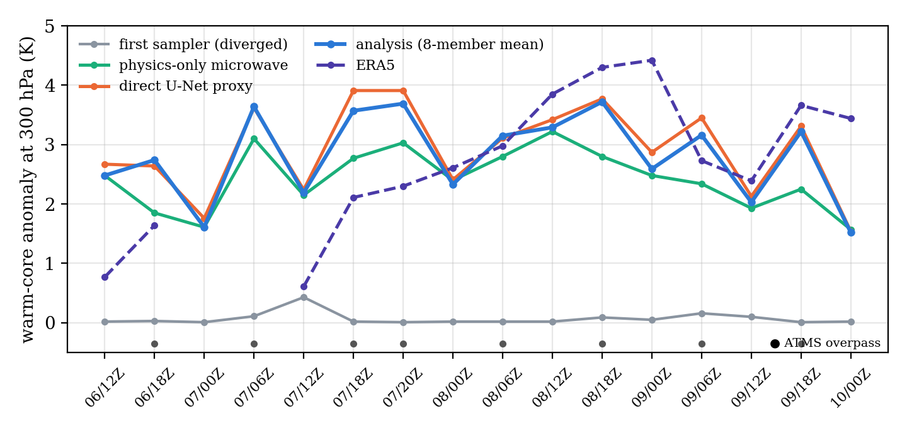
Figure 7. Core-minus-environment temperature at 300 hPa for the 16 analysis times: the 8-member analysis, the direct U-Net proxy, the physics-only microwave experiment, the first diverged sampler, and ERA5. Dots mark analysis times with an ATMS overpass. The warm core defined here is the 5 x 5 pixel centre mean minus the mean beyond 48 pixels from the centre.
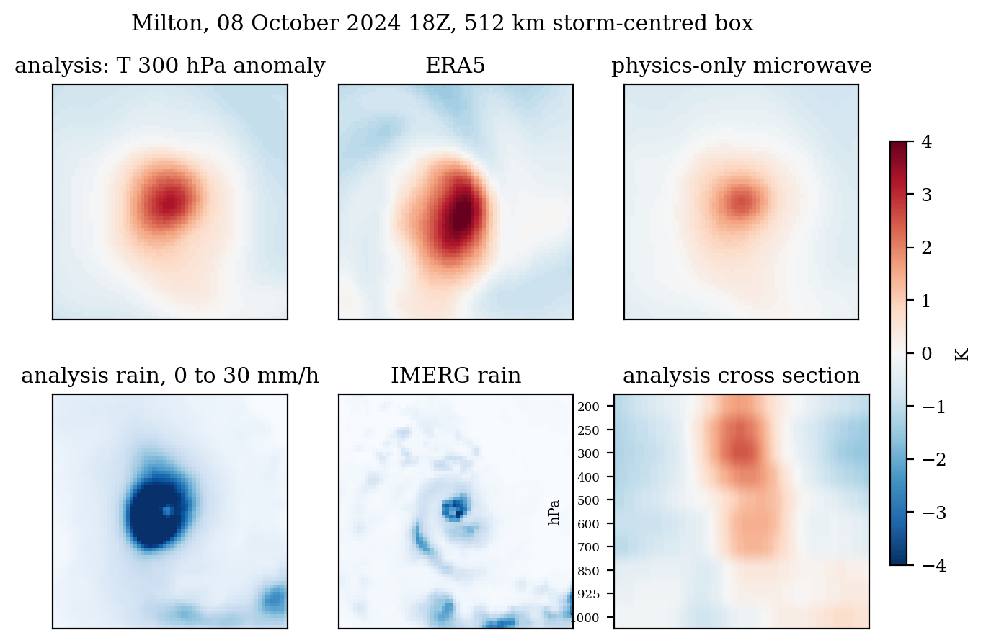
Figure 8. 08 October 2024 18Z. Top: 300 hPa temperature anomaly from the domain mean for the analysis, ERA5 and the physics-only retrieval. Bottom: analysis rain against IMERG, and the east-west cross section of the analysis temperature anomaly from each level's mean through the storm centre, 200 hPa at the top.
Table 12. Per-scene verification of the 8-member analysis against ERA5 and IMERG. Core: RMSE at 300 hPa in a central 16 x 16 pixel box (about 70 km at 4.4 km per pixel) around the best-track centre. Domain: mean over ten levels on the 128 x 128 grid. Warm core (WC) at 300 hPa in K. Two scenes have gaps in the labels and are not scored.
Time | ATMS | WC ana. | WC U-Net | WC phys. | WC ERA5 | Core ana. | Core U-Net | Core phys. | Domain ana. | Rain
06 Oct 12 | none | 2.5 | 2.7 | 2.5 | 0.8 | 0.23 | 0.30 | 0.23 | 1.02 | 2.7
06 Oct 18 | 99% | 2.7 | 2.6 | 1.9 | 1.6 | 0.54 | 0.55 | 1.32 | 1.25 | 5.3
07 Oct 00 | none | 1.6 | 1.8 | 1.6 | n/a | 1.64 | 1.71 | 1.65 | n/a | 2.2
07 Oct 06 | 100% | 3.6 | 3.6 | 3.1 | n/a | 1.26 | 1.27 | 0.34 | n/a | 10.0
07 Oct 12 | none | 2.2 | 2.2 | 2.2 | 0.6 | 0.54 | 0.60 | 0.57 | 1.35 | 3.3
07 Oct 18 | 66% | 3.6 | 3.9 | 2.8 | 2.1 | 0.42 | 0.49 | 1.41 | 1.05 | 11.0
07 Oct 20 | 100% | 3.7 | 3.9 | 3.0 | 2.3 | 0.37 | 0.43 | 1.27 | 1.15 | 6.5
08 Oct 00 | none | 2.3 | 2.4 | 2.4 | 2.6 | 2.05 | 2.04 | 1.99 | 1.60 | 4.3
08 Oct 06 | 96% | 3.2 | 3.1 | 2.8 | 3.0 | 0.80 | 0.84 | 1.52 | 1.25 | 11.4
08 Oct 12 | none | 3.3 | 3.4 | 3.2 | 3.9 | 2.13 | 2.14 | 2.20 | 1.32 | 3.2
08 Oct 18 | 100% | 3.7 | 3.8 | 2.8 | 4.3 | 2.08 | 2.11 | 3.51 | 1.65 | 8.1
09 Oct 00 | none | 2.6 | 2.9 | 2.5 | 4.4 | 3.86 | 3.85 | 3.93 | 2.17 | 4.4
09 Oct 06 | 79% | 3.2 | 3.5 | 2.3 | 2.7 | 1.17 | 1.09 | 2.56 | 2.00 | 8.4
09 Oct 12 | none | 2.0 | 2.1 | 1.9 | 2.4 | 3.27 | 3.23 | 3.33 | 1.91 | 5.9
09 Oct 18 | 58% | 3.2 | 3.3 | 2.3 | 3.7 | 2.29 | 2.25 | 3.43 | 1.82 | 6.8
10 Oct 00 | none | 1.5 | 1.5 | 1.6 | 3.4 | 5.36 | 5.39 | 5.33 | 2.79 | 5.1

Three things stand out. The warm core is now where it belongs, peaking at 250 to 400 hPa in 15 of 16 scenes and fading to near zero at the surface, with amplitudes of 2 to 3.7 K against ERA5's 0.6 to 4.4 K. The domain temperature error is 1.0 to 2.8 K against ERA5 on the 14 scored scenes, against 12 to 15 K for the first run. And the error grows through 09 and 10 October, the eyewall replacement and the approach to Florida, where the storm's structure changed fastest and where land enters the domain and degrades the labels. On every scene with an ATMS overpass the bias-corrected sounding-channel misfit of the analysis settles between 1.5 and 2.8 K, which is below the 2.5 to 3 K that the ERA5 truth itself achieves against the same radiances; the sounding channels are fitted to their noise floor.
Two honest caveats belong beside these numbers. First, the climatological standard deviation of temperature on these levels across the archive is only 2 to 4 K, so a domain-mean RMSE of 1 to 3 K is not far from what predicting each level's mean would score; the inner-core numbers and the warm-core profiles are the ones that carry information. Second, ERA5 at 0.25 degrees smooths the eye: its Milton warm core peaks at 4.4 K where reconnaissance aircraft measured well over 10 K, so the reference is a muted version of the storm and amplitude comparisons against it are not decisive. The retrieval and the reference are compared at the same resolution, and the production path is verification against dropsondes (Section 16).

13.5 Direct, generative, and physics-only
Whether the generative machinery earns its cost is the question Tomorrow.io answered for ICGen by pivoting to direct injection of sounder channels (Section 15), and it deserves a measured answer here. Three retrievals of the same 16 scenes were compared, all with 8 members and 500 steps: the full system (the microwave-aware proxy plus the calibrated physics term); the direct proxy alone, which is the U-Net output and is what the analysis collapses onto when the proxy dominates; and a physics-only microwave experiment (run_milton --proxy-no-mw) in which the proxy is shown only the infrared and the ATMS radiances reach the state through the calibrated likelihood alone. Because the proxy was trained with masked microwave gaps, an all-zero microwave input is in distribution for it, so no retraining was needed. Figure 9 and Table 13 give the results on the eight scenes with an ATMS overpass; on the other eight the three coincide, as they must.
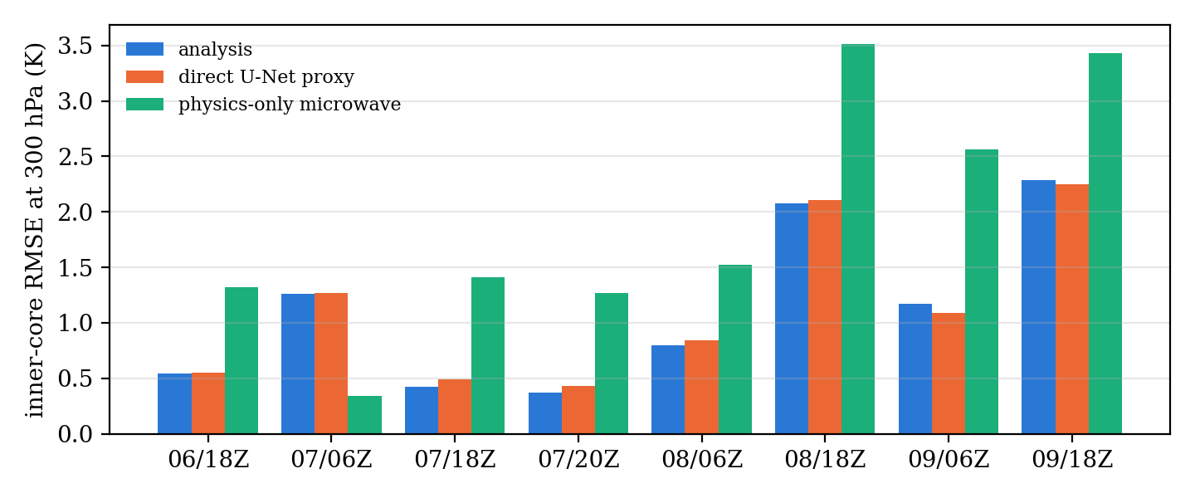
Figure 9. Inner-core temperature RMSE at 300 hPa (central 16 x 16 pixels, about 70 km) against ERA5 on the eight scenes with an ATMS overpass, for the full analysis, the direct U-Net proxy alone, and the physics-only microwave retrieval.
Table 13. Means over the eight scenes with an ATMS overpass.
Quantity | Analysis (full system) | Direct U-Net proxy | Physics-only microwave | ERA5
Inner-core RMSE at 300 hPa, K | 1.12 | 1.13 | 1.92 | 0
Domain RMSE, 10 levels, K | 1.45 | 1.45 | 1.59 | 0
Warm core at 300 hPa, K | 3.4 | 3.5 | 2.6 | 2.8
ATMS 5 to 9 misfit after correction, K | 1.5 to 2.8 | 1.5 to 2.8 | 1.5 to 2.8 | 2.5 to 3.0
Ensemble spread at 300 hPa in the core, K | 0.10 | n/a | 0.10 | n/a

The reading is in two parts. The full system and the direct proxy agree to 0.01 K: with sigma_u = 0.5 the proxy term outweighs the physics term by a factor of several hundred per unit misfit, the posterior collapses onto the U-Net, the physics term has nothing to correct because the proxy already fits the sounding channels to their noise floor, and the ensemble spread collapses to about 0.1 K. That is the ICGen conclusion reproduced on real data: direct injection is hard to beat when the proxy is in distribution. The physics-only experiment shows what the generative step is for. Starting from a proxy that has never seen the microwave, the likelihood drives the sounding-channel misfit to the same 1.5 to 2.8 K floor as the full system, so the observations enter the state through the physics with no retraining. It recovers a weaker warm core (2.6 K against 3.4 K, and 1.92 K against 1.12 K in inner-core RMSE) because a 16 x 16 sounder grid cannot resolve a 30 km eye and many inner-core structures fit the radiances equally well; the proxy learned the correlation between the coarse sounder pattern and the sharp core from 805 storms and supplies the resolution the observations lack. Averaged over these scenes the physics-only amplitude is nearer ERA5's 2.8 K than the full system's 3.4 K, but ERA5 smooths the eye, so the inner-core RMSE, where the full system is 0.8 K better, is the decisive comparison. The physics guarantees consistency with the observations; the learned proxy supplies resolution; and the ensemble spread, collapsed here, would open only where the proxy is uncertain, which is the regime a production system would need to characterise.

13.6 The prior
Figure 10 shows four unconditional draws from the score model at 60,000 steps, sampled with no observations at all. Each is a physically consistent column set with a compact warm anomaly at 400 hPa and an organised rain cluster, off-centre and differently placed in each draw. The network is fully convolutional with no positional embedding, so it learns that warm cores and rain rings exist but not that the training scenes were storm-centred; the observations supply the location during guided sampling. This is the distribution the sampler is drawing from, and the reason the guided chains return hurricane-like states rather than arbitrary temperature fields that happen to fit the radiances.
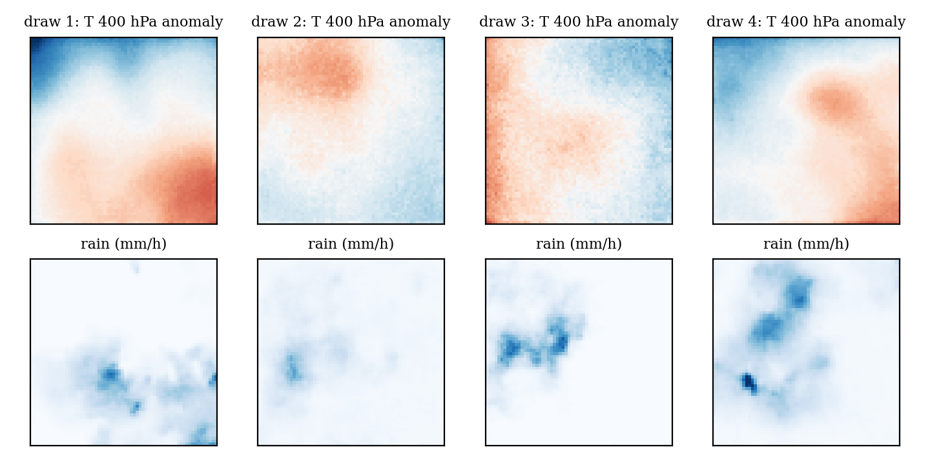
Figure 10. Four unconditional samples from the diffusion prior after 60,000 training steps: 400 hPa temperature anomaly from the domain mean (top) and rain rate (bottom), 128 x 128 at 4 km.

13.7 Cost
One scene with 8 members and 500 steps takes about 3.7 minutes on a Colab T4 (about 140 ms per score-network call including the backward pass through it), so the 16-scene sequence is an hour and each experiment in Section 13.5 the same again. On two CPU threads one member at 250 steps takes about 4 minutes, and a 2-member CPU run reproduced the T4 warm cores to 0.1 K, which is the configuration that was used to develop the dashboard before GPU quota was available. Step distillation or a deterministic corrector seeded by the proxy would reduce the cost by one to two orders of magnitude; neither has been implemented.

14. The Results Dashboard: a Guide
The results live on a single self-contained web page, Vaughan (Milton Inside Out), served from the project repository at https://ibekwemmanuel7.github.io/vaughan/dashboard/ and kept in dashboard/index.html. It is one HTML file of about 6 MB with the GOES imagery, the retrieval fields, the audit and the comparison tables embedded, so it works offline once loaded, needs no server, and can be handed to anyone as a file or a link. This section walks through the page from top to bottom and explains, for each element, what is plotted, from which data, how the numbers were computed, how to read it, and the questions it tends to raise. It is written to be read once alongside the page and then used as a reference before a presentation.

Figure 11. The top of the page: masthead, the GOES loop with its controls, and the headline tiles.

14.1 How the page is built and updated
Every number and image on the page is produced by code in the repository, not typed in. The export cell colab/export_dashboard_cell.py walks the run folders on Drive, reads each CF NetCDF analysis file, coarsens the two-dimensional fields to 64 x 64 (so the page stays small) and writes one JSON file with the warm-core profiles, the per-level errors, the rain errors, the ensemble spread, the observed and simulated brightness temperatures, the ERA5 and IMERG truth fields from the scene files, the operator audit and the prior samples. A build script embeds that JSON, together with the GOES imagery rendered from the raw CONUS files, into the HTML template; the charts and heat maps are drawn in the browser from the embedded data with plain SVG and canvas, no charting library. Rerunning a retrieval and the export, then rebuilding, republishes the page with the same layout; nothing else changes. The page renders in the viewer's light or dark theme and on a phone, where the panels stack.

14.2 Masthead and imagery loop
The masthead gives the storm, the dates, the two instruments and the author, and a one-sentence statement of the method. Below it is a looping animation of GOES-16 ABI band 13 (10.3 um) over the whole Gulf of Mexico, from 96 W to 77 W and 15 N to 31.5 N, rendered from the CONUS scan nearest each of the 16 analysis times, so the frames are the same times as everything else on the page. The colour scale is the enhanced-infrared convention forecasters use: greys from black (300 K) to light grey (243 K) for the warm surface and low cloud, then blue, cyan, green, yellow, orange, red and magenta for cloud tops colder than 243 K down to about 173 K. The eye is the warm dot inside the coloured ring; the coldest tops, red and magenta, mark the deepest convection in the eyewall. The loop plays on its own, has a pause button and a slider, and is linked to the scene explorer below: choosing a time in either place moves the other.
What to point at. Rapid intensification is visible between 07 October 00Z and 12Z as the eye clears and the ring turns red; the very small eye on 07 October is the hardest resolution test in the sequence; the asymmetry and wobble on 09 October are the shear and the eyewall replacement that preceded landfall near Siesta Key at about 00:30Z on 10 October. This is the observation, and everyone in the room can read it, which makes it the place to start. The caption below the loop states the data source and the projection so nobody has to ask.

14.3 Headline tiles
Six figures computed on the page from the embedded results. Domain temperature RMSE against ERA5: the range across the 14 scored scenes of the root mean square difference between the 8-member mean temperature and ERA5, over all ten levels and the full 128 x 128 grid. Inner-core RMSE at 300 hPa: the same quantity at one level in an 8 x 8 box of the coarsened field, about 70 km around the best-track centre. Scenes with the warm core peaking at 250 to 400 hPa: a count of scenes whose warm-core profile has its maximum at one of those three levels. ATMS sounding-channel misfit after calibration: the root mean square difference between the bias-corrected simulated radiances of the analysis and the observed ones over channels 5 to 9, quoted with the value the ERA5 truth itself achieves so that the reader knows the floor. Analysis times with an ATMS overpass: scenes where the swath mask covers more than 30 percent of the domain. Training and validation scenes. The note beneath states the climatological caveat of Section 13.4 so that the domain RMSE is not over-read.

14.4 Scene explorer
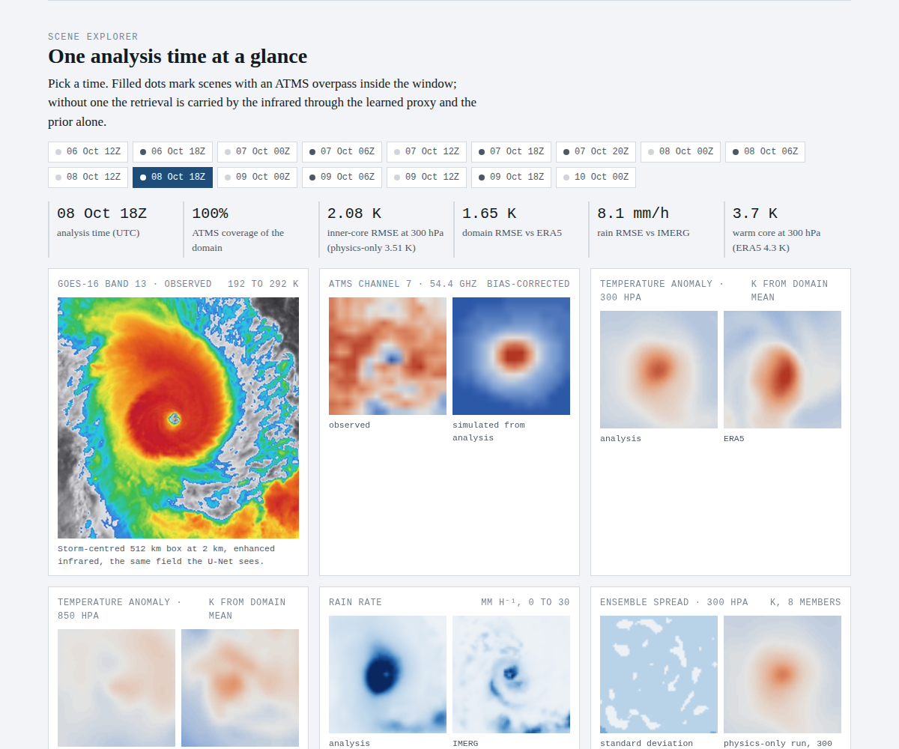
Figure 12. The scene explorer for 08 October 18Z.
The strip of 16 buttons selects an analysis time; a filled dot on a button means an ATMS overpass fell inside the window, an empty dot means the retrieval at that time is carried by the infrared through the proxy and the prior. Beneath the strip a row of six statistics for the chosen time: the time, the ATMS coverage as a percentage of the domain, the inner-core and domain RMSE against ERA5 (with the physics-only value for the same scene in brackets), the rain RMSE against IMERG, and the warm core at 300 hPa with ERA5's value for comparison. Then seven panels.
- GOES-16 band 13, observed. The storm-centred 512 km box at 2 km, in the same enhanced-infrared colours as the loop. This is literally the field the U-Net sees, so it is the panel to use when explaining what the proxy has to work with: a cold canopy that hides everything beneath it.
- ATMS channel 7, 54.4 GHz. Observed brightness temperature on the 16 x 16 coarse grid beside the value simulated from the analysis by the analytic operator after subtracting the channel's 18.3 K bias, on a common colour scale; grey where there is no swath. Channel 7 peaks near 300 hPa, so the warm core appears as a warm spot; a good retrieval matches the observed pattern to within the 1 K scatter the audit found for this channel.
- Temperature anomaly at 300 hPa and at 850 hPa. The analysis beside ERA5, each shown as the departure from its own domain mean, from -4 K (blue) to +4 K (red). The warm core is the red spot at 300 hPa; at 850 hPa it is weaker and the structure is dominated by the moist boundary layer. Comparing the two rows is the quickest visual check that the warm core is aloft, which the first sampler failed.
- Rain rate. The 8-member mean rain rate beside IMERG, 0 to 30 mm/h in blues. Expect the eyewall ring and the principal rainband; IMERG at 0.1 degrees is itself a satellite estimate, so agreement in placement matters more than pixel values, and the rain RMSE of 2 to 11 mm/h is dominated by the ring's exact radius.
- Ensemble spread at 300 hPa, and the physics-only field. The standard deviation across the 8 members, 0 to 0.5 K, which on Milton is about 0.1 K everywhere because the proxy term dominates the likelihood; and the 300 hPa anomaly from the physics-only run for the same scene, so the weaker core discussed in Section 13.5 can be seen directly.
- East to west cross section. Temperature anomaly from each level's mean along the row through the storm centre, 200 hPa at the top and 1000 hPa at the bottom, analysis beside ERA5. The warm core should appear as a red column widening with height and peaking in the upper troposphere; a cold or flat column aloft is the signature of the failed first run.
Below the panels is the warm-core profile for the chosen time: core-minus-environment temperature on each of the ten levels for the analysis (blue), the direct proxy (orange), the physics-only retrieval (green) and ERA5 (violet, dashed), on a logarithmic pressure axis. The definition is the one used throughout: the mean of the central 5 x 5 pixels minus the mean of all pixels farther than 48 pixels from the centre, computed on the 128 x 128 field. This is the figure that says whether the physics worked, and on any scene with ATMS it shows the three retrievals agreeing above 500 hPa and the physics-only line falling below the others in the core.

14.5 Warm-core evolution
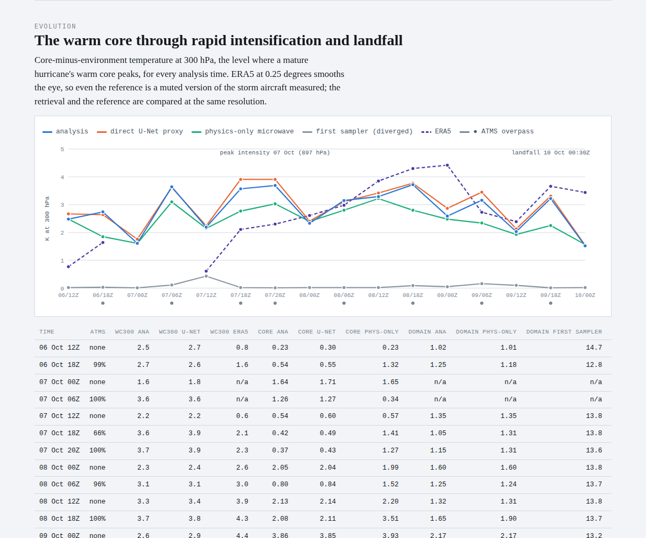
Figure 13. The evolution chart and the head of the per-scene table.
The chart plots the 300 hPa warm core for all 16 times with five series: the analysis, the direct proxy, the physics-only retrieval, the first diverged sampler (grey, flat at zero, which is the before picture) and ERA5 (dashed). Dots under the axis mark the times with an ATMS overpass; the two annotations mark peak intensity on 07 October (897 hPa) and landfall. Hovering gives every series' value at a time. Reading it: the analysis and the proxy track ERA5's rise through 08 October, and all fall away on 09 and 10 October as the core weakens under shear; the physics-only line sits below the analysis only on the ATMS scenes, and coincides elsewhere, which is exactly the signature one expects if the microwave is doing the work. The table beneath has, per scene, the ATMS coverage, the 300 hPa warm core for the analysis, the proxy and ERA5, the inner-core RMSE for the analysis, the proxy and the physics-only run, the domain RMSE for the analysis, the physics-only run and the first sampler, the rain RMSE, and the core spread. Its footnote defines every column.

14.6 Method
A single diagram of the pipeline: the two observation sources with their grids and coverage, the cross-attention U-Net with its validation scores and the radiance-consistency auxiliary loss, the diffusion prior with its training set and step count, the guided reverse SDE with the likelihood terms listed (proxy at sigma 0.5, ATMS 5 to 9 bias-corrected, static stability and non-negative rain, Tweedie-variance inflation, no guidance above t = 0.65), and the analysis products. The dashed arrow from ATMS to the sampler shows that the radiances enter the likelihood directly as well as through the proxy, which is the point of the physics-only experiment. Two short paragraphs beside it answer the two questions the diagram raises: why a prior at all, and why the physics is on the channels it is on.

14.7 Diagnostics
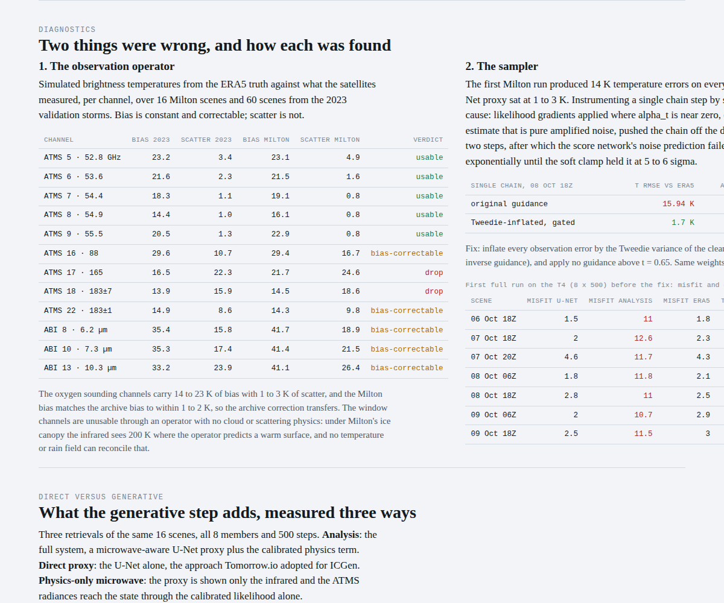
Figure 14. The diagnostics section: the operator audit and the sampler probe.
The left column is the observation-operator audit of Section 13.2 as a table: for each channel the bias and scatter on the 2023 storms and on Milton, and the verdict, coloured green for usable, amber for bias-correctable and red for drop. The verdict rule is scatter below three times the nominal channel error (5 K infrared, 2 K microwave) for usable and below six times for bias-correctable. The note beneath explains why the window channels fail (no cloud in the state under an ice canopy) and why the sounding channels can be trusted after a constant offset. The right column is the sampler divergence of Section 13.3: the one-chain probe table (15.9 K to 1.70 K), the mechanism in one paragraph, the fix in one sentence, and the first full run's numbers on seven scenes with an ATMS overpass, where the analysis misfit sat at 11 K while the proxy sat at 2 K. These two panels are the part of the page most worth rehearsing, because they are the evidence that the results were reached by diagnosis rather than by tuning.

14.8 Direct versus generative, prior, context, recommendations, limitations
The comparison section is Section 13.5 as six tiles computed on the page (inner-core RMSE for the three retrievals, the three warm-core means with ERA5, the domain RMSE pair, and the first sampler's error on the same scenes), a callout that states the collapse onto the proxy plainly, the two-part reading, and three cost tiles. The prior section is Figure 10 as four live panels. The context section summarises Cannon et al. (2024) and Guerrette et al. (2026) in a paragraph each and says where this work sits relative to them (Section 15). The recommendations section is the six proposals of Section 15.3, each anchored to a result on the page and labelled as proposals based on public material. The limitations section pairs what the system is not with what a production version would change. The footer lists the data sources, the archive size, the references and the code, and states that the work was built with AI-assisted development with the physics decisions the author's.

14.9 Questions the page tends to raise, with answers
- Why is the domain RMSE so small when the climatological spread is only 2 to 4 K? Because domain RMSE over a mostly undisturbed 512 km box is a weak metric for a hurricane; the page says so above the tiles, and the inner-core RMSE and the warm-core profiles are the metrics to discuss.
- Why does the analysis equal the U-Net? Because the proxy term is trusted at sigma 0.5 normalised units and the proxy is in distribution; that is the honest result and it is the same one Tomorrow.io reached. The physics-only experiment is the evidence that the machinery works when the proxy is not carrying the observation.
- Why is the ensemble spread 0.1 K? Same reason: the posterior has collapsed onto the proxy. The spread is only meaningful where the proxy is uncertain; characterising that regime is future work, and rank histograms against held-out storms would be the test.
- Why did you drop the infrared from the likelihood if the project was about fusing infrared and microwave? The infrared is still fused, through the learned proxy, which sees it at full resolution and attends to the microwave tokens; what was dropped is the analytic infrared operator, which the audit showed cannot represent a cloudy scene. The audit table is the answer.
- Why ERA5 as truth? It is the only 3D temperature reference available at every analysis time, and it is what the prior was trained on. The page says twice that it smooths the eye and that dropsondes are the production verification.
- How long does it take? 3.7 minutes per scene for 8 members and 500 steps on a T4; the proxy alone is one forward pass. The reduction path is distillation or a corrector seeded by the proxy.
- Would it work on another storm? Yes without retraining for any tropical cyclone with GOES or Himawari infrared and a sounder overpass; the prior is a tropical-cyclone prior and would need retraining for other phenomena. Helene (September 2024) is the natural second case.
- What would you build next? In order: a learned observation operator emulated from LBLRTM and DISORT references with ice cloud properties, so the infrared and the 118 and 183 GHz channels can enter the physics; cloud and humidity in the state; a positional embedding and 256 x 256 fine-tuning for the prior; distillation; a forecast background term to turn the retrieval into cycling assimilation; and dropsonde verification.

14.10 A five-minute walkthrough
Open the page on the loop and let it run while giving the motivation: Beryl came through Houston in July 2024, Milton three months later was the storm to look inside, and graduate work on ice cloud optical properties in the infrared is why the question of what the infrared cannot see was the interesting one. Pause the loop on 08 October 18Z and click that time in the strip. Point at the band 13 panel (what the proxy sees), the ATMS panel (what the physics sees), the 300 hPa anomaly beside ERA5 (the warm core, retrieved), and the profile (the three retrievals and ERA5 agreeing aloft). Scroll to the evolution chart and trace the rise through rapid intensification and the fall under shear. Scroll to the diagnostics and tell the two findings in the order they happened: the audit and what it said about the window channels, then the divergence and the guidance schedule that fixed it. Finish on the comparison tiles: the full system equals the proxy, the physics-only run fits the radiances but loses resolution, and that is what the generative step is and is not for. Stop there; the recommendations are for the questions.

15. Position Relative to Tomorrow.io's Published Work

15.1 ICGen
Tomorrow.io's engineering post on ICGen (its initial-condition generator) describes taking a six-hour-old forecast or analysis plus a five-channel configuration of its own sounder and producing an updated state for downstream AI forecast models such as Aurora and ForecastNet, trained against ERA5. Their first version was score-based data assimilation with Bayesian guidance toward the observations, which nudged humidity fields toward reality but did not scale; a version with a pretrained variational autoencoder compressing the state ran about 50 percent worse than the raw forecast because of reconstruction artefacts, and the team pivoted to direct injection of the sounder channels as model inputs, with consistent error reductions strongest in mid and upper tropospheric humidity. The present work reaches the same conclusion about direct injection on Milton (Section 13.5), and it does so with a pixel-space prior that has no autoencoder and therefore no reconstruction artefact; it also identifies, in the guidance schedule of Section 8.2b, a plausible contributor to any score-based system that nudged fields but did not scale.

15.2 The sounder papers
Cannon et al. (2024) describe the third generation of Tomorrow.io's near-real-time global precipitation product: an EfficientNetV2 encoder-decoder with 2+1D temporal convolutions that ingests an hour of raw geostationary imagery plus whatever passive-microwave overpasses (TROPICS, TMS, GMI) fell in the window, each instrument channel as its own sparse input plane with the view angle supplied so the network learns the off-nadir bias, and retrieves a 32-quantile rain distribution against ground radar at 0.04 degrees. For Milton after landfall on 10 October a single TMS overpass raised the Heidke skill score from 0.64 to 0.71 at 0.25 mm/h and from 0.25 to 0.37 at 6 mm/h, with the gain carried by the 91.65 GHz window and 204.8 GHz humidity channels. Guerrette et al. (2026) assimilate the constellation in FV3-JEDI all-sky with variational bias correction and a symmetric cloud-impact error model and find impact matching ATMS for water vapour and about half of ATMS for tropospheric temperature. Two facts from these papers bear directly on this work. TMS sounds temperature at 118 GHz rather than at the 50 to 60 GHz oxygen band ATMS uses, chosen for horizontal resolution, and the 118 GHz line is far more sensitive to ice scattering in a hurricane core; the channels the audit found trustworthy through an analytic operator are the ones that instrument does not carry. And the resolution limit Cannon et al. report at 12 mm/h from the sounder footprint is the same limit found here in the physics-only experiment.

15.3 Recommendations for a sounder-constellation system
Offered as proposals grounded in public material and in the results above, not as claims about internals.
- Keep diffusion in physical space. The reported degradation came from the autoencoder, not the diffusion model. Pixel-space priors on storm-centred or regional patches avoid the artefact; if compression is needed, train the decoder with a radiance-consistency loss so what the operator sees survives the bottleneck.
- Schedule the guidance. Inflate observation errors by the Tweedie variance and gate guidance early. On real data this was the difference between 15.9 K and 1.7 K with no other change.
- Use direct injection as the proxy inside the Bayesian framework, not instead of it. The injection model is the U-Net here; the prior and physics act as a corrector, the chains give flow-dependent spread, and the physics carries observations the proxy has not been trained on.
- Audit the operator per channel before it enters a likelihood. Table 10 is the template; the symmetric cloud-impact error model of Guerrette et al. is its operational form.
- An ice-scattering-aware fast operator for 118 and 183 GHz. Emulate a scattering reference (line-by-line plus multiple scattering, with ice habit and size) as a differentiable network with hydrometeors in the state; this is the step that lets the infrared and the TMS temperature channels into the physics.
- Verify the inner core against dropsondes, not reanalysis. ERA5 puts Milton's peak warm core at 4.4 K; reconnaissance measured well over 10 K.

16. Limitations and Roadmap
The following separate the prototype from an operational retrieval, in rough order of impact.
- Observation operator. The analytic operator is a placeholder that the audit showed to be usable on five channels. The production path is a learned operator emulated from LBLRTM and DISORT references with ice cloud properties (the HybridRTM and NeuralRTMResidual classes are the scaffolding), or CRTM or RTTOV through their adjoints, which brings the infrared and the 118 and 183 GHz channels into the physics.
- State vector. No cloud and no humidity. Both are needed for the infrared and the humidity channels to be modelled, and humidity is where Guerrette et al. found the constellation's largest impact.
- Prior. Small preset at 128 x 128, no positional embedding, trained on 805 scenes. A positional embedding, 256 x 256 fine-tuning and a larger archive (the East Pacific and West Pacific seasons, and Himawari) are the next steps.
- Proxy dominance. With sigma_u = 0.5 the posterior collapses onto the proxy and the spread is uninformative. Calibrating sigma_u against held-out storms, or making it a learned per-pixel uncertainty from the proxy, would let the physics and the spread speak where the proxy is out of distribution.
- Verification. ERA5 smooths the eye. Dropsondes and flight-level data from the Milton reconnaissance flights exist and are the right inner-core reference; rank histograms and spread-skill diagrams are the right test of the ensemble.
- Coverage and time. Eight of sixteen analysis times had no ATMS overpass. A constellation with sub-hourly revisit removes the gap; conditioning on the previous analysis, or a forecast background term, turns the retrieval into cycling assimilation.
- Cost. 3.7 minutes per scene on a T4 with 500 steps is conservative. Distillation or a deterministic corrector seeded by the proxy is the reduction path.

17. Conclusion
vaughan set out to reconstruct the three-dimensional structure of Hurricane Milton from two satellites and no forecast model, and it does: the warm core sits at 250 to 400 hPa in 15 of 16 analysis times, the analysis is within 1.0 to 2.8 K of ERA5 over the domain and 1.1 K in the inner core on the scenes with a sounder overpass, and the sounding channels are fitted to their noise floor. The two findings on the way are the part of the work that generalises. An analytic observation operator must be audited channel by channel against truth before it enters a likelihood, and on real data the audit sorted the channels cleanly into ones that need a constant correction and ones the physics cannot represent; and likelihood guidance in a diffusion sampler must be scheduled with the reliability of the clean-state estimate, or a coherent push of a hundredth of a unit per step will carry the chain off the manifold. On the question of whether the generative step is worth its cost, the answer on Milton is measured rather than flattering: with a microwave-aware proxy in distribution the posterior collapses onto it, as Tomorrow.io found for ICGen; the physics term earns its place where the proxy has not seen the observation, fitting the radiances without retraining and losing only the resolution a 16 x 16 sounder grid cannot supply. The dashboard, the report and the repository together are the record of that argument, and the recommendations of Section 15 are where it points.

Appendix A. Tensor Shape Reference
Table A1. Tensors through the pipeline (default configuration, B = batch).
Stage | Tensor | Shape | Units
Dataset | ir, ir_raw | [B, 3, 256, 256] | normalised / K
Dataset | ir_mask | [B, 1, 256, 256] | 0 or 1
Dataset | mw, mw_raw | [B, 9, 32, 32] | normalised / K
Dataset | mw_mask | [B, 1, 32, 32] | 0 or 1
Dataset | state | [B, 11, 256, 256] | normalised (10 T levels + log1p P)
U-Net | MW context | [B, 256, 32, 32] | features
U-Net | encoder level l | [B, 64 x 2^l, 256 / 2^l, 256 / 2^l] | features
U-Net | x_det | [B, 11, 256, 256] | normalised state
SDE | t, alpha(t), sigma(t) | [B] | dimensionless
Score net | x_t, epsilon_hat, score, x0_hat | [B, 11, 256, 256] | normalised state
Physics | temp, precip | [B, 10, 256, 256], [B, 1, 256, 256] | K, mm/h
Physics | ir_tb_sim, mw_tb_sim | [B, 3, 256, 256], [B, 9, 32, 32] | K
Likelihood | J terms | [B] each | nats
Sampler | samples, mean, std | [N, B, 11, 256, 256], [B, 11, 256, 256] | normalised state

Appendix B. Glossary of terms
Terms used in this report and on the dashboard, grouped by subject. The Tomorrow.io product terms are included because Section 15 refers to them.

B.1 Data assimilation and estimation
Term | Meaning
Data assimilation (DA) | The estimation of the state of the atmosphere by combining a prior estimate (the background, usually a short forecast or climatology) with observations, each weighted by how much it is trusted. Every forecast starts from an analysis produced this way.
Analysis | The estimated state of the atmosphere at one time after observations have been assimilated. Sky 1 produces one every hour; national centres produce one every six hours.
Background (first guess) | The prior state before observations are used, normally the previous forecast valid at the analysis time. In the Milton system the learned diffusion prior plays this role, and a background term is what cycling would add.
Initial conditions | The state a forecast model starts from. Errors here grow through the forecast, which is why a better starting picture improves the forecast without changing the model.
Cycling | Running the analysis repeatedly, each one starting from the forecast made from the previous analysis, so information from past observations is carried forward.
Observation operator (H) | The function that maps a model state to what an instrument would measure, for example temperature profile to brightness temperature. Also called the forward model. Its errors go straight into the analysis, hence the audit.
Observation error covariance (R) | The assumed errors of the observations, including instrument noise, representativeness and operator error. The per-channel weights in the Milton likelihood are 1 over the measured error variance.
Background error covariance (B) | How errors in the prior state are correlated in space and between variables. Hand-built in variational systems, estimated from members in ensemble systems, learned from data in a score-based prior.
Innovation (O minus B, residual) | Observation minus the simulated observation from the background. The per-channel bias and scatter of innovations is the standard health check of an assimilation system.
Bias correction | Removing a systematic offset from an observation or operator so that only random error remains. Works when the error is an offset (sounding channels), not when it is scatter (window channels under cloud).
VarBC | Variational bias correction: a bias model with a few predictors (scan angle, air mass) whose coefficients are estimated inside the assimilation itself.
3D-Var and 4D-Var | Variational DA: find the state that minimises a cost function of background misfit plus observation misfit, at one time (3D) or over a window with the forecast model and its adjoint (4D).
Ensemble Kalman filter (EnKF) | DA that estimates the background covariance from an ensemble of forecasts and applies a linear update to each member.
Adjoint | The transpose of the linearised model or operator, used to propagate gradients backward in variational DA. Automatic differentiation plays the same role in a learned system.
Posterior | The probability distribution of the state given the observations. The analysis is its mean or mode; the ensemble spread describes its width.
Likelihood | The probability of the observations given a state, p(y given x). Its negative log is the observation misfit term in the cost function.
Prior | What is believed about the state before the observations are used. In score-based DA the prior is a generative model trained on real states.
Retrieval | Estimating a geophysical quantity (temperature profile, rain rate) from satellite radiances, with or without a forecast model.
Denial experiment (OSE) | Assimilating with and without one observation type and scoring the forecasts, to measure that observation's impact.
Representativeness error | The part of the observation minus background difference caused by the model not resolving what the instrument sees (a 2 km cloud top versus a 30 km grid cell), rather than by instrument noise.

B.2 Diffusion and generative modelling
Term | Meaning
Score | The gradient of the log probability density with respect to the state. A network trained to output the score at every noise level is a complete description of the prior.
Score-based generative model (diffusion model) | A model that learns to reverse a gradual noising process. Sampling runs the noising backward using the learned score, producing realistic states from noise.
Forward process | Adding Gaussian noise to a real state in small steps until nothing but noise remains.
Reverse process | The learned denoising that turns noise back into a sample from the data distribution, written as a stochastic differential equation.
SDE | Stochastic differential equation: a differential equation with a random forcing term. The forward and reverse diffusion processes are both SDEs.
VP-SDE | Variance-preserving SDE: the noising schedule keeps the total variance of the noisy state near one, so normalised fields stay in range throughout.
alpha_t and sigma_t | The signal scale and noise scale at diffusion time t: x_t = alpha_t x_0 + sigma_t times noise. Near t = 0 the state is clean; near t = 1 it is nearly pure noise.
Denoising score matching (DSM) | The training objective: predict the noise that was added, which is equivalent to learning the score without ever knowing the density.
EMA (exponential moving average) | A slowly updated running average of the network weights during training; the averaged weights sample better than the raw ones.
Tweedie estimate (x0_hat) | The posterior mean of the clean state given the current noisy state, computed from the score: (x_t + sigma_t squared times score) divided by alpha_t. The likelihood in DPS is evaluated on it.
Tweedie variance | The uncertainty of the Tweedie estimate, about sigma_t squared over alpha_t squared. Huge near t = 1, tiny near t = 0. Inflating observation errors by it is the guidance schedule in the Milton sampler.
Guidance | Adding the gradient of an observation log-likelihood to the score during sampling so the samples satisfy the observations. The mechanism that turns a prior into a posterior sampler.
Diffusion posterior sampling (DPS) | Guidance where the likelihood is evaluated at the Tweedie estimate and differentiated through the score network (Chung et al. 2023).
Pseudo-inverse guidance (PiGDM) | A guidance method that accounts for the uncertainty of the Tweedie estimate by inflating the observation error with its variance (Song et al. 2023).
Guidance gate (guide_t_max) | The diffusion time above which no guidance is applied at all, because the denoised estimate carries no information there. Set to 0.65 in the Milton sampler.
Predictor-corrector sampler | A reverse-diffusion scheme that alternates a numerical step of the reverse SDE (predictor) with a Langevin refinement at the same noise level (corrector).
Langevin dynamics | Iterating x plus step times score plus noise; a way of sampling from a density using only its score.
Manifold | The set of states that look like real data. A sample pushed off it produces unphysical fields, which is what happened in the first Milton run.
Soft clamp (x0_clip) | A tanh limit on the denoised estimate in normalised units; a safety device that saturated at about 6 sigma (14 K) in the diverged run.
Latent diffusion | Diffusion run in the compressed space of an autoencoder (VAE) for speed; the approach ICGen tried before moving to direct injection.
VAE | Variational autoencoder: a network that compresses a field to a small latent vector and decodes it back.
Distillation (consistency, progressive) | Training a fast sampler to reproduce a slow one in a few steps, typically 4 to 8 instead of hundreds.
Mode collapse (spread collapse) | When an ensemble's members become nearly identical because a likelihood term is too tight; the Milton spread of about 0.1 K is an example.
Conditional mean | What a regression network trained with a pixel loss returns: the average of all plausible answers, which is blurred where the answer is uncertain.
GenCast, GraphCast, Pangu, FuXi, AIFS, Aurora | Machine-learning forecast models that step an analysis forward in time. GenCast is a diffusion model; the others are deterministic. All start from a conventional analysis.
Aardvark | An end-to-end machine-learning system that goes from raw observations to forecast, the academic family closest to a learned analysis.

B.3 Networks and training
Term | Meaning
U-Net | An encoder-decoder convolutional network with skip connections between matching resolutions; the standard backbone for image-to-image tasks and for score networks.
Cross-attention | Attention where the queries come from one input (infrared features) and the keys and values from another (microwave tokens), letting each location draw on the other sensor without a shared grid.
Attention mask | A term added to attention scores that removes some tokens entirely (minus infinity), used to handle scenes with no microwave overpass.
Token | One element in an attention layer; here, one coarse-grid microwave pixel with its channel values.
Positional embedding | Extra inputs that tell a network where in the frame each pixel is; the Milton prior lacks one, so it does not know where the storm centre is.
Proxy (direct U-Net) | The deterministic network that maps observations straight to the state; used both as a baseline and as a term in the likelihood.
Normaliser (per-channel statistics) | The mean and standard deviation of each state channel, fitted on the training split and stored with the checkpoint, used to convert between physical and normalised units.
Radiance-consistency loss (lambda_rtm) | An extra training term that asks the network's output, passed through the operator, to match the observed radiances; reduced to 0.01 because operator error dominated it.
Quantile loss (pinball loss) | A loss that trains a network to predict a chosen percentile rather than the mean; used in Cannon et al. for heavy rain.
EfficientNetV2, 2+1D convolution | A family of efficient convolutional backbones; 2+1D splits space and time into separate convolutions. Used in Tomorrow.io's precipitation retrieval.
Heteroscedastic head | A network output that predicts its own uncertainty per pixel, one way to calibrate spread.
Held-out season | A validation split made of an entire year so that no training scene is a few hours from a validation scene.
Checkpoint, resumable training | Saved weights and optimiser state at intervals so that an interrupted run (a Colab disconnect) continues where it stopped.
Preset (small) | The reduced network widths used on a free GPU: U-Net base 32, score network base 48.
Downscale 2 | Training and sampling at half resolution, 128 by 128 fine grid and 16 by 16 microwave grid.

B.4 Radiative transfer and instruments
Term | Meaning
Radiative transfer | The physics of how radiation is emitted, absorbed and scattered as it passes through the atmosphere; the basis of every satellite observation operator.
Brightness temperature (TB) | The temperature of a black body that would emit the measured radiance; the standard unit for microwave and infrared channels.
Weighting function | How much each height contributes to a channel's brightness temperature; the derivative of transmittance with height. Its peak height is what makes a channel a sounder of a particular layer.
Sounding channel | A channel on an absorption line (oxygen at 50 to 60 GHz or 118 GHz, water vapour at 183 GHz) whose weighting function peaks in the atmosphere, giving profile information.
Window channel | A channel where the atmosphere is nearly transparent (10.3 micron infrared, 89 GHz), so it sees the surface or the highest opaque cloud.
Water vapour channel | An infrared channel near 6 to 7 micron (GOES bands 8 and 10) that sees upper-tropospheric moisture and cloud top.
Oxygen absorption band | The 50 to 60 GHz band of oxygen lines used by ATMS and AMSU for temperature sounding; the 118.75 GHz line used by TMS.
Optical depth | A measure of how opaque a layer is; a channel sees down to roughly optical depth one.
Scattering | Redirection of radiation by particles. Ice and rain scatter microwaves more strongly at higher frequencies (118, 166, 183 GHz than 54 GHz), lowering brightness temperature over convection.
Ice cloud optical properties | Single-scattering properties (extinction, single-scattering albedo, phase function) of ice crystals, which depend on habit and size; the subject of the author's graduate research and the missing physics in the analytic operator.
Cloud canopy (cirrus shield) | The thick anvil of ice cloud over a hurricane that hides the eye and eyewall from infrared and makes window channels unusable for the column.
LBLRTM | Line-by-line radiative transfer model: a reference model computing gaseous absorption line by line, used to build and validate fast operators.
DISORT | Discrete ordinates radiative transfer: a reference solver for multiple scattering in plane-parallel layers.
RTTOV, CRTM | Fast operational radiative transfer models used by ECMWF and NOAA respectively for satellite assimilation; RTTOV-SCATT handles scattering.
Emulator (learned operator) | A small neural network trained to reproduce a reference radiative transfer model, giving speed and differentiability.
Jacobian | The matrix of derivatives of an operator's output with respect to the state; needed for gradients and a standard check on an emulator.
Analytic RTM | The simplified, differentiable operator in vaughan that maps the temperature and rain state to brightness temperatures without a cloud variable.
Zenith angle | The angle from vertical along which a satellite views a pixel; larger angles mean a longer path and higher weighting-function peaks.
Scan position | Where in the swath a pixel sits; biases often depend on it, which is why audits stratify by it.
Swath, overpass, revisit | The strip a polar instrument observes; one pass over a location; the time between passes. A constellation shortens the revisit.
Footprint | The ground area one microwave measurement averages over, 16 to 50 km for ATMS depending on channel.
Fixed-grid projection | The geostationary image coordinate system of GOES; inverting it gives latitude and longitude for each pixel.
GOES-16 ABI | The Advanced Baseline Imager on the GOES-East geostationary satellite: 16 bands, 2 km infrared, full disk every 10 minutes.
ATMS | Advanced Technology Microwave Sounder on Suomi-NPP and NOAA-20/21: 22 channels, 23 to 183 GHz; channels 5 to 9 are the mid-tropospheric oxygen temperature channels used here.
AMSU | The earlier Advanced Microwave Sounding Unit, whose channel set ATMS extends.
TMS (Tomorrow Microwave Sounder) | Tomorrow.io's small-satellite sounder with 12 channels between about 91 and 204 GHz, including 118 GHz oxygen and 183 GHz water vapour channels; no 50 to 60 GHz band.
Pathfinder | Tomorrow.io's earlier Ku-band precipitation radar satellites.
Constellation | Many satellites whose combined coverage shortens revisit time; Tomorrow.io cited 13 in orbit in early 2026 with a goal of about 60-minute global revisit.
DeepSky | Tomorrow.io's second constellation, announced January 2026, designed to feed its own models directly.
Radiosonde | A balloon-borne instrument measuring a profile of temperature, humidity and wind; the traditional truth for radiative transfer and DA, absent over the ocean.
Dropsonde | A radiosonde dropped from a reconnaissance aircraft, the best in situ truth inside a hurricane.

B.5 Meteorology and hurricanes
Term | Meaning
Warm core | The region of anomalously warm air above a hurricane's eye, produced by subsidence; its strength at 250 to 400 hPa is tightly linked to intensity.
Warm-core anomaly | Temperature in the eye minus the environmental mean at the same level, in Kelvin; the quantity on the warm-core chart.
Eye, eyewall, rainbands | The calm centre, the ring of strongest convection around it, and the spiral bands outside.
Eyewall replacement cycle | An outer eyewall forming and contracting to replace the inner one, temporarily weakening the storm; Milton began one after peak.
Rapid (explosive) intensification | A large pressure fall or wind increase in a short time; Milton fell from 977 to 897 hPa in about 16 hours on 7 October 2024.
Central pressure (hPa) | The minimum sea-level pressure in the eye; lower means stronger. 897 hPa is among the lowest on record in the Atlantic.
Pressure level | A surface of constant pressure used as a vertical coordinate; 1000 hPa is near the surface, 200 hPa near the tropopause.
Static stability | The resistance of a layer to vertical motion, set by how temperature decreases with height; a lapse rate steeper than the dry adiabat is unphysical, which the penalty forbids.
Super-adiabatic layer | A layer in which temperature falls faster with height than the dry adiabatic rate; physically unstable and a sign of a bad retrieval.
Hypsometric thickness | The depth between two pressure levels, proportional to the mean temperature of the layer; a check that links temperature to geopotential.
Best track (IBTrACS, HURDAT) | The post-season official record of a storm's position and intensity, used here to centre every scene on the storm.
Track error, intensity error, lead time | The standard forecast scores for hurricanes: distance between forecast and actual centre, difference in wind or pressure, and how far ahead a forecast was made.
Vertical wind shear | The change of wind with height, which tilts and weakens a hurricane; Milton encountered it on 9 October.
Reconnaissance aircraft | NOAA and Air Force flights into hurricanes that measure the eye directly; their Milton warm core exceeded 10 K.
NHC, NOAA, NCEP | The US National Hurricane Center, its parent agency, and the National Centers for Environmental Prediction that run the GFS model and its analysis.
ECMWF | The European Centre for Medium-Range Weather Forecasts, whose analysis and IFS model are the usual reference.
HAFS, HWRF | NOAA's hurricane-specific forecast models with inner-core resolution far finer than ERA5.

B.6 Datasets and verification
Term | Meaning
ERA5 | ECMWF's global reanalysis at about 31 km, used as temperature truth here; it smooths a 30 km eye, so its Milton warm core peaks at 4.4 K.
Reanalysis | A consistent historical analysis produced by running one modern DA system over decades of observations.
IMERG | NASA's half-hourly global precipitation product from merged satellite estimates, used as rain truth.
CF NetCDF | The Climate and Forecast conventions for self-describing NetCDF files; the output format of the retrieval.
RMSE | Root mean square error, the standard error score. Compare it to the climatological standard deviation (2 to 4 K per level here) to know whether it is good.
Inner-core RMSE | RMSE inside a central 16 x 16 pixel box, about 70 km across around the eye, where the warm core is and where a hurricane retrieval is actually tested.
Domain RMSE | RMSE over the whole storm-centred grid, dominated by the quiet environment and therefore a weak metric.
Misfit | The difference between simulated and observed radiances for an analysis, after bias correction; 1.5 to 2.8 K for the sounding channels here.
Ensemble spread | The standard deviation across members, which should match the error if the ensemble is calibrated (spread-skill relationship).
Rank histogram | A test of ensemble calibration: where the truth falls among the sorted members should be uniform.
Heidke skill score (HSS) | A categorical score for threshold events (rain above a level) that corrects for chance; used in Cannon et al.
Bootstrap confidence interval | Uncertainty on a score obtained by resampling the cases; needed to tell a real improvement from noise.
Stratified verification | Scoring separately by regime, for example hours with and without a sounder overpass, to isolate the effect of an observation.
Ablation | Removing one component (no microwave, no operator, no prior) and rescoring, to measure its contribution.
Persistence baseline | Forecasting no change; the minimum any model must beat.

B.7 Tomorrow.io products and terms
Term | Meaning
Sky 1 | Tomorrow.io's atmospheric state model (August 2026): an hourly analysis built from the centre's analysis plus the constellation's observations, using a learned update.
The modelling stack | Sky plus five decision-window models: Tactical (hours), Decision (1 to 2 days), Strategy (1 to 2 weeks), Forensic (backward), Risk (years).
CBAM | An earlier Tomorrow.io model name that still appears in its navigation.
ICGen | Tomorrow.io's initial-condition generation work, where a latent diffusion approach was about 50 percent worse than direct injection of sounder channels.
Direct injection | Feeding sounder channels straight into a forecast or state model as inputs rather than assimilating them through an operator.
Gale | Tomorrow.io's weather reasoning agent, exposed as GALE-AI/Chat and GALE-AI/Summary endpoints.
MCP server | A Model Context Protocol endpoint that lets a customer's own AI agent call Tomorrow.io data and tools natively.
Custom Vector Events (CVE) | Weather-triggered events with persistent identity (new, updated, cancelled) and trigger values, delivered into customer systems.
Decision window | The lead time over which a customer's decision is made; the organising principle of the stack.
Forensic weather | Reconstruction of what happened at a place and time in the past, for claims, maintenance and disputes.
Weather intelligence, resilience platform | Tomorrow.io's terms for its product: forecasts turned into operational decisions and alerts.
Nowcasting | Forecasting the next zero to six hours from the latest observations, the Tactical window.
Revisit time | How often a constellation sees the same place; the number the satellite roadmap is built around.

B.8 Project-specific names
Term | Meaning
vaughan | The PyTorch package: data, models, physics, assimilation, training, inference, colab, tests, dashboard.
JointLikelihood | The module holding the proxy term, the calibrated radiance terms and the thermodynamic penalties, with per-channel bias and weight buffers.
GuidedScoreSampler | The predictor-corrector sampler with DPS guidance, Tweedie inflation and the guidance gate.
calibrate_from_audit | The method that reads the audit table and sets which channels enter the likelihood and with what bias and weight.
proxy_no_mw (physics-only experiment) | A run in which the proxy is denied the microwave so that only the physical likelihood carries the sounder information.
sigma_unet | The assumed error of the proxy, which sets how tightly the sampler follows it; too small collapses the spread.
Scene | One storm-centred sample: infrared, microwave with mask and zenith angle, ERA5 temperature, IMERG rain, at one analysis time.
Archive | The 1,057 training and validation scenes from the 2017 to 2023 Atlantic and East Pacific seasons.
Milton Inside Out | The public results dashboard on GitHub Pages.
Probe | The instrumented single-chain script used to diagnose the divergence.

Appendix C. References
- Song, Y., Sohl-Dickstein, J., Kingma, D. P., Kumar, A., Ermon, S., and Poole, B. (2021). Score-based generative modeling through stochastic differential equations. ICLR.
- Chung, H., Kim, J., McCann, M. T., Klasky, M. L., and Ye, J. C. (2023). Diffusion posterior sampling for general noisy inverse problems. ICLR.
- Rozet, F. and Louppe, G. (2023). Score-based data assimilation. NeurIPS.
- Weng, F., Zou, X., Wang, X., Yang, S., and Goldberg, M. D. (2012). Introduction to Suomi NPP ATMS for NWP and tropical cyclone applications. Journal of Geophysical Research: Atmospheres, 117, D19112.
- Schmit, T. J., Griffith, P., Gunshor, M. M., Daniels, J. M., Goodman, S. J., and Lebair, W. J. (2017). A closer look at the ABI on the GOES-R series. Bulletin of the American Meteorological Society, 98(4), 681-698.
- Hersbach, H. et al. (2020). The ERA5 global reanalysis. Quarterly Journal of the Royal Meteorological Society, 146(730), 1999-2049.
- Huffman, G. J. et al. (2019). GPM IMERG Final Precipitation L3 Half Hourly 0.1 degree x 0.1 degree V06. NASA GES DISC.
- Knapp, K. R., Kruk, M. C., Levinson, D. H., Diamond, H. J., and Neumann, C. J. (2010). The International Best Track Archive for Climate Stewardship (IBTrACS). Bulletin of the American Meteorological Society, 91(3), 363-376.
- Han, Y. et al. (2006). JCSDA Community Radiative Transfer Model (CRTM), Version 1. NOAA Technical Report NESDIS 122.
- Ronneberger, O., Fischer, P., and Brox, T. (2015). U-Net: convolutional networks for biomedical image segmentation. MICCAI.

